ASSESSMENT OF OCCUPATIONAL HAZARDS AND DEVELOPMENT OF ENGINEERING EQUIPMENT TO SUPPORT HEALTH WORKERS AGAINST COVID-19

PREPARED BY

OLADIPO TOMI I.
17/ENG05/030
A TERM PAPER
SUBMITTED TO
MECHANICAL AND MECHATRONICS ENGINEERING DEPARTMENT,
COLLEGE OF ENGINEERING,
AFE BABALOLA UNIVERSITY, ADO-EKITI,
EKITI STATE, NIGERIA.
IN PARTIAL FULFILMENT OF ENG384: ENGINEERING LAW AND MANAGERIAL ECONOMICS

CERTIFICATION
This is to certify that the project is written by OLADIPO TOMI ISAAC with matriculation number 17/ENG05/030 in the department of Mechatronics Engineering, College of Engineering Afe - Babalola University, Ado Ekiti (ABUAD) during the 2019/2020 academic session under my supervision.

DEDICATION
This report is dedicated to the Almighty God, the giver of life. Also, I dedicate this report to my loving parents, Mr and Mrs. Oladipo for their parental care, advice, moral and financial assistance.

ACKNOWLEDGEMENT
Firstly, I want to appreciate God for his guidance and his mercy. He has been faithful in the journey of my life, there is no way I can honor Him enough for all He has done for me.
My special appreciation goes to my mother Engr. Mrs. Oladipo Foluke whose advice, devotion, guidance, sacrifice, suggestions, understanding, technical advice and mentoring despite her tight schedule. Thank you for your tenacity of purpose and valuable contribution.
Many thanks to the Provost College of Engineering: ENGR. PROF. J. O. DADA for his contributions. I am also indebted to all the academic and non-academic staff of College of Engineering for their immense contribution.
My profound gratitude also extends to my colleagues for their moral support.

ABSTRACT
As technology progresses, traditional barriers between different engineering disciplines disappear, diminish and hence the birth of mechatronics as an interdisciplinary branch of engineering at all levels of learning to satisfy the needs of many industrial establishments. Mechatronics is a term that refers to the knowledge area encompassing the traditionally separate disciplines of mechanical, electrical and computer engineering.

TABLE OF CONTENT
TITLE PAGES
Certification ……………………………………………………………………. 2
Dedication ……………………………………………………………………… 3
Acknowledgement ……………………………………………………………… 4
Abstract …………………………………………………………………………. 5
Table of Content …………………………………… …………..……………… 6
List of Figures …………………………………………………………………… 7

Chapter 1
Introduction………………...………………………………………………… 8
1.1 What is Corona Virus ……….……………………………………………….... 8
1.2 History of Corona Virus.…….……………………………………………….... 9
1.3 How did the Outbreak Start? ………..……………………………………….... 9 – 10
1.4 What are the symptoms of Corona Virus?.......................................................... 10

Chapter 2
Literature Review ………………………………………………………………. 11
2.1 Corona Virus Impact on industries ..…………………………...……………….. 11 – 12
2.2 Actions Taken in Response ..……………………………………………………. 12 -13
2.3.1 Health Impact of Covid-19 on engineering ………………………………….... 14
2.3.2 Measures to Be Taken By The Employers Within The Scope Of Occupational Health And Safety Regarding Coronavirus ……………………………………………………….. 14 – 15
2.3.3 Occupational Hazards ………………………………………………………….. 15
2.3.4 Types of Occupational Hazards ……………………………………………….. 15 – 16
Chapter Three
3.1 EQUIPMENTS TO HELP COMBAT AGAINST THE SPREAD OF COVID 19 …………………………………….……………………………………..…………... 17 - 18

Chapter Four
4.1 Conclusion………………………..……………..…………………………………… 19
4.2 References …………………………………………………………………………... 20

LIST OF FIGURES
FIGURE TITLE PAGE
1: Symptoms of Corona Virus………………………………….……………………….10
2: A POLL RESULTS CONCERNING THE IMPACT OF CORONA VIRUS ON INDUSTRIES …………………………………………………..……………………….11
3 : IMAGE OF A UVD ROBOT ……………………..…………………………………16

CHAPTER ONE
INTRODUCTION
  - What is Corona Virus
Coronaviruses are a group of related viruses that cause diseases in mammals and birds. In humans, coronaviruses cause respiratory tract infections that can range from mild to lethal. Mild illnesses include some cases of the common cold (which has other possible causes, predominantly rhinoviruses), while more lethal varieties can cause SARS, MERS, and COVID-19. Symptoms in other species vary in chickens, they cause an upper respiratory tract disease, while in cows and pigs they cause diarrhea. There are yet to be vaccines or anitiviral drugs to prevent or treat human coronavirus infections.
Coronaviruses constitute the subfamily Orthocoronavirinae, in the family Coronoviridae, order NIdivovirales, and realm Riboviria. They are enveloped viruses with a positive-sense single-stranded RNA genome and a nucleocapsid of helical symmetry. The genome size of coronaviruses ranges from approximately 26 to 32 kilobases, one of the largest among RNA viruses.

  - History of Corona Virus
Coronaviruses were first discovered in the 1930s when an acute respiratory infection of domesticated chickens was shown to be caused by infectious bronchitis virus (IBV). In the 1940s, two more animal coronaviruses, mouse hepatitis virus (MHV) and transmissible gastroenteritis virus (TGEV), were isolated.
Human coronaviruses were discovered in the 1960s.] The earliest ones studied were from human patients with the common cold, which were later named human corona virus 229E and human corona virus OC4R. Other human coronaviruses have since been identified, including SARS-coV-2 in 2003, HCov-NL63 in 2004, HKU1 in 2005, MERS-CoV in 2012, and SARS-CoV-2 in 2019. Most of these have involved serious respiratory tract infections.

  - How did the Outbreak Start?
On December 31, 2019, the World Health Organisation’s (WHO) China office heard the first reports of a previously unknown virus behind a number of pneumonia cases in Wuhan, a city in Eastern China with a population of over 11 million.
What started as an epidemic mainly limited to China has now become a truly global pandemic. There have now been of confirmed cases and 82,195 deaths, according the John Hopkins University covid-19-board, which collates information from national and international health authorities. The disease has been detected in more than 200 countries and territories, with Italy, the US and Spain experiencing the most widespread outbreaks outside of China. In the UK, there have b as of April 7.

  - What are the symptoms of Corona Virus?
Reported illnesses have ranged from mild symptoms to severe illness and death for confirmed coronavirus disease 2019 (COVID-19) cases.
These symptoms may appear 2-14 days after exposure (based on the incubation period of MERS-CoV viruses).
- Fever
- Cough
- Shortness of breath
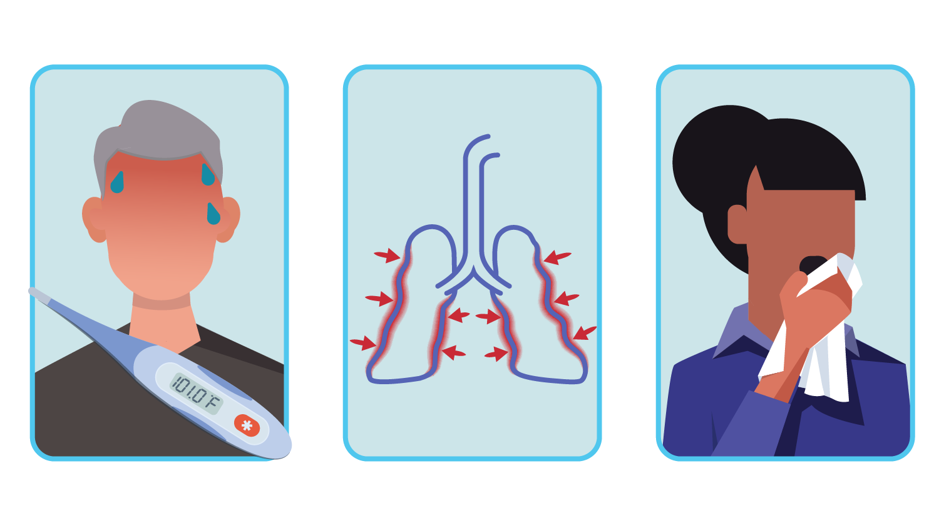
FIG 1: SYMPTOMS OF CORONA VIRUS

LITERATURE REVIEW
CHAPTER 2
2.1 CORONA VIRUS IMPACT ON INDUSTRIES
Coronavirus impact data was collected from March 12 to 17 from visitors to Control Engineering, Plant Engineering, Oil & Gas Engineering, and Consulting-Specifying Engineer websites. Half of respondents’ business have negative effects; half have supply chain problems. Results cover impact on business, company responses, travel, outlook, government strategies and other topics.

FIG 2: A POLL RESULTS CONCERNING THE IMPACT OF CORONA VIRUS ON INDUSTRIES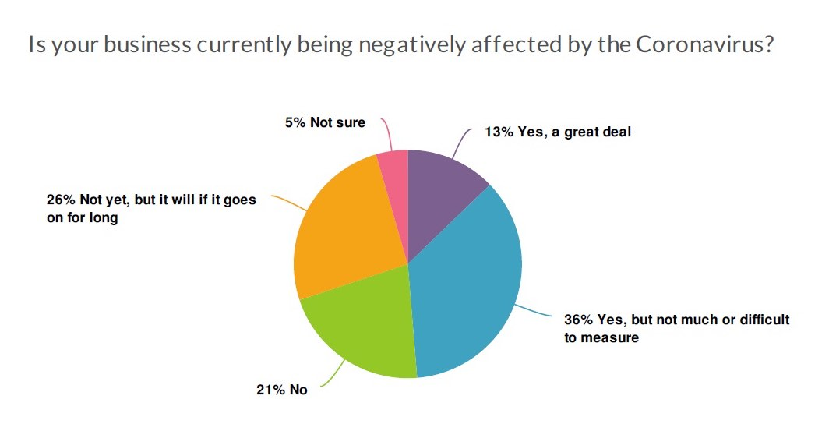
Half of the respondents to a Coronavirus (COVID-19) impact survey said their businesses have been negatively affected, and about half have supply chain problems. Leading company actions to date focus on limiting travel (77%); encouraging work from home (52%); working on contingency plans now with changes expected soon (52%); and eliminating travel (36%).

2.2 Actions taken in response
The survey asked what among 24 actions the respondents’ companies were taking because of coronavirus. The top 10 responses were:
- Limiting travel
- Working on contingency plans now; expect to see changes soon
- Encouraging work from home
- Eliminating travel
- Delaying or eliminating hiring
- Adding supply chain contingencies, secondary sources, etc.
- Delaying or eliminating investments
- Mandating work from home (for those that can)
- Adding new manufacturing capabilities to make up for breaks in supply chain
- Increasing production of relevant product categories to meet increased demand.

The survey also asked an open-ended question: What operational initiatives is your company taking to prevent the spread of coronavirus in your facility? Responses represented in a word cloud and included sending out health updates, changing sanitation processes, issuing gloves, hand sanitizer. Largest words in the cloud were hand, updates, and health, followed by sending, home, travel, and links.
Another question asked what technologies, processes or advice not mentioned here are the engineering-minded people in your organization suggesting or offering to help with the coronavirus impact? The largest words in the cloud of responses were home and work.

Not everyone can work at home
Even so, remote working doesn’t work for everyone, as 45% said they can complete critical parts job functions at home, 31% cannot, and 24% were not sure/only some parts. About half of respondents said their company is having supply chain problems. Eight percent said they were having severe problems, 40% minor problems, 39% no problems, and 12% were unsure. Cancellation or postponed industry event and user groups is a big problem for 15% of respondents and a medium-sized problem for 36%, with 49% saying it’s not a problem; they can get the information needed virtually and/or from suppliers.

2.3.1 HEALTH IMPACT OF COVID-19 ON ENGINEERING

Occupational health
The protection of health workers is one of the priorities for the response to COVID19 outbreaks. Occupational health services in health care facilities have an important role for protecting health workers and ensuring the business continuity of health care services.
2.3.2 Measures To Be Taken By The Employers Within The Scope Of Occupational Health And Safety Regarding Coronavirus
- Taking necessary measures for the safety and health protection of workers, including prevention of occupational risks and providing information and training, as well as providing the necessary organization and means and ensuring that these measures are adjusted taking account of changing circumstances and aiming to improve existing situations,
- Monitoring and checking whether occupational health and safety measures that have been taken in the workplace are followed and ensuring that nonconforming situations are eliminated,
- Carrying out a risk assessment or getting one carried out,
- Taking into consideration the employee’s capabilities as regards health and safety where he entrusts tasks to an employee
- Taking appropriate measures to ensure that employees other than those who have received adequate information and instructions are denied access to areas where there is life-threatening and special hazard.

2.3.3 OCCUPATIONAL HAZARDS
An occupational hazard is a hazard experienced in the workplace. Occupational hazards can encompass many types of hazards, including chemical hazards, biological hazards (biohazards), psychosocial hazards, and physical hazards. Occupational hazard as a term signifies both long-term and short-term risks associated with the workplace environment and is a field of study within occupational safety and health and public health. Short term risks may include physical injury, while long-term risks may be increased risk of developing cancer or heart disease.

2.3.4 TYPES OF HAZARDS
- Chemical hazards: There are many classifications of hazardous chemicals, including neurotoxins, immune agents, dermatologic agents, carcinogens, reproductive toxins, systemic toxins, asthmagens, pneumoconiotic agents, and sensitizers.
- Biological hazards: Biological agents, including microorganisms and toxins produced by living organisms, can cause health problems in workers. Influenza is an example of a biohazard which affects a broad population of workers.
- Psychological hazards: Psychosocial hazards are occupational hazards that affect someone's social life or psychological health.
- Physical hazards: Physical hazards are a subtype of occupational hazards that involve environmental hazards that can cause harm with or without contact. Physical hazards include ergonomic hazards, radiation, heat and cold stress, vibration hazards, and noise hazards.

CHAPTER 3
3.1 EQUIPMENTS TO HELP COMBAT AGAINST THE SPREAD OF COVID 19
- Medical professionals in China may soon deploy a new tool in the fight against coronavirus: disinfecting robots. The robots could help reduce the risk of hospital-acquired infections of the aggressive virus, which has sparked global fears and sweeping international travel restrictions.
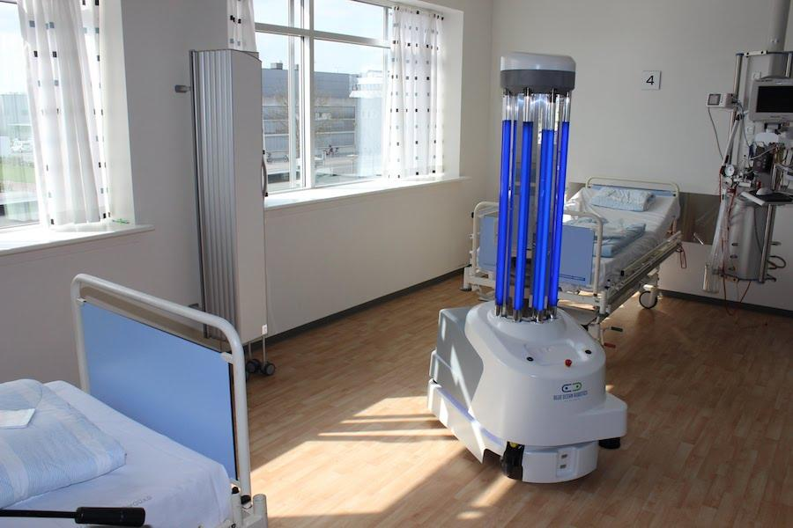
FIG 3: IMAGE OF A UVD ROBOT

- In the very early stages of the outbreak, the latest microfluidic chip technology was adopted to come up with a portable testing kit after obtaining the coronavirus’ genetic sequence in mid-January from China. By reducing the time needed to 40 minutes, the device is one of the biggest leaps in providing early and reliable detection of Covid-19 carriers.
- In terms of infection control, we developed PECD antimicrobial coating, a sterilizer that removes up to 99.99% of different infectious viruses. Using it as a coating on air-particulate filters in air purification systems in hospitals aids the effort to contain transmission of viruses.
- Another new antimicrobial formula recently developed, MAP-1, is effective in killing viruses that are more resistant than the coronavirus. Using it in disinfectants, paints and potentially even clothing and surgical masks could provide lasting protection against microbial contamination to public venues.

Conclusion
There are lots of measures that employers must take in their workplaces within the scope of Occupational Health and Safety regulations against the Coronavirus which shows its effect all over the world. In addition, if it is determined that the employee is caught with Coronavirus epidemic due to the work being carried out by the employer, this situation will be accepted as a work accident and the employer’s responsibility will also arise.

REFERENCES
wikipedia.com
cdc.gov/coronavirus
controleng.com
lexology.com
imeche.org/news
weforum.org

