OMEJE PEACE OJOMA
17/MHS07/026
PHARMACOLOGY
300 LEVEL
PHA 312 – CHEMOTHERAPY OF PARASITIC DISEASES, ANTISCEPTICS AND DISINFECTANTS
ASSIGNMENT

1. LIFE CYCLE OF MALARIA PARASITE
Malaria parasite lifecycle involves two hosts (human and mosquito). During a blood meal, a malaria infected female anopheles mosquito inoculates sporozoites into the human host. The sporozoites infect liver cells and mature into schizonts which rupture and release merozoites. After this initial replication in the liver (exo-erythrocytic schizogony), the parasites undergo asexual multiplication in the erythrocytes (erythrocytic schizogony) and the merozoites infect the red blood cell. Within the red blood cells, the merozoites first grow into a ring shaped form before maturing into trophozoites. Trophozoites then mature into schizoites which rupture and releases new merozoites. Some parasites then differentiate into sexual erythrocytic stages (gametocytes). Blood stage parasite are responsible for the clinical manifestation of the disease. Sporogonic cycle is the parasite’s multiplication in the mosquito. The gametocytes, male (microgametocytes) and female (macrogametocytes), are ingested by the female anopheles mosquito into the mid gut during a blood meal. In the mid gut, the microgametocytes penetrate the macrogametocytes and produce zygotes. The zygotes develop into motile forms called ookinetes which invade the mid gut wall of the mosquito where they develop into oocytes. The oocytes grow, rupture and release sporozoites which make their way to the mosquito’s salivary glands. Inoculation of the sporozoites into a new human host continues the malaria life cycle.
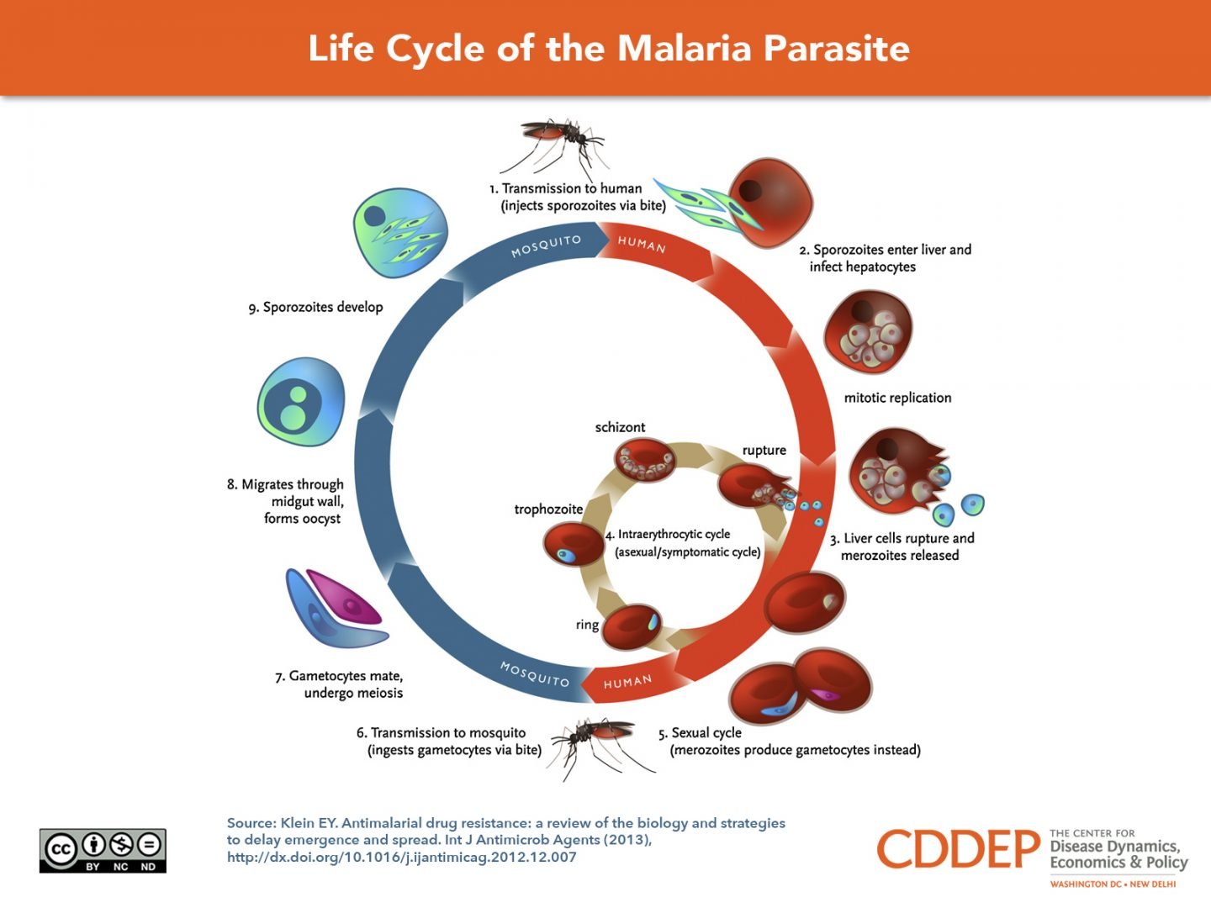

2. CLASSIFICATION OF ANTIAMOEBIC DRUGS
a) Tissue amoebacides
b) Luminar amoebacides

3. GROUPS OF DRUGS USED FOR AMOEBIASIS, DRUG NAMES AND THEIR EXAMPLES
a) Tissue Amoebacides
- Nitromidazole: metronidazole, tinidazole (for intestinal and extraintestinal amoebiasis)
- Alkaloids: imitin, dehydroimitin (for intestinal and extraintestinal amoebiasis)
- Chloroquine (for extraintestinal amoebiasis)

b) Luminar Ameobacides
- Amide: diloxanide flourate, nitazoxanide
- Antibiotics: tetracycline, paromomycine
- 8-hydroxylquinolones: quinidochlor, diiodohydroxylquinine

4. MECHANISM OF ACTION OF METRONIDAZOLE
Metronidazole does not affect aerobic bacteria. It is selectively toxic to anaerobic and microaerophilic microorganisms. After entering the cell by diffusion, its nitro group is reduced by certain redox-proteins operative only in anaerobic microbes to a highly reactive nitroradical which exerts cytotoxicity. The nitroradicals of metronidazole acts as an electron sink which competes with the biological electron acceptors of the anaerobic organism for the electrons generated by the pyruvate; ferodoxine oxydoreductase enzyme (PFOR), pathway of pyruvate oxidation. The energy metabolism of anaerobes that have no mitochondria is thus disrupted. Metronidazole has been found to inhibit cell mediated immunity, to induce mutagenesis and to cause radiosensitization.

