COMPREHENSIVE RESEARCH ON
“CRITICAL ASSESSMENT OF LEGAL IMPLICATIONS AND ECONOMIC IMPACT OF LOCKDOWN OF ACTIVITIES IN NIGERIA”
WRITTEN BY
NAME; ELUWA TOCHUKWU DIVINE JESSICA
MATRIC NUMBER; 17/ENG07/010
DEPARTMENT; PETROLEUM ENGINEERING
COURSE CODE; ENG384
COURSE TITLE; ENGINEERING LAW AND MANAGERIAL ECONOMICS
TO BE SUBMITTED TO; ENGR OYEBODE

ABSTRACT

Human coronaviruses, first characterized in the 1960s, are responsible for a substantial proportion of upper respiratory tract infections in children. Since 2003, at least 5 new human coronaviruses have been identified, including the severe acute respiratory syndrome coronavirus, which caused significant morbidity and mortality. NL63, representing a group of newly identified group I coronaviruses that includes NL and the New Haven coronavirus, has been identified worldwide. These viruses are associated with both upper and lower respiratory tract disease and are likely common human pathogens. The global distribution of a newly identified group II coronavirus, HKU1, has not yet been established. Coronavirology has advanced significantly in the past few years. The SARS epidemic put the animal coronaviruses in the spotlight. The background and history relative to this important and expanding research area are reviewed here.
As businesses worldwide navigate the challenges brought on by the rapid spread of COVID-19 (coronavirus), it is now more essential than ever that corporations be ready with solutions to address risk issues as they arise. Beyond the obvious health repercussions, this global pandemic has presented major disruptions for global businesses. Some have had direct commercial impacts on specific sectors, with interruptions to supply chains, challenges in meeting contractual obligations and implications under funding arrangements. Others are universal: workplace health and safety obligations, the impact of travel restrictions and containment measures, increased record keeping, protecting sensitive personal data and business continuity planning.

LIST OF FIGURES

- FIGURE 1………………………………………………………………………………………………2
- FIGURE 2……………………………………………………………………………………………….4
- FIGURE 3……………………………………………………………………………………………….9
- FIGURE 4……………………………………………………………………………………………….17

Table of Contents
i
ABSTRACT ii
LIST OF FIGURES iii
CHAPTER 1 1
INTRODUCTION 1
CHAPTER 2 5
LITERATURE REVIEW 5
CHAPTER 3 6
METHODOLOGY 6
ANALYSIS OF RESULTS 14
CHAPTER 4 16
CONCLUSION AND RECOMMENDATION 16
REFERENCES 18

CHAPTER 1

INTRODUCTION
The lockdown affecting the economy in general was not a situation overnight. This lockdown was said to hold after different minds had come together to ponder on what can reducing the risk of people having this deadly virus called THE CORONA VIRUS(COVID-19).
What is a coronavirus?
According to the WHO, Coronaviruses are a large family of viruses which may cause illness in animals or humans. In humans, several coronaviruses are known to cause respiratory infections ranging from the common cold to more severe diseases such as Middle East Respiratory Syndrome (MERS) and Severe Acute Respiratory Syndrome (SARS). The most recently discovered coronavirus causes coronavirus disease COVID-19.
COVID-19 is the infectious disease caused by the most recently discovered coronavirus. This new virus and disease were unknown before the outbreak began in Wuhan, China, in December 2019.

The history of human coronaviruses began in 1965 when Tyrrell and Bynoe¹ found that they could passage a virus named B814. It was found in human embryonic tracheal organ cultures obtained from the respiratory tract of an adult with a common cold. The presence of an infectious agent was demonstrated by inoculating the medium from these cultures intranasal in human volunteers; colds were produced in a significant proportion of subjects, but Tyrrell and Bynoe were unable to grow the agent in tissue culture at that time. At about the same time, Hamre and Procknow² were able to grow a virus with unusual properties in tissue culture from samples obtained from medical students with colds. Both B814 and Hamre's virus, which she called 229E, were ether-sensitive and therefore presumably required a lipid-containing coat for infectivity, but these 2 viruses were not related to any known myxo- or paramyxoviruses. While working in the laboratory of Robert Chanock at the National Institutes of Health, McIntosh et al³ reported the recovery of multiple strains of ether-sensitive agents from the human respiratory tract by using a technique similar to that of Tyrrell and Bynoe. These viruses were termed “OC” to designate that they were grown in organ cultures.
Within the same time frame, Almeida and Tyrrell⁴ performed electron microscopy on fluids from organ cultures infected with B814 and found particles that resembled the infectious bronchitis virus of chickens. The particles were medium sized (80–150 nm), pleomorphic, membrane-coated, and covered with widely spaced club-shaped surface projections. The 229E agent identified by Hamre and Procknow² and the previous OC viruses identified by McIntosh et al³ had a similar morphology (Fig. 1).
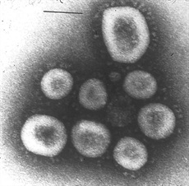
FIGURE 1.:
Coronavirus OC16. Reprinted with permission from Proc Natl Acad Sci USA. 1967;57;933–940.
In the late 1960s, Tyrrell was leading a group of virologists working with the human strains and a number of animal viruses. These included infectious bronchitis virus, mouse hepatitis virus and transmissible gastroenteritis virus of swine, all of which had been demonstrated to be morphologically the same as seen through electron microscopy.^{5,6} This new group of viruses was named coronavirus (corona denoting the crown-like appearance of the surface projections) and was later officially accepted as a new genus of viruses.
Coronaviruses are common viruses that can infect humans, and animals as diverse as bats and alpacas. There are a number of Human coronaviruses and they usually cause respiratory infections—mostly mild illnesses such as the common cold. However, several coronaviruses including the Middle East Respiratory Syndrome (MERS), especially seen in Saudi Arabia or visitors to that area, and Severe Acute Respiratory Syndrome (SARS), seen mainly in China and travelers from there, can cause more severe and sometimes life-threatening human infections.52,57 Coronaviruses that cause severe acute respiratory infections have >50% mortality rates in older and immunosuppressed people.58 WIV1-CoV, a virus similar to SARS, could also be poised to cause epidemics.59

People living with or caring for someone with a coronavirus infection are most at risk of developing the infection themselves. Coronavirus transmission is mainly oral–fecal and respiratory from small droplets of saliva or on fomites. Oral–urine and saliva transmission of MERS-CoV and SARS-CoV are also highly likely.11,12 Salivary cystatin D, a cysteine protease inhibitor, can inhibit replication of some coronaviruses.60 Although evidence is sparse, SARS-CoV appears to be transmitted primarily through saliva droplets. Kissing could constitute a route for transmission.
What are the symptoms of COVID-19?
The most common symptoms of COVID-19 are fever, tiredness, and dry cough. Some patients may have aches and pains, nasal congestion, runny nose, sore throat or diarrhea. These symptoms are usually mild and begin gradually. Some people become infected but don’t develop any symptoms and don't feel unwell. Most people (about 80%) recover from the disease without needing special treatment. Around 1 out of every 6 people who gets COVID-19 becomes seriously ill and develops difficulty breathing. Older people, and those with underlying medical problems like high blood pressure, heart problems or diabetes, are more likely to develop serious illness. People with fever, cough and difficulty breathing should seek medical attention.
The first human cases of COVID-19 were identified in Wuhan City, China in December 2019. At this stage, it is not possible to determine precisely how humans in China were initially infected with SARS-CoV-2.
However, SARS-CoV, the virus which caused the SARS outbreak in 2003, jumped from an animal reservoir (civet cats, a farmed wild animal) to humans and then spread between humans. In a similar way, it is thought that SARS-CoV-2 jumped the species barrier and initially infected humans, but more likely through an intermediate host, that is another animal species more likely to be handled by humans - this could be a domestic animal, a wild animal, or a domesticated wild animal and, as of yet, has not been identified.
Until the source of this virus is identified and controlled, there is a risk of reintroduction of the virus in the human population and the risk of new outbreaks like the ones we are currently experiencing.
There are cases of this virus daily. The rapidly evolving situation of COVID-19 seems to have made the entire world pause for a moment. Things have been changing extremely rapidly and everywhere you look there’s information on the virus and how to protect yourself from it.
Knowing the facts is key to being properly prepared and protecting yourself and your loved ones. Sadly, there’s a lot of information out there that is incorrect. Misinformation during a health crisis leaves people unprotected and vulnerable to the disease and spreads fear and stigmatization.
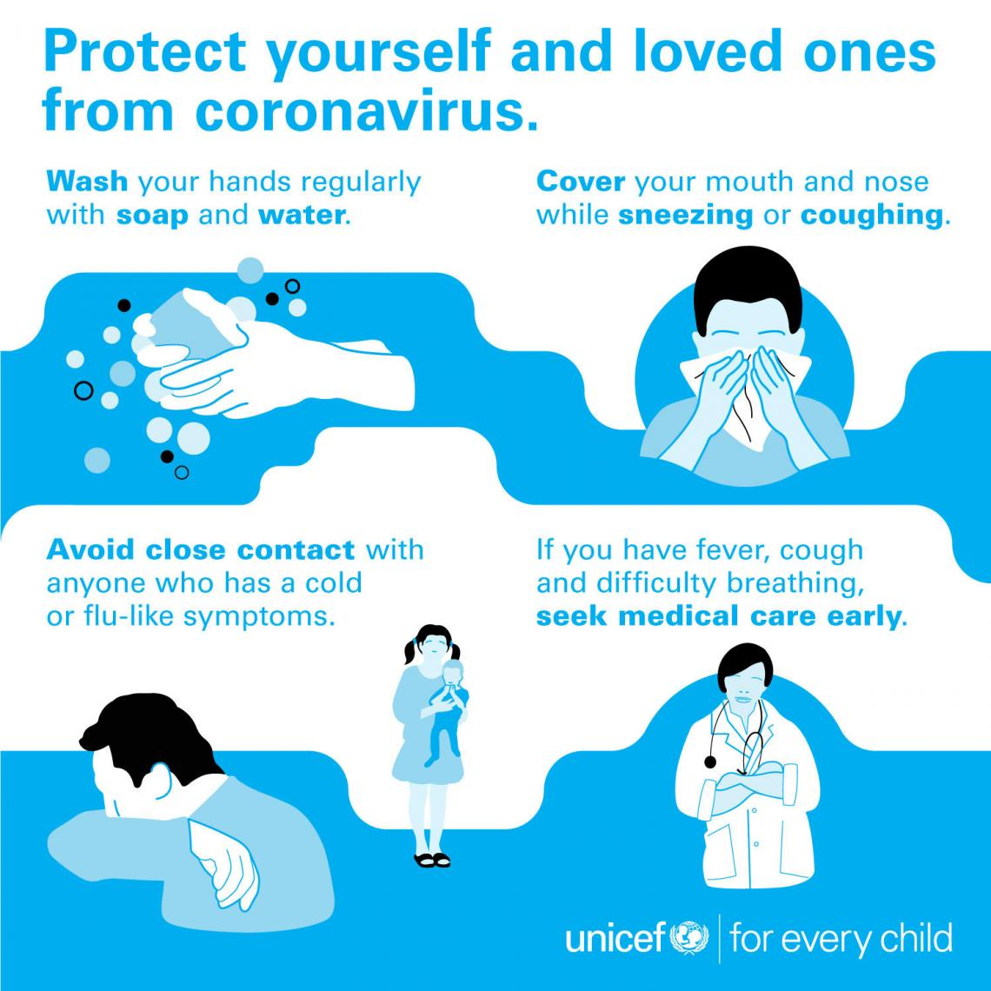
FIGURE 2; Preventive measures to take against the virus.

CHAPTER 2

LITERATURE REVIEW
RESEARCH BY;
COVID-19 and Commercial Transactions: Some Emerging Legal Issues
By the time the World Health Organization (“WHO”) upgraded the status of the novel Coronavirus Disease (officially known as COVID-19) outbreak from an epidemic to a global pandemic on 11th March, 2020, the virus had already travelled beyond Wuhan, China, its point of original outbreak in December 2019 and crossed international borders. Given the rapid rate of infection and increasing number of deaths in the wake of the unprecedented spread of the virus, various emergency measures have been deployed by municipal, local, state, national and multilateral authorities to contain the outbreak
Besides being a public health crisis, COVID-19 continues to trigger severe social and economic consequences for individuals, corporates and governments across the world. Specifically, markets and industries are reacting negatively to the pandemic. Global stock and commodity prices (especially crude oil) have plummeted to unprecedented levels in recent weeks, with grave multiplier effects on economies. The general consensus is that this trend is not expected to reverse anytime soon, given the impact of current border closures, international travel restrictions, and lockdown of large swaths of movements of persons in many cities, countries and regions of the world.
The sudden collapse of industrial and commercial activities is, in many respects, unforeseen. This may also not have been within the reasonable contemplation of most entities, investors, industry & financial market players; who are parties to existing commercial arrangements across several jurisdictions. To date, a sizeable number of domestic and international contractual obligations have been frustrated while many others face possible and imminent performance crisis.
This article analyses the key socio-economic consequences of COVID-19 and offers legal options for mitigating its impact on the operations of commercial entities, as well as technical guidance on including provisions in future commercial agreements, against any similar unforeseen pandemic

CHAPTER 3

METHODOLOGY

CRITICAL ASSESSMENT OF THE LOCKDOWN OF ACTIVITIES IN NIGERIA

A few weeks back, the commander-in-chief of the Armed Forces in Nigeria, President Muhammadu Buhari announced a lockdown of three major states, Lagos, Ogun and Abuja, to curb the coronavirus pandemic. Those that will be affected the hardest will be households that rely on the day to day activities of self-employed individuals for consumption.
Lagos is the country’s major economic center as well as its financial capital. Ogun state borders Lagos state to the south and is notable for having a high concentration of industrial estates and being a major manufacturing hub. Abuja is the seat of government.
Nigeria is one of many countries to shut down economic activities to prevent the rapid spread of the coronavirus pandemic. Most, especially developed nations, have implemented economic support measures to mitigate the impact of lockdowns on their economies.
In his speech to the nation, the Nigerian President Muhammadu Buhari, acknowledged that the restrictions may make it hard for people to feed themselves and so “relief materials” would be distributed to communities around the states affected.
But the Nigerian government will have to take into account the country’s peculiar economic circumstances when it implements its mitigating measures. In particular, it must bear in mind the millions of Nigerian households whose livelihoods depend on the self-employed and small scale entrepreneurs.
The governor of Ekiti state announced a lockdown and announced the reactivation of the state food bank. Ekiti state is also considering providing a stipend to self-employed citizens whose daily incomes would be interrupted. This is a positive development and should be followed through. Other state governments should also take note and do the same if they lockdown their self-employed workers.
The Lagos state government has announced an emergency food response but has not gone as far as talking about a self-employment stipend. It would be beneficial to follow the steps of the Ekiti state government, especially if the lockdown is extended.
Nigerian entrepreneurs like Mike Adenuga and Tony Elumelu have donated large sums of money to catalyze a comprehensive Pan-African response to fight the pandemic. A sizeable chunk of those donations has gone to the Lagos state government. It would be useful if some of this went to self-employed individuals who are the lifeblood of cities like Lagos.
- IMPACT IN THE OIL AND GAS INDUSTRY
Before the pandemic, the Nigerian government had been grappling with weak recovery from the 2014 oil price shock, with GDP growth tapering around 2.3 percent in 2019. In February, the IMF revised the 2020 GDP growth rate from 2.5 percent to 2 percent, as a result of relatively low oil prices and limited fiscal space. Relatedly, the country’s debt profile has been a source of concern for policymakers and development practitioners as the most recent estimate puts the debt service-to-revenue ratio at 60 percent, which is likely to worsen amid the steep decline in revenue associated with falling oil prices. These constraining factors will aggravate the economic impact of the COVID-19 outbreak and make it more difficult for the government to weather the crisis.
How the Covid-19 coronavirus is affecting the offshore industry
1. Oil price crash;
One important impact of the coronavirus outbreak on the downstream oil industry is that the price of crude oil has fallen significantly in a short time, taking billions off the stock prices of major oil and gas companies.
Covid-19 was first identified in China, where it caused an economic slowdown for the world’s largest energy consumer. The decrease in demand led to fears of over-supply for fuel and oil products, and a resulting fall in prices. The Organization of the Petroleum Exporting Countries (OPEC) met to discuss on Friday 6 March.
At their summit, OPEC countries agreed to cut another 1.5 million barrels per day from production. They then met with Russian representatives to propose it took 500,000 bpd of the cuts, but Russia did not agree. Talks continued as stock markets closed.
2. Demand drops;
Oil price wars began with a decrease in supply and demand within China. As the virus spreads, other governments expect similar effects. Austrian oil company OMV said Europe’s demand was steady, except for kerosene. As governments advise people to reduce social contact and much international travel is banned, less air travel means less kerosene consumption. This is particularly noticeable in transatlantic flights after the US stopped all travel with Europe.
As demand decreases in Europe and the US, China is hoping to restore production. However, in its monthly report, the International Energy Agency predicted an annual decrease in demand of 90,000 barrels per day, the largest fall in a decade.
Brent crude oil prices fell to approximately $33 per barrel (bbl.) on Monday 9 March, the worst of its kind fall in a day since 1991. Saudi Arabia, and its erstwhile non-OPEC (OPEC+) ally, Russia failed to agree on the 6th of march on proposed oil production cuts. Earlier in 2020, oil prices had fallen to almost $45 per barrel, the lowest for years. Back then, the combination of shale oil production from the US and predictions about sluggish global demand growth, was to blame. Now the coronavirus, which has slashed Chinese oil demand more up to 20%, has added fuel to the fire.
Some OPEC members could decide to go renegade and pump out more barrels in the hope of compensating for the rapid decline in prices. Already the uncertainty has been devastating to oil markets, with the lack of coordination and trust amongst key OPEC and non-OPEC actors, fueling a new era of volatility.

- IMPACT ON AGGREGATE DEMAND
In Nigeria, efforts were already being made to bolster aggregate demand through increased government spending and tax cuts for businesses. The public budget increased from 8.83 trillion naira ($24.53 billion) in 2019 to 10.59 trillion naira ($29.42 billion) in 2020, representing 11 percent of the national GDP, while small businesses have been exempted from company income tax, and the tax rate for medium-sized businesses has been revised downwards from 30 to 20 percent. Unfortunately, the COVID-19 crisis is causing all components of aggregate demand, except for government purchases, to fall (Figure 1).
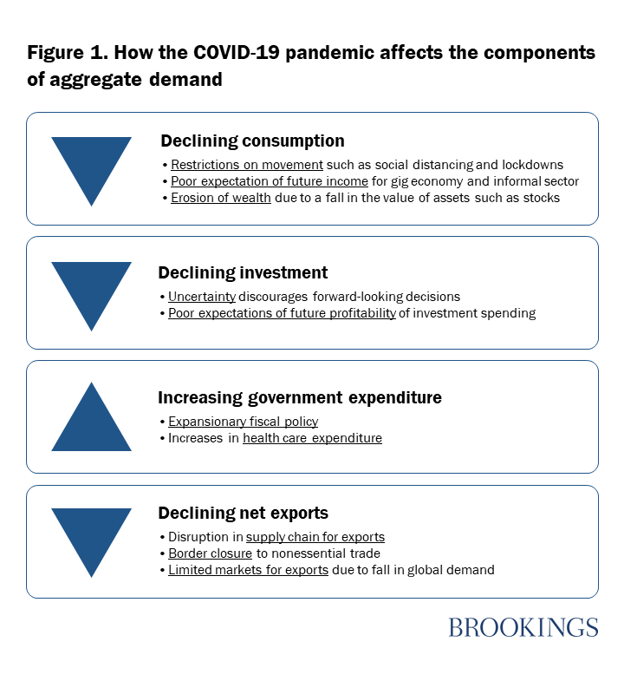
FIGURE 3; How the covid-19 pandemic affects the components of aggregate demand

CRITICAL ASSESSMENT OF THE LEGAL IMPLICATIONS CAUSED BY THE LOCKDOWN OF ACTIVITIES IN NIGERIA
As part of attempts to limit the spread of Covid-19, governments have instituted lock-down measures and banned public gatherings. Lagos, Africa’s largest city with 21 million people, is attempting to do the same. With over 200 confirmed cases, by far the most in Nigeria, the state government has asked schools to shut down and banned public gatherings, particularly religious congregations. In the event of more cases, tougher measures will likely follow. Given Lagos’ standing as Nigeria’s economic nerve center, the threat of a highly contagious viral outbreak in a state where 20 million people are squeezed into land mass that’s about the size of Indianapolis (population: 870,000), is grim. But shutting down Lagos on any scale will likely be an uphill task for the government.
KEY ISSUES FOR COMMERCIAL ENTITIES AND TRANSACTIONS
Massive disruptions in global supply chains are affecting commerce in every sector and jurisdiction. In the circumstances, business organizations are confronted with existential risks for which many do not have contingency plans in place, and which are affecting how they can deliver on their contractual obligations. For enterprises such as manufacturing (production & assembly plants), construction, mining, marketing and consultancy firms with operations largely dependent on imported raw materials, semi-processed or finished products, as well as imported services (skilled labor & expertise); the various responses to COVID-19 worldwide (particularly in the most affected economies) have either crippled their operations or adversely affected the international value chain for their products.
We have considered a few enterprises/contractual arrangements below:
- Financing
The COVID-19 outbreak will likely have a negative impact on the ability of many companies with existing loan/debt financing obligations to meet their obligations to their lenders/creditors. The need to assess the impact of the COVID-19 outbreak on obligations under relevant financing agreements is now of significant importance. For instance, have provisions relating to material adverse change/event been triggered? Are the representation and warranties made by the borrower still accurate? Will there be need to seek waivers or extension of time to comply with obligations?
- Employment
One of the side effects of the various measures against COVID-19 is the inability of several employees (especially those whose work require physical delivery) to perform their duties for lengthy period. The liability of employers to still pay salaries in such circumstances is now in question. Indeed, several employers may be unable to meet their salary obligations to their employees due to possible challenges in receiving payments from clients by reason of non-delivery of services. Thus, the ability of employers to terminate the services of the employees under current circumstances have come up for discussions. Can the employers convert the period to paid or unpaid leave? Can an employer implement a reduction in salary without the consent of the employees?
Also, several employers currently allowing their employees to work remotely do not have provisions in their contracts of employments or staff handbook governing such work-from-home arrangements. Can accidents occurring whilst working from home be considered an occupational accident? Can an employee who refuse to come to work due to high level of anxiety be penalized?
- Aviation, Shipping & Logistics
The restrictions on international air travels and the closure of land and coastal borders in many countries have grounded business for many enterprises in the transport sector. This has resulted in many impromptu cancellations of flights and trips along international air, water and land routes. There have also been consequential implications for enterprises expecting delivery of shipments, consignments, cargoes, and arrival of expatriate workers from foreign countries. This also holds for business entities, persons, and business executives travelling for previously scheduled business meetings and conferences across international borders. The determination of the party to bear the losses or liabilities arising under the relevant contracts is now a major consideration for parties.

- Tourism & Entertainment
With lockdown placed on major cities across the globe and directives to maintain the WHO-recommended social distancing protocols, COVID-19 outbreak has had serious toll on global tourism and entertainment. In the circumstances, legal questions arise as to the status of previously scheduled events and paid bookings for hotel accommodation and event venues; particularly if the pandemic persists for a period longer than envisaged.
- Construction & Mining
Operators in the construction sector and their clients have had to face serious interruptions to the performance of their contractual obligations. In most cases, importation of construction materials has been stalled with material adverse effects on building projects and concession contracts. This will either elongate agreed durations for, or completely frustrate the performance of, infrastructure projects earlier awarded. In the same vein, mining agreements such as leases and licenses are expected to suffer serious performance crisis, particularly where expatriate workers from foreign countries are required or where heavy machinery are required to be imported for exploration and exploitation purposes. Will they still be entitled to payments and/or liable for delayed performance?
- Healthcare
Enterprises engaged in the health sector are significantly affected by the pandemic. With hospitals running out of drugs, test kits and protective masks, and pharmaceutical companies (particularly in Africa) unable to either import drugs or raw materials from affected producing countries around the world; there is pressure on the supply side of the market with many pre-COVID-19 arrangements/orders disrupted. Will health care providers be liable for negligence arising from inability to provide adequate treatment to patients due to shortages caused by COVID-19?
- African Trade
The ravaging impact of COVID-19 is becoming increasingly felt in Africa only about three (3) months to the take-off date of the African Continental Free Trade Area. The Agreement establishing the AfCFTA was signed on March 21, 2018, in Kigali, Rwanda and it came into force on May 30, 2019. As highlighted in a Special Issue of our Grey Matter Tax Alert in January 2020, the AfCFTA created a single market for the free movement of goods, services and persons within the continent, with the vision that capital, investments and technology will flow across the continent unimpeded. The COVID-19 pandemic is likely going to affect the take-off as well as the objectives of the AfCFTA, should the pandemic persists.
As a consequence of all of the foregoing, the nature/scope of the provisions in underlining contracts for business entities' obligations have come to the fore of the conversations, as consequential adjustments to the various commercial arrangements/agreements becomes imperative.

ANALYSIS OF RESULTS
POSSIBLE / RECOMMENDED APPROACHES
- Force Majeure
Most commercial agreements contain force majeure clauses, included to protect the positions of parties to such agreements, in case certain events (defined in the agreement) occur to prevent performance of contractual obligations. Such circumstances usually include natural disasters, otherwise known as "acts of god", such as earthquakes, tsunamis, plagues or "serious epidemic". Force majeure events can also include "acts of man" which are reasonably unforeseeable and disruptive in nature, such as an industrial action.
In effect, a force majeure event will relieve a commercial entity, that is unable to perform under a contract due to circumstances outside of its control from obligation. Thus, commercial entities who have failed to perform any of their contractual obligations, as a result of the COVID-19 pandemic, may be able to invoke the force majeure clauses in their commercial agreements; to avoid liability for non-performance. However, where "Coronavirus outbreak" is not contained in the list of defined events in a contract, it is assumed that the current pandemic should qualify as a force majeure event under the umbrella "serious epidemic", a phrase commonly inserted in commercial agreements.
For contracts containing no force majeure clauses, commercial entities could result to invoking the common law principles of supervening impossibility or frustration, to avoid huge liability for non-performance. However, the availability of this principle would depend on the applicable law to such contracts.
Whether COVID-19 will find application under the general term, "serious epidemic" or will be adjudged a supervening event by operation of law, depends substantially on the construction of the underlining contract, the applicable laws and the unique facts and circumstances of each case. At any rate, commercial entities should consider specifically including a pandemic, such as Coronavirus, in the definition of force majeure events in future contracts.
- Insurance Policy
Commercial entities having "All-Risks Insurance" and "Special Perils Insurance" as well as "Consequential Loss Insurance" and the like, should review the terms of such policies or seek appropriate professional advice, on whether the current Coronavirus scourge could be accommodated in the risks insured against.
For instance, insured manufacturing companies may benefit under a "Plant-All-Risk Insurance Policy", as a result of the lockdown in many cities of the world, preventing their operations. In like manner, construction companies may be able to make claims under a "Contractor-All-Risk Insurance Policy".
However, for "Special Perils Insurance Policies", it is not clear whether the damage/disruptions caused by the COVID-19 outbreak could amount to special perils. Similarly, it is not clear whether insured commercial entities who have suffered loss of revenue/profit in the wake of the Coronavirus pandemic could claim under a "Consequential Loss Insurance Policy".
The quantum of claims possible under the various insurance policies will depend on the construction of the insurance contracts. It is necessary that commercial entities negotiate future insurance policies, with a pandemic like the COVID-19 in mind.
- Business Continuity Plan
The COVID-19 pandemic is changing the world of work. For enterprises without a contingency plan, the economic adverse effect of the pandemic could be extremely devastating. In view of present realities, commercial entities should invest in system automation whereby services can be provided remotely to their clients or customers, in times of natural disasters, widespread plaques or lockdown. For entities relying on delivery of services, the inclusion of provisions in the contract obliging the service provider to have a robust business continuity plan will be important.
Well negotiated commercial and insurance contracts, that will adequately take care of business disruptions and ensure continuity of businesses in the post-crisis period, without losing vital business relationships are crucial. This is imperative for commercial entities, particularly those whose services may not be possibly rendered virtually; such as enterprises in the construction, manufacturing, transport & logistics sectors.

CHAPTER 4

CONCLUSION AND RECOMMENDATION
As the COVID-19 coronavirus outbreak continues to accelerate its spread worldwide, the international community is facing a global crisis with public health, geopolitical, and economic repercussions.
As businesses worldwide navigate the challenges brought on by the rapid spread of COVID-19 (coronavirus), it is now more essential than ever that corporations be ready with solutions to address risk issues as they arise. Beyond the obvious health repercussions, this global pandemic has presented major disruptions for global businesses. Some have had direct commercial impacts on specific sectors, with interruptions to supply chains, challenges in meeting contractual obligations and implications under funding arrangements. Others are universal: workplace health and safety obligations, the impact of travel restrictions and containment measures, increased record keeping, protecting sensitive personal data and business continuity planning.
In conclusion, commercial entities are enjoined, in the light of the global reach of the COVID-19 pandemic and the attendant unprecedented disruptions to businesses, to consider seeking proper legal advice on:
- Which existing contracts may be impacted by the ubiquitous restrictions and lockdown on businesses, or where a counterparty may lawfully seek to terminate or suspend a contract;
- The employment obligations and/or liability that may crystallize by reason of the current pandemic and how to mitigate against same;
- Appropriate steps to mitigating the risks associated with Coronavirus or outbreak of similar epidemic in future contractual relationships/commercial arrangements;
- Building an effective Business Continuity Plan within the context of extant applicable laws; and Whether a force majeure event applies to specific contracts to which they are parties or what reliefs may be available, in the circumstance.

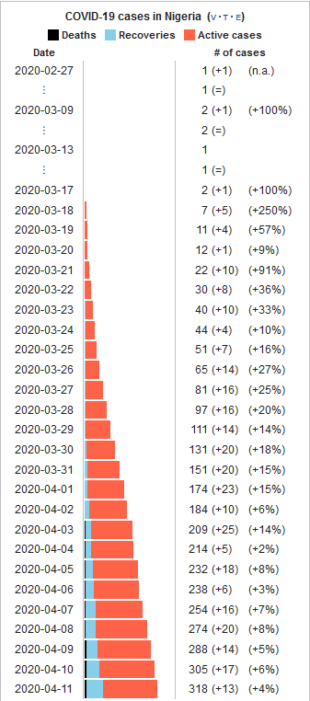
FIGURE 4; Corona virus pandemic growth in Nigeria

REFERENCES
- https://banwo-ighodalo.com/grey-matter/covid-19-commercial-entities-legal-fallout-global-pandemic?utm_source=Mondaq&utm_medium=syndication&utm_campaign=LinkedIn-integration
- https://www.who.int/news-room/q-a-detail/q-a-coronaviruses
- https://www.nortonrosefulbright.com/en/knowledge/publications/f63695f4/coronavirus-legal-implications-of-a-global-pandemic
- https://www.sciencedirect.com/topics/neuroscience/coronavirus
- https://www.theafricareport.com/25998/how-nigeria-is-doing-nearly-two-weeks-into-the-covid-19-lockdown/
- https://theconversation.com/lockdown-will-hit-nigerias-smallscale-entrepreneurs-hard-what-can-be-done-135362
- https://www.brookings.edu/blog/africa-in-focus/2020/04/08/understanding-the-impact-of-the-covid-19-outbreak-on-the-nigerian-economy/
- https://www.offshore-technology.com/features/rock-bottom-how-covid-19-has-shattered-the-oil-industry/
- https://en.wikipedia.org/wiki/2020_coronavirus_pandemic_in_Nigeria#Background
- https://brooksandknights.com/2020/03/23/covid-19-legal-business-considerations-for-african-businesses/?utm_source=Mondaq&utm_medium=syndication&utm_campaign=LinkedIn-integration
- https://www.mondaq.com/nigeria/contracts-and-commercial-law/909602/legal-and-business-considerations-for-african-businesses-during-covid-19
- https://www.atlanticcouncil.org/blogs/new-atlanticist/coronavirus-and-the-oil-market-the-effects-thus-far-and-what-to-expect-next/

