ASSESSMENT OF OCCUPATIONAL HAZARDS AND DEVELOPMENT OF ENGINEERING FACILITIES, EQUIPMENT, SENSORS AND PUBLIC HEALTH SYSTEMS FOR TACKLING COVID – 19 PANDEMIC

ASITA OBONISO
17/ENG06/014

A TERM PAPER SUBMITTED TO THE DEPARTMENT OF MECHANICAL AND MECHATRONICS ENGINEERING.
AFE BABALOLA UNIVERSITY, ADO EKITI, EKITI
IN PARTIAL FULFILMENT OF THE REQUIREMENT FOR THE AWARD OF BACHELOR OF ENGINEERING (B.ENG) ENG 384

2ND OF APRIL 2020
ABSTRACT
Occupational hazard is a hazard experienced in the workplace. Occupational hazards can encompass many types of hazards, including chemical hazards, biological hazards (biohazards), psychosocial hazards, and physical hazards. In the United States, the National institute for Occupational Safety and Health (NIOSH) conduct workplace investigations and research addressing workplace health and safety hazards resulting in guidelines. The Occupational Safety and Health Administration (OSHA) established enforceable standards to prevent workplace injuries and illnesses. In the EU a similar role is taken EU-OSHA.
Occupational hazard as a term signifies both long-term and short-term risks associated with workplace environment and is a field of study within occupational safety and health and public health. Short term risks may include physical injury, while long-term risks may be increased risk of developing cancer or heart disease.
COVID-19 is an infectious disease caused by severe acute respiratory syndrome. The disease was first identified in December 2019 in Wuhan, the capital of China’s Hubei province, and has since spread globally, resulting in the ongoing 2019-20 coronavirus pandemic. Common symptoms include fever, cough and shortness of breath. Other symptoms may include fatigue, muscle pain, diarrhoea, sore throat, loss of smell and abdominal pain. While the majority of cases result in mild symptoms, some progress to viral pneumonia and multi-organ failure. As of 8 April 2020, more than 1.44 million cases have been reported in more than 200 countries and territories, resulting in more than 82,900 deaths. More than 307,000 people have recovered.
The engineering industry is being encouraged to gear up and innovate as it tackles COVID-19. They can design, fabricate and manufacture equipment and facilities to help in curbing the virus.
Many businesses have temporarily shut or are working with a skeleton staff to limit the spread of the virus. But, for those in engineering, they might find themselves with an increased workload, because engineers have certain facilities abilities and skills that could help our National Health Service tackle COVID-19.

INTRODUCTION
What are occupational hazards?
Occupational hazards are risks accepted as consequences of a particular occupation. Occupational hazards can also be seen as illnesses or accidents in the workplace. In other words, hazards are those negative events that workers experience in their place of work or they are unpleasant things that a person experiences or suffers as a result of doing his/her job. Some dictionaries say that the term also includes hazards that people experience as a result of working on their hobbies. If a hazard is an undesirable, unpleasant event or danger then Occupational Hazards can mean the ‘risks’ that are found in a job.

TYPES OF OCCUPATIONAL HAZARDS
There are several types of known occupational hazards, some of them are a follows;
- Biological hazards: Biological hazards or biohazards are biological substances that threaten the health of human beings and other living organisms. This type of hazard may include samples of a toxin of a biological source like a virus, or a microorganism. Specifically, those samples that harm human health.
- Chemical hazards: Chemical hazards are occupational hazards that expose people to chemicals in their workplace. Victims can suffer acute or long-term negative health effects.
There are hundreds of hazardous chemicals, including immune agents, dermatologic agents, carcinogens, neurotoxins, and reproductive toxins. Asthmagens, sensitizers, and systemic toxins are also hazardous chemicals.
“Long-term exposure to chemicals such as silica dust, engine exhausts, tobacco smoke, and lead (among others) have been shown to increase risk of heart disease, stroke, and high blood pressure.”
- Physical hazards: Physical hazards may be factors, agents, or circumstances that can cause harm without or with contact. We classify them as either environmental or occupational hazards.
Radiation, heat and cold stress, vibrations, and noise, for example, are types of physical hazards.
Physical hazards are very common cause injuries and illnesses in several industries. In some industries, such as mining and construction, they are unavoidable.
However, over time, we have developed safety producers and methods to minimize the risks of physical danger in people’s place of work.
- Psychosocial hazards: Psychosocial hazards are occupational hazards that affect employees’ psychological health. These hazards affect their ability to take part in a work environment with other colleagues.
Psychosocial hazards are occupational hazards that affect employees’ psychological health. These hazards affect their ability to take part in a work environment with other colleagues.
Psychosocial hazards are associated with how the work was designed, organized, and managed. They are also related to the social and economic contexts of the work. Patients suffer psychological or psychiatric injury or illness. Some also suffer physical injury or illness.
Workplace violence and occupational stress, for example, are psychosocial hazards.

COVID-19(CORONAVIRUS DISEASE 2019)
Coronavirus is a biological hazard and can be contacted at the work place. This is the main reason why people are asked to work from home.
COVID-19 is an infectious disease caused by severe acute respiratory syndrome. The disease was first identified in December 2019 in Wuhan, the capital of China’s Hubei province, and has since spread globally, resulting in the ongoing 2019-20 coronavirus pandemic. Common symptoms include fever, cough and shortness of breath. Other symptoms may include fatigue, muscle pain, diarrhoea, sore throat, loss of smell and abdominal pain. While the majority of cases result in mild symptoms, some progress to viral pneumonia and multi-organ failure. As of 8 April 2020, more than 1.44 million cases have been reported in more than 200 countries and territories, resulting in more than 82,900 deaths. More than 307,000 people have recovered
Other names of Coronavirus disease 2019 include;
- Coronavirus
- 2019-nCoV acute respiratory disease
- Novel coronavirus pneumonia
- Wuhan pneumonia

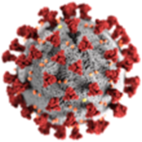
A Picture of a Corona Virus

Comon Symptoms of someone suffering from Corona Virus.

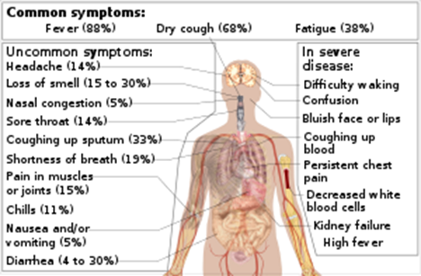

The virus is mainly spread during close contact and by small droplets produced when those infected cough, sneeze or talk. These droplets may also be produced during breathing; however, they rapidly fall to the ground or surfaces and are not generally spread through the air over large distances. People may also become infected by touching a contaminated surface and then their face. The virus can survive on surfaces for up to 72 hours. It is most contagious during the first three days after onset of symptoms, although spread may be possible before symptoms appear and in later stages of the disease. The time from exposure to onset of symptoms is typically around five days, but may range from two to 14 days. The standard method of diagnosis is by real-time reverse transcription polymerase chain reaction (rRT-PCR) from a nasopharyngeal swab. The infection can also be diagnosed from a combination of symptoms, risk factors and a chest CT scan showing features of pneumonia.
Recommended measures to prevent infection include frequent hand washing, social distancing (maintaining physical distance from others, especially from those with symptoms), covering coughs and sneezes with a tissue or inner elbow and keeping unwashed hands away from the face. The use of masks is recommended for those who suspect they have the virus and their caregivers. Recommendations for mask use by the general public vary, with some authorities recommending against their use, some recommending their use and others requiring their use. Currently, there is no vaccine or specific antiviral treatment for COVID-19. Management involves treatment of symptoms, supportive care, isolation and experimental measures.
The World Health Organization (WHO) declared the 2019–20 coronavirus outbreak a Public Health Emergency of International Concern (PHEIC) on 30 January 2020 and a pandemic on 11 March 2020. Local transmission of the disease has been recorded in many countries across all six WHO regions.

Those infected with the virus may be asymptomatic or develop flu-like symptoms, including fever, cough, fatigue and shortness of breath. Emergency symptoms include difficulty breathing, persistent chest pain or pressure, confusion, difficulty waking and bluish face or lips; immediate medical attention is advised if these symptoms are present. Less commonly, upper respiratory symptoms, such as sneezing, runny nose or sore throat may be seen. Symptoms such as nausea, vomiting and diarrhoea have been observed in varying percentages. Some cases in China initially presented only with chest tightness and palpitations. In March 2020 there were reports indicating that loss of the sense of smell (anosmia) may be a common symptom among those who have mild disease, although not as common as initially reported. In some, the disease may progress to pneumonia, multi-organ failure and death. In those who develop severe symptoms, time from symptom onset to needing mechanical ventilation is typically eight days.
As is common with infections, there is a delay between the moment when a person is infected with the virus and the time when they develop symptoms. This is called the incubation period. The incubation period for COVID-19 is typically five to six days but may range from two to 14 days. 97.5% of people who develop symptoms will do so within 11.5 days of infection.
Reports indicate that not all who are infected develop symptoms, but their role in transmission is unknown. Preliminary evidence suggests asymptomatic cases may contribute to the spread of the disease. The proportion of infected people who do not display symptoms is currently unknown and being studied, with the Korea Centre for Disease Control and Prevention (KCDC) reporting that 20% of all confirmed cases remained asymptomatic during their hospital stay. China’s National Health Commission began including asymptomatic cases in its daily cases on 1 April, of the 166 infections on that day, 130 (78%) were asymptomatic.
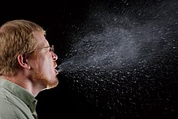
IMAGE: RESPIRATORY DROPLETS, PRODUCED WHEN A MAN IS SNEEZING

Some details about how the disease is spread are still being determined. The WHO and the US Centre’s for Disease Control and Prevention (CDC) say it is primarily spread during close contact and by small droplets produced when people cough, sneeze or talk; with close contact being within 1–3 m (3 feet 3 in–9 feet 10 in). A study in Singapore found that an uncovered cough can lead to droplets travelling up to 4.5 meters (15 feet). A second study, produced during the 2020 pandemic, found that advice on the distance droplets could travel might be based on old 1930s research which ignored the protective effect and speed of the warm moist outbreath surrounding the droplets; it advised that droplets can travel around 7–8 metres.
Respiratory droplets may also be produced while breathing out, including when talking. Though the virus is not generally airborne, The National Academy of Science has suggested that bio aerosol transmission may be possible and air collectors positioned in the hallway outside of people's rooms yielded samples positive for viral RNA. The droplets can land in the mouths or noses of people who are nearby or possibly be inhaled into the lungs. Some medical procedures such as intubation and cardiopulmonary resuscitation (CPR) may cause respiratory secretions to be aerosolised and thus result in airborne spread. It may also spread when one touches a contaminated surface, known as fomite transmission, and then touches one’s eyes, nose or mouth. While there are concerns it may spread by faeces, this risk is believed to be low.
The virus is most contagious when people are symptomatic; while spread may be possible before symptoms appear, this risk is low. The European Centre for Disease Prevention and Control (ECDC) says while it is not entirely clear how easily the disease spreads, one person generally infects two to three others.
The virus survives for hours to days on surfaces. Specifically, the virus was found to be detectable for one day on cardboard, for up to three days on plastic and stainless steel and for up to four hours on copper. This, however, varies based on the humidity and temperature. Surfaces may be decontaminated with a number of solutions (within one minute of exposure to the disinfectant to achieve a 4 or more log reduction), including 78–95% ethanol (alcohol used in spirits), 70–100% 2-propanol (isopropyl alcohol), the combination of 45% 2-propanol with 30% 1-propanol, 0.21% sodium hypochlorite (bleach), 0.5% hydrogen peroxide, or 0.23–7.5% povidone-iodine. Ordinary soap and detergent are also highly effective if correctly used; soap products attack the virus' fatty protective layer, deactivating it, as well as freeing them from skin and other surfaces.

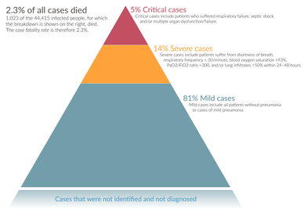
The severity of diagnosed COVID-19 cases in China

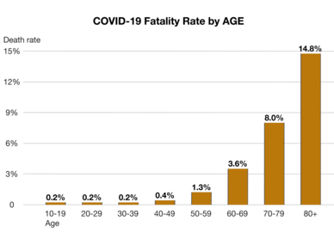
Case fatality rates by age group in China. Data through 11 February 2020.
Case fatality rate in China depending on other health problems. Data through 11 February 2020.
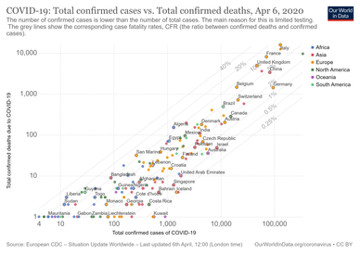

The number of deaths versus total cases by country and approximate case fatality rate
The severity of COVID-19 varies. The disease may take a mild course with few or no symptoms, resembling other common upper respiratory diseases such as the common cold. Mild cases typically recover within two weeks, while those with severe or critical diseases may take three to six weeks to recover. Among those who have died, the time from symptom onset to death has ranged from two to eight weeks.
Children are susceptible to the disease, but are likely to have milder symptoms and a lower chance of severe disease than adults; in those younger than 50 years, the risk of death is less than 0.5%, while in those older than 70 it is more than 8%. Pregnant women may be at higher risk for severe infection with COVID-19 based on data from other similar viruses, like SARS and MERS, but data for COVID-19 is lacking.
In some people, COVID-19 may affect the lungs causing pneumonia. In those most severely affected, COVID-19 may rapidly progress to acute respiratory distress syndrome (ARDS) causing respiratory failure, septic shock or multi-organ failure. Complications associated with COVID-19 include sepsis, abnormal clotting and damage to the heart, kidneys and liver. Clotting abnormalities, specifically an increase in prothrombin time, have been described in 6% of those admitted to hospital with COVID-19, while abnormal kidney function is seen in 4% of this group. Liver injury as shown by blood markers of liver damage is frequently seen in severe cases.
Some studies have found that the neutrophil to lymphocyte ratio (NLR) may be helpful in early screening for severe illness.
Many of those who die of COVID-19 have pre-existing (underlying) conditions, including hypertension, diabetes mellitus and cardiovascular disease. The Istituto Superiore di Sanità reported that out of 8.8% of deaths where medical charts were available for review, 97.2% of sampled patients had at least one comorbidity with the average patient having 2.7 diseases. According to the same report, the median time between onset of symptoms and death was ten days, with five being spent hospitalised. However, patients transferred to an ICU had a median time of seven days between hospitalisation and death. In a study of early cases, the median time from exhibiting initial symptoms to death was 14 days, with a full range of six to 41 days. In a study by the National Health Commission (NHC) of China, men had a death rate of 2.8% while women had a death rate of 1.7%. Histopathological examinations of post-mortem lung samples show diffuse alveolar damage with cellular fibro hypoid exudates in both lungs. Viral cytopathic changes were observed in the pneumocystis. The lung picture resembled acute respiratory distress syndrome (ARDS). In 11.8% of the deaths reported by the National Health Commission of China, heart damage was noted by elevated levels of troponin or cardiac arrest.
Availability of medical resources and the socioeconomics of a region may also affect mortality. Estimates of the mortality from the condition vary because of those regional differences, but also because of methodological difficulties. The under-counting of mild cases can cause the mortality rate to be overestimated. However, the fact that deaths are the result of cases contracted in the past can mean the current mortality rate is underestimated.

HOW ENGINEERING IS HELPING TO BATTLE COVID-19
The engineering industry is being encouraged to gear up and innovate as it tackles COVID-19.
Many businesses have temporarily shut or are working with a skeleton staff to limit the spread of the virus. But, for those in engineering, you might find yourself with an increased workload, because engineers have certain facilities and skills that could help our National Health Service tackle COVID-19. Discussed below is what admirable actions engineering companies have already taken.
Three things that engineering companies can do to help fight COVID-19
Engineering companies are gearing up to help tackle the pandemic in the following ways:
- Design and manufacture respiratory equipment
The symptoms of the novel coronavirus have created a unique and urgent demand for many crucial pieces of healthcare equipment. Engineers can help in designing and manufacturing of better equipment that can serve this purpose. They can be respiratory ventilators, lifesaving equipment, building etc.
- Provide personal protective equipment (PPE)
We are all feeling the immense pressure to take care when venturing out of the house and to only do so when necessary. But the doctors and nurses who are working on the frontline can't stay home, so it's absolutely crucial that they have the right personal protective equipment to keep them safe from the virus while assisting those suffering from the symptoms of COVID-19.
This has created an immediate demand for medical equipment, including N95 fluid-resistant face masks, disposable gloves, and surgical gowns and aprons that can help to limit the spread between doctors and coronavirus patients. In fact, these are considered so crucial in protecting healthcare professionals from contracting the virus themselves that GPs are beginning to call for the same protective measures to be brought into place rather than PPE just being offered to hospital staff.
- Build temporary hospitals or donate materials
The world seems to be following Wuhan's pattern of infection and the lifespan of the coronavirus, so it's expected that it will very shortly reach a peak where temporary hospitals are going to have to be built to cope with the rising number of cases. And, while some countries have built temporary hospitals to reach the demand for care, there are still other things we can be doing to maximize the number of people getting access to treatment.
For example, donating any empty shipping containers to the healthcare system can mean there are many more temporary intensive care units (ICUs) for patients in life-threatening states to be treated. Along with this, being able to offer any other helpful materials and manpower to help make these will be appreciated.

WHAT SENSORS ARE USED TO DETECT THE CORONA VIRUS
- Thermography is the front-line sensing technology to detect and isolate victims of the coronavirus (COVID-19). The non-contact thermal sensors have been ubiquitous over the past few weeks as the numbers of those contracting the virus and dying as the result of it have risen. Accuracy of the infrared (IR) thermometer gun’s measurements depends on several factors from proper operation (the right distance from the person’s forehead) to environmental factors, including recent exertion by the person being measured to temperature suppression due to taking drugs as well as their usage outside of carefully controlled health care settings.
A far more accurate technique uses infrared cameras. For example, Infrared Cameras Inc. (ICI) lines of medical thermal infrared cameras have FDA 510(k) Clearance for medical use. Offering two fever detection systems, the P-Series IR Camera is a 640 x 512 radiometric imager. The camera operates on less than 1 watt of power and uses a USB 2.0 connection to provide real time radiometric data streamed directly to a display.
Unlike the hand-held thermometer guns, the screening process involves the person being screened to stand still, look into the camera and remove any distraction such as a cap or glasses. The display includes a blackbody object for known level of infrared emissions. They provide accurate skin surface temperature readings from the first 1/1000th inch of epidermal layer.
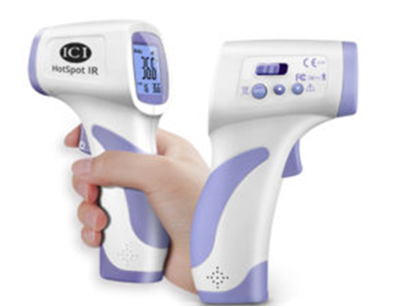

ICI also offers a non-contact thermometer gun. With their gun, readings can be taken as close as 5 cm or as far as 15 cm from the target and achieve a display resolution of 0.1 °C (0.1 °F).
- Wearable monitoring temperature device is a continuous temperature sensor which is helping to combat the spread of the disease in China. Created after the previous SARS outbreak the Shanghai Public Health Clinical Center (SPHCC) contains specialised wards that are designed to limit cross infection and to provide more efficient treatments.
The treatment centre has been designated as the primary centre in Shanghai after the coronavirus outbreak. Confirmed patients from area hospitals are also sent to the SPHCC for quarantine and treatment. One of the key challenges when it comes to combatting contagious diseases is limiting the spread of the virus within hospitals.
Cross infection from patient-to-patient and patient-to-caregiver can be a very serious problem. While quarantining patients may limit patient-to-patient contact, contact between caregivers and patients can also be avoided with technology.
The temperature sensor has clearances from the CFDA, FDA, and CE, and is part of the medical wearable platform which includes sensors to monitor a variety of other vitals and biometrics.
The temperature sensor is applied directly onto the patient and allows for continuous, real-time monitoring of changes in body temperature. The data collected is then sent electronically from the patient to a remote observation dashboard at the nursing station, providing a view of the patients. This means that instead of physically checking the patient’s temperature every few hours with a mercury thermometer, temperatures can be monitored remotely and automatically, thereby limiting patient-to-caregiver contact.

HOW ENGINEERING COMPANIES ARE ALREADY HELPING
Below is how the United Kingdom government have requested there engineering team to help in tackling the virus.
With an increased demand for everything from temporary hospitals to PPE and lifesaving medical equipment, many engineering companies have already started to lend a hand to help provide these critical supplies. For example, Dyson and Airbus have been given the green light to begin creating up to 30,000 ventilators to help the NHS fight COVID-19 as part of The Ventilator Challenge UK consortium's plan.
There have now been multi-million-pound orders of the ventilators from the government who are wholeheartedly backing the prototypes. However, it's clear that these two companies cannot make the necessary number of ventilators on their own, and therefore will need to work alongside other members of the consortium.
Overseas, efforts have certainly ramped up, with the Massachusetts Institute of Technology (MIT) teaming up with an Italian design company to create pre-fabricated ICUs made from shipping containers to deal with the rapidly increasing number of COVID-19 cases.
These have been designed so that they can be joined together to create mobile field hospitals, and are supposedly very easy to arrange while having the same properties of containing infection as hospitals do. And, this can be easily replicated in the UK if we have enough donations from companies with empty shipping containers.

METHODOLOGY
A research on occupational hazard was conducted and how COVID-19 came about. From the research it was observed that COVID-19 is a biological hazard.
Engineering as a whole has basically been helping to curb out the corona virus disease.

ANALYSIS OF RESULT
Coronavirus disease (COVID-19) is an infectious disease.
Most people infected by with the COVID-19 virus will experience mild to moderate respiratory illness and recover without requiring special treatment. Older people and those with underlying medical problems like cardiovascular disease, diabetes, chronic respiratory disease and cancer are more likely to develop serious illness.
The best way to prevent and slow down transmission is be well informed about the COVID-19 virus.
Much equipment has been built to help the world health organisation (WHO). Equipment’s such as sensors (thermal infrared cameras, thermometer guns), ventilators the engineering team has also provided some personal protective equipment (PPE) for the health department.
Creation of transparent facemask in order to help the impaired patients read people lips.
A new laser-based bimodal waveguide interferometer sensor detects coronavirus via changes in the sensor's evanescent light field.

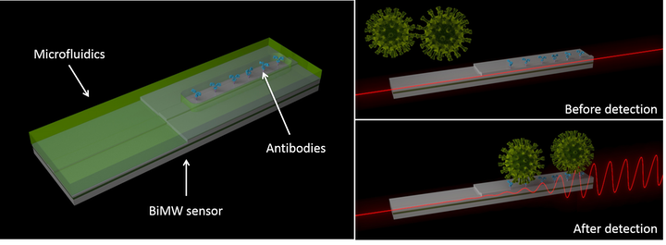

European photonics researchers are now developing a laser-based sensor that detects coronavirus at the earliest point of infection from a saliva or nasal swab in minutes. Responding to the European Commission’s express calls to tackle the coronavirus pandemic, the scientists are developing a new rapid, non-invasive optical biosensor demonstrator that will detect COVID-19 in humans as soon as it is present in the body.
Calling themselves CONVAT and coordinated at the Catalan Institute of Nano science and Nanotechnology (ICN2; Barcelona, Spain) the researchers have tested the demonstrators on patients’ fluid samples provided by Vall D´Hebrón Hospital in Barcelona and several other hospitals in Spain for other pathologies. Having already created six working laboratory demonstrators for other applications, the research team says the technology still needs further adaptation and testing but could be available in a year at the latest.
With the ability to diagnose in real-time with high specificity from a low concentration sample, the sensor is much more reliable than the coronavirus rapid-test finger-prick kit that detects if a person has had the coronavirus before and has since recovered.

RECOMMENDATION AND CONCLUSION
It's important that employees are protected from the virus, any non-essential work should be ceased and any workers that don't need to be in to help with the production of critical supplies should be sent home. In general, the government guidelines are advising people to stay at home for a three-week period, and this is particularly crucial if workers are experiencing any of the symptoms of COVID-19, no matter how mild.
But, for those who are still in work, it's important they are following health and safety guidelines to limit the spread of infection through asymptomatic individuals.
You can do this by imposing rules that ensure employees are always kept two meters apart, and wear gloves and facemasks if they are working among others. As COVID-19 is believed to be primarily transmitted by touching surfaces contaminated with the virus and then touching your eyes, nose or mouth, it's important you and your staff are covering these areas of skin. You will also need to provide plenty of hand washing facilities, including hand sanitizing stations where sinks and soap aren't available.
Also read and implement the government's advice for more guidance and support.
We are all being faced with a unique business challenge in one way or another but, when you work in engineering, you might be able to use your resources and skills to help tackle this pandemic. Whether you find inspiration from what other firms are doing, or you feel encouraged to help in another way, our healthcare system is sure to appreciate any assistance you can give.
Furthermore, sensors that can be operated at home like through phone applications should be created to detect the virus from the house to avoid the spread also smaller and cheaper ventilators should be created to help the masses of corona virus patients so that the need for building temporary hospitals would not arise or would be at a minimal rate.
CONCLUSION
Occupational hazards are risks accepted as consequences of a particular occupation.
There several types of occupational hazards but in this document it was more focused on biological hazard because coronavirus 2019 otherwise known as COVID-19 is a biological hazard. COVID-19 is an infectious disease caused by severe acute respiratory syndrome. The disease was first identified in December 2019 in Wuhan, the capital of China’s Hubei province, and has since spread globally, resulting in the ongoing 2019-20 coronavirus pandemic.
It can be spread through many ways that’s why social distancing has been encouraged in order to stop the spread of the disease.
The engineering industries are being encouraged to gear up and innovate as it tackles COVID-19. They can design, fabricate and manufacture equipment and facilities to help in curbing the virus.

REFERENCES
- https://en.wikipedia.org/wiki/Coronavirus_disease_2019
- https://interestingengineering.com/11-ways-engineers-are-helping-out-to-fight-against-the-pandemic
- https://www.google.com/url?q=https://marketbusinessnews.com/financial-glossary/occupational-hazards/&usg=AFQjCNF0CHYs-FciGNZ8LVKTtkmp9VLK_A
- https://www.google.com/url?q=https://en.m.wikipedia.org/wiki/Occupational_hazard&usg=AFQjCNEogKpBPdrKAlCGI5iTyScJpoFPTQ
- https://www.sensortips.com/featured/what-sensors-are-used-to-detect-the-coronavirus/

