Nwabineli Emelda Chisom
15/ENG05/016
Mechatronics engineering
ENG 510

ASSIGNMENT
- Differentiate between controlled and uncontrolled rectifier
- Differentiate between single phase half wave and single phase full wave rectifier
- Operational characteristics of a DIAC
- Operational characteristics of a TRIAC

DIFFERENCES BETWEEN CONTROLLED AND UNCONTROLLED RECTIFIER
- In an uncontrolled rectifier, once the SCR is triggered in ON state, it has to be manually shutdown by cutting off the source voltage while in a controlled rectifier the gate pulse supplied to the thyristor can be used to automatically put output into ON or OFF mode.
- The triggering circuit is not required in uncontrolled rectifier while in controlled rectifier, the triggering circuit is needed.

DIFFERENCES BETWEEN SINGLE PHASE HALF WAVE AND SINGLE PHASE FULL WAVE RECTIFIER

- Half Wave and Full Wave Rectifiers are the two categories of rectifier circuits. The crucial difference between Half Wave and Full Wave Rectifier is that a half wave rectifier converts only one-half cycle of the ac input supplied into pulsating dc signal. As against a full wave, rectifier converts both halves of the applied input signal into pulsating dc.

- Another major difference between the two is that the rectification efficiency of half wave rectifier is somewhat less as compared to the full wave rectifier.

- A circuit of half wave rectifier requires only 1 diode. While 2 or even 4 diodes are also utilized in the circuit of full wave rectifier.
- The fundamental ripple frequency in case of half wave rectifier is f i.e., supplied input frequency (50 Hz). While it is twice the supplied frequency i.e., 2f (100 Hz) in case of full wave rectifiers.
- A half wave rectifier has good voltage regulation. However, full wave rectifiers provide better voltage regulation as compared to half wave rectifiers.
- The ripple factor in case of half wave rectifier is more in comparison to the full wave rectifier. For half-wave rectifier, it is about 1.21 but for full wave rectifier, it is 0.482.
- The peak inverse voltage in case of half wave rectifier is equivalent to the maximum value of applied input voltage. While peak inverse voltage of full wave rectifier is twice the maximum value of applied input voltage.

OPERATIONAL CHARACTERISTICS OF A DIAC

Its looks like a letter Z due to symmetrical switching characteristics for each polarity of the applied voltage.
The diac performs like an open-circuit until its switching is exceeded. At that position the diac performs until its current decreases toward zero. Because of its abnormal construction, doesn’t switch sharply into a low voltage condition at a low current level like the triac or SCR, once it goes into transmission, the diac preserves an almost continuous –Ve resistance characteristic, that means, voltage reduces with the enlarge in current. This means that, unlike the triac and the SCR, the diac cannot be estimated to maintain a low voltage drop until its current falls below the level of holding current.

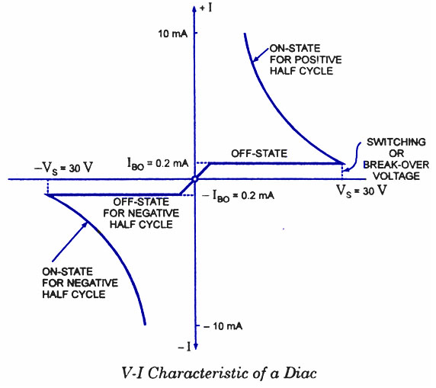
OPERATIONAL CHARACTERISTICS OF A TRIAC

The triac is designed with two SCRs which are fabricated in the opposite direction in a crystal. Operating characteristics of triac in the 1st and 3rd quadrants are similar but for the direction of flow of current and applied voltage.
The V-I characteristics of triac in the first and third quadrants are basically equal to those of an SCR in the first quadrant.
It can be functioned with either +Ve or –Ve gate control voltage but in typical operation generally the gate voltage is +Ve in first quadrant and -Ve in third quadrant.
The supply voltage of the triac to switch ON depends upon the gate current. This allows utilizing a triac to regulate AC power in a load from zero to full power in a smooth and permanent manner with no loss in the device control




