AFE BABALOLA UNIVERSITY KM 8.5
ADO EKITI, EKITI STATE
COLLEGE OF ENGINEERING
DEPARTMENT OF ELECTRICAL/ELECTRONICS ENGINEERING

DEVELOPMENT OF ENVIRONMENTAL HEALTH ENGINEER FACILITIES, EQUIPMENT, SENSORS AND PUBLIC HEALTH SYSTEMS FOR TACKLING COVID-19 PANDEMIC

PREPARED BY
OJEIKERE OHIKHATEEME .O.
17/ENG04/051

A TERM PAPER SUBMITTED TO THE
DEPARTMENT OF ELECTRICAL/ELECTRONICS ENGINEERING,
COLLEGE OF ENGINNERING, AFE BABALOLA UNIVERSITY,ADO EKITI

IN PARTIAL FULFILLMENT OF
ENG384; ENGINEERING LAW AND MANAGERIAL ECONOMICS

ABSTRACT
What started as an epidemic mainly limited to China then, now has become a truly global pandemic. There have now been over 1,018,948 confirmed cases and 53,211 deaths, according the John Hopkins University Covid-19 dashboard. Also more than 1,018,948 people have been infected with the novel virus, with significant outbreaks in the US, Italy and Spain, and 2,921 deaths in the UK, which collates information from national and international health authorities. The disease has been detected in more than 200 countries and territories, with Italy, the US and Spain experiencing the most widespread outbreaks outside of China. In the UK, there have been 33,718 confirmed cases and 2,921 deaths as of April 2.
Ultimately, we need to design creative, workable and effective responses that better balance protection from the virus with disruption to daily life. Instead, we have scientists with fantastically deep knowledge about the biology and epidemiology of viruses, and maybe about the cognitive tricks that lean us towards doing one action over another.
In conclusion, engineers can effectively provide help to the world at large by providing inventions such as
- Make shift hospitals
- Applications for online studies
- Sensor carmeras
- Applications to handle bulk of data in the society
As mentioned above, enginners are problem solvers and this pademic is aproblem that could be solved through enginneering solutions but we all have to work together to get throuht the pandemic.

TABLE OF CONTENTS
TITLE PAGE

ABSTRACT 2

TABLE OF CONTENTS 3

LIST OF FIGURES 4

CHAPTER 1 5

CHAPTER 2 8

CHAPTER 3 9

CHAPTER 4 15

CHAPTER 5 16

REFERENCES 17

LIST OF FIGURES
Figure Title Page
1 Doctors in make shift hospitals 11
- Drone transporting relief materials 12
3 Street cameras with heat sensors and solar power 13

CHAPTER 1
INTRODUCTION
THE CORONAVIRUS DISEASE 2019
On December 31, 2019, the World Health Organisation’s (WHO) China office recieved the first reports of a previously-unknown virus behind a vast number of pneumonia cases in Wuhan, a city in Eastern China with a population of over 11 million.
What started as an epidemic mainly limited to China then, now has become a truly global pandemic. There have now been over 1,018,948 confirmed cases and 53,211 deaths, according the John Hopkins University Covid-19 dashboard. Also more than 1,018,948 people have been infected with the novel virus, with significant outbreaks in the US, Italy and Spain, and 2,921 deaths in the UK, which collates information from national and international health authorities. The disease has been detected in more than 200 countries and territories, with Italy, the US and Spain experiencing the most widespread outbreaks outside of China. In the UK, there have been 33,718 confirmed cases and 2,921 deaths as of April 2.
The Chinese government responded to the initial outbreak by placing Wuhan and nearby cities under a de-facto quarantine encompassing roughly 50 million people in Hubei province. This quarantine is now slowly being lifted, as authorities watch to see whether cases will rise again. The US is now the new epicenter of the Covid-19 outbreak, becoming the first country to surpass China's total confirmed cases. As of April 3, the country has 245,573 confirmed infections and 6,058 deaths. In Italy, where the death toll surpassed that of China on March 19, the government took the unprecedented step of extending a lockdown to the entire country, shutting cinemas, theatres, gyms, discos and pubs and banning funerals and weddings. In the UK, the government has shut schools, pubs, restaurants, bars cafés and all non-essential shops.
On March 23, prime minister Boris Johnson put the UK under lockdown saying that police will now have the power to fine people who gather in groups of more than two or who are outside for non-essential reasons. People with the main coronavirus symptoms – a fever or dry cough – are required to stay at home for seven days while households in which at least one person is displaying symptoms should quarantine themselves for 14 days. Four days later the prime minister and health secretary Matt Hancock both tested positive for the virus – they are currently self-isolating while working on the UK's response.
On March 11 the WHO officially declared that the Covid-19 outbreak is a pandemic. "WHO has been assessing this outbreak around the clock and we are deeply concerned both by the alarming levels of spread and severity, and by the alarming levels of inaction," said its director-general Tedros Adhanom Ghebreyesus. Although the WHO designated Covid-19 a "public health emergency of international concern" (PHEIC) on January 30, it had been reluctant to call it a pandemic. "Pandemic is not a word to use lightly or carelessly. It is a word that, if misused, can cause unreasonable fear, or unjustified acceptance that the fight is over, leading to unnecessary suffering and death," Adhanom said.
Although popularly referred to as corona virus, on February 11, the WHO announced the official name of the disease: Covid-19. The virus that causes that disease is called Severe Acute Respiratory Syndrome Corona virus 2, or Sars-CoV-2 for short.
The disease appears to have originated from a Wuhan seafood market where wild animals, including marmots, birds, rabbits, bats and snakes, are traded illegally. Corona viruses are known to jump from animals to humans, so it’s thought that the first people infected with the disease – a group primarily made up of stallholders from the seafood market – contracted it from contact with animals.
The hunt for the animal source of Covid-19 is still unknown, although there are some strong contenders. A team of virologists at the Wuhan Institute for Virology released a detailed paper showing that the new coronaviruses' genetic makeup is 96 per cent identical to that of a corona virus found in bats, while a study published on March 26 argues that genetic sequences of corona virus in pangolins are between 88.5 and 92.4 per cent similar to the human virus. Some early cases of Covid-19, however, appear to have inflicted people with no link to the Wuhan market at all, suggesting that the initial route of human infection may pre-date the market cases.
The Wuhan market was shut down for inspection and cleaning on January 1, but by then it appears that Covid-19 was already starting to spread beyond the market itself. On January 21, the WHO Western Pacific office said the disease was also being transmitted between humans – evidence of which is apparent after medical staff became infected with the virus. Since then, evidence of widespread human-to-human transmission outside of China has been well established, making chances of containing the virus much harder.
The Corona virus disease 2019 (COVID-19) is an infectious disease caused by a severe acute respiratory syndrome; corona virus 2 (SARS-CoV-2). Common symptoms of this virus include fever, cough, and shortness of breath. Other symptoms may include muscle pain, diarrhea, sore throat, loss of smell, and abdominal pain. While the majority of cases result in mild symptoms, some progress to viral pneumonia and multi-organ failure. As of 5 April 2020, more than 1.2 million cases of have been reported in more than two hundred countries and territories, resulting in over 64,700 deaths. Thankfully, more than 247,000 people have recovered. The virus is mainly spread through/during close contact, and by small droplets produced when people cough, sneeze, or talk near others. These small droplets may be produced during breathing but the virus is not generally airborne and is said to be grounded. People may also contact COVID-19 by touching a contaminated surface and then placing their hands on their face. The virus can survive on surfaces up to 72 hours and is most contagious during the first three days after symptom onset. Although the spread of the symptoms may be possible before symptoms appear in later stages of the disease. The time from exposure to onset of symptoms is generally between two and fourteen days, with an average of five days. The standard method of diagnosis is by reverse transcription polymerase chain reaction (rRT-PCR) from a nasopharyngeal swab. The infection can also be diagnosed from a combination of symptoms, risk factors and a chest CT scan showing features of pneumonia.

Due to the outbreak of this virus, some recommended measures to prevent infection include frequent hand washing, social distancing or physical distancing (maintaining physical distance from others, especially from those with symptoms), covering coughs and sneezes with a tissue or inner elbow, and keeping unwashed hands away from the face. The use of masks is recommended for those who suspect they have the virus and their caregivers. Recommendations for mask use by the general public vary, with some authorities recommending against their use, some recommending their use, and others requiring their use. Currently, there is no vaccine or specific antiviral treatment for COVID-19. Management involves treatment of symptoms, supportive care, isolation, and experimental measures. The World Health Organization (WHO) declared the 2019–20 corona virus outbreak a Public Health Emergency of International Concern (PHEIC) on 30 January 2020, and a pandemic on 11 March 2020. Local transmission of the disease has been recorded in many countries across all six WHO regions.

CHAPTER 2
LITERATURE OVER VIEW
The corona virus outbreak has shown a bright light on the use of experts and scientific advice. In the UK the prime minister, Boris Johnson, is flanked by his chief scientist and chief medical officer when giving updates about his response to the outbreak, emphasizing that it is driven by scientific advice. Similarly, the Canadian prime minister, Justin Trudeau, has urged people to “trust in science” while Germany’s chancellor, Angela Merkel, has referred to “consensus among experts”.
But one of the silently asked questions is where the engineers in this are? Surely, as all hands are required on deck, we should check if there are engineering solutions that could help halt, slow or even eradicate the spread of the virus – from door handles that kill viruses to new ways of pressing lift buttons. In the UK, the government normally consults the Scientific Advisory Group for Emergencies (SAGE) in situations like this. So far, engineers have been relegated to a (respiratory) bit part: answering the sudden call to arms for 3D printing components for ventilators. But is this using engineering expertise to its full capacity? Engineers have designed safe traffic systems, effective security facilities and airport screening systems. If you want an expert to help you redesign parts of normal life, you’d do hard to beat them.
The obvious place to have engineering expertise would be on SAGE. However, there’s a problem: it’s SAGE not ESAGE or SEAGE, reflecting that science and engineering advice are both different and necessary. The name hasn’t stopped SAGE from calling on engineering experts in the past. But this time round, it seems clear that engineering is not part of the advisory system. SAGE for corona virus comprises two groups, one which draws on the epidemiology of historic pandemic flu, and one that focuses on the social science of public health. These groups feature experts across medicine, epidemiology and social sciences only. But engineers? Not likely, it seems. There are no dams here to fix … or are there? Clearly the infection needs to be contained, and allowed to trickle out in a controlled flow in order for the whole system to be managed safely into a less critical state. That sounds like an engineering challenge when critically looked at.
When we look at which countries have done relatively well in tackling the virus, there are signs of (electrical/computer) engineering at work. In South Korea it is reported that an app - Corona 100m - helped mobilize crowd sourced information on infections, both possible and actual. In China, part of the “effectiveness” in containing the deaths from the virus is reportedly due to the rapid construction of new hospitals. No country, however, has managed to deploy engineering solutions in a way that also helps day-to-day life continue in some safe way.
Where are the engineers?
Ultimately, we need to design creative, workable and effective responses that better balance protection from the virus with disruption to daily life. Instead, we have scientists with fantastically deep knowledge about the biology and epidemiology of viruses, and maybe about the cognitive tricks that lean us towards doing one action over another.

CHAPTER 3
METHODOLOGY
HOW ENGINEERS CAN CONTRIBUTE TO THE DEVELOPMENT OF ENVIRONMENTAL HEALTH FACILITIES, EQUIPMENT, SENSORS AND PUBLIC HEALTH SYSTEMS FOR TACKLING THE COVID-19 PANDEMIC
Engineers are diversified, multi-operational and thus can apply their knowledge to any problems in their community, national and world wide faced and find a solution. In the following chapters, how engineers can provide solutions to the covid-19 pandemic will be discussed and explained as much as possible.
Ways engineers can help fight corona virus
Manufacturers are racing against time to build new ventilators for a predicted surge in the number of corona virus patients. Companies from across the engineering spectrum have offered their assistance, and work is under way to build 30,000 devices. But what else can engineers do to help during this national and global crisis?
For some expert suggestions, a group of Professional Engineering readers were asked this question: “Apart from making ventilators, how could engineers help the fight against corona virus?” The answers were hugely encouraging, with many good ideas and willing helpers. They provide inspiration for potential volunteers and maybe even guidance for under-pressure officials, who could use this engineering expertise to help minimize the worst of the virus’ impact.
Of course, everyone should follow social distancing and other temporary rules. But with potentially months of restrictions ahead and the possibility of the outbreak stretching on, here are a few ways that engineers could help with facilities, equipments, sensors and public systems.
Prevention of the spread
With numbers of patients skyrocketing, stopping the spread of Covid-19 is an immediate concern. Multiple suggestions urged engineering companies to design, develop and manufacture more diagnostic kits, as well as improve logistics to distribute them quicker. Following criticism of the government’s comparatively low level of testing, one member suggested engineers could come up with “intelligent body temperature detectors at schools, supermarkets, etc” and install them at entrances and exits (and other strategic positions in these areas of mass population.
Other cutting-edge engineering that could help in the lowering of the infection rates would be the creation of cleaning solutions and material development with inbuilt anti-bacterial properties being developed into our design solutions.

Supporting health workers and providing solutions to minimal work spaces

More hospital spaces are needed for patients as the NHS comes under increasing strain. The Excel Centre in East London is being co-opted as a field hospital and could reportedly hold up to 4,000 patients. Following similar measures in China, readers suggested engineers could help build new hospitals, including by designing and manufacturing buildings using offsite construction. In response to that, an Italian design company has teamed up with the Massachusetts Institute of Technology to create prefabricated intensive care units (ICUs), to deal with escalating numbers of corona virus patients around the world.

Carlo Ratti Associati and the MIT Senseable City Lab are looking to address this growing need with ICUs built inside shipping containers, which can be joined together to create mobile field hospitals. They have teamed up with engineering firms, logistic experts and medical equipment suppliers, as part of a non-profit effort, to create the Connected Units for Respiratory Ailments, or CURA. These are designed to be as quick as a tent to put up, but as safe as a hospital with “biocontainment” – a series of safety practices to prevent the spread of disease.
The structure is quick to assemble and disassemble. Because it is made of shipping containers, it can be moved from epicenter to epicenter by road, rail and ship, within countries and from city to city around the world. There is no international standard requiring a set number of hospital beds per thousand of population, so there are huge differences between countries.
There is even more variation when it comes to ICU beds per 100,000 inhabitants. Italy, which has suffered the deadliest outbreak of the disease with almost 64,000 cases, has 12.5 critical care beds per 100,000 people.

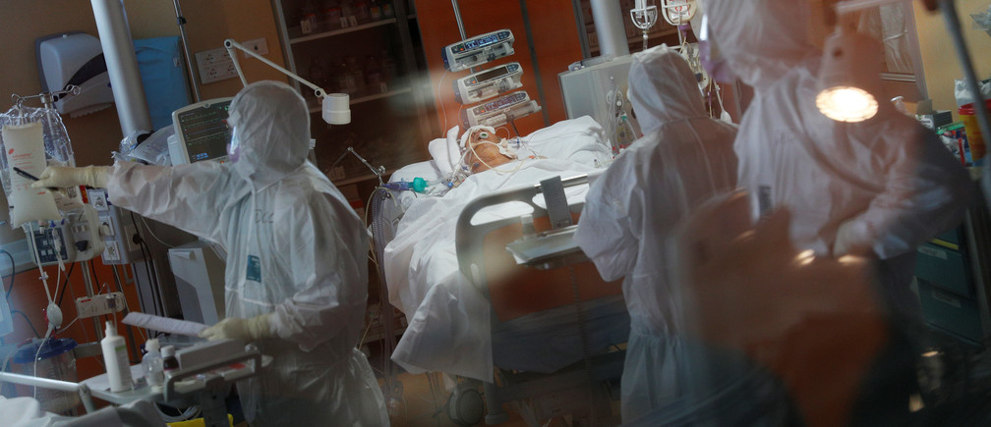

Figs 1 Doctors in make shift hospitals

Spread Stem knowledge
While pupils might have hoped for a break during school closures, teaching is ongoing. This could be a great opportunity to educate and inspire a future generation of engineers, as said by.
In other words, students should have a virtual school society that has an understandable interface and also have a user friendly interface that provides the necessary information to keep the students up to date with their curriculum and thus the students miss no year in their education.
“Help support education in Stem subjects to take the pressure from teachers, and provide some real-world examples to further engage our student population – of all ages – in what engineering can offer, and hopefully do something that is fun and real while they are learning in a virtual world,” Dave Hughes said.

‘Strengthen home industry’
This can be seen as an opportunity for the countries affected to provide opportunities for engineering companies to create and invent devices which in turn boost the economy.
Other members hoped the crisis will be a wake-up call about over-reliance on foreign imports. “Long term, the UK needs to think about what is manufactured here. Importing all your critical supplies only works if there isn't a crisis,” said Richard Goodfellow.
“My hope is that we can strengthen home industry, leaving us less reliant on foreign imports when we have so many untapped skills and resources in the UK,” said Paul W.

Prevention of future outbreaks
Engineers should carry out a full assessment of medical equipment that might be required in similar situations, said Rich Pearson, to ensure that designs can be open-sourced and shared with manufacturers when needed. The Industry itself should have a frank appraisal of its international activity to help prevent a repeat of this pandemic, said Paul Thurgood. Companies and employees might need to act differently in future.
“Hopefully this will be a wake-up call in many ways. This is an aggressive virus, but it could be that in future another one will show itself much more slowly, infecting many more people and with much more serious effects. Many of us engage far too much in international travel, with little regard for global warming. The virus is here in the UK solely because of this travel.”

Run the country
For Justin Greenhalgh, the best way engineers could help is simple: “By being put in charge of the country and making long-term decisions!”
Others suggested practical ways of helping the government, including giving guidance on statistical modeling and risk assessment, managing supply chains and assisting planning.
“Whole-system thinking is something that is often lacking in central government – partly because it can be really hard,” said Grant Tuff. “Engineers can help with this, in terms of understanding the implications of different options and choices for handling many aspects of the current situation.”
Use of drones to dispatch/deliver relief materials
As a lot of individuals and health care workers are afraid of delivering health care and carrying out testing, the use of drones can thus be very effective. The advantages of using drones are that drones have the ability to:
- Supply health care where humans cannot go to (i.e. the rural communities).
- Work for longer hours without rest as they just need human operators.
- Supply relief materials without contacting the virus.
- Test patients with no fear of contacting the virus.
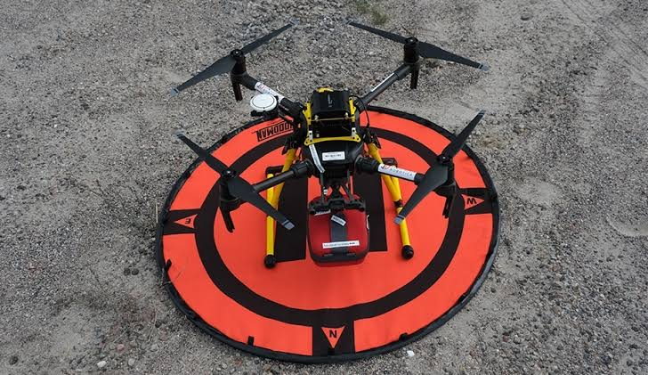
Fig 2 Drone transporting relief materials
Installation of cameras with heat sensors around street corners
As discovered, one of the symptoms that the virus has is high fever. With this discovery, cameras with installed temperature detectors could be invented with a unit in the society solely concentrated on the daily living of individuals. Since these cameras would be monitoring the living of individuals they would make no mistake when scanning the mass and detect those with the stated symptoms.
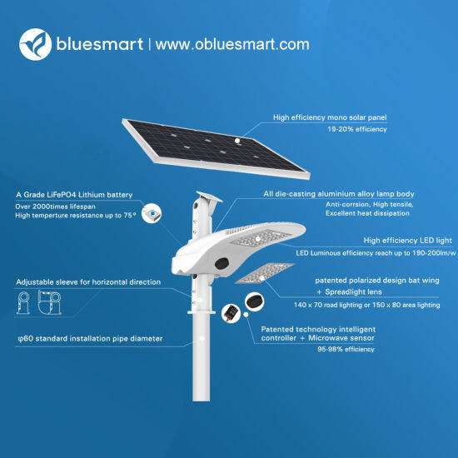Fig 3 Street cameras with heat sensors and solar power
Inventing of applications to collect accurate data from the government
With the alarming rate at which the virus spreads, data (records) about those infected, the mortality rate and much more is very important. The provision of an app that can accumulate, collect and calculate the given data is crucial. A typical example of data needed and calculated on a global scale is shown below.
Case fatality rates (%) by age and country
Age | 0–9 | 10–19 | 20–29 | 30–39 | 40–49 | 50–59 | 60–69 | 70–79 | 80-89 | 90+
China as of 11 February | 0.0 | 0.2 | 0.2 | 0.2 | 0.4 | 1.3 | 3.6 | 8.0 | 14.8
Denmark as of 3 April | 0.0 | 0.0 | 0.0 | 0.0 | 0.0 | 0.0 | 3.1 | 8.7 | 18.1 | 34.8
Italy as of 2 April | 0.0 | 0.0 | 0.1 | 0.4 | 0.8 | 2.3 | 8.0 | 21.8 | 30.9 | 28.7
Netherlands as of 3 April | 0.0 | 0.0 | 0.0 | 0.1 | 0.1 | 1.0 | 5.4 | 14.9 | 25.1 | 21.3
South Korea as of 3 April | 0.0 | 0.0 | 0.0 | 0.1 | 0.2 | 0.6 | 1.9 | 7.3 | 18.9
Spain as of 2 April | 0.0 | 0.2 | 0.2 | 0.3 | 0.4 | 1.0 | 3.2 | 10.6 | 21.5 | 25.9

Case fatality rates (%) by age in the United States
Age | 0–19 | 20–44 | 45–54 | 55–64 | 65–74 | 75–84 | 85+
United States as of 16 March | 0.0 | 0.1–0.2 | 0.5–0.8 | 1.4–2.6 | 2.7–4.9 | 4.3–10.5 | 10.4–27.3
Note: The lower bound includes all cases. The upper bound excludes cases that were missing data.
Table 1
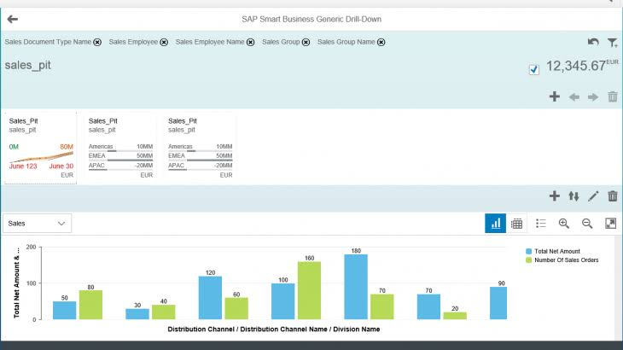
Table2

CHAPTER 4
CHALLENGES THAT COULD BE ENCOUNTERED WITH THESE SOLUTIONS IN NIGERIA
As a third world country, nigeria has a few problems which could also affect the world at large as we are all humans. Some of the challenges that may come up along the way are listed below
- Lack of effective management: Effective management of the devicees invented is key and necessary for effective eradication of the virus. If the equipments are not managed properly managed there the cost of management increases thus reducing the amount iof generated income.
- Lack of properly skilled labourers: those handling the equipmen need a sufficient knowledge on how to operate the devices and systems they are on charge of if ot the operation of the devices woud be poor and could thus lead to a malfunction in the systems. Gthe solution is to provide a training programe for thise that would be in charge of handling the equipent.
- Bad economy and infrastructures
- Lack of proper maintenance of equipment
- Poor quality of equipment: if the quality of the equipment made is poor, the operation of the equipment would beterrible and thus a poor performance.
- Negligence
- Unplanned or emergency maintenance to fix equipment breakdowns or other urgent work as it comes up
- Planned or preventative maintenance to keep systems/equipment running in peak condition
- Forecast and Prediction
- Contingency management
- Cost planning and control
- Effective time management

CHAPTER 5
CONCLUSION
In conclusion, engineers can effectively provide help to the world at large by providing inventions such as
- Make shift hospitals
- Applications for online studies
- Sensor carmeras
- Applications to handle bulk of data in the society
As mentioned above, enginners are problem solvers and this pademic is aproblem that could be solved through enginneering solutions but we all have to work together to get throuht the pandemic.

RECOMMENDATION
The following are recommended:
- Knowledge competence of the field
- Scientific knowledge
- Design creative skills:
- Interpretation of engineering drawing and symbols
- Proactive instinct of thinking and analytical minds in decision making:
- Good listening ability and skills in any engineering field
- Ability to match the best maintenance strategy with any production setup and its machines
- Data of the pandemic
- Good team spirit

REFERENCES
  - Epidemiologische situatie COVID-19 in Nederland 03 April 2020 (PDF) (Report) (in Dutch). Bilthoven: Rijksinstituut voor Volksgezondheid en Milie. 3 April 2020. Retrieved 3 April 2020.
  - ^ The updates on COVID-19 in Korea as of 3 April (Report). Korea Centers for Disease Control and Prevention. 3 April 2020. Retrieved 3 April 2020.
  - ^ Actualización nº 64. Enfermedad por el coronavirus (COVID-19) (PDF) (Report) (in Spanish). Ministerio de Sanidad, Consumo y Bienestar Social. 2 April 2020. Retrieved 3 April 2020.
  - ^ CDC COVID-19 Response Team (18 March 2020). "Severe Outcomes Among Patients with Coronavirus Disease 2019 (COVID-19)—United States, February 12 – March 16, 2020". Morbidity and Mortality Weekly Report. Centers for Disease Control. 69 (12): 343–346. doi:10.15585/mmwr.mm6912e2. PMID 32214079. Archived from the original on 22 March 2020. Retrieved 22 March 2020.
  - ^ "BSI open letter to Government on SARS-CoV-2 outbreak response". immunology.org. British Society for Immunology. Archived from the original on 14 March 2020. Retrieved 15 March 2020.
  - ^ "Can you get coronavirus twice or does it cause immunity?". The Independent. 13 March 2020. Archived from the original on 14 March 2020. Retrieved 15 March 2020.
  - ^ "They survived the coronavirus. Then they tested positive again. Why?". Los Angeles Times. 13 March 2020. Archived from the original on 14 March 2020. Retrieved 15 March 2020.

