A TERM PAPER ON
ENGINEERING STRATEGIES FOR HANDLING COVID-19 FOR ENVIROMENTAL HEALTH AND ECONOMIC HEALTH AND ECONOMIC SUSTAINABILITY

PREPARED BY
IWATT ENOBONG UDO.
MATRIC NUMBER: 18/ENG04/080

SUBMITTED TO
ENGR. OYEBODE OLUWADARE JOSHUA
DEPARTMENT OF CIVIL ENGINEERING
COLLEGE OF ENGINEERING, AFE BABALOLA UNIVERSITY, ADO-EKITI, NIGERIA.
IN PARTIAL FULFILMENT OF THE REQUIREMENT FOR THE AWARD OF BACHELOR OF ENGINEERING DEGREE(B.ENG) IN ELECTRICAL/ELECTRONICS ENGINEERING.

13TH APRIL, 2020.

ABSTRACT

Modern medicine and healthcare rely heavily on engineering to deliver improved prevention, diagnosis and treatment of illness. These technologies are vital to the delivery of efficient health services through the National Health Service (NHS). However, in the health sector the contribution of engineering is often hidden. This paper looks at key areas of medical science and technology, specific issues within healthcare and medicine and uses examples to show the contribution of engineering in each area, and to highlight its contribution to the battle with the covid-19 pandemic.Our digital infrastructure needs strengthening to deal with the impact of COVID-19 and future public health crises; Better integration of Artificial Intelligence in to the public health response should be a priority; Analysis of big data relating to citizens' movement, disease transmission patters and health monitoring could be used to aid prevention measures. In recent years, the world has witnessed the rise of SARS, Zika virus, Ebola and now COVID-19. Epidemics are a rising threat. Cities across the world have made infrastructure innovation a priority to safeguard their physical systems so they can stay robust and antifragile during natural disasters such as earthquakes, tsunami and hurricanes. But pandemics have shown that these methods aren’t enough when it comes to ensuring connectivity and accessing our society during biological disasters.
Much remains unknown about how SARS-CoV-2, the virus that causes COVID-19, spreads through the environment. A major reason for this is that the behaviors and traits of viruses are highly variable—some spread more easily through water, others through air; some are wrapped in layers of fatty molecules that help them avoid their host's immune system, while others are "naked." This makes it urgent for environmental engineers and scientists to collaborate on pinpointing viral and environmental characteristics that affect transmission via surfaces, the air and fecal matter, this paper will highlight engineering contribution in the effort to overcome the covid-19 pandemic.

TABLE OF CONTENTS
Contents
ABSTRACT 2
CHAPTER 1 4
INTRODUCTION 4
1.1 ENGINEERING IN MEDICINE 4
1.2 COVID-19/CORONAVIRUS 5
CHAPTER 2 6
LITERATURE REVIEW 6
2.1 ELECRTRICAL/ELECTRONIC ENGINNERING IN MEDICINE 6
2.2 MEDICAL ELECTRONICS APPLICATIONS IN ENGINEERING 6
2.3 ENGINEERING INVOLVEMENT IN THE COVID-19 PANDEMIC 12
2.4 ENGINEERINGS MOST NOTABLE CONTRIBUTION TO THE COVID-19 PANDEMIC 13
2.5 Roles for engineers in the covid-19 pandemic preparedness and response. 16
2.6 IMPORTANCE OF ENGINEERING IN HANDLING A PANDEMIC 21
2.7 WAYS ENGINEERING CAN BE APPLIED IN THE MEDICAL FIELD 21
CHAPTER 3 24
METHODOLOGY 24
Research Methods 24
CHAPTER 4 25
CONCLUSION AND RECOMMENDATIONS 25
CHAPTER 5 26
REFERENCE 26

CHAPTER 1

INTRODUCTION

1.1 ENGINEERING IN MEDICINE

The practice of medicine is no longer an independent arena. The art of medicine is exclusively exposed through its inherent interdisciplinary nature. Research scientists continue to elegantly discover what exists within various diseases; they inform the biomedical community of what already exists. Engineers utilize this information to create that which is yet to exist ; they develop novel tools that can be implemented into clinical practice. And the physician of the future holds the honorable responsibility of bridging the gap between these once distant worlds. A physician of the future connects the dots, and pushes the limits of what we can offer patients. A physician of the future constantly searchers for the answers through an interdisciplinary approach involving bioengineers and scientists. Bioinformatics and open access medical data has ushered in an era of medical practice infused with information unseen hitherto. And now, the responsibility to formulate solutions to unresolved clinical problems rests within the collaborative efforts of the biomedical community.
When it comes to medical field the primary goal is to improve the health of people. Doctors have the knowledge of human body. They know what is good for a person and what not. But to build anything, you need engineers.
Electronic Engineers can develop and build new gadgets that can help people improve their health. Software Engineers can write software that uses algorithms to analyze massive amount of health information and generate results that help people and doctors in making healthy decisions. Plus making health information readily available using cloud, is something that is being done these days. In India especially.Chemical engineers can contribute to development and testing of new drugs and medicines. Same goes for genetic engineers.And wherever you can find application of robotics in medical field, mechanical engineers also kick in.
Engineering is everywhere. Even in medical field.

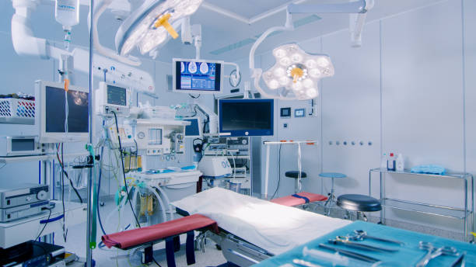
Figure 1: A modern operating room.

1.2 COVID-19/CORONAVIRUS

Coronavirus disease 2019 (COVID-19) is an infectious disease caused by severe acute respiratory syndrome coronavirus 2 (SARS-CoV-2). The disease was first identified in December 2019 in Wuhan, the capital of China's Hubei province, and has since spread globally, resulting in the ongoing 2019–20 coronavirus pandemic. Common symptoms include fever, cough, and shortness of breath. Other symptoms may include fatigue, muscle pain, diarrhea, sore throat, loss of smell, and abdominal pain. The time from exposure to onset of symptoms is typically around five days, but may range from two to fourteen days. While the majority of cases result in mild symptoms, some progress to viral pneumonia and multi-organ failure. As of 12 April 2020, more than 1.83 million cases of COVID-19 have been reported in 210 countries and territories,^{[15]} resulting in more than 113,000 deaths. More than 420,000 people have recovered, although there may be a possibility of reinfection. The virus is mainly spread between people during close contact, often via small droplets produced during coughing, sneezing, or talking. While these droplets are produced when breathing out, they usually fall to the ground or onto surfaces rather than being infectious over large distances. People may also become infected by touching a contaminated surface and then their face. The virus can survive on surfaces for up to 72 hours. It is most contagious during the first three days after onset of symptoms, although spread may be possible before symptoms appear and in later stages of the disease. The standard method of diagnosis is by real-time reverse transcription polymerase chain reaction (rRT-PCR) from a nasopharyngeal swab. Chest CT imaging may also be helpful for diagnosis in individuals where there is a high suspicion of infection based on symptoms and risk factors but is not recommended for routine screening. Recommended measures to prevent infection include frequent hand washing, maintaining physical distance from others (especially from those with symptoms), covering coughs and sneezes with a tissue or inner elbow, and keeping unwashed hands away from the face. The use of masks is recommended for those who suspect they have the virus and their caregivers. Recommendations for mask use by the general public vary, with some authorities recommending against their use, some recommending their use, and others requiring their use. Currently, there is no vaccine or specific antiviral treatment for COVID-19. Management involves treatment of symptoms, supportive care, isolation, and experimental measures. The World Health Organization (WHO) declared the 2019–20 coronavirus outbreak a Public Health Emergency of International Concern (PHEIC) on 30 January 2020 and a pandemic on 11 March 2020. Local transmission of the disease has been recorded in many countries across all six WHO regions.
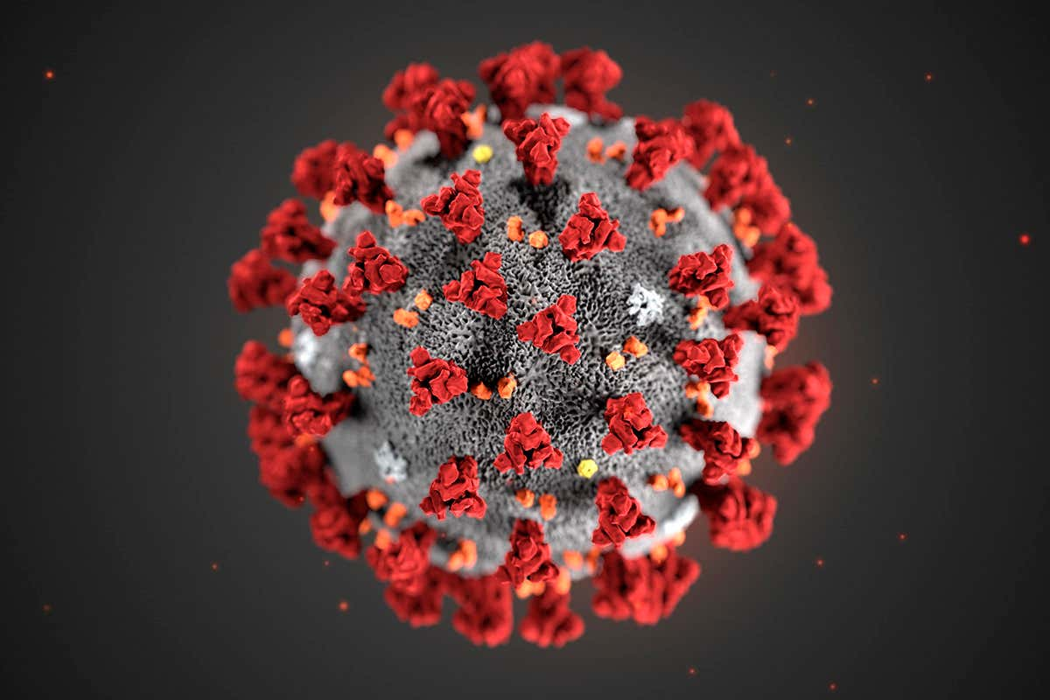
Figure 2: the coronavirus.

CHAPTER 2

LITERATURE REVIEW

2.1 ELECRTRICAL/ELECTRONIC ENGINNERING IN MEDICINE
In an era of electronic engineering, we are using electronics for various applications in medical electronics, by that we are able to modify the medical treatment. Non medical professionals may also monitor the health problems by the use of easy medical electronics. Below are the engineering applications which will be designed for medical electronics. These applications made medical field very simple and perfect identification of diseases. Medical electronics are most widely developing fields of this era. Medical electronics are finding cures for almost all diseases and to implement treatment. By using medical electronics doctors and surgeons can do medical examinations in a very smart way. Medical electronics provides sophisticated equipment with precision. A medical electronics professional is the person who deals with the operation of these medical electronics applications. Without medical electronics, it will be difficult for doctors to identify particular disease with which a person is suffering.

2.2 MEDICAL ELECTRONICS APPLICATIONS IN ENGINEERING

Some Medical electronics applications in engineering includes the following devices;

Blood gas analyzer
The best application of electronics in the medical field is gas analyzer. It is used to calculate the pressure of the chemical elements like carbon monoxide, nitrogen, oxygen in blood. By analyzing results we able to understand if any disorder in blood, particularly after we feel sick quite 2days. By exploiting results we are able to observe if any disorder when we feel sickness within the basic level solely within the home. It is often enforced as medical electronics projects. Blood collected from the person is introduced within the chemical device strip that has particle selective electrodes, by exploitation by device amplifiers and analog electronic device, the results are going to be shown in a digital manner with ADC for a microcontroller. Then the output is going to be displayed within the digital display module in terms of millimeters of mercury (mmHg), kilopascals (kPa), typical values for the carbon monoxide and dioxide measure thirty four(34) to thirty five (35) mm Hg , which of Oxygen in between eighty(80) to ninety (90) mm Hg.
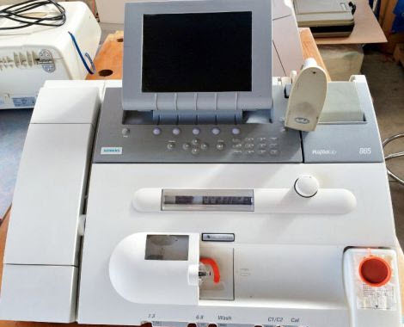
Figure 3: Blood Gas Analyzer.
- Blood Glucose Monitor
Blood glucose monitor is used to calculate glucose level of diabetic patients. These devices are often designed as medical electronic projects. The working of blood glucose monitor is, when a little drop of blood is placed on the chemical strip, the strip has sensors to live content of various chemical components, within seconds it will calculate the amount of glucose in the blood and displays by using a LED display.
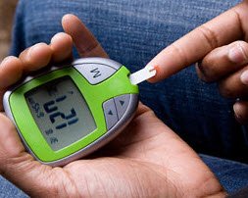
Figure 4: Blood Glucose Monitor.

It is very helpful to observe sugar levels with less prices and straight forward approach. It is a relief to a heap of diabetic patients. Making of Blood Glucose Monitor is easy by usual material which are available in the market.

- Brain Wave Machine
Brain wave machine is one type of instrument in medical electronics which is used to record the electrical activity of the scalp with Electroencephalography by firing of neurons within the brain. It processes the data that has taken from the electrodes which are placed on the scalp and can be displayed within the screen. It is helpful in the treatment of disorders of brains like sleeping disorder, brain death, and mental unhealthiness, also in emergency units at hospitals. These types of electronic devices are used in the medical field in the treatment of mental issues.
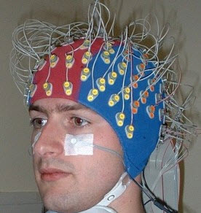
Figure 5: Brain Wave Machine.

- Electronic Cardiac Monitor
The Electronic Cardiac Monitor is used in all medical electronics applications. This medical electronic device is used to display the electrical and pressure waveforms of the cardiac system. By inserting specific electrodes on the various elements of the body we can get ECG of the cardiac system. It will observe irregular activity within the cardiac system and heart issues. It is used throughout medical treatment and especially while surgery.
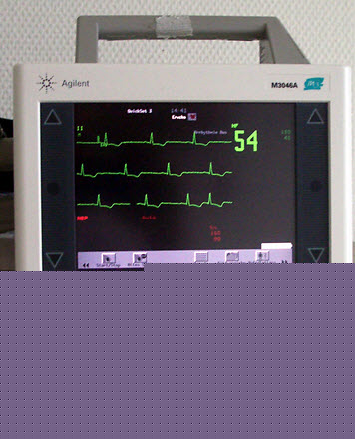
Figure 6: Electronic Cardiac Monitor.
- Digital Thermometers
The digital thermometers are used to sense the temperature of the body and these devices are portable, have permanent probes, and a convenient digital display. These devices are used in different industries to control processes in scientific research, the study of weather and in medicine.
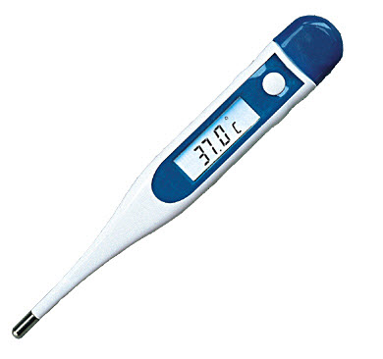
Figure 7: Digital Thermometer.

- IR Thermometers
IR thermometer is used to measure the temperature by detective work with radiation generated by the body. These devices are often used in airports for defectively knowing the condition of passenger’s health from a distance to observe the diseases like viral hemorrhagic fever like EBOLA, SAARC etc. This system consists of a lens to focus the infrared (IR) energy onto a target body, and detects the energy, and displayed in the form of electrical signal which will be displayed in units of temperature.
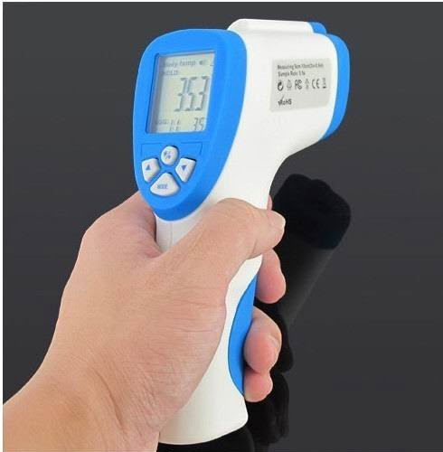
Figure 8: IR Thermometer.
- Defibrillator
Defibrillator is used in emergency conditions like heart attack occurs. It affects the rhythm of the heart such as ventricular fibrillation, cardiac arrhythmia and pulseless ventricular tachycardia. The working procedure of the Defibrillator involves, when the electric shock delivers to the heart, it causes depolarization of the muscles of the heart and regenerates normal conduction of the electrical pulse of the heat. There are different types of defibrillators include implanted, trans venous and external defibrillators
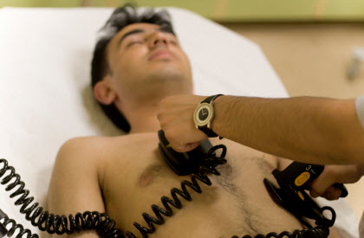
Figure 9: Defibrilator.

- Sphygmomanometer
The sphygmomanometer is a device used to measure blood pressure(BP), composed of an inflatable cuff to control blood flow and a mercury to measure the pressure.The standard unit of measurement of BP is millimeters of mercury (mmHg) as directly measured with a manual sphygmomanometer. These devices are classified into two types they are Mercury Sphygmomanometers and Aneroid Sphygmomanometers.
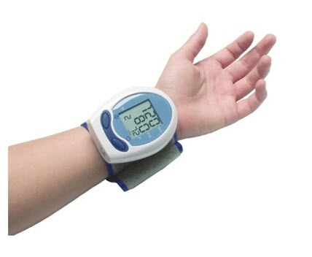
Figure 10: Sphygmomanometer.
- MRI (Magnetic Resonance Imaging)
The medical resonance imaging technique is used in radiology, to review the natural object of inner elements of the body. They use strong magnetic fields to make pictures of the body. Magnetic resonance imaging includes a big selection of applications in diagnosing and there calculable to be over scanners in use worldwide. Magnetic resonance imaging has an effect on identification and treatment in several specialties, though the effect on improved health outcomes is unsure.
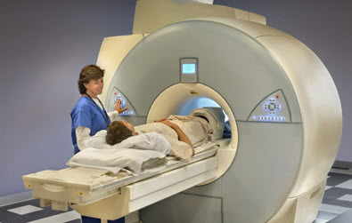
Figure 11: MRI Machine .
Since magnetic resonance imaging doesn’t use any radiation its use is usually recommended in preference to CT once either modality might yield a similar information. Image resonance is normally a security technique, however the amount of incidents inflicting patient damage has up. Contraindications to magnetic resonance imaging body most tube-shaped structure implants and cardiac pacemakers, shell gold and foreign bodies within the orbits. The protection of magnetic resonance imaging throughout the primary trimester of physiological condition is unsure; however, it’s going to be desirable to different choices. The sustained increase in demand for magnetic resonance imaging among the attention trade has died to considerations concerning price effectiveness and other medical specialty.

- Stethoscope
The stethoscope is an audio medical device for listening to the internal sounds of the human body or an animal. It is frequently used to hear the sounds of the lung and heart. It is also used to listen to intestines and blood flow in veins and arteries. It is used In combination with a sphygmomanometer for measurements of blood pressure. Stethoscopes can also be used to check scientific vacuum chambers for leaks, and for various other small-scale acoustic monitoring tasks.
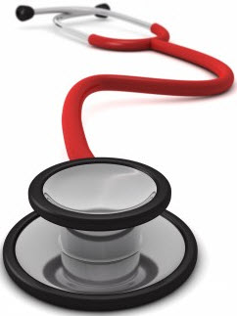
Figure 12: Stethoscope.

2.3 ENGINEERING INVOLVEMENT IN THE COVID-19 PANDEMIC
As the COVID-19 pandemic spreads around the world, it is straining medical systems and supplies, and changing daily life as people practice social distancing, schools close, and organizations tell their employees to work from home. Medical professionals are on the frontlines in the fight against COVID-19 as they care for patients and work to create a vaccine. These unprecedented times have left other professionals wondering what they can do? How can they contribute to help society through this pandemic? Every profession has a role to play, and they’re probably more effective when they’re working in concert with others, and among engineers there are many ways in which the engineering community can contribute during this pandemic—from manufacturing supplies for frontline medical workers, to ensuring that essential services continue to serve. . For example, conducting research to adapt a hand-held, portable technology to detect whether someone carries the corona virus that causes COVID-19.

2.4 ENGINEERINGS MOST NOTABLE CONTRIBUTION TO THE COVID-19 PANDEMIC
THE VENTILATOR
A ventilator is a machine that provides mechanical ventilation by moving breathable air into and out of the lungs, to deliver breaths to a patient who is physically unable to breathe, or breathing insufficiently. Modern ventilators are computerized microprocessor controlled machines, but patients can also be ventilated with a simple, hand-operated bag valve mask. Ventilators are chiefly used in intensive care medicine, home care, and emergency medicine (as standalone units) and in anesthesiology (as a component of an anesthesia machine). Ventilators are sometimes called respirators, a term commonly used for them in the 1950s (particularly the "Bird respirator”). However, in contemporary hospital and medical terminology, a respirator is a protective face mask.
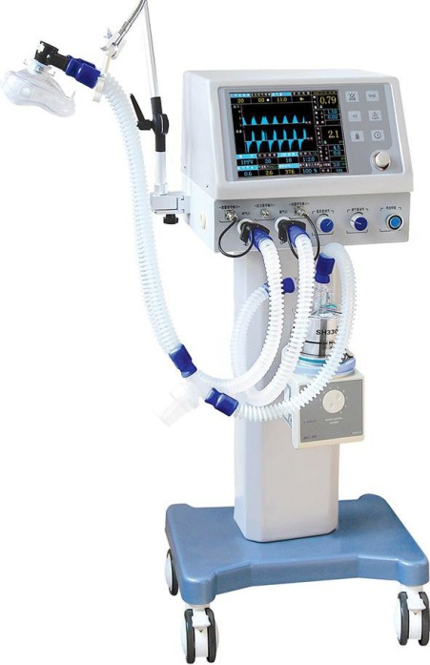
Figure 14: A respiratory Ventilator.
FUNCTION OF A VENTILATOR
In its simplest form, a modern positive pressure ventilator consists of a compressible air reservoir or turbine, air and oxygen supplies, a set of valves and tubes, and a disposable or reusable "patient circuit". The air reservoir is pneumatically compressed several times a minute to deliver room-air, or in most cases, an air/oxygen mixture to the patient. If a turbine is used, the turbine pushes air through the ventilator, with a flow valve adjusting pressure to meet patient-specific parameters. When over pressure is released, the patient will exhale passively due to the lungs' elasticity, the exhaled air being released usually through a one-way valve within the patient circuit called the patient manifold.
Ventilators may also be equipped with monitoring and alarm systems for patient-related parameters (e.g. pressure, volume, and flow) and ventilator function (e.g. air leakage, power failure, mechanical failure), backup batteries, oxygen tanks, and remote control. The pneumatic system is nowadays often replaced by a computer-controlled turbo pump.
Modern ventilators are electronically controlled by a small embedded system to allow exact adaptation of pressure and flow characteristics to an individual patient's needs. Fine-tuned ventilator settings also serve to make ventilation more tolerable and comfortable for the patient. In Canada and the United States, respiratory therapists are responsible for tuning these settings, while biomedical technologists are responsible for the maintenance. In the United Kingdom and Europe the management of the patient's interaction with the ventilator is done by critical care nurses.
The patient circuit usually consists of a set of three durables, yet lightweight plastic tubes, separated by function (e.g. inhaled air, patient pressure, exhaled air). Determined by the type of ventilation needed, the patient-end of the circuit may be either noninvasive or invasive.
Noninvasive methods, such as continuous positive airway pressure (CPAP) and non-invasive ventilation, which are adequate for patients who require a ventilator only while sleeping and resting, mainly employ a nasal mask. Invasive methods require intubation, which for long-term ventilator dependence will normally be a tracheotomy cannula, as this is much more comfortable and practical for long-term care than is larynx or nasal intubation.
HISTORY OF VENTILATORS
The history of mechanical ventilation begins with various versions of what was eventually called the iron lung, a form of noninvasive negative pressure ventilator widely used during the polio epidemics of the twentieth century after the introduction of the "Drinker respirator" in 1928, improvements introduced by John Haven Emerson in 1931, and the Both respirator in 1937. Other forms of noninvasive ventilators, also used widely for polio patients, include Biphasic Cuirass Ventilation, the rocking bed, and rather primitive positive pressure machines.
In 1949, John Haven Emerson developed a mechanical assister for anaesthesia with the cooperation of the anaesthesia department at Harvard University. Mechanical ventilators began to be used increasingly in anaesthesia and intensive care during the 1950s. Their development was stimulated both by the need to treat polio patients and the increasing use of muscle relaxants during anaesthesia. Relaxant drugs paralyse the patient and improve operating conditions for the surgeon but also paralyse the respiratory muscles.
In the United Kingdom, the East Radcliffe and Beaver models were early examples. The former used a Sturmey-Archer bicycle hub gear to provide a range of speeds, and the latter an automotive windscreen wiper motor to drive the bellows used to inflate the lungs.^{[5]} Electric motors were, however, a problem in the operating theatres of that time, as their use caused an explosion hazard in the presence of flammable anaesthetics such as ether and cyclopropane. In 1952, Roger Manley of the Westminster Hospital, London, developed a ventilator which was entirely gas-driven and became the most popular model used in Europe. It was an elegant design, and became a great favourite with European anaesthetists for four decades, prior to the introduction of models controlled by electronics. It was independent of electrical power and caused no explosion hazard. The original Mark I unit was developed to become the Manley Mark II in collaboration with the Blease company, which manufactured many thousands of these units. Its principle of operation was very simple, an incoming gas flow was used to lift a weighted bellows unit, which fell intermittently under gravity, forcing breathing gases into the patient's lungs. The inflation pressure could be varied by sliding the movable weight on top of the bellows. The volume of gas delivered was adjustable using a curved slider, which restricted bellows excursion. Residual pressure after the completion of expiration was also configurable, using a small weighted arm visible to the lower right of the front panel. This was a robust unit and its availability encouraged the introduction of positive pressure ventilation techniques into mainstream European anesthetic practice.
The 1955 release of Forrest Bird's "Bird Universal Medical Respirator" in the United States changed the way mechanical ventilation was performed, with the small green box becoming a familiar piece of medical equipment.^{[6]} The unit was sold as the Bird Mark 7 Respirator and informally called the "Bird". It was a pneumatic device and therefore required no electrical power source to operate.
In 1965, the Army Emergency Respirator was developed in collaboration with the Harry Diamond Laboratories (now part of the U.S. Army Research Laboratory) and Walter Reed Army Institute of Research. Its design incorporated the principle of fluid amplification in order to govern pneumatic functions. Fluid amplification allowed the respirator to be manufactured entirely without moving parts, yet capable of complex resuscitative functions. Elimination of moving parts increased performance reliability and minimized maintenance. The mask is composed of a poly(methyl methacrylate) (commercially known as Lucite) block, about the size of a pack of cards, with machined channels and a cemented or screwed-in cover plate. The reduction of moving parts cut manufacturing costs and increased durability.
The bistable fluid amplifier design allowed the respirator to function as both a respiratory assistor and controller. It could functionally transition between assistor and controller automatically, based on the patient's needs. The dynamic pressure and turbulent jet flow of gas from inhalation to exhalation allowed the respirator to synchronize with the breathing of the patient.
Intensive care environments around the world revolutionized in 1971 by the introduction of the first SERVO 900 ventilator (Elema-Schönander). It was a small, silent and effective electronic ventilator, with the famous SERVO feedback system controlling what had been set and regulating delivery. For the first time, the machine could deliver the set volume in volume control ventilation.
Ventilators used under increased pressure (hyperbaric) require special precautions and few ventilators can operate under these conditions. In 1979, Sechrist Industries introduced their Model 500A ventilator which was specifically designed for use with hyperbaric chambers.
PRINCIPLE OF VENTILATORS
Breathe in, breathe out
The principal function of a ventilator is to pump or blow oxygen-rich air into the lungs; this is referred to as “oxygenation”. Ventilators also assist in the removal of carbon dioxide from the lungs, and this is referred to as “ventilation”.
One basic type of ventilator is the Bag Valve Mask (BVM). The BVM, also known as the Ambu Bag, is operated manually by a person squeezing a self-inflating bladder. This is an essential tool for ambulance crews, first responders and critical care units. It is light, compact and easy to use.
However, in situations where a steady and controlled air exchange (oxygen in, carbon dioxide out) is needed, mechanical ventilators are required. These look like a quintessential medical product.

2.5 Roles for engineers in the covid-19 pandemic preparedness and response.
The worldwide impact of the COVID-19 virus has been sudden and dramatic. While the immediate effects are seen in terms of the humanitarian crisis and the threat to the ability of all health care systems to function - the social, political and economic effects of this virus are also profound. Engineering has a huge role in both to play in both the short term and in the immediate future. In response to cases of COVID-19 rising worldwide, the World Health Organization has recently warned that the pandemic is "accelerating." Thankfully, it does say the trajectory can still be changed. That’s why the global scientific community is pulling together in order to develop viable treatments and vaccines to combat the spread of the infectious disease. Much in the same vein, the world is in desperate need of ingenious solutions to widespread issues such as supply shortages of medical equipment.
Some notable engineering contributions
Here are some ways the engineering community has stepped up to the challenge.
1. Italy's reverse-engineered 3D-printed ventilators
After the outbreak soared to uncontrollable levels in Italy this month, Dr Daniele Macchini famously wrote that a scarcity in the medical equipment required to treat patients means that "every ventilator becomes like gold." That's why a group of volunteers in Italy, including Massimo Temporelli, founder of The FabLab in Milan, decided to help out by making 3D-printed versions of the sorely-needed item.
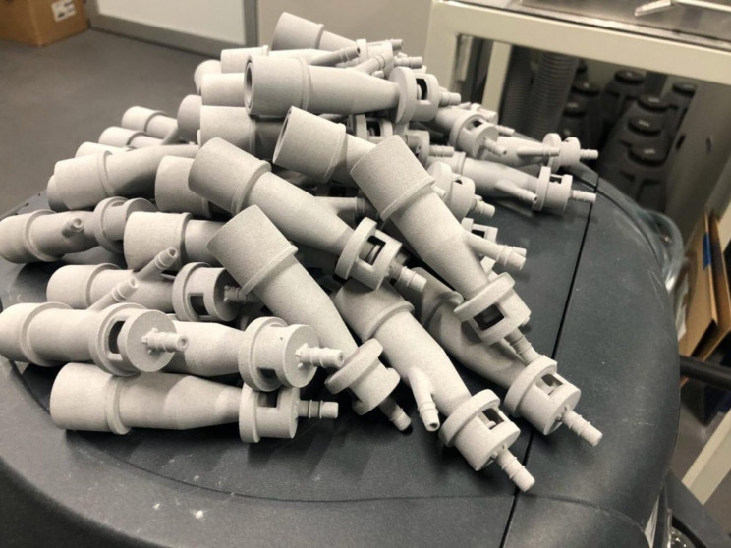
Figure 12: 3D ventilators.
Despite the possibility of being sued by the medical technology company that manufactures a specific ventilator, the volunteers reverse-engineered the piece that was required and were able to print it in a matter of hours to help save lives.

2. The snorkeling mask ventilator
Only a few days after helping an Italian hospital by playing their part in fixing the broken supply chain for ventilators, the same group of engineers shared a 3D printed design for an adapter that converts snorkel masks into ventilators. Through the use of the adapter, a converted "Easybreath" snorkel mask becomes a functional C-PAP mask for oxygen therapy — a treatment that is critical for the recovery of people with severe cases of COVID-19.
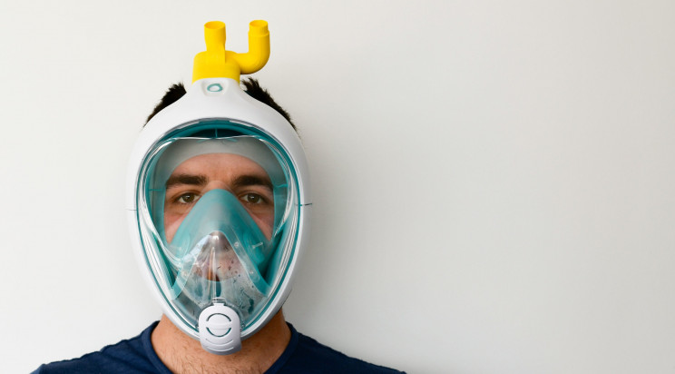
Figure 13: The Snorkeling mask ventilator.
As the volunteer company, called Isinnova, told Futurism, "Easybreath" snorkel-maker Decathlon "was immediately willing to cooperate" on the design. As Isinnova points out, however, "neither the mask nor the link are certified and their use is subject to a situation of mandatory need."

3. Robots helping populations affected by the pandemic worldwide
Countries throughout the world are deploying robots to help amidst the growing crisis. In Bangkok, Chulalongkorn University has teamed up with Advanced Info Service (AIS) to develop robots that utilize 5G technology to monitor coronavirus patients while keeping doctors in the loop from afar. As Business Insider points out, the city of Wuhan, where the outbreak started, is using robots to spray disinfectant throughout urban spaces.
- Chulalongkorn University has joined forces with Advanced Info Service (AIS) to develop smart robots with 5G tech to monitor and take care of coronavirus patients and those under monitoring for the first time in Thailand. #BangkokPost #Business https://t.co/iGLYT1PCUU
— Bangkok Post (@BangkokPostNews) March 8, 2020
Other use cases include robots for delivering packages to sick people, robots that take people's temperatures and hand out sanitizing gel, robots that spread awareness on COVID-19, robot assistant doctors, and even robot chefs that prepare food while minimizing human contact.

4. Coronavirus isolation pods made by Mexican engineer
Special fully-sealed isolation pods were recently created by Mexican engineer Fernando Aviles for safely transporting COVID-19 patients. The specially-designed pods are equipped with air pumps that create a negative pressure within the sealed space.
The negative pressure means that, even if the plastic lining of the pod is torn during the transfer of a patient, any fluids will remain inside the isolation pod — an ingenious method for stopping the spread of the infectious disease amongst healthcare workers.

5. UV light-emitting disinfection robots
UV light disinfectant robots weren't specifically developed for the COVID-19 pandemic and they haven't been definitively proven to be effective at eradicating the virus (SARS COV-2) from surfaces — and yet, demand has skyrocketed to the point that companies are sending truckloads of the machines to different countries worldwide.
Per Juul Nielsen, chief executive of UVD Robots, a subsidiary of Blue Ocean Robotics, told the BBC that "coronavirus is very similar to other viruses like MERS and SARS. And we know that they are being killed by UV-C light."
Hospitals worldwide seem to be trusting that this is true, as demand is sky-high for the robots which use eight light bulbs to emit concentrated UV-C ultraviolet light over hospital surfaces. This type of light has been shown to destroy viruses, bacteria, and other harmful microbes by damaging their DNA and RNA so that they can no longer multiply.

6. Oxford University and King's College prototype ventilator for mass production
Engineers, anesthetists, and surgeons from the University of Oxford and King's College London are working on one of the many new ventilator designs needed to help patients with severe conditions. Though it is less advanced than other existing ventilator designs, it has been designed for its quick construction and deployment time.
- Simple, robust, effective - here’s the OxVent in action pic.twitter.com/3K4Mkpa8w9
— OxVent (@OxVent) March 21, 2020
As a University of Oxford statement on the "OxVent" project highlights, "by pooling available expertise from
inside and outside the University, and making the design freely available to local manufacturers, we are pleased to be able to respond to this challenge so quickly."

7. 3D-printed 'Made in Catalonia' ventilator
After Italy, Spain currently has the second-highest death toll in the world for the coronavirus — at over 3,400 deaths, Spain has recently surpassed the number of deaths in China. As with any country currently suffering a wave of COVID-19 cases, ventilators are in very high demand.
That's why the Consorci de la Zona Franca (CZFB), HP, Leitat (Tecnio), CatSalut, and several other companies have teamed up to make a scalable design.
- Un respirador 'made in Catalonia' comenzará a producirse este lunes https://t.co/5xM0CiJvK6
— El Periódico (@elperiodico) March 22, 2020
As the above tweet by Spanish publication El Periódico points out, the manufacture of the respirator started on Monday.

8. More open-source ventilator designs
It's not just Spain and Italy that are suffering of course, and even countries with relatively low cases have to
be prepared. It is heartening then that engineers worldwide have been supplying their work as open-source documents and looking for global collaborations to help out hospitals in need.
Take the Edison HealthOS open-source ventilator, which is looking for engineers and medical volunteers to be able to approve its design.
- Progress on the design of the Edison HealthOS open-sourced ventilator. Please email Dr. Sarah Haynes at sarah@edison.co to collaborate. Need project management, engineering and medical volunteers. pic.twitter.com/5COcuKocY2
— Shervin Pishevar (@shervin) March 21, 2020
Or the student-designed OxyGEN prototype that can be made using plywood or acrylic glass.
Of course, designs need to be rigorously tested before they can be approved for use on patients and, much like with Isinnova's converted snorkel mask ventilator, some of these makeshift concepts will only be used in the most desperate situations.

9. Artificial intelligence used to analyze self-isolation habits
Some countries have taken longer than others to announce police-enforced lockdowns. In the United Kingdom, for example, the decision was only enforced yesterday. According to research by Vivacity Labs, a startup that makes camera-based traffic sensors, the enforcement was severely needed.
Until yesterday, Brits had only been advised to self-isolate. Using its artificial intelligence (AI) traffic sensors Vivacity Labs researchers deducted that the UK government's advice had only resulted in a 30% reduction in pedestrian activity from the week starting on February 3.
The drop in traffic was even smaller with car and motorcycle traffic down only 15% and cyclists down by only 13%. The research is based on anonymous data from over 200 sensors installed across 10 UK cities.

10. U.S. army corps engineers convert buildings to provide 10,000 new beds
Confirmed cases of the coronavirus have surged in New York in the last week. With over 25,000 cases and 210 deaths at the time of writing, it has become the epicenter of coronavirus cases in the U.S.
- Lt. Gen. Todd Semonite, Chief of the @USACEHQ, provides a 'simple' solution to the complicated problem of building temporary medical facilities to assist states with responding to #COVID19. This clip is from a press conference by Army senior leader on March 20, 2020. pic.twitter.com/HrASBfRSjz
— U.S. Army (@USArmy) March 21, 2020
That's why the United States Army Corps of Engineers has stepped in to convert buildings into hospitals in order to create new ICU space for the growing number of patients. The plan is expected to provide 10,000 hospital beds in the state of New York.

11. Spain to use AI and robots to quadruple testing capacity
As well as a great necessity for ventilators, and hospital beds, there is also a need to test huge numbers of people while keeping up with the growing number of infections. In Spain, they have turned to AI and robotics to enhance the country's testing capability. According to Bloomberg, Spain has been testing between 15,000 and 20,000 people a day. Now, the country will use robots and AI to quadruple that capacity. “A plan to automate tests through robots has been already designed, and Spain has committed to buying four robots that will allow us to execute 80,000 tests per day,” Raquel Yotti, head of Madrid-based Health Institute Carlos III, explained at a health ministry press conference Saturday. Amidst reports of cases rising worldwide and widespread uncertainty over when and how the pandemic will be controlled, it is encouraging to see scientific and engineering communities come together to save lives by tackle the COVID-19 pandemic head-on.

2.6 IMPORTANCE OF ENGINEERING IN HANDLING A PANDEMIC
The world is considered a global village, due to the ease of access to information and connectivity but it also isn’t the only reason the world is a global village. Other examples of why the world can be considered a global village is trade, ease of transportation thus factors can be detrimental in a case of a pandemic especially if the virus is easily transmitted, various precautions can be taking to reduce the impact of such pandemics like social distancing and basic hygiene but such measures aren’t enough. For the safety of the health workers and citizens connectivity and robotics comes into play.

2.7 WAYS ENGINEERING CAN BE APPLIED IN THE MEDICAL FIELD
- Remote surgery and patient care
Many believe that 5G will revolutionize how medical staff perform surgery and administer medical treatments. These innovations include “tele-presence,” where a surgeon watch a real-time operation and can provide expert support, and “tele-surgery,” where the doctor actually operates the surgical device remotely.
4G networks are not suitable for these types of applications because the lag time between input and output can sometimes be as long as 2 seconds—a delay long enough to prove devastating in an operating room. 5G, on the other hand, aims to reduce latency to an almost instantaneous 2 milliseconds between devices. Further, as 5G services expand for the medical field, it may no longer be necessary for patients to be transported a specific clinic or specialist. Instead, they can undergo a remote consultation, saving both doctor and patient time and making it possible for individuals who struggle to receive care to be more appropriately treated.
Recently, the first laparoscopy surgical procedure—in which a fiber-optic instrument is inserted through the abdominal wall—was performed at the Skolkovo Innovation Center in Moscow using 5G. The procedure, which involved the use of a laparoscope and 4K camera connected to the 5g network, resulted in the successful removal of a cancer tumor.
- Medical data
Finally, 5G promises to transform medical field by drastically increasing the amount and quality of valuable medical data that can be gathered and processed at high speed. From medical records to larger image files from MRI or CAT scans, a single patient can generate hundreds of gigabytes of data each day. The transfer of this data can be hugely aided by the implementation of a 5G, improving care by reducing the time it takes to reach a diagnosis and to begin treatment. In addition, surgeons can receive real-time data from their patients during surgery, and medical specialists will all be able to work together from across the world.
- Pathology and diagnoses
A few weeks ago, Samsung Medical Center (SMC) and Korean telecom KT Corporation announced their partnership to develop 5G medical services to support the development of smart hospitals, including improving pathology services, or the study of a disease or ailment’s causes and effects. KT has built an enterprise-dedicated 5G network at SMC, which includes a 5G-powered digital pathological analysis. According to the companies, the digital pathological analysis is a world-first example of using 5G technology for on-site medical problems. Previously, diagnostic pathology at the Korean hospital involved sending tissues taken from the patient during surgery to pathologists in an adjacent room, a process that required roughly 20 minutes and made on-site group analyses a challenge. Now, doctors will be able to utilize the high speed and low latency of the 5G network to efficiently and quickly access pathological data obtained during surgery, as well as access relevant materials and files from anywhere in the world, which ensures better medical services. Obtaining this information quickly is critical in determining the conditions of patients during a procedure.
In China, ZTE and China Telecom are claiming to have developed China’s first 5G remote diagnosis of the new coronavirus pneumonia backed up with the latest 5G technology. The pneumonia-like virus was first reported in Wuhan, China, on December 31, 2019, and has subsequently spread to various other countries, causing worldwide concern. Since the outbreak, ZTE and China Telecom have been moving quickly. First, the two built interconnected 5G indoor base stations on January 25, connecting the conference room for remote diagnosis and treatment in West China Hospital to the remote diagnosis and treatment system; and then, completed the construction, optimization, speed test and commissioning of the 5G indoor distribution system at another core point of the remote diagnosis and treatment system the following day.
In arrangement with the Sichuan Health and Health Commission, the 5G remote consultation system will access 27 hospitals that have accepted and treated patients. ZTE will then build China’s first 5G remote diagnosis coronavirus infection system covering the Sichuan province, city and county to provide a single network for remote diagnosis in front-line hospitals.

- Staff-patient communication
AT&T is working with The Lawrence J. Ellison Institute for Transformative Medicine of USC to open a “smart” facility to further advance the multidisciplinary cancer research ecosystem. One of the partnerships goals is to use the telecom’s 5G network to ‘revolutionize the communication between researchers and patients.’ According a press release, the pair will accomplish this by equipping the building with multi access edge computing (MEC), artificial intelligence (AI) and various other technology from AT&T to power the facility for cancer research, treatment and wellness education. The solution will include a distributed antenna system (DAS), 5G using millimeter wave spectrum, multi-access edge computing and an IoT platform,.
Some of the specific ways 5G can be expected to improve patient experience is the implementation of connected sensors that will track patient-staff interactions to be analyzed in an effort to provide better outcomes and immersive and personalized experiences for patients.

CHAPTER 3

METHODOLOGY

The type of research used in this study is online research and the use of questionnaires. This research makes use of a qualitative research strategy in the sense that there will be no numeric data or quantitative data was produced (Bell, 2005; Sarantakos, 2013; Silverman, 2004). A qualitative research strategy is particularly applicable for the purposes of this research, where the connection between several different variables had to be established through interpretation. Also, the research makes use of triangulation because triangulation gives the opportunity to approach the research objectives from different viewpoints (Cohen and Manion, 2002; Altrichter et. al, 2008), obtaining a more nuanced view of the connections between the different variables. For this study, triangulation was very useful because the researcher aimed to find the intersection between two very different variables belonging to very distinct industries – the arts (performing arts in particular) and business. This necessitated questionnaires and interviews with the employees who have been recipients of the management with performing art model and with their managers as well.The validity and the advantages and disadvantages of the tools used to implement the research strategy will be discussed next.

Research Methods
For the purposes of this research, a combination of two of the classic social sciences research tools – questionnaires and online research were used (Winchester, 1999; Sarantakos, 2013; Silverman, 2004; Greenfield, 2002). The questionnaires were distributed among neighbors and acquaintances from several places which have, as well as among carefully selected friends in different regions of the world, to get the update of other places. As a complementary method, the writer conducted interviews with an equal number of representatives of each group. The advantages and disadvantages of each method are discussed below.
Questionnaires were chosen for this research because they are a reliable and quick method to collect information from multiple respondents in an efficient and timely manner. This is especially important when it comes to large projects, with several complex objectives, where time is one of the major constraints (Greenfield, 2002; Silverman, 2004; Bell, 2005). This study was no exception and questionnaires were a quick and effective way for the researcher to reach multiple respondents within several weeks. A general disadvantage of the questionnaires however is their fixed and strict format, which eliminates the possibility for more in-depth or abstract observation (Bell, 2005; Sarantakos, 2013). Again, this study was not an exception from this rule, as the questionnaires provided linear and clear results, but many elements from the research were left uncovered.
Online research was used, as the covid-19 is a recent virus found in the human body and nit so much is known about it, so for more reliable information, we count on the update from the WHO on the internet.

CHAPTER 4

CONCLUSION AND RECOMMENDATIONS

CONCLUSION
Engineering has a vital role in improving health and healthcare services. The Royal Academy of Engineering is active in the field of biomedical engineering through the Panel for Biomedical Engineering. The group provides advice to government, organises briefing seminars and engages with the policy community to promote awareness of new technologies, their applications and implications for the delivery of healthcare.
In this report I have outlined ways engineering can be effective in the medical field and how connectivity will support growth in a modern society. I have also shown some engineering strategies for handling covid-19 for environmental health and economic health and economic sustainability and how engineers are contributing to the covid-19 pandemic.

RECOMMENDATIONS
- I recommend that more funds be provided to engineers to aid in supporting the covid-19 response
- I recommend that the government work with engineers to help the public health.
- I recommend proper safety measures are taken bt all, so the virus can be contained and dealt with properly.

CHAPTER 5

REFERENCE

  - Chen N, Zhou M, Dong X, Qu J, Gong F, Han Y, et al. (February 2020). "Epidemiological and clinical characteristics of 99 cases of 2019 novel coronavirus pneumonia in Wuhan, China: a descriptive study". Lancet. 395 (10223): 507–513. doi:10.1016/S0140-6736(20)30211-7. PMC 7135076. PMID 32007143.
  - ^ Han X, Cao Y, Jiang N, Chen Y, Alwalid O, Zhang X, et al. (March 2020). "Novel Coronavirus Pneumonia (COVID-19) Progression Course in 17 Discharged Patients: Comparison of Clinical and Thin-Section CT Features During Recovery". Clinical Infectious Diseases. doi:10.1093/cid/ciaa271. PMID 32227091.
  - ^ Campbell C (20 January 2020). "The Wuhan Pneumonia Crisis Highlights the Danger in China's Opaque Way of Doing Things". Time. Archived from the original on 13 March 2020. Retrieved 13 March 2020.
  - ^ Lucey D, Sparrow A (14 January 2020). "China Deserves Some Credit for Its Handling of the Wuhan Pneumonia". Foreign Policy. Archived from the original on 15 January 2020. Retrieved 13 March 2020.
  - ^ Jump up to: ª ^{b} ^{c} ^{d} ^{e} ^{f} "Symptoms of Coronavirus". U.S. Centers for Disease Control and Prevention (CDC). 10 February 2020. Archived from the original on 30 January 2020.
  - ^ Jump up to: ª ^{b} ^{c} ^{d} ^{e} ^{f} ^{g} ^{h} ^{i} ^{j} ^{k} ^{l} ^{m} "Q&A on coronaviruses". World Health Organization. 11 February 2020. Archived from the original on 20 January 2020. Retrieved 24 February 2020.
  - ^ Jump up to: ª ^{b} ^{c} ^{d} ^{e} "Coronavirus COVID-19 Global Cases by the Center for Systems Science and Engineering (CSSE) at Johns Hopkins University (JHU)". ArcGIS. Johns Hopkins CSSE. Retrieved 12 April 2020.
  - ^ "Naming the coronavirus disease (COVID-19) and the virus that causes it". World Health Organization (WHO). Archived from the original on 28 February 2020. Retrieved 28 February 2020.
  - ^ Jump up to: ª ^{b} ^{c} ^{d} Hui DS, I Azhar E, Madani TA, Ntoumi F, Kock R, Dar O, et al. (February 2020). "The continuing 2019-nCoV epidemic threat of novel coronaviruses to global health—The latest 2019 novel coronavirus outbreak in Wuhan, China". Int J Infect Dis. 91: 264–66. doi:10.1016/j.ijid.2020.01.009. PMID 31953166.
  - ^ Jump up to: ª ^{b} "WHO Director-General's opening remarks at the media briefing on COVID-19". World Health Organization (WHO) (Press release). 11 March 2020. Archived from the original on 11 March 2020. Retrieved 12 March 2020.
  - ^ "Q&A on coronaviruses (COVID-19)". World Health Organization (WHO). Archived from the original on 20 January 2020. Retrieved 11 March 2020.
  - ^ Jump up to: ª ^{b} ^{c} Hopkins, Claire. "Loss of sense of smell as marker of COVID-19 infection". Ear, Nose and Throat surgery body of United Kingdom. Retrieved 28 March 2020.
  - ^ Velavan, T. P.; Meyer, C. G. (March 2020). "The COVID-19 epidemic". Tropical Medicine & International Health. n/a (n/a): 278–80. doi:10.1111/tmi.13383. PMID 32052514.
  - ^ Jump up to: ª ^{b} "Q&A on coronaviruses". World Health Organization (WHO). Archived from the original on 20 January 2020. Retrieved 27 January 2020.
  - ^ "Coronavirus Update (Live)—Worldometer". ncov2019.live.
  - ^ Jump up to: ª ^{b} Politi, Daniel (11 April 2020). "WHO Investigating Reports of Coronavirus Patients Testing Positive Again After Recovery". Slate. Retrieved 11 April 2020.
  - ^ Feng, Emily (27 March 2020). "Mystery In Wuhan: Recovered Coronavirus Patients Test Negative ... Then Positive". NPR. Retrieved 11 April 2020.
  - ^ Jump up to: ª ^{b} ^{c} ^{d} ^{e} ^{f} ^{g} ^{h} "How COVID-19 Spreads". Centers for Disease Control and Prevention (CDC). 2 April 2020. Archived from the original on 3 April 2020. Retrieved 3 April 2020.
  - ^ Jump up to: ª ^{b} Bourouiba L (March 2020). "Turbulent Gas Clouds and Respiratory Pathogen Emissions: Potential Implications for Reducing Transmission of COVID-19". JAMA. doi:10.1001/jama.2020.4756. PMID 32215590.
  - ^ Jump up to: ª ^{b} ^{c} ^{d} "Q & A on COVID-19". European Centre for Disease Prevention and Control. Archived from the original on 5 February 2020. Retrieved 23 March 2020
Photo credits:
- Medical Electronics Equipment by a-mrazek
- Blood glucose monitor by 4dpharmacy
- Brain wave machine by binauralbrains
- Electronic cardiac monitor by wikimedia
- Digital thermometers by healthaidindia
- Defibrillator by defibrillatorinformation
- Sphygmomanometer by volusion
- MRI by hswstatic
- Stethoscope by stethoscope-reviews
- Blood gas analyzer by dotmed
- IR thermometers by ecwid

