OGWUDA CHUKWUEMEKA
MATRIC NO: 16/SMS01/019
COURSE TITLE ASSIGNMENT: GLOBALISATION
COURSE ASSIGNMENT CODE: ECO 410

QUESTION 1

Before delving into the relevant question asked of us in this research assignment let us explicitly take an insight on what globalisation is. What is globalisation?
There will be adequate graphs and diagrams to answer this question below.

GLOBALISATION
Globalisation is a process of interaction and integration among the people, companies, and governments of different nations, a process driven by international trade and investment and aided by information technology. This process has effects on the environment, on culture, on political systems, on economic development and prosperity, and on human physical well-being in societies around the world.Globalisation is not new, though. For thousands of years, people—and, later, corporations—have been buying from and selling to each other in lands at great distances, such as through the famed Silk Road across Central Asia that connected China and Europe during the Middle Ages. Likewise, for centuries, people and corporations have invested in enterprises in other countries. In fact, many of the features of the current wave of globalisation are similar to those prevailing before the outbreak of the First World War in 1914.
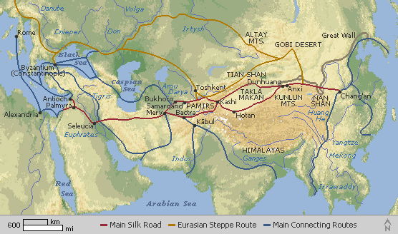
Map of the Silk Road

But policy and technological developments of the past few decades have spurred increases in cross-border trade, investment, and migration so large that many observers believe the world has entered a qualitatively new phase in its economic development. Since 1950, for example, the volume of world trade has increased by 20 times, and from just 1997 to 1999 flows of foreign investment nearly doubled, from $468 billion to $827 billion. Distinguishing this current wave of globalisation from earlier ones, author Thomas Friedman has said that today globalisation is “farther, faster, cheaper, and deeper.”This current wave of globalisation has been driven by policies that have opened economies domestically and internationally. In the years since the Second World War, and especially during the past two decades, many governments have adopted free-market economic systems, vastly increasing their own productive potential and creating myriad new opportunities for international trade and investment. Governments also have negotiated dramatic reductions in barriers to commerce and have established international agreements to promote trade in goods, services, and investment. Taking advantage of new opportunities in foreign markets, corporations have built foreign factories and established production and marketing arrangements with foreign partners. A defining feature of globalisation, therefore, is an international industrial and financial business structure.Technology has been the other principal driver of globalisation. Advances in information technology, in particular, have dramatically transformed economic life. Information technologies have given all sorts of individual economic actors—consumers, investors, businesses—valuable new tools for identifying and pursuing economic opportunities, including faster and more informed analyses of economic trends around the world, easy transfers of assets, and collaboration with far-flung partners.Globalisation is deeply controversial, however. Proponents of globalisation argue that it allows poor countries and their citizens to develop economically and raise their standards of living, while opponents of globalisation claim that the creation of an unfettered international free market has benefited multinational corporations in the Western world at the expense of local enterprises, local cultures, and common people. Resistance to globalisation has therefore taken shape both at a popular and at a governmental level as people and governments try to manage the flow of capital, labor, goods, and ideas that constitute the current wave of globalisation.To find the right balance between benefits and costs associated with globalisation, citizens of all nations need to understand how globalisation works and the policy choices facing them and their societies.Globalisation is the word used to describe the growing interdependence of the world’s economies, cultures, and populations, brought about by cross-border trade in goods and services, technology, and flows of investment, people, and information. Countries have built economic partnerships to facilitate these movements over many centuries. But the term gained popularity after the Cold War in the early 1990s, as these cooperative arrangements shaped modern everyday life. This research assignment uses the term more narrowly to refer to international trade and some of the investment flows among advanced economies, mostly focusing on the United States.The wide-ranging effects of globalisation are complex and politically charged. As with major technological advances, globalisation benefits society as a whole, while harming certain groups. Understanding the relative costs and benefits can pave the way for alleviating problems while sustaining the wider payoffs.
Today, Americans rely on the global economy for many of the things they buy and sell, expanding businesses, and making investments. Many products and services have become affordable to the average American through the coordination of production across countries.It is known today that the history of globalisation is driven by technology, transportation and international cooperation.
Since ancient times, humans have sought distant places to settle, produce, and exchange goods enabled by improvements in technology and transportation. But not until the 19th century did global integration take off. Following centuries of European colonisation and trade activity, that first “wave” of globalisation was propelled by steamships, railroads, the telegraph, and other breakthroughs, and also by increasing economic cooperation among countries. The globalisation trend eventually waned and crashed in the catastrophe of World War I, followed by postwar protectionism, the Great Depression, and World War II. After World War II in the mid-1940s, the United States led efforts to revive international trade and investment under negotiated ground rules, starting a second wave of globalisation, which remains ongoing, though buffeted by periodic downturns and mounting political scrutiny.
Below we will take a look at the different time periods in which globalisation has developed gradually,
DEVELOPMENT OF GLOBALISATION THROUGHOUT THE AGES

1800-1899
TECHNOLOGY BREAKTHROUGHS AND INDUSTRIALISATION
Streamships, railroads and the telegraph accelerate global commerce, along with industrialisation and mass production. Rapid population growth increases demand for goods and services. England becomes the first country to adopt the gold standard- meaning currencies are convertible to a specific amount of gold creating stability in exchange rates and facilitating trade and investment. Most developed countries follow suit. Western nations capitalise on natural resources provided by colonies and foreign markets, use force and economic pressure to open China and Japan.
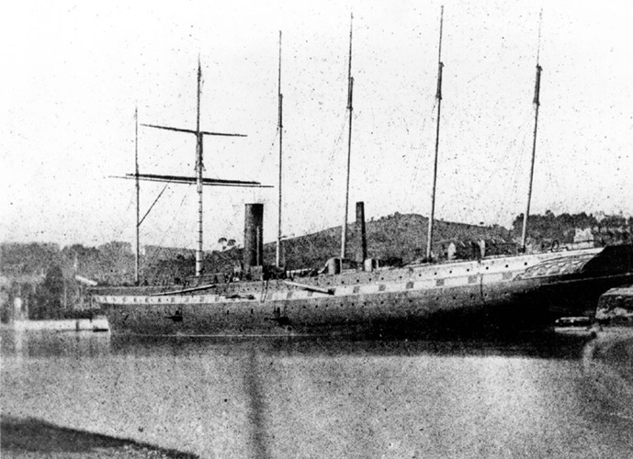

1900-1950
RISE OF AUTOMOBILES AND AIRPLANES
New modes of transportation further link economies. The first transatlantic flight from Berlin lands in New York in 1938.

1914-1918
WORLD WAR 1 IGNITED BY NATIONALIST CONFLICT
The war wreaks havoc on global economies and trade. Defeated Germany is forced to make massive reparation payments to Britain and France.

1920-1929
GOLD STANDARD AND ECONOMIC BOOM
The United States and other countries adopt the gold standard along with protectionist policies. The US economy booms, spurred by a stock market bubble and mass production. Germany struggles to pay reparations and prints money to pay war debts, igniting hyperinflation. Countries retaliate against German manufacturing for delayed reparation payments.

1929-1939
GREAT DEPRESSION AND PROTECTIONISM
The 1929 US stock market crash ushers in the GREAT DEPRESSION. Many countries leave the gold standard and devalue their currencies to try to gain trade advantage. The United States adopts Smoot-Hawley Tariff Act in 1930; other countries retaliate with their own tariffs on US goods, deepening global economic downturn. Deteriorating German economy fuels rise of Nazi party. Regional trade bloc form, excluding Germany, Italy and Japan. Axis powers launch imperialist conquests in Manchuria, Ethiopia, Austria and Czechoslovakia. Britain and France declare war against Germany.
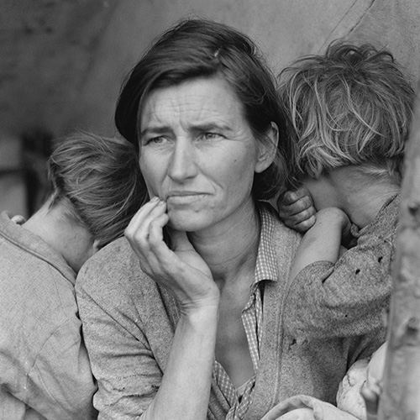

1939-1945
WORLD WAR 2 MOBILISES ALLIES AGAINST AXIS POWERS
The United States, Britain, The Soviet Union, China and others wage war against fascism and nazism.

1944
BRETTON WOODS CONFERENCE SEEKS ORDER
The United States and soon to be victorious allies host parley, setting new postwar rules and institutions to liberalise trade and revive economic growth the dollar and its peg to gold dominate the new global currency framework. The Soviet Union does not ratify the agreement. The Cold War (1945-91) deepens Russian isolation from the Western trade order.
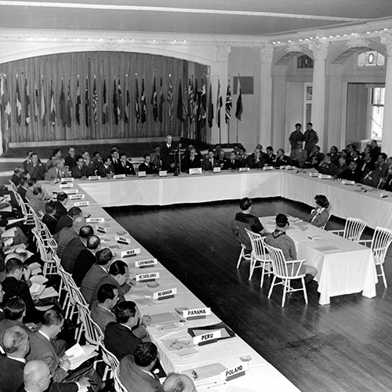

1948
GENERAL AGREEMENT ON TARIFFS AND TRADE (GATT)
The first worldwide multilateral trade agreement ushers in postwar era of more open trade
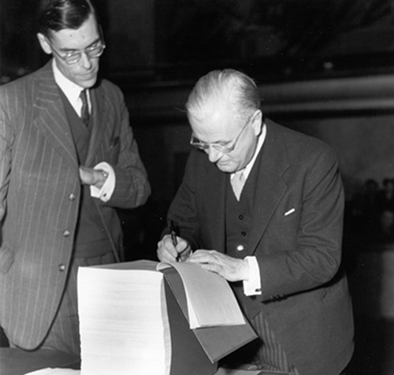

1950-1969
COMPUTERS AND KENNEDY ROUND
Computers pave way for new commercial breakthroughs. “Kennedy Round” of the GATT talk accelerates trade liberalisation.
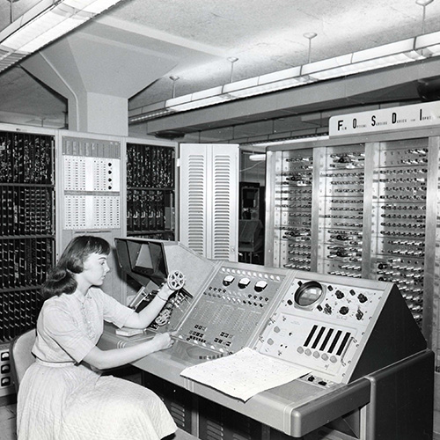

1989-1991
END OF THE COLD WAR
The collapse of The Soviet Union produces greater cooperation in international institutions, increasing trade and financial integration.
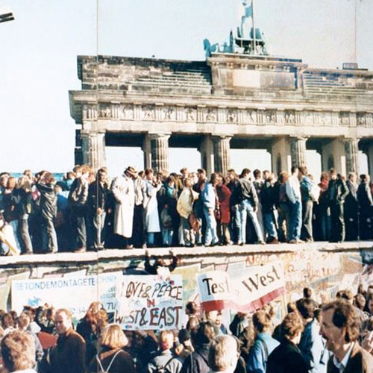

1993
EUROPEAN UNION LINKS CONTINENT
The formation of The European Union solidified the single market that began developing in the 1950s, leading to the creation of the euro currency in 1999.
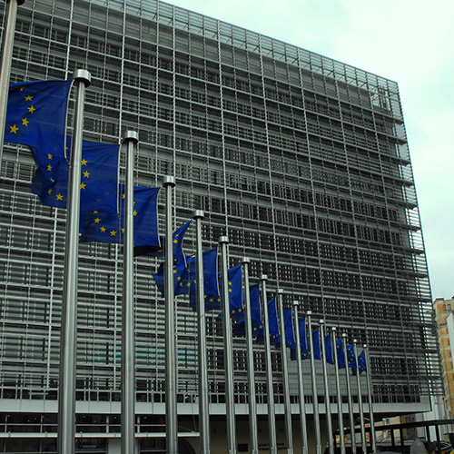

1994
NORTH AMERICA FREE TRADE AGREEMENT ( NAFTA)
The first trade agreement between a rich country (The United States) and a poor country (Mexico) goes into force after bitter US debate. Canada is also a party to NAFTA.

1995
WORLD TRADE ORGANIZATION (WTO)
The modern trading system governed by rules is established, replacing the GATT.
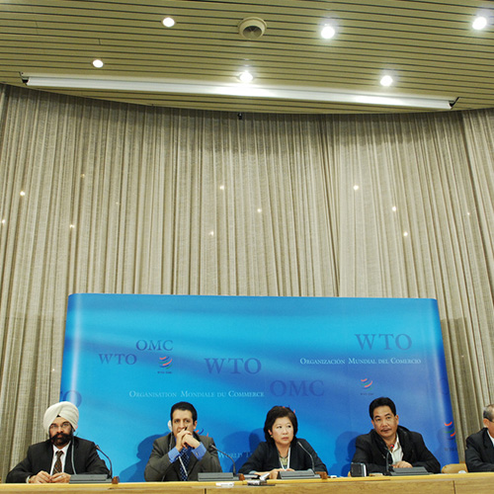

1997
EAST ASIAN FINANCIAL CRISIS
Declines in Asian currencies sparks crisis in the region, forcing austerity measures that revive hostility towards the IMF.

1990-1999
INTERNET CONNECTS THE WORLD
The internet begins its meteoric rise transforming global commerce. Powerful multinational corporations dominate the global economy

2008
GLOBAL FINANCIAL CRISIS IGNITES BACKLASH
An international banking crash along with a European debt crisis results in the worst global recession since The Great Depression. The Group of Twenty (G-20) nations serve as steering committee for efforts to counter crisis effects, but their role produces backlash against globalisation and US leadership.

GLOBALISATION IN CHARTS
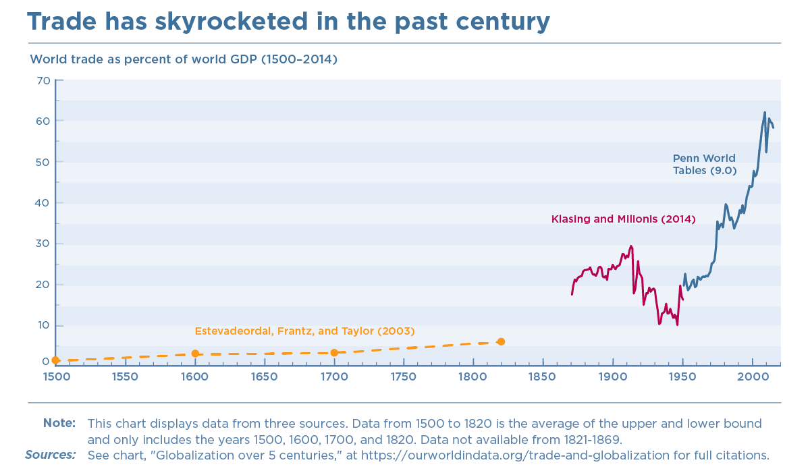
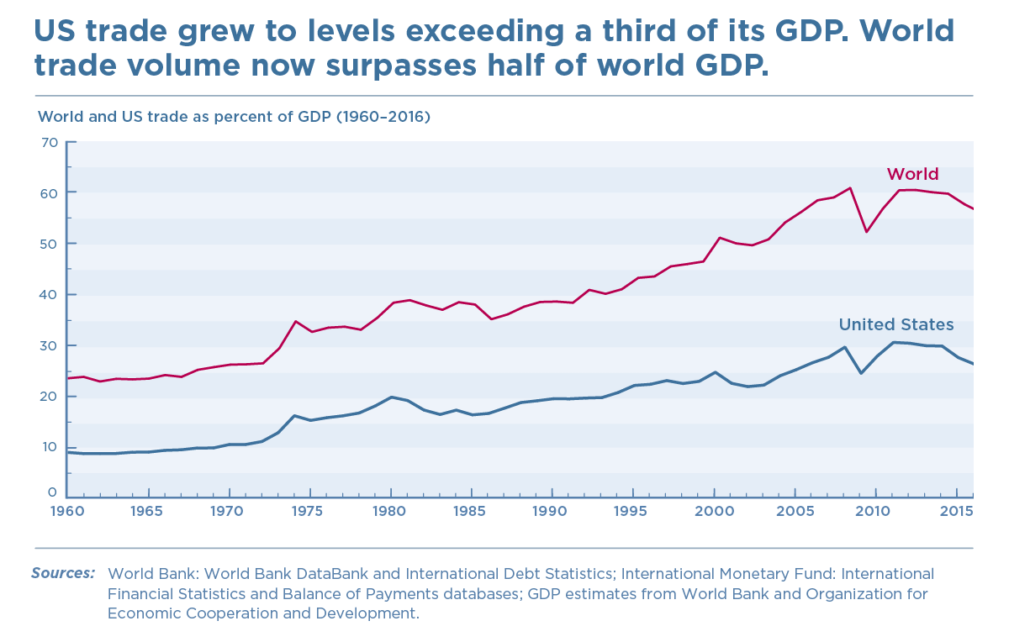

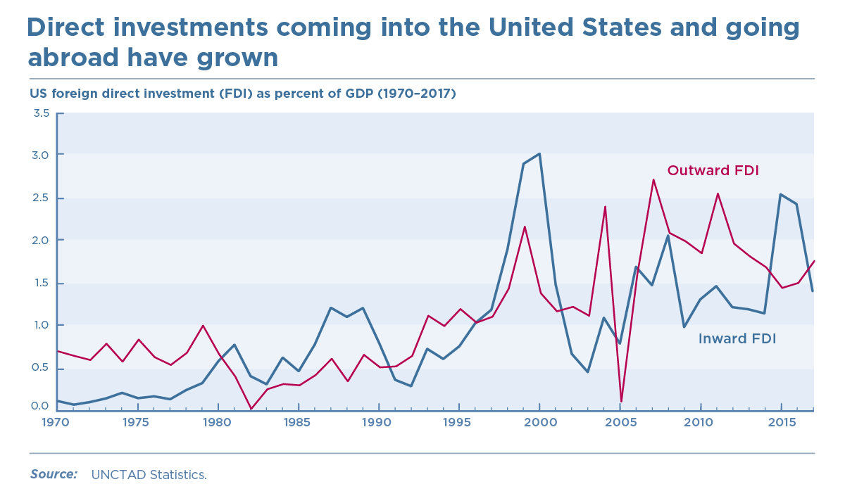
Foreign direct investment (FDI) involves establishing ownership or controlling interest of a business in another country.
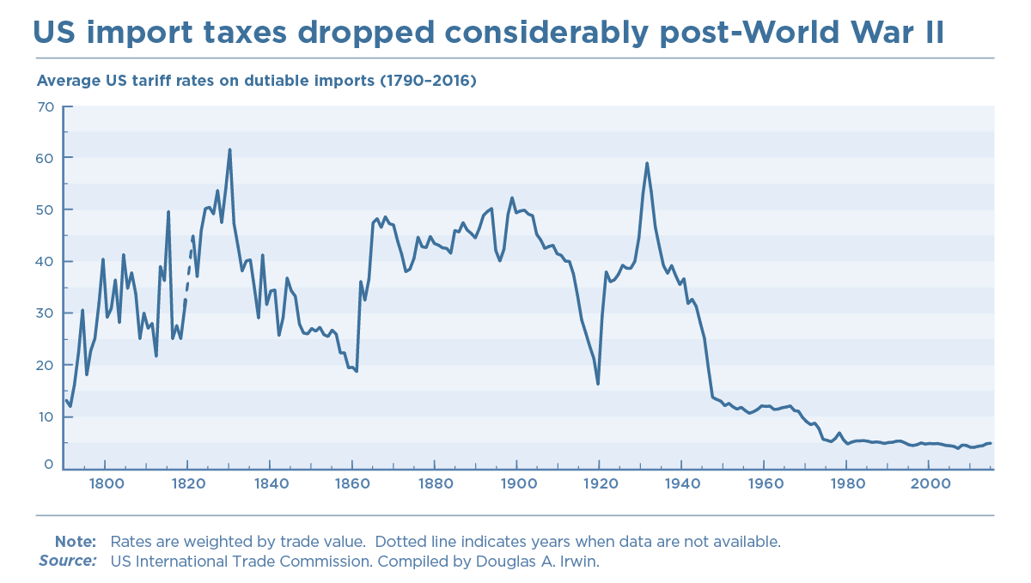

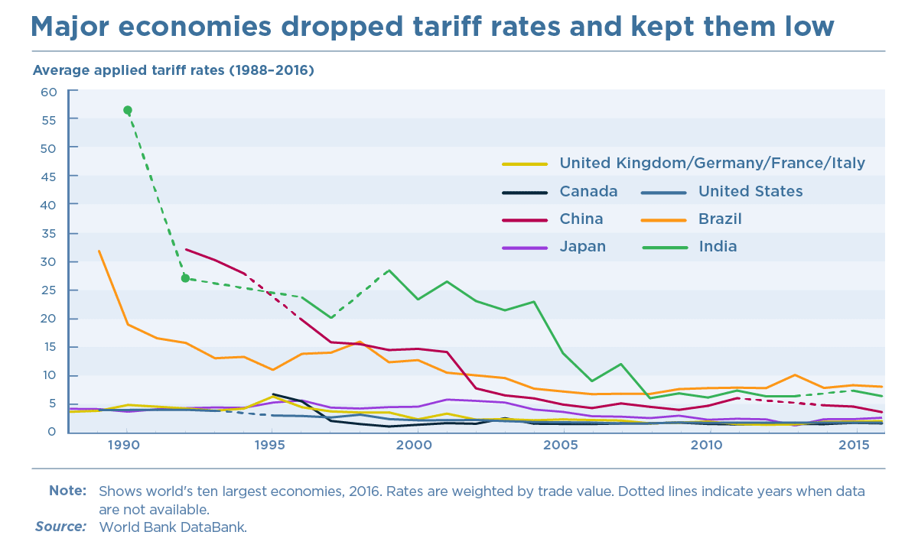
China, India, and Brazil dropped their rates to enter the World Trade Organization (WTO).
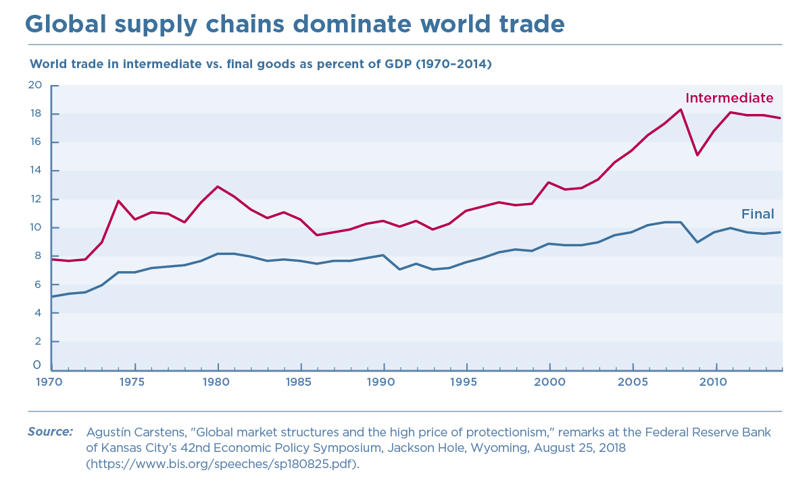
Global supply chains are production networks that assemble products using parts from around the world (known as intermediate goods). Today, 80 percent of world trade is driven by supply chains run by multinational corporations. Trade in intermediate goods is now nearly twice as large as trade in final goods and is especially important in advanced manufacturing, like autos.
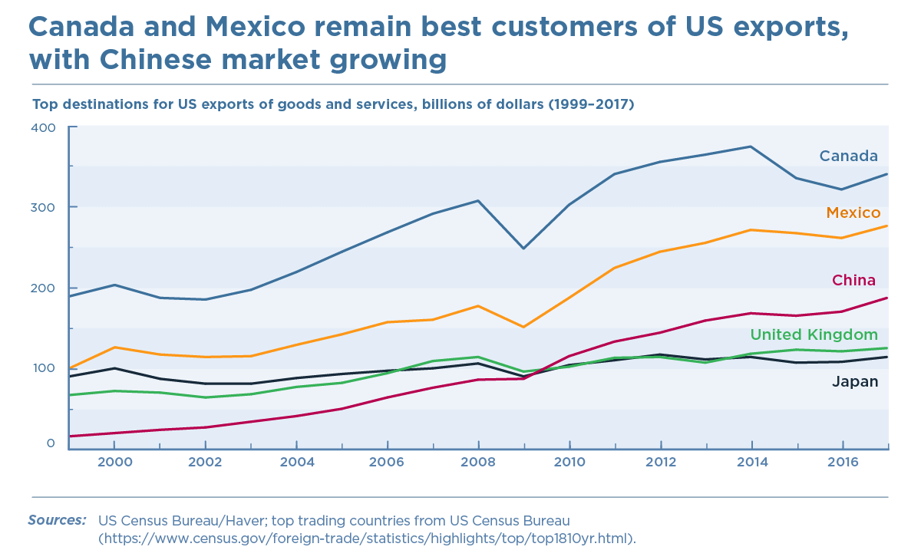
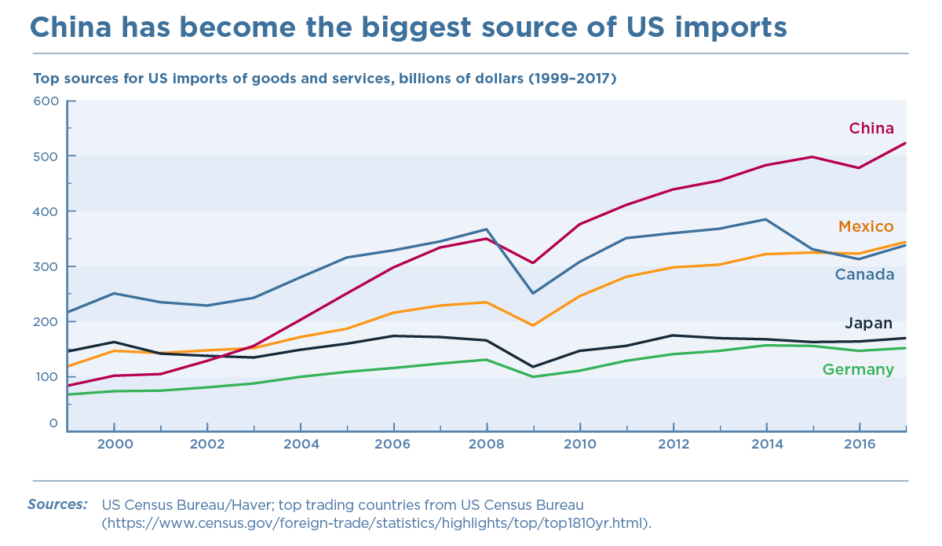
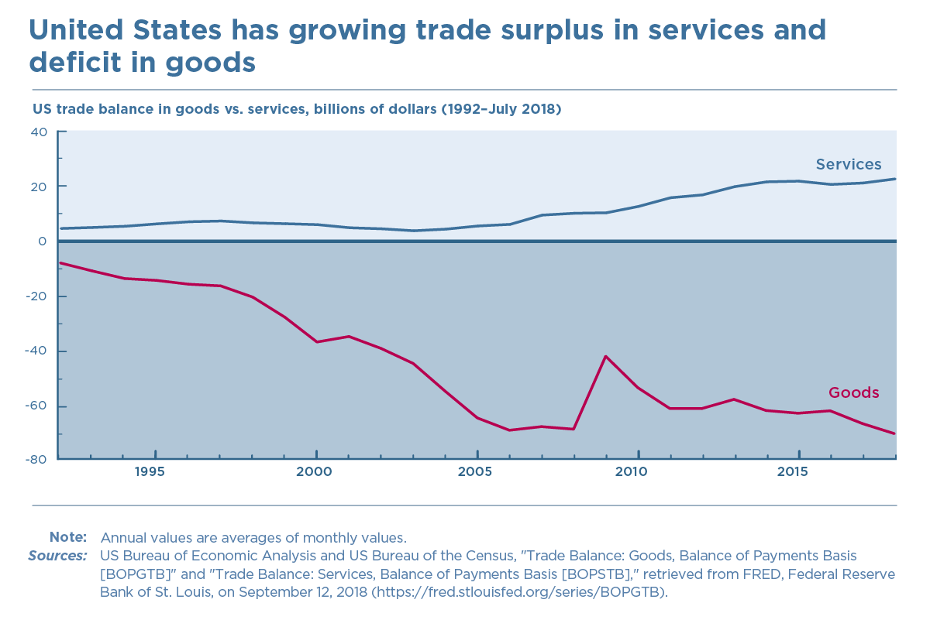
The surplus in services suggests the competitive strength of US services in the global market. The United States had an overall trade deficit of $447 billion in 2017, according to the US International Trade Commission, as a result of Americans spending more than they earn and financing the difference with foreign credit.

THE CONCEPT OF GLOBALISATION

It is the world economy which we think of as being globalised. We mean that the whole of the world is increasingly behaving as though it were a part of a single market, with interdependent production, consuming similar goods, and responding to the same impulses. Globalization is manifested in the growth of world trade as a proportion of output (the ratio of world imports to gross world product, GWP, has grown from some 7% in 1938 to about 10% in 1970 to over 18% in 1996). It is reflected in the explosion of foreign direct investment (FDI): FDI in developing countries has increased from $2.2 billion in 1970 to $154 billion in 1997. It has resulted also in national capital markets becoming increasingly integrated, to the point where some $1.3 trillion per day crosses the foreign exchange markets of the world, of which less than 2% is directly attributable to trade transactions.

While they cannot be measured with the same ease, some other features of globalization are perhaps even more interesting. An increasing share of consumption consists of goods that are available from the same companies almost anywhere in the world. The technology that is used to produce these goods is increasingly standardised and invariant to the location of production. Above all, ideas have increasingly become the common property of the whole of humanity.

It was discussed during an economic conference that the evolution of economic thought around the world during the half-century since World War Two (Coats 1997).It was debated by relevant economists whether the increasing degree of convergence in economic thinking and technique, and the disappearance of national schools of economic thought, could more aptly be described as the internationalisation, the homogenisation, or the Americanisation of economics. My own bottom line was that economics had indeed been largely internationalised, that it had been substantially homogenised, but only to a limited extent Americanised, for non-American economists continue to make central contributions to economic thought, as the Nobel Committee recognised by its award to Amartya Sen a few weeks before this conference took place. Incidentally, the nicest summary of the change in economic thinking over the period was offered by the Indian participant in that conference, who remarked that his graduate students used to return from Cambridge, England focusing on the inadequacies of the Invisible Hand, while now they return from Cambridge Mass. focusing on the inadequacies of the Visible Hand! In the same vein, one of the more telling criticisms of my phrase "the Washington Consensus" was that the (substantial though certainly incomplete) consensus on economic policy extends far beyond Washington.

However, there are areas where globalization is incomplete, even in the economic sphere. In particular, migration is very far from being free. Highly skilled professionals have a relatively high degree of mobility, but those without skills often face obstacles in migrating to higher-wage countries. Despite the difficulties, substantial proportions of the labour forces of some countries are in fact working abroad: for example, around 10% of the Sri Lankan labour force is now abroad.

Moreover, globalization is much less of a reality in other fields than it is in the economic one. Culture still displays strong national, and even regional and local, variations. While English is clearly in the process of emerging to be a common world language, at least as a second language, minority languages are making something of a comeback, at least in developed countries. Sport is still very different around the world: the Americans have still not learnt to play cricket, and most of the rest of us have still not learned to understand what they see in baseball. Although the nation state is far less dominant than it used to be, with significant powers being devolved both downwards to regional and local authorities and upwards to international and in Europe to supranational institutions (and although "interfering in the internal affairs of another state" is less frowned on than formerly), politics is still organised primarily on the basis of nation-states.
THE CORE INDICATORS AND DRIVERS OF GLOBALISATION
Economic globalization stands for the economic interconnectedness of countries with the global economy as a whole. This interdependence relates both to the exchange of factors of production (labor, capital, technologies, know-how) and the exchange of products (material goods and services, finished and unfinished products, consumer and capital goods). In my opinion, there are three main drivers for economic globalization and its different characteristics such as trade (see figure 1), international capital markets, currency markets, migration and more:

- Demography: The size of the population of a country is important for factor endowment differences between countries. If a certain economy has a large number of workers but only a small stock of physical capital, the country is labor-abundant and capital-poor. Such a country has an international competitive advantage in manufacturing labor-intensive products. Concerning international division of labor, it will specialise on the production and
export of labor-intensive products.

- Technology: Due to technical progress, costs of transportation and of communication decreased strongly during the last decades. Without these reductions of costs, phenomena such as outsourcing, long-distance trade and global value chains would not be possible.

- Political decisions: Economic processes are not operating in a political or institutional vacuum. Reducing or even eliminating barriers to trade in goods, services, labor and capital are political decisions. At the end of the day, whether economically motivated cross-border activities do actually take place or not depends on the policy frameworks in place. It is this framework which decides whether cross-border activities are facilitated, made more difficult or even completely forbidden.

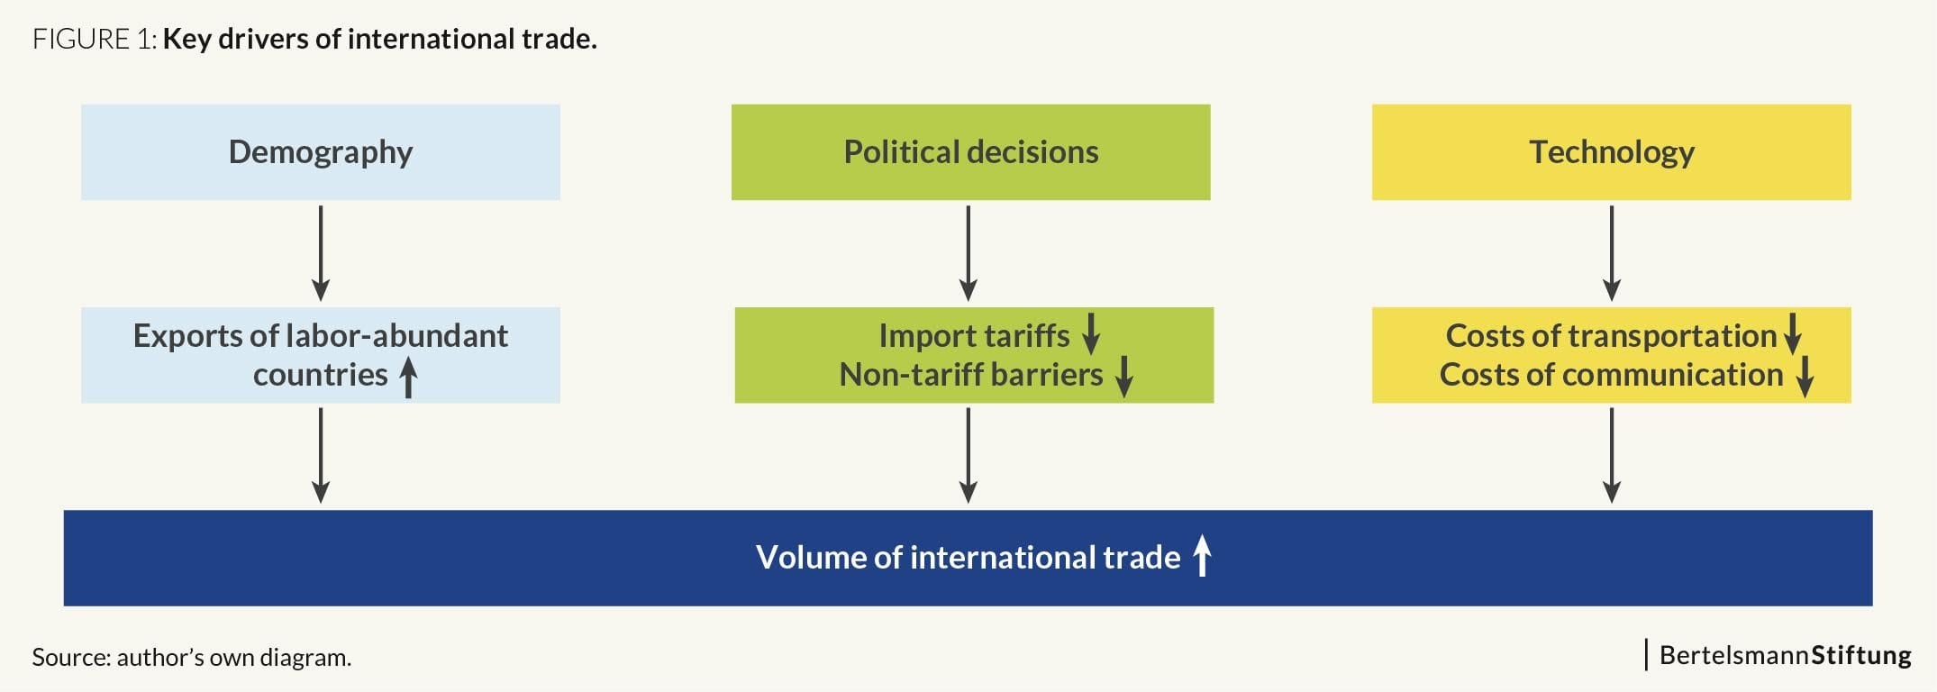

- Stock Market: As domestic markets become more and more saturated, the opportunities for growth are limited and global expanding is a way most organisations choose to overcome this situation. Common customer needs and the opportunity to use global marketing channels and transfer marketing to some extent are also incentives to choose internationalisation.

- Cost: Sourcing efficiency and costs vary from country to country and global firms can take advantage of this fact. Other cost drivers to globalization are the opportunity to build global scale economies and the high product development costs nowadays.

- Competition among markets: With the global market, global inter-firm competition increases and organisations are forced to “play” international. Strong interdependences among countries and high two-way trades and FDI actions also support this driver

QUESTION 1b

HOW THESE INDICATORS AND DRIVERS OF GLOBALISATION AFFECT THE GROWTH AND DEVELOPMENT OF THE NIGERIAN ECONOMY.
Looking at the various indicators and drivers of globalisation above let us critically look at how this has affected the growth and development of the Nigerian economy over the recent years.
Firstly looking at Demography;
This research explores the effect of population growth on the economic growth of Nigeria over the period of 1981 to 2015. Data on GDP and exchange rate were obtained from Central Bank of Nigeria Statistical bulletin, while data on Population growth rate, fertility rate, and crude death rate, were obtained from the World Bank World Development indicators. Ordinary least squares regression was used to analyze data in this study. The findings of the study reveals that population growth has a positive and significant effect on economic growth of Nigeria, while fertility was negative and significant for economic growth in Nigeria. Exchange rate and crude death rate are however insignificant for economic growth of Nigeria. The study recommends amongst other recommendations that the Nigeria government should ensure that Nigeria’s rising population are channeled into areas of the economy where they may more fully utilized in bringing about high rates of economic growth for the country. In addition, the Nigeria government should increase access to affordable health care services so as to reduce death rates in order for Nigeria to achieve increased economic growth.
The population of Nigeria is growing at a rate of 3.75%/year indicating a doubling of the population every 22 years. Demographers estimated the population to be 91,178,000 in 1985. Even though population density is high (288 people/square mile), it is not equally distributed. It is highest in the south and southwest urban areas such as Lagos (1045 people/square mile) and lowest in the northeast (75 people/square mile). Moreover rural-urban migration is growing. A major reason for rural-urban migration is the dual nature of the economy in Nigeria. In urban areas, economic development brings about higher standards of living, but, in rural areas, a subsistence economy predominates. This coupled with rapid population growth results in small or no growth in per capita income. Only if the government were to integrate redistribution policies into complete economic development plans should it consider redistributing the population. It should stress rural development (e.g., incentives for firms to set up in rural areas). Further it should move some government offices to rural areas. The government also needs to adopt population policies encouraging the lowering of fertility levels. If it were to provide education through the secondary and prevocational education level free of charge, educated women will lower their fertility. Sex education should be included in the curriculum. Further the government must play an active role in family planning programs, especially educating rural women about family planning. It should also use the mass media to promote small family size, but it should not dictate family size. It also needs to recognize that population growth puts much pressure on the environment. For example, population growth causes soil erosion, nutrient exhaustion, rapid deforestation, and other problems which render the land unusable for agriculture.

Now that we have critically looked at the first indicator and driver of globalisation and how it affects the growth and development of the Nigerian economy let us critically look at the second driver
Technology; Firstly, Advancement in technology is considered to be one of the major divers of globalization. Technology/Innovation adoption can be seen in various sector in Nigeria. Such sectors include, e-banking, telemedicine, e-learning, tele-commuting, the use of ICT enhances the possibilities of developing countries to improve the standard of living thus Globalisation, promoting media networks, security, medical practitioners, governance, safety, agriculture producers, research institutions, financial organisations, and small business enterprises. They suggested possible ways to achieve ICT growth in Nigeria which include Human Resource Development, infrastructure development, Research and Development and Electronic Government. Technological improvement in the area of transportation and communication has accelerated globalization in recent years. The new era of shipping was begun with the creation of the world’s first container ship in 1956. Containerization has significantly reduced the transportation cost, which in turn has increased the pace of globalization. Introduction of commercial jet aircraft in the 1970s was the great progress that accelerated the transportation of goods among different regions of the globe. Another major technological development in the 1970s was the advancement in microprocessors and telecommunication and then later on the growth of internet. The main purpose of internet is access to information, business, entertainment and awareness. This source of globalization provides the easy access to everything on a single click. These are few examples of technological improvement. Numerous other technological innovations have affected the process of globalization. Information and communication technology (ICT) offers the promise of fundamentally changing the lives of much of the world’s population. In its various forms, ICT affects many of the processes of government and business, how individuals live, work and interact, and the quality of the natural and built environment. The development of internationally comparable ICT statistics is essential for governments to be able to adequately design, implement, monitor and evaluate ICT policies.Information and Communication Technology (ICT) has now been accepted as one of the main driving force behind organizational competitiveness in the present day business environment. Presently, ICT is having dramatic influence on almost all areas of human activities and one of the areas of economic activities in which this influence is most manifest is the banking sector. The banking industry is one of the critical sectors of the economy which makes invaluable contributions to the pace of economic growth and development of nations. However, this study seeks to examine the impact of ICT on the Nigerian economic growth and development.Most developing nations including Nigeria have embarked on various reforms that foster the use of ICTs in their economies. These reforms tend to yield little or minimal benefits to economic growth and development, especially when compared with the developed countries of the world. Technological advancement is known to impact fast rate of economic development. In Nigeria, policy on adoption of Information and Communication Technologies was initiated in 1999, when the civilian regime came into power of government. The operations of the licensed telecommunication service providers in the country has created some well-felt macroeconomic effects in terms of job creation, faster delivery services, reduced transport costs, greater security and higher national output.Attempts to ensure sustainable economic development and poverty reduction of most nations usually involve the development of agriculture, mining, industrial as well as the service sectors. The Industrial Revolutions in Europe and America, generally and specifically, have been premised on technological breakthroughs. During the late 1990s, Information and Communication Technology (ICT) was the largest contributor to growth within capital services for both Canada and the United States. Similar trend has been observed with the economic development of China, Korea, Taiwan, India, South Africa, and other emerging economic powers.At the wake of 2000, the Federal Government of Nigeria embarked on an aggressive drive towards the provision of more efficient services in the nation through its privatization and deregulation policies the ICT sub-sector. The policy thrives led to the establishment of National Telecommunication Policy in December 2001. The policy, among other things, recognised the need for the establishment of an enabling environment for deregulation and rapid expansion of the telecommunication services in the country. The mission statement of the government was to use ICTs for Education, Creation of Wealth, Poverty Eradication, Job Creation, and Global Competitiveness. The policy objective was to develop globally competitive quality manpower in ICTs and related disciplines. This entails developing a pool of ICT engineers, scientists, technicians and software developers. Consequently, attractive career opportunities will emerge in addition to development of software’s and computer components that can earn the nation some foreign exchange. The implementation of ICTs policy led to the adoption of Global System for Mobile-Communications (GSM) and its related components in Nigeria. Therefore with this explanation we know that technology as a driver for globalisation has affected the Nigerian economy growth and development in a positive way.

Thirdly we can critically examine how political decisions can affect the growth and development of the Nigerian economy
Political Decisions;
How a country operates can have a dramatic impact on the development within a country. The government-enforced policies and administrative norms known as political factors can influence economic development, which is the process that increases standard of living by moving away from traditional farming cultures to industrialized societies.In general, political factors influence economic development by supporting or disrupting the process of development.

The Role of Political Factors
Political factors that tend to have an important impact on economic development include:

- Regime type
- Political stability or instability
- Policy management
- Corruption
- Trade laws

Regime type is the form of government within a country. This includes whether a country is democratic, authoritarian, communist, or other. The regime type influences the policies that affect personal and public economic development. For example, in a democratic nation, people are able to obtain small business loans and start their own company. The business is able to expand exponentially and pay employees different rates depending on the work they are doing. However, in a communist nation, there are strict regulations such as paying all staff equally, which can impact how businesses operate and prevent growth that would increase economic development. In this case the country Nigeria is operating a democratic form of regime.

Political stability, or instability, refers to the reliability and durability of a government's structures. The more stable a political system is, the less risk a business operating in that country will face. Nations where there is a high risk of terrorism or internal conflicts are less stable. This makes opening and operating a business expensive and risky in the region. When a country goes to war, this decreases business and it can harm the quality of the currency exchange rate, or the amount the country's money is worth when compared to that of other nations. Thus, less stable systems are less likely to see an increase in economic development because they are risky to operate in.

Political management refers to how well the government monitors and enforces national and international policies or laws. Countries where copyright and piracy laws are not enforced are less desirable for businesses to operate in. Failure to enforce copyright or piracy laws means that a company may not make money and, in turn, this increases the risk of operating in the region. For example, a company that wants to sell music may change their mind because this won't be profitable. Everyone will illegally download the music for free.

Level of corruption identifies the level of dishonest, unethical, and illegal practices that are imposed on people and businesses operating in a region. Corruption can include bribing politicians, bribing local companies for materials, or paying to prevent competitors from entering the market. Imagine that a company pays the government to keep a competitor out. This prevents further economic development and can cause a monopoly that makes services overly expensive. It has been observed by scholars and commentators that corruption is a major challenge to social, political, and economic development in any country. The consequences of corruption are unfavourable for the progress of any society. Against this backdrop, this article examines the effects of corruption on the economic development of Nigeria. It discusses the sociocultural, political, and economic factors responsible for the endemic nature of corruption in Nigeria and concludes that the “top-to-bottom” corruption in Nigeria has negatively affected the country’s economic development. To change this situation, the leadership must genuinely commit to fighting corruption from the top down; corruption control mechanisms need to be strengthened, the offenders need to be punished, and the citizenry needs to be mobilised to demand transparency and accountability.

Trade laws are the local and international policies that impact the importation or exportation of goods. Trade laws are a political factor because governments and politicians develop the policies regarding trade. Trade includes tariffs, or fees and taxes imposed on certain level of imports and exports. Some trade deals between countries can reduce trade tariffs. However this often occurs between two developed countries which is not the case for Nigeria which is a developing country and economy and undeveloped or developing countries face high taxes that can prevent them from participating in international trade.

So looking at the above explanation we can come to a conclusion that the economic predicament of Nigeria can be attributed to the nature and practice of politics and government, and the collapse of the economy which is an upshot of bad governance and its consequences.
Apart from the high profile political murders, the intensity with which acquisition of political power in Nigeria is being pursued in terms of guns and cash, intimidation and manipulation, threats and blackmails have all raised the question as to whether the Nigerian political system is not costing Nigerians too much compared to what it is offering and hence the necessity for transformation. The last election was simply a war. It was waged with all the logistics of war and sometimes with the crudity and the barbarity of ancient traditional power mongers.
Those who were in the tick of the primaries of the party as actors were witnesses to an admixture of the ridiculous, the absurd and the un-imaginable. In the party primaries, candidates emerged under arrangement other than party constitution and guidelines, some emerged as governorship candidate after they have taken oath surrounded by dead bodies in evil ancestral shrines. In general election, stolen money either from public coffer or from the vaults of Banks by those who were licensed as bankers and were deployed together with guns and bullets to ‘take over power’. You either had command of the army or police to displace an incumbent or you were an incumbent ready to turn your state into a killing field with your own private army to survive the hurricane.
Those who had no private armies were forced to either align with those who had or were simply politically irrelevant. They were losers vilified by a new tribe of power sycophants who had emerged as columnist in a section of Nigeria press devoting most of space to tutoring politician in the writings of Nicolo Machieveli and Robert Green. They were the promoters of Mafioso politics today’s acolytes of Nigeria’s Pablo Escobar’s (Roderick, 2011).
With a population of 150 million people, Nigeria is the most populous country in Africa, with a GDP second only to South Africa’s yet following several years of military rule and poor economic management, Nigeria has experienced a prolonged period of economic stagnation, rising poverty levels, and the decline of its public institutions. By most measures, human development indicators in Nigeria were comparable to that of other least developed countries while widespread corruption undermined the effectiveness of various public expenditure programs. The lack of public investments in previous decades meant that there were severe infrastructural bottlenecks that hindered private sector activities. In particular, the poor condition of the power sector prior to economic transformation illustrated the severity of Nigeria’s infrastructure deficit. Per capita power consumption in Nigeria was estimated at 82 kilowatts (kW) compared with an average of 456kW in other sub-Saharan African countries and 3,793kW in South Africa (Adam, 2006).
Following the election in 1999, the first administration of President Olusegun Obasanjo (1999-2003) focused on ensuring political stability, strengthening democratic practices, and tackling corruption. The second administration of Obasanjo (2003 – 2007) embarked on a comprehensive economic reform program based on a homegrown strategy, the National Economic Empowerment and Development Strategy (NEEDS).The development of NEEDS at the federal level was complemented by individual State Economic Empowerment and Development Strategies (SEEDS), which were prepared by all 36 Nigerian states and the Federal Capital Territory (FCT). The NEEDS program emphasised the importance of private sector development to support wealth creation and poverty reduction in the country. The objectives of NEEDS were addressed in four main areas: macroeconomic reform, structural reform, public sector reform, and institutional and governance reform.
So in a nutshell political decisions as a driver of globalisation greatly affects the Nigerian economic growth and development.

Moving on we want to see how the stock markets as a driver of globalisation affects the growth and development of the Nigerian economy
Stock Market; The stock market promotes economic growth in Nigeria. It serves as an important mechanism for effective and efficient mobilisation and allocation of savings, a crucial function, for an economy desirous of growth. It is obvious that the stock market plays a very critical role in economic growth and development of any nation. Therefore, the development of stock market is regarded as key and important vehicle in accelerating the growth of economy. Over the years, Nigeria stock market experienced phenomenon growth from year 1985 with market capitalization of paltry N6.6 billion to an average of N13 trillion in 2014.
The enormous benefits which the stock market possessed have made it an interesting topic for so many authors, economists and policy makers. The fact that Nigeria has been enjoying tremendous inflow of foreign direct investment in its stock market cannot be ignored. This has greatly impacted the development of the market especially in the period preceding global recession of year 2008. Stock market is regarded as a guide to business and was argued that an active capital market is a reliable platform to measure general economic activities with the use of market index (Obadan, 1998).
The main essence of the stock market is to consolidate growth in the financial systems, and enhance the consequent impact of the latter on economic development. According to Yartey and Adjasi (2007), the establishment of stock markets in Africa is expected to boost domestic savings and increase the quantity and quality of investments. Singh (1997) emphasised that in principle, the stock market is expected to accelerate economic growth by providing a boost to domestic savings thereby increasing the quantity and the quality of investment.
Equally, stock exchange can increase economic growth by making available information on firms‟ prospects and redistributing investible capital. Supporting this view, in the case of Africa, Yartey and Adjasi (2007) establish that the stock markets have contributed to the financing of the growth of large corporations in certain African countries and that large corporations in Africa have made considerable use of the stock markets to finance their growth.
In the case of Africa, however, little proofs are available to support arising theoretical projections on the role of the stock market in encouraging capital formation and investments. This situation has instead helped to tilt public opinion towards believing the allegation that emerging African economies have not felt the impact of the huge growth recorded by the stock markets over the years.

QUESTION 2.

As we know the global market and village has become a contagious spectacle in the recent years due to the implications of global policies and its environmental effects on the global market but the main question here is that is this relevantly true in the Nigerian case ? Let us critically analyse the policies of globalisation and its environmental effects before justifying our answer with relevant examples.

EFFECTS OF GLOBALISATION ON GLOBAL MARKETS AND INTERNATIONAL TRADE
Interconnectedness
Globalization has resulted in greater interconnectedness among markets around the world and increased communication and awareness of business opportunities in the far corners of the globe. More investors can access new investment opportunities and study new markets at a greater distance than before. Potential risks and profit opportunities are within easier reach thanks to improved communications technology.Products and services previously available within one country are made available to new markets outside the country due to globalization. In addition, countries with positive relations between them are able to increasingly unify their economies through increased investment and trade.

Maintaining Competitiveness
Globalization has had the effect of increased competition. Companies are broadening their target area, expanding from local areas and home countries to the rest of the world. Suddenly, some companies are fighting strong competition from outside their home country. This forced them to source materials and outsource labor from other countries. This story of ‘sourcing and outsourcing’ turned many companies into global ones, actively seeking for production locations and partners for new ventures. Globalization has facilitated this and made the transition to global markets easier.

Technology and Efficiency
More advanced systems are needed to facilitate global trade. Globalization pushed us to create better systems to track international trade. ERP systems are one of the solutions provided to support global trade.
Enterprise resource planning (ERP) is a process by which a company (often a manufacturer) manages and integrates the important parts of its business. An ERP management information system integrates areas such as planning, purchasing, inventory, sales, marketing, finance and human resources.
This technological innovation in global trade has enabled a more efficient environment. Technology empowers efficiency in global trade and reduces cost and time. In addition, production processes became more efficient due to globalization as companies want to maintain their competitive advantage.
However, we still find a gap between globalization and blockchain. Blockchain could help companies become even more ‘global’. It helps companies to save time and money, storing data tamper-proof and improving communication.
Companies could use smart contracts in which they can define their business rules. These smart contracts can be used when trading with other companies, creating an environment of trust. ModulTrade provides such a platform where companies can trade safely using smart contracts acting as an escrow, including all business criteria.

Now let us look at the environmental effects that it has on the environment

GLOBALISATION AND ITS IMPACT ON THE GLOBAL ENVIRONMENT

Globalization has had far-reaching effects on our lifestyle. It has led to faster access to technology, improved communication and innovation. Apart from playing an important role in bringing people of different cultures together, it has ushered a new era in the economic prosperity and has opened up vast channels of development. However, globalization has also created some areas of concern, and prominent among these is the impact that it has had on the environment. Globalization has featured extensively in the debates on environmentalism, and green activists have highlighted its far-reaching effects. Let us know about the impact of globalization on our environment.Activists have pointed out that globalization has led to an increase in the consumption of products, which has impacted the ecological cycle. Increased consumption leads to an increase in the production of goods, which in turn puts stress on the environment. Globalization has also led to an increase in the transportation of raw materials and food from one place to another. Earlier, people used to consume locally-grown food, but with globalization, people consume products that have been developed in foreign countries. The amount of fuel that is consumed in transporting these products has led to an increase in the pollution levels in the environment. It has also led to several other environmental concerns such as noise pollution and landscape intrusion. Transportation has also put a strain on the non-renewable sources of energy, such as gasoline. The gases that are emitted from the aircraft have led to the depletion of the ozone layer apart from increasing the greenhouse effect. The industrial waste that is generated as a result of production has been laden on ships and dumped in oceans. This has killed many underwater organisms and has deposited many harmful chemicals in the ocean. The damage caused to ecosystem from the oil that spilled from one of the leaking containers of British Petroleum in 2010 is just one of the examples of the threat globalization poses to the environment.Globalization has had far-reaching effects on our lifestyle. It has led to faster access to technology, improved communication and innovation. Due to globalization and industrialization, various chemicals have been thrown into the soil which have resulted into the growth of many noxious weeds and plants. This toxic waste has caused a lot of damage to plants by interfering in their genetic makeup. It has put pressure on the available land resources. In various parts of the world, mountains are being cut to make way for a passing tunnel or a highway. Vast barren lands have been encroached upon to pave way for new buildings. While humans may rejoice on the glimmer with these innovations, these can have long-term effects on the environment. Various studies over the years, have found that plastic is one of the major toxic pollutants, as it is a non-biodegradable product. However, plastic is of immense use when it comes to packaging and preserving goods that are to be exported. This has led to increased use of plastic, causing widespread environmental pollution. It has made so many changes in our lives that reversing it is not possible at all. The solution lies in developing effective mechanisms that can check the extent to which it can impact the environment. Researchers are of the view that the answer to this problem lies in the problem itself, that is, globalization itself can lend support to building a better structure which is economically feasible and environment-friendly. Globalization is about competition, and if certain privately owned companies can take the lead in being environment friendly, then it will encourage others to follow suit.It is important that we put in some efforts to maintain harmony with the environment. The survival of human race on this planet is dependent on the environment to such a large extent that we cannot afford to ignore the consequences of our own actions. While there is a lot of debate and discussion on this issue, the need of the hour is to have effective policies in place, and implementation of those policies. The people that we have chosen to represent us have the responsibility of ensuring that the extent of damage on environment is curtailed, if not totally prevented. We hope this article helped you in understanding globalization and its impact on the environment and the importance of taking concrete actions against it.

So looking at the relevant analysis above I can say that the case is true for Nigeria taking an example in the oil sector of the nation and how globalisation has affected it
Oil pumped from the Niger Delta is loaded on supertankers and shipped into the global market, accounting for 3% of world production and generating substantial revenues for the Nigerian government. What has this connection to the world economy done for Nigeria?

Q: Oil was discovered in Nigeria some 50 years ago. How has that impacted the country?
The first exports left Nigeria for London in 1958. So we’re marking a half-century of oil and gas activities in Nigeria. Oil became economically significant almost precisely at the time Nigeria became independent from Britain in 1960. In a sense, then, the history of post-colonial Nigeria is the history of oil and gas in the country. And yet it’s been a period of, without being too dramatic, unremitting political and economic failure and wasted opportunity.Nigerians are incredibly talented, cre­ative, entrepreneurial people. They have an extra­ordinary vitality. They have Nobel Prize winners. Nigeria’s population of 150 mil­lion means one in every five Africans is a Nigerian. This is not in any sense a country that is short of human capital. It’s the eighth-largest exporter of oil in the world, a major supplier to the U.S. market, and in 2008 was in receipt of $83 billion in oil and gas revenues. But most of the country lives on less than a dollar a day and has a life expectancy of less than 50 years. Since the 1970s, oil has accounted for around 90–95% of all foreign exports, 80–85% of all government revenues, and 40–50% percent of gross domestic product. Nigeria is an archetypical “oil nation,” a mono-economy in which oil dwarfs everything else.Since 1960, over $600 billion in oil revenues has flowed into Nigeria’s coffers; it represents an opportunity unavailable to much of the developing world. These petrodollars could have been spent pro­duc­tively, could have transformed agriculture, laid the foundation for an effective public education system, pro­vided much-needed infrastructure. Yet, according to the World Bank, of that $600 billion, $300 billion has simply disappeared into overseas bank accounts through theft and corruption. The history of post-colonial Nigeria is the serial inability to put these oil wells to developmental use — the catastrophic failure of the national development project

. Q: Has being plugged into the global economy done anything? Is no oil revenue working its way into the economy?
Of course money is trickling through this system. But whatever development indi­cators we look at, oil has not, according to an IMF report, contributed in any sig­nificant way to the average standard of living or the life chances of Nigerians. And, paradoxically, the oil-producing Niger Delta has experienced a decline in those indicators. Life expectancy in the Niger Delta is 45. It has fallen significantly since 1970, though not, as in the case of southern Africa, from the impact of HIV/AIDS. That gives you a sense of the utter horror of conditions.The government often points an ac­cusatory finger at the oil companies, and indeed oil companies, for a long, long time, essentially got away with whatever they could, which is to say that they neglected community development, operated with impunity, often during periods of military dictatorship, and largely ignored the en­vi­ronmental costs of the industry. In addition, the volatility of global oil and gas prices does create real challenges for fiscal management, planning, and development. But the reality is that, in my view, the polit­ical leadership of Nigeria has massively failed on virtually every single level. In that sense, pointing to something called “globalization” as being a contributory factor to Nigeria’s developmental failure is a radically incomplete explanation.

Q: What is Nigeria’s history of engagement with international markets?
Globalization is central to understanding the Nigeria story, but it’s not a product of the 1970s or of Big Oil. The history of globalization and its local meanings run much deeper, and in some profound way are very much wrapped up — specifically for the Niger Delta — with a popular consciousness of the longue durée of the region’s in­corporation into a world market. There’s a photograph in the book that I just completed with the photographer Ed Kashi. It’s an aerial shot of a place called Bonny Island, located on the coast in southeastern Nigeria in the heart of the oil-producing Niger Delta. The photograph shows one of the largest liquefied natural gas plants in the world — leading-edge gas-to-fluids technology — and right next to it is the most unimaginable poverty — villages with no running water, no power, no functioning schools, no roads, or any infrastructure to speak of. It’s an extra­ordinary juxtaposition — the vast potential of 21st-century oil cheek by jowl with an almost pre-modern deprivation and poverty. Nigeria has been part of global markets for 500 years, a history captured in Bonny Island itself. The photograph shows huge oil tankers plying the Cawthorne Channel, which links Bonny to the Atlantic Ocean. A century ago those tankers would have been steamships coming for palm oil, which was critical for lubricants and soaps in an emerging industrial economy. From the mid-19th century throughout the colonial period, the Niger Delta was the heart of the global palm oil industry. And 200 years before that, we would have seen slave ships in the Cawthorne Channel. Bonny was one of the main arterial points for the assemblage of slave labor prior to the horrors of the Mid­dle Passage. There’s a type of terrifying historical continuity in this history of Nigeria’s central involvement with world markets, as a supplier of, initially, slaves, then other commodities, and now a particular type of hydrocarbon, all of which have been central to the emergence of modernity itself.

