TITLE: ASSESSMENT OF OCCUPATIONAL HAZARDS AND DEVELOPMENT OF ENGINEERING EQUIPMENTS TO SUPPORT HEALTH WORKERS AGAINST COVID-19.

OYENIYI VICTOR OREOLUWA
19/ENG07/024

ENG 384
PETROLEUM ENGINEERING
COLLEGE OF ENIGINEERING
AFE BABALOLA UNIVERSITY ADO-EKITI (ABUAD)
APRIL 2020

OBJECTIVE
The aim of the study was to identify all the possible occupational hazards related to covid -19 affecting health workers and mild descriptions of engineering equipment’s to support health workers during the pandemic.

ABSTRACT
The aim of the study was to identify all the possible occupational hazards related to covid -19 affecting health workers and mild descriptions of engineering equipment’s to support health workers during the pandemic.
Also includes steps to take by health workers (also other working class members) to protect their selves and reduce the possible risk of contracting the virus.
Possible solutions were also included including the thorough steps involved in developing a ventilator (which supports the lungs during breathing).

TABLE OF CONTENTS
OBJECTIVE………………………………………………………………………………………………………………………….I
ABSTRACT II
CHAPTER ONE
INTRODUCTION
CHAPTER TWO
ASSESSMENT OF OCCUPATIONAL HAZARDS …………………………………………………………………….
HOW TO CONDUCT A RISK ASSESSMENT FOR CORONAVIRUS
MANAGE THE RISKS
RECOMMENDED PRECAUTIONARY MEASURES
WHAT IF A MEMBER OF STAFF GETS INFECTED?
CHAPTER THREE
DEVELOPMENT OF ENGINEERING EQUIPMENTS TO SUPPORT HEALTH WORKERS AGAINST COVID-19.
Construction and development of a ventilator
Principles of operation
Operating steps
Use and maintenance
Environment of use
REFERENCES

Chapter 1
INTRODUCTION
CORONAVIRUS DISEASE (COVID-19) OUTBREAK: RIGHTS, ROLES AND RESPONSIBILITIES OF HEALTH WORKERS, INCLUDING KEY CONSIDERATIONS FOR OCCUPATIONAL SAFETY AND HEALTH Coronaviruses are a group of viruses belonging to the family of Coronaviridae, which infect both animals and humans. Human coronaviruses can cause mild disease similar to a common cold, while others cause more severe disease (such as MERS - Middle East Respiratory Syndrome and SARS – Severe Acute Respiratory Syndrome). A new coronavirus that previously has not been identified in humans emerged in Wuhan, China in December 2019. Signs and symptoms include respiratory symptoms and include fever, cough and shortness of breath. In more severe cases, infection can cause pneumonia, severe acute respiratory syndrome and sometimes death. Standard recommendations to prevent the spread of COVID-19 include frequent cleaning of hands using alcohol-based hand rub or soap and water; covering the nose and mouth with a flexed elbow or disposable tissue when coughing and sneezing; and avoiding close contact with anyone that has a fever and cough. WHO is working closely with global experts, governments and partners to rapidly expand scientific knowledge on this new virus and to provide timely advice on measures to protect people’s health and prevent the spread of this outbreak.
How does COVID-19 Spread?
Although the ongoing outbreak likely resulted originally from people who were exposed to infected animals, COVID-19, like other coronaviruses, can spread between people. Infected people can spread COVID-19 through their respiratory secretions, especially when they cough or sneeze. According to the CDC, spread from person-to-person is most likely among close contacts (about 6 feet). Person-to-person spread is thought to occur mainly via respiratory droplets produced when an infected person coughs or sneezes, similar to how influenza and other respiratory pathogens spread. These droplets can land in the mouths or noses of people who are nearby or possibly be inhaled into the lungs.
There is much more to learn about the transmissibility, severity, and other features associated with COVID-19, and investigations are ongoing.
Workers Who May Have Exposure Risk
Workers with increased exposure risk include those involved in:
- Healthcare (including pre-hospital and medical transport workers, healthcare providers, clinical laboratory personnel, and support staff).
- Deathcare (including coroners, medical examiners, and funeral directors).
- Airline operations.
- Waste management.
- Travel to areas where the virus is spreading.
Identifying Potential Sources of Exposure
OSHA standards, including those for personal protective equipment (PPE, and respiratory protection , require employers to assess the hazards to which their workers may be exposed.
In assessing potential hazards, employers should consider whether or not their workers may encounter someone infected with COVID-19 in the course of their duties. Employers should also determine if workers could be exposed to environments (e.g., worksites) or materials (e.g., laboratory samples, waste) contaminated with the virus.
Depending on the work setting, employers may also rely on identification of sick individuals who have signs, symptoms, and/or a history of travel to COVID-19-affected areas that indicate potential infection with the virus, in order to help identify exposure risks for workers and implement appropriate control measures.
Classifying Worker Exposure to COVID-19
Worker risk to the virus during an outbreak may vary from very high, to high, to medium to low risk (caution) The level of risk depends, in part, on the industry type, need for contact within 6 feet of people known to be, or suspected of being, infected with SARS-CoV-2. To help employers determine appropriate precautions, OSHA has divided job tasks into the four risk exposure levels. Most American workers will likely fall in the lower exposure or medium exposure risk levels.
- Very High Exposure. Examples include healthcare workers (doctors, nurses, dentists, paramedics etc.) performing aerosol-generating procedures on known or suspected COVID-19 patients.
- High Exposure. Examples include healthcare delivery and support staff exposed to known or suspected COVID-19 patients and medical transport workers.
- Medium Risk Exposure. Examples include workers with ongoing community transmission, those in frequent contact with travelers, those who are in contact with the general public often (schools, high-population-density work environments and some high-volume retail settings).
- Lower Exposure Risk (Caution). Examples include jobs that do not require contact with people known to be, or suspected of being, infected with the virus. Workers in this category have minimal occupational contact with the public and other coworkers.

Rights, roles and responsibilities of health workers, including occupational safety and health
Health workers are at the front line of any outbreak response and as such are exposed to hazards that put them at risk of infection with an outbreak pathogen (in this case COVID-19). Hazards include pathogen exposure, long working hours, psychological distress, fatigue, occupational burnout, stigma, and physical and psychological violence. This document highlights the rights and responsibilities of health workers, including specific measures needed to protect occupational safety and health.
Health worker rights include that employers and managers in health facilities:
• assume overall responsibility to ensure that all necessary preventive and protective measures are taken to minimize occupational safety and health risks ;
• provide information, instruction and training on occupational safety and health, including; o Refresher training on infection prevention and control (IPC); and o Use, putting on, taking off and disposal of personal protective equipment (PPE);
• provide adequate IPC and PPE supplies (masks, gloves, goggles, gowns, hand sanitizer, soap and water, cleaning supplies) in sufficient quantity to healthcare or other staff caring for suspected or confirmed.
e.t.c.
Health workers should:
• follow established occupational safety and health procedures, avoid exposing others to health and safety
risks and participate in employer-provided occupational safety and health training;
• use provided protocols to assess, triage and treat patients;
• treat patients with respect, compassion and dignity;
• maintain patient confidentiality;
• swiftly follow established public health reporting procedures of suspect and confirmed cases;
• provide or reinforce accurate infection prevention and control and public health information, including to
concerned people who have neither symptoms nor risk;
• put on, use, take off and dispose of personal protective equipment properly;
• self-monitor for signs of illness and self-isolate or report illness to managers, if it occurs;
• advise management if they are experiencing signs of undue stress or mental health challenges that require
support interventions; and
• report to their immediate supervisor any situation which they have reasonable justification to believe
presents an imminent and serious danger to life or health.
Steps Health care workers Can take to Reduce Risk of Exposure
Health care workers should prepare to implement basic infection prevention measures. Good hygiene and infection control practices include:
- promote frequent hand washing
- encourage respiratory etiquette like covering coughs and sneezing
- discourage workers from using other workers’ phones, desks, officers or work tools when possible
- maintain regular housekeeping practices and disinfect surfaces often

CHAPTER TWO
ASSESSMENT OF OCCUPATIONAL HAZARDS
RISK ASSESSING FOR CORONAVIRUS
Since the outbreak of coronavirus (COVID-19) at the end of 2019, the newly discovered virus has now spread to more than 100 countries and infected tens of thousands of people.
Although the risk of a major outbreak in Nigeria is still classed as moderate, it is important that you show due diligence in the case of the coronavirus spreading further. You should complete one (or more) risk assessments, then put policies and procedures in place to protect you and the people around you from contracting and spreading the virus.
HOW TO CONDUCT A RISK ASSESSMENT FOR CORONAVIRUS
Creating a risk assessment takes five simple steps. It’s important that a Competent Person covers all of these steps in detail to create a risk assessment that is compliant and protects your staff and members of the public. We’ve included some things you should consider relating specifically to controlling the spread of coronavirus.
Identify the hazards
The first step in the process, and an important step to ensure you leave no stone unturned. Look around your premises – if an infected person were to enter your property, either a visitor or staff member, what hazards would be caused? How would this then affect the none-infected staff members of visitors?
Try to approach this in terms of what areas they would make contact with, which areas are high traffic. Consider what tasks staff are completing in certain areas, what equipment is being used and what PPE is currently provisioned. This should give you a good idea of the hazards posed by a potential coronavirus infection.
Decide who may be harmed and how
Based on the information gathered in the previous step, which members of staff (this could likely be all of them but to differing levels) would be affected by the hazard of coronavirus being present in your property? Create a clear picture of who could be harmed and how, including to what level – consider individuals who are at a higher risk due to the tasks they carry out or their health such as being immunocompromised or having pre-existing medical conditions.
Assess the risks and control them
A competent person should now go through each risk and assess how likely they are to occur and how potentially severe. Follow this up by establishing how to control each risk in a reasonable manner. Control measures should include cleaning procedures, use of PPE and measures such as allowing staff members to work from home if possible.
Record your findings
Create a method statement and share it with the workforce. Ensure it is seen and understood by every member of staff it affects. Keep a track of everyone that has acknowledged the documentation and if you have visitors or contractors who need to see them, share documents with them at the earliest point possible.
Complete reviews
Should the risk of coronavirus change then procedures should also be reviewed and updated if necessary. For example, as more information is known about coronavirus, the risks to your workforce may lessen or worsen and all risk assessments and method statements should reflect these changes. Depending on your business, choose an appropriate review period and be prepared to do ad-hoc reviews if required. Remember that if documents are updated they need to be re-distributed and acknowledged by all relevant employees.
MANAGE THE RISKS
It is worth noting that you should always assess the risks in how they specifically relate to your business, think about factors such as how many visitors you get, whether they are known to you (Are they contractors and regular clients or do you get passing trade?), how people flow through buildings and how often.
The level of risk may differ depending on people you have within your premises that are more vulnerable to the virus – do you care for the elderly or immunocompromised, do you have any pregnant women or those with respiratory conditions such as asthma or other medical conditions within the building?
RECOMMENDED PRECAUTIONARY MEASURES
You can get detailed information on recommended precautionary measures from gov.uk and the NHS. We’ve included the most highly recommended measures which everyone can benefit from.
Hand hygiene
Washing hands has been named as the most effective way of preventing the spread of infection. Ensure that all your staff have access to soap and running water where possible, as well as the provision of hand sanitizers where water is not available (e.g. in reception areas and offices)
Train your staff in the correct process of hand washing. Effective hand washing should take 20-30 seconds and cover all areas of the hands using lathered, soapy water. Consider putting up posters at handwashing stations so that employees have everything they need to protect themselves and those around them.
Surface sanitizing
Regularly sanitize surfaces with a general purpose detergent such as washing-up liquid, followed by a chlorine-based sanitizer. We’d recommend chlorine sanitizing tablets dissolved in water at a level above 1000ppm available chlorine. (1 tablet per liter of water should be sufficient, but always check the label). Simply dilute into a mop bucket to carry out a deep clean or into a trigger spray bottle for regular daily cleaning efforts.
Sanitize all hard surfaces and concentrate especially on high-traffic areas such as door handles, lights switch, reception desks. These areas should generally be sanitized twice a day, but tailor this based on the risks you have identified.
When creating a cleaning procedure, ensure you understand cleaning chemical contact times. Generally, a bleach-based sanitizer should be left for 5 minutes to safely kill bacteria and viruses. Check the label or safety data sheet for any specific products you are using.
PPE
Review the PPE items you already provide your staff members and whether this is the appropriate level, given the risks of coronavirus. Again, this will differ depending on different factors within your organization, the tasks you undertake and the people within your premises.
When PPE items are identified as necessary, you must ensure that staff members are fully trained in:
- When to use PPE
- What PPE items to use
- The limitations of their PPE
- How to put on and remove PPE
- How to dispose of PPE correctly
- How to clean, disinfect and maintain PPE

WHAT IF A MEMBER OF STAFF GETS INFECTED?
If a member of the staffs gets infected, the staff should be quarantined and provided with the necessary medical appliances to aid the recovery of the staff.
More tests should also be carried out on other members of staff in other to ensure safety of other workers and patients. Other additional steps to be taken should include providing additional PPE on top of your usual provisions, creating a process for deep cleaning and sanitizing the premises daily.

CHAPTER THREE
DEVELOPMENT OF ENGINEERING EQUIPMENTS TO SUPPORT HEALTH WORKERS AGAINST COVID-19.
Due to the upending spread of the covid-19 virus, a cure is yet to be found, just ways to manage it and hope the immune system can overcome.
The main cause of death from COVID-19 is acute respiratory distress syndrome, where the lungs are unable to provide enough oxygen for the body. The treatment is to place these patients on a mechanical ventilator, a device that forces oxygen or medical air into the lungs.
I will be listing two but speaking on the development of only one equipment’s development to support workers in the fight against covid-19.
Equipment’s include:
- A warm room that can kill the virus (if it’s still on surfaces of the body and not yet entered the body system.
- A ventilator ( to support the lungs of an infected person nearing critical stage)

Construction and development of a ventilator
Product description
Ventilators designed to provide support to patients who do not require complex critical care ventilators. These ventilators typically consist of a flexible breathing circuit, a control system, monitors, and alarms. Some systems may also include specialized breathing circuits, oxygen accumulators, and heated humidifiers or heat and moisture exchangers (HMEs). Most devices use positive pressure to deliver gas to the lungs at normal breathing rates and tidal volumes through an endotracheal tube, a tracheostomy cannula, or a mask. Power is typically supplied from a power line or from an internal or external battery (e.g., a car battery). These ventilators are used for long-term respiratory support in extended care facilities and in the home; they may also be used in emergency care.
THE VENTILATOR
A mechanical ventilator is an automatic machine designed to provide all or part of the work the body must do to move gas into and out of the lungs. The act of moving air into and out of the lungs is called breathing, or, more formally, ventilation.
The simplest mechanical device we could devise to assist a person’s breathing would be a hand-driven, syringe-type pump that is fitted to the person’s mouth and nose using a mask. A variation of this is the self-inflating, elastic resuscitation bag. Both of these require one-way valve arrangements to cause air to flow from the device into the lungs when the device is compressed, and out from the lungs to the atmosphere as the device is expanded. These arrangements are not automatic, requiring an operator to supply the energy to push the gas into the lungs through the mouth and nose. Thus, such devices are not considered mechanical ventilators.
Automating the ventilator so that continual operator intervention is not needed for safe, desired operation requires three basic components:
- A source of input energy to drive the device;
- A means of converting input energy into output energy in the form of pressure and flow to regulate the timing and size of breaths; and
- A means of monitoring the output performance of the device and the condition of the patient.
There was a time when you could take a handful of simple tools and do routine maintenance on your car engine. About that time the average clinician could also completely disassemble and reassemble a mechanical ventilator as a training exercise or to perform repairs. In those days (the late 1970s), textbooks describing ventilators understandably paid much attention to the individual mechanical components and pneumatic schematics. In fact, this philosophy was reflected to some extent in previous editions of this book. Today, both cars and ventilators are incredibly complex mechanical devices controlled by multiple microprocessors running sophisticated software. All but the most rudimentary maintenance of ventilators is now the responsibility of specially trained biomedical engineers. My approach to describing ventilator design has thus changed from a focus on individual components to a more generalized model of a ventilator as a “black box,” that is, a device for which we supply an input and expect a certain output and whose internal operations are largely unknowable, indeed, irrelevant, to most clinical operators. What follows, then, is only a brief overview of the key design features of mechanical ventilators with an emphasis on input power requirements, transfer functions (pneumatic and electronic control systems), and outputs (pressure, volume, and flow waveforms). The rest of the chapter focuses on the interactions between the operator and the ventilator (the operator interface), and between the ventilator and the patient (the patient interface).
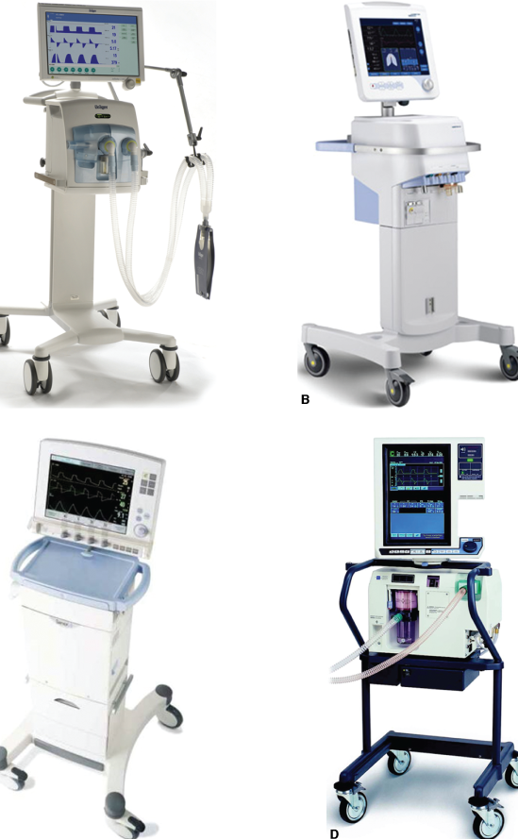
Examples of commonly used intensive care ventilators: A. Dräger Infinity V500, B. Hamilton G5, C. Maquet Servo i, D. Covidien PB840.
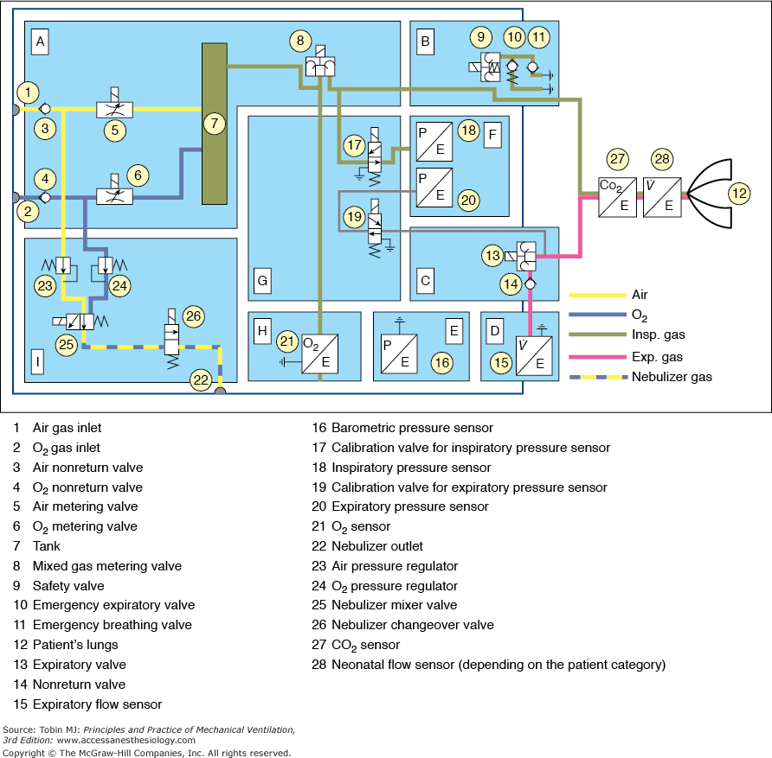fig3.2
Pneumatic schematic of the Dräger Infinity V500 intensive care ventilator.
A. Gas-mixture and gas-metering assembly. Gas from the supply lines enters the ventilator via the gas-inlet connections for oxygen and air (1,2). Two nonreturn valves (3,4) prevent one gas from returning to the supply line of the other gas. Mixing takes place in the tank (7) and is controlled by two valves (5,6). Inspiratory flow is controlled by a third valve (8).
B. Inspiratory unit consists of safety valve (9) and two nonreturn valves (10,11). In normal operation, the safety valve is closed so that inspiratory flow is supplied to the patient’s lungs (12). During standby, the safety valve is open and enables spontaneous inspiration by the emergency breathing valve (11). The emergency expiratory valve (10) provides a second channel for expiration when the expiratory valve (13) is blocked.
C. Expiratory unit consists of the expiratory valve (13) and a nonreturn valve (14). The expiratory valve is a proportional valve and is used to adjust the pressure in the patient circuit. In conjunction with the spring-loaded valve of the emergency air outlet (10), the nonreturn valve (14) prevents pendulum breathing during spontaneous breathing.
D. Expiratory flow sensor.
E. Barometric pressure sensor. Conversion of mass flow to volume, body temperature and pressure saturated (BTPS) requires knowledge of ambient pressure.
F. Pressure measurement assembly. Pressure in the patient circuit is measured with two independent pressure sensors (18,20).
G. Calibration assembly. The pressure sensors are regularly zero calibrated by connection to ambient pressure via the two calibration valves (17,19).
H. Oxygen sensor.
I. Medication nebulizer assembly.

Inputs
Mechanical ventilators are typically powered by electricity or compressed gas. Electricity, either from wall outlets (e.g., 100 to 240 volts AC, at 50/60 Hz) or from batteries (e.g., 10 to 30 volts DC), is used to run compressors of various types. Batteries are commonly used as the primary power source in the home-care environment but are usually reserved for patient transport or emergency use in hospitals. These sources provide compressed air for motive power as well as air for breathing. Alternatively, the power to expand the lungs is supplied by compressed gas from tanks, or from wall outlets in the hospital (e.g., 30 to 80 pounds per square inch [psi]). Some transport and emergency ventilators use compressed gas to power both lung inflation and the control circuitry. For these ventilators, knowledge of gas consumption is critical when using cylinders of compressed gas.
The ventilator is generally connected to separate sources of compressed air and compressed oxygen. In the United States, hospital wall outlets supply air and oxygen at 50 psi, although most ventilators have internal regulators to reduce this pressure to a lower level (e.g., 20 psi). This permits the delivery of a range of oxygen concentrations to support the needs of sick patients. Because compressed gas has all moisture removed, the gas delivered to the patient must be warmed and humidified so as to avoid drying out the lung tissue.
Conversion and Control
The input power of a ventilator must be converted to a predefined output of pressure and flow. There are several key systems required for this process. If the only power input is electrical, the ventilator must use a compressor or blower to generate the required pressure and flow. A compressor is a machine for moving a relatively low flow of gas to a storage container at a higher level of pressure (e.g., 20 psi). A blower is a machine for generating relatively larger flows of gas as the direct ventilator output with a relatively moderate increase of pressure (e.g., 2 psi). Compressors are generally found on intensive care ventilators whereas blowers are used on home-care and transport ventilators. Compressors are typically larger and consume more electrical power than blowers, hence the use of the latter on small, portable devices.
Flow-Control Valves
To control the flow of gas from a compressor, ventilator engineers use a variety of flow-control valves, from very simple to very complex. The simplest valve is just a fixed orifice flow resistor that permits setting a constant flow to the external tubing that conducts the gas to the patient, called the patient circuit. Such devices are used in small transport ventilators and automatic resuscitators. Manually adjusted variable-orifice flow meters have been used in simple infant ventilators in the past (e.g., Bourns BP-200) and are currently used in the Infant Flow SiPAP device (CareFusion, Minneapolis, MN), as shown in Figure 3-3. The advent of inexpensive microprocessors in the 1980s led to development of digital control of flow valves that allow a great deal of flexibility in shaping the ventilator’s output pressure, volume, and flow waveforms (Fig 3-4. Such valves are used in most of the current generation of intensive care ventilators.

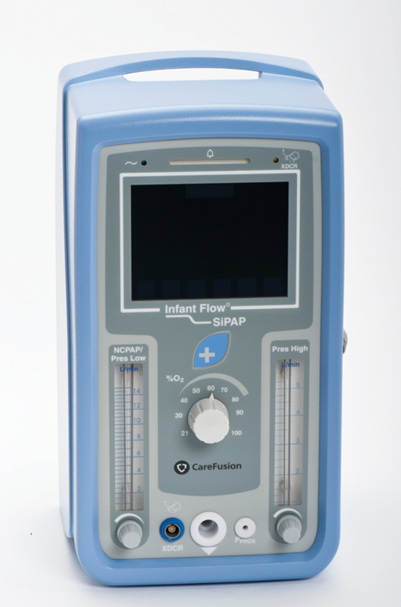
Fig 3.3. CareFusion Infant Flow SiPAP device.

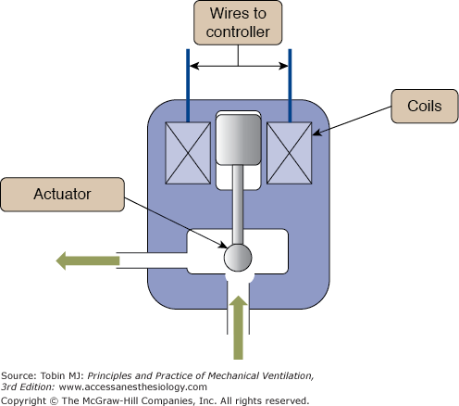
Fig 3.4. Schematic of an output flow-control valve.
Directing flow from the source gas into the patient requires the coordination of the output flow-control valve and an expiratory valve or “exhalation manifold” (Fig. 3-5). In the simplest case, when inspiration is triggered on, the output control valve opens, the expiratory valve closes, and the only path left for gas is into the patient. When inspiration is cycled off, the output valve closes and the exhalation valve opens, flow from the ventilator ceases and the patient exhales out through the expiratory valve (see Fig. 3-2). The most sophisticated ventilators employ a complex interaction between the output flow-control valve and the exhalation valve, such that a wide variety of pressure, volume, and flow waveforms may be generated to synchronize the ventilator output with patient effort as much as possible.
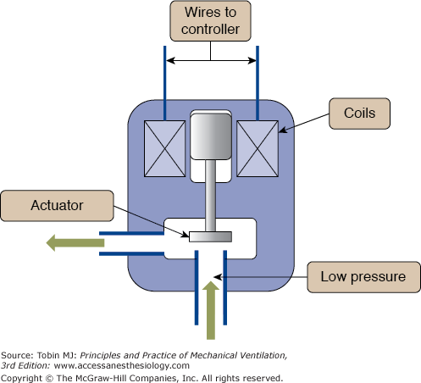
Fig 3.5. Schematic of an exhalation valve.
Control Systems
In the simplest terms, the control system of a ventilator is comprised of components that generate the signals that operate the output valve and the exhalation manifold to obtain the desired output waveforms and modes of ventilation. Control systems may be based on mechanical, pneumatic, fluidic, or electronic components. Mechanical components include levers, pulleys, cams, and so on. Pneumatic control circuits use gas pressure to operate diaphragms, jet entrainment devices, pistons, and other items. Use of lasers to create micro channels for gas flow has enabled miniaturization of ventilator control circuits that are powered entirely by gas pressure to create small, but sophisticated, ventilators for transport, such as the CAREvent (O-Two Medical Technologies) shown in Figure 3-6. Fluidic circuits are analogs of electronic logic circuits. Just as an electronic logic circuit uses electricity, the fluidic circuit uses a very small gas flows to generate signals that operate switches and timing components. Both pneumatic and fluidic control systems are immune to failure from electromagnetic interference, such as around magnetic resonance imaging equipment. Examples of simple pneumatic and fluidic ventilator control circuits have been illustrated elsewhere. By far, the majority of ventilators use electronic control circuits with microprocessors to manage the complex monitoring (e.g., from pressure and flow sensors) and control (valves) functions of modern ventilators used in almost every health care environment.
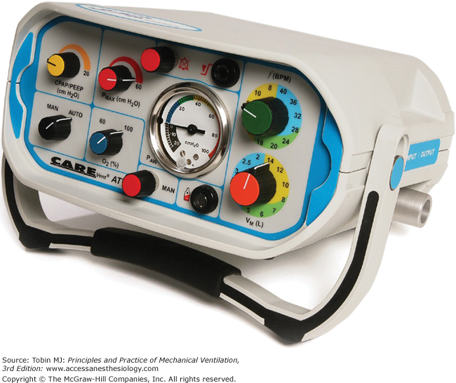
Fig 3.6. Small, pneumatically powered transport ventilator using a pneumatic control system.
What makes one ventilator so different from another has as much to do with the control system software as it does with the hardware. The control software determines how the ventilator interacts with the patient; that is, the modes available. Thus, a discussion about control systems is essentially a discussion about mode capabilities and classifications.
Outputs
Just as the study of cardiology involves the use of electrocardiograms and blood pressure waveforms, the study of mechanical ventilation requires an understanding of output waveforms. The waveforms of interest are the pressure, volume, and flow.
Idealized Pressure, Volume, and Flow Waveforms
Output waveforms are conveniently graphed in groups of three. The horizontal axis of all three graphs is the same and has the units of time. The vertical axes are in units of pressure, volume, and flow. For the purpose of identifying characteristic waveform shapes, the specific baseline values are irrelevant. What is important is the relative magnitudes of each of the variables and how the value of one affects or is affected by the value of the others.
Figure 3-7 illustrates the typical waveforms available on modern ventilators. These waveforms are idealized; that is, they are precisely defined by mathematical equations and are meant to characterize the operation of the ventilator’s control system. As such, they do not show the minor deviations, or “noise,” often seen in waveforms recorded during actual ventilator use. This noise can be caused by a variety of extraneous factors such as vibration and flow turbulence. Of course, scaling of the horizontal and vertical axes can affect the appearance of actual waveforms considerably. Finally, the waveforms in Figure 3-7 do not show the effects of the resistance and compliance of the patient circuit.
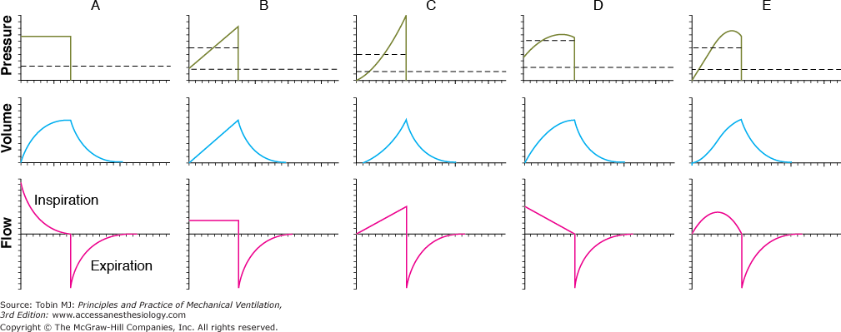
Fig 3.7. Idealized ventilator output waveforms.
A. Pressure-controlled inspiration with a rectangular pressure waveform.
B. Volume-controlled inspiration with a rectangular flow waveform.
C. Volume-controlled inspiration with an ascending-ramp flow waveform.
D. Volume-controlled inspiration with a descending-ramp flow waveform.
E. Volume-controlled inspiration with a sinusoidal flow waveform. The short dashed lines represent mean inspiratory pressure, and the long dashed lines represent mean pressure for the complete respiratory cycle (i.e., mean airway pressure). Note that mean inspiratory pressure is the same as the pressure target in A. These waveforms were created as follows: (a) defining the control waveform using a mathematical equation (e.g., an ascending-ramp flow waveform is specified as flow = constant × time), (b) specifying the tidal volume for flow-control and volume-control waveforms, (c) specifying the resistance and compliance, (d) substituting the preceding information into the equation of motion for the respiratory system, and (e) using a computer to solve the equation for the unknown variables and plotting the results against time.
No ventilator is an ideal pressure, volume, or flow controller, and ventilators are designed to only approximate a particular waveform. Idealized waveforms as shown in Figure 3-7 are, nevertheless, helpful because they are used commonly in other fields (e.g., electrical engineering), which makes it possible to use mathematical procedures and terminology that already have been established. For example, a standard mathematical equation is used to describe the most common ventilator waveforms for each control variable. This known equation may be substituted into the equation of motion, which is then solved to get the equations for the other two variables. Once the equations for pressure, volume, and flow are known, they are easily graphed. This is the procedure that was used to generate the graphs in Figure 3-7.
Effects of the Patient Circuit
The pressure, volume, and flow the patient actually receives are never precisely the same as what the clinician sets on the ventilator. Sometimes these differences are caused by instrument inaccuracies or calibration error. More commonly, the patient delivery circuit contributes to discrepancies between the desired and actual patient values. This is so because the patient circuit has its own compliance and resistance. Thus, the pressure measured inside a ventilator upstream of the patient always will be higher than the pressure at the airway opening because of patient circuit resistance. In addition, the volume and flow coming out of the ventilator’s exhalation manifold will exceed those delivered to the patient because of the compliance of the patient circuit.
Exactly how the mechanical properties of the patient circuit affect ventilator performance depends on whether they are connected in series or in parallel with the patient. It turns out that the resistance of the patient circuit is connected in series whereas the compliance is modeled as a parallel connection. To understand this, we first make the simplifying assumption that we can examine the patient circuit’s resistance separate from its compliance. It is intuitively obvious that the same flow of gas that comes from the ventilator travels through the circuit tubing as through the patient’s airway opening. We also can see that the pressure drop across the patient circuit will be different from that across the respiratory system because they have different resistances. By a definition we borrow from electronics, when two circuit components share the same flow but have different pressure drops, they are connected in series. This means that the patient circuit resistance, however small, adds to the total resistive load seen by the ventilator. Thus, in a volume-controlled breath, the peak inspiratory pressure is higher, and in a pressure-controlled breath, the tidal volume and peak flow are lower. In practice, the effect of patient circuit resistance is usually ignored because it is so much lower than the resistance of the respiratory system.
Now consider the patient circuit compliance. The effective compliance of the patient circuit is a combination of the tubing compliance and the compressibility of the gas inside it. As the ventilator delivers the breath to the patient, pressure at the airway opening rises relative to atmospheric pressure, which is the driving force for flow into the lungs. The patient circuit is connected between the ventilator and the airway, so the pressure it experiences across its walls is the same as that experienced by the respiratory system (remember that we are ignoring its resistance now, so we can ignore any pressure drop between the ventilator outlet and the airway opening). The volume change of the patient circuit tubing is different from that of the respiratory system because the compliance of the circuit is different. Because the patient circuit and the respiratory system fill with different volumes during the same inspiratory time, the flows they experience are different (remember that flow = volume ÷ time). Again borrowing a definition from electronics, if two circuit components share the same pressure drop but different flows, they are connected in parallel. Because they are in parallel, the two compliances are additive, so the total compliance is greater than either component.
Patient circuit compliance sometimes can be greater than respiratory system compliance and thus can have a large effect on ventilation. It must be accounted for either automatically by the ventilator or manually by increasing the tidal volume. For example, when ventilating neonates, patient circuit compliance can be as much as three times that of the respiratory system, even with small-bore tubing and a small-volume humidifier. Thus, when trying to deliver a preset tidal volume during volume-controlled ventilation, as little as 25% of the set volume will be delivered to the patient, with 75% compressed in the patient circuit. The compliance of the patient circuit can be determined by occluding the tubing at the patient Y, delivering a small volume under flow control (using zero positive end-expiratory pressure [PEEP]), and noting the resulting pressure. Using a short inspiratory hold will make it easier to read the pressure. Then compliance is calculated as before, by dividing the volume by the pressure. Once the patient circuit compliance is known, the set tidal volume can be corrected using the following equation:
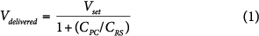
where V_{delivered} is the tidal volume delivered to the patient, V_{set} is the tidal volume setting on the ventilator, C_{PC} is the patient circuit compliance, and C_{RS} is the respiratory system compliance.
We can get a more intuitive understanding of this equation if we put in some values. Suppose, for example, that we use the perfect patient circuit that has zero compliance. Substituting zero for C_{PC}, we get
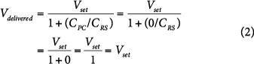
which shows that there is no effect on the delivered tidal volume. Suppose now that C_{PC} is as large as C_{RS} (i.e., C_{PC} = C_{RS}). Now we have
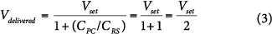
in which case, half the volume from the ventilator goes to the patient, and the other half is compressed in the patient circuit. Some ventilators automatically compensate for gas lost to the patient circuit.²
The effect of the patient circuit is more troublesome during volume-controlled modes than during pressure-controlled modes. This is so because during volume control, the ventilator meters out a specific volume of gas, and unless it measures flow at the airway opening, it has no way of knowing how much goes to the patient and how much goes to the patient circuit. In contrast, during pressure-controlled modes, the ventilator simply meters out a set pressure change no matter where the gas goes. Because the respiratory system and the patient circuit compliance are in parallel, they both experience the same driving pressure (peak inspiratory pressure minus end-expiratory pressure), so tidal volume delivery is affected very little. The only effect might be that the patient circuit compliance may tend to increase the pressure rise time, which would tend to decrease peak flow and tidal volume slightly.
Another area where patient circuit compliance causes trouble is in the determination of auto-PEEP. There are several methods for determining auto-PEEP. One method to determine auto-PEEP during mechanical ventilation is to create an expiratory hold manually (i.e., delay the next inspiration) until static conditions prevail throughout the lungs (i.e., no flow anywhere in the lungs). The pressure at this time (total PEEP) minus the applied PEEP is an estimation of global auto-PEEP. Note that auto-PEEP may vary throughout the lungs depending on the distribution of lung disease and may not reflect pressure behind collapsed areas in patients with severe flow limitation. Auto-PEEP is an index of the gas trapped in the system at end expiration secondary to an insufficient expiratory time:
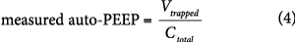
where V_{trapped} is the volume of gas trapped in the patient and the patient circuit at end-expiration (above that associated with applied PEEP), and C_{total} is the total compliance of the respiratory system and the patient circuit. The problem is that we want auto-PEEP to reflect the gas trapped in the patient, not in the circuit. If we know the compliances of the patient circuit and the respiratory system, we can correct the measured auto-PEEP as follows:
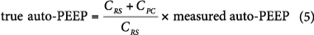
where true auto-PEEP is that which exists in the lungs, measured auto-PEEP is the amount of end-expiratory pressure in equilibration with the lungs and the patient circuit, C_{RS} is the respiratory system compliance, and C_{PC} is the patient circuit compliance. If the ventilator displays auto-PEEP on its monitor, check the ventilator’s operating manual to see whether or not the auto-PEEP calculation is corrected for patient circuit compliance. The larger C_{PC} is relative to C_{RS}, the larger will be the error. Again, the error will be most noticeable in pediatric and neonatal patients.
Principles of operation
Portable ventilators deliver room air or O2-enriched gas into the breathing circuit, where it can be humidified by a heated humidifier or an HME before delivery to the patient. Typically, these ventilators drive air into the breathing circuit with a motor-driven piston or turbine. In the home setting, O2 is usually delivered directly into the breathing circuit from a separate source, such as an O2 tank. Most devices use positive pressure to deliver gas to the lungs at normal breathing rates and tidal volumes through an endotracheal tube, a tracheostomy cannula, or a mask. Portable/home care ventilators may use several methods of cycling (e.g., volume, time) and several ventilation modes, including control, assist/control, and synchronized intermittent mandatory ventilation (SIMV) modes.
Operating steps
Users first check that the unit is ready for use (e.g., run performance and calibration checks). They then make sure that settings (including alarms) are correct and appropriate for the patient type and condition. Once completed, the patient is connected to the ventilator. When the ventilator-patient connection is completed, users ensure that the patient is being properly ventilated. While patient is being ventilated, caregivers are responsible for monitoring/evaluating the patient, and for promptly responding to alarms. Reported problems Most of the reported problems involving portable ventilators arise from user error, poorly maintained exhalation valve assemblies, and the use of poor-quality breathing circuits. Other issues include disconnection of the breathing circuit from the device, equipment failure, disconnection/kinking/bending of tubing, and extreme environmental conditions. Also, critical changes in patient conditions can be missed if alarms are not set properly or are not noted by clinical staff.
Use and maintenance
User(s): Physicians, nurses, respiratory therapist, other medical staff Maintenance: Biomedical or clinical engineer/ technician, medical staff, manufacturer/ servicer Training: Initial training by manufacturer, operator’s manuals, user’s guide; clinical staff to assist family with home care operation
Environment of use
Settings of use: Home care, long-term care facilities, patient transport vehicles Requirements: Battery, uninterruptible power source (for recharging batteries), proper tubing/masks.
Types and variations
Portable, carrying case

REFERENCES
- WHO.com
- Principles of practice of mechanical ventilation, Robert L. Chatburn
- Wikipedia
- Article by fedor Kossakovski
- hsa.ie
- https://www.crams.online/

