OPERATION, MAINTENANCE AND MANAGEMENT OF ENGINEERING EQUIPMENT FOR SUSTAINABLE DEVELOPMENT IN NIGERIA
PREPARED
BY

ORAFU FRANKLYN

17/ENG01/025

A TERM PAPER SUBMITTED TO THE

DEPARTMENT OF CHEMICAL AND PERTOLEUM ENGINEERING
IN PARTIAL FULFILMENT
OF
ENGINEERING LAW AND MANAGERIAL ECONOMICS

DATE OF SUBMISSION: 13TH APRIL 2020

ABSTRACT
Many industries are becoming moribund, while those who are in operatives are producing at low efficiency which are not commensurate to the resources invested. These imbalances and poor performance attest to the fact that the maintenance practices adopted were unskillfully implemented and are not sustainable. Therefore, the objective of this term paper is to identify and examine the operation, maintenance and management of engineering equipment for sustainable development in Nigeria, as a way of outlining an engineering approach to sustainability that permits us to engineer sustainability into many facets of society.
Engineering is the use of scientific principles to design and build machines, structures, and other items, including bridges, tunnels, roads, vehicles, and buildings. The discipline of engineering encompasses a broad range of more specialized fields of engineering, each with a more specific emphasis on particular areas of applied mathematics, applied science, and types of application.
Sustainable development is the organizing principle for meeting human development goals while simultaneously sustaining the ability of natural systems to provide the natural resources and ecosystem services based upon which the economy and society depend. Sustainable development can be defined as development that meets the needs of the present without compromising the ability of future generations to meet their own needs. The concept of sustainable development has been, and still is, subject to criticism, including the question of what is to be sustained in sustainable development. It has been argued that there is no such thing as a sustainable use of a non-renewable resource, since any positive rate of exploitation will eventually lead to the exhaustion of earth's finite stock. Sustainability is a critically important goal for human activity and development. Sustainability in the area of engineering is of great importance to any plans for overall sustainability given 1) the pervasiveness of engineering activities in societies, 2) their importance in economic development and living standards, and 3) the significant impacts that engineering processes and systems have had, and continue to have, on the environment.
Equipment engineers may evaluate, inspect, maintain, design, analyze and improve various types of equipment, including electronic and mechanical equipment. These engineers can work in distinct areas, such as electrical, mechanical or computer engineering. Engineering equipment means engineering plant and any other plant or equipment designed and constructed for the purpose of engineering operations.

Maintenance and management of equipments involves functional checks, servicing, repairing or replacing of necessary devices, equipment, machinery, building infrastructure, and supporting utilities in industrial, business, governmental, and residential installations. Over time, this has come to include multiple wordings that describe various cost-effective practices to keep equipment operational; these activities take place either before or after a failure.

TABLE OF CONTENTS

ABSTRACT 2
TABLE OF CONTENTS 3
LIST OF FIGURES 4
LIST OF TABLES 5
CHAPTER ONE 6
INTRODUCTION 6
CHAPTER TWO 7
LITERATURE REVIEW 7
2.1 ABOUT ENGINEERTING 7
2.2 EQUIPMENT ENGINEERING…………………………………………………………………….8
2.3 SUSTAINABILITY DEVELOPMENT……………………………………………………9
2.4 MAINTENANCE OF EQUIPMENT………………………………………………...…...10
CHAPTER THREE 11
METHODOLOGY 19
3.1 STEPS TO ASSET & EQUIPMENT MANAGEMENT SUCCESS 20
3.2 WAYS TO MAINTAIN EQUIPMENTS 22
CHAPTER FOUR 24
CONCLUSIONS AND RECOMMENDATIONS 24
5.1 CONCLUSIONS 24
5.2 RECOMMENDATIONS 24
REFERENCES 25

LIST OF FIGURES
Figure 1. Wrench 8
Figure 2 Hydraulic jack 10
Figure 3 Toolbox 11
Figure 4 Saw 11
Figure 5 Jumper cables...............................................................................................................….............13
Figure 6 Flashlight ………...………………………........................................………………………...…14
Figure 7 Pliers……………………..………………………………………………………......………......14
Figure 8 Googles………......……………………………………………………………......……………..15
Figure 9 Spirit level………………………………………………………………………………………..16
Figure 10 Hammer…………..…………………….......................…………..............…………………....17

CHAPTER ONE

INTRODUCTION
It is increasingly recognized, in public discussion and political discourse, that many of the practices and lifestyles of modern society – particularly but not exclusively industrialized society – simply cannot be sustained indefinitely. We are exceeding the capacity of the planet to provide many of the resources we use and to accommodate our emissions, while many of the planet’s inhabitants cannot meet even their most basic needs. This problem, of recognizing the need to live within constraints and to ensure more fairness in access to limited resources, lies at the heart of the concepts of sustainability and sustainable development. It is something new in human history – the planet is full and we have no new geographical horizons to move to. This Guide is intended to provide an introduction to how sustainability and sustainable development affect the way in which engineering must in future be practiced.
Engineering is the application of economic, social, scientific, and practical principles to invent, build, design, maintain, and otherwise improve machines, devices, materials, systems, and processes. Engineering is an important field of work, especially in our company, so we can keep ahead of the design and machining curve. Engineering is the use of scientific principles to design and build machines, structures, and other items, including bridges, tunnels, roads, vehicles, and buildings. The discipline of engineering encompasses a broad range of more specialized fields of engineering, each with a more specific emphasis on particular areas of applied mathematics, applied science, and types of application.
Regular maintenance of equipment is an important and necessary activity. The term ‘maintenance’ covers many activities, including inspection, testing, measurement, replacement and adjustment, and is carried out in all sectors and workplaces. It has a vital role to play in reducing the risk associated with some workplace hazards and providing safer and healthier working conditions. Insufficient/inadequate maintenance can cause serious (and potentially deadly) accidents or health problems. PUWER (the Provision and Use of Work Equipment Regulations 1998) states that ‘all work equipment be maintained in an efficient state, in efficient order and in good repair.’ Machinery that has a maintenance log needs to be kept up to date and maintenance operations need to be carried out safely.
Equipment management is essentially asset management. Our sister company, Aerial Adventure Tech, has put together this handy guide for creating an equipment management system that will help you protect your assets. The aerial adventure products in your inventory are assets for your organization. This equipment is likely the most important asset because it is directly involved in employee and participant safety. A solid equipment management system can serve as the asset and safety management system for your entire organization, allowing you to track maintenance on vehicles, inspections of the physical activity or structure, staff trainings, and a host of other items requiring records. To some, a management system seems like unnecessary administrative work but developing one creates real world value. Others specialize in a particular field, such as nanomaterials (extremely small substances) or biological engineering. Still others specialize in developing specific products.
Maintenance activities are related with repair, replacement and service of components or some identifiable group of components in a manufacturing plant so that it may continue to operate at a specified ‘availability’ for a specified period. Thus maintenance management is associated with the direction and organization of various resources so as to control the availability and performance of the industrial unit to some specified level.
Thus maintenance management may be treated as a restorative function of production management which is entrusted with the task of keeping equipment/machines and plant services ever available in proper operating condition.
The minimization of machine breakdowns and down time has been the main objective of maintenance but the strategies adopted by maintenance management to achieve this aim have undergone great changes in the past.
Maintenance has been considered just to repair the faulty equipment and put them back in order in minimum possible time.
In view of the utilization of mostly general purpose/conventional machines with low production output, the demands on maintenance function were not very high. But with fast developments in the design, development and mechanisms of control such as electronic, NC and CNC in machine tools the manufacturing scenario has changed a lot.

IMPORTANCE OF MAINTAINANCE AND MANAGEMENT OF EQUIPMENTS
Maintenance management is responsible for the smooth and efficient working of the industrial plant and helps in improving the productivity.
- It also helps to keep the machines/equipment in their optimum operating conditions. Thus plant maintenance is an important and inevitable service function of an efficient production system.
- It also helps in maintaining and improving the operational efficiency of the plant facilities and hence contributes towards revenue by decreasing the operating cost and improving the quality and quantity of the product being manufactured.
- As a service function it is related with the incurrence of certain costs. The important component of such costs are — employment of maintenance staff, other minor administrative expenses, investment in maintenance equipment and inventory of repair components/ parts and maintenance materials.
- Absence of plant maintenance may lead to frequent machine breakdown and failure of certain productive centres/services which in turn would result in stoppages of production activities, idle man and machine time, dislocation of the subsequent operations, poor quality of production, failure to meet delivery dates of product supply, industrial accidents endangering the life of workers/ operators and allied costs etc.

CHAPTER TWO

LITERATURE REVIEW

2.1 ABOUT ENGINEERING
Engineering is the application of scientific and mathematical principles for practical purposes such as the design, manufacture, and operation of products and processes, while accounting for constraints invoked by economics, the environment and other sociological factors. Many technical advances are brought about through engineering. Engineering activities are significant contributors to economic development, standards of living and well-being of a society, and impact its cultural development and environment. Engineering is continually evolving as a profession, and engineering education is correspondingly continually changing
Sustainable development is increasingly becoming a goal to which numerous countries throughout the world aspire. Overall sustainability has been defined in many ways, and is often considered to have three distinct components: environmental sustainability, economic sustainability and social sustainability. These three factors when considered separately usually pull society in different directions (e.g., economic sustainability may be achieved at the expense of environmental and social sustainability). Overall sustainable development in general requires the simultaneous achievement of environmental, economic and social sustainability. Achieving this balance is indeed a challenging task.
Although engineering is not directly one of the three components of sustainability cited above, it is indirectly linked to each. That is, engineering uses resources to drive much if not most of the world’s economic activity, in virtually all economic sectors, e.g., industry, transportation, residential, commercial, etc. Also, resources used in engineering, whether fuels, minerals or water, are obtained from the environment, and wastes from engineering processes (production, transport, storage, utilization) are typically released to the environment. Finally, the services provided by engineering allow for good living standards, and often support social stability as well as cultural and social development. Given the intimate ties between engineering and the key components of sustainable development, it is evident that the attainment of sustainability in engineering is a critical aspect of achieving sustainable development, in individual countries and globally. In fact, Kreith writes on sustainability, “no subject is more important to the engineering profession or the wider world that we live in.”
The facts that all countries utilize engineering services and consume resources, and that impacts on the environment of engineering processes span from local to global, and that the world’s economy is becoming increasingly globalized, together suggest that the quest for sustainable engineering is global in nature.
Engineering sustainability is taken here to be a comprehensive concept. That is, engineering sustainability is taken to involve the sustainable application of engineering in systems. Such systems include processes and technologies for harvesting resources, converting them to useful forms, transportation and storage, and the utilization of engineering products and processes to provide useful services such as operating computers, providing healthcare or sheltering people. Thus, engineering sustainability goes beyond the search for sustainable resources, and implies sustainable engineering systems, i.e., systems that use sustainable resources, and that process, store, transport and utilize those resources sustainably.
Despite its importance, engineering sustainability is not well understood or widely accepted. According to Kreith [4], “Engineers are still trying to understand how the concept of sustainability fits in with our profession.” He provides a partial explanation by noting that “It’s reasonable that engineers would have trouble with (…) sustainability: There are no equations (…) that can optimize it and no widely agreed upon standards to which we can adhere. In fact, the concept is (…) nebulous.”

2.2 WHAT IS EQUIPMENT ENGINEERING
Equipment engineering is much more than machine build and applying techniques. The entire process of intake, engineering, manufacturing and commissioning, including software, machine vision inspection, control, integration on existing systems, up to complete turnkey units, all is supplied within compliance of the quality standard ISO 9001-2008.To be able to sustain our innovative edge, new ideas can be tested in our own R&D department, on almost every aspect of the real-life use. This in-house testing and prototyping gave way to many unique solutions on the Simac machines.

2.3 SUSTAINALE DEVELOPMENT?
The term “sustainable development” was first proposed by the World Commission on Environment and Development (WCED) in its 1987 report Our Common Future (also known as the Brundtland Commission report). WCED, which included 23 members from 22 countries, was formed by the United Nations in 1984, and for three years studied the conflicts between growing global environmental problems and the needs of less-developed nations. WCED’s widely used definition of sustainable development is: “Meeting the needs of the present without compromising the ability of future generations to meet their own needs.” Since 1987, there have been many efforts to explain and amplify what is meant by sustainable development. To an engineer, a sustainable system is one that is either in equilibrium, or one that changes slowly at a tolerable rate. This concept of sustainability is best illustrated by natural ecosystems, which consist of nearly closed loops that change slowly. For example, in the food cycle of plants and animals, plants grow in the presence of sunlight, moisture and nutrients and are then consumed by insects and herbivores which, in turn, are eaten by successively larger animals. The resulting natural waste products replenish the nutrients, which allows plants to grow and the cycle to begin again. If humans are to achieve sustainable development, we will have to adopt patterns that reflect these natural processes. The roles of engineers in sustainable development can be illustrated by a closed-loop human ecosystem that mimics natural systems. This model of a closed-loop ecosystem was first proposed in 1990. Other authors have since suggested modifications to this model, one of the most sophisticated of which is described in this attached file (SDProdConsumModel.pdf). Engineers contribute to all the steps in this systems model:
• By developing, processing and transporting natural resources in closed-loop systems, we can reduce waste and increase the efficient use of resources.
• Harvesting renewable resources such as water, fish and trees within the limits allowed by nature will ensure a continuing supply of resources for humans and natural ecosystems. Minimizing our use of non-renewable resources, such as petroleum and scarce minerals, and replacing them with environmentally friendly substitutes will also help extend the supply of natural resources. ‘
• Processing natural resources efficiently and with little or no waste helps to preserve the earth’s finite natural resources. We can further preserve resources by designing products and packaging for reuse and recycling, and we can protect resources through industrial processes and facilities that have minimal adverse environmental impacts throughout their full life-cycles.
• Transporting goods contributes heavily to pollution; to minimize these effects, we can transport resources and manufactured goods efficiently to consumers by pipelines, rivers, railways, roads, ships. Engineering equipment means engineering plant and any other plant or equipment designed and constructed for the purpose of engineering operations.
• How we develop, process and transport resources can improve living standards in many ways. These include providing clean water, energy, housing and commercial buildings and streets and other forms of infrastructure; efficiently storing and distributing food; and meeting acceptable health standards, including high-quality waste management and treatment.
• To allow natural and built environments to be clean and unpolluted, we can reduce waste throughout this ecosystem cycle by continually recycling and recovering residual byproducts of resource development, industrial processing and meeting consumer needs. Some waste in the system is inevitable but should be in forms that have minimal long-term impacts on the natural environment. The impacts from residual waste can be offset by continuing programs to clean up and reuse old waste sites, along with other forms of environmental restoration.
• The effects of developing energy sources on the atmosphere, earth and water can be reduced by more efficient use of power and by production from non-fossil sources.
• As described in other sections of this CD, engineers fill vital roles in each phase of this human ecosystem model.

2.4 MAINTENANCE OF EQUIPMENTS

Maintenance involves functional checks, servicing, repairing or replacing of necessary devices, equipment, machinery, building infrastructure, and supporting utilities in industrial, business, governmental, and residential installations. Over time, this has come to include multiple wordings that describe various cost-effective practices to keep equipment operational; these activities take place either before or after a failure.
TYPES OF MAINTENANCE
Traditionally, 5 types of maintenance have been distinguished, which are differentiated by the nature of the tasks that they include:
- Corrective maintenance: The set of tasks is destined to correct the defects to be found in the different equipment and that are communicated to the maintenance department by users of the same equipment.
- Preventive Maintenance: Its mission is to maintain a level of certain service on equipment, programming the interventions of their vulnerabilities in the most opportune time. It is used to be a systematic character, that is, the equipment is inspected even if it has not given any symptoms of having a problem.
- Predictive Maintenance: It pursues constantly know and report the status and operational capacity of the installations by knowing the values of certain variables, which represent such state and operational ability. To apply this maintenance, it is necessary to identify physical variables (temperature, vibration, power consumption, etc.). Which variation is indicative of problems that may be appearing on the equipment? This maintenance it is the most technical, since it requires advanced technical resources, and at times of strong mathematical, physical and / or technical knowledge.
- Zero Hours Maintenance (Overhaul): The set of tasks whose goal is to review the equipment at scheduled intervals before appearing any failure, either when the reliability of the equipment has decreased considerably so it is risky to make forecasts of production capacity . This review is based on leaving the equipment to zero hours of operation, that is, as if the equipment were new. These reviews will replace or repair all items subject to wear. The aim is to ensure, with high probability, a good working time fixed in advance.
- Periodic maintenance (Time Based Maintenance TBM): the basic maintenance of equipment made by the users of it. It consists of a series of elementary tasks (data collections, visual inspections, cleaning, lubrication, retightening screws,…) for which no extensive training is necessary, but perhaps only a brief training. This type of maintenance is the based on TPM (Total Productive Maintenance).
MAINTENANCE STRATEGIES
Maintenance strategies can be categorized into four major types:
- Reactive/corrective/breakdown maintenance
- Preventive maintenance
- Improvement or design-out maintenance and
- Terotechnology maintenance strategy
Preventive maintenance can be subdivided into two major types, namely:
Periodic maintenance
Predictive maintenance
These periodic and predictive maintenance are well subdivided into two types each as shown in Figure 1. The periodic maintenance is divided into routine and scheduled maintenance, whereas the predictive maintenance is divided into condition monitor maintenance and condition-based preventive maintenance .
Figure 2 shows the three broad categories plus terotechnology, which is the latest development in maintenance engineering. Preventive maintenance is being split into two subcategories. All the seven categories have been arranged in progressive order of effectiveness in terms of scientific value, colour coding and cost of such a maintenance programme. Although design-out maintenance and terotechnology maintenance strategies have (same) green colour, it is an indication that the practice is efficient, safe and mostly equal in its service delivery to the upkeep of plant. These strategies shall be briefly discussed in the order at which they are spelt out in Figure 2.
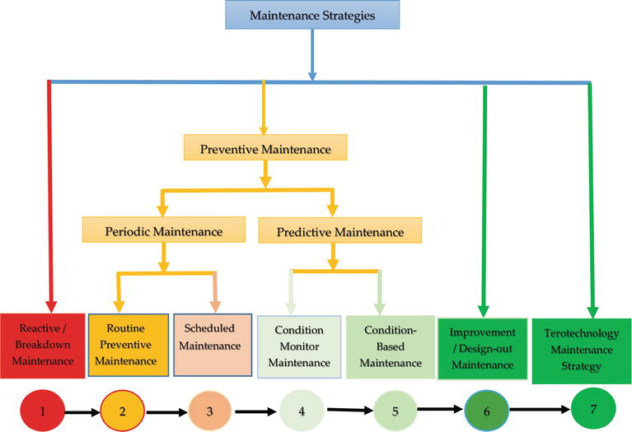
Figure 11.
Modified maintenance strategies indicating ascending order of technology effectiveness [5].
1.2.1. Reactive maintenance
This is also termed to be run to failure maintenance or corrective maintenance or breakdown maintenance. These are operations carried out to restore a machine to operative condition after a breakdown, accident, wear, etc. Since these activities are generally not known in advance and therefore cannot be scheduled, they are often referred to as unscheduled, emergency or repair maintenance. In this type of maintenance, there is no routine maintenance task performed on the equipment until after it has suffered a failure. In other words, machines are repaired or replaced upon failure. It is the simplest approach to maintenance and equally the least effective. It can only be practiced in an industry or applied to equipment’s that are inexpensive, largely duplicated and easy to repair or replace.
1.2.2. Preventive maintenance
Preventive maintenance is hinged on activities put in-place prior to machinery breakdown or failure of its component parts. It is aimed at ensuring smooth production/machine running that will lead to high product quality and minimal or zero (0) % materials wastage. Production systems repaired or maintenance are scheduled or planned regularly at set interval of time. It uses the tools of condition monitoring where critical component parts are being monitored [7].
Preventive maintenance can be subdivided into periodic and predictive maintenance. These subgroups can be further subdivided into routine and scheduled maintenance and condition monitor (or condition monitoring) and on-condition maintenance, respectively.
Routine preventive maintenance: These are maintenance operations, not involving disassembly or replacement of components and comprising mainly of cleaning and adjustments, which are carried out regularly such as every hour, every day, or every week.
Scheduled maintenance: This is maintenance in which preventive activities are scheduled for fixed intervals that are much longer than routine intervals. Moreover, these activities include oiling, greasing, adjustments, replacement of parts, etc. This type of maintenance may be due to government regulations, scheduling of downtime around production operations, availability of special personnel or simply the need for a finite standard that can be understood by everyone involved (e.g. oil changes).
1.2.3. Predictive maintenance
Predictive maintenance is a maintenance practice aimed at predicting the performance behaviour of machinery and their component parts in order to take necessary steps in averting the occurrence of intending and incipient failures and breakdown and its consequences. It uses prognosis tools principle as basis for its operation which is based on monitoring the equipment’s condition.
Predictive maintenance allows failures to be forecasted through analysis of the equipment’s condition. Thus, it ensures high service. Its analysis is generally conducted through some forms of trending on parameters like vibration, temperature, and noise/acoustic sound and lubricant/oil flow in the machinery.
1.2.4. Condition monitor maintenance
Condition monitor maintenance is a self-scheduled, machine-cued predictive maintenance that is based on the periodic, and sometimes continuous, measurement of one or several parameters of condition in an equipment such that a significant change is indicative of a developing failure. Examples are measurement of the viscosity of engine oil in a working machine or the amplitude of vibration of rotating machinery. The evolution of these parameters is considered to be representative of the actual condition of the machine. However, a deviation from a reference value (e.g. temperature, viscosity or vibration amplitude) must occur to identify impending damages. In failure detection, the emphasis is on inspection and test because that is the best way to determine whether warning signs of impending failure are occurring. In order for condition monitoring to be effective, the failure must not be catastrophic. The pay-off from inspection is best with a slow wear-out situation
1.2.5. Condition-based maintenance
Maintenance carried out in response to a significant deterioration in a plant unit as indicated by a change in a monitored parameter of the unit condition or performance is called condition-based maintenance. It uses the machine condition monitoring tools discussed in Section 1.1. vis-à-vis: vibration monitoring tools, thermal monitoring tools, sound monitoring tools, acoustic emission monitoring tool, shock pulse monitoring tools, strain load monitoring tool, lubricant monitoring tools, corrosion monitoring tools, crack detection tools, ultrasonic tools and flux monitoring tools. All these aimed at giving: good indication whenever machine is running smoothly and efficiently or otherwise for failed condition; giving early sign of warning when fault is noticed and providing diagnoses for developed faults.
1.2.6. Design-out (improvement) maintenance
Considering scientific values and overall cost implication, design-out maintenance is the most effective maintenance strategy to be embarked on. It aims at eliminating the effect of failure. The design-out maintenance approach initiates learning system, which collects and provides information on maintenance problems as a feedback loop to design.
Design-out maintenance is usually a phenomenon for areas of high maintenance cost resulting from poor design or operating outside initial design specifications. In a nut-shell, design-out maintenance is to pre-act to eliminate failure instead of reacting to failure

2.5 MANAGEMENT OF EQUIPMENTS
Equipment management includes managing, monitoring and maintenance of both motorized assets and non-motorized equipment. ... Furthermore, it provides a real-time overview of operations via asset tracking, ensuring that managers are better equipped to determine where improvements to efficiency can be made. it also means all personnel and services necessary to the leasing and financing activities of the Partnership, including but not limited to:
• leasing and re-leasing of Partnership Equipment or financing Partnership Equipment through a Secured Loan;
• arranging for necessary maintenance and repair of the Equipment;
• collecting revenues;
• paying operating expenses;
• determining that the Equipment is used in accordance with all operative contractual arrangements;
• providing clerical and bookkeeping services necessary to the operation of Partnership Equipment.

SOME TOOLS USED BY ENGINEERS

Every self-respecting engineer has a good wrench
Wrenches are essential tools for any self-respecting engineer. They are vital for turning nuts and bolts, and are incredibly useful for any task that needs you to 'get a grip' on something.
Wrenches come in a few 'flavors,' with each type being more specialized than others; some are for specific tasks. They include the following but in reality, you'll want to have a collection of each (or get a decent set).
- Box end wrenches are perfectly designed for offering a nice firm grip on a nut or bolt. These types offer excellent leverage for the task at hand.
- Open end wrenches are the simplest of all and their flat jaws make gripping things in tight spaces a breeze. They tend to have two open ends which are usually of different sizes.
- Combination wrenches are, the name suggests, a combination of an open-end jaw wrench and box-end wrench. The open and box end tend to be the same size.
- Adjustable wrenches tend to be low-cost, and are the ones most widely used. They include the venerable monkey wrench and tend to work with both standard and metric fasteners. Most importantly the lower can is adjustable to fit many sizes of bolts and nuts.
- Ratchet wrenches include a ratchet action on one end that moves freely in one direction to engage the fastener in the other direction. Some have pivoting ratchet ends for working in tight spaces.
- Allen wrenches tend to be steel bars bent into an L-shape and are specially designed for hex-head screws and bolts. You'll often get these 'for free' with self-assembly furniture.
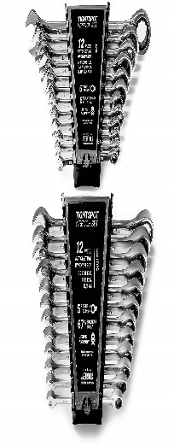figure1: wrenches

2. Jacks are great tools for lifting stuff
Depending on your needs a good jack will go a long way. They are great for anyone who likes to tinker with their car but has many other applications.
They come in a variety of forms.
- Hydraulic floor jacks tend to be in the form of small trolleys with one long lever arm. The take advantage of hydraulics to lift some serious weight.
- Scissor jacks are some of the most common and typically come included with your car.
- Bottle or piston jacks are also hydraulically operated and differ from floor jacks by being cylindrical in form. Their advantage over others is their small footprint.
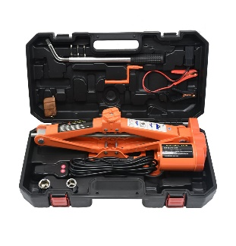figure 2:hydraulic jack

3. Carry all your stuff in a rugged bag or toolbox
With all these awesome tools in your disposal, you are going to need something to carry them all in. Just make sure it's nice a rugged to take all the punishment it's bound to receive throughout its lifetime.
Whether it's a bag or box is a completely personal choice and will depend on the number of tools you intend to carry around.
figure 3:toolbox

4. A good trusty saw is a must
A good saw is essential whether you need to cut wood, stone, or anything else. They come in a variety of forms but generally fall into either the toothed blade or disk types.
Saws tend to come in specific sizes and shapes and can either be hand powered or motorized for maximum cutting power.
The good old fashioned hand saws are the most common and the simplest/most satisfying to use in our humble opinion. These are ideal for small tasks and wood cutting and, of course, living out your dream of being a 'proper' lumberjack.
Jigsaws are great all-purpose saws that are perfect for cutting awkward shapes like curves but can be used to cut straight lines.
Circular saws are power tools which come in cordless or corded varieties. These tend to be used for more hardcore cutting like masonry and metal cutting.
There are also band saws that are powered by a single motor and use a continuous band to cut through anything (within reason). These tend to be used for cutting meat, metal, and wood.
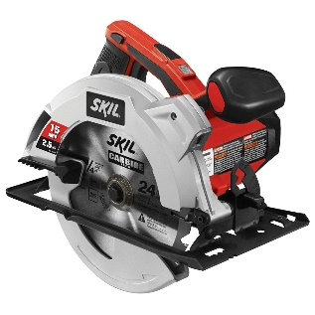figure 4: saw

5. Jumper cables are always handy
Jumper cables or booster cables are great for those amongst you who like tinkering with cars.
Better quality ones tend to be able to handle bigger batteries, offer high-quality insulation, provide surge control, and are a good length.
figure 5:Jumpercable

6. A good quality flashlight is always a good idea
When you need to throw some light on a situation a good torch is invaluable. They come in many shapes, sizes and power but a good hardwearing metal cased one is always a good investment.
There are some good guides out there to help you narrow down your choice.
figure 6: flashlight

7. Pliers, enough said
Pliers are essential tools for any engineer to have in their arsenal. They are very simple tools by design and you'll want a selection of different types depending on the task at hand.
Pliers are ideally suited for plying (manipulating) something - hence the name. You'll be using them to bend or grip things, "crimp" wires, squeeze something or holding something that is small, sharp, hot, corrosive or anything that your fingers are too weak, too big, or awkward to hold in place.
As you'd expect they, like many other tools, come in a variety of shapes and sizes. These tend to fall into the following categories:-
- Extra-long, spring lever needlenose pliers
- Regular needlenose pliers
- Slip-joint pliers
- Tonge and groove arc-joint (aka Channel-lock) pliers
- Locking (Vice-Grip) pliers
- Wire cutters/strippers - though most modern pliers tend to have a wire cutter near the joint.
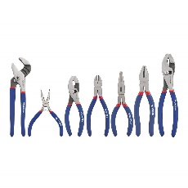 figure 7: pliers

8. Protect your eyes with some eyeglasses or goggles
With all the drilling, hammering, cutting and sawing you're going to be getting up to you'll want to make sure you protect your eyes from flying shrapnel. If you don’t want to permanently damage your eyesight you should get yourself a decent pair of safety goggles.
They come in a wide variety of styles but generally fall into the categories of full-face visors, safety glasses, goggles or foam line/sealed safety glasses. The choice is up to you.
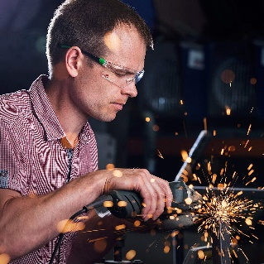 figure 8: googles

9. Keep things level with a spirit level
If you want to make sure something is perfectly level, or vertical for that matter, you'll want to get yourself a decent spirit level. Although there are a plethora of smartphone apps out there, you might not want to get our phone dirty or risk damaging it.
Spirit levels come in various forms but good ones will generally have unbreakable vials with some form of magnification and luminescent fluid. You'll also want to make sure they have a low tolerance which should be specified on the device for normal and reverse positioning.
You will also want to make sure they have a strong profile weight, 500g/m is usually considered good.
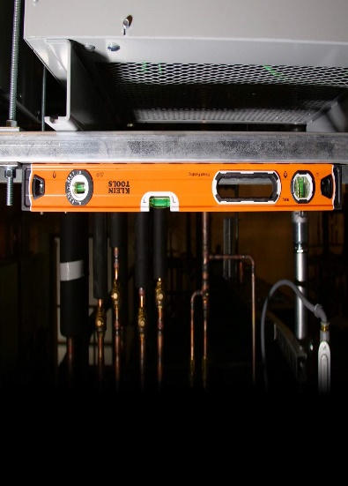 figure 9: spirit level

10. Every engineer needs a good hammer
The hammer. An age-old tool with many, many uses.
If you are going to be hitting something, breaking something or assembling things with nails you'll need a good ol' hammer.
It's always advisable to buy a good quality one as they will tend to last a lifetime and are usually an excellent investment.
As you'd expect they come in a variety of forms depending on the intended task.
- A claw hammer (nail hammer) is the most common type and is superb for most hammer tasks like carpentry, laying floorboards, hammering or removing nails etc.
- Cross-pein hammers are ideal for furniture making.
- Ball-pein hammers (aka Engineer's Hammers) are designed for use in shaping metal, closing rivets and rounding off edges.
- Club or lump hammers are intended for use with chisels to break up masonry.
- Sledgehammers are the granddaddy of hammers as are ideally suited for demolition tasks like breaking down walls, doors or large slabs of concrete etc. They are also used for driving in stakes.
- Dead-blow hammers are specialized sledgehammers designed to deliver maximum momentum on impact to pulverize the intended target.
- Mallet hammers are specialized woodworking hammers used to drive or hit a chisel tap wooden joints etc.
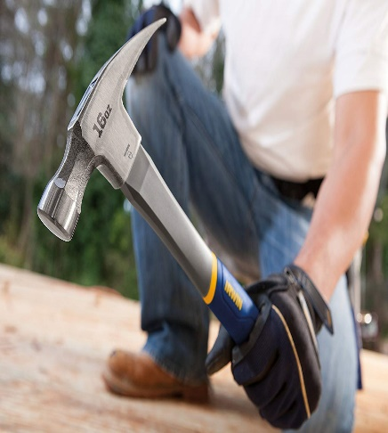 figure 10: hammer

CHAPTER THREE

METHODOLOGY

3.1 STEPS TO ASSET & EQUIPMENT MANAGEMENT SUCCESS

1. Reduce the Need for Corrective Maintenance.
Traditional maintenance only involves the breakdown of assets and equipment. It is the unscheduled correction to failed equipment to maintain performance. Unplanned repairs can result in $300 billion dollars in costs in the United States alone. With regulated asset & equipment management software, organizations keep track of all their assets. They can track the performance data of an equipment and notify staff to properly schedule preventative maintenance prior to a breakdown. Preventative maintenance will not disturb daily operations because it works to prevent longer delays.

2. Save Money on Maintenance.
During the operational phase of the asset/equipment life cycle, a company can face under maintenance or over maintenance problems. Maintenance is a business expense that can cut into the profits of the company. Overdoing it can bring significant costs. On the other hand, under-maintenance can lead to reduced productivity. With Gensuite’s Inspection Tool application (as part of the asset and equipment software suite), you can find the right balance of corrective and preventative maintenance tasks. Conduct Mobile equipment inspections for operational, safety and compliance needs. Gensuite applications allow you to export findings across all of your apps and sites for improved workflow.

3. Standardize Management Processes.
Asset management allows an organization to understand the capabilities of its assets, and how they can be operated in the most effective manner. Standardize your asset & equipment management processes for the tasks that matter most to you. Whether that be tracking specific part details and managing SOPs or authoring, reviewing, and tracking lock-out tag-out (LOTO) procedures, Gensuite has the applications that matter most to you with customization capabilities.

4. Manage Assets and Equipment Across Multiple Sites.
If you work for a large organization that performs various operations across multiple sites, you understand the need for accurate information. With asset & equipment management software, your company can easily create an inventory report across multiple sites to enhance workflow, communication and create a culture of safety. Equipment management success depends not only on the tools to enhance performance, but the employees and managers that are involved in the maintenance activities.

5. Optimize Planning and Resource Use.
Proper asset management can help optimize operations including planning, resource use and ultimately the implementation of an asset management program. As you obtain information on equipment performance and create a standardized process across your sites, you’ll gain valuable information as to what resources you need and what parts of your asset management program are well planned–then you can begin to enhance weak areas.
3.2 WAYS TO MAINTAIN EQUIPMENTS
Heavy machinery, especially Mining, Industrial or Farming Equipment, requires constant maintenance to keep it in good working order. Conversely, poorly maintained large machinery equipment runs inefficiently. Breakdowns are costly and safety is also an important consideration.
Here are five top tips for large machinery maintenance:

Stay on top of large machinery operator training
Many types of large machinery have multiple operators. One of the ongoing inspections on any checklist should be overseeing the correct operation of the equipment.
Large machinery should be inspected as soon as it is purchased. Operator training is usually done at that point, but training needs to be kept up. Employees come and go, skills become rusty and poor operation leads to breakdowns.
Operator manuals can be revised for the specific work situation. They can be rewritten in simpler language. A short manual can be provided to each operator for easy reference. And, if you operate in a paperless environment, you can rest assured operators use the most current version of each manual.
One other note is to identify best practices, which can then be applied to other facilities or geographic locations. The knowledge you learn about how to maintain your equipment can become quite valuable – be sure to best leverage this important knowledge and use it at every applicable location.

Add and test lubricants frequently
Lubricants reduce friction around any moving part. A schedule of good lubrication maintenance extends the life of large machinery equipment and parts.
Lubrication is one of the first and most important of maintenance checks. Look for signs of excess oil or grease build-up on pistons. Check for leaks around oil seals.
Be sure to use the right lubricant. There are specific kinds of oil and grease for every component. Check the manufacturer’s recommendations.
Getting the lubricants checked is a good way to diagnose problems with large machinery. Experts analyze particles in the used oil. The makeup of any contaminants will indicate which part may be suffering from wear or breakdown.

Check for signs of wear
Vibration, shock, high temperatures, friction and age all contribute to the breakdown of parts in heavy machinery.
- Vibration can come from gears and belts that are out of alignment
- Shock can come from accidents and from poor operator technique
- High temperatures can come from extended use, friction, poor lubrication and worn parts, among other reasons
- Age affects many key components. Over time, belts will warp. Seals will dry and crack. Bolts will loosen and stretch out of shape. Age is a factor to monitor in equipment.
Should you discover wear and tear on any moving parts within your heavy equipment, be sure to quickly perform the necessary replacement of any worn parts.

Keep large machinery clean, and maintain a clean environment
There are many seals and filters in place on heavy machinery to keep working parts clean and free of contamination. Seals should be inspected regularly to make sure they’re in good condition. Filters should be inspected and changed regularly. Breathers should be kept clean to avoid creating a vacuum in the cab which will suck contaminants into the cab. The electronics in the cab are susceptible to breakdown if contaminated. This impacts the clutch, for example.
Large machinery should be stored in a shed or other building if at all possible. Exposure to wind and weather can lead to rust and rot. The machinery should be run periodically if it is not in use.

Have a maintenance and repair schedule, and keep good records
Fluids, tires, tracks and electrical systems are among the components that have to be checked regularly for preventive maintenance. Know what needs to be inspected and when. Here are some examples.
- Power transmissions have many moving parts that need to be maintained in top condition. Gearboxes need to be checked for lubrication, vibration and damage to parts.
- Friction materials, seals, gaskets and bearings all need to be inspected for wear and replaced. Gears and shafts usually last a long time and don’t need to be replaced often, if at all.
- Drive train components need constant monitoring. Check pulleys and v-belts on CVT transmissions for alignment and wear. Check sprockets for correct meshing with chains and for breaks.
- Test the oil to diagnose problems. Change filters frequently.
- Bearings keep great amounts of force running smoothly and are vital to large machinery performance. Check bearing lubrication often. Maintaining bearings well extends their life.
- Lubricate gears frequently.
- Do a seal check to prevent bearing raceway contamination.
- Run torque checks on the bolts. Bolts can elongate and creep over time.

CHAPTER 4

CONCLUSIONS AND RECOMMENDATIONS

CONCLUSIONS
In conclusion, from the literature review and the methodology, we can see how the operation, maintenance and management of engineering equipment for sustainable development in Nigeria and how it has saved the world so following the above methods in methodology it can be shown how engineers can manage and maintain their equipment’s to solve some environmental and mankind problems

RECOMMENDATIONS
  - Establish and follow safe chemical storage procedures for your laboratory
  - While working outside normal hours ensure that information about your presence in the laboratory is available to another person
  - Avoid all skin contact with toxic and corrosive chemicals through minimum usage and use of personal protective equipment
  - Ensure good housekeeping, adequate spacing between experimental setups
  - While handling flammables ensure that no ignition sources are available in the vicinity; in case highly flammable substances are in use consider use of sensors to detect leakages if reasonable amount of inventories are available
  - Ensure all chemical containers are labelled (along with a date of purchase) according to relevant industry guidelines
  - Use appropriate signage to indicate highly hazardous chemicals and wastes
  - Use signage to demarcate work areas subject to non-chemical hazards such as noise, temperature, radioactivity, microwave exposure, etc.
  - Document any known hazardous properties of new chemicals, nanomaterials, toxins, etc
  - While using a chemical ensure that information on other chemicals which are incompatible with the former

REFERENCES
- Walmsly, N., & Pearce, G. (2010). Towards Sustainable Water Resources Management: Bringing the Strategic Approach up-to-date. Irrigation & Drainage Systems, 24(3/4), 191–203.
- ^ USGS - Earth's water distribution
- ^ Fry, Carolyn The Impact of Climate Change: The World's Greatest Challenge in the Twenty-first Century 2008, New Holland Publishers Ltd
- ^ "Extend access to water with the help of technology. [Social Impact]. DESAFIO. Democratization of Water and Sanitation Governance by Means of Socio-Technical Innovation (2013–2015). Framework Programme 7 (FP7)". SIOR, Social Impact Open Repository.
- ^ Grafton, Q. R., & Hussey, K. (2011). Water Resources . New York: Cambridge University Press.
- ^ Molden, D. (Ed). Water for food, Water for life is A Comprehensive Assessment of Water Management in Agriculture. Earthscan/IWMI, 2007.
- ^ The World Bank, 2006 "Reengaging in Agricultural Water Management: Challenges and Options". pp. 4–5. Retrieved 2011-10-30.
- ^ Chartres, C. and Varma, S. Out of water. From Abundance to Scarcity and How to Solve the World’s Water Problems FT Press (USA), 2010
- ^ "GES knowledgebase". Global Economic Symposium. Retrieved 2016-02-16.
- ^ Escolero, O., Kralisch, S., Martínez, S.E., Perevochtchikova, M. (2016). "Diagnóstico y análisis de los factores que influyen en la vulnerabilidad de las fuentes de abastecimiento de agua potable a la Ciudad de México, México". Boletín de la Sociedad Geológica Mexicana (in Spanish). 68 (3): 409–427. doi:10.18268/bsgm2016v68n3a3.
- ^ Howard, K.W.F (2003). Intensive Use of Groundwater:: Challenges and Opportunities. A.A. Balkema Publishers.
- ^ Mund, Jan-Peter. "Capacities for Megacities coping with water scarcity" (PDF). UN-Water Decade Programme on Capacity Development. Retrieved 2014-02-17

