DESIGN OF INNOVATIVE AND AUTOMATED RESPIRATORY BUILDINGS FOR PATIENTS AND HEALTH WORKERS AGAINST CORONAVIRUS DISEASE OUTBREAK
BY
OFOEGBU CHIJIOKE FORTUNE
17/ENG02/062
A TERM PAPER SUBMITTED TO
COLLEGE OF ENGINEERING, AFE BABALOLA UNIVERSITY, ADO-EKITI, EKITI STATE.
FOR ENGINEERING LAW AND MANAGERIAL ECONOMICS (ENG 384)
IN PARTIAL FULFILMENT TO THE REQUIREMENTS FOR THE DEGREE OF BACHELOR OF ENGINEERING IN CHEMICAL ENGINEERING.

12th of APRIL, 2020
TABLE OF CONTENTS

TITLE PAGE………………………………………………..…………………………………1

TABLE OF CONTENTS………………………………………………………………………2

ABSTRACT…………………………………………………………………………………...3

- INTRODUCTION…………………………………………………….……………..…….4

2.0 LITERATURE REVIEW………………………………………………...……………......6

3.0 CHALLENGES…………………………………………………………………………..11

4.0 RECOMMENDATION……………………………………….………………………….12

5.0 CONCLUSION…………………………………………………………………………..13

6.0 REFERENCES…………………………………………………………………………...14

ABSTRACT
With the rapid spread of severe acute respiratory syndrome coronavirus 2 (SARS-CoV-2) that results in coronavirus disease 2019 (COVID-19), corporate entities, federal, state, county and city governments, universities, school districts, places of worship, prisons, health care facilities, assisted living organizations, day-cares, homeowners, and other building owners and occupants have an opportunity to reduce the potential for transmission through built environment (BE) mediated pathways. Over the last decade, substantial research into the presence, abundance, diversity, function, and transmission of microbes in the BE has taken place and revealed common pathogen exchange pathways and mechanisms. In this paper, we synthesize this microbiology of the BE research and the known information about SARS-CoV-2 to provide actionable and achievable guidance to BE decision makers, building operators, and all indoor occupants attempting to minimize infectious disease transmission through environmentally mediated pathways. We believe this information is useful to corporate and public administrators and individuals responsible for building operations and environmental services in their decision-making process about the degree and duration of social-distancing measures during viral epidemics and pandemics

- INTRODUCTION
Coronaviruses are a family of viruses that cause disease in animals. Seven, including the new virus, have made the jump to humans, but most just cause cold-like symptoms.
Covid-19 is closely related to severe acute respiratory syndrome (Sars) which swept around the world in 2002 to 2003. That virus infected around 8,000 people and killed about 800 but it soon ran itself out, largely because most of those infected were seriously ill so it was easier to control.
Another coronavirus is Middle East respiratory syndrome (Mers), cases of which have been occurring sporadically since it first emerged in 2012 - there have been around 2,500 cases and nearly 900 deaths. Those with weakened immune systems may develop more serious symptoms, like pneumonia or bronchitis. You may never develop symptoms after being exposed to COVID-19. So far, most confirmed cases are in adults, but some children have been infected. There is no evidence that children are at greater risk for getting the virus. Humans first get a coronavirus from contact with animals. Then, it can spread from human to human. Health officials do not know what animal caused COVID-19. The COVID-19 virus can be spread through contact with certain bodily fluids, such as droplets in a cough. It might also be caused by touching something an infected person has touched and then touching your hand to your mouth, nose, or eyes.
If you believe you have COVID-19, you should contact your family doctor immediately. Before going to the doctor’s office, call with your concerns. This will allow the office to collect information and offer you guidance on next steps. To diagnose you, your doctor may run tests to rule out other common infections. In some cases, your doctor may suggest you self-isolate to prevent the spread of infection. Currently, the only way to be tested for COVID-19 is to talk to your family doctor. Practice social distancing. Avoid people who are sick or meeting in large groups. Stay home if you are sick. Cover your cough with a tissue or cough into your upper sleeve or elbow. Do not cough into your hands.
Wash your hands often with soap and water for at least 20 seconds, especially after going to the bathroom, before eating, and after blowing your nose, coughing, or sneezing. If soap and water are not readily available, use an alcohol-based hand sanitizer with at least 60% alcohol. Always wash hands with soap and water if hands are visibly dirty. Avoid touching your mouth, nose, or eyes. There is currently no vaccine or treatment for COVID-19. Symptoms of a coronavirus usually go away on their own. If symptoms feel worse than a common cold, contact your doctor. He or she may prescribe pain or fever medication. The FDA is currently advising people to be cautious of websites and stores selling products that claim to prevent, treat or cure COVID-19. Additionally, do not take any form of chloroquine unless it has been prescribed for you by your family doctor and purchased from a legitimate source. As with a cold or the flu, drink fluids and get plenty of rest. If you are having trouble breathing, seek immediate medical care. When possible, avoid contact with others when you are sick. If you have COVID-19, wear a facemask to prevent spreading the virus to others. The CDC does not recommend wearing a mask if you do not have COVID-19.

2.0 LITERATURE REVIEW
The World Health Organisation’s research paper ‘Natural Ventilation for Infection Control in Healthcare Settings’ specifies how important ventilation is in controlling the spread of germs in medical facilities. A proper flow of air through treatment and recovery spaces helps reduce the growth of infectious illnesses while also stimulating the natural recovery process. This makes structural principles that incorporate natural airflow in perfect healthcare facility design vital. We took an in-depth look into this building trend, known as ‘breathing architecture’ to determine why this design principle contributes to a more effective medical space.
2.1 RESPIRATORY BUILDINGS FOR PATIENTS
Healthcare facility design that aids health: It may seem unusual, but even the most minor architectural elements of your medical facility can contribute to faster patient recovery time, and improved mental and physical well-being. The basic health elements that apply in everyday life are even more applicable in healthcare facilities. We still need ample natural light exposure and regular airflow to minimise the risk of infections spreading. This makes architectural designs that consider these factors an excellent long-term investment. Natural air flow is vital to improving a patient’s recovery and mental well-being.
What is breathing architecture and why is it a positive influence on patient health?: Breathing architecture is a principle that employs structural and aesthetic strategies to maximise the flow of natural air and improve mechanical ventilation for better indoor air quality. These practices contribute to beautiful buildings with a more ‘open’ feel and improved breathability. The positive influences of breathing architecture to maximise airflow and ventilation include:
Breathing architecture helps to dilute or remove other air pollutants from high-traffic areas, as well as naturally reduce the risk of infections spreading. Breathing architecture incidentally also considers natural light as an important design element. Natural light is well-documented in numerous studies, including one conducted by Northwestern University on natural light in the office, as essential to better healthcare facility design.
Improved mechanical ventilation through breathing architecture elements in healthcare facility design can help to reduce a building’s HVAC costs. Incorporating breathing architecture into healthcare facility design. Employing elements of breathing architecture in healthcare facility design is easier when you enlist the help of medical architecture experts. Space for Health has several relevant offerings, including feasibility and design development services, offering guidance on how you can maximise natural airflow in your healthcare facility.

2.2 INNOVATIVE INFRASTRUCTURE FOR HEALTH WORKERS
Ventilators
Ventilators are key in cases of severe treatment of coronavirus infections. Coronavirus attacks people’s lungs and can cause especially people with pre-existing respiratory conditions severe shortness of breath, that require them to be put on a ventilator.
Ventilator machines mechanically move air in and out of a patient's lungs, keeping them alive when the patient’s body can no longer do it on its own. Since the ventilators first usage in the 1950s, it has become a key medical device for hospitals, where startups continue to tackle this opportunity to come up with smaller and easier to use devices. Ventilators are crucial to fight the COVID 19, but they are in a huge shortage in the US. The ventilator to critical patient ratio is estimated to 1:10.
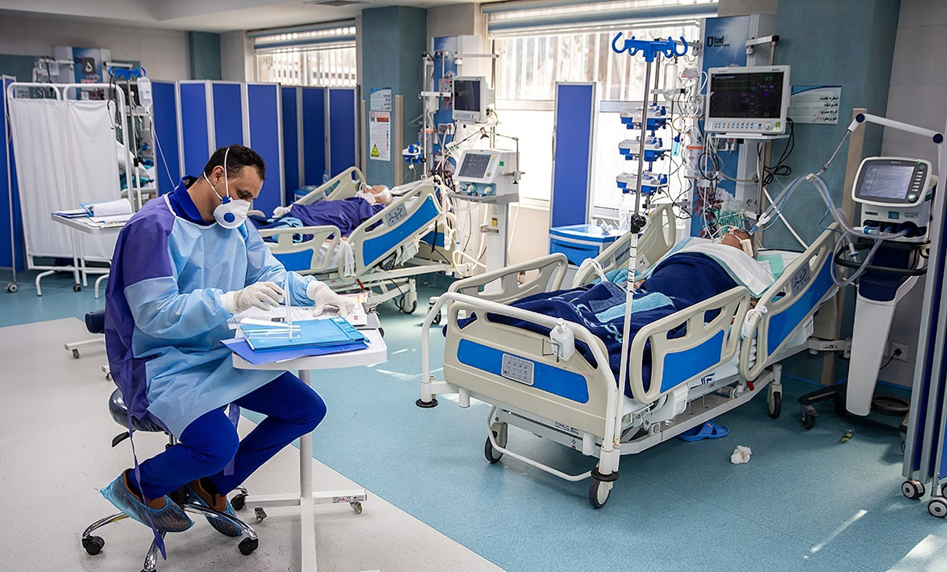
Fig 1.0: A Ventilator At Use In A Hospital

Ventec Life
Ventec Life’s mission is to redefine respiratory care, by improving patient outcomes and helping caregivers to provide effective treatments. Ventec’s product VOCSN integrates five different medical devices (a ventilator, oxygen concentrator, cough assist, suction, and nebulizer) into one integrated respiratory system. Their portable device runs on batteries and thus gives the patients freedom of movement. Its advanced operating system and customizable toolsets it apart from traditional ventilators currently deployed hospitals. Its small size is another advantage that allows hospitals and care facilities to store and place the machines at the point of use, storing them more effectively.
For COVID-19, ventilators are key and are deployed to prolong a patient's life expectancy, supporting them through the worst time. Most of the hospitals in the US do not have enough respiratory devices at the moment to supply the increasing demand of patients diagnosed with COVID-19. Ventec provides a 5-in-1 solution to help hospitals and communities fighting the virus. General Motor is working with Ventec to ramp up the production of ventilators to alleviate the shortage in the US.
Onebreath Ventilators
OneBreath is a new business addressing one of the most difficult problems in critical care medicine: Delivering high precision, high-reliability mechanical ventilation at an affordable cost. Affordable mechanical ventilation is a critical unmet need globally, particularly in severely under-resourced developing markets, presenting a massive opportunity.
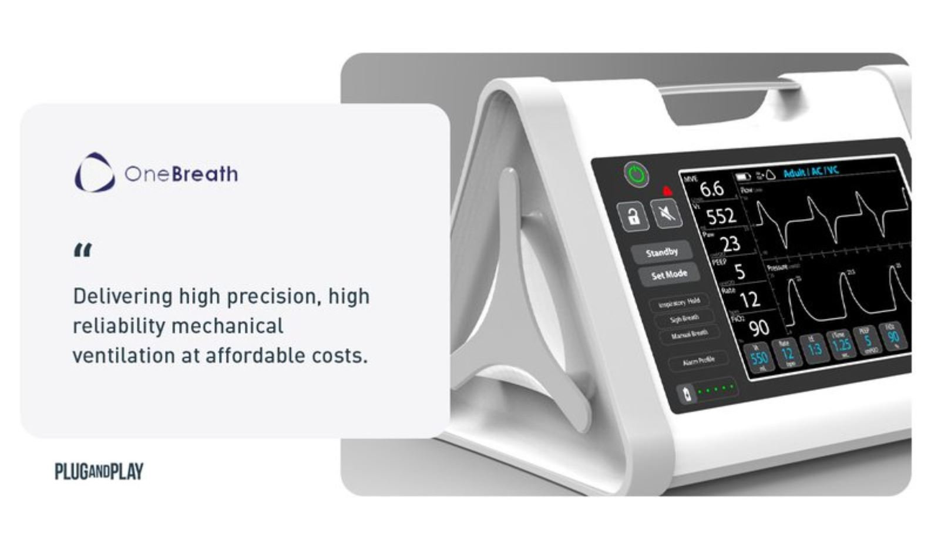
Fig 2.0: OneBreath Ventilators
Ao-Air
Ao-Air’s patented PositivAir™ technology utilizes fans to create a positive pressure that creates a clean air environment and allows a person to breathe freely, requiring no seal around the mouth and nose. This system allows clean, cool air to comfortably escape the mask around the face creating a continuous, one-way outflow that keeps outside air out. This means unparalleled protection, which is up to 50x better than current market-leading solutions and creates a more humane experience.
NasoFilters
Developed by a team from IIT Delhi, Nasofilters offer a respiratory nasal filter that sticks to your nose and prevents entry of harmful air pollutants (PM2.5). Nasofilters are easier to use than traditional anti-pollution masks. The product is small and stealth; it offers protection when wearing masks is not possible, such as in business meetings.
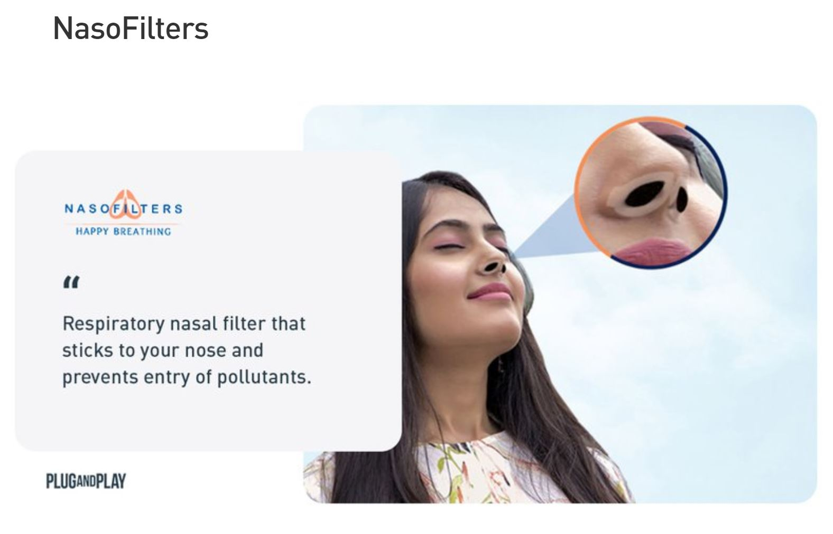
Fig 3.0: NasoFilters

BreathResearch
BreathResearch’s mission is to revolutionize respiratory monitoring and management by enabling early detection and treatment of respiratory attacks and exacerbations. Over $130 billion is spent on asthma and COPD in the U.S. annually. Currently, over 27 million people with asthma and COPD in the U.S. have had at least one hospitalization. Others with chronic heart disease, kidney disease, and diabetes are at risk for respiratory attacks due to respiratory flu viruses such as COVID-19. Their dual-sensor spirometer can measure and track lung flow volumes and lung sounds to provide screening and monitoring at a clinic or at home via Telehealth. Breathsearch converts airwaves generated from a person’s breathing into sound waves, thereby allowing them to analyze one’s breath with acoustic analytics and artificial intelligence.
Their predictive analytics can be deployed either standalone or integrated into other respiratory devices and equipment and be applied individually as well as tracked nationally and globally to identify people and areas in need of attention and treatment. Breathsearch have applied their technology to asthma and COPD severity in a small pilot at Mayo. For COVID-19, Breathsearch learned about a three 3 week window where the disease may be 1) non-symptomatic, 2) upper respiratory mild flu-like symptoms or 3) develop into severe acute respiratory syndrome (unique to COVID-19). Enabling Breathsearch’s technology allows tracking lung flow volumes and lung sounds to do early detection on an individual and national/global basis. Specifically for COVID-19 Breathsearch could predict in week one or two after infection which patient might need aggressive treatment earlier, what hospital resources would be needed in a week's time and in what locations.

3.0 CHALLENGES
1. Nigeria doesn’t have the industry that can manufacture these equipments therefore the country has to import them leading to continual reliance on foreign countries.
2. Difficulties In Ventilators Supply
Ventilators have to operate in an extremely reliable way in a high-stakes environment. “If they fail, the patient is very likely to die,” explains Mauricio Toro, a Colombian engineer who joined a group in Medellin that completed the design of three different open-source ventilators. “This is what makes them so challenging to build.” If they fail, the patient is very likely to die. This is what makes them so challenging to build – Mauricio Toro. As intensive care units overcrowd and doctors must care for more patients, the reliability of the machines cannot be in question. But the only way to make them reliable is extensive testing, and that takes time – up to two years of testing, for commercial manufacturers. This is an extremely long period under the circumstances. Many more ventilators are needed now, not later. And scientists have calculated that the development of a vaccine against Covid-19 could take up to 18 months.
3. The lack of adequate infrastructure to create automated respiratory buildings for Nigerian patients diagnosed with COVID-119.
4. The lack of funding by both the private sector and the federal government to achieve this goal.

4.0 RECOMMENDATIONS
1. Respiratory Protective Devices
Respiratory protective equipment is not something that people use very often. But it is a very important measure for protection to a person, particularly during a pandemic outbreak in order to prevent the transmission of infectious diseases. Similar to SARS, COVID-19 is an extremely contagious respiratory disease that has a significant effect on society. Accordingly, COVID-19 has increased the usage of masks and caused a global shortage of supply. However, there are alternatives to masks that could protect people from deadly airborne pathogens that are worth considering.
2. Point of Care Diagnostics
Point of Care Diagnostics becomes ever more important as the numbers of those diagnosed with COVID-19 increase every day. A pandemic outbreak leads to an exponential growth rate for as long as the uninfected and the infected continue to interact and there are still large numbers of uninfected people running the risk of getting infected.
3. Designing spaces with fewer walls, pillars and other hindrances to airflow.
4. Incorporating more windows and access points to the outside in the building plans.
5. Analysing natural wind-flow tunnels in the early facility design phase and arranging your floor plan to place areas that require high airflow the most around these spaces. For example, locating patient recovery rooms here would be more advantageous than incubators or laboratories that require stable environmental conditions.

5.0 CONCLUSION
In conclusion, the design of innovative and automated respiratory buildings for patients and health workers against coronavirus outbreak would be very important in the process of eradicating the virus from our Nigerian society and the world at large.

8.0 REFERENCES
A. Costello, M. Abbas, A. Allen, S. Ball, S. Bell, R. Bellamy, S. Friel, N. Groce, A. Johnson, M. Kett. Managing the health effects of climate change. Lancet (London, England), 373 (2009), pp. 1693-1733.
Allen, F., & Carletti, E. (2010). An overview of the crisis: Causes, consequences, and solutions. International Review of Finance, 10(1), 1-26. Bagliano, F. C., & Morana, C. (2012). The Great Recession: US dynamics and spillovers to the world economy. Journal of Banking & Finance, 36(1), 1-13. Bentolila, S., Jansen, M., & Jiménez, G. (2018).
Coronavirus Disease 2019 (COVID-19). American Academy of Family.2020. Physicians. Available at: “https://familydoctor.org/condition/coronavirus/”
Credit availability and investment: Lessons from the “great recession”. European Economic Review, 59, 212-227. Georgieva, K (2020). IMF Managing Director Kristalina Georgieva’s Statement Following a G20 Ministerial Call on the Coronavirus Emergency. IMF Press statement. Available at: https://www.imf.org/en/News/Articles/2020/03/23/pr2098-imf-managing-director-statement-following-a-g20-ministerial-call-on-the-coronavirus-emergency Horowit, J. (2020).
Elevate.2018. “Why ‘Breathing Architecture’ Is Key To Healthcare Facility Design”. Space For Health Pty Ltd.
Goniewicz M, Włoszczak-Szubzda A, Niemcewicz M, Witt M, Marciniak- Niemcewicz A, Jarosz MJ. Injuries caused by sharp instruments among healthcare workers international and Polish perspectives. Annals of Agricultural and Environmental Medicine. 2012;19(3):523–527.
Global Asthma Network. Global Asthma Report 2018. Available at: http://www.globalasthmareport.org/Global%20Asthma%20Report%202018.pdf. Accessed May 2019
Larry Elliot, L. (2020). Prepare for the coronavirus global recession. The Guardian. Media report. Available at: https://www.theguardian.com/business/2020/mar/15/prepare-for-the-coronavirus-global-recession Mian, A., & Sufi, A. (2010).
Moore Jr RM, Kaczmarek RG. Occupational hazards to health care workers: Diverse, ill-defined and not fully appreciated. American Journal of Infection Control. 1990;18(5):316–327.
Stonerock T. Professional Burnout. Recent Developments in Theory and Research, London and New York; 2004.
The Coming Coronavirus Recession and the Uncharted Territory Beyond. Foreign Affairs, Media Report. Available at: https://www.foreignaffairs.com/articles/2020-03-17/coming-coronavirus-recession Financial Times (2020). Global recession already here, say top economists. Available at: https://www.ft.com/content/be732afe-6526-11ea-a6cd-df28cc3c6a68 Gaiotti, E. (2013).
The Drug Development Process. Available at: https://www.fda.gov/forpatients/approvals/drugs/ucm405622.htm. Last accessed: May 2019
The global coronavirus recession is beginning. CNN. Media report. Available at: https://edition.cnn.com/2020/03/16/economy/global-recession-coronavirus/index.html Jagannathan, R., Kapoor, M., & Schaumburg, E. (2013). Causes of the great recession of 2007–2009: The financial crisis was the symptom not the disease. Journal of Financial Intermediation, 22(1), 4-29.
Triolo PK. Occupational health hazards of hospital staff nurses. Part II: Physical, chemical and biological stressors. AAOHN Journal. 1989;37(7):274–279.
WHO. The Global Impact of Respiratory Disease. Available at: https://www.who.int/gard/publications/The_Global_Impact_of_Respiratory_Disease.pdf. Accessed May 2019

