ENGINEERING STRATEGIES FOR HANDLING COVID-19 CASES FOR ENVIRONMENTAL HEALTH AND ECONOMIC STABILITY
PREPARED BY
UDEMGBA RITA CHIDUM
17/ENG04/069
A TERM PAPER SUBMITTED TO
THE DEPARTMENT OF ELECTRICAL AND ELECTRONICS ENGINEERING
COLLEGE OF ENGINEERING
AFE BABALOLA UNIVERSITY, ADO-EKITI, EKITI STATE, NIGERIA.
IN PARTIAL FUFILLMENT OF REQUIREMENTS FOR ENG 384 ENGINEERING LAW AND MANAGERIAL ECONOMICS
MONDAY 13TH APRIL, 2020

ABSTRACT
With 1.39 million coronavirus cases and 79,382 deaths globally, the world continues to battle the COVID-19 pandemic. Even before the outbreak, the outlook for the world economy—and especially developing countries like Nigeria—was fragile, as global GDP growth was estimated to be only 2.5 percent in 2020. While many developing countries have recorded relatively fewer cases—Nigeria currently has 238 confirmed cases and 5 deaths as of this writing—the weak capacity of health care systems in these countries is likely to exacerbate the pandemic and its impact on their economies.

Nowadays, sustainable development is considered a key concept and solution in creating a promising and prosperous future for human societies. Nevertheless, there are some predicted and unpredicted problems that epidemic diseases are real and complex problems. Hence, in this research work, a serious challenge in the sustainable development process was investigated using the classification of confirmed cases of COVID-19 (new version of Coronavirus) as one of the epidemic diseases. Hence, binary classification modeling was used by the group method of data handling (GMDH) type of neural network as one of the artificial intelligence methods.

Contents
ABSTRACT 2
LIST OF FIGURES 5
CHAPTER 1 6
1.0 INTRODUCTION 6
CHAPTER 2 10
2.0 LITERATURE REVIEW 10
2.1 How does economic development affect environmental health? 12
2.2 AGGREGATE DEMAND WILL FALL, BUT GOVERNMENT EXPENDITURE WILL RISE 13
2.3 WHAT ARE THE POLICY RESPONSES BY THE NIGERIAN GOVERNMENT? 15
CHAPTER 3 16
3.0 METHODOLOGY 16
3.1 Conditions of analysis 17
3.2 Case Study 18
3.3 Group Method of Data Handling (GMDH) 18
3.4 How can environmental health be integrated into sustainable development? 20
CHAPTER 4 25
4.0 ANALYSIS OF RESULTS 25
4.1 Predicting and modelling outbreaks 25
CHAPTER 5 27
5.0 CONCLUSION 27
CHAPTER 6 28
6.0 RECOMMENDATIONS 28
REFERENCES 30

LIST OF FIGURES
Figure 1 11
Figure 2 17
Figure 3 18
Figure 4: World Economic Forum 21
Figure 5 23
Figure 6 24
Figure 7 25

CHAPTER 1

INTRODUCTION
The concept of sustainable development as a new concept, process, and undeniable fact has emerged in the policies of major governments, and plays a key role in the development of human societies Sustainable development is, generally, a combination of the three social, economic, and environmental goals in which political goals are involved. In fact, sustainable development is the advancement of the quality of all aspects of life of today’s generation without creating negative impacts on the lives of future generations. While it may seem easy to create sustainability in theory, the process of sustainable development faces many unforeseen problems and obstacles that slow down the process. One of the anticipated problems is the emergence of epidemic diseases that not only have a negative impact on the economy but also cause social problems, both of which are fundamental to sustainable development. Although this is a temporary and transient problem, it has the potential to disrupt the process, which can have years of adverse effects. With rapid global urbanization, the importance of understanding relationships between the changing urban environment and human health and wellbeing is being increasingly recognized. However, the science underlying the complexity of linkages is poorly developed. In this paper, we explore the different types of health and wellbeing risks in the urban environment, their dynamic, ever evolving nature, and define both their spatial and socioeconomic dimensions. We also present the new innovative program on Health and Wellbeing in the Changing Urban Environment that was launched recently by the International Council for Science (ICSU) wherein an integrated systems approach is recommended to address this complexity. We conclude by identifying key elements needed for the success of the new science initiative.
► urban environments play an essential role in shaping human health and wellbeing.
► a systems approach is required in understanding the many linkages between health and wellbeing and urban environments.
► We present the new program on Health and Wellbeing in the Changing Urban Environment launched by the International Council for Science (ICSU).
► We discuss several essential elements for the success of this initiative, including adopting a broadly defined systems approach, integrating social science perspectives, adopting trans disciplinary and participatory approaches, establishing long term monitoring and data bases, and promoting innovative practices and cross city learning.
With more than half of world's human population now living in cities, and with that proportion projected to increase into the foreseeable future, cities are important determinants of future sustainability and human health and wellbeing .The value of linking urban environment and health and wellbeing outcomes is now well recognized, however the myriad relationships are far from being understood scientifically, let alone guiding urban environmental planning, policy and governance.
Urban environments are multi-faceted, diverse, dynamic, complex and evolving, as are the underlying features for human health and wellbeing. Globally, health status is better in urban areas than in rural areas. The many positive aspects of urban life, such as employment, higher incomes, better opportunities for education, and access to health care, encourage rural to urban migration. However, recent studies show that such advantages of urban health status can be eroded due to the adverse impacts of urban environment, increased fat in diet, and sedentary ways of living. Potential urban hazards with associated health risks include substandard housing, crowded living conditions, contaminated food, unclean water, inadequate sanitation, poor solid waste disposal services, air pollution, and congested traffic . Furthermore, within cities there are often significant health inequities, such as differences in life expectancy for people living in slum conditions than those living in wealthy neighborhoods? These health inequities can be traced back to differences in social and living conditions of urban dwellers, and variable environmental qualities in cities. There are significant equity issues in terms of access to health-care, vaccination coverage, and rate of work related accidents and injuries in cities. To identify these urban health inequities, it is important to disaggregate data on health and health determinants and to examine spatial and socio-economic differences.
Importantly, effective interventions to improve urban health and wellbeing often require action well beyond those that can be offered by the formal health sector. There is a need for the engagement of many different societal sectors (e.g. water supply, sanitation, housing, transport, education) and all levels of government – local, provincial and national. Importantly, effective interventions to improve urban health and wellbeing often require action well beyond those that can be offered by the formal health sector. There is a need for the engagement of many different societal sectors (e.g. water supply, sanitation, housing, transport, education) and all levels of government – local, provincial and national. The complexity of the linkages between urbanization, environmental change and human health and wellbeing, requires a systems approach towards health, wellbeing and urban environment. The following section illustrates the health and wellbeing challenges presented by rapid urbanization, and the multifaceted linkages between urban environment and wellbeing. The COVID-19 (a new version of Coronavirus) is one of the newest and most serious challenges facing governments, and there has not been much research into this problem. Although the understanding of COVID-19 is limited, interim guidance on laboratory biosafety was introduced by the World Health Organization (WHO). Kampf et al. investigated the persistence of coronaviruses on inanimate surfaces and ways to deal with it. They found that the period of persistence is nine days for coronaviruses, and some disinfectants, such as 62%–71% ethanol, 0.5% hydrogen peroxide, or 0.1% sodium hypochlorite can be very efficient in dealing with this virus. Lai et al. have evaluated the outbreak of COVID-19 and its challenges. Based on their results, they made some recommendations for the prevention of more outbreaks of the virus. In another study, the role of inanimate surfaces in the outbreak of coronaviruses is investigated by Kampf. Based on the obtained results, he provided some recommendations about the impact of surface disinfection to prevent further viral spread. Telles has conducted an overview of the behaviors of viruses. Some datasets were investigated, and the obtained results show that dynamic mathematical modeling was essential to predict behaviors of viruses. The role of media coverage on the public was evaluated by Wen et al. Their obtained results indicated that misleading and biased media coverage could have a negative impact on individuals’ mental health. Chen et al. carried out an investigation for predicting the number of confirmed cases of COVID-19. They evaluated the trend of transmission and recovery rates based upon time, and a mathematical model was proposed. The obtained results show that the proposed model had a suitable performance to predict the confirmed cases]. In another study, the trend of the COVID-19 outbreak was estimated in China by Li and Feng. Their results show that rapid and dynamic strategies can be useful to diminish and constrain the current crisis. Chinazzi et al. evaluated the effect of travel constraints to reduce the COVID-19 outbreak. The obtained results indicated that travel restrictions are highly effective in reducing the spread of this new coronavirus. It is worth mentioning that the impact of temperature on virus spread and survival show different results. There have been some investigations on the effects of environmental parameters on epidemic diseases, too. The flu virus spreads quickly in cold and dry conditions, while it is completely inactive at temperatures above 30 °C. However, the epidemic of one type of coronavirus, MERS-CoV, was between April and August, which meant that the virus spread quickly in warm temperature, low wind speed, low relative humidity, and high ultraviolet index.
A review of previous studies shows that very few researchers have addressed the challenges of the COVID-19 (new version of Coronavirus) in the sustainable development process and, also, unpredictable problems and complexity of the issues require the use of highly capable approaches like artificial intelligence methods to understanding these types of issues. Hence, due to the importance of the subject, the present study investigated the feasibility of artificial intelligence in the classification of confirmed cases of COVID-19, which is a severe challenge in the sustainable development process, and it is an imperative task. In addition, statistical analysis was carried out, and the obtained results were discussed. It is worth mentioning that this type of analysis has not been used in previous research. Ravi Anupindi is a professor of technology and operations at the Ross School of Business and faculty director for the Center for Value Chain Innovation.
“It is important to recognize that virus outbreaks are different from other types of disruptions like fires, floods and earthquakes,” he said. “COVID-19 and other virus outbreaks, depending on the scale and severity of the event, prevent people from coming to work and disrupt supply chains. Unlike natural disasters, viruses like COVID-19 spread geographically, making the scale of supply chain impacts highly unpredictable.”
“In the face of a global pandemic and fears of a macroeconomic slowdown, now is the time to strengthen oversight of financial markets, not roll back regulations as the big banks insist,” Jeremy Kress, assistant professor of business law at the Ross School of Business.

CHAPTER 2

LITERATURE REVIEW
As discussed by Amponsah-Tawiah occupational health and safety matters are particularly critical in the developing world especially Africa and Asia. Africa is especially beleaguered with unsafe working conditions in industries such as mining, construction, manufacturing and even service. Alli [12] describes that Africa and Asia have most unsafe practice and conditions in management of children labor, employment, informal economy, gender mainstreaming, labor statistics, labor inspection and maritime safety, HIV/AIDS and the world of work and international migration. Migration especially from Africa to Europe is one which indicates that the existence of unsafe and sustainable workplace safety and health. People are crossing borders to Europe due to the workplace and living area unsafe for all kinds of activities. Unsustainable development comes from uncomfortable working conditions or low economic status otherwise due to instable political condition.
Estimating the economic cost of occupational injuries and illnesses is another issue of workplace accident and disease. In addition to immeasurable human suffering, these fatalities and ill health cause major economic losses for enterprises and societies as a whole, including lost productivity and reduced work capacity. This study has compiled that an estimated that around 4% of the world’s gross domestic product (GDP) is lost due to various direct and indirect costs, including compensation, medical expenses, property damage, lost earnings and replacement training (ILO, 2003, 2012 cited in ).
It is much more widely recognized today that occupational accidents and diseases can have a major impact on the productivity, competitiveness, reputation of individual enterprises, livelihoods of individuals and their families. Moreover, at the national level, occupational accidents and ill health can cause an intolerable humanitarian and economic burden, damaging any reputation for good business and negatively impacting sustainable economic growth. In short, prevention pays. This indicates that relevant high-burden non-communicable diseases are getting increased than communicable disease in which these are from occupational burdens globally. These non-communicable disease results in deficiency of sustainable development of the citizen, especially for developing countries, it draws backward from sustainable development movement.

The global community is racing to slow down and eventually halt the spread of COVID-19, a pandemic that has claimed thousands of lives and sickened tens of thousands of others. In Africa, the virus has spread to dozens of countries within weeks. Governments and health authorities across the continent are striving to limit widespread infections.
Since the start of the outbreak the World Health Organization (WHO) has been supporting African governments with early detection by providing thousands of COVID-19 testing kits to countries, training dozens of health workers and strengthening surveillance in communities. Forty-seven countries in the WHO African region can now test for COVID-19. At the start of the outbreak only two could do so.
WHO has issued guidance to countries, which is regularly updated to take into account the evolving situation. The guidelines include measures such as quarantine, repatriations of citizens and preparedness at workplaces. The Organization is also working with a network of experts to coordinate regional surveillance efforts, epidemiology, modelling, diagnostics, clinical care and treatment, and other ways to identify, manage the disease and limit widespread transmission.
WHO is providing remote support to affected countries on the use of electronic data tools, so national health authorities can better understand the outbreak in their countries. Preparedness and response to previous epidemics is providing a firm foundation for many African countries to tackle the spread of COVID-19.
Importantly, basic preventative measures by individuals and communities remain the most powerful tool to prevent the spread of COVID-19. WHO is helping local authorities craft radio messaging and TV spots to inform the public about the risks of COVID-19 and what measures should be taken. The Organization is also helping to counter disinformation and is guiding countries on setting up call centres to ensure the public is informed.
A healthy population is essential for economic development. The poorest people on the planet tend to suffer most from the health effects from exposures to environmental hazards like air pollution and impure water. In turn, disease and disability related to polluted environments slows and blocks economic development. In addition to its toll on human suffering, illness carries a significant financial burden in the form of healthcare expenditures and lost productivity. For example, unhealthy children often cannot attend or perform well in school, and unhealthy adults cannot work or care for their families.

2.1 How does economic development affect environmental health?
Economic development has led to tremendous improvements in people’s well-being, but often at the expense of the environment. Industrialization has contributed to pollution of air and water, changing dietary patterns, and shifting patterns of transportation and land use. Exposures to air and water pollutants directly increase disease. Similarly, dietary changes and decreased levels of physical activity, resulting from transportation and other work and lifestyle changes, are contributing to global epidemics of obesity, diabetes, and associated diseases. Globalization and the large geographic scale over which rapid industrialization is occurring make these environmental health problems global health problems.
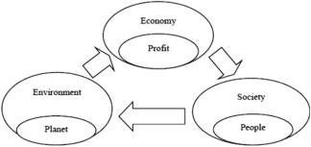Figure 1
Before the pandemic, the Nigerian government had been grappling with weak recovery from the 2014 oil price shock, with GDP growth tapering around 2.3 percent in 2019. In February, the IMF revised the 2020 GDP growth rate from 2.5 percent to 2 percent, as a result of relatively low oil prices and limited fiscal space. Relatedly, the country’s debt profile has been a source of concern for policymakers and development practitioners as the most recent estimate puts the debt service-to-revenue ratio at 60 percent, which is likely to worsen amid the steep decline in revenue associated with falling oil prices. These constraining factors will aggravate the economic impact of the COVID-19 outbreak and make it more difficult for the government to weather the crisis.

2.2 AGGREGATE DEMAND WILL FALL, BUT GOVERNMENT EXPENDITURE WILL RISE
In Nigeria, efforts were already being made to bolster aggregate demand through increased government spending and tax cuts for businesses. The public budget increased from 8.83 trillion naira ($24.53 billion) in 2019 to 10.59 trillion naira ($29.42 billion) in 2020, representing 11 percent of the national GDP, while small businesses have been exempted from company income tax, and the tax rate for medium-sized businesses has been revised downwards from 30 to 20 percent. Unfortunately, the COVID-19 crisis is causing all components of aggregate demand, except for government purchases, to fall (Figure 1).
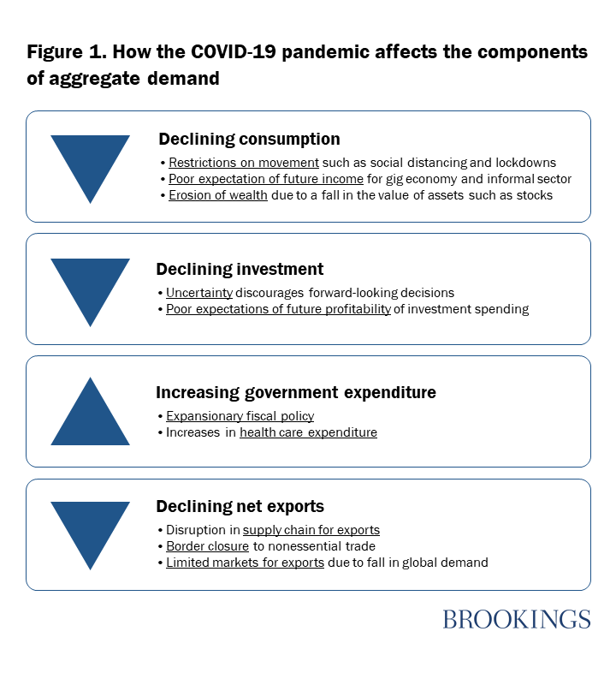Figure 2
The fall in household consumption in Nigeria will stem from 1) partial (or full) restrictions on movement, thus causing consumers to spend primarily on essential goods and services; 2) low expectations of future income, particularly by workers in the gig economy that are engaged on a short-term/contract basis, as well as the working poor in the informal economy; and 3) the erosion of wealth and expected wealth as a result of the decline in assets such as stocks and home equity. The federal government has imposed a lockdown in Lagos and Ogun states as well as Abuja (which have the highest number of coronavirus cases combined). Subnational governments have quickly followed suit by imposing lockdowns in their states. Nigeria has a burgeoning gig economy as well as a large informal sector, which contributes 65 percent of its economic output. Movement restrictions have not only reduced the consumption of nonessential commodities in general, but have affected the income-generating capacity of these groups, thus reducing their consumption expenditure.
Investments by firms will be impeded largely due to the uncertainties that come with the pandemic-limited knowledge about the duration of the outbreak, the effectiveness of policy measures, and the reaction of economic agents to these measures—as well as negative investor sentiments, which are causing turbulence in capital markets around the world. Indeed, the crisis has led to a massive decline in stock prices, as the Nigerian Stock Exchange records its worst performance since the 2008 financial crisis, which has eroded the wealth of investors.
Taking into consideration the uncertainty that is associated with the pandemic and the negative profit outlook on possible investment projects, firms are likely to hold off on long-term investment decisions. On the other hand, government purchases will increase as governments, which typically can afford to run budget deficits, utilize fiscal stimulus measures to counteract the fall in consumer spending. However, for governments that are commodity dependent, the fall in the global demand for commodities stemming from the pandemic will significantly increase their fiscal deficits. In Nigeria’s case, the price of Brent crude was just over $26 a barrel on April 2, whereas Nigeria’s budget assumes a price of $57 per barrel and would still have run on a 2.18 trillion naira ($6.05 billion) deficit. Similarly, with oil accounting for 90 percent of Nigeria’s exports, the decline in the demand for oil and oil prices will adversely affect the volume and value of net exports. Indeed, the steep decline in oil prices associated with the pandemic has necessitated that the Nigerian government cut planned expenditure. In fact, on March 18, the minister of finance announced a 1.5 trillion naira ($4.17 billion) cut in nonessential capital spending.

The restrictions on movement of people and border closures foreshadow a decline in exports. Already, countries around the world have closed their borders to nonessential traffic, and global supply chains for exports have been disrupted. Although the exports of countries that devalue their currency due to the fall in the price of commodities (like Nigeria), will become more affordable, the limited markets for nonessential goods and services nullifies the envisaged positive effect on net exports.

2.3 WHAT ARE THE POLICY RESPONSES BY THE NIGERIAN GOVERNMENT?
Already, the Central Bank of Nigeria (CBN) has arranged a fiscal stimulus package, including a 50 billion naira ($138.89 million) credit facility to households and small and medium enterprises most affected by the pandemic, a 100 billion naira ($277.78 million) loan to the health sector, and a 1 trillion naira ($2.78 billion) to the manufacturing sector. In addition, the interest rates on all CBN interventions have been revised downwards from 9 to 5 percent, and a one-year moratorium on CBN intervention facilities has been introduced, effective March 1. With oil being Nigeria’s major source of foreign exchange, amid the steep decline in oil prices, the official exchange rate has been adjusted from 306 to 360 naira. The exchange rate under the investors and exporters (I&E) window has also been adjusted from 360 to 380 naira in order to unify the exchange rates across the I&E window, Bureau de Change, and retail and wholesale windows. Furthermore, the government has introduced import duty waivers for pharmaceutical companies and increased efforts toward ensuring that they receive forex.

CHAPTER 3

METHODOLOGY
The National Emergency Operations Centre led by the Nigeria Centre for Disease Control supported by partners continues to coordinate response activities and strengthen preparedness capacity across states nationwide. An intensive national risk communications campaign is ongoing to inform Nigerians about COVID-19. The Federal Ministry of Health working closely with states and the Presidential Task Force on COVID-19 continues tol review response activities and institute measures to protect the health of Nigerians.
It is important that Nigerians strictly adhere to social distancing and other necessary precautions in place. These measures include taking the following precautions below to protect yourself and your family:
1. Wash hands regularly with soap and water or use an alcohol-based sanitizer if no water and soap is available
2. Social distancing is crucial to reducing the spread of COVID-19 through;
● Use of no-touch greetings
● maintaining at least 2 meters (5 feet) distance between yourself and anyone who is coughing or sneezing
● staying home if you feel unwell with symptoms like fever, cough and difficulty in breathing. Immediately call NCDC’s 24/7 toll-free number 0800 970 000 0010. Do not self-medicate
● Avoiding/postponing events with large gatherings of people including schools, workplaces, places of worship, crowded supermarkets and pharmacies, social and sporting events.
3. Persons with a persistent cough or sneezing, should stay at home until they recover
4. Make sure you and people around you observe hand and respiratory hygiene by:
● Covering your nose with tissue when sneezing or coughing. Immediately dispose of tissue in a covered bin and wash your hands with soap and water. Use an alcohol-based sanitiser if no water and soap is available
● Coughing or sneezing into the sleeve of your bent elbow if no tissue is available.
5. Avoid all non-essential travel to all countries
The Federal Ministry of Health through the Nigeria Centre for Disease Control will maintain a real-time update on new cases through www.covid19.ncdc.gov.ng. We will continue to provide updates as and when they become available. The Federal Ministry of Health reiterates its commitment to ensure the control of the COVID-19 outbreak in Nigeria.
COVID-19 (Novel Coronavirus, Sars-Cov-2) pandemic is wreaking havoc and bringing the whole world into a standstill in an unprecedented fashion. The two major approaches were used in the current study, as follows:
- The possible correlations among the trends of confirmed cases in different case studies were investigated, and then a binary classification model was constructed to predict and classify using the group method of data handling (GMDH) algorithm based upon some critical factors; maximum, minimum, and average temperature, the density of a city, relative humidity, and wind speed were considered as the input dataset and the number of confirmed cases was selected as the output dataset for 30 days.
- Regression analysis was used, and a trend of the confirmed cases of COVID-19 analyzed in the five provinces with the highest confirmed cases, including Hubei, Guangdong, Henan, Zhejiang, and Hunan, and the daily fluctuations of confirmed cases were compared with fluctuations of weather parameters.

3.1 Conditions of analysis
- The environmental and urban parameters in the analysis included density, sex ratio, average age, elevation, maximum, minimum, and average temperature, relative humidity, and wind.
- For daily analysis of the possible trend between confirmed cases of COVID-19 and environmental factors, the data of Hubei province was used.
- The climate data is based on the stations situated in the capital of the provinces or regions because the population is generally higher in these areas.
- The analysis period was from 28 January 2020 to 26 February 2020 (30 days).
- The analysis of the possible correlations about trends of confirmed cases in different case studies was based on the average values in one month.

3.2 Case Study
To carry out the analysis of correlation among environmental factors and confirmed cases of COVID-19, a set of data, including 42 provinces in China, Japan, South Korea, and Italy, were used. The selected case studies can be seen below and are based on the most confirmed cases of COVID-19 and available data, as shown below. It is worth mentioning that the quarantine on travel in and out of Wuhan and the suspension of flights, trains, public buses, and the metro system began on 23 January 2020 and also on 24 January 2020 in 15 cities in Hubei. The estimated incubation period of COVID-19 is about 2–14 days.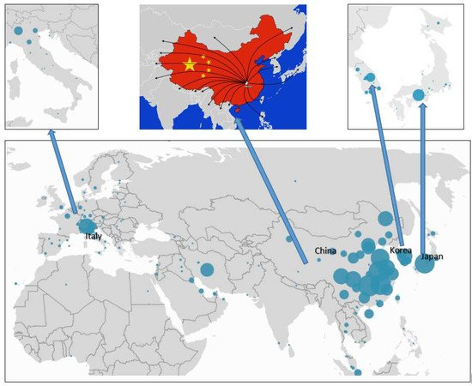Figure 3

3.3 Group Method of Data Handling (GMDH)
Artificial Intelligence includes a wide range of methods and algorithms that work based on machine intelligence and has many applications in various fields of science, including fuzzy logic theory and application artificial intelligence techniques and sociology, risk assessment and hazard identification, machine learning, and meta-heuristic algorithms and clustering techniques The group method of data handling (GMDH) type of neural network is one of these algorithms that was proposed by Ivakhnenko . GMDH is a self-organization algorithm that has been used successfully for pattern recognition, optimization of complex systems modeling, and prediction problems, and it is also called the polynomial of the Ivakhnenko equation. This algorithm can predict the value of yˆi from an approximate function (f∧), for each input vector (X), which is shown in Equation (1). The basic form of a relation between input and output data can be declared as a discrete type of the Volterra functional series, referred to as the Kolmogorov–Gabor polynomial. Equation (2) shows the underlying neural network map, which is also called the polynomial of Ivakhnenko
y∧ = f∧(xi1 , xi2 , xi3 , ……… xim ) i=(1,2,3,……, m)………….(1)
y = a + ∑i=1mbi xi + ∑i=1m∑j=1mcij xi xj + ∑i=1m∑j=1m∑k=1mdijk xi xj xk + ∑i=1m∑j=1m∑k=1m∑l=1meijkl xi xj xk xl ,…………(2)
Where Y is the output, m is the number of data, and X₁, X₂, X₃… X_{m} is the input variables vector. In many cases, the quadratic and bivariate form of this polynomial is used as Equation (3).
yˆ = G (xi, xj) =a0 + a1 xi + a2 xj+ a3 xixj+ a4 x2i+ a5 x2j……… (3)
Figure 2 shows a schematic of input and output variables of the GMDH algorithm, where X= (X₁, X₂, X₃… X_{m}) is the input dataset and Y= (y₁, y₂, y₃… y_{n}) is the output dataset. In this algorithm, the input dataset is imported to the initial layer and then, after evaluation and optimization, the output is considered as a new input for the next layer. This process is continued and stopped if the algorithm reaches a better answer from layer (n+1) in comparison with layer (n). As mentioned before, to deal with unpredicted and uncertain problems, the GMDH algorithm can be applied as a powerful tool. Hence, a binary classification analysis was done by the GMDH algorithm in the present study.
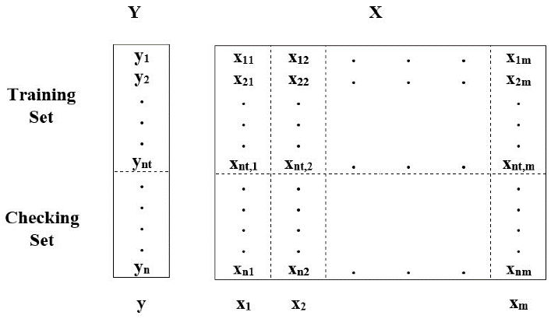Figure 4
The Federal Ministry of Health has confirmed ten (10) new cases of the coronavirus disease (COVID-19) in Nigeria; three (3) new cases in the Federal Capital Territory (FCT) and seven (7) new cases in Lagos State. This brings the total number of confirmed cases in Nigeria to twenty-two (22).
All ten (10) new cases are Nigerian nationals. Nine (9) of them have travel history to the United Kingdom, Spain, Netherlands, Canada and France. They returned to the country in the last one week. The 10th case is a close contact of a previously confirmed case.
The three (3) cases in the FCT are being treated at the University Of Abuja Teaching Hospital (UATH), Gwagwalada while the seven (7) new cases in Lagos are being treated at the Infectious Disease Hospital (IDH), Yaba. All ten (10) new cases have mild to moderate symptoms and are currently receiving treatment.
As at the 21st of March 2020, twenty-two (22) cases have been confirmed, two cases have been discharged and there has been no death from COVID-19 in Nigeria. The Federal Government of Nigeria remains committed to working with states to provide optimal care for all COVID-19 confirmed cases in the country.
Contact tracing is ongoing to identify all persons who have been in contact with the new confirmed cases. The Port Health Services of the Federal Ministry of Health has heightened screening at all air, land and sea points of entry into Nigeria and adapted the protocols to reflect the travel guidance issued by the Presidential Task Force on Coronavirus.

3.4 How can environmental health be integrated into sustainable development?
Protecting and creating healthy environments is a critical component of sustainable development. Environmental health can be integrated into sustainable development by:
- Improving environmental quality for the poorest populations with the greatest burden of environmental diseases, by reducing exposures to air pollution in homes and villages from biomass burning, and providing clean water and sanitation
- Identifying efforts to address environmental problems that can also provide health benefits. For example, creating environments that encourage biking and walking for transportation reduces greenhouse gas and toxic air pollution emissions (environmental benefit) and increases physical activity (health benefit).
- Recognizing that some policies, practices, and technologies designed to promote sustainability and economic development may have unintended adverse environmental health effects, and attempting to prevent or mitigate these before they are implemented.
It remains unclear when much of the world might once again open up to migrants in a way that could help re-start a flagging global economy. It's also unclear what the lasting impact of the current state of affairs on migrants might be.
Figure 5: World Economic Forum
Africa’s largest innovation incubator, CcHub, will offer funding and engineering support to tech projects aimed at curbing COVID-19 and its social and economic impact.
The Lagos and Nairobi based organization posted an open application on its website this week, CcHub CEO Bosun Tijani told TechCrunch on a call.
CcHub will provide $5,000 to $100,000 funding blocks to companies with COVID-19 related projects covering last-mile communication, support for the infected and the most vulnerable, production of essential medical supplies and support for disrupted food supply-chains. he organization, and its iHub affiliate, will also open up engineering support and resources from its CcHub Design Lab to funded companies, according to Tijani.
He noted that established startups that want to create COVID-19 related projects on the side of their core-business can apply.
The initiative stems from concerns Africa could be less prepared than other regions in dealing with an outbreak of the virus that has spread in China, Europe and the U.S. and is wreaking economic havoc globally.
Tijani hopes CcHub can employ its network and resources to limit the spread and damage of COVID-19 in Africa.
The Lagos based innovation-space acquired Kenya’s iHub in 2019, bringing together two of Africa’s most powerful tech hubs by membership networks, VC, volume of programs, startups incubated and global visibility.
“Quite a number of African countries, if they get to the level of Italy or the UK, I don’t think the system… is resilient enough to provide support to something like that,” Tijani said.
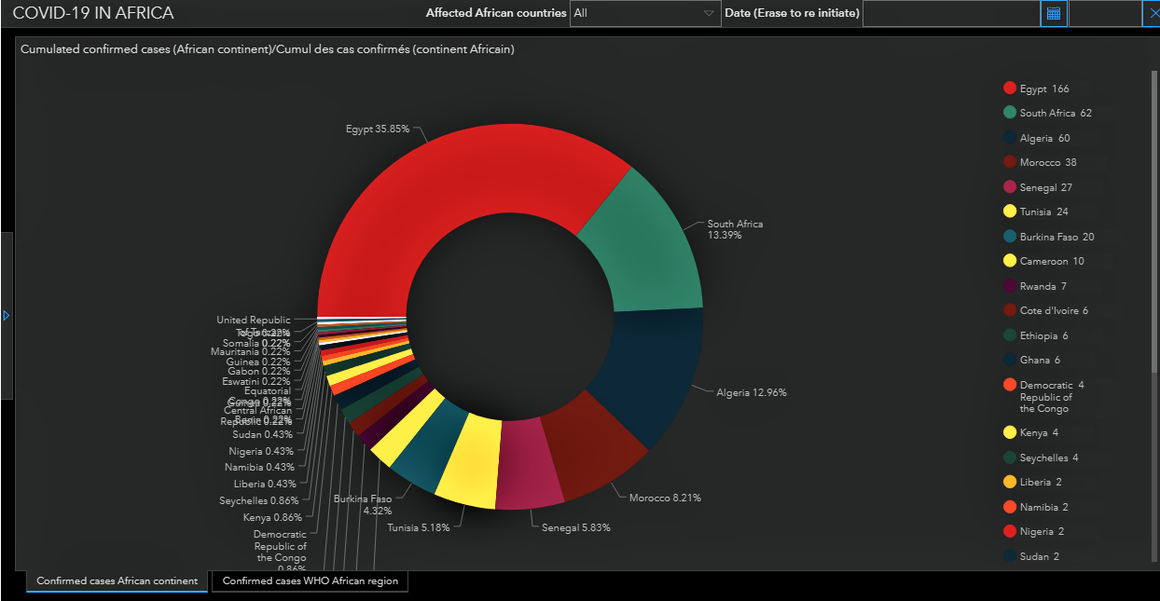
Figure 6
Pan-African on-demand trucking logistics company Kobo360 has asked employees who can work remotely to do so in Ghana and Nigeria, according to the Chief Strategy Officer Kagure Wamunyu. The Goldman Sachs backed startup is also planning contingencies to ensure supply-chain continuity, should COVID-19 disrupt business and mobility in its markets.
In Kenya, the country is turning to its leading mobile-money product, M-Pesa, to reduce the the chances of an outbreak. Safaricom waived transaction fees on the app this week to increase digital-payments use and lower the risk of spreading the COVID-19 through physical handling of cash.

CHAPTER 4

ANALYSIS OF RESULTS

Governments are now relying on ubiquitous instruments (sensors) and powerful algorithms instead of flesh-and-blood spooks. In the war against COVID-19, several governments have implemented these new surveillance tools.
Maps of the world show how the decrease in the transportation of people has drastically reduced carbon emissions across different countries, but what’s the case for emissions from digital technologies? Will the volume of people working from home or using digital devices in quarantine cause an increase in emissions from other sources? What is being done by the large cloud-providers to address the capacity issue?
Figure 7

4.1 Predicting and modelling outbreaks
In the ongoing covid-19 pandemic, we are witnessing three major occurrences across the globe:
1. Wider acceptance of online services;
2. A humongous requirement for internet services for conventional industries;
3. Boosted connectivity among diverse types of industries.
These three data streams provide important, real-time data about travel patterns that spread disease and longitudinal alterations in populations at risk, which until recently have been very difficult to quantify on schedules related to a fast-moving pandemic. With an exponential rise in mobility and growing global connectivity, this information will be critical to planning surveillance and containment strategies.
Some researchers and private entities along with their respective state governments are developing a digital platform, HealthMap, which visually represents the disease outbreaks according to location, time and the type of contagious virus, bacterial disease that is being carried while entering into the city.
Digital infrastructure plays a pivotal role in predicting and modelling outbreaks. Take AI-supported services for a lung CT scan: the AI is premeditated to quickly detect lesions of likely coronavirus pneumonia; to measure its volume, shape and density; and to compare changes of multiple lung lesions from the image. This provides a quantitative report to assist doctors in making fast judgements and thus helps expedite the health evaluation of patients.
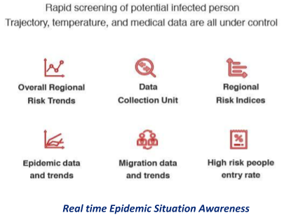Figure 8

CHAPTER 5

CONCLUSION
The COVID-19 pandemic is a wake-up call to policymakers as the unusual and unprecedented nature of the crisis has made it impossible for citizens to rely on foreign health care services and more difficult to solicit for international support given the competing demand for medical supplies and equipment. A more integrated response spanning several sectors—including the health, finance, and trade sectors—is required to address structural issues that make the country less resilient to shocks and limit its range of policy responses. In the long term, tougher decisions need to be made, including but not limited to diversifying the country’s revenue base away from oil exports and improving investments in the health care sector in ensuring that the economy is able to recover quickly from difficult conditions in the future. a serious challenge of sustainable development was investigated using the GMDH algorithm and regression analysis. According to the results, the GMDH algorithm has an appropriate performance to predict and classify the parameters of a case study affected by COVID-19, and the accuracies based on Wuhan datasets were equal to 95.7% and 85.7% for training and testing, respectively. No correlation was found among the different case study datasets in four countries, which might be due to different policies and types of restrictions in each country and means that the prediction of the trend could be made case by case. The results of collinearity diagnostics of the regression analysis demonstrated that the relative humidity and maximum daily temperature and average temperature had the highest share in the expression of changes of output (confirmed cases), respectively. The relative humidity (in the case study with an average of 77.9%) affected positively, and maximum daily temperature (in the case study with an average of 15.4 °C) affected negatively, the confirmed cases. The study shows the positive impact of quarantine in decreasing the number of confirmed cases, which was effective after about 14 days, alongside the impact of environmental factors in confirmed cases of COVID-19 and the role of regression analysis and binary classification by using artificial intelligence in the investigations.
Finally, since the analysis shows the impact of the weather parameters on confirmed cases of COVID-19, the development of a prediction model with more datasets is suggested for future studies.

CHAPTER 6

RECOMMENDATIONS
WASHINGTON, April 9, 2020—Growth in Sub-Saharan Africa has been significantly impacted by the ongoing coronavirus outbreak and is forecast to fall sharply from 2.4% in 2019 to -2.1 to -5.1% in 2020, the first recession in the region over the past 25 years, according to the latest Africa’s Pulse, the World Bank’s twice-yearly economic update for the region. “The COVID-19 pandemic is testing the limits of societies and economies across the world, and African countries are likely to be hit particularly hard,” said Hafez Ghanem, World Bank Vice President for Africa. “We are rallying all possible resources to help countries meet people’s immediate health and survival needs while also safeguarding livelihoods and jobs in the longer term – including calling for a standstill on official bilateral debt service payments which would free up funds for strengthening health systems to deal with COVID 19 and save lives, social safety nets to save livelihoods and help workers who lose jobs, support to small and medium enterprises, and food security.”
The Pulse authors recommend that African policymakers focus on saving lives and protecting livelihoods by focusing on strengthening health systems and taking quick actions to minimize disruptions in food supply chains. They also recommend implementing social protection programs, including cash transfers, food distribution and fee waivers, to support citizens, especially those working in the informal sector. The analysis shows that COVID-19 will cost the region between $37 billion and $79 billion in output losses for 2020 due to a combination of effects. They include trade and value chain disruption, which impacts commodity exporters and countries with strong value chain participation; reduced foreign financing flows from remittances, tourism, foreign direct investment, foreign aid, combined with capital flight; and through direct impacts on health systems, and disruptions caused by containment measures and the public response. While most countries in the region have been affected to different degrees by the pandemic, real gross domestic product growth is projected to fall sharply particularly in the region’s three largest economies – Nigeria, Angola, and South Africa— as a result of persistently weak growth and investment. In general, oil exporting-countries will also be hard-hit; while growth is also expected to weaken substantially in the two fastest growing areas—the West African Economic and Monetary Union and the East African Community—due to weak external demand, disruptions to supply chains and domestic production. The region’s tourism sector is expected to contract sharply due to severe disruption to travel. The COVID-19 crisis also has the potential to spark a food security crisis in Africa, with agricultural production potentially contracting between 2.6% in an optimistic scenario and up to 7% if there are trade blockages. Food imports would decline substantially (as much as 25% or as little as 13%) due to a combination of higher transaction costs and reduced domestic demand. Several African countries have reacted quickly and decisively to curb the potential influx and spread of the coronavirus, very much in line with international guidelines. However, the report points out several factors that pose challenges to the containment and mitigation measures, in particular the large and densely populated urban informal settlements, poor access to safe water and sanitation facilities, and fragile health systems. Ultimately, the magnitude of the impact will depend on the public’s reaction within respective countries, the spread of the disease, and the policy response. And these factors together could lead to reduced labor market participation, capital underutilization, lower human capital accumulation, and long-term productivity effects.
“In addition to containment measures, we have seen that in responding to COVID-19, countries are opting for a combination of emergency fiscal and monetary policy actions with many central banks in the region taking important actions like cutting interest rates and providing extraordinary liquidity assistance,” said Albert Zeufack, Chief Economist for Africa at the World Bank. “However, it is important to ensure that fiscal policy builds in space for social protection interventions, especially targeting workers in the informal sector, and sows the seed for future resilience of our economies.”
The authors emphasize the need for a customized policy response to reflect the structure of African economies (especially the large informal sector) and the peculiar constraints policymakers currently face, particularly the deteriorating fiscal positions and heightened public debt vulnerabilities, and the overall low operational capacity to respond.“The immediate measures are important but there is no doubt there will be need for some sort of debt relief from bilateral creditors to secure the resources urgently needed to fight COVID-19 and to help manage or maintain macroeconomic stability in the region,” said Cesar Calderon, Lead Economist and Lead author of the report. Due to the COVID-19 pandemic, economic circumstances within countries and regions are fluid and change on a day-by-day basis. The macroeconomic analysis in the report is based on data available by the first quarter of March 2020.
The World Bank Group is taking broad, fast action to help developing countries strengthen their pandemic response, increase disease surveillance, improve public health interventions, and help the private sector continue to operate and sustain jobs. It is deploying up to $160 billion in financial support over the next 15 months to help countries protect the poor and vulnerable, support businesses, and bolster economic recovery.

REFERENCES
- https://www.worldbank.org/en/news/press-release/2020/04/09/covid-19-coronavirus-drives-sub-saharan-africa-toward-first-recession-in-25-years
- https://www.weforum.org/agenda/2020/04/digital-infrastructure-public-health-crisis-covid-19/
- https://www.brookings.edu/blog/africa-in-focus/2020/04/08/understanding-the-impact-of-the-covid-19-outbreak-on-the-nigerian-economy/
- Andrijevic, M.; Crespo Cuaresma, J.; Muttarak, R.; Schleussner, C.F. Governance in socioeconomic pathways and its role for future adaptive capacity. Nat. Sustain. 2020, 3, 35–41. [Google Scholar] [CrossRef]
- Pirouz, B.; Arcuri, N.; Pirouz, B.; Palermo, S.A.; Turco, M.; Maiolo, M. Development of an assessment method for evaluation of sustainable factories. Sustainability 2020, 12, 1841. [Google Scholar] [CrossRef]
- Pirouz, B.; Arcuri, N.; Maiolo, M.; Talarico, V.C.; Piro, P. A new multi-objective dynamic model to close the gaps in sustainable development of industrial sector. IOP Conf. Ser. Earth Environ. Sci. 2020, 410, 012074. [Google Scholar] [CrossRef]
- Shen, M.; Peng, Z.; Guo, Y.; Xiao, Y.; Zhang, L. Lockdown may partially halt the spread of 2019 novel coronavirus in Hubei province, China. medRxiv 2020. [Google Scholar] [CrossRef]
- Yu, H.; Sun, X.; Solvang, W.; Zhao, X. Reverse logistics network design for effective management of medical waste in epidemic outbreak: Insights from the Coronavirus Disease 2019 (COVID-19) in Wuhan. Int. J. Environ. Res. Public Health 2020, 17, 1770. [Google Scholar] [CrossRef]
- Phan, L.T.; Nguyen, T.V.; Luong, Q.C.; Nguyen, T.V.; Nguyen, H.T.; Le, H.Q.; Nguyen, T.T.; Cao, T.M.; Pham, Q.D. Importation and human-to-human transmission of a novel coronavirus in Vietnam. N. Engl. J. Med. 2020, 382, 872–874. [Google Scholar] [CrossRef] [PubMed]
- Qiang ChenSustainable development of occupational health and safety management system − active upgrading of corporate safety culture
- Int. J. Arch. Sci., 5 (4) (2004), pp. 108-113
- CrossRefView Record in ScopusGoogle Scholar
- [2]
- Joan. BurtonWHO Healthy Workplace Framework and Model: Background Document and Supporting Literature and Practices
- International Labour Organization, Geneva (2010)
- Google Scholar
- [3]
- ILO, Safety and health at work: a vision for sustainable prevention: XX World Congress on Safety and Health at Work 2014: Global Forum for Prevention, 24–27 August 2014, Frankfurt, Germany/International Labour Office. – Geneva, 2014.
- Google Scholar
- [4]
- BHPbilliton, Health, safety, environment and community management standards: BHP Billiton HSEC management standards, no. 3, 2005.
- Google Scholar
- [5]
- K. Amponsah-TawiahOccupational health and safety and sustainable development in Ghana
- Int. J. Bus. Administration, 4 (2) (2013), pp. 74-78
- View Record in ScopusGoogle Scholar
- [6]
- WHO, Global strategy on occupational health for all: the way to health at work. Recommendation of the second meeting of the WHO Collaborating Centres in Occupational Health, Beijing, China. [Online]. Available: http://www.who.int/occupational_health/globstrategy/en/, 1994.
- Google Scholar

