IGHODARO ALEXANDRA OSATO
15/ENG05/010
MECHATRONICS ENGINEERING
MCT 510 ASSIGNMENT
QUESTIONS
1. Differentiate between a controlled and Uncontrolled Rectifier.
2. Differentiate between Single phase half- wave Rectifier and a Single phase full wave Rectifier
3. Explain the operational characteristics of a DIAC
4. Explain the operational characteristics of a TRIAC

- DIFFERENCE BETWEEN A CONTROLLED AND UNCONTROLLED RECTIFIER

UNCONTROLLED RECTIFIER | CONTROLLED RECTIFIER
The triggering circuit is not required in ordinary rectifier | The triggering circuit is required in controlled rectifier.
Only diodes are used in ordinary rectifier. | The SCR and diodes are used in controlled rectifier.
The continuous control of the output is not obtained. | The continuous control of the output is obtained.
The freewheeling diode is not necessary in ordinary rectifier. | The freewheeling diode is necessary in controlled rectifier.
The direction of power flow is form source to load only. | The direction of power flow is from source to load and sometimes vice versa.
Wastage of power in ordinary rectifier. | No wastage of power in controlled rectifier.
It is used in power supplies. | It is used for speed control of DC motors.

- DIFFERENCE BETWEEN SINGLE PHASE HALF- WAVE RECTIFIER AND A SINGLE PHASE FULL WAVE RECTIFIER
SINGLE PHASE HALF-WAVE RECTIFIER | SINGLE PHASE FULL WAVE RECTIFIER
Low efficiency | High-efficiency rectifier
Half wave rectifier does not require center tapping of the secondary winding of transformer | full wave requires center tapping of the secondary winding of the transformer.
It requires less electronic components | Full wave requires more electronic components as compared to half wave
It is less costly | full wave rectifier is costly as compared to half wave
Number of diodes is Only 1 | Vary from 2 to 4, 4 in case of bridge rectifier
Voltage Regulation is Good | It is better.

- OPERATIONAL CHARACTERISTICS OF A DIAC
The DIAC is a bi-directional semiconductor switch that can be switched on in both polarities. The full form of the name DIAC is diode alternating current. The DIAC is a two terminal device; it is a combination of parallel semiconductor layers that allows activating in one direction. Diac is connected back to back using two zener diodes and the main application of this DIAC is, it is widely used to activating devices for a TRIAC when used in AC switches, dimmer applications and starter circuits for florescent lamps. The basic construction of diac consist of two terminals namely MT1 and MT2. When the MT1 terminal is designed +Ve with respect to the terminal MT2, the transmission will take place to the p-n-p-n structure that is another four-layer diode. The diac can be performing for both the direction. The symbol of the diac looks like a transistor.
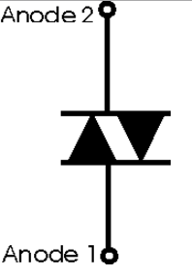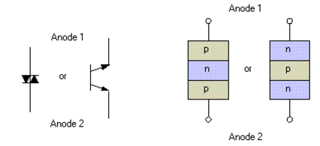
Figure: Construction of DIAC
The DIAC is basically a diode that conducts after a ‘break-over’ voltage, selected VBO, is exceeded. When the diode surpasses the break-over voltage, then it goes into the negative dynamic resistance of region. This causes in a reduce in the voltage drop across the diode with rising voltage. So there is a quick increase in the current level that is mannered by the device. The diode leftovers in its transmission state until the current through it falls below, what is termed the holding current, which is usually chosen by the letters IH. The holding current, the DIAC reverts to its non-conducting state. Its behavior is bidirectional and thus its function takes place on both halves of an alternating cycle.
Volt-ampere characteristic of a diac is shown in figure below. Its looks like a letter Z due to symmetrical switching characteristics for each polarity of the applied voltage. The diac performs like an open-circuit until its switching is exceeded. At that position the diac performs until its current decreases toward zero. Because of its abnormal construction, doesn’t switch sharply into a low voltage condition at a low current level like the triac or SCR, once it goes into transmission, the diac preserves an almost continuous –Ve resistance characteristic, that means, voltage reduces with the enlarge in current. This means that, unlike the triac and the SCR, the diac cannot be estimated to maintain a low voltage drop until its current falls below the level of holding current.
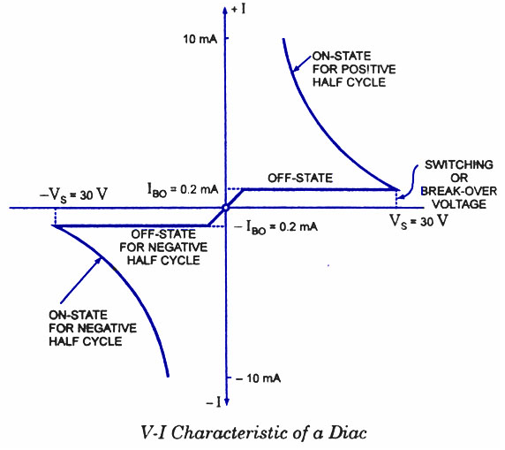
Figure: V-I Characteristic of a
- OPERATIONAL CHARACTERISTICS OF A TRIAC
A Triac device comprises of two thyristors that are connected in opposite direction but in parallel but, it is controlled by the same gate. Triac is a 2-dimensional thyristor which is activated on both halves of the i/p AC cycle using + Ve or -Ve gate pulses. Traic is a three terminal device, the three terminals of the Triac are MT1; MT2 & gate terminal (G). Here the gate terminal is the control terminal. Generating pulses are applied between MT1 and gate terminals. The ‘G’ current to switch 100A from triac is not more than 50mA or so.
The flow of current in the triac is bi directional that means current can flow in both the directions. The structure of triac is shown in the below figure.
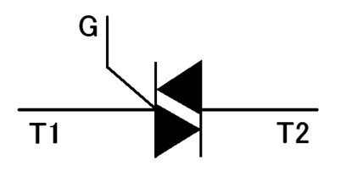
Figure: Structure of TRIAC

Here, in the structure of triac, two SCRs are connected in the anti-parallel and it will act like a switch for both the directions. The MT1 and gate terminals are near to each other. When the gate terminal is open, the triac will obstruct the both the polarities of the voltage across the MT1 & MT2.
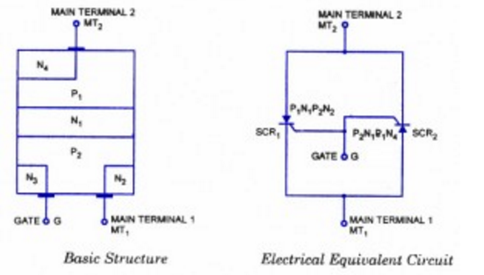
Figure: The TRIAC
The V-I characteristics of TRIAC is shown in the figure below. The triac is designed with two SCRs which are fabricated in the opposite direction in a crystal. Operating characteristics of triac in the 1st and 3rd quadrants are similar but for the direction of flow of current and applied voltage.
The V-I characteristics of triac in the first and third quadrants are basically equal to those of an SCR in the first quadrant. It can be functioned with either +Ve or –Ve gate control voltage but in typical operation generally the gate voltage is +Ve in first quadrant and -Ve in third quadrant. The supply voltage of the triac to switch ON depends upon the gate current. This allows utilizing a triac to regulate AC power in a load from zero to full power in a smooth and permanent manner with no loss in the device control.
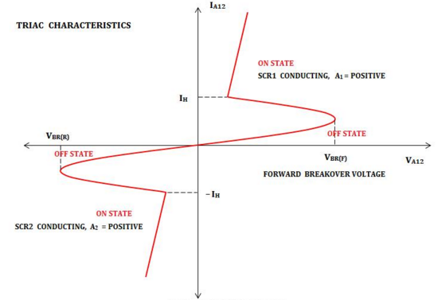
Figure: V-I Characteristics of TRIAC

