NAME: IGE FAVOUR OLUWADAMILOLA
MATRIC NO: 19/MHS01/194
COURSE: CHM102

- Discuss the two major classification of alkanols. Give the two examples for each class
ANSWER
- They may be classified as primary(1º),secondary(2º) or tertiary(3º) depending on the number of hydrogen atoms attached to the carbon atom containing the hydroxyl group. If the numbers of hydrogen atoms attached to the carbon atom bearing the hydroxyl group are three or two, it is a primary alcohol; if it is one hydrogen atom, it is a secondary alcohol and if no hydrogen atom is attached to the carbon atom bearing the hydroxyl group, it is a tertiary alcohol.
Examples
CH₃OH; CH₃CH(OH)CH₃; CH₃CH(OH)CH₃; (CH₃)₃C-OH Methanol(1º) ethanol(2º) propan-2-ol(2º) 2-Methylpropan-2-ol(3º)
- Alcohols are also classified as mono-,di-,tri- or polyhydric, depending upon the number of hydroxyl groups they possess. Alcohols containing one hydroxyl group are described as MONOHYDRIC ALCOHOLS, those containing two hydroxyl group as DIHYDRIC ALKANOLS, DIOLS or GLYCOLS, those containing three groups as TRIHYDRIC ALCOHOLS or TRIOLS and those containing more than three hydroxyl groups as POLYHYDRIC ALCOHOLS or POLYOLS
Examples
CH₃-CH₂CH₂OH; HOCH₂CH₂OH; HOCH₂CH(OH)CH₂OH
Propanol; Ethane-1,2-diol; propane-1,2,3-triol
(Monohydric alcohol); (Dihydric alcohol); (trihydric alcohol)
- In the Grignard synthesis of alkanols, react a named Grignard reagent with CH₃CH₂CH₂CH₂C=OCH₂CH₂CH_{3.} Show the steps.

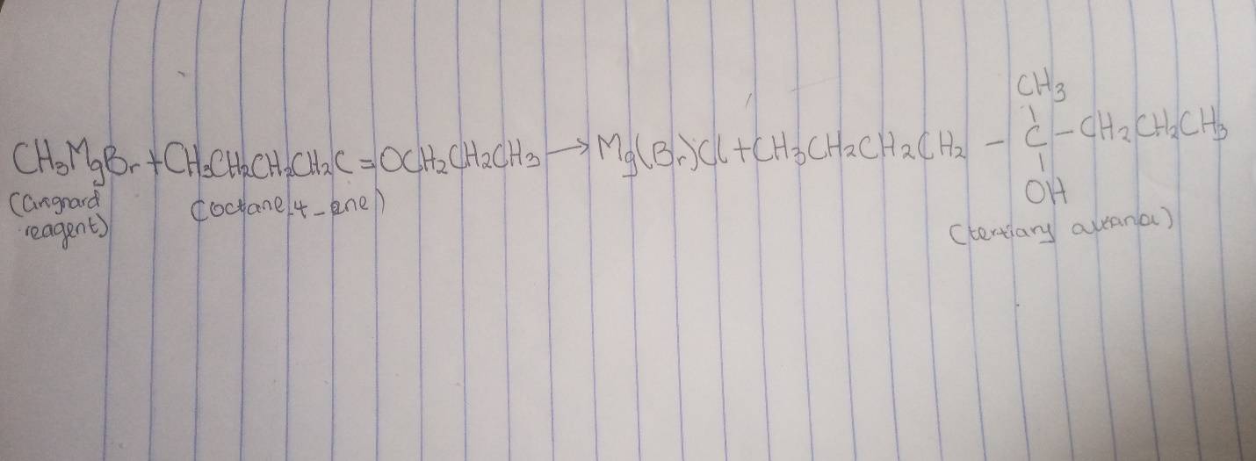
- Discuss the industrial manufacture of ethanol showing all reaction equations and necessary enzymes and temperature of reaction
Answer
Carbohydrates such as starch are a major group of natural compounds that can be made to yield ethanol by the biological process of fermentation. The biological catalysts, enzymes, found in the yeast break down the carbohydrate molecules into ethanol to give a yield of 95%. The starch-containing materials include molasses, potatoes, cereals rice etc and on warming with malt to 60⁰c for a specific period of time, are converted into maltose by enzyme DIASTASE contained in the malt.
Diatase
2(C₆H₁₀O₅)_{n} + nH₂O Nc₁₂H₂₂O₁₁
60⁰C
The maltose is broken down into glucose on addition of yeast, which contains the enzyme MALTASE, and at a temperature of 15ºC
Maltase
C₁₂H₂₂O₁₁ + H₂O 2C₆H₁₂O₆
15ºC Glucose
The glucose, at constant temperature of 15ºC is then converted into alcohol by the enzyme ZYMASE also contained in the yeast.
Zymase
C₆H₁₂O₆ 2CH₃CH₂OH + 2CO₂
glucose 15ºC ethanol carbondyhoxide
- Determine the product obtained in the reduction of alkanone and alkanal. Use a specific example for each and show the equation of reaction
Alkanone and alkanal are reduced to primary and secondary alcohols respectively by reaction with hydrogen in the presence of a platinum or nickel catalyst or with complex metal hydride, such as lithium tetrahydridoaluminate(III) (LiAlH₄) or sodium tetrahydridoborate(III) (NaBH₄).

