ASSESSMENT OF OCCUPATIONAL HAZARDS AND DEVELOPMENT OF ENGINEERING EQUIPMENT TO SUPPORT HEALTH WORKERS AGAINST COVID-19
BY
BAKARE SHARAFADEEN OMOGBOLAHAN
17/ENG04/014
A TERM PAPER SUBMITTED TO
COLLEGE OF ENGINEERING, AFE BABALOLA UNIVERSITY, ADO-EKITI, EKITI STATE.
FOR ENGINEERING LAW AND MANAGERIAL ECONOMICS (ENG 384)
IN PARTIAL FULFILMENT TO THE REQUIREMENTS FOR THE DEGREE OF BACHELOR OF ENGINEERING IN ENGINEERING.

11th of APRIL, 2020

TABLE OF CONTENTS

TITLE PAGE………………………………………………..…………………………………1

TABLE OF CONTENTS………………………………………………………………………2

ABSTRACT…………………………………………………………………………………...3

- INTRODUCTION…………………………………………………….……………..…….4

- LITERATURE REVIEW……………………………………………………………….....6

- METHODOLOGY……………………………………………………………………….17

4.0 CHALLENGES…………………………………………………………………………..26

5.0 RECOMMENDATION……………………………………….………………………….24

6.0 CONCLUSION…………………………………………………………………………..27

7.0 REFERENCES…………………………………………………………………………...28

ABSTRACT
According to the World Health Organisation (WHO), coronaviruses are a family of viruses that cause illnesses ranging from the common cold to more severe diseases such as severe acute respiratory syndrome (SARS) and the Middle East respiratory syndrome (MERS). These viruses were originally transmitted from animals to people. SARS, for instance, was transmitted from civet cats to humans while MERS moved to humans from a type of camel. Several known coronaviruses are circulating in animals that have not yet infected humans.
Coronaviruses constitute the subfamily Orthocoronavirinae, in the family Coronaviridae, order Nidovirales, and realm Riboviria. They are enveloped viruses with a positive-sense single-stranded RNA genome and a nucleocapsid of helical symmetry. The genome size of coronaviruses ranges from approximately 27 to 34 kilobases, the largest among known RNA viruses. The name coronavirus is derived from the Latin corona, meaning "crown" or "halo", which refers to the characteristic appearance reminiscent of a crown or a solar corona around the virions (virus particles) when viewed under two-dimensional transmission electron microscopy, due to the surface being covered in club-shaped protein spikes.

- INTRODUCTION
The name Coronavirus comes from the Latin word corona, meaning crown or halo. Under an electron microscope, the looks like it is surrounded by a solar corona. The novel coronavirus, identified by Chinese authorities on January 7 and since named SARS-CoV-2, is a new strain that had not been previously identified in humans. Little is known about it, although human-to-human transmission has been confirmed. According to the WHO, signs of infection include fever, cough, shortness of breath and breathing difficulties. In more severe cases, it can lead to pneumonia, multiple organ failure and even death. Current estimates of the incubation period - the time between infection and the onset of symptoms - range from one to 14 days. Most infected people show symptoms within five to six days. However, infected patients can also be asymptomatic, meaning they do not display any symptoms despite having the virus in their systems.
With more than 24,000 recorded deaths, the number of fatalities from the new coronavirus has overwhelmingly surpassed the toll of the 2002-2003 SARS outbreak, which also originated in China.SARS killed about 9 percent of those it infected - nearly 800 people worldwide and more than 300 in China alone. MERS, which did not spread as widely, was more deadly, killing one-third of those infected. While the new coronavirus is more widespread than SARS in terms of case numbers, the mortality rate remains considerably lower at approximately 3.4 percent, according to the WHO.
Since March 16, more cases were registered outside mainland China than inside, marking a new milestone in the spread of the global pandemic. The virus has spread from China all around the world, prompting the WHO to label the COVID-19 outbreak a pandemic. Human-to-human transmissions became evident after cases were recorded with no apparent link to China. Scientists around the globe are racing to develop a vaccine but have warned it is not likely one will be available for mass distribution before 2021. Meanwhile, a growing number of countries have introduced a series of sweeping measures to slow the spread of the coronavirus, including nationwide lockdowns, bans on gatherings, closure of schools, restaurants, bars and sports clubs, as well as issuing mandatory work-from-home decrees. International airlines have cancelled flights the world over. Some countries have banned non-citizens from entering their territories, and several more have evacuated their citizens from abroad. Chinese health authorities are still trying to determine the origin of the virus, which they say likely came from a seafood market in Wuhan, China where wildlife was also traded illegally.
On February 7, Chinese researchers said the virus could have spread from an infected animal species to humans through illegally-trafficked pangolins, which are prized in Asia for food and medicine. Scientists have pointed to either bats or snakes as possible sources of the virus. This outbreak is a global health emergency, the WHO said on January 30, raising the alarm further on March 11 when it declared the crisis a pandemic. The international health alert is a call to countries around the world to coordinate their response under the guidance of the WHO. There have been five global health emergencies since 2005 when the declaration was formalised: swine flu in 2009, polio in 2014, Ebola in 2014, Zika in 2016 and Ebola again in 2019.

2.0 LITERATURE REVIEW
2.1.1 ASSESSMENT OF OCCUPATIONAL HAZARDS
Getting your workplace ready for COVID-19
In January 2020 the World Health Organization (WHO) declared the outbreak of a new coronavirus disease in Hubei Province, China to be a Public Health Emergency of International Concern. WHO stated there is in high risk of the 2019 coronavirus disease (COVID-19) spreading to other countries around the world. WHO and public health authorities around the world are taking action to contain the COVID-19 outbreak. However, long term success cannot be taken for granted. All sections of our society – including businesses and employers – must play a role if we are to stop the spread of this disease.
When someone who has COVID-19 coughs or exhales they release droplets of infected fluid. Most of these droplets fall on nearby surfaces and objects - such as desks, tables or telephones. People could catch COVID-19 by touching contaminated surfaces or objects – and then touching their eyes, nose or mouth. If they are standing within one meter of a person with COVID-19 they can catch it by breathing in droplets coughed out or exhaled by them. In other words, COVID-19 spreads in a similar way to flu. Most persons infected with COVID-19 experience mild symptoms and recover. However, some go on to experience more serious illness and may require hospital care. Risk of serious illness rises with age: people over 40 seem to be more vulnerable than those under 40. People with weakened immune systems and people with conditions such as diabetes, heart and lung disease are also more vulnerable to serious illness.
This document gives advice on:
1. Simple ways to prevent the spread of COVID-19 in your workplace.
2. How to manage COVID-19 risks when organizing meetings & events.
3. Things to consider when you and your employees travel.
4. Getting your workplace ready in case COVID-19 arrives in your community.
1. Simple ways to prevent the spread of COVID-19 in your workplace
The low-cost measures below will help prevent the spread of infections in your workplace, such as colds, flu and stomach bugs, and protect your customers, contractors and employees.
Employers should start doing these things now, even if COVID-19 has not arrived in the communities where they operate. They can already reduce working days lost due to illness and stop or slow the spread of COVID-19 if it arrives at one of your workplaces.
• Make sure your workplaces are clean and hygienic
o Surfaces (e.g. desks and tables) and objects (e.g. telephones, keyboards) need to be wiped
with disinfectant regularly.
o Why? Because contamination on surfaces touched by employees and customers is one of
the main ways that COVID-19 spreads.
• Promote regular and thorough hand-washing by employees, contractors and customers.
o Put sanitizing hand rub dispensers in prominent places around the workplace. Make sure
these dispensers are regularly refilled.
o Display posters promoting hand-washing – ask your local public health authority for these
or look on www.WHO.int.
o Combine this with other communication measures such as offering guidance from occupational health and safety officers, briefings at meetings and information on the intranet to promote hand-washing.
o Make sure that staff, contractors and customers have access to places where they can
wash their hands with soap and water.
o Why? Because washing kills the virus on your hands and prevents the spread of COVID19
• Promote good respiratory hygiene in the workplace.
o Display posters promoting respiratory hygiene. Combine this with other communication
measures such as offering guidance from occupational health and safety officers, briefing
at meetings and information on the intranet etc.
o Ensure that face masks1 and / or paper tissues are available at your workplaces, for those
who develop a runny nose or cough at work, along with closed bins for hygienically
disposing of them.
o Why? Because good respiratory hygiene prevents the spread of COVID-19.
• Advise employees and contractors to consult national travel advice before going on business trips.
• Brief your employees, contractors and customers that if COVID-19 starts spreading in your community anyone with even a mild cough or low-grade fever (37.3 C or more) needs to stay at home. They should also stay home (or work from home) if they have had to take simple medications, such as paracetamol/acetaminophen, ibuprofen or aspirin, which may mask symptoms of infection
o Keep communicating and promoting the message that people need to stay at home even
if they have just mild symptoms of COVID-19.
o Display posters with this message in your workplaces. Combine this with other communication channels commonly used in your organization or business.
o Your occupational health services, local public health authority or other partners may have developed campaign materials to promote this message.
o Make clear to employees that they will be able to count this time off as sick leave.
2. How to manage COVID-19 risk when organizing meetings & events
Why do employers and organizers need to think about COVID-19?
Organizers of meetings and events need to think about the potential risk from COVID-19 because:
• There is a risk that people attending your meeting or event might be unwittingly bringing the
COVID-19 virus to the meeting. Others might be unknowingly exposed to COVID-19.
• While COVID-19 is a mild disease for most people, it can make some very ill. Around 1 in every 5 people who catch COVID-19 needs hospital treatment.
Key considerations to prevent or reduce COVID-19 risks
BEFORE the meeting or event
• Check the advice from the authorities in the community where you plan to hold the meeting or event. Follow their advice.
• Develop and agree a preparedness plan to prevent infection at your meeting or event.
o Consider whether a face-to-face meeting or event is needed. Could it be replaced by a
teleconference or online event?
o Could the meeting or event be scaled down so that fewer people attend?
o Ensure and verify information and communication channels in advance with key partners
such as public health and health care authorities.
o Pre-order sufficient supplies and materials, including tissues and hand sanitizer for all
participants. Have surgical masks available to offer anyone who develops respiratory symptoms.
o Actively monitor where COVID-19 is circulating. Advise participants in advance that if they
have any symptoms or feel unwell, they should not attend.
o Make sure all organizers, participants, caterers and visitors at the event provide contact
details: mobile telephone number, email and address where they are staying. State clearly that their details will be shared with local public health authorities if any participant becomes ill with a suspected infectious disease. If they will not agree to this they cannot attend the event or meeting.
• Develop and agree a response plan in case someone at the meeting becomes ill with symptoms
of COVID-19 (dry cough, fever, malaise). This plan should include at least:
o Identify a room or area where someone who is feeling unwell or has symptoms can be
safely isolated.
o Have a plan for how they can be safely transferred from there to a health facility.
o Know what to do if a meeting participant, staff member or service provider tests positive
for COVID-19 during or just after the meeting.
o Agree the plan in advance with your partner healthcare provider or health department.
DURING the meeting or event
• Provide information or a briefing, preferably both orally and in writing, on COVID-19 and the measures that organizers are taking to make this event safe for participants.
o Build trust. For example, as an icebreaker, practice ways to say hello without touching.
o Encourage regular hand-washing or use of an alcohol rub by all participants at the meeting
or event
o Encourage participants to cover their face with the bend of their elbow or a tissue if they
cough or sneeze. Supply tissues and closed bins to dispose of them in.
o Provide contact details or a health hotline number that participants can call for advice or
to give information.
• Display dispensers of alcohol-based hand rub prominently around the venue.
• If there is space, arrange seats so that participants are at least one meter apart.
• Open windows and doors whenever possible to make sure the venue is well ventilated.
• If anyone who starts to feel unwell, follow your preparedness plan or call your hotline.
o Depending on the situation in your area, or recent travel of the participant, place the person in the isolation room. Offer the person a mask so they can get home safely, if appropriate, or to a designated assessment facility.
• Thank all participants for their cooperation with the provisions in place.
AFTER the meeting
1. Retain the names and contact details of all participants for at least one month. This will help public health authorities trace people who may have been exposed to COVID-19 if one or more
participants become ill shortly after the event.
2. If someone at the meeting or event was isolated as a suspected COVID-19 case, the organizer
should let all participants know this. They should be advised to monitor themselves for symptoms for 14 days and take their temperature twice a day.
3. If they develop even a mild cough or low-grade fever (i.e. a temperature of 37.3 C or more) they should stay at home and self-isolate. This means avoiding close contact (1 meter or nearer) with other people, including family members. They should also telephone their healthcare provider or the local public health department, giving them details of their recent travel and symptoms.
4. Thank all the participants for their cooperation with the provisions in place.

Rights, roles and responsibilities of health workers, including occupational safety and health
Health workers are at the front line of any outbreak response and as such are exposed to hazards that put them at risk of infection with an outbreak pathogen (in this case COVID-19). Hazards include pathogen exposure, long working hours, psychological distress, fatigue, occupational burnout, stigma, and physical and psychological violence. This document highlights the rights and responsibilities of health workers, including specific measures needed to protect occupational safety and health.
Health worker rights include that employers and managers in health facilities:
• assume overall responsibility to ensure that all necessary preventive and protective measures are taken to minimize occupational safety and health risks;
• provide information, instruction and training on occupational safety and health, including;
o Refresher training on infection prevention and control (IPC); and
o Use, putting on, taking off and disposal of personal protective equipment (PPE);
• provide adequate IPC and PPE supplies (masks, gloves, goggles, gowns, hand sanitizer, soap and water, cleaning supplies) in sufficient quantity to healthcare or other staff caring for suspected or confirmed.
Including implementation of occupational safety and health management systems to identify hazards and assess risks to health and safety; infection prevention and control (IPC) measures; zero-tolerance policies towards workplace violence and harassment.
Health workers should:
• follow established occupational safety and health procedures, avoid exposing others to health and safety risks and participate in employer-provided occupational safety and health training;
• use provided protocols to assess, triage and treat patients;
• treat patients with respect, compassion and dignity;
• maintain patient confidentiality;
• swiftly follow established public health reporting procedures of suspect and confirmed cases;
• provide or reinforce accurate infection prevention and control and public health information, including to concerned people who have neither symptoms nor risk;
• put on, use, take off and dispose of personal protective equipment properly;
• self-monitor for signs of illness and self-isolate or report illness to managers, if it occurs;
• advise management if they are experiencing signs of undue stress or mental health challenges that require support interventions; and
• report to their immediate supervisor any situation which they have reasonable justification to believe presents an imminent and serious danger to life or health.

2.2 DEVELOPMENT OF ENGINEERING EQUIPMENT TO SUPPORT HEALTH WORKERS AGAINST COVID-19
K Health
K Health is a free primary care app with which millions of users get healthcare at 90% lower costs than usual. Digital tools, such as K Health’s app, can help in preventing major strains on health care systems. K Health offers free virtual primary care, addressing the key questions to analyze symptoms that would speak for infection with COVID-19. Their app allows patients to directly connect with U.S. doctors and to discuss potential risks as well as to create a treatment plan.
Since the virus outbreak last fall, K Health has recorded an increasing number of searches for “cough” as a chief complaint symptom through their app.
Gyant*
Leveraging its customizable, artificial intelligence-enabled platform, which integrates into any Electronic Health Record (EHR) system, GYANT creates easy to navigate and enjoyable experiences for patients that equate to cost and time savings, whilst improving the patient conversion rates for health systems. GYANT’s unique combination of deep intelligence, physician oversight, and a human-driven, empathetic approach allows health systems to solve traditional complex care issues, ensuring that patients receive the right care – anytime and anywhere, increasing engagement, trust, and loyalty along their entire healthcare journey.
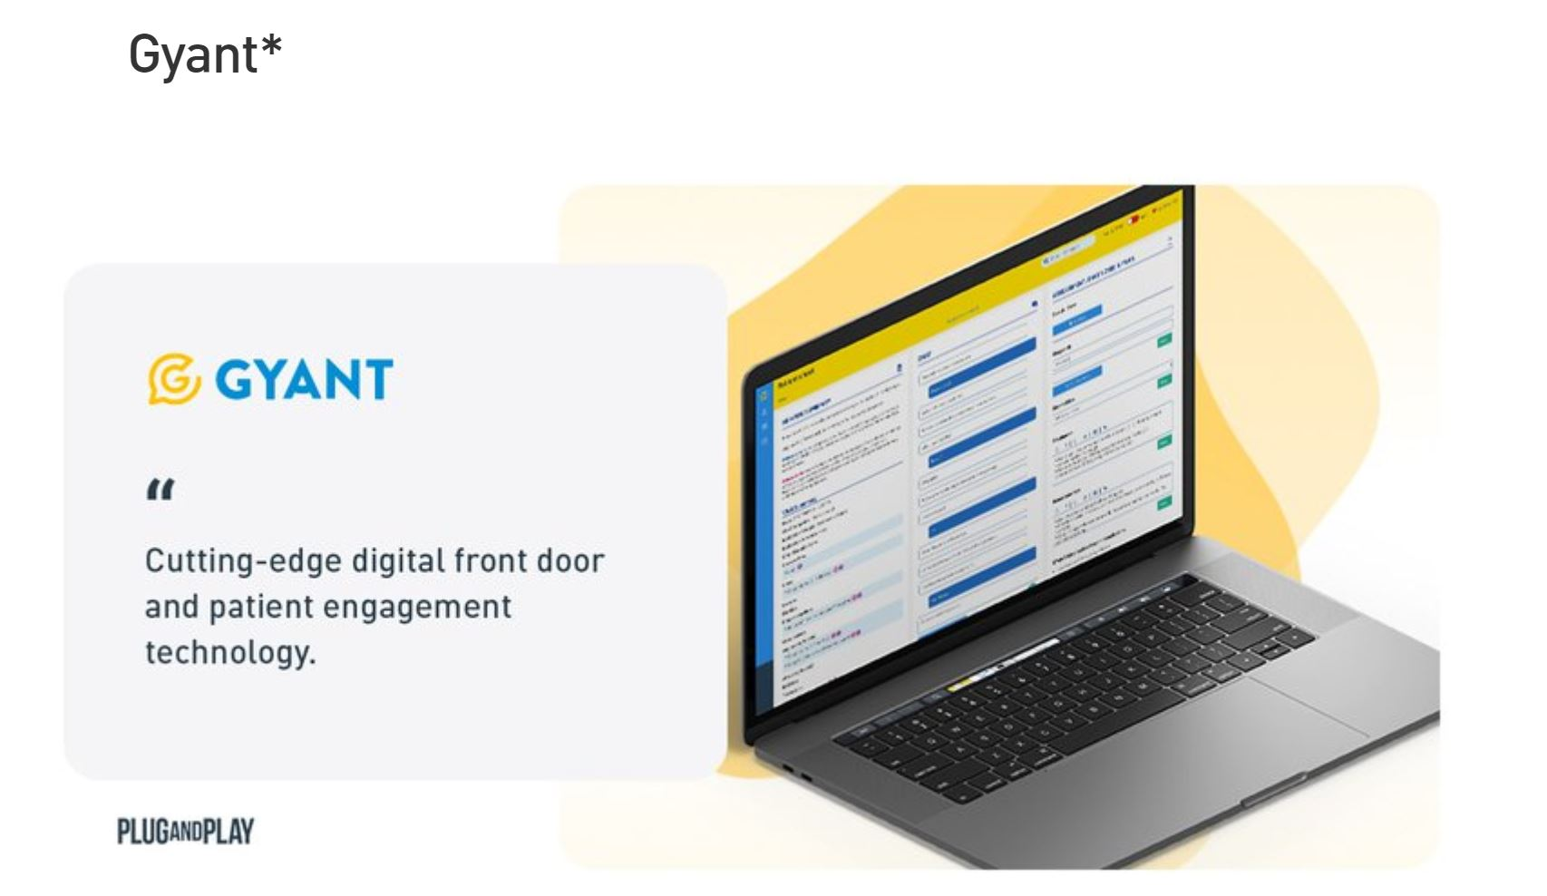
Fig 1: Gyant
In these last weeks, GYANT has developed clinical protocols that can be incorporated into a company’s software and that can serve as an initial check for Coronavirus infections. At the moment, they are finalizing these protocols and will be sharing them with clients in the near future. GYANT’S goal is to deploy this protocol as an additional feature through their software solution, e.g. on their websites. GYANT will continue to update these protocols as there are more and more insights from the CDC and other global sources about the COVID virus. As a B2B healthcare company, it is important for GYANT to consider the needs of their clients and their end-users (patients). Such protocols were not on their product development roadmap, nor were they scoped with any client; but as a leading source of health information for patients and consumers, GYANT considers it as critical to incorporate Coronavirus into their medical protocols.
Infermedica
Infermedica is a health AI company that improves the diagnostic process, using the most advanced reasoning technology for medical diagnosis. Their goal is to increase healthcare accessibility, minimize the rate of misdiagnosis and streamline costs of providing quality care. Their core product is a triage platform that uses AI to perform a preliminary diagnostic interview on patients.
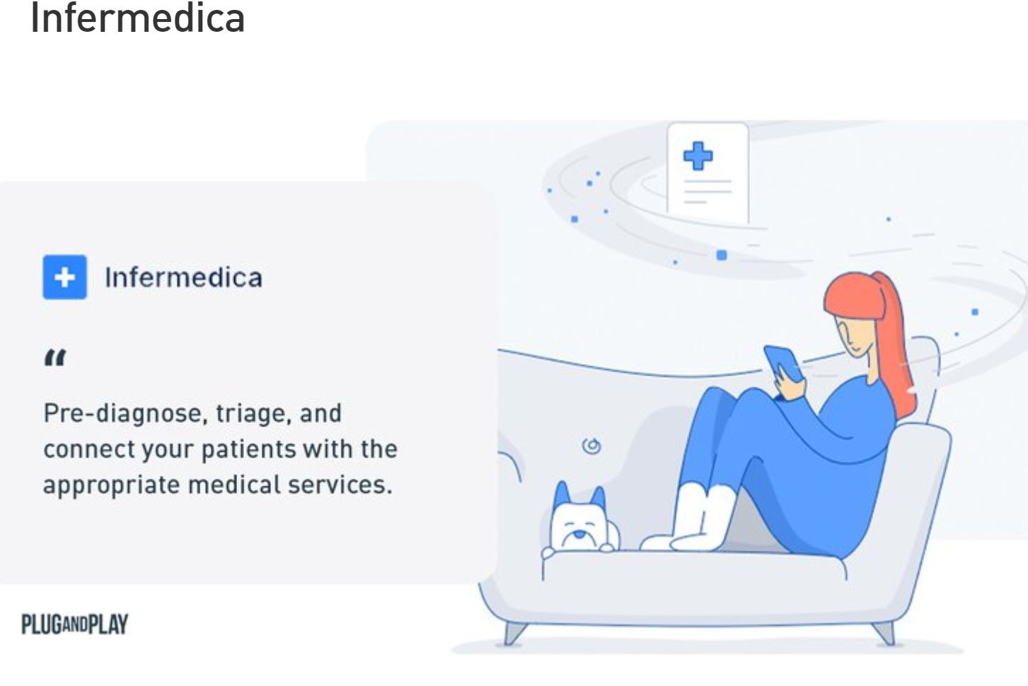
Fig 2: Infermedica
Helping patients to quickly assess their risk of suffering from coronavirus, then providing recommendations on the next steps is how Infermedica can help. Medical personnel is rapidly being overburdened. Doctors are already busy taking care of sick people and are at high risk of becoming infected themselves. The demand for health services is escalating and patient triage is, more than ever, an important tool in guiding patients on what to do when they’re feeling unwell.
Infermedica’s teams have now begun working on COVID-19 triage-oriented screening protocol, including it in all their platforms. The basis for the protocol will be the official guidelines established by WHO, CDC, and other key sources. The COVID-19 screening protocol will first be deployed to Symptomate, then to the other platforms including Symptom Checker, Call Center Triage and Infermedica API. Infermedica is also considering a standalone HTML widget that can easily be embedded into existing websites or apps. These products will be offered for free to their existing clients as well as to the general public.

Buoy Health
Buoy builds a free digital health tool that helps people from the moment they get sick to start their health care on the right foot. Started by a team of doctors and computer scientists working at the Harvard Innovation Laboratory in Boston MA, Buoy was developed in direct response to the downward spiral we’ve all faced when we attempt to self-diagnose our symptoms online. Buoy leverages artificial intelligence-powered by advanced machine learning and proprietary granular data - to resemble an exchange you would have with your favorite doctor – to provide consumers with real-time, accurate analysis of their symptoms and help them easily and quickly embark on the right path to getting better.
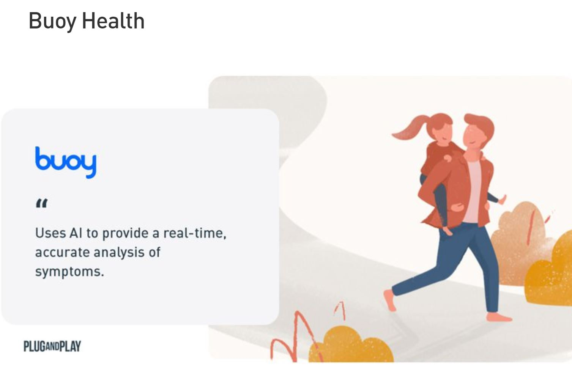
Fig 3: Buoy Health
Buoy Health started collecting information about COVID-19 after January 25, 2020, when there were only two confirmed cases in the United States. Hoping to ease growing fears over a pandemic, Buoy updated its algorithm to screen for symptoms and risk factors related to COVID-19. To customers, they provide advice for the next steps and methods for self-triage. They recently partnered with HealthMap, an outbreak tracking system, to help identify hotspots of disease based on Buoy’s own data.

Intelligent Virtual Assistant
In the time of this global health crisis, COVID -19 virus has significantly interfered with normal business operations. Co-browsing solutions such as Recursive labs, Unblu and Techsee, can continue to support representatives to engage with their clients through a low friction high fidelity platform with no download required. For example, insurance agents can start a meeting by sending a text to their clients with the meeting URL. There is no downloading or any preparation required from the client-side. It helps both the insurance company and clients to continue to have high-quality interaction regarding quoting a policy, managing claims at a time when we have to exercise social distancing and quarantines.

- METHODOLOGY

This was a descriptive cross-sectional study that was carried out over a 6 week period between September to October 2015. The sampling location covered the two government hospitals in Ondo (University of Medical Science Teaching Hospital, Ondo and State Specialist Hospital Ondo) situated in Ondo State, South West of Nigeria. The University of Medical Science Teaching hospital is a newly established hospital that is about 4 year old while the State specialist hospital was established over five decades ago. Ethical approval was obtained from the hospitals’ Ethics Committee on research, and consents were obtained from respondents.
The study population included health workers in the hospitals who were doctors, nurses, pharmacists, laboratory scientists, engineers, physiotherapists, health record officers, health attendants, and cleaners. The professions were categorised into clinical (doctors, nurses, pharmacist, laboratory scientist and health assistants) and non-clinical (cleaners, engineers, health information workers, physiotherapist) professions depending on their duties in the hospital. A minimum sample size of 263 was calculated using the formulae:
n=Z 1-α/22 p.(1-p)/d2
Where:
n = the minimum sample size,
Z 1-α/2 = standard normal variate (at 5% type 1 error (P<0.05) i.e 1.96, p = expected Proportion in population based on previous study. (A previous report of an average of 76% awareness of Occupational health hazard was used)
d = absolute error or precision (0.05).
A total of 400 questionnaires were distributed in both hospitals with 345 completely filled and returned which gave a response rate of 86.3%. A standardized structured questionnaire adopted from the National Institute of Occupational Safety and Health, US Centre for Disease Control and Prevention, and modified to suit the objectives of this research was used for data collection. The questionnaire consisted of questions regarding socio-demographic characteristics which included age, gender, marital status, profession, and their work history.
In addition, questions about awareness of occupational health and safety, source of awareness, common hazards, personal risk assessment, and the safety practices to mitigate those hazards. The questionnaires were administered by research assistants who were well trained on questionnaire administration. A scoring system was adopted for the two major sections of the questionnaire. The highest score of 40 and the lowest score of 10 were obtainable in the risk assessment section of the questionnaire in which scores ≥ 20, 21-30 and > 30 were considered as low, moderate and high risk, respectively. The lowest and highest scores obtainable in the safety practices assessment section were 9 and 27, respectively, whereas scores of 21-27, 14-20 and ≥ 13 were considered as poor, moderate and good safety practices respectively.

3.1 DATA ANALYSIS
Data obtained were entered and subjected to descriptive and inferential statistics using Statistical Package for Social Sciences version 17.0 (Chicago Inc.,). Frequency (percentage) of variables and association between variables were established. Univariate analysis was used in obtaining the frequency of socio - demographic characteristics and other discrete variables of the study population. Chi-square test was used to determine the significance of the observed differences for categorical variables while chi-square with trend was used where the categorical variable was ordinal. P value of <0 .05 was considered as significant.

3.1.2 RESULTS
A total of 345 respondents participated in the study comprising of 136 (39.4%) males and 209 (60.4%) females. Majority of the respondents were 40 years and below accounting for 286 (82.9%) of all the respondents. One hundred and ninety-six (56.8%) were married while 145(42.0%) were single. Two-hundred and eighty-two (81.7%) had ten years and below of practice experience. Amongst the respondents, 95(27.5%) were nurses, 67(19.4%) were doctors, 46 (13.3%) were laboratory scientists, 26 (7.5%) were pharmacists, 31 (9.0%) were cleaners, 15 (4.3%) were health attendants. Two hundred and ninety-two (84.6%) were aware of occupational health safety (Table 1).

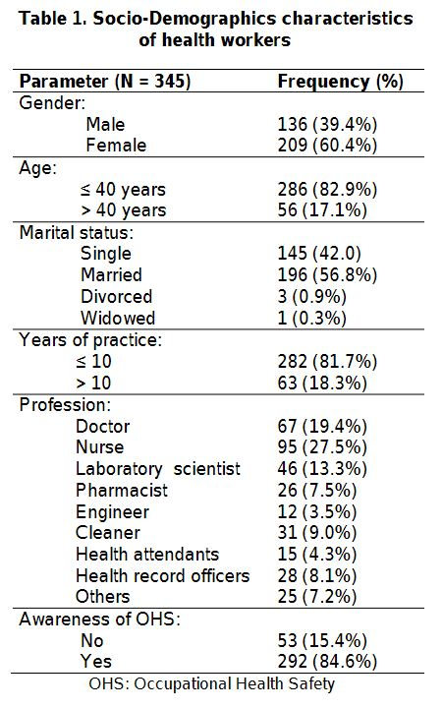
The common sources of awareness were during undergraduate training (51.3%) and seminar/workshop (22.9%)(Fig.1). The most common biological and non-biological hazards identified among the respondents were sharp related injuries in 75.4% and stress in 77.7% while the least common were blood borne infections in 48.1% and exposure to radiation in 26.1% respectively(Table 2).
Amongst the respondents, 131(38%), 192(55.7%), 22(6.4%) had high, moderate and low level of occupational health hazard risk respectively (Fig. 2). Also, 21(6.1%), 100(26.7%)) and 231(67.2%) of the respondents had good, moderate and poor level of safety measures respectively. There was no significant association between profession, year of experience, awareness of occupational health safety and level of personal risk assessment among the respondents(Table 3).
Non-clinical health workers had significantly better use of safety measures compared to clinical health workers (P < 0.01)(Table 4). Clinical health workers were significantly more aware of OHS compared to non-clinical health workers (P < 0.01). Also, those with more than 10 years of experience were significantly more aware of OHS (P = 0.01)(Table 5)
3.1.3 DISCUSSION
The study showed that majority of the government health workers in Ondo had high occupational hazard risk, poor compliance to occupational safety measures despite high awareness of OHS.

Table 2: Types Of Hazards
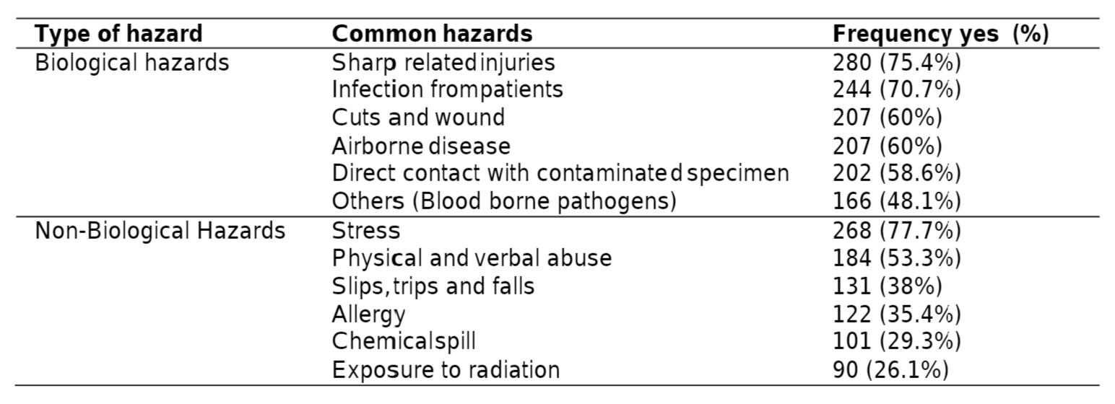

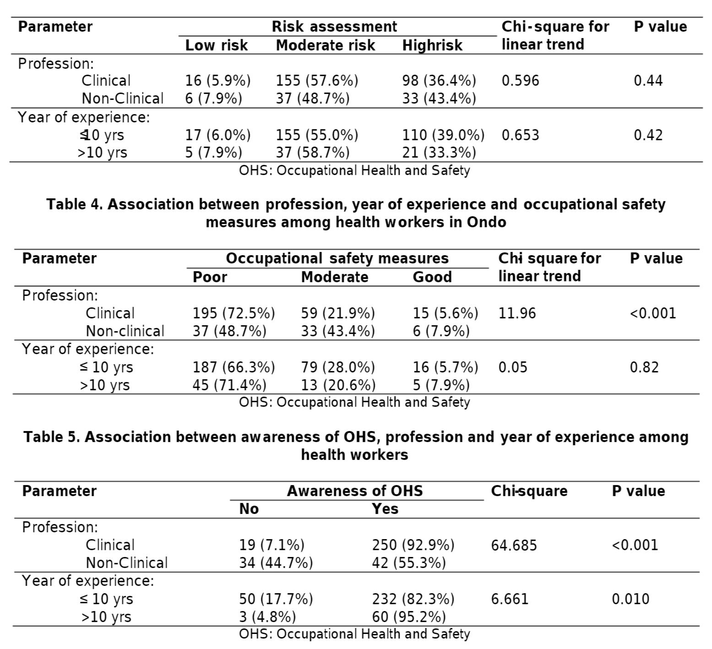
The majority of the respondents were nurses and doctors which is not surprising as they constitute the largest workforce in all health facilities. Also, most of the respondents were 40 years and below similar to reports by Amosu et al. This may be due to the fact that one of the two hospitals selected in this study was newly established and had relatively young work force in terms of age and year of practice experience. The high level of awareness of OHS among health workers in this study is similar to the previous Indian study conducted by Manuel et al. However, It is different from studies done by Manyele et al. and Awoyemi and Kabir who reported a low level of awareness among health workers. The high awareness among the respondents in this study might be due to the fact that there were more clinical health workers compared to the non-clinical health workers. The former are usually exposed to OHS during the course of their undergraduate training. Undergraduate training was the major source of awareness of OHS in this study which is not surprising because OHS is part of undergraduate curriculum for most clinical disciplines in Nigeria. However, this also showed that awareness of OHS could be promoted through other means especially mass media which has not been well explored in the past as seen in this study.
Osungbemiro et al.; BJMMR, 13(8): 1-8, 2016; Article no.BJMMR.236206 study which is largely corroborated by previous studies. Majority of health workers in this study had moderate to high risk of occupational hazards which further confirmed that HCWs are exposed to a very wide variety of risks and that they operate in an environment that is considered to be one of the most hazardous occupational settings. There was no significant association between the level of occupational risk among HCWs and profession. However, clinical health workers were more exposed and moderate to high risk compared to non-clinical health workers. This might be explained by the facts that most hazardous activities carried out by clinical workers compared to non-clinical workers. Furthermore, studies have shown that long working hour increases the risk of hazards among health workers which is commoner with clinical health workers. There was no significant association between the level of risk of health workers and year of experience. This may be due to the fact that all health workers regardless of their year of experience are exposed to similar degree of risk in the course of discharging their professional duties.
There was a significant association between type of profession (clinical vs non-clinical) and practice of safety measures among the respondents. Surprisingly, clinical health workers had poorer safety practices compared to non-clinical health workers which is inconsistent with findings of Orji et al. However, this may be due to increase pressure of work experienced by clinical workers compared to non-clinical workers. This tends to agree with Caillard’s study which reported that doctors and nurses render selfless services to their patients at the expense of their safety and health. Also, experienced clinical workers (Doctors and Nurses) have sensation of safety and do not give necessary attention to safety measures increasing their vulnerability and risk to hazards. The year of experience had no significant association with the safety practices of workers in this study. This was similar to findings of Iliayasu et al. This could be because health workers in hospitals use similar safety equipments provided by the hospital authorities irrespective of their year of experience. About 70% of the respondents had poor practice of safety measures despite the fact that there was high awareness of OHS. This was similar to previous studies that involved both health and non-health workers. This showed that high awareness of OHS did not translate into better safety practices. This may be due to workload of the health care workers, lack of a functional, active occupational safety policy system and lack of safety officers to supervise and monitor health workers on safety practices. This also reiterates the need for regular in-service retraining for health workers on OHS. It was also established that profession and number of years of experience had significant association with the level of awareness of OHS among health care workers. Clinical health workers had better awareness of OHS than non-clinical workers even though they had poorer safety practices compared to non-clinical health workers. This may be due to the fact these clinical health have OHS integrated in their undergraduate training. Also, they are likely to be more educated and informed than the non-clinical HCWs such as cleaners. The limitation of the study was that workload and specialty of the clinical HCWs which might have association with their occupational health hazard risk were not assessed in this study.

4.0 CHALLENGES
1. A lack of access to healthcare and paid sick leave are among the concerns.
2. Job losses are set to exceed predictions of 25 million worldwide.
3. Only 21% of countries are providing sick leave for all or some workers. The countries polled represent a swathe of the world's most powerful economies, including 28 out of 36 OECD countries and fifteen G20 countries.
4. This unprecedented situation is sending shockwaves through the world of work. To soften the blow, governments were most likely to opt for the five policies below, according to the ITUC:
Provision of free health care - 50% of countries
Employment protection for those self-isolating - 34% of countries
Tax relief for businesses - 31% of countries
Paid sick leave for a period of self-isolation - 29% of countries
Bailout funds for business or sectors - 29% of countries
5. It's a challenge now to manage, a global office of people in their own homes. The technology we have now really does play up the opportunities, but it also highlights the costs and potential risks of people being atomized from their place of work.
6. And for people with young children, this is an incredibly difficult time. Balancing work and family is a whole new realm of challenges. So from a personal point of view and from an economic point of view, this is nothing short of potentially disastrous for people's livelihoods and indeed for stable economies.
7. there are many businesses who have simply taken an opportunity to lay off staff. In some cases, they are taking government support and still laying off staff, where the factories and retail outlets and services are shutting down, people often have far too little sick pay, if any at all. Wage and job guarantees are lacking. The International Labor Organization (ILO) says we could lose up to 25 million jobs worldwide – and depending on the timeframe, it could be worse than that.
8. Only 50% of countries are providing free public healthcare – that is a glaring gap. And if that's the case in the richer world, then in developing economies where the virus is only just starting to spread, the health fallout could be disastrous.
9. Only around 15 of the G20 countries have given guarantees about supporting jobs.

5.0 RECOMMENDATIONS
1. Familiarize personnel with technical updates on COVID-19 and provide appropriate tools to assess, triage, test and treat patients and to share infection prevention and control information with patients and the public;
2. As needed, provide with appropriate security measures for personal safety and provide a blame-free environment for workers to report on incidents, such as exposures to blood or bodily fluids from the respiratory system or to cases of violence, and to adopt measures for immediate follow-up, including support to victims;
3. Advise workers on self-assessment, symptom reporting and staying home when ill, maintain appropriate working hours with breaks, consult with health workers on occupational safety and health aspects of their work and notify the labour inspectorate of cases of occupational diseases.
4. Workers are not be required to return to a work situation where there is continuing or serious danger to life or health, until the employer has taken any necessary remedial action.
5. Allow workers to exercise the right to remove themselves from a work situation that they have reasonable justification to believe presents an imminent and serious danger to their life or health. When a health worker exercises this right, they shall be protected from any undue consequences.
6. Honour the right to compensation, rehabilitation and curative services if infected with COVID-19 following exposure in the workplace. This would be considered occupational exposure and resulting illness would be considered an occupational disease,
7. Provide access to mental health and counselling resources; and enable co-operation between management and workers and/or their representatives.

6.0 CONCLUSION
This study showed that majority of the government health workers in Ondo had high occupational hazard risk, poor compliance to occupational safety measures despite high awareness of OHS. Clinical health workers and health workers with more than 10 years experience had better awareness of OHS.

7.0 REFERENCES
Ahmed HO, Newson-Smith MS. Knowledge and practices related to occupational hazards among cement workers in United Arab Emirates. J Egypt Public Health Assoc. 2010;85(3-4):149-67.
Amosu AM, Degun AM, Atulomah NOS, Olanrewju MF, Aderibigbe KA. the level of knowledge regarding occupational hazards among nurses in Abeokuta, Ogun State, Nigeria. Current Research Journal of Biological Sciences. 2011;3(6):586-590.
Awoyemi AO, Kabir M. Awareness about occupational hazards among doctors at a hospital in Nigeria. Bioscience Research Communications. 1997;9(3):183–187.
Caillard JF. General aspects of occupational health for healthcare workers. African Newsletter on Occupational Health and Safety. Proceedings of PACIH’92, 1993;3:78–85
Ceri Parker. World Economic Forum. 2020. ”Only a fifth of countries provide sick pay – The big challenges for work in a pandemic”. “https://www.weforum.org/agenda/2020/03/coronavirus-challenges-work-economy-sharan-burrow-ituc/”
Charan J, Biswas T. How to calculate sample size for different study designs in medical research. Indian J Psychol Med. 2013;35(10):121–126.
Coronavirus: All you need to know about symptoms and risks.(2020). Al Jazeera Media Network. Available at: https://www.aljazeera.com/news/2020/01/coronavirus-symptoms-vaccines-risks-200122194509687.html
Getting your workplace ready for COVID-19. World Health Organisation. 2020. Available: “https://www.who.int/docs/default-source/coronaviruse/getting-workplace-ready-for-covid-19.pdf?sfvrsn=359a81e7_6”
Iliyasu G, Dayyab FM, Habib ZG, Tiamiyu AB, Abubakar S, Mijinyawa MS, et al. Knowledge and practice of infection contrl among health workers in a tertiary center in North-West Nigeria. Ann Afr Med. 2015;1. DOI:10.4103/1596-3519.161724
Kirkcaldy BD, Trimpop R, Cooper CL. Working hours, job stress, work satisfaction and accident rates among medical practitioners and allied personnel. International Journal of Stress Management. 1997;4(2):79-87.

Lipscomb JA, Trinkoff AM, Geiger-Brown J, Brady B. Work-schedule characteristics and reported musculoskeletal disorders of registered nurses. Scandinavian Journal of Work, Environment and Health. 2002; 28(6):394-401.
Manuel M, Daphnie L, D'cunha S, Suresh S. A study to assess the awareness regarding occupational health hazards among the employees in the laundry department of a selected hospital. Muller J Med Sci Res. 2015;6:40-4.
Ogunnowo BE, Anunobi CC, Onajole AT, Odeyemi KA. Awareness of occupational health hazards and the practice of universal safety precautions among mortuary workers in South West Nigeria. Nig Q J Hosp Med. 2010;20(4):192-6.
Orji EO, Fasubaa OB, Onwudiegwu U, Dare FO, Ogunniyi SO. Occupational health hazards among health care workers in an obstetrics and gynaecology unit of a Nigerian teaching hospital. Journal of Obstetrics & Gynaecology. 2002;22(1):75-78
Richard Bates & Justin Le Blond. Kennedys Law LLP. 2020. Workplace Issues & COVID-19 in Asia Pacific. Available: “https://www.kennedyslaw.com/thought-leadership/article/workplace-issues-covid-19-in-asia-pacific”
Workplace Issues and COVID-19. 2020 Husch Blackwell LLP. Written by Sonni Nolan & Tyler Hibler. Available at: “https://www.huschblackwell.com/newsandinsights/workplace-issues-and-the-covid-19-virus”
World Health Organisation. 2020. Coronavirus Disease (COVID-19) Outbreak: Rights, Roles and Responsibilities Of Health Workers, Including Key Consideration For Occupational Safety And Health. “https://www.who.int/docs/default-source/coronaviruse/who-rights-roles-respon-hw-covid-19.pdf?sfvrsn=bcabd401_0”

