A
TERM PAPER
ON
ENGINEERING LAW AND MANAGERIAL ECONOMICS FOR INFRASTRUCTURAL DEVELEOPMENT IN NIGERIA: CHALLENGES AND WAY FORWARD
BY
EGUAKUN JOSHUA OSADEBAWMEN
16/ENG03/021
SUBMITTED TO
DEPARTMENT OF CIVIL ENGINEERING
AFE BABALOLA UNIVERSITY ADO-EKITI [ABUAD]
IN PARTIAL FULFILLMENT OF THE REQUIREMENT FOR THE AWARD
OF
BACHELOR OF ENGINEERING [B.ENG] DEGREE IN
CIVIL ENGINEERING

April 4, 2020
ABSTRACT
Nigeria is the most populous black nation on planet earth and sets a great vision to be among the top 20 economies in the world in 2020 with a minimum GDP of $900 billion and a per capita income of no less than $4000 per annum. This paper argues that infrastructural development is critical to achievement of the vision. Consequently, a discourse on theoretical framework and review of literature on the role of infrastructure in engineering economic development was undertaken. The
paper also places the country’s engineering economy in a global context and assessed the challenges of infrastructural development in the country. Also, factors responsible for the current state of infrastructural development in the country were examined. The paper reveals that two years into the vision, the country’s economy is growing at a very low pace than envisaged. It also reveals that the quantity and quality of infrastructure needed to propel a rapid economic development are absent. The paper recommended adequate funding of infrastructure in critical sector, transparency and good governance, population control and physical planning of settlements among others for the realization of the vision. The paper concluded the way-forward of economic transformation through infrastructural development in the country.
Keywords: Vision, Economy, Infrastructure, Development, Planning, Population.

INTRODUCTION
A key concern for any government facing large development challenges is where and how to focus limited resources and capabilities. It is not always feasible to tackle every development need concurrently, whether it is poor access to basic services, eliminating extreme poverty and unhealthy living conditions, addressing climate change, arresting environmental degradation, slowing rising inequality, managing the ups and downs of economic activities as well as its corresponding changes in unemployment. Such implementation constraints raise the difficult question of how to prioritize interventions by spatially targeting development efforts and resources, a question that brings into focus cities as engines of growth, using managed urbanization and spatial development initiatives. At the heart of this style of economic and human development strategy lays infrastructure development and growth with its attendant challenges. Managing infrastructure and growth challenges inevitably raises the prospects of public-private partnership in the financing and delivery of infrastructure services particularly as governments face increasingly hard budget constraints and troubling sovereign debt levels.
Road infrastructure as a social good
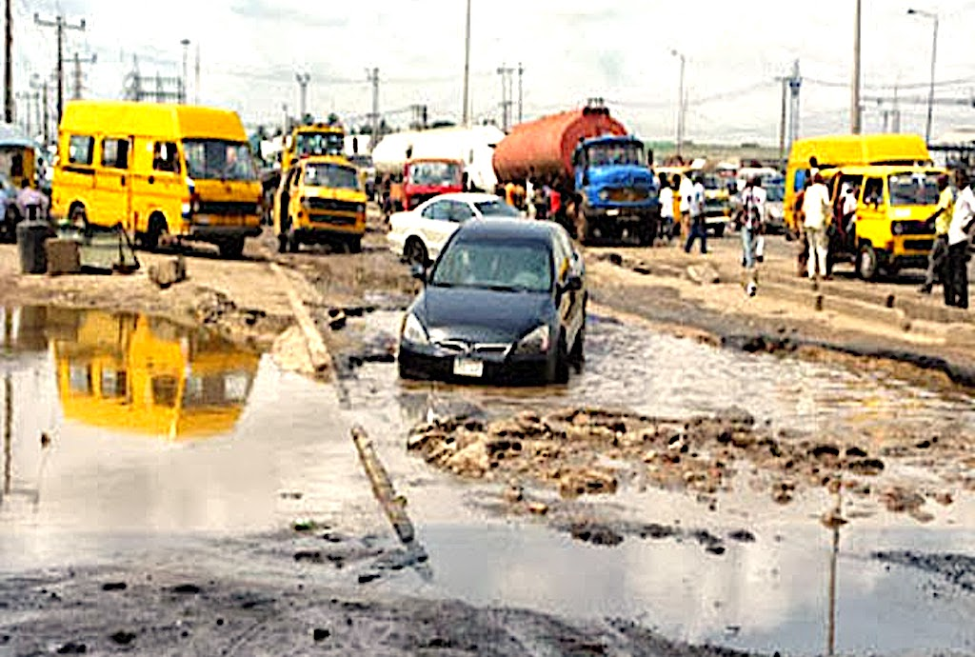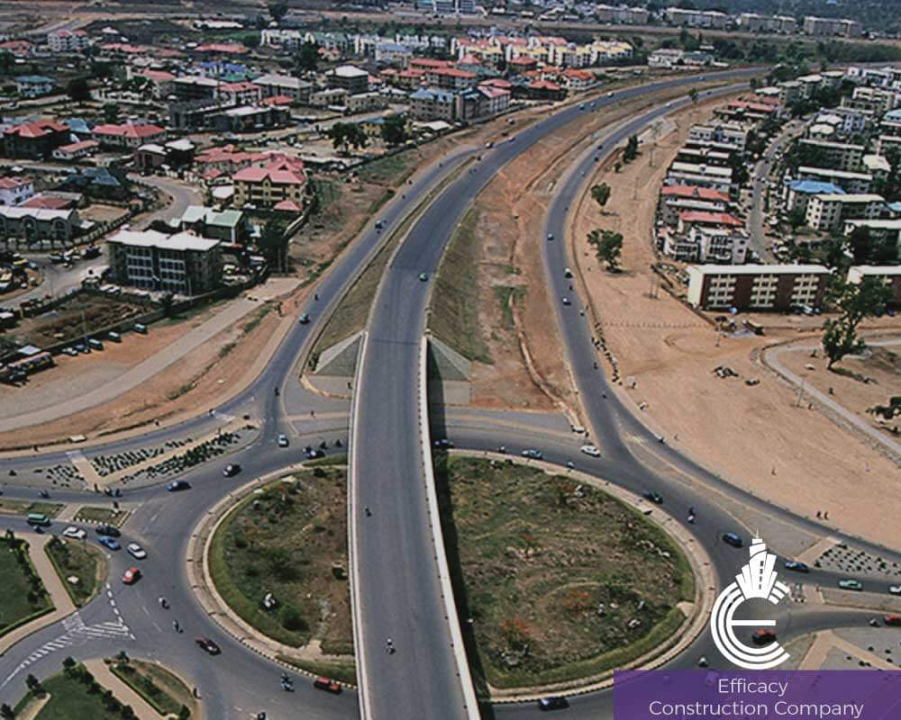
Figure1: Lagos roads causing uneasy movement of vehicles VS Good road infrastructure
Source: Google
Residents of Nigeria and visitors alike experience the unsatisfactory state of infrastructure services in Nigeria, perhaps more of poor quality of service delivery than in the relative cost of delivered services. Furthermore, discussions about service deficit or ``gaps in infrastructure" are very loud without necessarily being clear as to whether the gaps represent deficiencies in service delivery (i.e. variances between promised and delivered quanta and/or quality); gaps between installed capacity and operable capacity, or suboptimal investment in capacities. Any of these deficiencies can be usefully labeled a gap. Therefore, the discussions could be improved by injecting more specificity into the analysis. It does not help matters that infrastructure analytics are inherently complex because some of the outputs are often delivered from components that come as a bundle. Water, electricity, roads, highways, educational buildings, health facilities, telecommunications, parks and recreational facilities come to mind easily. The density and configuration of feeder roads as well as highway networks matter in determining the quality of roads infrastructure. That quality is also codetermined by the adequacy of its complements such as congestion pricing, enforcement and traffic engineering. Bulk water supply cannot be properly anticipated without planning for energy to power the pumping stations. Similarly, planning for roads network may not be realistic without a thorough consideration of land use as well as the nature of feeder roads and highways that comprise the envisaged roads network configuration.
DISCUSSION
The Role of Infrastructure in Economic Development Infrastructure is an umbrella term for many activities usually referred to as “social overhead capital” by development economists. Precisely, infrastructure refers to a network of transport, communication and public (social) services – all functioning as a system or as a set of interrelated and mutually beneficial services provided for the improvement of the general well-being of the population. Public or social services refer to those services or facilities meant for the common goods of the people. They include water supply, health care delivery, education, postal and telecommunication facilities, electricity, etc. Sufficient infrastructural services are indispensable for economic development. The adequacy of infrastructure helps to determine a country’s success or failure in diversifying production, coping with population growth, reducing poverty, improving environmental conditions, etc. Indeed, socio-economic development can be facilitated and accelerated by the presence of infrastructure. If these facilities and services are not in place, development will be very difficult and in fact can be likened to a very scarce commodity that can only be secured at a very high price and cost. Adequate access to social welfare services, such as medical services, education, potable water supply, roads, electricity, employment opportunities etc, are strong indices of development. In any discourse on infrastructure, it is important to note that infrastructure can be broadly classified in two:
Physical (roads, electricity, telecommunication, etc.) and Social (education, health, recreation, housing etc.). In some clime, physical infrastructure is often referred to as economic infrastructure. Thus, the role of infrastructure in economic development will be discoursed along this line.
1.1 The Role of Physical Infrastructure gives examples of physical infrastructure as public utilities such as power, telecommunications, piped water supply, sanitation and sewage, solid waste collection and disposal and piped gas as well as public works which include roads, major dam and canal works for irrigation and drainage, and other transport projects like urban and interurban railways, urban transport, seaports and waterways and airports. Physical infrastructure has played a very significantly positive role in the growth performance of countries in recent times. Where development of economic infrastructure has followed a rational, well-coordinated and harmonized path, growth and development has received a big boost. Examples are Korea and Japan. Where the growth of infrastructures has not followed such a rational and coordinated path, growth and development has been stunted. Examples can be found in most African countries and other LDCs; good infrastructure raises productivity and lowers production costs. Thus, it is clear that infrastructural development is a function of economic development;
2.2 The Role of Social Infrastructure Education and health are the two dominant social infrastructures which can have profound effect on economic development of any nation. Education has been considered as a very important source of economic growth. Even though education may be a social investment, it is also an economic investment since it enhances the stock of human capital Again, the role of education as a social infrastructure and as a stimulant of growth and development can be enhanced only if it is qualitatively provided. Qualitative education is a major determinant of the stock of human capital. It has proved to be the vehicle for national transformation in human history and no nation ever rises above her investment in education A less developing economy needs professionals in all sectors to accelerate the growth and development of such sectors. In fact, UNESCO recommends a minimum of fifteen percent of national expenditures on education. Some advanced countries spend more than 15% of their GDPs on education and yet, education still remains in the front burner of national debate on their development priorities. Similarly, health is a very important argument in the socio-economic production function. A popular adage says that a sound mind usually resides in a healthy body. Health is one of the major determinants of labour productivity and efficiency. Public health deals with the environment in which economic activities take place. In fact a conducive environment would be permissive of accelerated growth and development. Found that human capital components of infrastructure appear to have impact on growth.
The subsequent sections present an assessment of the state of infrastructural development in some of the country’s critical sectors. Physical Infrastructure Power supply in Nigeria is an exclusive responsibility of the Federal government. Water and Sanitation Water and sanitation are also critical to economic growth and wellbeing of Nigerians. A study of the provision of improved drinking water, households connected with water and improved access to sanitation in Nigeria compared to other nations in the league of 60 top economies shows that access to improved drinking water is generally high in all the top 20 countries (FGN, 2009a). Nigeria’s figure is amongst the lowest.
Challenges Responsible for the Present State of Infrastructure
Several factors are responsible for the present state of infrastructure in Nigeria. These include,
- Poor funding
- Poor governance
- Corruption and economic sabotage
- Poor maintenance culture
- Population explosion
- Neglect of urban and regional planning etc.
These factors are subsequently discussed.
Poor Funding has become a major challenge to infrastructural development in Nigeria for decades. As the country’s population soars, demand for additional infrastructure in all sectors also increases. Unfortunately, the government resources can hardly meet the increasing demand. Consequently, government has relied on foreign loans to complement budgetary allocations in the provision of infrastructure. This situation has led to the country’s indebtedness over the years. At the inception of the fourth republic in 1999, Nigeria’s foreign debt profile was over $40bn. Although, the country received debt pardon from her creditors and recorded a zero debt profile about five years ago, again, the country has been plunged into debt largely because of need to develop infrastructure in critical sectors of the economy.
Population Explosion Nigeria’s population is now 167million and growing at 3.2% per annum. The physical and social infrastructure required to support this huge population is enormous and requires huge funding. The huge population which is more than 50% urban has placed undue pressure on existing infrastructure and on governments’ budgets over the years. Thus, the infrastructure base is grossly inadequate and suffered from deferred maintenance. Besides, Nigerian government has failed over time to integrate population policy with overall development planning. The www.ccsenet.org/jsd Journal of Sustainable Development Vol. 5, No. 2; February 2012 Published by Canadian Center of Science and Education 71 short-fall in infrastructural provision affects the economy negatively and lowers productivity in every sector and aggravates the poverty profile of the country. 6.3 Poor Governance Apart from poor funding, poor system of governance in the country is largely responsible for the poor state of infrastructure in all sectors. To realize the 2020 vision, the country’s economy was expected to grow at 14% per annum; but current data show that the economy is growing at 7%. The low GDP growth is largely due to inefficient allocation and poor management of the country’s human and natural resources (The Punch, 2011). Also, the current system of governance in Nigeria has truncated infrastructural development at the grassroots. Section 7 of the 1999 constitution empowers states House of Assemblies to make laws for the operations of the Local Government Councils. Consequently, this provision gave the state governments opportunities to control the finance of the local governments, therefore, many local governments across the country today lacks freedom and financial strength to embark on any infrastructural development project that can serve as catalyst for economic growth and propel economic empowerment among the people in the grassroots.
Corruption and Economic Sabotage Corruption has become a major socio-economic problem in Nigeria with negative effects on infrastructural development. Embezzlement of funds allocated for infrastructural development is a common feature in public offices. Also, many projects for which funds have been allocated and released were never completed while inflation of project costs is a common experience. The case of abandoned projects is common because civil servants in charge of such projects collect bribe from contractors and this either results in sub-standard jobs or abandonment. According Transparency International Report on Bribe Tax Payers Index for 2011, Nigerian civil servants received $3bn bribes in 2010. Indeed, the private companies were also said to be involved in such economic crimes (Saturday Punch, 2011). Besides corruption, economic sabotage through vandalization of public facilities has impacted negatively on the nation’s economy. Vandals’ activities are regularly observed with oil pipelines and power transmission lines. In the same vein, the plundering of the country’s gas resources due to the failure of foreign oil companies to invest in infrastructure to utilize natural gas is an act of economic sabotage and needs to be checked. Gas flaring not only wastes a potentially valuable source of energy; it also adds significant carbon emissions to the atmosphere. As long as the country intends to be among the 20 top economies in the next nine years, the country cannot afford to be wasteful.
RECOMMENDATIONS
It is good to have great vision, because it can be achieved, but it is much better to run with the vision to ensure its achievement. Nigeria is currently on the 42nd position among the sixty nations with the largest economy. The country seeks to join the top 20 in the next nine years assuming the country’s economy is growing at 14% per annum. It must be understood that other nations ahead of Nigeria will not go to sleep. Many other countries also have great vision of joining the top 20. This suggests that Nigeria has to be awake and run with her vision. The greatest asset of the country is her vast human and natural resources. To achieve the 20:2020 vision;
The following key success/way-forward will be required:
Adequate Funding and Greater Private Sector Involvement One of the causes for the present poor condition of Nigeria’s infrastructure is lack of investment in new capacity, new technologies, and maintenance. It is important that the Government commits to a long-term and consistent funding of the costs of improving and maintaining the various infrastructures. Providing new sources of funding for power, transport, water and sanitation from other sources will g the 20:20:20 Vision. At the moment, many ministries, departments and agencies (MDAs) in the country have not audited their accounts for years and this is not good enough for a nation that aspires to be among the top 20 nations in the next nine years.
Good governance and proper devolution of power to the grassroots must be enshrined in the day to day business of the government. The people should also have a voice in the way they are governed especially in the area of infrastructural development. The recently passed freedom of information bill is a welcome development. According to most accounts the government of Nigeria is inefficient and corrupt.
Population Control: Rapid growth of population in a developing nation like Nigeria is inevitable. However, the growth can be planned and sustained to achieve economic growth. For instance, between 1960 and 2000, the share of the population living in urban areas rose from 20% to 36% in both Asia and Africa, the per capital income increased to 340% in Asia; and only 50% in Africa. Africa in general and Nigeria in particular has not taken full advantage of the process of urbanization to promote economic growth while Asia cities have capitalized on it by providing industries and the required infrastructure to sustain the growth. To reduce governments’ financial burden on infrastructural development, there must be deliberate control of the country’s population as done in China. In Europe, North America and parts of South America, where family planning has been adopted for population control, the healthy balance between populations and resource stock is a major factor in their enviable standards of living and impressive economic performances. China, for its part, with a population growth rate of 0.493, has moved rapidly into healthier development trends than countries such as India and Nigeria, where little is done on population control. It is either Nigeria deliberately controls her population or nature does it. Already, about 55 per cent of the Nigerian population lives on less than $1 per day, this is one of the highest poverty rates in sub-Saharan Africa. At the level of government, its responsibilities Centre on the provision of quality education to enhance quality human capital, quality health care and basic infrastructure.
The Need for Physical Planning: One of the major omissions of previous governments in their quest for economic development is the lack of integration of economic plans with physical development plans. The present government has recognized this failure and has put in place a National Technical Working group on urban and rural development to ensure that development activities meant for the economic transformation of the country is given a spatial expression. Referring to physical planning, the Vision document states that "...One of the objectives of the 20:2020 plan is the achievement of equitable and spatial socio-economic development across the various geopolitical regions in Nigeria, driven by a comprehensive regional strategy- The regional development strategy will be targeted at specific cities within each region into regional growth centers which will then be catalysts for the diffusion process of growth to the secondary growth urban centers within their respective regions or states. The plan went further to propose regional development plans for each of the geo-political zones while also treating the geographical Niger Delta as a region in its own right. However, in the document it was not quite explicit how the planning and management of such growth centers and other human settlements in the country would be achieved. In reality, the Nigerian Vision 20:2020 launched in 2009, is anchored on balanced spatially sensitive socio-economic development. But there is the need to properly emphasize the role of urban and regional planning and how its understanding could facilitate a balanced and sustainable national development. Big cities in Nigeria, especially city ports and capital-cities, concentrate infrastructure, equipment and resources while secondary cities and small towns have huge deficits of basic services, infrastructure and other amenities. This imbalance represents a tremendous challenge for achieving harmonious development and economic prosperity within the country not to talk of the total or near absence of regional network of infrastructure which can integrate the national economies. Conceptualizing the achievement of the 20:2020 vision within the context of urban and regional planning will go a long way in achieving the desired balanced growth and development and usher in a new era of prosperity in the country. www.ccsenet.org/jsd Journal of Sustainable Development Vol. 5, No. 2; February 2012 Published by Canadian Center of Science and Education 73 8.
CONCLUSION
This paper has shown clearly that infrastructure is critical to the economic growth and development of any nation. It has also demonstrated that in spite of the current position of Nigeria relative to other nations with the largest economy, the country can indeed make it to the top 20 if her vast human and economic resources are efficiently managed. Besides, the nation as a whole has to imbibe the culture of transparency and accountability with greater managerial skills, adequate funding and greater private sector participation. Rapid urbanization, poor governance, poor funding, corruption and poor management culture and lack of proper urban and regional planning are some of the major challenges facing the attainment of the goals of Nigeria's Vision 20:2020. Although some of these challenges were highlighted in the vision statement, the contribution of urban and regional planning was not very well articulated in the implementation plan of the vision. Rapid urbanization possess a major challenge to achieving the Nigerian Vision 20:2020 and significant land and infrastructure development will have to take place to accommodate this growing population. Infrastructural development policies, plans and programs are carried out in time and space and for the benefits of the people and improvement of their welfare; they have to be carried out in human settlements, hence the imperative to properly plan and adequately provide for such settlement. The war of economic transformation in the country would be lost or won in our settlements where productive economic activities are located; hence physical planning of these settlements and the regions across the country is germane to the realization of the 2020 vision.

REFERENCE
- Melvin Ayogu and Christie Research Foundation. (2019, june 19). Infrastructure Development and Growth.
- Vision 20:2020 and the Challenges of Infrastructural Development in Nigeria. Mobolaji Olaseni

