Name: Bulus Ritkhat Amos
Dept: medicine and surgery
Mat NO: 19/mhs01/123
Couse code: PHY 102
COVID-19 HOLIDAT ASSIGNMENT
SECTION A
1(a). Charging by induction
Electrical charges can be obtained on an object without touching it, by a process called electrostatic induction. Consider a positively charged rubber rod brought near a neutral conducting sphere that is insulated so that there is no conducting path to ground. The repulsive force between the electrons in the rod and those in the sphere causes a redistribution of charges on the sphere so that some electrons move to the side of the sphere farthest away from the rod. The region of the sphere nearest the negatively charged rod has an excess of positive charge because of the migration of electrons away from this location. If a grounded conducting wire is then connected to the sphere, some of the electrons leave the sphere and travel to the earth. If the wire to ground is then removed, the conducting sphere is left with an excess of induced positive charge.
Finally, when the rubber rod is removed from the vicinity of the sphere, the induced positive charge remains on the ungrounded sphere and becomes uniformly distributed over the surface of the sphere.
DIAGRAM
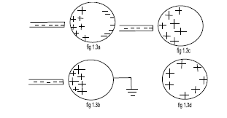
1(b).
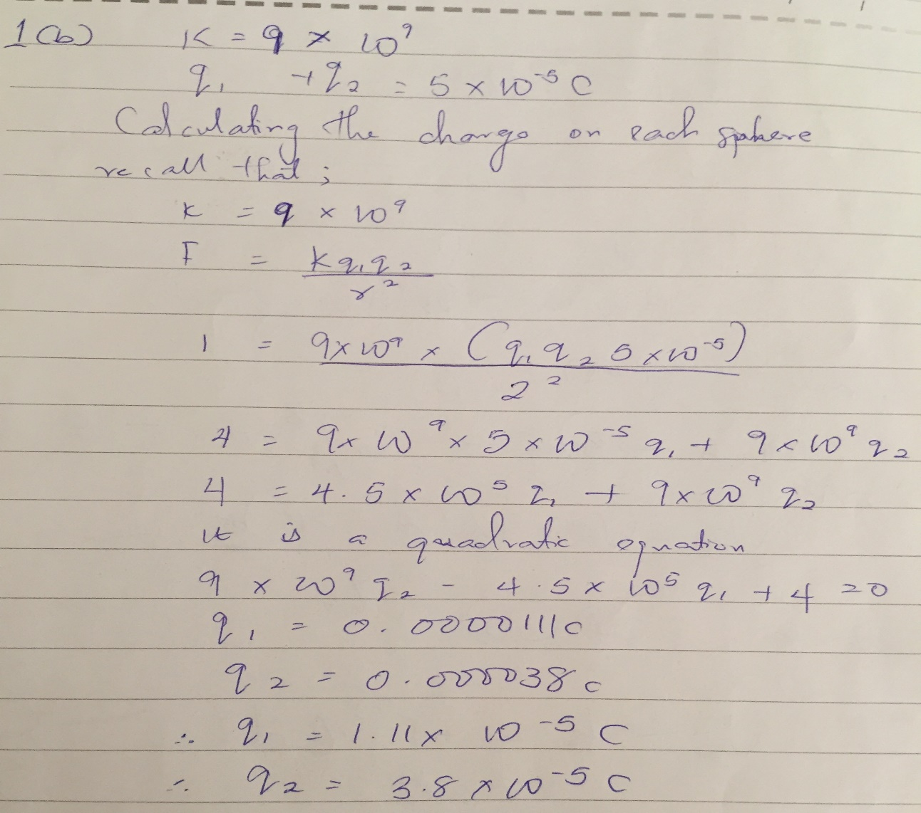
1(c)
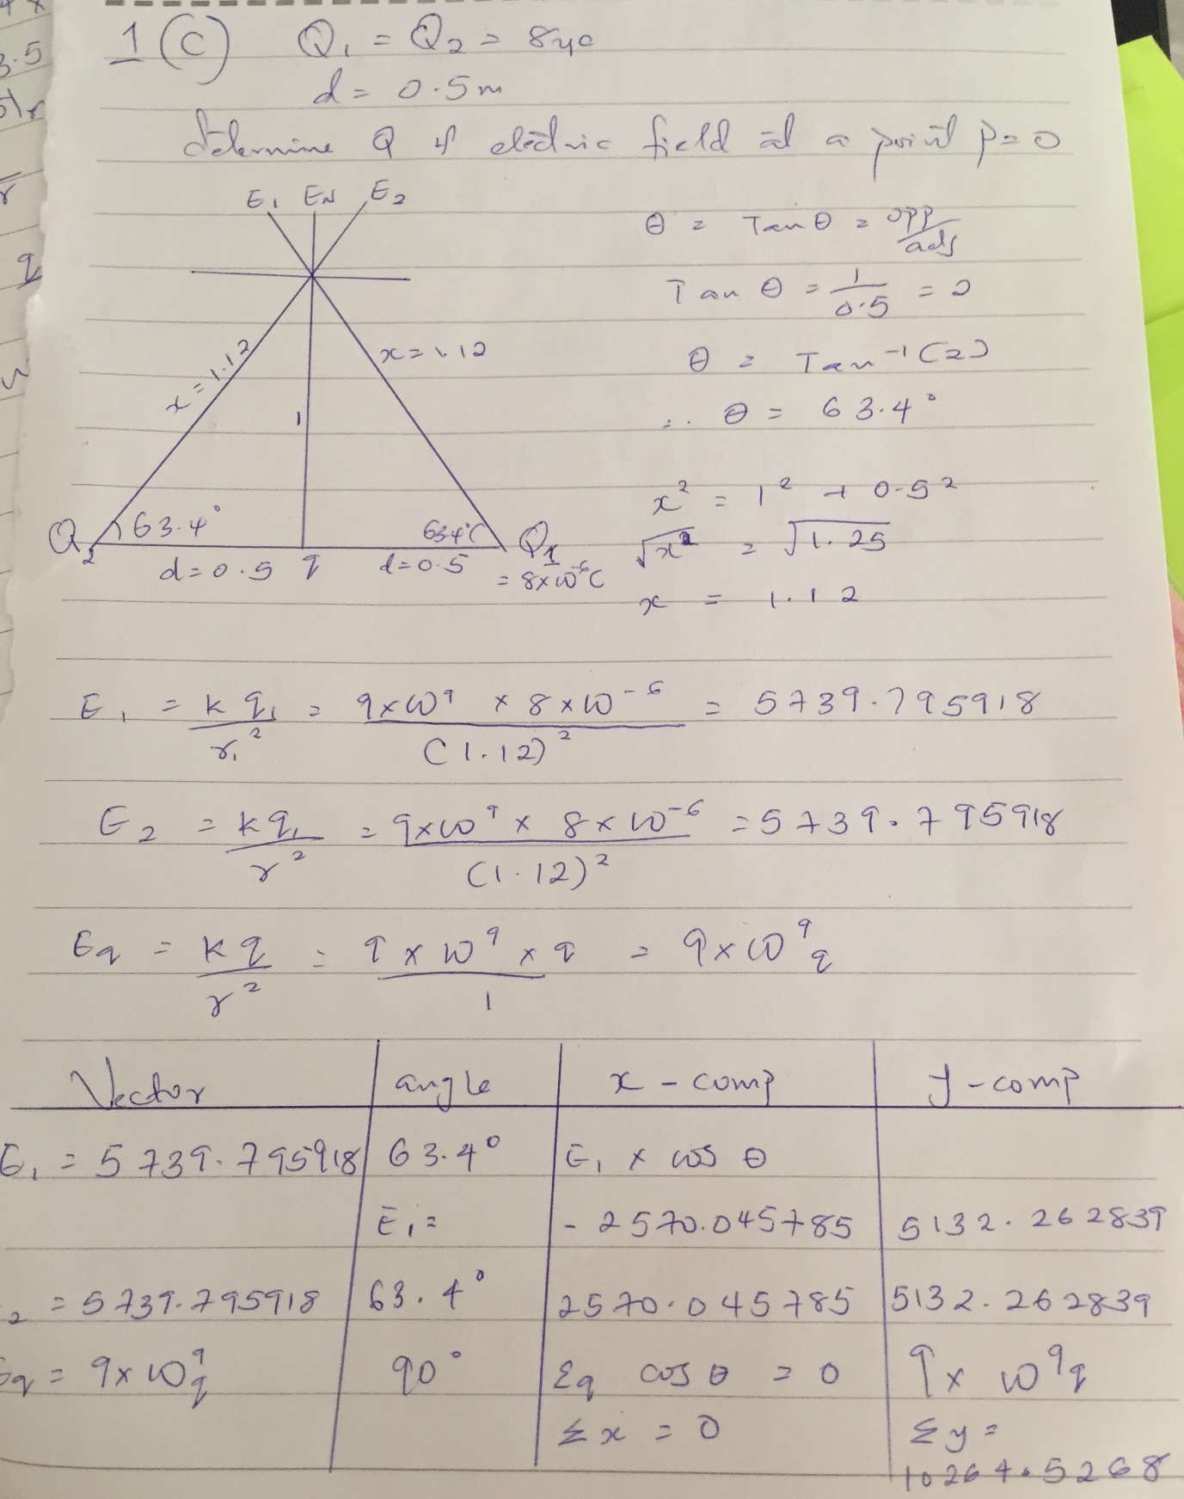
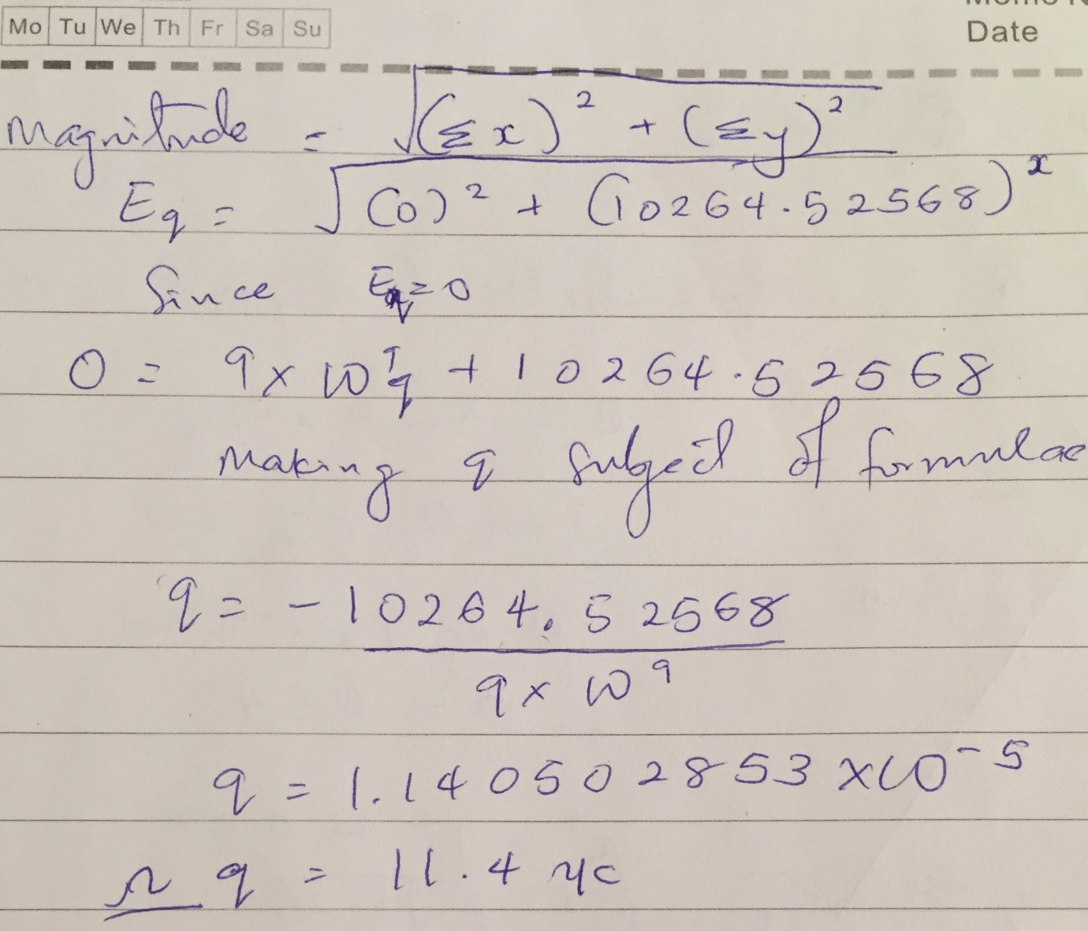
3(a).
(i) Volume charge density
(ii) Surface charge density
(iii) Linear charge density

3(b)
ELECTRIC POTENTIAL DIFFERENCE
The electric potential difference between two points in an electric field can be defined as the work done per unit charge against electrical forces when a charge is transported from one point to the other. It is measured in Volt or Joules per Coulomb. Electric potential difference is a scalar quantity.
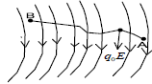
Consider the diagram above, suppose a test charge is moved from point to point along an arbitrary path inside an electric field. The electric field exerts a force on the charge as shown in fig. To move the test charge from to at constant velocity, an external force of must act on the charge. Therefore, the elemental work done is given as:
dW=F.dl…………………..(1)
But
F=q.E………………………..(2)
Substituting equation (2 ) in ( 1) yields
dW= -q.Edl……………….(3)
Then total work done in moving the test charge from(A) to (B )is
W(A→ B)Ag = -q.∫baEdl………(4)
From the definition of electric potential difference, it follows that:
Vb – Va = w(A→ B)Ag…………..(5)
q.
Putting equation (4 ) in ( 5) yields
Vb – Va = -∫ Edl…………………(6)

SECTION B

4(a) Magnetic flux can be defined as the strength of the magnetic field which can be represented by line of forces. It is represented by ɸ. Mathematically given as ɸ = B. Da
4(b)
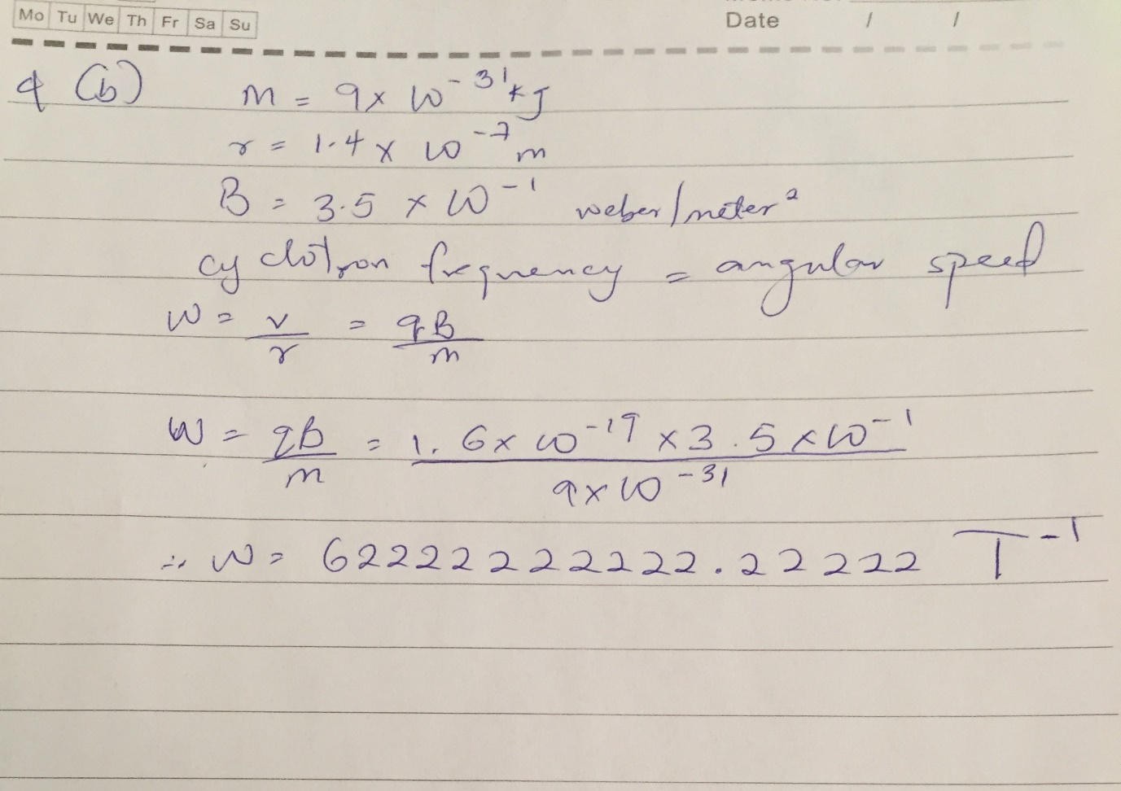
4(c). in the question we were given parameters such as:
Mass of the electron = 9.11x10^-13 Kg
Radius = 1.4 x 10^-7m
Magnetic field of 3.5 x 10^-1 weber/meter square
We are to find the cyclotron frequency which is equal or the same thing as angular speed. It is the frequency of an accelerator called cyclotron.
Recall that the angular speed is given as 1.6 x 10^-10 x 3.5 x 10^-10 x 9.iix10^-31 = 62222222222.22222T^-1
Since cyclotron frequency = angular speed = 6.2222222222.22222T^-1, having a unit as 1/T which is equal to the unit of frequency dimentionally.
5(a)
Biot-savart law states that the magnetic field is directly proportional to the product pemeability of fee space, the current, the change in length, the radius and inversely proportional to squae of radius.
The unit is in weber/meter square
5(b)
Magnetic field of a straight current carrying conductor
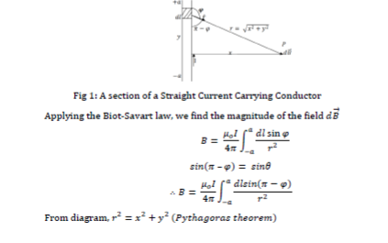
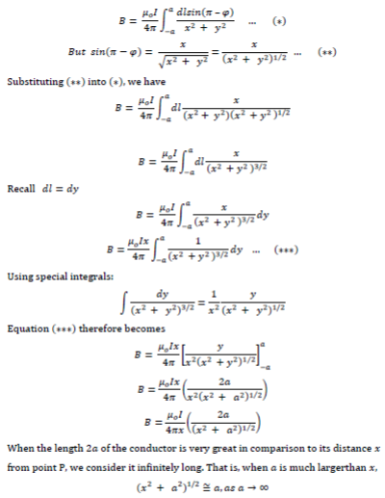
:. B = ɥ◦I
2∏x

