ENGINEERING STRATEGIES FOR HANDLING COVID-19 FOR ENVIRONMENTAL HEALTH AND ECONOMIC SUSTAINABILITY

INTRODUCTIION

WHAT IS COVID-19

Coronavirus disease (COVID-19) is an infectious disease caused by a new virus.
The disease causes respiratory illness (like the flu) with symptoms such as a cough, fever, and in more severe cases, difficulty breathing. You can protect yourself by washing your hands frequently, avoiding touching your face, and avoiding close contact (1 meter or 3 feet) with people who are unwell.

HOW IT SPREADS

Coronavirus disease spreads primarily through contact with an infected person when they cough or sneeze. It also spreads when a person touches a surface or object that has the virus on it, then touches their eyes, nose, or mouth.

SYMPTOMS

People may be sick with the virus for 1 to 14 days before developing symptoms. The most common symptoms of coronavirus disease (COVID-19) are fever, tiredness, and dry cough. Most people (about 80%) recover from the disease without needing special treatment.
More rarely, the disease can be serious and even fatal. Older people, and people with other medical conditions (such as asthma, diabetes, or heart disease), may be more vulnerable to becoming severely ill.

People may experience:
cough
fever
tiredness
difficulty breathing (severe cases)

ENGINEERING STRATEGIES

Presently in China, people are given a covid19 colour code according to the situation in area of residence. Green = no incidence, yellow =someone has had it around you, red if your house has had a cases. They do this using data uploaded to an AI system via smartphone
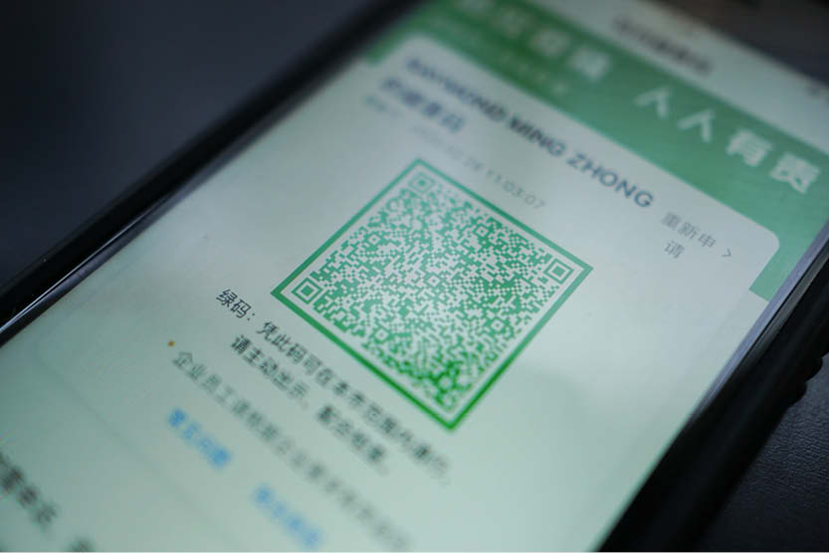

The AI monitors people’s movement and instantly delivers an alert to your phone when someone with colour code yellow comes close to you in a public place. Those with color code red are not allowed to move out beyond a certain distance of their homes. Their phone alerts police !

China deployed its resources like never seen before. For Wuhan alone, it deployed 9,000 contact tracers. It overrode people’s privacy and tapped into their gadgets & wechat apps for information re location & status. It locked down an entire city of 11 million people for weeks.

Artificial Intelligence
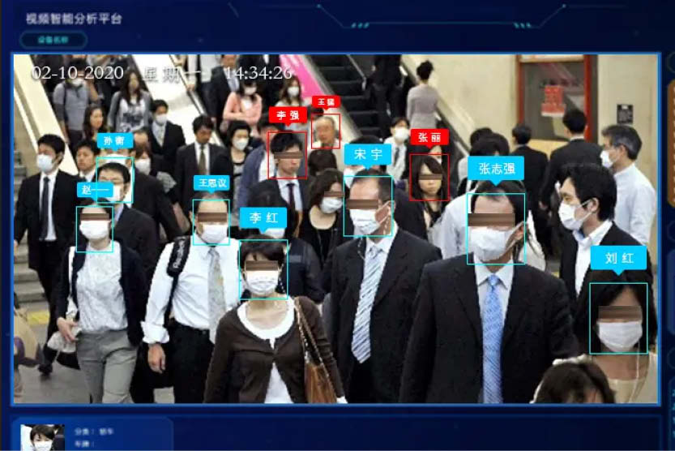
In a crisis, collaboration is key. During the outbreak, a range of companies made their algorithms publicly available to improve efficiency and to support coronavirus testing and research.
Baidu Research, a world leader in AI R&D, open-sourced LinearFold (its linear-time AI algorithm), to epidemic prevention centers, gene testing institutions, and global scientific research institutions. The algorithm is an important tool for gene testing institutions, and R&D institutions during the epidemic, reducing the time taken to predict and study coronavirus’s RNA secondary structure from 55 minutes to just 27 seconds. The algorithm also improves the speed of predicting and studying coronavirus‘s RNA secondary structure by 120 times and saves the waiting time for virus detectors and researchers by two orders of magnitude With the improved algorithm comes much-improved efficiency in virus detection and diagnosis than traditional algorithm.
Additionally, Zhejiang Provincial Center for Disease Control and Prevention (Zhejiang CDC) launched an automated genome-wide testing and analysis platform. Based on the AI ​​algorithm developed by the Alibaba DAMO Academy (a platform funded by Jack Ma for science research), the group has shortened the genetic analysis of suspected cases from several hours to half an hour and can accurately detect virus mutations.
Artificial intelligence was also leveraged in subway stations, train stations and other public places where there is a high concentration of people and a high degree of mobility. While using the traditional method of temperature measurement is time-consuming, and would increase the risk of cross-infection due to the clustering of the people, companies such as Wuhan Guide Infrared Co. Ltd put forth new temperature measurement technology based on computer vision and infrared technology. This technology made it possible to take body temperature in a contactless, reliable, and efficient manner, with the people even unaware of it. With this technology in place, those whose body temperatures exceeded the threshold could quickly and
accurately be located.

Big Data
After the outbreak, big data played an important role in prediction and early warnings, analyzing the flow of people and the distribution of materials. Qihoo 360, a leading Internet company in China, released “Big Data Migration Map” this past February which users can access through mobile phones or computers to view the migration trend of the Chinese mainland from January 1, 2020 up to date. The tool became an important means of understanding and predicting changes in the epidemic situation nationwide.

Cloud Computing

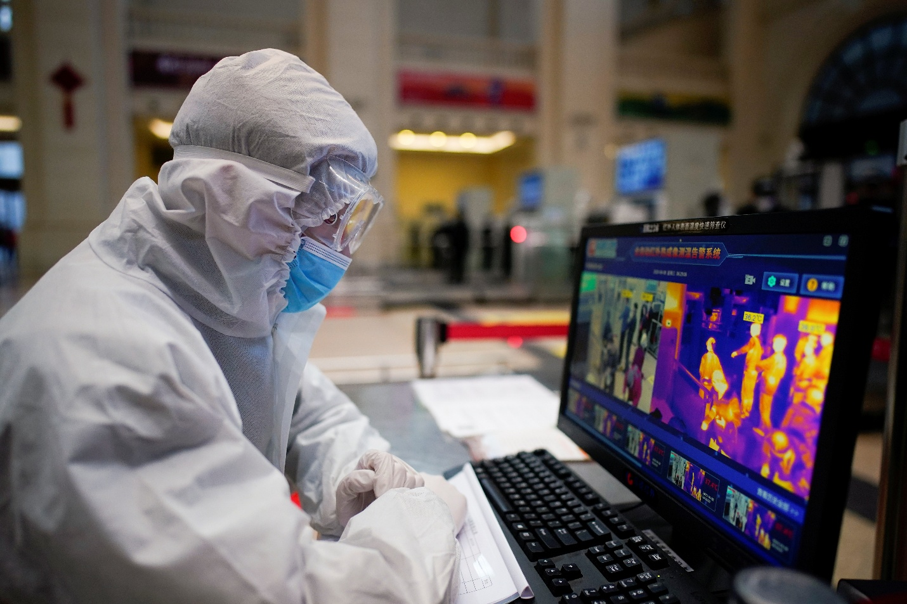
In the epidemic response, relatively mature cloud computing technologies became as essential as water or electricity. Alibaba Cloud made its AI computing power available to public research institutions around the world for free to accelerate the development of new pneumonia drugs and vaccines. Meanwhile, Didi offered GPU cloud computing resources and technical support for combating the novel coronavirus to domestic scientific research institutions, medical and rescue platforms, for free.
As the virus spread, the demand for cloud-based video conferencing and online teaching has skyrocketed. Various cloud service vendors have actively upgraded their functions and provided resources. For example, Youku and Ding Talk (an all-in-one platform under Alibaba Group) launched the "Attending Class at Home" program to provide students with a secure learning environment and convenient learning tools. The “Online Classroom” function, which is made available for students of universities, primary and middle schools across China without charges during the epidemic, can support millions of students to take online classes simultaneously and has also covered schools in vast rural areas.
Furthermore, other enterprise companies increased access to their tools. Tencent Meeting made unlimited-time meetings for up to 300 participants free until the end of the epidemic. WeChat Work can support the audio and video conference up to 300 participants during the epidemic. During the epidemic, the tool provided free access to stable HD video conferences are accessible from phones allowing sharing documents and screens among up to 300 participants.
Blockchain
Blockchain technology eliminates intermediary, prevents data loss and tampering and provides traceability. It can play an important role in ensuring the openness and transparency of the epidemic information and the traceability of the epidemic materials. For example, blockchain technology can be used to record epidemic information and ensure that information sources are open, transparent, and traceable, thus effectively reducing rumors.
Lianfei Technology launched the nation's first blockchain epidemic monitoring platform, which can track the progress of COVID-19 in all provinces in real time, and register the relevant epidemic data on the chain so that the data can be traced and cannot be tampered with. The data links based on transparent monitoring and accountability are initially established to ensure that epidemic information is open and transparent.

5G + Smart Applications
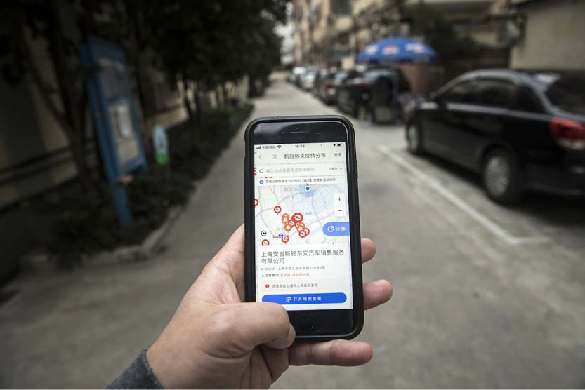
5G, which has just been commercialized, has also played an important role in the epidemic prevention and control. It is mainly used in the fields of live-streaming video and telemedicine. China Mobile opened 5G base stations at Huoshenshan and Leishenshan hospitals, and realized 5G high-definition live broadcasting of the construction of these two hospitals, providing real-time views of the construction sites on a 24-hour basis for more than 20 mainstream media platforms such as People's Daily and Xinhua News Agency. The content was also distributed by China Daily overseas simultaneously, and the number of online viewers exceeded 490 million.

Robotics

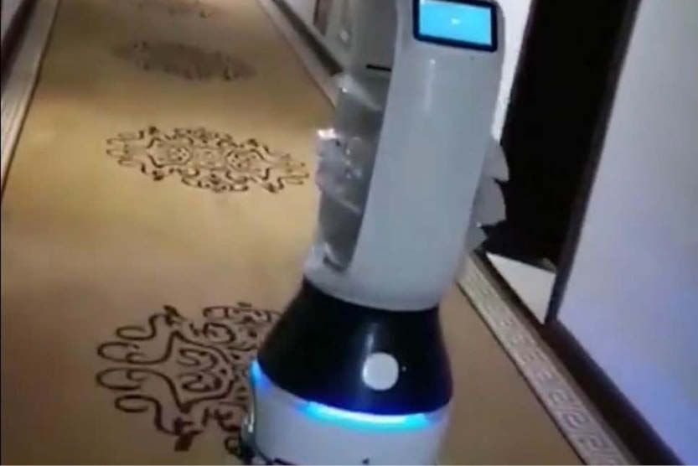
From preparing meals at hospitals, doubling up as waiters in restaurants, spraying disinfectants to vending rice and dispensing hand sanitizers, robots were on the frontline to prevent the spread of Coronavirus. In many hospitals, robots were also performing diagnosis and conducting thermal imaging. Shenzhen-based company Multicopter is using robots to transport medical samples.
A hospital in Wuhan, the epicenter of the outbreak, was being staffed entirely by robots. Wuchang Hospital, China Mobile and Cloud Minds, a manufacturer of Cloud-based robotics systems, came together for this project aimed at making the hospital facility completely smart and digital. Most of the devices in the hospital are IoT enabled and services are carried out by robots. The initial screening of the patients is done by 5G-enabled thermometers that send instant updates. Also, there are rings and bracelets that are connected to the CloudMinds AI platform so that it can monitor all changes in the body.
As per a Reuters report, a small robot called Little Peanut was delivering food to passengers on a flight from Singapore to Hangzhou, China who were being held under quarantine in a hotel.
CloudMinds alone has deployed 100 robots in the country’s hospitals. A few modified robots like Cloud Ginger (aka XR-1) and the Smart Transportation Robot carry food and medicine to patients from healthcare providers without any human contact.

Drones

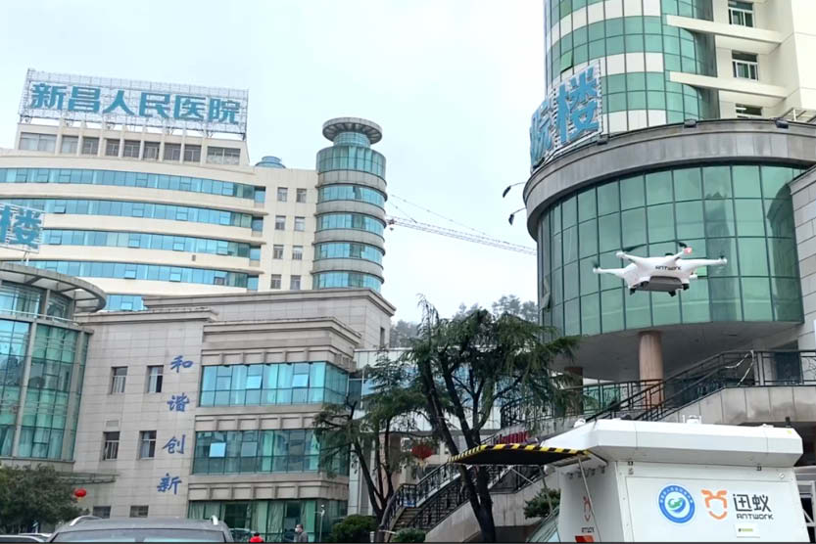
In some of the severely affected areas, where humans were at a risk of catching the virus, drones came to the rescue. Drones were transporting both medical equipment and patient samples, saving time and enhancing the speed of deliveries, while preventing contamination of medical samples.
Drones were also flying with QR code placards that could be scanned to register health information. Agricultural drones were spraying disinfectants in the countryside. Drones powered with facial recognition were also being used to broadcast warnings to the citizens to not step out of their homes, and chide them for not wearing face masks.
Antwork, a group company of Japanese dronemaker Terra Drone, carried medical samples and other essential materials in Xinchang when the city was grappling with the virus.

SENSITIZING OF SURFACES
Sensitizing of surfaces, railings, roads, chairs in public dormain using disinfectants should be carried out across the nation because as results have shown that the virus survives for up to 3 days on plastic surfaces.

ECONOMIC SUSTAINABILITY
Ever since Covid 19 was announced as a pandemic, we have often heard of schools and work places complaining about how it might be close to impossible conducting online classes and jobs, However since the virus was made pandemic, we have seen students and employees working from the comfort of their homes. However this approach is not possible for wage earners who go out on daily basis to hustle before getting what to feed from.
In the adherent of event, the government introduced a scheme whereby low earners will be given a means of sustainability due to the lockdown hence if Covid 19 doesn’t kill you, hunger would. The sporting world is on lockdown as they are all physical sports that involves social interaction. Companies, philanthropist donating huge sums to fight the pandemic, Government subsidizing Electricity & Water tariffs, Network providers gifting airtime bonuses because citizens don’t have place to buy from.
Government introduced a four hour period where citizens go out to local stores and markets to stock up on food suppliers provided stores and markets enforce the social distancing rule.
Religious institutes are lockdown and any place of worship discovered active will be sealed till further notice, night clubs likewise, social centers like amusement parks e.t.c also shutdown.

Citizens will be greatly inconvenienced but it had to be done for a greater cause and the government also providing relief through radio & television stations on any latest on the pandemic. As such if the above precautions are duly taken, when the pandemic (hopefully) is finally over, only few adjustments have to be taken and the economy will back to be working on full throttle. In summary,
- Government should ban movement and enforce a 24hour curfew with the exception of only security forces, doctors.
- Religious institutes should be shut down
- Social centers should also be shut down
- Online classes should be held for students so as to tally with objectives of the semester
- Public and Private sectors should work from home using E-communication platform
- Government should provide relief for daily earners with provisions

PRECAUTION
There’s currently no vaccine to prevent coronavirus disease (COVID-19). You can protect yourself and help prevent spreading the virus to others if you:

- Mass gatherings and events should be suspended, schools shut, traffic was restricted and social distancing became the new norm.
- Wash your hands regularly for 20 seconds, with soap and water or alcohol-based hand rub
- Cover your nose and mouth with a disposable tissue or flexed elbow when you cough or sneeze
- Avoid close contact (1 meter or 3 feet) with people who are unwell
- Stay home and self-isolate from others in the household if you feel unwell
- DON’T Touch your eyes, nose, or mouth if your hands are not clean

CONCLUSION

I believe that the above strategies of engineering in handling the pandemic are effective.

Recommendation
- People should strictly adhere to WHO instructions and guidance
- People should obey the country’s orders and protocols
- Government in the country should take responsibility and provide and provide for her citizens especially those with little or no means of provision
- People should use this medium to be creative and engage in one form of activity (legal) or the other from their various homes

