A TECHNICAL REPORT
ON
ENGINEERING STRATEGIES FOR HANDLING
COVID-19 FOR ENVIRONMENTAL HEALTH
AND ECONOMIC SUSTAINABILITY
BY
EVAH OGHENELURE FAVOUR
17/ENG01/011
SUBMITTED TO
ENG 384
COLLEGE OF ENGINEERING,
AFE BABALOLA UNIVERSITY,

ADO-EKITI, EKITI STATE, NIGERIA.

13TH APRIL, 2020.
ABSTRACT
This report contains a brief summary of how chemical engineers can help in the handling of covid-19 for environmental health and economic sustainability. Coronaviruses are group of viruses that can cause diseases in mammals and birds. The disease causes respiratory illness (like the flu) with symptoms such as a cough, fever, and in more severe cases, difficulty breathing. You can protect yourself by washing your hands frequently, avoiding touching your face, and avoiding close contact (1 meter or 3 feet) with people who are unwell. The way chemical engineers help to fight the disease are briefly discussed here and also diagrams of kits worn by doctors and scientists are as well shown in this report. Symptoms, causes, and preventative measures to cure the disease are also contained in this report.
With this, you can clearly see engineering strategies for handling covid-19 for environmental health and economic sustainability.

LIST OF FIGURES
FIGURE 1.1: ENGINEERS TESTING VACCINES
FIGURE 1.2: DOCTORS IN COMPLETE PPE

CONTENTS
CHAPTER ONE 1
INTRODUCTION 1
1.1CHECMICAL ENGINEERING 1
1.2CHEMICAL ENGINEERS AND GOOD HEALTH 1
CHAPTER TWO 3
LITERATURE REVIEW 3
2.1 CORONAVIRUS DISEASE PANDEMIC (COVID-19) 3
2.2 PREVENTIVE MEASURES FOR COVID-19 4
2.3 CHEMICAL ENGINEERING STRATEGIES FOR HANDLING COVID-19 FOR ENVIRONMENTAL HEALTH 4
2.4 ECONOMIC SUSTAINABILITY 5
2.5 WAYS COVID-19 AFFECT ECONOMIC SUSTAINABILITY 5
2.6 CHEMICAL ENGINEERING STRATEGIES FOR HANDLING COVID-19 FOR ECONOMIC SUSTAINABILITY 6
CHAPTER THREE 7
METHODOLOGY 7
3.1 DIAGRAMS OF EQUIPMENT USED IN FIGHTING COVID-19 7
3.2 MATERIALS THAT CAN HELP IN PREVENTING COVID-19 7
CHAPTER FOUR 8
CONCLUSION AND RECOMMENDATION 8
4.1 CONCLUSION 8
4.2 RECOMMENDATION 8
REFERENCES 9
APPENDIX 10

CHAPTER ONE

INTRODUCTION

1.1CHECMICAL ENGINEERING
Chemical engineering is a branch of engineering that uses principles of chemistry, physics, mathematics, biology, and economics to efficiently use, produce, design, transport and transform energy and materials. The work of chemical engineers can range from the utilization of nano-technology and nano-materials in the laboratory to large-scale industrial processes that convert chemicals, raw materials, living cells, microorganisms, and energy into useful forms and products. Chemical engineers are involved in many aspects of plant design and operation, including safety and hazard assessments, process design and analysis, modeling, control engineering, chemical reaction engineering, nuclear engineering, biological engineering, construction specification, and operating instructions.
Chemical engineers typically hold a degree in Chemical Engineering or Process Engineering. Practicing engineers may have professional certification and be accredited members of a professional body. Such bodies include the Institution of Chemical Engineers (IChemE) or the Nigerian society of Chemical Engineers (NSChE). A degree in chemical engineering is directly linked with all of the other engineering disciplines, to various extents.

1.2CHEMICAL ENGINEERS AND GOOD HEALTH
Modern medicine and healthcare rely heavily on engineering to deliver improved prevention, diagnosis and treatment of illness. These technologies are vital to the delivery of efficient health services through the National Health Service (NHS). However, in the health sector the contribution of engineering is often hidden. Many applications of engineering in the health and medical sciences involve contact between a physiological fluid or tissue and a nonphysiological artificial surface. The opportunities for chemical engineers to participate in advancing the medical and health sciences fields are abundant.
Chemical engineers working in the medical field can work on pharmaceuticals or perform research into new medical devices and procedures. A career in pharmaceuticals involves finding new medicines and medical solutions to diseases and other medical conditions.
A related part of the healthcare field is the pharmaceutical industry, where chemical engineers might create new medicines, synthetic versions of existing medicines, or use bacteria, animal, and plant cells to help them understand diseases, disease pathways, and human responses to drugs.
The present pandemic in the world corona virus otherwise known as covid-19 can been solved with the help of chemical engineers and not only medical doctors, scientists or micro biologists.

CHAPTER TWO

LITERATURE REVIEW

2.1 CORONAVIRUS DISEASE PANDEMIC (COVID-19)
Coronaviruses are a group of related viruses that cause diseases in mammals and birds. In humans, coronaviruses cause respiratory tract infections that can range from mild to lethal. Mild illnesses include some cases of the common cold (which has other possible causes, predominantly rhinoviruses), while more lethal varieties can cause SARS, MERS, and COVID-19. Symptoms in other species vary: in chickens, they cause an upper respiratory tract disease, while in cows and pigs they cause diarrhea. The disease causes respiratory illness (like the flu) with symptoms such as a cough, fever, and in more severe cases, difficulty breathing. You can protect yourself by washing your hands frequently, avoiding touching your face, and avoiding close contact (1 meter or 3 feet) with people who are unwell.
Coronavirus disease spreads primarily through contact with an infected person when they cough or sneeze. It also spreads when a person touches a surface or object that has the virus on it, then touches their eyes, nose, or mouth. Coronavirus disease (COVID-19) is an infectious disease caused by a new virus. Infection with the new coronavirus (severe acute respiratory syndrome coronavirus 2, or SARS-CoV-2) causes coronavirus disease 2019 (COVID-19).
It's unclear exactly how contagious the new coronavirus is. Data has shown that it spreads from person to person among those in close contact (within about 6 feet, or 2 meters). The virus spreads by respiratory droplets released when someone with the virus coughs, sneezes or talks.
It can also spread if a person touches a surface with the virus on it and then touches his or her mouth, nose or eyes. Signs and symptoms of COVID-19 may appear two to 14 days after exposure and can include:
- Fever
- Cough
- Shortness of breath or difficulty breathing
Other symptoms can include:
- Tiredness
- Aches
- Runny nose
- Sore throat
There are yet to be vaccines or antiviral drugs to prevent or treat human coronavirus infections.

2.2 PREVENTIVE MEASURES FOR COVID-19
Here are some ways to prevent covid-19 they include;
- Wash your hands regularly for 20 seconds, with soap and water or alcohol-based hand rub.
- Cover your nose and mouth with a disposable tissue or flexed elbow when you cough or sneeze.
- Avoid close contact (1 meter or 3 feet) with people who are unwell.
- Stay home and self-isolate from others in the household if you feel unwell.
- Do not touch your eyes, nose, or mouth if your hands are not clean.

2.3 CHEMICAL ENGINEERING STRATEGIES FOR HANDLING COVID-19 FOR ENVIRONMENTAL HEALTH
Fifty years ago, when diseases such as polio and pneumonia took many lives, only a handful of today's high-performance pharmaceuticals existed. Through collaboration with biologists and clinicians, chemists and chemical engineers have helped change the course of medical history in the intervening years. Vaccines, antibiotics, and other pharmaceuticals can now save and prolong lives or improve the quality of life for those who suffer from illnesses. Today, chemical engineers can play important roles in fighting diseases.
The following are the ways chemical engineers can help in handling covid-19 for environmental health:
- Help in the production of hand sanitizers.
- Help in manufacturing fabrics for the production of face masks, hand gloves and other medical PPE.
- They can help in the manufacturing of pharmaceutical products for covid-19.
- They work in hand with the micro-biologists to test vaccines for the virus in lab.
- Chemical engineers help in studying the behaviours of pathogens of coronavirus in places like hospitals, schools or public areas to know how to sanitize the various environments.
- Chemical engineers also help in creating new systems to speed up the process of making life-saving vaccines for new viruses (such as covid-19).

2.4 ECONOMIC SUSTAINABILITY
Economic sustainability refers to practices that support long-term economic growth without negatively impacting social, environmental, and cultural aspects of the community Economic sustainability is the maintenance and sustenance of a high real growth rate of the economy to achieve the development or economic objectives. Despite the huge resources in Nigeria, the country ranks low in economic performance. Nigeria has not been able to maintain the growth rate necessary to reduce poverty.

2.5 WAYS COVID-19 AFFECT ECONOMIC SUSTAINABILITY
Covid-19 has affected our today economic in the following ways:
- Increase in the price rate of goods.
- Shortage of income in businesses
- Due to the lock down, most businesses are on hold.
- Shortage of supply of goods from companies.
- No import or export of goods within and outside the country to prevent the spread of the virus.

2.6 CHEMICAL ENGINEERING STRATEGIES FOR HANDLING COVID-19 FOR ECONOMIC SUSTAINABILITY
The following are ways chemical engineers can handle the issue of covid-19 for economic sustainability:
- Manufacturers directly from the company can help share sanitizers, face mask etc. to houses without payment to help save money.
- They can help supply machines and equipment needed to hospitals with discount.
- Engineering companies such as the chemical, biomedical, civil, computer etc. can help give loans to hospitals, or pharmaceutical companies in the supply of materials and equipment used in the lab in testing of vaccines.

CHAPTER THREE

METHODOLOGY

3.1 DIAGRAMS OF EQUIPMENT USED IN FIGHTING COVID-19
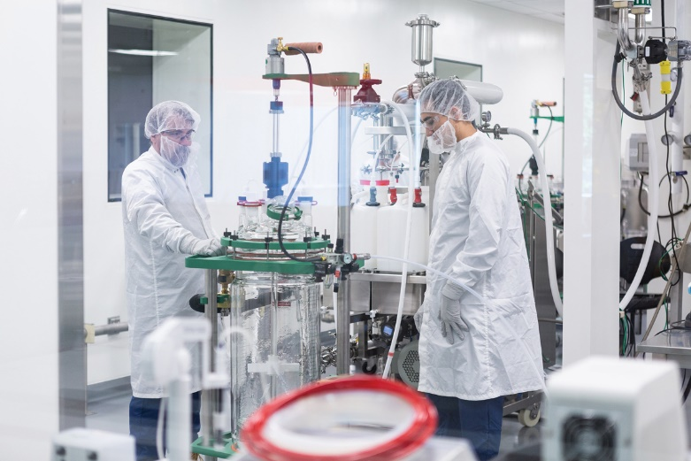
Figure 1.1: engineers testing vaccines

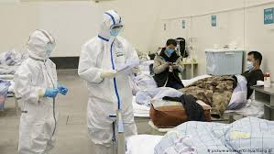
Figure 1.2: doctors in complete PPE

3.2 MATERIALS THAT CAN HELP IN PREVENTING COVID-19
- Hand sanitizer
- Face mask
- Hand glove
- PPE (personal protective equipment)

CHAPTER FOUR

CONCLUSION AND RECOMMENDATION

4.1 CONCLUSION
Chemical engineers can help in handling covid-19 for environmental health and economic sustainability. Chemical engineers working in medical field can work on pharmaceuticals or perform research into new medical devices and procedures.
Coronaviruses are a group of related viruses that cause diseases in mammals and birds. Covid-19 has done so much harm and has affected the economic sustainability of the society. It spreads primarily through contact with an infected person when they cough or sneeze. It also spreads when a person touches a surface or object that has the virus on it, then touches their eyes, nose, or mouth.
At the end of the research, it can be said that chemical engineers are needed in handling covid-19 for environmental health by: Helping in the production of hand sanitizers, helping in manufacturing fabrics for the production of face masks, hand gloves and other medical PPE, and also working in hand with the micro-biologists to test vaccines for the virus in lab. They can also help in handling the pandemic disease for economic sustainability by allowing engineering companies such as the chemical, biomedical, civil, computer etc. to give loans to hospitals, or pharmaceutical companies in the supply of materials and equipment used in the lab in testing of vaccines and also manufacturers directly from the company can help share sanitizers, face mask etc. to houses without payment to help save money.

4.2 RECOMMENDATION
The following are some of the things recommended to help fight covid-19:
- The government should give room to engineers to bring up ideas in finding vaccines and also build equipment or machines that can help in fighting the disease.
- Funds should be raised to purchase sanitizers and PPE for companies who manufacture them.
- Labs should be made available to run tests for the vaccines.

REFERENCES
- Campbell C (20 January 2020). "The Wuhan Pneumonia Crisis Highlights the Danger in China's Opaque Way of Doing Things". Time. Archived from the original on 13 March 2020. Retrieved 13 March 2020.
- Lucey D, Sparrow A (14 January 2020). "China Deserves Some Credit for Its Handling of the Wuhan Pneumonia". Foreign Policy. Archived from the original on 15 January 2020. Retrieved 13 March 2020.
- Jump up to:a b c d e f "Symptoms of Coronavirus". U.S. Centers for Disease Control and Prevention(CDC). 10 February 2020. Archived from the original on 30 January 2020.
- Jump up to:a b c d e f g h i j k l m "Q&A on coronaviruses". World Health Organization. 8 April 2020. Archived from the original on 20 January 2020. Retrieved 12 April 2020.
- Jump up to:a b c "Coronavirus COVID-19 Global Cases by the Center for Systems Science and Engineering (CSSE) at Johns Hopkins University (JHU)". ArcGIS. Johns Hopkins CSSE. Retrieved 13 April 2020.
- "Naming the coronavirus disease (COVID-19) and the virus that causes it". World Health Organization (WHO). Archived from the original on 28 February 2020. Retrieved 28 February 2020.
- Walles T. Tracheobronchial bio-engineering: biotechnology fulfilling unmet medical needs. Adv Drug Deliv Rev. 2011; 63(4-5): 367–74.
- "Accredited Biomedical Engineering Programs". Bmes.org. Archived from the original on 2011-09-28. Retrieved 2011-09-24.
- ^ ABET List of Accredited Engineering Programs Archived August 23, 2006, at the Wayback Machine.

APPENDIX
IChemE- Institution of Chemical Engineers
NSChE- Nigerian society of Chemical Engineers

