DEVELOPMENT OF AUTOMATED MACHINE AND ELECTRO-MECHANICAL DEVICES FOR PRODUCTION OF INFECTION PREVENTION AND CONTROL (IPC) AND PERSONAL PROTECTIVE EQUIPMENT (PPE) FOR PUBLIC HEALTH AND ECONOMIC GROWTH IN NIGERIA
BY
ADEDEJI FAROUQ ADEDOTUN
17/ENG04/001
A TERM PAPER SUBMITTED TO
COLLEGE OF ENGINEERING, AFE BABALOLA UNIVERSITY, ADO-EKITI, EKITI STATE.
FOR ENGINEERING LAW AND MANAGERIAL ECONOMICS (ENG 384)
IN PARTIAL FULFILMENT TO THE REQUIREMENTS FOR THE DEGREE OF BACHELOR OF ENGINEERING IN ELECTRICAL & ELECTRONICS ENGINEERING.

10th of APRIL, 2020

TABLE OF CONTENTS

TITLE PAGE………………………………………………..…………………………………1

TABLE OF CONTENTS………………………………………………………………………2

ABSTRACT…………………………………………………………………………………...3

- INTRODUCTION…………………………………………………….……………..…….4

- LITERATURE REVIEW……………………………………………………………….....5

- METHODOLOGY……………………………………………………………………….12

4.0 CHALLENGES…………………………………………………………………………..20

5.0 RECOMMENDATION……………………………………….………………………….21

6.0 CONCLUSION…………………………………………………………………………..22

7.0 REFERENCES…………………………………………………………………………...23

ABSTRACT
Small business industries account for a large proportion of our jobs and play a very vital role in most countries’ economic growth and prosperity. However, the employees are routinely and regularly exposed to numerous physical, chemical and accidental hazards and the use of personal protective equipment (PPEs) is very low. PPEs are very effective in minimizing occupational injuries, accidents and other hazards which otherwise result in substantial human sufferings and financial losses. The aim of this study was to assess the availability and use of PPEs as well as self-reported occupational exposures among workers in surveyed small industries. This study involved 102 workers from 28 workshops (vehicle repair, welding and paint). A custom developed questionnaire composed of sociodemographic, self-reported occupational exposures and frequency of use of different types of PPEs was used. The occupational exposures percentages reported (never, sometimes and always) including; noise exposure (19.6, 73.5 and 6.9%); dust/smoke exposure (9.8, 69.6 and 20.6%); vapors/fumes exposure (11.8, 60.8 and 27.5%); direct sunlight/heat exposure (43.1, 56.9 and 0%), respectively. The reported use of different PPEs in descending order was; knee joints mats (50%), welding shields (50%), safety glasses (33.3%), gloves (27.5%), face masks (26.5%), safety shoes (10.8%) and ear plugs/muffs (8.8%). A hand hygiene and awareness regarding benefits of wearing proper PPEs based interventions program can be developed on the basis of this study findings to minimize workplace exposures and their health implications for workers in small scale industry workers.

- INTRODUCTION
On 30 January 2020, WHO announced that the COVID-19 outbreak was a Public Health Emergency of International Concern. Initially, most cases were reported from China and among individuals with travel history to China. Please refer to the latest situation reports for COVID-19. COVID-19 is an acute respiratory illness caused by a novel human coronavirus (SARS-CoV-2, called COVID-19 virus), which causes higher mortality in people aged ≥60 years and in people with underlying medical conditions such as cardiovascular disease, chronic respiratory disease, diabetes and cancer. RECLong-term care facilities (LTCFs), such as nursing homes and rehabilitative centers, are facilities that care for people who suffer from physical or mental disability, some of who are of advanced age. The people living in LTCF are vulnerable populations who are at a higher risk for adverse outcome and for infection due to living in close proximity to others. Thus, LTCFs must take special precautions to protect their residents, employees, and visitors. Note that infection prevention and control (IPC) activities may affect the mental health and well-being of residents and staff, especially the use of PPE and restriction of visitors and group activities. For further information on resilience during the time of COVID, see Mental health and psychosocial considerations during COVID-19 outbreak. This interim guidance is for LTCF managers and corresponding IPC focal persons in LTCF. The objective of this document is to provide guidance on IPC in LTCFs in the context of COVID-19 to 1) prevent COVID-19-virus from entering the facility, 2) prevent COVID-19 from spreading within the facility, and 3) prevent COVID-19 from spreading to outside the facility. WHO will update these recommendations as new information becomes available. All technical guidance for COVID-19 is available online.

2.0 LITERATURE REVIEW
BioMedomics
BioMedomics focuses on building fast and easy-to-use testing kits for various diseases at a patient's point of care. BioMedomics specialized in product offerings that help in the diagnosis of blood disorders and in the identification of microorganisms and pathogens which are of global concern.
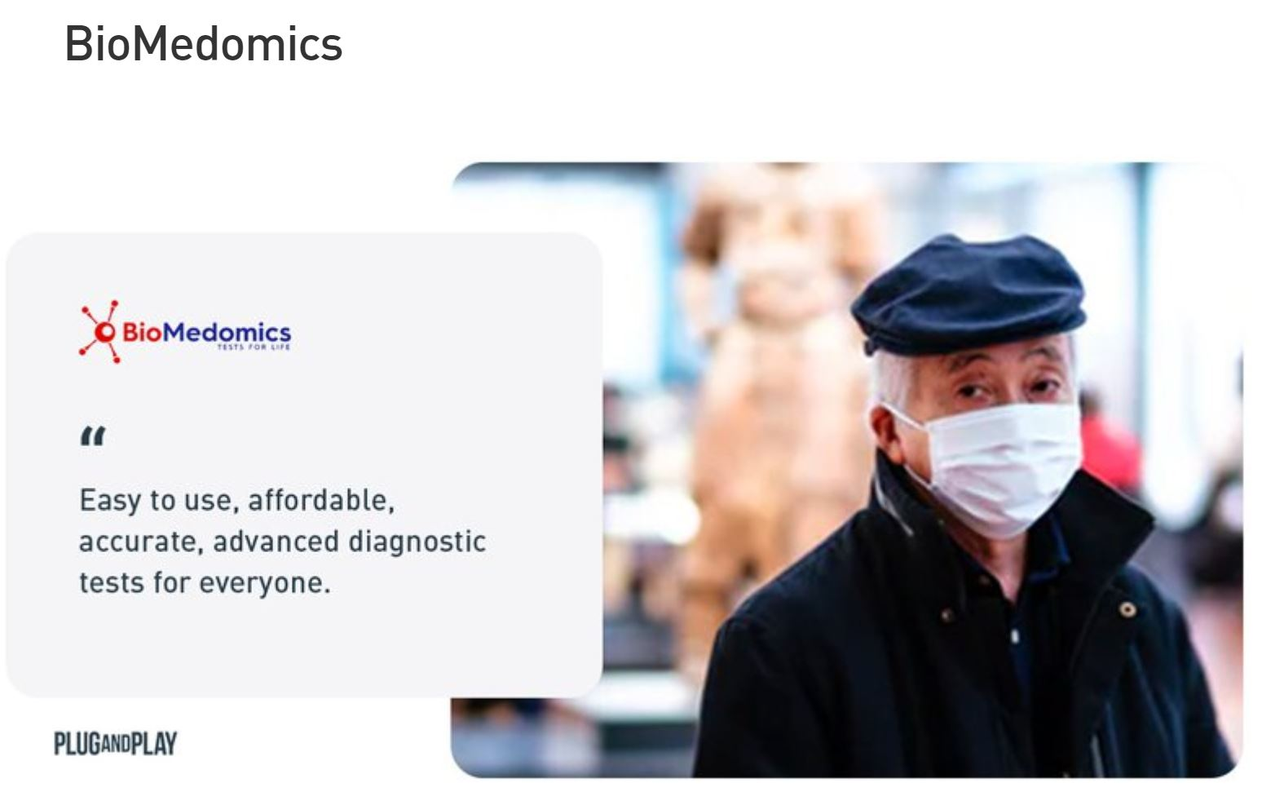
Fig 1.0: BioMedics
They recently developed a quick immunoassay diagnostic test for COVID-19 in two ways: antibody and PCR (polymerase chain reaction) testing. At the point of care, the BioMedomics solution can deliver results within 15 minutes using just a blood sample. This blood sample can be used for rapid screening for carriers of the virus that are symptomatic or asymptomatic.
Recent studies around the new COVID-19 outbreak suggest that a high percentage of patients show no clinical symptoms of the virus, thus screening patients is key. This kind of testing is perfectly tailored for hospitals, clinics, and test laboratories, but can also be effectively deployed in businesses, schools, airports, seaports and train stations giving it the potential to become a compelling force in the fight against this global threat.
Bat-Call
Bat-Call is a startup that focuses on respiratory and cardiovascular diagnosis through chest sound and machine learning classification. They developed a wide range of devices to use in different settings. Their latest invention is a vest that patients can wear to collect sound samples from various angles and which get wirelessly communicate to doctors for an accurate diagnosis. Another device they developed is called CompuSteth, which is a digital Stethoscope that enables doctors to use them at patient’s bedside, the device is able to detect inaudible sounds, analyze them and visually present them to doctors, thus making the diagnosis faster and more precise.
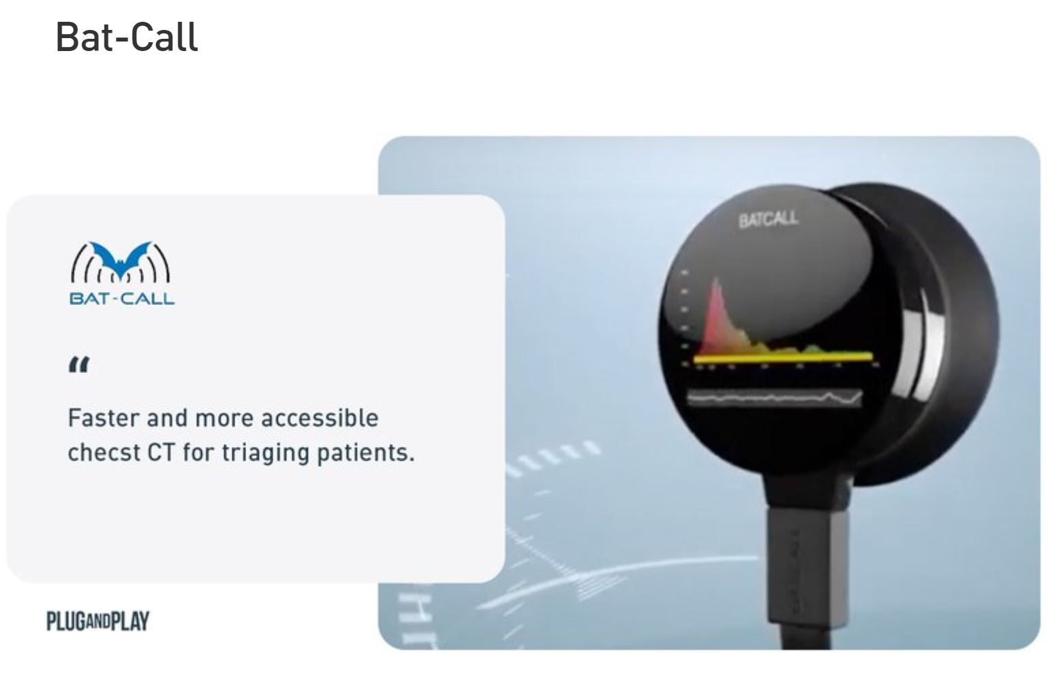

Fig 2.0: Bat-Call
To combat COVID-19, constant monitoring and quick diagnosis are key. Chest CT is widely used in China to rapidly diagnose and screen for people who got infected and has proven to be as accurate for testing as a testing kit which may not be accessible in some areas. Bat-call can offer a more accessible and faster scan that could significantly help in triaging patients and thus in relieving the limited capacities of healthcare providers.

Codagenix
Codagenix Inc. utilizes a breakthrough platform technology called SAVE to construct live-attenuated viral vaccines against multiple targets. All live-attenuated vaccines that are currently used in clinics were created using a trial-and-error based testing developed in the 1880s, pre-dating the discovery of the DNA double helix. The SAVE platform relies on synthetic biology and the “re-designing” of a target virus’s entire genome to yield a vaccine strain. This customization process uses software-based algorithms to ‘re-code’ the genome of a target virus.
Codagenix is currently developing a live-attenuated vaccine that will carry all proteins from a natural virus. They will be targeting the spike protein, along with all other structural and non-structural proteins of SARS-CoV-2. A coronavirus vaccine is now a part of the pipeline. Codagenix is working on bringing the vaccine into Phase I trials within the next 4 months. After that, through a partnership with the Serum Institute, they will manufacture and distribute the vaccine under a US EUA.

Preventive measures for COVID-19 disease
Based on the available evidence, the COVID-19 virus is transmitted between people through close contact and droplets, not by airborne transmission. The people most at risk of infection are those who are in close contact with a COVID-19 patient or who care for COVID-19 patients.
Preventive and mitigation measures are key in both healthcare and community settings. The most effective preventive measures in the community include:
Performing hand hygiene frequently with an alcohol-based hand rub if your hands are not visibly dirty or with soap and water if hands are dirty;
Avoiding touching your eyes, nose and mouth;
Practicing respiratory hygiene by coughing or Sneezing into a bent elbow or tissue and then immediately disposing of the tissue;
Wearing a medical mask if you have respiratory symptoms and performing hand hygiene after disposing of the mask;
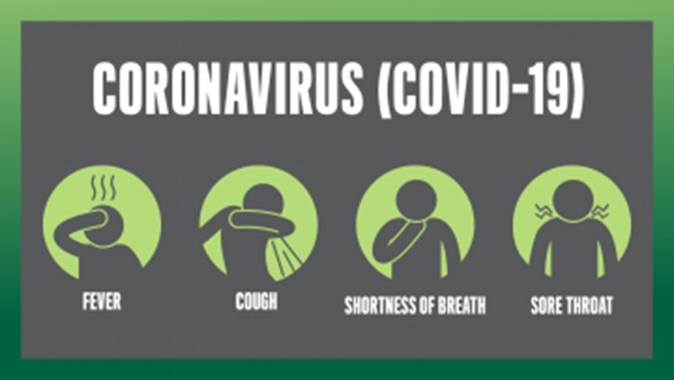
Fig 3.0: Preventive Measures
Maintaining social distance (a minimum of 1 m) from individuals with respiratory symptoms.
Additional precautions are required by healthcare workers to protect themselves and prevent transmission in the healthcare setting. Precautions to be implemented by healthcare workers caring for patients with COVID-19 disease include usingPPE appropriately; this involves selecting the proper PPE and being trained in how to put on, remove and dispose of it.
PPE is only one effective measure within a package that comprises administrative and environmental and engineering controls, as described in WHO’s Infection prevention and control of epidemic- and pandemic-prone acute respiratory infections in health care (1). These controls are summarized here.
Administrative controls include ensuring the availability of resources for infection prevention and control measures, such as appropriate infrastructure, the development of clear infection prevention and control policies, facilitated access to laboratory testing, appropriate triage and placement of patients, adequate staff-to-patient ratios and training of staff.
Environmental and engineering controls aim at reducing the spread of pathogens and reducing the contamination of surfaces and inanimate objects. They include providing adequate space to allow social distance of at least 1 m to be maintained between patients and between patients and healthcare workers and ensuring the availability of well-ventilated isolation rooms for patients with suspected or confirmed COVID-19 disease.
COVID-19 is a respiratory disease that is different from Ebola virus disease, which is transmitted through infected bodily fluids. Due to these differences in transmission, the PPE requirements for COVID-19 are different from those required for Ebola virus disease. Specifically, coveralls (sometimes called Ebola PPE) are not required when managing COVID-19 patients.
Disruptions in the global supply chain of PPE
The current global stockpile of PPE is insufficient, particularly for medical masks and respirators; the supply of gowns and goggles is soon expected to be insufficient also. Surging global demand − driven not only by the number of COVID-19 cases but also by misinformation, panic buying and stockpiling − will result in further shortages of PPE globally. The capacity to expand PPE production is limited, and the current demand for respirators and masks cannot be met, especially if the widespread, inappropriate use of PPE continues.

Recommendations for optimizing the availability of PPE.
In view of the global PPE shortage, the following strategies can facilitate optimal PPE availability.
(1) Minimize the need for PPE
The following interventions can minimize the need for PPE while protecting healthcare workers and other individuals from exposure to the COVID-19 virus in healthcare settings.
Consider using telemedicine to evaluate suspected cases of COVID-19 disease (2), thus minimizing the need for these individuals to go to healthcare facilities for evaluation.
Use physical barriers to reduce exposure to the COVID-19 virus, such as glass or plastic windows. This approach can be implemented in areas of the healthcare setting where patients will first present, such as triage areas, the registration desk at the emergency department or at the pharmacy window where medication is collected. Restrict healthcare workers from entering the rooms of COVID-19 patients if they are not involved in direct care. Consider bundling activities to minimize the number of times a room is entered (e.g., check vital signs during medication administration or have food delivered by healthcare workers while they are performing other care) and plan which activities will be performed at the bedside.
Ideally, visitors will not be allowed but if this is not possible, restrict the number of visitors to areas where COVID-19 patients are being isolated; restrict the amount of time visitors are allowed to spend in the area; and provide clear instructions about how to put on and remove PPE and perform hand hygiene to ensure visitors avoid self-contamination (seehttps://www.who.int/csr/resources/publications/putontakeoffPPE/en/).
Ensure PPE use is rationalized and appropriate PPE should be used based on the risk of exposure (e.g., type of activity) and the transmission dynamics of the pathogen (e.g., contact, droplet or aerosol). The overuse of PPE will have a further impact on supply shortages. Observing the following recommendations will ensure that the use of PPE rationalized. The type of PPE used when caring for COVID-19 patients will vary according to the setting and type of personnel and activity. Healthcare workers involved in the direct care of patients should use the following PPE: gowns, gloves, medical mask and eye protection (goggles or face shield).
Specifically, for aerosol-generating procedures (e.g., tracheal intubation, non-invasive ventilation, tracheostomy, cardiopulmonary resuscitation, manual ventilation before intubation, bronchoscopy) healthcare workers should use respirators, eye protection, gloves and gowns; aprons should also be used if gowns are not fluid resistant (1). Respirators (e.g., N95, FFP2 or equivalent standard) have been used for an extended time during previous public health emergencies involving acute respiratory illness when PPE was in short supply (3). This refers to wearing the same respirator while caring for multiple patients who have the same diagnosis without removing it, and evidence indicates that respirators maintain their protection when used for extended periods. However, using one respirator for longer than 4 hours can lead to discomfort and should be avoided (4−6).
Among the general public, persons with respiratory symptoms or those caring for COVID-19 patients at home should receive medical masks. For additional information, see Home care for patients with suspected novel coronavirus (COVID-19) infection presenting with mild symptoms, and management of their contacts (7). For asymptomatic individuals, wearing a mask of any type is not recommended. Wearing medical masks when they are not indicated may cause unnecessary cost and a procurement burden and create a false sense of security that can lead to the neglect of other essential preventive measures. For additional information, see Advice on the use of masks in the community, during home care and in healthcare settings in the context of the novel coronavirus (2019-nCoV) outbreak (8).
(3) Coordinate PPE supply chain management mechanisms.
The management of PPE should be coordinated through essential national and international supply chain management mechanisms that include but are not restricted to using PPE forecasts that are based on rational quantification models to ensure the rationalization of requested supplies;
Monitoring and controlling PPE requests from countries and large responders;
Promoting the use of a centralized request management approach to avoid duplication of stock
and ensuring strict adherence to essential stock management rules to limit wastage, overstock and stock ruptures;
Monitoring the end-to-end distribution of PPE;
Monitoring and controlling the distribution of PPE from medical facilities stores

3.0 METHODOLOGY
This quantitative, exploratory and descriptive study was conducted at different small
industries in Jeddah KSA. Initially participants from 37 different small scale industries
(vehicle repair, welding workshops, body paint shops) were randomly selected, 4 workshops
were not willing to participate and 5 others didn’t response as any contact through
telephone/personal could not be established after several attempts. From the remaining 28 small workshops, 102 workers were recruited for this study. This study was reviewed and approved by the Institutional Review Committee of Faculty of Meteorology, Environment and Arid Land Agriculture King Abdul-Aziz University (KAU) Jeddah. An informed consent was obtained as well as ethical approval was obtained from Research Ethics Committee KAU Hospital, Jeddah KSA. Ethics Committee. Almost at all the workshops, expatriate workers belonged to different countries like Pakistan, India, Yemen, and Syria. The interviews were made in the native language of the workers, most of them were Urdu speaking. The workers were approached by some personal contacts, suppliers, clients and some drivers who used the services of these workshops. The subjects gave informed consent to the work.

A custom developed questionnaire was used that composed of 3 sections; 1)
sociodemographic characteristics (job type, age, residence status, education level, job
experience, marital status, work days/week, work hours/day, smoking); 2) different types of routine occupational exposures to which study participants are exposed; 3) self-reported frequency of use of different types of necessary PPEs. The study was conducted through December 2016 to February 2017 at different small scale industries. For measuring questionnaire reliability, Cronbach’s alpha was executed, α value was 0.7 which indicates that scores variance is explainable (Rocha et al. 2014, Silveira 1999). A pre-planned script was employed to monitor observation related to research. 15 minutes of observation and interview were recorded with each worker on average. Interviews were performed during working hours, between 9 am to 4 pm, and the data was gathered from a total of 102 workers. The data was organized and analyzed using Statistical Package for Social Sciences (SPSS), version 20.0. Descriptive analysis i.e. mean, frequencies, standard deviation and percentages were recorded.

Observations and answers to pre-planned script were noted and recorded in the field diary.
Our study data was reasonably applicable for the analysis as case-to-variable ratio was
according to minimum requirement of 5:1 (Hair et al., 1995). Question for perceived or actual
occupational exposures (vehicle smoke, workplace dust, noise, fuel/welding/paints vapors
and fumes, direct sunlight and heat) were asked to the workers i.e. how often do you expose
to occupational exposures for the possible answer never, sometimes and always. The
questions related to the use of PPEs were as below;

(a). Do you use safety glasses and/or googles as needed?
(b). Do you utilize ear plugs/muffs when required?
(c). Do you wear hand gloves as required?
(d). Do you wear safety boots/shoes as required?
(e). Do you wear face masks as needed?
(f). Do you use welding shield, apron and curtain used as needed?
(g). Do you use knee and joint protecting mats as needed?

3.1 ANALYSIS OF RESULTS
Sociodemographic characteristics of small industry workers
The sociodemographic characteristics of small industry workers in Jeddah were assessed throygh survey study. Among 102 surveyed workers, there were 40 mechanics(39.2%), 18 welders (17.6%), 22 painters (21.6%) and 22 panel beaters (21.6%) having mean age 34.9 years (range 21-52). Expatriate workers were 84.3% while 15.7% were local residents having mean job experience 10.6 years (range 1-31). Surveyed workers education, marital, working durations, smoking and marital status details are in Table 1.
For informal workers of small scale industries policies and measures for delivery of OSH services is limited and deficient. Even though the laws and regulation are there byt their implementation, inspection and audits for proper adherence to regulations needs to be improved. For example, according to KSA local regulations in some specific occupations like diesel engine mechanics the maximum hours is 10. Also the maximum general working hours (Resolution 258, of amended lbor law 2015) is 12 per day with compulsory 1 hour rest, lunch and pray. But some breaches of working time limits were found in this survey study. The employers have an obligation to ensure OSH of workers as being mentioned in the article of the hazardous work (2012). But in some workplaces this responsibility is being ignored, either involuntarily or otherwise, their legal and ethical obligations toward their employees (Khasawneh 2014).
Occupational exposures among small industry workers
A number of self-reported occupational exposures among small industry workers in Jeddah were assessed. The occupational exposures percentages reported were categorized into; never, sometimes and always. This included noise exposure (19.6, 73.5 and 6.9%); smoke/dust exposure (9.8, 69.6 and 20.6%); vapors and fumes(chemicals, fuels, paints) exposure (11.8, 60.8 and 27.5%); direct sunlight and heat exposure (43.1, 56.9 and 0%), repectively (Table 2).
In this study the reported exposures to vapors and fumes of chemicals, fuels (diesel, gasoline) and paint was high, which can have many detrimental effects on health of workers. Vehicle-repair workers, welders and car painters are routinely come in contact with gasoline and diesel exhausts, welding fumes, mineral oil and organic solvents while perfroming work. These workplace chemiclas and pollutants can be absorbed through ingestion, inhalation and through dermal routes (Hansen 1989; Siemiatycki et al. 1988; Eqani et al. 2016; Munir et al. 2017). Many health outcomes are associated with exposures to such substances like cancers, lung ailments, eczema, dermatitis and malignant mesothelioma. These symptoms have been reported by many studies(Taha 200, Ebeid 1987, Cheng 1986). Even the actual number of exposures or hazards might be greater than reported but workers might be reluctant to mention it, possibly due to the fear of losing their jobs or restrictions from management(Taha 2000).
In this study survey 73.5% subjects rported that they expose to noise sometimes. A study at Universite de Montreal indicated that at vehicle repair workshops exposure to noise is often more than 90 decibels. Different operations and tools (air hoses, electric grinders pneumatic grinders and chisels and sanders) contribute to it i.e. they produce sounds that sometimes may be loud as 100 dBA (Bejan et al. 2011). A study at small scale industries in China reported that at least one type of hazards was prevalent among 83% surveyed industries across the country, same study reports that hearing loss due to noise was one among seen types of occupational diseases in the studied population (Zhi et al. 2000). According to a study findings in Norway at small mechanical enterprises, hazards and risks can be reduced by use of proper PPEs (Bull et al. 2002). Smoking at small workshops can be very dangerous and risky as working environment contains multiple ignition sources like trash, fuel oils, dust, rags, papers, acids etc. Besides that some workshops have “No smoking” sign, that was the only one found among slogans related to OSH. The majority of workers still smoke, smoking can contribute to the non-use of PPEs, fire incidences, burns, injuries, accidents and excess sick leave in industries (Taha 2000). Among the surveyed population in our study, 66.7% reported smoking as compared to another previous study in another city of KSA where 58% studied workers reported smoking (Taha 2000).
Use of personal protective equipment among small industry workers
The use of PPEs among workers at small industries in Jeddah are presented in figure 1. The surveyed workers among selected small industries reported the use of safety glasses(33.3%), ear plugs/muffs (8.8%), gloves (27.5%), safety shoes (10.8%), and face masks (26.5%). The reported usage of welding shields/screens and mats for knee joints protection was 50% among welders and mechanics respectively. Nevertheless, the type and quality of mats used were poor and unsatisfactory as the rags, plastic and paper sheets etc. were employed for this purpose at many sites observed which cannot provide adequate protection. So the maximum reported positive response of 50% was for the use of knee joint protection mats while working under the vehicles and welding shields whereas the lowest positive response of 8.8% was reported for the use of ear plugs and muffs for protection of ears against the noise.
Despite the host of enormous physical and chemical hazards, on average less than a third (29.7%) interviewed workers were reported to be employing PPEs at work in surveyed small industries. Moreover, among this recorded proportion, none of studied subjects were found to use full complement of the required PPEs i.e boots, shields, goggles, masks, overalls, gloves and respirators. A study in Ghana reported about only 8% were using goggles among surveyed welders while the use of face masks was 56% among sprayers (Monney et al. 2014). Surprisingly welders and sprayers think it to be sufficient to use face shields and masks for escaping exposures however this type of protection is not adequate as other parts like hands, arms, body and clothes are equally exposed to different chemicals, fumes, vapors and radiations. (Monney et al. 2014).
In our study, storage of PPEs in all surveyed industries was poor and inadequate. In the visited workshops no proper storage places were managed, most of the PPEs were left lying in open dusty oily ground or working benches or clusterd cabinets. PPEs physical condition and maintenance was alo observed, thses were found to be in poor state of maintenance, for instance, missing headbands/straps for welding helmets, broken legs and missing filters for goggles. Kadasah study of 2015 revealed that the practice of OSH in KSA is not promising in general with a poor accomplishment of hazard identification and risk assessment (Khasawneh 2014). A special charcteristics of the studied small industries in Jeddah is that it’s dominant by expatriate workers. As per survey results, 84.3% were reported to be expatriates. According to Health and Safety Executive (HSE) and OSHA the expatriate workers are at increased risk form safety and heath point of view. The main reasons cited for this are languages and communication problems (85% of cases), being new to job, cultural factors also feature. Despite this, 50% of employers do nothing different for migrant worker health and safety than they do for other workers (HSE). This can cause gaps in communication and understanding of hazards and preventive measures. Along with some other social barrier and lack of education will contribute toward ineffective health education messages. Among such workers low education level may contribute to non-use of personal protective measures, as they don’t know, recognize and appreciate the significance of PPEs (Taha 2000). Their knowledge regarding hazards protective measures is inadequate, many of them don’t use self-protective gadgets (Taha 2000).

Health implications for workers
The small industry workers are among more vulnerable occupational groups due to many reasons such as deficient resources, negligence and passive attitude of employees and employers, lack of education and awareness, ineffective legislation and monitoring and non-availability or use of PPEs. For example, lack of education limits workers accessibility to knowledge, information and training prospects along with putting them at a greater risk to injuries, diseases and other negative health outcomes. Studies proved that small scale enterprise workers have deficiency of understanding, knowledge and information on proper use of PPEs and are least aware of health effects resulting from the workplace activities and materials (Adewoye et al. 2013, Kumar et al. 2013). Although PPEs are considered as the last resort for workplace hazards control and are placed in case where managerial and engineering control measures have been put in place already. PPEs stand out as the most decent measure of protection for small scale enterprises where conventional hazards control techniques and programs remain a challenge to implement (Ahmad et al. 2017). In Jeddah, there is an information gap among small scale workshops employees on occupational hazards, risks, their health effects, utilization and effectiveness of safety measures and level of awareness. OSH information is very important in understanding and combating workplace hazards and risks, it can also be vital for designing interbention plans for promoting and upholding good OSH standards at small informal industries (Zgambo, 2015)>

Table 1.0: Sociodemographic Characteeristics
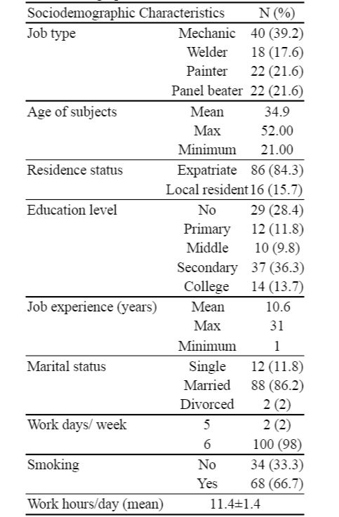

Non-use of PPEs leads to accidents, cut injuries and other hazards in small industries. The contributing factors compromise lack of education, training and awareness, negligence, employees and employer’s passive attitude, PPEs unavailability, legislation aqnd lack of regular monitoring and inspections (Taha 2000, Ahmad et al. 2016). It was observed during this study survey that workers sometimes employ unconventional and nonstandard PPEs, whose protection level is less or minimum for example aa piece of cloth for nose, sunglasses for eyes, plastic or paper sheets/rags/mat for knee joint protection. Out of order PPEs like broken glasses, damaged headbands for welding shields, worn and teared gloves and masks were also observed. The use of such type of PPEs is found common in low income countries among small industries employees contrary to KSA which is a high income country. A study form Nepal found that welders were found to use sunglasses which they considered protective. The use of different types and quality of PPEs can be attributed toward their availability and easy access, disparities in work environment and cultures, safety practices, working procedures adopted, comfortable to use and cheap price, as has been observed in Nigeria(Sabitu et al. 2009, Ajayi et al. 2011). In addition, for PPEs to be effective, it is important to ensure that the workers know the right type of PPE to be used and that it is used in the correct way for the periods when the worker is exposed to harmful substances or situations (Ahmad et al. 2017).

Table 2.0: Types Of Occupational Exposures
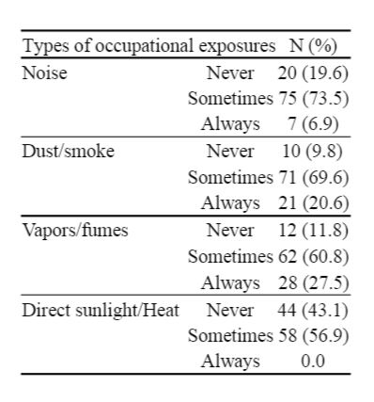
4.0 CHALLENGES
The current study depends on subjective reporting of workers which can possibly be biased in some cases. Due to harsh climate and hot weather conditions in Jeddah the use of PPEs and perception of workplace exposures among study subjects might vary. Shortcomings of the employed cross-sectional design can be another limitation. Also being questionnaire-based survey; it might reflect attitude and perception of participants for the reported use of PPEs. Thus, the reported use and need for PPEs as well as the workplace exposures among study subjects in other regions might be different having diverse attitudes and perception even though exposed to a similar level of workplace exposures, hazards and risks. Further studies are required to accurately assess the OSH conditions and practices in small industries in KSA.
The current global stockpile of PPE is insufficient, particularly for medical masks and respirators; the supply of gowns and goggles is soon expected to be insufficient also. Surging global demand − driven not only by the number of COVID-19 cases but also by misinformation, panic buying, and stockpiling − will result in further shortages of PPE globally. The capacity to expand PPE production is limited, and the current demand for respirators and masks cannot be met, especially if widespread inappropriate use of PPE continues.
Surgical site infections: Surgical site infections are also frequent: the incidence varies from 0.5 to 15% depending on the type of operation and underlying patient status. The main risk factor is the extent of contamination during the procedure (clean, clean contaminated, contaminated, dirty), which is to a large part dependent on the site of surgery, length of the operation, and the patient’s general condition. • Hospital associated pneumonia: The most important are patients on ventilators in intensive care units, where the rate of pneumonia is 3% per day. There is a high case fatality rate associated with ventilator-associated pneumonia, although the attributable risk is difficult to determine because co-morbidities are high. • Hospital associated blood stream infection: Though less frequent than the other types of HAIs, hospital associated blood stream infections result in high case fatality rates- more than 50% for some microorganisms. Infection may occur at the skin entry site of the intravascular device, or in the subcutaneous path of the catheter (tunnel infection).It is considerably dependent on how lines are handled and duration of lines. Even peripheral lines are a potential source of line related infections.

5.0 RECOMMENDATIONS
Performing hand hygiene frequently with an alcohol-based hand rub if your hands are not visibly dirty or with soap and water if hands are dirty; • avoiding touching your eyes, nose, and mouth; • practicing respiratory hygiene by coughing or sneezing into a bent elbow or tissue and then immediately disposing of the tissue; • wearing a medical mask if you have respiratory symptoms and performing hand hygiene after disposing of the mask; • maintaining social distance (a minimum of 1 metre) from persons with respiratory symptoms. Using PPE appropriately; this involves selecting proper PPE and being trained in how to put on, remove, and dispose of it.
Administrative controls include ensuring resources for infection prevention and control (IPC) measures, such as appropriate infrastructure, the development of clear IPC policies, facilitated access to laboratory testing, appropriate triage and placement of patients, adequate staff-to-patient ratios, and training of staff. • Environmental and engineering controls aim at reducing the spread of pathogens and the contamination of surfaces and inanimate objects. They include providing adequate space to allow social distance of at least 1 m to be maintained between patients and between patients and health care workers and ensuring the availability of well-ventilated isolation rooms for patients with suspected or confirmed COVID-19.

6.0 CONCLUSION
This study has described in full detail, the assessment results of occupational exposures and the use of PPEs among workers in small workshops (vehicle repair, welding and paint) in Jeddah, KSA. It was found that the highest reported positive response of 50% was for the use of knee joint protection mats and welding shields whereas the lowest positive response of 8.8% was reported for the use of ear plugs and muffs. The use of other PPEs showed positive responses of 33.3% for safety glasses, 27.5% for gloves, 26.5% face masks and 10.8% for safety shoes. Intervention plans like education, awareness and regular medical checkups should be advocated which help in prevention and minimizing workplace exposures. The identification and prevention of work-related health costs could result in substantial savings for the national health system, leading to more sustainable social system.
It fully describes the development of automated machine and electro-mechanical devices for production of infection prevention and control (IPC) and personal protective equipment (PPE) for public health and economic growth in Nigeria.

7.0 REFERENCES
Advice on the use of masks in the community, during home care and in healthcare settings in the context of the novel coronavirus (2019-nCoV) outbreak: interim guidance, 29 January 2020. Geneva: World Health Organization; 2020 (WHO/nCov/IPC_Masks/2020; https://www.who.int/publications-detail/advice-on-the-use-of-masks-in-the-community-duringhome-care-and-in-healthcare-settings-in-the-context-of-the-novel-coronavirus-(2019-ncov)-outbreak, accessed 27 February 2020).
Beckman S, Materna B, Goldmacher S, Zipprich J, D’Alessandro M, Novak D, et al. Evaluation of respiratory protection programs and practices in California hospitals during the 2009-2010 H1N1 influenza pandemic. Am J Infect Control.2013;41(11):1024-31. doi:10.1016/j.ajic.2013.05.006.
Home care for patients with suspected novel coronavirus (COVID-19) infection presenting with mild symptoms, and management of their contacts: interim guidance, 4 February 2020. Geneva: World Health Organization; 2020(WHO/nCov/IPC/HomeCare/2020.2; https://apps.who.int/iris/handle/10665/331133, accessed 27 February 2019).
Infection prevention and control of epidemic-and pandemic-prone acute respiratory infections in health care. Geneva: World Health Organization; 2014(https://apps.who.int/iris/bitstream/handle/10665/112656/9789241507134_eng.pdf;jsessionid=BE25F8EAA4F631126E78390906050313?sequence=1, accessed 27 February 2020).
Janssen LL, Nelson TJ, Cuta KT. Workplace protection factors for an N95 filtering facepiece respirator. J Occup Environ Hyg.2007;4(9):698–707. doi:10.1080/15459620701517764.
Janssen L, Zhuang Z, Shaffer R. Criteria for the collection of useful respirator performance data in the workplace. J OccupEnviron Hyg. 2014;11(4):218–26. doi:10.1080/15459624.2013.852282.
Radonovich LJ Jr, Cheng J, Shenal BV, Hodgson M, Bender BS. Respirator tolerance in health care workers. JAMA.2009;301(1):36–8. doi:10.1001/jama.2008.894.
Telemedicine: opportunities and developments in Member States: report on the second global survey on eHealth. Geneva: World Health Organization; 2009 (Global Observatory for eHealth Series, 2; https://apps.who.int/iris/handle/10665/44497, accessed 27 February 2020).

