ENGINEERING STRATEGIES FOR HANDLING COVID-19 FOR ENVIRONMENTAL HEALTH AND ECONOMIC STABILITY
BY
ODUNEYE LEONARD MOYOSOREOLUWA
17/ENG02/061
COMPUTER ENGINEERING
A TERM PAPER SUBMITTED TO ENGR. OYEBODE,
COLLEGE OF ENGINEERING, AFE BABALOLA UNIVERSITY, ADO-EKITI, EKITI STATE.
FOR THE COURSE: ENGINEERING LAW AND MANAGERIAL ECONOMICS (ENG 384)
IN PARTIAL FULFILMENT TO THE REQUIREMENTS FOR THE DEGREE OF BACHELOR OF ENGINEERING IN COMPUTER ENGINEERING.
11th of APRIL, 2020
TABLE OF CONTENTS

TITLE PAGE………………………………………………..…………………………………1

TABLE OF CONTENTS………………………………………………………………………2

ABSTRACT…………………………………………………………………………………...4

- INTRODUCTION…………………………………………………….……………..…….5

- LITERATURE REVIEW………………………………………………...……………......7

2.1 THE EFFECT OF COVID-19 ON ENVIRONMENTAL HEALTH……………………….7

2.1.1 ARTIFICIAL INTELLIGENCE AS A SOLUTION……...……………………………..8
2.1.2 THE APPLICATION OF VENTILATORS………………………………..……………8
2.1.3 THE PROBLEM OF BASIC INFRASTRUCTURE…………………………………….8
2.2 THE EFFECT OF COVID-19 ON NIGERIA’S ECONOMIC STABILITY……………...12
2.2.1 PROPOSED SOLUTIONS TO THE COVID-19 CRISIS……………………………...12

3.0 METHODOLOGY……………………………………………………………………….14
3.1 DATA COLLECTED……………………………………………………………………..14
4.0 ANALYSIS OF RESULTS……………………………………………………………….16

5.0 CHALLENGES…………………………………………………………………………..19

6.0 RECOMMENDATION……………………………………….………………………….22

7.0 CONCLUSION…………………………………………………………………………..24

8.0 REFERENCES…………………………………………………………………………...25

ABSTRACT

The Nigerian Engineering Industry is a major driver of economic growth. However, activities from the Nigerian industry contribute significantly to environmental pollution and unsustainable consumption of depleting natural resources. Green growth on the other hand, is an innovative growth which motivates businesses to adopt environmental friendly activities. This paper assessed sustainability strategies in the construction industry. A quantitative research design was adopted with the use of questionnaires distributed to construction organizations in Lagos, Nigeria. Findings reveal that many of the construction organizations surveyed do not have sustainability strategies because of low awareness about sustainability issues in construction. However, of the three pillars of sustainability (environmental, economic and social sustainability), environmental sustainability was found to yield greatest benefit. For the construction industry to contribute to Nigeria’s green growth agenda there should be increased awareness of sustainability issues and institutional policies to drive sustainability.
The study goes in-depth into the current state of the economy which has been crippled by the Coronavirus (COVID-19) and how we can improve the health of Nigerian citizens and stabilize the economy.

- INTRODUCTION
Coronaviruses are a group of related viruses that cause diseases in mammals and birds. In humans, coronaviruses cause respiratory tract infections that can be mild, such as some cases of the common cold (among other possible causes, predominantly rhinoviruses), and others that can be lethal, such as SARS, MERS, and COVID-19. Symptoms in other species vary: in chickens, they cause an upper respiratory tract disease, while in cows and pigs they cause diarrhea. There are yet to be vaccines or antiviral drugs to prevent or treat human coronavirus infections.
Coronaviruses constitute the subfamily Orthocoronavirinae, in the family Coronaviridae, order Nidovirales, and realm Riboviria. They are enveloped viruses with a positive-sense single-stranded RNA genome and a nucleocapsid of helical symmetry. The genome size of coronaviruses ranges from approximately 27 to 34 kilobases, the largest among known RNA viruses. The name coronavirus is derived from the Latin corona, meaning "crown" or "halo", which refers to the characteristic appearance reminiscent of a crown or a solar corona around the virions (virus particles) when viewed under two-dimensional transmission electron microscopy, due to the surface being covered in club-shaped protein spikes.
Coronaviruses were first discovered in the 1930s when an acute respiratory infection of domesticated chickens was shown to be caused by infectious bronchitis virus (IBV). In the 1940s, two more animal coronaviruses, mouse hepatitis virus (MHV) and transmissible gastroenteritis virus (TGEV), were isolated.
Human coronaviruses were discovered in the 1960s. The earliest ones studied were from human patients with the common cold, which were later named human coronavirus 229E and human coronavirus OC43. Other human coronaviruses have since been identified, including SARS-CoV in 2003, HCoV NL63 in 2004, HKU1 in 2005, MERS-CoV in 2012, and SARS-CoV-2 in 2019. Most of these have involved serious respiratory tract infections.
Coronavirus disease 2019 (COVID-19) is an infectious disease caused by severe acute respiratory syndrome coronavirus 2 (SARS-CoV-2). The disease was first identified in 2019 in Wuhan, the capital of China's Hubei province, and has since spread globally, resulting in the ongoing 2019–20 coronavirus pandemic. Common symptoms include fever, cough, and shortness of breath. Other symptoms may include muscle pain, sputum production, diarrhea, sore throat, loss of smell, and abdominal pain. While the majority of cases result in mild symptoms, some progress to pneumonia and multi-organ failure. As of 28 March 2020, the overall rate of deaths per number of diagnosed cases is 4.6 percent; ranging from 0.2 percent to 15 percent according to age group and other health problems. In comparison, the overall mortality rate of the 1918 Spanish Flu were approximately 3% to 5%.
The virus is spread mainly through close contact and via respiratory droplets produced when people cough or sneeze. Respiratory droplets may be produced during breathing but the virus is not generally airborne. People may also contract COVID-19 by touching a contaminated surface and then their face. It is most contagious when people are symptomatic, although spread may be possible before symptoms appear. The virus can survive on surfaces up to 72 hours. Time from exposure to onset of symptoms is generally between two and fourteen days, with an average of five days. The standard method of diagnosis is by reverse transcription polymerase chain reaction (rRT-PCR) from a nasopharyngeal swab. The infection can also be diagnosed from a combination of symptoms, risk factors and a chest CT scan showing features of pneumonia.
Recommended measures to prevent infection include frequent hand washing, social distancing (maintaining physical distance from others, especially from those with symptoms), covering coughs and sneezes with a tissue or inner elbow, and keeping unwashed hands away from the face. The use of masks is recommended for those who suspect they have the virus and their caregivers. Recommendations for mask use by the general public vary, with some authorities recommending against their use, some recommending their use, and others requiring their use. Currently, there is no vaccine or specific antiviral treatment for COVID-19. Management involves treatment of symptoms, supportive care, isolation, and experimental measures.
On 30 January 2020, the World Health Organization (WHO) declared the 2019–20 coronavirus outbreak a Public Health Emergency of International Concern (PHEIC) and a pandemic on 11 March 2020. Local transmission of the disease has been recorded in many countries across all six WHO regions.

- LITERATURE REVIEW
The continued spread of coronavirus (COVID-19) has laid bare the apparent infrastructural frailties in most African countries. For a virus that advanced countries have barely been able to cope with, Africa’s relatively low healthcare standards do not inspire much confidence.
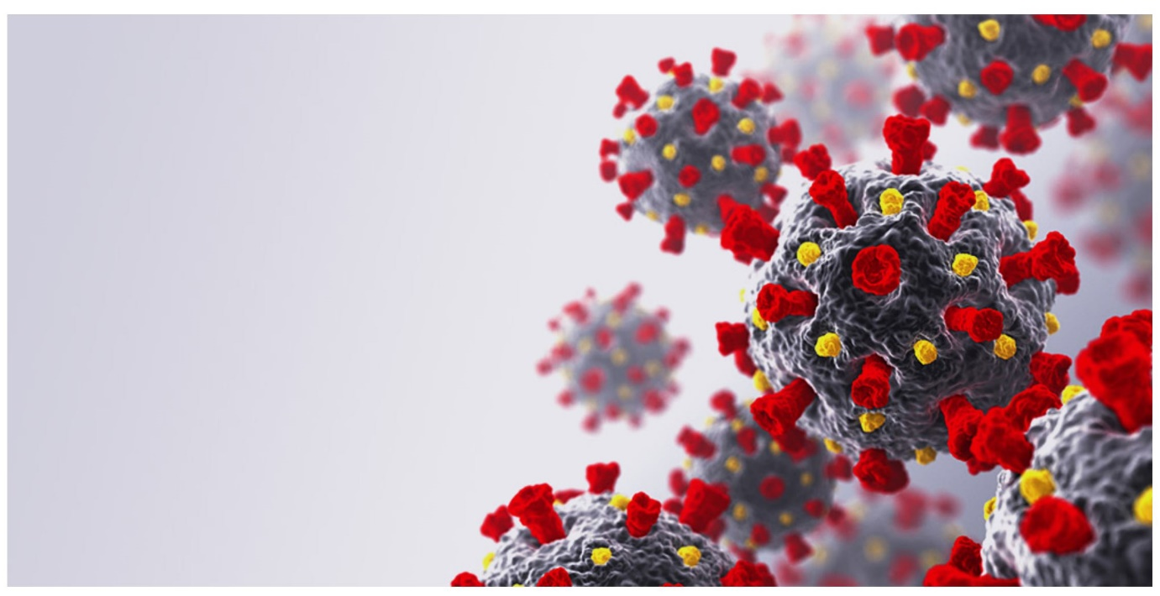
Fig 1.0: Coronavirus

2.1 THE EFFECT OF COVID-19 ON ENVIRONMENTAL HEALTH
President Muhammadu Buhari on Monday signed the Covid-19 Regulations 2020 to declare Covid-19 as a “dangerous infectious disease.” A statement from the presidency noted that the president had signed the regulations “in exercise of the powers conferred on him by Sections 2, 3 and 4 of the Quarantine Act (CAP Q2 LFN 2004), and all other powers enabling him in that behalf.” A spokesman, said the regulations, effective March 30, 2020, “also gave legal backing to the various measures outlined in the President’s National Broadcast on March 29, 2020, such as Restriction / Cessation of Movement in Lagos, FCT and Ogun State and others toward containing the spread of the pandemic in the country. ”The government’s chief lawyer, Attorney General Abubakar Malami, dismissed a reported legal challenge on the propriety of Buhari’s lockdown orders of March 29. He said the quarantine act empowered the president to restrict movement when a “dangerous disease” breaks out.
According to lockdown rules, Nigerians can still perform on-line transactions and use ATMs during these restrictions, “exemption is granted financial system and money markets to allow very skeletal operations in order to keep the system in light operations during the pendency of these regulations,” the spokesman stressed.

2.1.1 ARTIFICIAL INTELLIGENCE AS A SOLUTION
Despite a number of apparent limitations, globally, artificial intelligence and machine learning are providing ways to tackle the rise and spread of COVID-19. AI platforms, BlueDot, HealthMap, and Metabiota, reportedly flagged the virus in Wuhan China, nine days before it was announced by WHO, and have been fairly accurate in predicting its spread. With the rapid spread of the virus clearly putting a strain on the medical staff, the likes of Baidu and Alibaba have reportedly developed AI systems that can screen people for possible symptoms. For the most part, responses from governments, disease control agencies, non-profit organisations, and private sectors across the continent have been laudable. However, there are lessons to be learnt from the lack of advanced technologies that could help tackle the spread of the virus in Africa.
Developing AI systems and solutions requires a lot of power and, of course, fast and reliable Internet connections with little to no disruptions over an extended period. In 2018, the United States Agency for International Development (USAID) placed the power access rate in Nigeria at 45% while 20 million households were without power. With roughly 3,000 megawatts available for use, Dr Wiebe Boer, CEO of All-on, likened the average power available for each Nigerian to the power generated by a candlestick.

2.1.2 THE APPLICATION OF VENTILATORS
A ventilator is a machine that provides mechanical ventilation by moving breathable air into and out of the lungs, to deliver breaths to a patient who is physically unable to breathe, or breathing insufficiently. Modern ventilators are computerized microprocessor controlled machines, but patients can also be ventilated with a simple, hand-operated bag valve mask. Ventilators are chiefly used in intensive care medicine, home care, and emergency medicine (as standalone units) and in anesthesiology (as a component of an anesthesia machine).
In its simplest form, a modern positive pressure ventilator consists of a compressible air reservoir or turbine, air and oxygen supplies, a set of valves and tubes, and a disposable or reusable "patient circuit". The air reservoir is pneumatically compressed several times a minute to deliver room-air, or in most cases, an air/oxygen mixture to the patient. If a turbine is used, the turbine pushes air through
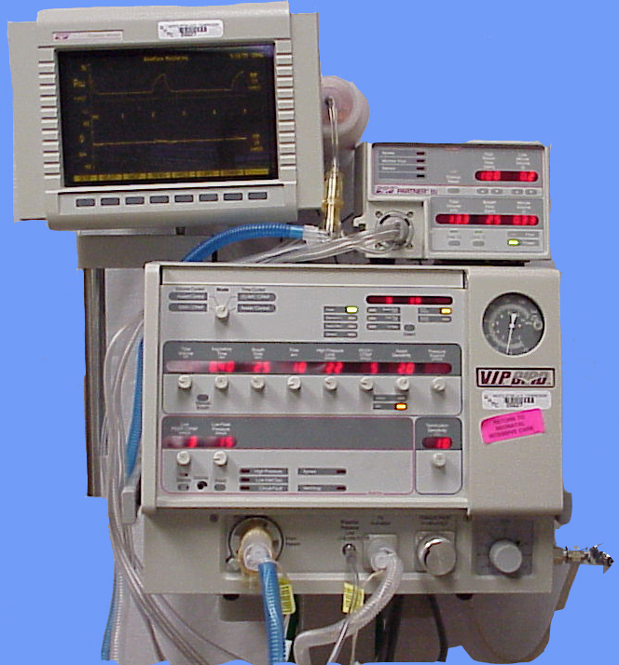
Fig 2.0: A Ventilator Machine.
the ventilator, with a flow valve adjusting pressure to meet patient-specific parameters. When over pressure is released, the patient will exhale passively due to the lungs' elasticity, the exhaled air being released usually through a one-way valve within the patient circuit called the patient manifold.
Ventilators may also be equipped with monitoring and alarm systems for patient-related parameters (e.g. pressure, volume, and flow) and ventilator function (e.g. air leakage, power failure, mechanical failure), backup batteries, oxygen tanks, and remote control. The pneumatic system is nowadays often replaced by a computer-controlled turbopump. Modern ventilators are electronically controlled by a small embedded system to allow exact adaptation of pressure and flow characteristics to an individual patient's needs. Fine-tuned ventilator settings also serve to make ventilation more tolerable and comfortable for the patient. In Canada and the United States, respiratory therapists are responsible for tuning these settings, while biomedical technologists are responsible for the maintenance. In the United Kingdom and Europe the management of the patient's interaction with the ventilator is done by critical care nurses. The patient circuit usually consists of a set of three durable, yet lightweight plastic tubes, separated by function (e.g. inhaled air, patient pressure, exhaled air). Determined by the type of ventilation needed, the patient-end of the circuit may be either non-invasive or invasive. Non-invasive methods, such as continuous positive airway pressure (CPAP) and non-invasive ventilation, which are adequate for patients who require a ventilator only while sleeping and resting, mainly employ a nasal mask. Invasive methods require intubation, which for long-term ventilator dependence will normally be a tracheotomy cannula, as this is much more comfortable and practical for long-term care than is larynx or nasal intubation.
According to the World Health Organization (WHO), some 80% of people with Covid-19 - the disease caused by coronavirus - recover without needing hospital treatment. But one person in six becomes seriously ill and can develop breathing difficulties. In these severe cases, the virus causes damage to the lungs. The body's immune system detects this and expands blood vessels so more immune cells enter. But this can cause fluid to enter the lungs, making it harder to breathe, and causing the body's oxygen levels to drop. To alleviate this, a machine ventilator is used to push air, with increased levels of oxygen, into the lungs. The ventilator also has a humidifier, which modifies adds heat and moisture to the medical air so it matches the patient's body temperature. Patients are given medication to relax the respiratory muscles so their breathing can be fully regulated by the machine. People with milder symptoms may be given ventilation using facemasks, nasal masks or mouthpieces which allow pressurised air or mixtures of gases to be pushed into the lungs.
University College London engineers have worked with clinicians at UCLH and Mercedes Formula One to build what is known as the Continuous Positive Airway Pressure (CPAP) device. It is being trialled at several London hospitals and if all goes well, the Mercedes-AMG-HPP group can begin building up to 1,000 of the machines per day from next week (6 April). The CPAP device has already got approval from the Medicines and Healthcare products Regulatory Agency. Early reports from Lombardy in northern Italy suggest about 50% of patients given CPAP have avoided the need for invasive mechanical ventilation.
However, the use of CPAP machines in patients with contagious respiratory infections has raised some concern, as any small leaks around the mask could spray droplets on medical staff. Hoods, where pressurised oxygen is pumped in via a valve, are also being commonly used to treat Covid-19 patients, partly because they reduce the risk of airborne transmission of the virus from droplets in the breath.
These are known as "non-invasive" ventilation, as no internal tubes are required. However, Intensive Care Units (ICUs) would generally put patients suffering acute respiratory distress on mechanical ventilation quickly, to ensure oxygen levels in the body stay normal. Dr Shondipon Laha, from the Intensive Care Society, told the BBC most patients with Covid-19 would not need a mechanical ventilator and could be treated at home or with supplementary oxygen. But although there were risks when using ventilators, such as not knowing who would suffer long-term effects, he said, sometimes a ventilator was "the only way of getting oxygen into the patient".
Another issue, Dr Laha explained, was having enough of the right staff in place to manage all the ventilators expected to be needed. "A ventilator is a complex beast - it can cause a patient trauma if not set up properly," he said. "The technical aspects are challenging. People have knowledge on varying types of ventilator in other specialities, but may need support in using them in intensive care if they're unfamiliar with this."

2.1.3 THE PROBLEM OF BASIC INFRASTRUCTURE
A dearth of infrastructure is perhaps one of the biggest challenges facing most entrepreneurs in Africa. The lack of power, fast and reliable Internet connection, and decent public healthcare has perhaps made social distancing and remote work more daunting than it should be. However, in practice, it is not uncommon for some persons in Nigeria to have access to more power or faster Internet connection than others.

2.2 THE EFFECT OF COVID-19 ON NIGERIA’S ECONOMIC STABILITY
The Coronavirus (COVID-19) has resulted in mass production shutdowns and supply chain disruptions due to port closures in China, causing global ripple effects across all economic sectors in a rare “twin supply-demand shock”. With South Africa having just reported its first cases of COVID-19, Africa is beginning to feel its full impact and plans to control and manage the humanitarian challenges of the virus are underway across the continent. Economically, the effects have already been felt – demand for Africa’s raw materials and commodities in China has declined and Africa’s access to industrial components and manufactured goods from the region has been hampered. This is causing further uncertainty in a continent already grappling with widespread geopolitical and economic instability.

2.2 PROPOSED SOLUTIONS TO THE COVID-19 CRISIS
Jack Ma, founder of Alibaba, made global headlines last week with his donation of essential medical supplies amid the coronavirus pandemic.
It’s perhaps the most high profile example of how private businesses are utilizing their assets and funds for social good amid a devastating outbreak that has pretty much shut down the global economy. In France, luxury group LVMH is making hand sanitizers while China’s Foxconn, which assembles Apple’s iPhones, is making face masks.
In Nigeria, tech startups are beginning to step up too. Fledgling tech companies in Nigeria have been successful in the last few years in helping to reposition the country’s commercial capital, Lagos as Africa’s leading tech hub, particularly when it comes to funding and innovation. Last year local startups raised nearly $650 million, about half of all startup funding in Africa.
But innovative approaches to problem-solving in a crisis maybe the most crucial offering from these young companies. Lifebank, a health startup that finds and delivers blood to patients has turned its attention to seeking critical medical equipment for Covid-19 treatment and has created a national register to track hospitals with working ventilators and respirators. Hotel booking platform Hotels.ng has partnered with hotels to create isolation centers across Nigeria, an added buffer for the country’s limited quarantine facilities.
For its part, Jumia, the pan-African e-commerce giant, has donated face masks to Nigeria’s health ministry and has replicated the gesture in Kenya, Ivory Coast, Uganda and Morocco. Jumia has also offered its logistics network to distribute health products for local authorities.
Some of the support has come in form of targeted funding too. One year-old genomics research startup 54gene has launched a $500,000 fund to boost local testing capacity for coronavirus. It’s a significant move especially given Nigeria’s alarmingly low number of tests: South Africa has tested 100 times more people than Nigeria. Ventures Platform, a local VC firm, has also partnered with the Lagos science and research agency to find and fund innovative tech-based solutions that tackle coronavirus-related issues.
The efforts add to the impact young tech companies are having in Africa’s most populous country—from facilitating financial inclusion and solving perennial electricity problems to plugging gaps in local healthcare—and show how innovative thinking can be applied to easing the burden of the pandemic on Africa’s largest economy and by extension other countries in Africa. This is especially the case amid growing concerns about the level of the outbreak in Nigeria being understated given its low testing numbers.
But there’s also a tinge of irony with Nigerian authorities relying on support from a tech industry that has flourished in spite of the government’s broad lack of support.
Helping the government fight a damaging pandemic might be seen as a low-hanging PR opportunity for some of these startups but ultimately, their actions will impact ordinary Nigerians for whom aid might have been otherwise out of reach. But the startups’ actions will also inadvertently highlight Nigeria’s biggest healthcare shortcomings too: Lifebank’s national register of medical equipment has found fewer than 100 ventilator units across Nigeria.

- METHODOLOGY
3.1 DATA COLLECTED
The quantitative research approach was used in this research. Target population for this research comprised of owners and managers of construction businesses in Lagos, Nigeria. Sixty copies of the questionnaire were distributed to owners and managers of construction businesses in Lagos, Nigeria. The questionnaire had four sections. Section one covered questions on the core elements in a organizations’ mission statement, section two was about the factors militating against the development and implementation of sustainability strategies in construction organizations, Section three sought to elicit information on the benefits of incorporating sustainability in construction, while the fourth section covered demographic information of the respondents. The descriptive statistics (tables and mean score) were used to analyze the data obtained for this study. The core element in the mission statement of majority of the construction businesses surveyed is quality in project and product delivery (Table 2). Profit maximization (Table 2) was also found as the second core element in the mission statement of the construction businesses surveyed. Client satisfaction (Table 2) was the third core element in the mission statement of the construction businesses surveyed. Recycling waste was the least element in the mission statement of the construction businesses surveyed.
Table 1.0: Mean Statistics Relating The Company’s Mission
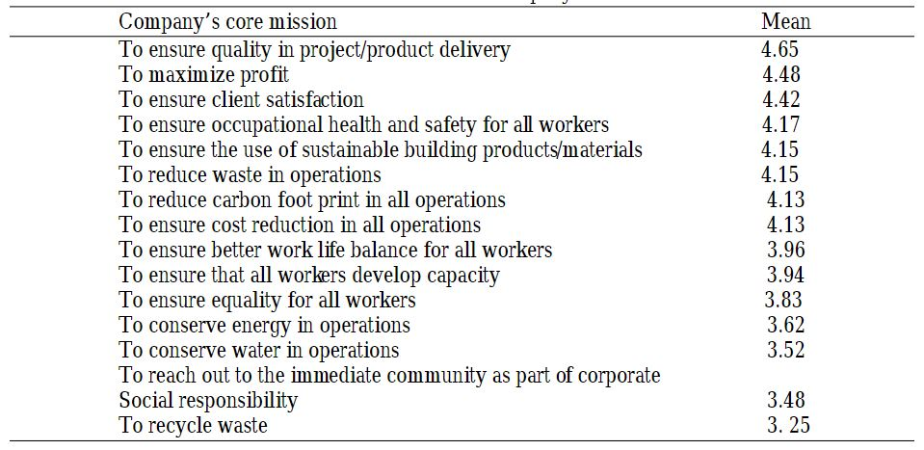

Factors militating against the development and implementation of sustainability strategies. The most significant factor militating against the development and implementation of sustainability is low awareness of sustainable construction (Table 3). Poor government support for sustainable construction and lack of leadership support for sustainable construction were the second and third most significant factors respectively militating against the development and implementation of sustainable construction (Table 3).
Table 2.0: Factors For Construction Of Environmentally Sustainable Infrastructure
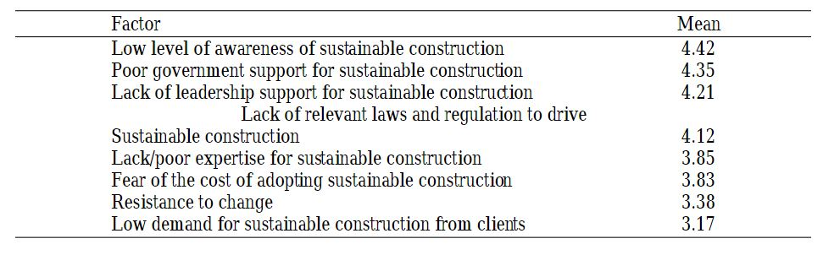

Benefits of incorporating sustainability indicates the benefits of sustainable construction. The greatest benefit of sustainable construction is the belief that sustainable construction makes a company environmentally sustainable (Table 4). The second greatest benefit of sustainable is it perceived economic benefits while the third benefit of sustainable construction is that sustainable construction improves a company’s reputation.
Table 3.0: Benefits Of Sustainable Construction
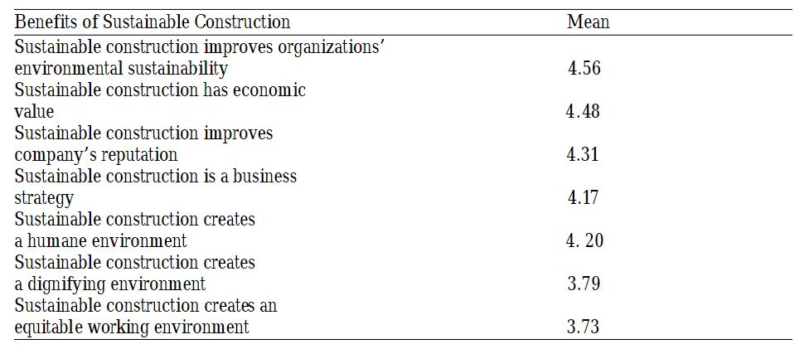

3.2 ANALYSIS OF RESULTS
The survey that was taken revealed a lot about the results of the current state of the spread of the COVID-19 pandemic in the country:
As of April 10. 2020, the number of COVID-19 cases in the country are recorded in the table below:
Table 4: COVID-19 Statistics In Nigeria
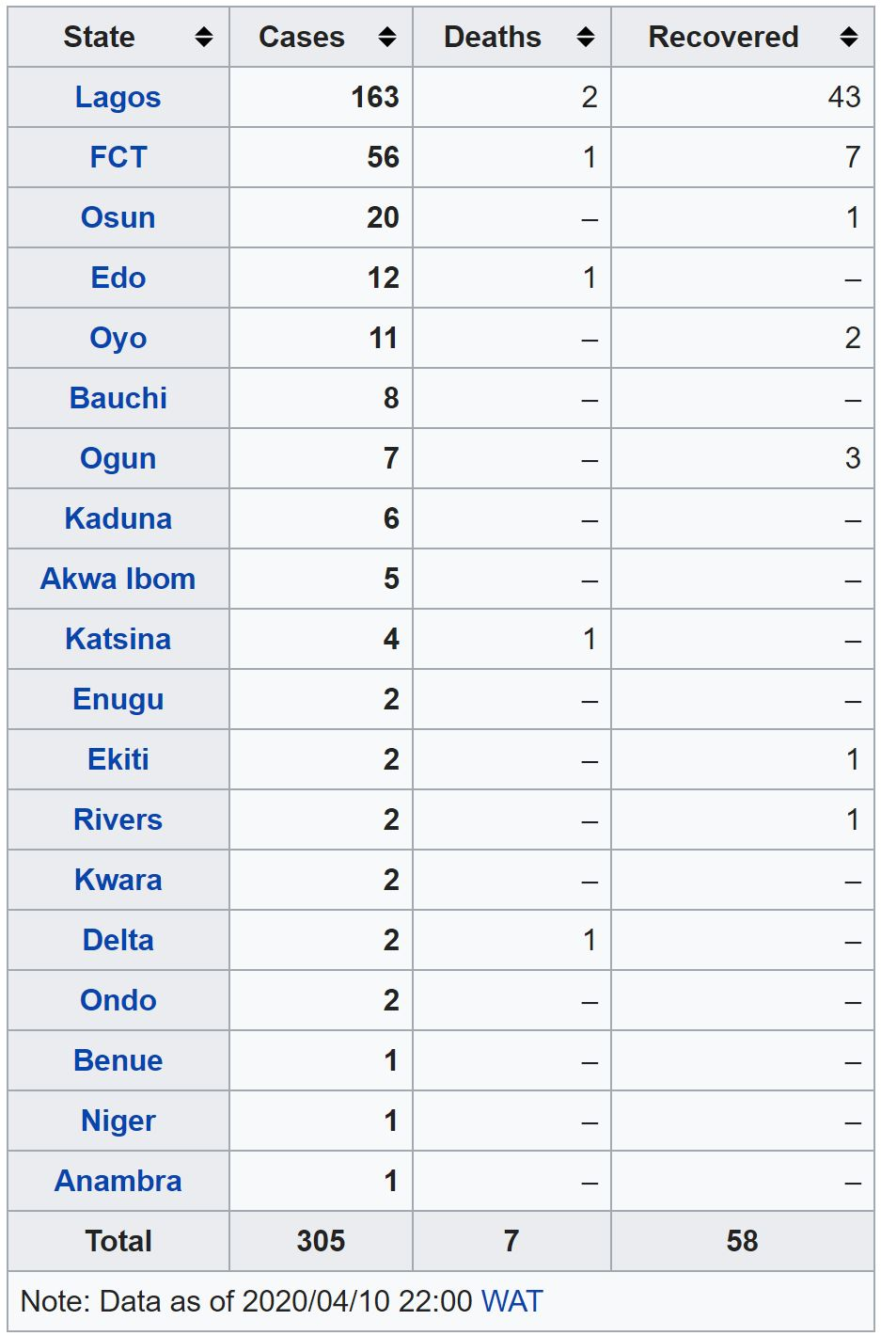
The first confirmed case of the pandemic of coronavirus disease 2019 in Nigeria was announced on 27 February 2020, when an Italian citizen in Lagos tested positive for the virus, caused by SARS-CoV-2. On 9 March 2020, a second case of the virus was reported in Ewekoro, Ogun State, a Nigerian citizen who had contact with the Italian citizen.
On 28 January 2020, the Federal government of Nigeria assured citizens of the country of its readiness to strengthen surveillance at five international airports in the country to prevent the spread of coronavirus. The government announced the airports as Enugu, Lagos, Rivers, Kano and the FCT. The Nigeria Centre for Disease Control also announced same day that they had already set up coronavirus group and was ready to activate its incident system if any case emerged in Nigeria.

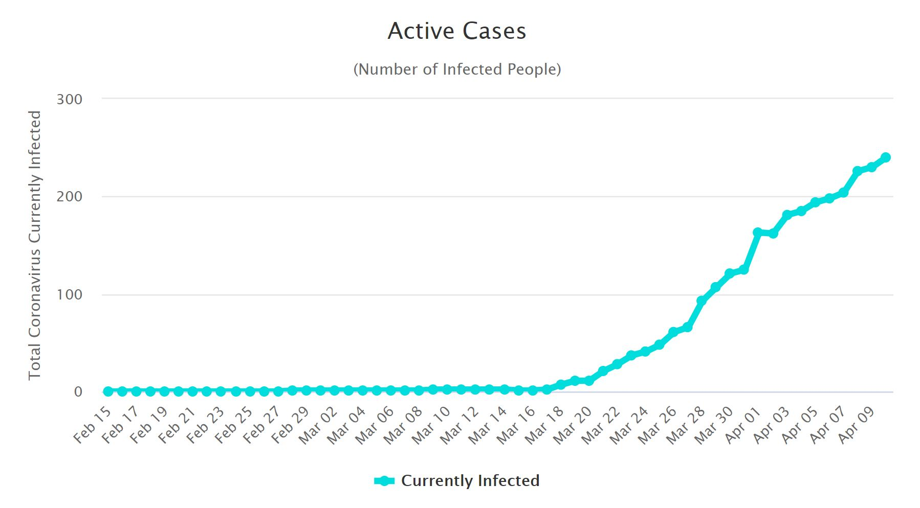
Fig 4.0: Active Cases In Nigeria
On 31 January 2020, following the developments of COVID-19 pandemic in mainland China and other countries worldwide, the federal government of Nigeria set up a Coronavirus Preparedness Group to mitigate the impact of the virus if it eventually spreads to the country.^{[6][7]} On the same day, the World Health Organization listed Nigeria among other 13 African countries identified as high-risk for the spread of the virus.
On 26 February 2020, a Chinese citizen presented himself to the Lagos State government on suspicion of being infected with coronavirus. He was admitted at Reddington Hospital and was released the following day after testing negative.

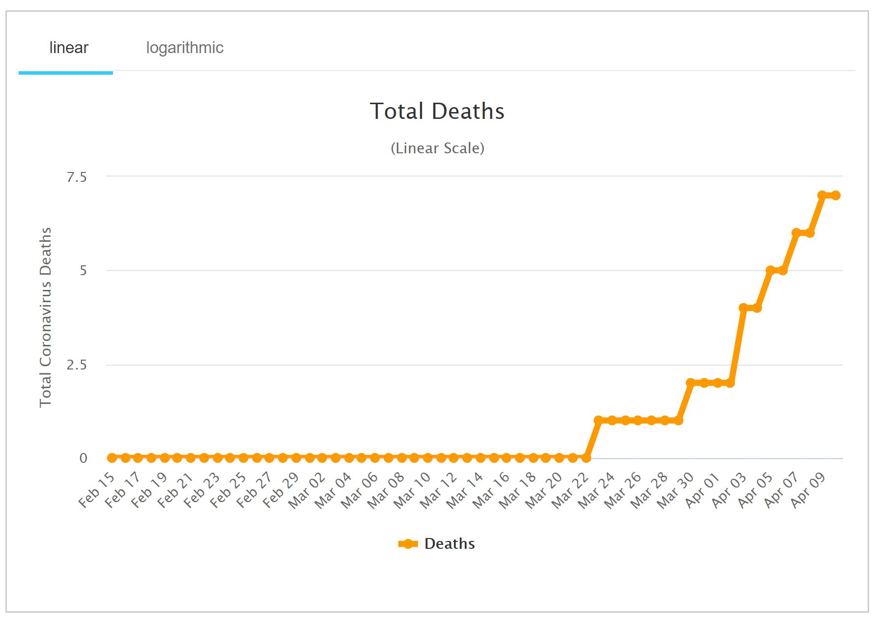
Fig 5.0: Graph of Death Roll In The Country.

- CHALLENGES
1. The effect of this development on the Nigerian economy could be significant. The last major crash in the price of crude oil in 2014 precipitated the downturn in the nation’s economy, culminating in a recession. Thus, there are reasonable fears that a sustained period of low oil prices could send the nation’s economy spiralling into another downturn.
This is quite worrying given that since the 2014 slump in global oil prices, the Central Bank of Nigeria (CBN) has rolled out a string of policies geared towards maintaining an artificially strong Naira reliant upon high crude oil prices and external borrowings. Thus, if crude oil prices remain in the $40-range for an extended period of time or drop even further, there could be even more pressure on the already pressured exchange rate and the nation’s overall economy.
2. Another risk posed by the COVID-19 pandemic to the Nigerian economy is the likelihood that the nation’s already high inflation rate could rise even further. Given that China accounts for about a quarter of Nigerian imports, greasing much of the country’s supply chain; and that the nation is reliant on China for raw materials, inputs and machinery utilized in local production, there is a significant possibility that the pandemic could induce an increase in the cost of local production or at least a significant reduction in the already limited local production capacity.
3. Furthermore, if China remains unable to export due to a myriad of reasons, there is a risk that raw material and inputs usually sourced from China for the manufacturing industry might need to be sourced from other nations where they are presumably more expensive. The economic effect of this will also be an increase in the prices of goods and services, thus resulting in a rise in the inflation rate.
4. In addition, the current crude oil price of $45 a barrel is significantly below the $57 a barrel benchmark planned in the nation’s 2020 federal budget. Therefore, if the low crude oil price regime persists for an extended period of time, the viability of the nation’s 2020 budget will remain further in doubt.
5. The stacks are obviously not in our favour and as things get worse for the oil markets, so will they be for the economy. The Federal Government will struggle to fund its statutory capital and recurrent expenditures, state governments will struggle to pay salaries, and oil companies could default on their loans, thereby piling pressure on commercial banks.
6. Small businesses, which rely heavily on foreign imports to augment their value chains, will suffer from supply shortages while looming job cuts will intensify. The aviation sector could suffer, as businesses will cut down on travel plans. The struggling service sector will feel most of the heat, as the manufacturers will cut back budget to survive.
7. The planned increase in electricity tariffs may be put on hold, further worsening the situation in the power sector. As things get worse, the CBN may have no choice but to embark on a massive devaluation.
8. The stock market has already taken a hit as a result of the virus. The Nigerian Stock Exchange (NSE) lost ₦2.3 trillion in the three weeks after Nigeria's first case - an 18% drop. Uncertainty is a big factor for the shock in financial markets which has implications for the real economy. As investors lose money and businesses lose capital, spending by both individuals and firms decrease.
9. Another big hit to the economy and perhaps, the most direct hit will come from the restrictions on movement around the world and in Nigeria. The shutdown of offices and non-essential businesses will reduce productive effort and output. Take as examples, the closure of a Chinese fabric manufacturing company that produces input for a Nigerian fashion line or the shutdown of bars in Lagos. In both cases, Nigerian businesses will be required to slow down or halt production. Moreover, with stay-at-home policies and the uncertainty that comes with the pandemic, non-essential commodities will be less sought after.
10. The CBN hopes to avert the economic impact of the pandemic by loaning money to the individuals, businesses and industries that are most affected and those that are in the front line of fighting the pandemic. The total stimulus package is ₦3.5 trillion. This includes 5% interest loans of up to ₦50 billion to households, airline service providers and hoteliers, ₦150 billion to the pharmaceutical and healthcare sector and ₦1 trillion for the manufacturing sector. It is also delaying repayments from SMEs under its many intervention funds.
11. The CBN hopes that the money can be used to keep vital sectors afloat. It particularly wants the manufacturing and pharmaceutical sectors to boost local production, reducing their reliance on foreign exchange for imports. The Federal Government is yet to announce any major plans and there is a question of whether the CBN loans will be enough to stop the economy grinding to a halt and employees being laid off. Businesses are likely to need more grants. For some, taking up too many loans may be tricky, and if the crisis is prolonged the CBN might find that a lot of these loans end up being bailouts with no repayment.
12. A recession seems very likely. Considering that the informal sector contributes about 41% of Nigeria’s economic output, how many people can stay at home and still be productive? Work-from-home policies would not apply to food vendors and artisans. Even within the formal economy, workers who are not skilled in working remotely like Nigeria’s civil servants and sectors without telework technology like manufacturing will be unable to work from home. A shutdown of movement will lead to a massive decline in economic output, income and consumer spending.
13. While most recessions are either caused by demand, supply or financial shocks, the COVID-19 pandemic promises to deliver all three in a single package. The shock to demand (restrictions to movement, and uncertainty causing consumers to reduce non-essential spending), to supply (shutdown of factories and service providers causing a reduction in goods and services produced) and the financial system (disruptions in the capital market) could be fatal. Nevertheless, the CBN is already making moves that it failed to make during the last crisis. Once the Federal Government comes into play, they might manage to minimise the damage. But regardless of how our economy or economic policymakers react, the coronavirus is first a public health emergency. Without the population adhering to the World Health Organisation (WHO) guidelines and the government adopting preventive policies, the economy will continue to tumble.

- RECOMMENDATIONS
1. Perhaps most importantly, there is a need to address the biggest elephant in the room: Nigeria’s reliance on the sale of crude oil as the major source of the nation’s foreign exchange earnings. There is a need to diversify the nation’s economy away from a reliance on crude oil. The need to restructure and diversify the productive base of the economy, with a view to reducing dependence on the oil sector and imports has never been more apparent. As long as the Nigerian economy remains a mono-economy totally dependent on oil revenues, the nation will continue to remain vulnerable to oil price shocks. Therefore, Nigeria needs to ensure sustainable fiscal management that is resilient to global oil price cycles.
2. Adequately support the healthcare system: Prior to COVID-19, healthcare institutions were already overburdened with many ailments given poor medical supplies, shortage of medical workers and poor infrastructure.
To have a fighting chance against COVID-19 and in treating those requiring intensive care, the healthcare sector must be supported through adequate funding, incentives for health workers, and health care subsidies for the most vulnerable people.
3. Provide incentives and safety nets to the most affected: Through targeted tax incentives, social transfers, and regulatory support, the Nigerian government could help minimize the impact of COVID-19 on the most vulnerable businesses and citizens.
4. With the adoption of social distancing measures to limit the spread of the virus, the government should partner with informal groups such as trade associations, who have a wider reach, to deliver support to people in vulnerable employment.
5. Enable vulnerable sub-national (state) governments: Sub-national governments have improved their resilience to oil-related crises by improving Internally Generated Revenue (IGR) but many would struggle to pay salaries given the crisis. Therefore, the FG and the CBN can expand loans to states to enable them to pay workers and support the healthcare sector.
6. Reduce cost and Improve transparency: The government should reduce the cost of governance by changing its ways in the incurring of administrative costs and prioritizing the most effective development programs. This will free up more money for social and infrastructural spending and improve its resilience.
7. Similarly, reducing the misuse of public finances through commitment to transparency, opening up budgets, and strengthening anti-corruption institutions should be a priority during and post COVID-19.
8. Now more than ever, policymakers must be responsive to lessen the effects of the impending social and economic crises and better prepare Nigeria for the future.

6.0 CONCLUSION
Sustainability awareness and sustainability polices are recommended in order to increase interest and implementation of sustainability in the construction industry. Development and implementation of sustainability strategies will foster achievement of the green growth agenda in Nigeria. The strategies and solutions given in the paper will definitely help to bolster the growth of the economy.
Quality performance was found to be the most common element in the mission statement of the organizations studied. This is followed by profit maximization and then client satisfaction. The mission statement of most of the construction organizations surveyed is more inclined towards project performance indicators. Sustainability elements in mission statements of the organizations studied ranked low. This may be because of poor awareness of the concept of sustainable construction and poor government and leadership support for sustainable construction.
The greatest deterrent to developing and implementing a sustainable economy is poor awareness. It is difficult to drive a concept that is not well understood by citizens and business operators. This probably explains why sustainable is not a core element in the mission statement of most construction organizations surveyed. Another factor militating against the development and implementation of sustainable construction is poor support from the government in driving the sustainability agenda. This is evident in the absence of relevant laws and regulations to drive sustainability especially in the economic sector. Respondents view sustainability more in terms of environmentally sustainability. This may be because of greater emphasis on environmental sustainability than economic or social sustainability. Since majority of the firms surveyed do not have strategies for tackling sustainability challenges from construction activities, Nigeria’s green growth will be hampered. Moreover, since the sustainability ethos is yet to be enshrined in construction organizations, it may be difficult to achieve the much needed green growth in Nigeria.

7.0 REFERENCES
A. Haines, K.R. Smith, D. Anderson, P.R. Epstein, A.J. McMichael, I. Roberts, P. Wilkinson, J. Woodcock, J. Woods. Policies for accelerating access to clean energy, improving health, advancing development, and mitigating climate change. Lancet, 370 (2007), pp. 1264-1281
Abdur Rahman Alfa Shaban.2020. “Coronavirus: Buhari signs lockdown regulations, cases hit 131, 2 deaths.“ “https://www.africanews.com/2020/03/31/nigeria-confirms-third-coronavirus-case-index-patient-fully-recovers/”
A.J. McMichael, R.E. Woodruff, S. Hales. Climate change and human health: present and future risks. Lancet, 367 (2006), pp. 859-869
Coronavirus.(2020). Available at: https://en.wikipedia.org/wiki/Coronavirus
Coronavirus disease 2019. https://en.wikipedia.org/wiki/Coronavirus_disease_2019
C.P. Durand, M. Andalib, G.F. Dunton, J. Wolch, M.A. Pentz. A systematic review of built environment factors related to physical activity and obesity risk: implications for smart growth urban planning. Obes Rev, 12 (2011), pp. e173-e182
D. Vlahov, S. Galea. Urban health: a new discipline. Lancet, 362 (2003), pp. 1091-1092. ArticleDownload PDFView Record in Scopus. Google Scholar S. Boyden. People and Nature: The Big Picture. Nature and Society Forum (2005). Google Scholar
D.S. Rogers, A.K. Duraiappah, D.C. Antons, P. Munoz, X. Bai, M. Fragkias, H. Gutscher. A vision for human well-being: transition to social sustainability. Curr Opin Environ Sustain, 4 (2012), pp. 61-73
Emmanuel Paul(2020): “COVID-19, technology, and the future lessons for Africa.”. Available at: https://techpoint.africa/2020/03/24/ai-regulations-covid-19-african/
G. McGranahan, P. Marcotullio, X. Bai, D. Balk, T. Braga, I. Douglas, T. Elmqvist, W. Rees, D. Satterthwaite, J. Songsore. Urban systems. Ecosystems and Human Well-Being, Current State and Trends, Findings of the Condition and Trends Working Group. Millennium Ecosystem Assessment Series, vol 1 (2005)
K. Proust, B. Newell, H. Brown, A. Capon, C. Browne, A. Burton, J. Dixon, L. Mu, M. Zarafu. Human health and climate change: leverage points for adaptation in urban environments. Int J Environ Res Public Health, 9 (2012), pp. 2134-2158
K.R. Smith, M. Jerrett, H.R. Anderson, R.T. Burnett, V. Stone, R. Derwent, R.W. Atkinson, A. Cohen, S.B. Shonkoff, D. Krewski, et al. Public health benefits of strategies to reduce greenhouse-gas emissions: health implications of short-lived greenhouse pollutants. Lancet, 374 (2009), pp. 2091-2103.
N.B. Grimm, S.H. Faeth, N.E. Golubiewski, C.L. Redman, J.G. Wu, X.M. Bai, J.M. Briggs. Global change and the ecology of cities. Science, 319 (2008), pp. 756-760. CrossRefView Record in Division U-P: World Population Prospects, the 2010 Revision 2011.
R. Lafortezza, G. Carrus, G. Sanesi, C. Davies. Benefits and well-being perceived by people visiting green spaces in periods of heat stress. Urban Forestry Urban Green, 8 (2009), pp. 97-108
The Coronavirus and the Nigerian Economy. 2020. Lanre Rufai. Available at: https://businessday.ng/columnist/article/the-coronavirus-and-the-nigerian-economy/
X.M. Bai, H. Imura. A comparative study of urban environment in East Asia: stage model of urban environmental evolution. Int Rev Global Environ Strategies, 1 (2000), pp. 135-158
X.M. Bai. The process and mechanism of urban environmental change: an evolutionary view
Int J Environ Pollut, 19 (2003), pp. 528-541
X.M. Bai, P.J. Shi. Pollution control: in China's Huai River Basin: what lessons for sustainability? Environ Sci Policy Sustain Dev, 48 (2006), pp. 22-38
WHO. Emergency ministerial meeting on COVID-19 organized by the African union and the Africa centres for disease control and prevention. 2020. https://www.who.int/dg/speeches/detail/emergency-ministerial-meeting-on-covid-19-organized-by-the-african-union-and-the-africa-centres-for-disease-control-and-prevention
Yomi Kazeem(2020): “Tech startups are joining Nigeria’s fight against coronavirus”. Available at: https://qz.com/africa/1828438/coronavirus-nigerian-tech-startups-step-up-to-assist-government/
Zumla A. Dar O. Kock R. et al. Taking forward a ‘One Health’ approach for turning the tide against the Middle East respiratory syndrome coronavirus and other zoonotic pathogens with epidemic potential. Int J Infect Dis. 2016; 47: 5-9

