A
TECHNICAL TERM PAPER REPORT
ON THE TOPIC
DESIGN OF INNOVATIVE AND AUTOMATED RESPIRATORY BUILDINGS FOR PATIENTS AND HEALTH WORKERS AGAINST CORONAVIRUS DISEASE OUTBREAK
BY
ADEPOJU, MARY ABIMBOLA
(17/ENG03/004)
SUBMITTED TO
ENGR. OYEBODE, OLUWADARE JOSHUA
FROM THE
DEPARTMENT OF CIVIL ENGINEERING
COLLEGE OF ENGINEERING

CERTIFICATION

This is to certify that this TERM PAPER was carried out by ADEPOJU, MARY ABIMBOLA with matriculation number 17/ENG03/004 of the department of Civil Engineering, College of Engineering, AfeBabalola University, Ado Ekiti, Ekiti State; in partial fulfilment of the requirements for the award of Bachelor of Engineering (B.Eng) Degree in Civil Engineering.

DEDICATION
This technical TERM PAPER report is dedicated to God almighty, the maker of life. I would also like to dedicate it to my wonderful parents and family for their support.

ABSTRACT
This report is a detailed account made on the topic that “DESIGN OF INNOVATIVE AND AUTOMATED RESPIRATORY BUILDINGS FOR PATIENTS AND HEALTH WORKERS AGAINST CORONAVIRUS DISEASE OUTBREAK.” It covers the introduction, literature review, methodology, conclusion and references.

Contents
CHAPTER ONE 6
INTRODUCTION 6
ABOUT TERM PAPER 6
OBJECTIVES OF TERM PAPER 6
THE CORONA VIRUS 7
BUILDING AUTOMATION 9
CHAPTER TWO 10
LITERATURE REVIEW 10
RESPIRATORY BUILDING 10
CHAPTER THREE 12
THE NEED FOR THE DESIGN OF INNOVATIVE AND AUTOMATED RESPIRATORY BUILDINGS FOR PATIENTS AND HEALTH WORKERS AGAINST CORONA VIRUS DISEASE OUTBREAK 12
DISADVANTAGES OF INEFFECTIVE DESIGN OF INNOVATIVE AND AUTOMATED RESPIRATORY BUILDINGS FOR PATIENTS AND HEALTH WORKERS AGAINST CORONA VIRUS OUTBREAK 13
ADVANTAGES OF THE DESIGN OF INNOVATIVE AND AUTOMATED RESPIRATORY BUILDINGS FOR PATIENTS AND HEALTH WORKERS AGAINST CORONA VIRUS OUTBREAK 14
CONCLUSION 15
REFERENCES 16

CHAPTER ONE
INTRODUCTION

  - ABOUT TERM PAPER
A term paper is a research paper written by students over an academic term, accounting for a large part of a grade. Merriam-Webster defines it as “a major written assignment in a school or college course repesentative of a student’s achievement during a term”. Term papers are generally intended to describe an even, a concept, or argue a point. It is a written original work discussing a topic in detail, usually several typed pages in length,and is often due at the end of the semester.

  - OBJECTIVES OF TERM PAPER
The main objectives of a term paper include:
- To provide an opportunity for some individual interaction between the student and instructor.
- Guide students through the process of planing and executing a substantial project.
- Allow students the opportunity to teach themselves.

  - THE CORONA VIRUS

The corona virus (COVID-19), is an infectious disease caused by members of the corona virus family. The corona virus can be spread from person to person via the droplets produced when an infected person coughs, talks, or sneezes. It can also be transmitted when one touches surfaces which have small droplets of the virus.
Fig 2.1 Microscopic structure of the COVID-19

The 2019-2020 coronavirus disease outbreak, caused by COVID-19 was declared a pandemic by the WORLD HEALTH ORGANISATION (WHO) on 11 march 2020. A pandemic is the global outbreak of a disease, in other words, a pandemic is the rapid spread of a disease across a particular region or regions.
Since the outbreak of the COVID-19, there has been a record of:
- 1699595 confirmed cases,
- 106138 confirmed deaths,
- 213 territories with confirmed cases.

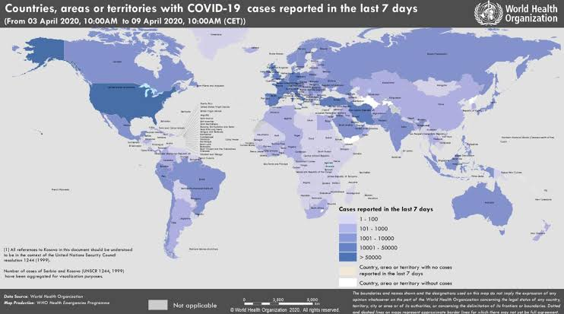
FIG 2.2 Teritories with confirmed cases.

At this time, there are no specific vaccines or treatments for COVID-19. However, there are many ongoing clinical trials evaluating potential treatments. THE WORLD HEALTH ORGANOIZATION (WHO) will continue to provide update information as soon as clinical findings become available.

  - BUILDING AUTOMATION

Building automation is the automatic centralized control of a building’s heating, ventilation, and air conditioning, lighting and other systems through a building management system or building automation system.
The objectives of building automation are:
- Improved occupant comfort,
- Efficient operation of building systems,
- Reduction in energy consumption and operating costs,
- Improved life cycle of utilities.

CHAPTER TWO
LITERATURE REVIEW

  - RESPIRATORY BUILDING

The term respiratory building is basically all about ventilation in a building. Ventilation is the introduction of outdoor air into a space. Ventilation is mainly used to control indoor air quality by diluting and displacing indoor pollutants; it can also be used to control indoor temperature, humidity, and air motion to benefit thermal comfort, satisfaction with other aspects of indoor environment, or other objectives.
Ventilation is necessary in respiratory building to help:
- Moderate internal temperature,
- Moderate internal humidity
- Replenish oxygen
- Reduce accumulation of moisture, odours, bacteria, dust, etc.
The introduction of outdoor air is usually categorised as either:
- Natural ventilation which is a introduction of doors and windows in a building design.
- Mechanical ventilation which is the introduction of supply fans (which push outdoor air into a building), and exhaust fan (which draw air out of a building thereby causing equal ventilation flow into a building.
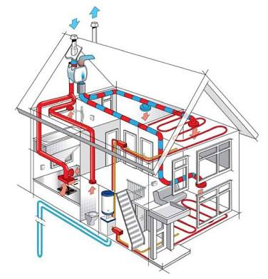
FIG 2.3 Diagram showing ventilation in a respiratory building.
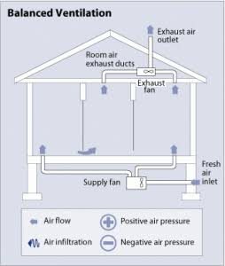
FIG 2.4 A balanced ventilation building

CHAPTER THREE
  - THE NEED FOR THE DESIGN OF INNOVATIVE AND AUTOMATED RESPIRATORY BUILDINGS FOR PATIENTS AND HEALTH WORKERS AGAINST CORONA VIRUS DISEASE OUTBREAK

As a civil engineer, the health and wellbeing of the building occupants (patients and health workers) should be a key priority in the design, building and operation of new and existing buildings. To provide good air quality, enough air needs to be brought in and circulated so that it reaches all areas of the building. For almost all buildings, windows and structural elements contribute to bringing in fresh air.
There is a need to design innovative and automated respiratory buildings for patients and health workers against corona virus disease outbreak, this reduces and prevents the cross-contamination of air within the clinical building.
Case study: an investigation of a sars outbreak that infected 187 people found plumes of virus-laden air from a bathroom were transported around the building.
Most civil engineers use cheap filters while designing clinical buildings. These cheap filters capture less than 20 percent of airbone virus-sized particles. A higher- rated filter cup trap closer to 80 percent. Therefore there is need to design a very good and effective building which could help reduce the rate at which people get infected within the building.
Civil engineers should build in plenty of outdoor air and control direction of airflow.

  - DISADVANTAGES OF INEFFECTIVE DESIGN OF INNOVATIVE AND AUTOMATED RESPIRATORY BUILDINGS FOR PATIENTS AND HEALTH WORKERS AGAINST CORONA VIRUS OUTBREAK
- Patients infected with COVID-19 may experience respiratory difficulties (difficulty in breathing). When the respiratory building is inffective, ventilation system will be poor thus, these patients will be uncomfortable.
- Cross-contamination is a process where viruses are unintentionally transferred from one place to another. Ineffective respiratory buildings can result to cross-contamination. Persons who initially were infected with COVID-19 could get infected through cross-contamination

  - ADVANTAGES OF THE DESIGN OF INNOVATIVE AND AUTOMATED RESPIRATORY BUILDINGS FOR PATIENTS AND HEALTH WORKERS AGAINST CORONA VIRUS OUTBREAK
Some of the advantages of the design of innovative and automated respiratory buildings for patients and health workers against coronavirus outbreak includes:
- Helps flush out stale indoor air within the building.
- Provides a comfortable environment for patients infected with the corona virus.
- Prevents cross-contamination of the corona virus disease between infected patients and health workers.

CONCLUSION
As civil engineers, we need to put our buildings to work for us in the fight against the corona virus outbreak. Therefore, it is very important that civil engineers design and plan proper innovative and automated respiratory buildings.

REFERENCES
- www.wikipedia.org
- www.images.googles.com.ng
- www.who.int
- www.google.com

