A TERM PAPER ON THE

ASSESSMENT OF OCCUPATIONAL HAZARDS AND DEVELOPMENT OF ENGINEERING EQUIPMENT TO SUPPORT HEALTH WORKERS AGAINST COVID-19

BY

OGBOGU PATRICK OFILI
15/ENG03/025

TO

ENGR. OLUWADARE JOSHUA OYEBODE

MARCH,2020

ABSTRACT
Occupational hazard assessment is a method for estimating health risks from exposure to various levels of a workplace hazard. Understanding how much exposure to a hazard poses health risks to workers is important to appropriately eliminate, control, and reduce those risks. The aim of a risk assessment is to answer three basic questions:
- What can happen?
- How likely is it to happen?
- What are the consequences if it does happen?

CHAPTER ONE
INTRODUCTION
- Hazard Recognition
The risks from SARS-CoV-2, the virus that causes Coronavirus Disease 2019 (COVID-19), for workers depends on how extensively the virus spreads between people; the severity of resulting illness; pre-existing medical conditions workers may have; and the medical or other measures available to control the impact of the virus and the relative success of these measures. The U.S. Centers for Disease Control and Prevention (CDC) provides detailed information about this topic.
According to the CDC, certain people, including older adults and those with underlying conditions such as heart or lung disease or diabetes, are at higher risk for developing more serious complications from COVID-19.

  - Occupational hazard controls for COVID-19
These are the application of occupational safety and health methodologies for hazard controls to the prevention of coronavirus disease 2019 (COVID-19). The proper hazard controls in the workplace depend on the worksite and job task, based on a risk assessment of sources of exposure, disease severity in the community, and risk factors of individual workers who may be vulnerable to contracting COVID-19.
According to the U.S. Occupational Safety and Health Administration (OSHA), lower exposure risk jobs have minimal occupational contact with the public and other co-workers, for which basic infection prevention measures are recommended, including hand washing, encouraging workers to stay home if they are sick, respiratory etiquette, and maintaining routine cleaning and disinfecting of the work environment.
Medium exposure risk jobs include those that require frequent or close contact with people who are not known or suspected with COVID-19, but may be infected due to ongoing community transmission or international travel. This includes workers who have contact with the general public such as in schools, high-population-density work environments, and some high-volume retail settings. Hazard controls for this group, in addition to basic infection prevention measures, include ventilation using high-efficiency air filters, sneeze guards, and having personal protective equipment available in case a person with COVID-19 is encountered.
OSHA considers healthcare and mortuary workers exposed to known or suspected person with COVID-19 to be at high exposure risk, which increases to very high exposure risk if workers perform aerosol-generating procedures on, or collect or handle specimens from, known or suspected person with COVID-19. Hazard controls appropriate for these workers include engineering controls such as negative pressure ventilation rooms, and personal protective equipment appropriate to the job task.

  - Classifying Risk of Worker Exposure to SARS-CoV-2
Worker risk of occupational exposure to SARS-CoV-2 during a pandemic may depend in part on the industry type and the need for contact within 6 feet of people known to be, or suspected of being, infected with SARS-CoV-2. Other factors, such as conditions in communities where employees live and work, their activities outside of work (including travel to COVID-19-affected areas), and individual health conditions, may also affect workers' risk of getting COVID-19 and/or developing complications from the illness.
OSHA has divided job tasks into four risk exposure levels: very high, high, medium, and lower risk, as shown in the occupational risk pyramid, below. The four exposure risk levels represent the probable distribution of risk. Most American workers will likely fall in the lower exposure risk (caution) or medium exposure risk level

Lower Exposure Risk (Caution)
Jobs that do not require contact with people known to be, or suspected of being, infected with SARS-CoV-2. Workers in this category have minimal occupational contact with the public and other co-workers. Examples include:
- Remote workers (i.e., those working from home during the pandemic).
- Office workers who do not have frequent close contact with co-workers, customers, or the public.
- Manufacturing and industrial facility workers who do not have frequent close contact with co-workers, customers, or the public.
- Healthcare workers providing only telemedicine services.
- Long-distance truck drivers.

Medium Exposure Risk
Jobs that require frequent/close contact with people who may be infected, but who are not known to have or suspected of having COVID-19. Workers in this category include:
- Those who may have frequent contact with travellers who return from international locations with widespread COVID-19 transmission.
- Those who may have contact with the general public (e.g., in schools, high population density work environments, and some high-volume retail settings).

High Exposure Risk
Jobs with a high potential for exposure to known or suspected sources of SARS-CoV-2. Workers in this category include:
- Healthcare delivery and support staff (hospital staff who must enter patients’ rooms) exposed to known or suspected COVID-19 patients.
- Medical transport workers (ambulance vehicle operators) moving known or suspected COVID-19 patients in enclosed vehicles.
- Mortuary workers involved in preparing bodies for burial or cremation of people known to have, or suspected of having, COVID-19 at the time of death.

Very High Exposure Risk
Jobs with a very high potential for exposure to known or suspected sources of SARS-CoV-2 during specific medical, post-mortem, or laboratory procedures. Workers in this category include:
- Healthcare workers (e.g., doctors, nurses, dentists, paramedics, emergency medical technicians) performing aerosol-generating procedures (e.g., intubation, cough induction procedures, bronchoscopies, some dental procedures and exams, or invasive specimen collection) on known or suspected COVID-19 patients.
- Healthcare or laboratory personnel collecting or handling specimens from known or suspected COVID-19 patients (e.g., manipulating cultures from known or suspected COVID-19 patients).
- Morgue workers performing autopsies, which generally involve aerosol-generating procedures, on the bodies of people who are known to have, or are suspected of having, COVID-19 at the time of their death.

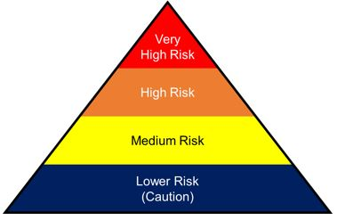
FIG I: PYRAMID OF RISK EXPOSURE.

  - Planning and risk assessment
COVID-19 outbreaks can have several effects within the workplace. Workers may be absent from work due to becoming sick, needing to care for others, or from fear of possible exposure. Patterns of commerce may change, both in terms of what goods are demanded, and the means of acquiring these goods (such as shopping at off-peak hours or through delivery or drive-through services). Lastly, shipments of items from geographic areas severely affected by COVID-19 may be interrupted.
An infectious disease preparedness and response plan can be used to guide protective actions. Plans address the levels of risk associated with various worksites and job tasks, including sources of exposure, risk factors arising from home and community settings, and risk factors of individual workers such as old age or chronic medical conditions. They also outline controls necessary to address those risks, and contingency plans for situations that may arise as a result of outbreaks. Infectious disease preparedness and response plans may be subject to national or subnational recommendations. Objectives for response to an outbreak include reducing transmission among staff, protecting people who are at higher risk for adverse health complications, maintaining business operations, and minimizing adverse effects on other entities in their supply chains. The disease severity in the community where the business is located affects the responses taken.

  - Hazard controls
The hierarchy of hazard controls contains methods for controlling exposures to hazards. Methods listed towards the top potentially more effective than those at the bottom at reducing the risk of illness or injury.
The hierarchy of hazard controls is a framework widely used in occupational safety and health to group hazard controls by effectiveness. Where COVID-19 hazards cannot be eliminated, the most effective controls are engineering controls, followed by administrative controls, and lastly personal protective equipment. Engineering controls involve isolating employees from work-related hazards without relying on worker behaviour, and can be the most cost-effective solution to implement. Administrative controls are changes in work policy or procedures that require action by the worker or employer. Personal protective equipment (PPE) is considered less effective than engineering and administrative controls, but can help prevent some exposures. All types of PPE must be selected based upon the hazard to the worker, properly fitted as applicable (e.g., respirators), consistently and properly worn, regularly inspected, maintained, and replaced, as necessary, and properly removed, cleaned, and stored or disposed of to avoid contamination.

  - Rights, roles and responsibilities of health workers, including occupational safety and health
Health workers are at the front line of any outbreak response and as such are exposed to hazards that put them at risk of infection with an outbreak pathogen (in this case COVID-19). Hazards include pathogen exposure, long working hours, psychological distress, fatigue, occupational burnout, stigma, and physical and psychological violence. This document highlights the rights and responsibilities of health workers, including specific measures needed to protect occupational safety and health.
Health worker rights include that employers and managers in health facilities;
- Assume overall responsibility to ensure that all necessary preventive and protective measures are taken to minimize occupational safety and health risks
- Provide information, instruction and training on occupational safety and health, including;
- Refresher training on infection prevention and control (IPC); and
- Use, putting on, taking off and disposal of personal protective equipment (PPE);
- Provide adequate IPC and PPE supplies (masks, gloves, goggles, gowns, hand sanitizer, soap and water, cleaning supplies) in sufficient quantity to healthcare or other staff caring for suspected or confirmed.

Health workers should:
- Follow established occupational safety and health procedures, avoid exposing others to health and safety risks and participate in employer-provided occupational safety and health training;
- Use provided protocols to assess, triage and treat patients;
- Treat patients with respect, compassion and dignity;
- Maintain patient confidentiality;
- Swiftly follow established public health reporting procedures of suspect and confirmed cases;
- Provide or reinforce accurate infection prevention and control and public health information, including to concerned people who have neither symptoms nor risk;
- Put on, use, take off and dispose of personal protective equipment properly
- Self-monitor for signs of illness and self-isolate or report illness to managers, if it occurs;
- Advise management if they are experiencing signs of undue stress or mental health challenges that require support interventions; and
- Report to their immediate supervisor any situation which they have reasonable justification to believe presents an imminent and serious danger to life or health
CHAPTER TWO
DEVELOPMENT OF ENGINEERING EQUIPMENT TO SUPPORT HEALTH WORKERS AGAINST COVID-19.

CASE I: ENGINEERS DEVELOP ROBOTS TO TREAT AND TEST COVID-19 PATIENTS IN A BID TO PROTECT HEALTH WORKERS
Engineers in China have developed a robot to treat and test Covid-19 patients while allowing healthcare workers to remain at a safe distance from the highly infectious virus.
The remote-controlled, wheeled machine can take mouth swabs, perform ultrasound scans and listen to organs with a robot stethoscope.
Medical staff can operate the robots from a safe distance using on-board cameras to monitor the patient.
High infection rates among health care workers have hampered efforts to tackle the outbreak, prompting the designers to see if a robot could provide protection.
Robot engineers have long promised their machines will eventually save human workers from dull, dangerous or dirty work. The coronavirus epidemic presents an opportunity to tests what robots may be able to do, some scientists believe.
The robots are almost entirely automated, and could even disinfect themselves after performing actions involving contact.

CASE II: ADJUSTABLE FACE SHIELD BY APPLE INC.
Engineers at Apple recently helped develop an adjustable face shield to protect healthcare workers on the front lines of the coronavirus pandemic.
The piece of PPE designed by Apple is made of three pieces – the face shield, forehead strap and silicone strap.
Apple's shields can be assembled in less than two minutes and are fully adjustable. They can be worn in two ways, regular fit and extra space.
Apple has delivered the first face shields to a medical facility in California and is planning to manufacture a million masks per week in the US and China.
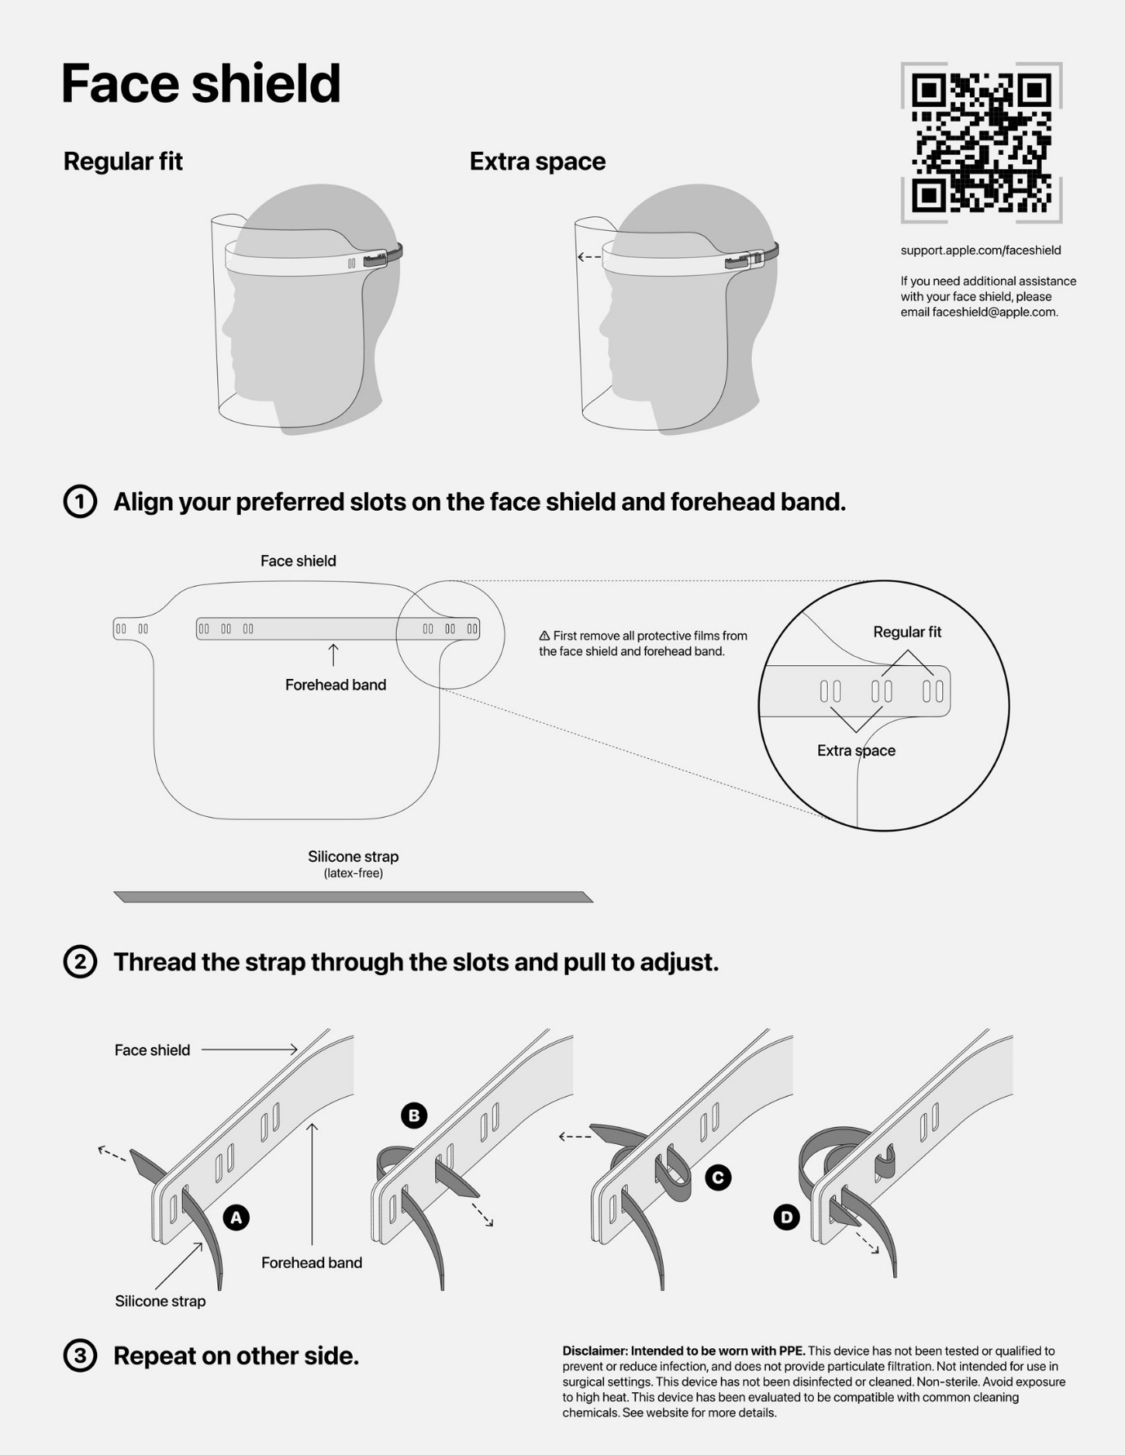
FIGURE II: APPLE FACE SHIELD.
Face shields are designed to offer protection from fluids that may contain the coronavirus, however they are designed to be worn with a face mask and other protective clothing.

CASE III: OXFORD AND KING’S DEVELOPING PROTOTYPE FOR RAPIDLY DEPLOYABLE VENTILATOR(OXVENT)
An interdisciplinary team of engineers and medics is addressing ways to increase the UK’s capacity for ventilator manufacture.
Engineers, anaesthetists and surgeons from the University of Oxford and King’s College London are building and testing prototypes that can be manufactured using techniques and tools available in well-equipped university and small and medium enterprise (SME) workshops.
The researchers are working in response to UK government calls to increase the country’s ventilator manufacturing capacity due to COVID-19. Demonstrating safety and reliability and achieving regulatory approval of the open source design will be necessary, and once this has been achieved, the approach could unlock potential for a new kind of distributed manufacturing effort.
The Department of Engineering Science has committed to support prototyping efforts and the team is looking for options to develop regulatory approval. The next steps are ensuring the prototype has buy in from all stakeholders, especially healthcare staff, and to demonstrate compliance with the MHRA requirements of performance, safety and reliability.
The Ox Vent, a brainchild of engineers and medics at the University of Oxford and King's College London, is designed to be shipped as a kit that can be put together quickly by hospitals amid the coronavirus pandemic. The pared-down ventilator is meant to satisfy demand at increasingly desperate hospitals in need of basic machines to help critically-ill patients breathe.
It was designed, prototyped and now tested in the course of just a couple of weeks. Major manufacturers in Europe and the U.S.
