ENGINEERING LAW AND MANAGERIAL ECONOMICS FOR INFRASTRUCTURAL DEVELOPMENT IN NIGERIA: CHALLENGES AND WAY FORWARD
BY
EZERIBE NELSON EBUKA
17/ENG02/027
A TERM PAPER SUBMITTED TO
COLLEGE OF ENGINEERING, AFE BABALOLA UNIVERSITY, ADO-EKITI, EKITI STATE.
FOR ENGINEERING LAW AND MANAGERIAL ECONOMICS (ENG 384)
IN PARTIAL FULFILMENT TO THE REQUIREMENTS FOR THE DEGREE OF BACHELOR OF ENGINEERING IN ENGINEERING.

12th of APRIL, 2020

TABLE OF CONTENTS

TITLE PAGE………………………………………………..…………………………………1

TABLE OF CONTENTS………………………………………………………………………2

ABSTRACT…………………………………………………………………………………...3

- INTRODUCTION…………………………………………………….……………..…….5

- LITERATURE REVIEW……………………………………………………………….....7

3.0 CHALLENGES…………………………………………………………………………..11

4.0 RECOMMENDATION……………………………………….………………………….13

5.0 CONCLUSION…………………………………………………………………………..14

6.0 REFERENCES…………………………………………………………………………...15

ABSTRACT
The place of any country in this technological age would be predicated on the role of Engineers.
In performing their role, Engineers are faced with a lot of challenges and the Nigerian engineers
are no exception. This paper discusses the engineering profession, world federation of engineering organization (WFEO) proposal on Engineering ethics, the history of engineering science in the world and the history of Engineering in Nigeria. It also highlights Engineering challenges in Nigeria and the task ahead for a sustainable development.

A link exists between the level of investment in infrastructure and economic growth. However, it has been shown that in spite of huge amounts earmarked for infrastructural projects, the desired outcome/benefits are not attained in many cases. This has been attributed to poor adherence to project management principles in the conception, design, and execution of these projects. This paper highlights poor project conception and definition, poor budget and stakeholder management, as well as inadequate monitoring and evaluation as major causes of these failures. This can be minimized through the integration of good project management principles in the planning, design and execution of projects, supported by a robust monitoring and evaluation procedure. A link exists between the level of investment in infrastructure and economic growth. However, it has been shown that in spite of huge amounts earmarked for infrastructural projects, the desired outcome/benefits are not attained in many cases. This has been attributed to poor adherence to project management principles in the conception, design, and execution of these projects. This paper highlights poor project conception and definition, poor budget and stakeholder management, as well as inadequate monitoring and evaluation as major causes of these failures. This can be minimized through the integration of good project management principles in the planning, design and execution of projects, supported by a robust monitoring and evaluation procedure.

A link exists between the level of investment in infrastructure and economic growth. However, it has been shown that in spite of huge amounts earmarked for infrastructural projects, the desired outcome/benefits are not attained in many cases. This has been attributed to poor adherence to project management principles in the conception, design, and execution of these projects. This paper highlights poor project conception and definition, poor budget and stakeholder management, as well as inadequate monitoring and evaluation as major causes of these failures. This can be minimized through the integration of good project management principles in the planning, design and execution of projects, supported by a robust monitoring and evaluation procedure.

A link exists between the level of investment in infrastructure and economic growth. However, it has been shown that in spite of huge amounts earmarked for infrastructural projects, the desired outcome/benefits are not attained in many cases. This has been attributed to poor adherence to project management principles in the conception, design, and execution of these projects. This paper highlights poor project conception and definition, poor budget and stakeholder management, as well as inadequate monitoring and evaluation as major causes of these failures. This can be minimized through the integration of good project management principles in the planning, design and execution of projects, supported by a robust monitoring and evaluation procedure.

1.0 INTRODUCTION
Engineers perform services or creative work as consultation, testimony, investigation, evaluation, planning, analysis, design and design coordination of engineering works and systems, planning the use of land and water, performing engineering surveys and studies, and the review of construction or other design products for the purpose of monitoring compliance with drawings and specifications. Engineering law (or law in engineering) is the empirical study of the application of laws and legal strategy in engineering. Law can be defined as those rules and regulations, backed by sanctions when flouted, which guide the conduct and behaviour of members of a community or society, and which they accept and consider as binding.
The knowledge of engineering law is important to every engineer as we are involved in construction, contracts, consultancy services on capital projects, design, analysis, fabrications, adjudication of tender, bill of engineering measurements and evaluation. It does not mean that the legal profession plays a part in every contract; the majority of contracts are executed with both parties satisfied with their involvement and these never come to the court. However, when there is a dispute, provided that the courts are satisfied that a valid contract existed, they will enforce the details of the agreement. When alternative courses of action are available, the decision that produces a result most consistent with managerial objectives is the optimal decision. The process of arriving at the best managerial decision, or best problem resolution, is the focus of managerial economics. Forecasting refers to the process of analyzing available information regarding economic variables and relationships and then predicting the future values of certain variables of interest to the firm or economic policymakers. A good forecast should be timely, simple to understand, accurate, reliable and cost effective
Sources of law
Sources of law means the origin from which rules of human conduct come into existence and derive legal force or binding characters. It also refers to the sovereign or the state from which the law derives its force or validity. There are many different sources of law in any society. Some laws will be written in the country's Constitution; others will be passed by the legislature (usually a parliament or congress); others will come from long social tradition. Sources of law is a legal term that refers to the authorities by which law is made. There are a number of different sources that are used to define the creation and force of law, though not all are used equally. Some examples of sources include legislation, government regulation, court decisions, and custom. Several factors of law have contributed to the development of law. These factors are regarded as the sources of law. There are many different sources of law: The Constitution, Customary law, Common law, Legislation, Case law
Managerial economics is the science of directing scarce resources to manage cost effectively. Nearly every organization in our society—whether it is a business, non-profit entity, or governmental unit—can be viewed as providing a set of goods, services, or both. The responsibility for overseeing and making decisions for these organizations is the role of executives and managers. In today’s competitive world of business it has become essential that engineers should practice financial project analysis for engineering projects and make rational decisions.
Engineering economy also includes the study of accounting practices for manufacturing concerns. Unique features of accounting for manufacturing concerns are process costing, batch costing, cost allocation. Most engineering projects exhibit cost overruns, time extensions, and conflicts among parties involved in various contracts because of lack of knowledge about managerial economics. The responsibility for overseeing and making decisions for these organizations is the role of executives and managers. In a civilized society, nearly every organization in our society—whether it is a business, non-profit entity, or governmental unit—can be viewed as providing a set of goods, services, or both.

2.0 LITERATURE REVIEW
Law is a system of rules that govern a society with the intention of maintaining social order, upholding justice and preventing harm to individuals and property. A body of rules of conduct of binding legal force and effect, prescribed, recognized, and enforced by controlling authority.
Our laws embody the basic moral values of our society. They impose limits on the conduct of individuals in order to promote the greater good and to make our communities safe places to live. It is against the law to steal, to be involved in drug abuse, to injure another person, to drive recklessly or to pollute the environment, to name just a few of the countless ways the law is designed to protect us. We are said to be ruled by law, not by those who enforce the law or wield government power. No one in the country is above the law. Everyone, no matter how wealthy or how powerful they are, must obey the law or face the consequences.
There are different participants in the law: Those who pass laws (legislature), Those who apply laws (judiciary)
Civil Law And Criminal Law
Definition: Civil law deals with the disputes between individuals, organizations, or between the two, in which compensation is awarded to the victim. Criminal law is the body of law that deals with crime and the legal punishment of criminal offenses. Burden of proof: "Preponderance of evidence" The burden of proof falls on the plaintiff. "Beyond a reasonable doubt": Burden of proof is always on the state/government. .Examples: Landlord/tenant disputes, divorce proceedings, child custody, theft, assault, robbery, trafficking in controlled substances, murder, etc. proceedings, property disputes, personal injury, etc.
Type of punishment:
Civil litigation usually involves some type of compensation for injuries
1) Criminal and civil law: Those who enforce laws (police and others). Not all court cases involve crimes. Many of them do, of course; but many others involve what is called civil law, rather than criminal law. Criminal law deals with offences by people against society as a whole. Prosecutions are usually brought in the name of the Head of State, or of the State itself. Civil law deals with offences by people against other individuals. This may include disputes over fences and other land matters, defamation cases, damaged property, broken promises or a host of other disputes between people. In a criminal court, the two sides are called the prosecution and the defence. In a civil court the two sides are called the plaintiff (that is the person who is bringing the complaint) and the defendant or in some cases, the respondent. In a criminal court, the judgment at the end of the hearing will be that the defendant is either guilty or not guilty. In a civil case there is no question of guilt, because nobody has been charged with any crime; the judgment will simply be either for the plaintiff or for the defence. In a criminal court, a defendant who has been convicted (that is, found guilty) will be sentenced – usually by either a fine or imprisonment. In a civil case, there is no sentence. However, if judgment is for the plaintiff (that is, the person bringing the complaint wins), the court may award damages against the defence. This means the court agrees that the plaintiff has been wronged by the defendant, and orders the defendant to pay a sum of money (called damages) by way of compensation. The court may also, under certain circumstances, order the losing side to pay all the legal costs of the winning side. This would happen usually if the judge considers that the loser has acted unreasonably in fighting the case at all, and should have settled out of court without forcing the other person into expensive legal proceedings.
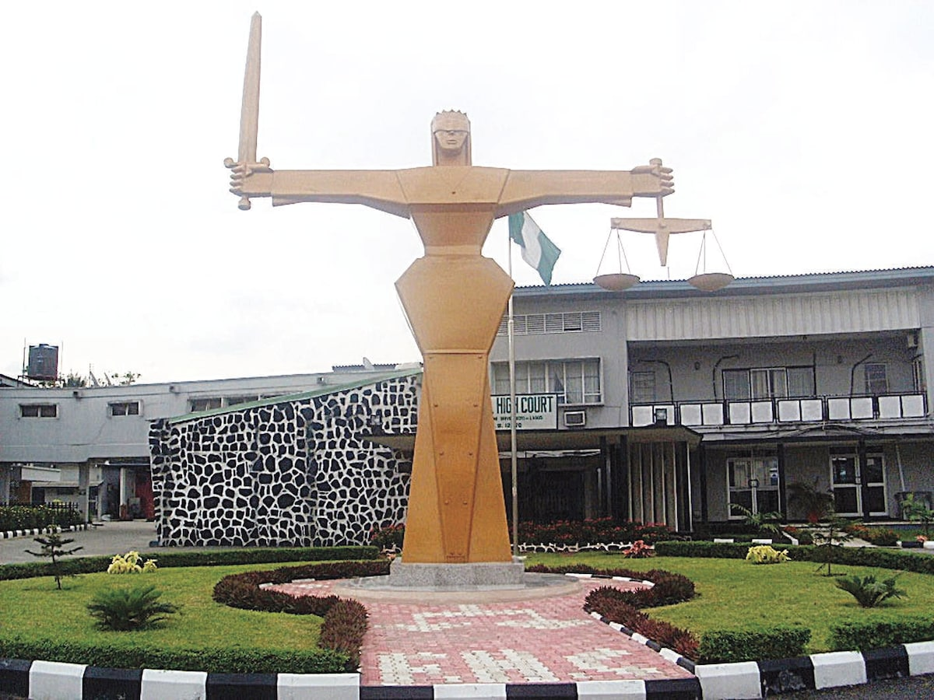
Figure 1: The Nigerian Court Of Appeal
There are two main kinds of law: Criminal law AND Civil law. Civil law and criminal law are two broad and separate entities of law with separate sets of laws and punishments. According to William Geldart, Introduction to English Law 146 (D.C.M. Yardley ed., 9th ed. 1984), "The difference between civil law and criminal law turns on the difference between two different objects which law seeks to pursue - redress or punishment. The object of civil law is the redress of wrongs by compelling compensation or restitution: the wrongdoer is not punished; he only suffers so much harm as is necessary to make good the wrong he has done. The person who has suffered gets a definite benefit from the law, or at least he avoids a loss.
On the other hand, in the case of crimes, the main object of the law is to punish the wrongdoer; to give him and others a strong inducement not to commit same or similar crimes, to reform him if possible and perhaps to satisfy the public sense that wrongdoing ought to meet with retribution.” Examples of criminal law include cases of burglary, assault, battery and cases of murder. Civil law applies to cases of negligence or malpractice, for example. Comparison chart
A guilty or damages as well as disposition of property and other disputes. defendant is punished by incarceration and/or fines, or in exceptional cases, the death penalty. Crimes are divided into two broad classes: Felonies and Misdemeanors. Now that Nigeria has come to rank among the world’s leading economic superpowers, policymakers along with major corporate names must now take pains to focus on a long-term strategy, in order for the country’s successes to continue far into the future.
Critical to Nigeria’s economic development is the engineering sector, which has long stood as a major driver of growth and an essential solution in addressing the country’s infrastructural deficiencies. The aim for Nigerian policymakers, as is the case with many other emerging markets, is to capitalise on the opportunities that have come as a result of rapid economic growth and focus first on improving the building blocks on which long-term prosperity depends. We spoke to Alfred Jagun, CEO and Managing Director of Stag Engineering Nigeria Ltd, winner of European CEO’s Best Engineering Company – 2014, about the various ways in which Nigeria’s engineering sector has grown, and how the company plans to build upon its already impressive reputation in the region.
How has Nigeria’s engineering sector contributed to the country’s growth in recent years?
Nigeria is now recognised as the largest economy in Africa due to the growth in GDP seen in recent years, and, according to the Nigeria Bureau of Statistics, national GDP stands at NGN80.22trn. Given that the engineering sector underpins a lot of other sectors, such as construction, power, agriculture, telecommunications and so on, it plays a prominent role in its contribution to GDP.
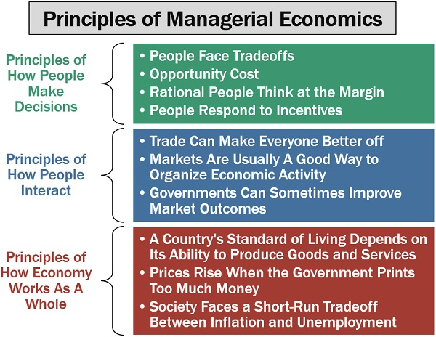
Figure 2: Principles Of Managerial Economics
This expertise can best be seen in the construction and telecommunications industries, which are booming sectors in the country. What’s more, the spectrum of the ongoing engineering activities and the growth in GDP has enhanced the development and training of young engineers, as well as the creation of job opportunities. How has it grown in recent years?
There has been tremendous growth in recent years, with some of the more notable opportunities opening up in the power and communications industry over the course of the last 10 years. The telecommunications industry has over 125 million subscribers, most of whom access data via their mobile phones, a trend that has also paved the way for e-commerce in the country, with the likes of Jumia and Konga leading the way. The sector has grown in terms of innovation and created millions of jobs, while at the same time giving rise to the implementation and enforcement of relevant policies and laws.

3.0 CHALLENGES
1. Engineers being all in all: In most government and private establishments in Nigeria, engineering personnel are assuming to know all. A civil engineer can be employed to do the work of an electrical engineer, chemical engineer, Mechanical Engineer etc. at the same time. instead of seeking the services of engineering professionals in these other areas of engineering.
2. Corruption: most engineering projects in the country is carried out using the fifty percent (50%) rule, thereby eating the capital and not the profit. That is, contractors giving even more than fifty percent of the total cost of a project to some corrupt government officials and politicians before actually embarking on a project and in most cases, since the remaining part of the money will not be enough to do the job, the project may not be carried out and if it is carried out at all, it is usually sub-standard or abandoned.
3. Non-Engineers carrying out engineering contracts using engineering credentials: Most
engineering contractors carry out engineering projects using engineering credentials of
engineering professionals in order to win or get engineering contracts.
4. Politics: the nature of the training of the engineers does not actually expose him/her to be actively involved in politics, though they may be passively involved. For instance, a power engineer in a power station cannot be actively involved in politics. Since power stations are usually sited in secluded areas.
5. Existing engineering facilities and infrastructures not being upgraded: most engineering
establishment ever since they were commissioned have not been upgraded, thereby not able to
meet up with the present-day demand.
6. Non-adherence to workshop sections in conferences: most engineering conferences do not adhere to workshop sections, usually after technical paper presentation, then, it is all over.
7. Attitude towards maintenance: our industries and infrastructures are built “once and for all” without any routine maintenance work, the result is the general decay of industries and infrastructures in the country.
8. Reverse engineering not in our engineering curriculum; hence, making technology transfer somehow difficult.
9. Engineer not fellowshipping with their colleagues; most engineering personnel occupying
managerial positions are not registered with the Nigerian society of Engineers (NSE) and the
council for the regulation of engineering in Nigeria. (COREN). Hence, such person’s may seem
not concern with the advancement of engineering and technology in the country.
10. Research and Development: Government lackadaisical attitude towards research and
development hinders research opportunities in research institutions and universities. Government considers research and development to cost a lot of money and there is no link between research institutes, universities and industries in the country.

4.0 RECOMMENDATIONS
1. Different engineering personnel in various fields should be employed in all engineering departments in both government and private establishments, so that specific jobs can be given to an engineer in his/her chosen area of specialization. That is, there should be division of labor.
2. The pay package of engineers in Nigeria should be commensurate with their counterparts in Europe and America, so that they will not be tempted to eat the capital of any project.
3. Engineers should be discipline and avoid non-engineers using them to achieve their selfish aim. They should only tender their certificate when they are involved in a project. And establishments should be mandated by the Nigerian society of engineers, to employ at least one registered engineer.
4. Just as the office of the Attorney General is occupied by a lawyer, the offices of the ministers and commissioners of Energy, Works and Housing, Environment and Transport should be specially for engineers.
5. Existing engineering facilities and infrastructures should be upgraded with the present-day state of the art facilities in order to meet up with the present-day demand.
6. Engineering conferences organized in Nigeria should always adhere to workshop sections after technical paper presentation, this will go a long way to develop our local technology.
7. Routine maintenance work should be carried out, on a regular basis after a project have been
commissioned, this will increase the life span of such infrastructures and facilities.
8. Reverse engineering should be introduced into our educational curriculum, in order to make
technology transfer very easy, we should all embrace the foreign labels on our locally manufactured goods.
9. Engineers should be mandated to belong to their professional bodies and without this, they should not be allowed to practice. That is, they should be mandated to fellowship with their professional colleagues.
10. Government should make money available for engineering research and development, in order for the country to advance technologically.

5.0 CONCLUSION
Engineering is a double-edged sword. It is both the cause of many environmental, social, economic and political problems faced by man and also a key to solving them. It is now recognized that engineers need considerable support in their attempts in various walk of life to promote sustainable development. There is no doubt that a lot has been achieved by the Nigerian engineers in this respect, but our unsatisfactory performance so far is a principal challenge for us to preserve the conditions for life and welfare of mankind, today and in the future. Even though our submissions here may not be all inclusive, it is our candid opinion that if the opinion given above are adhered to, and the engineer upholds the values of truth, honesty and trust-worthiness, human life will be safeguarded.

6.0 REFERENCES
B. M. Rai et al “The engineer and society” 2nd edition, Ambik press, Benin City. August 2001.
Cain, L.P. (1997) Historical Perspective on Infrastructure and US Economic Development. Regional Science and Ur-ban Economics, 27, 117-138. http://dx.doi.org/10.1016/S0166-0462(96)02148-5
Greenwald, D. (1965) The McGraw Hill Dictionary of Modern Economics. McGraw-Hill, New York.
Ikechukwu A. Diugwu, Musa Mohammed & Dorothy I. Baba. (2015). Towards Effective Infrastructure Development in Nigeria: Theoretical Considerations from a Project Management Perspective.“https://www.researchgate.net/publication/274953950_Towards_Effective_Infrastructure_Development_in_Nigeria_Theoretical_Considerations_from_a_Project_Management_Perspective”
Jim Webber and Dave Hill: reverse engineering the sustainable Development process: adapting
eight decades of Experience to enhance the future., www.google.com, 2007.
Michael S Pritchard; Teaching Engineering Ethics; A case study approach; center for the study
of ethics in society, National science Foundation, www.google.com, 2007.
The Nigerian society of Engineers, Benin Branch, A one-day pre-interview seminar; March,
2006.
The Nigerian society of engineers, proceedings of the national engineering conference, opening
address by the federal commission of works, Literamed press; Ikeja, December 1977.
The Nigerian society of Engineers, Train the trainers workshop; C.C. Okoro: “professional
ethics in engineering”, March 2006.
Sarkar, S. (2009) Disparities in Infrastructure Development: An Inter-District Analysis of West Bengal State. The IUP Journal of Infrastructure, VII, 56-78.
Usifo. F. O et al, accepted paper submitted for publication, JESA, Faculty of engineering and
technology, Ambrose Alli University, Ekpoma, 2007.

