TECHNICAL REPORT
ON
OPERATION, MAINTENANCE AND MANAGEMENT OF ENGINEERING
EQUIPMENT FOR SUSTAINABLE DEVELOPMENT IN NIGERIA

PREPARED BY
Obika Promise Chisom
(17/ENG02/058)
SUBMITTED TO
ENGR. OYEBODE,
COLLEGE OF ENGINEERING,
AFEBABALOLA UNIVERSITY ADO-EKITI, NIGERIA.
IN PARTIAL FULFILLMENT OF REQUIREMENTS FOR THE AWARD OF BACHELOR OF ENGINEERING (B. ENG) DEGREE IN MECHANICAL ENGINEERING. APRIL 2020.

CERTIFICATION
This is to certify that this project ‘TECHNICAL REPORT ON OPERATION, MAINTENANCE AND MANAGEMENT OF ENGINEERINGEQUIPMENT FOR SUSTAINABLE DEVELOPMENT IN NIGERIA was carried out by me: OBIKA PROMISE CHISOM with matriculation number: 17/ENG02/058 of the DEPARTMENT OF Computer Engineering, AFE BABALOLA UNIVERSITY, EKITI STATE and was thoroughly supervised by

Mr. OYEBODE Date
LECTURER

DEDICATION
This project is dedicated to my lecturer Mr. Oyebode for his great lessons and benefits I have gotten from this course.

ACKNOWLWDGEMENT
I sincerely want to thank the almighty God who gave me the opportunity to learn in this great environment.
My profound gratitude goes to all my lecturers who assisted and guided me throughout my learning and difficulties in this course.

ABSTARCT
This report covers essentially the knowledge and experience acquired during my lectures in this course.

Table of Contents
CERTIFICATION 1
DEDICATION 2
ACKNOWLWDGEMENT 3
ABSTARCT 4
CHAPTER ONE 2
INTRODUCTION 2
CHAPTER TWO 6
CHAPTER THREE 7
CHAPTER FOUR 9
CHAPTER FIVE 12
CONCLUSION 12

CHAPTER ONE

INTRODUCTION

What is sustainable development?
Sustainable development is frequently defined as development that meets the needs of present generations without compromising the ability of future generations to meet their own needs. As evidence of the harm to health and well-being from widespread environmental degradation and global climate change grows, communities and governments are placing greater emphasis on assuring that economic development is achieved in a sustainable way.

How can environmental health be integrated into sustainable development?
Protecting and creating healthy environments is a critical component of sustainable development. Environmental health can be integrated into sustainable development by:
- Improving environmental quality for the poorest populations with the greatest burden of environmental diseases, by reducing exposures to air pollution in homes and villages from biomass burning, and providing clean water and sanitation
- Identifying efforts to address environmental problems that can also provide health benefits. For example, creating environments that encourage biking and walking for transportation reduces greenhouse gas and toxic air pollution emissions (environmental benefit) and increases physical activity (health benefit).
- Recognizing that some policies, practices, and technologies designed to promote sustainability and economic development may have unintended adverse environmental health effects, and attempting to prevent or mitigate these before they are implemented.

CURRENT STATE OF SUSTAINABLE DEVELOPMENT IN NIGERIA
Now I come to the unglamorous portion of my remarks; please bear with me. We must speak candidly, to understand the gravity of the challenges facing our country. I will try to not bore you here by dishing out detailed statistics, which you can easily find through various public sources. I will focus my remarks more on what those statistics should tell us.
Poverty: Recently, World Poverty Clock, an NGO that estimates and tracks the number of world’s poor, reported that Nigeria has surpassed India to become the global capital of poverty, with 87 million people living on less than $1.90 per day and that number is rising. This is a central and one of the most devastating facts on the situation we have found ourselves, after extracting almost $1 trillion worth of oil since our national independence.
We have effectively squandered an opportunity to utilize the natural resources we obtained purely by chance; instead of investing to uplift our peoples’ lives, our political elite, by commission or omission, chose the path of short-term comfort and purchase of loyalty through economically unwise, or corruption-riddled national expenditures, at the expense of economically-sound investments in both human and physical assets to transform our nation.
As we head to the SDGs end-date, in the next decade, what is at stake for Nigeria is clear, given that, the first goal, ending extreme poverty is already going in the wrong direction? Nigerians are getting poorer, and unless our economy is transformed, the prospect in the next few years does not appear as bright as we think it can be.
Population: A “big elephant in the room” is Nigeria’s population dynamics. We have a large and fast-growing, youthful population. By the year 2050, it is likely that our population, based on current estimated growth rates, will be more than 400 million, making us the 3rd or 4th most populous country in the world.
There are economic benefits for a nation from having a youthful population when they are gainfully employed. This potential benefit, also called the demographic dividend, results when the share of the working-age population is larger relative to the non-working-age, dependent population.
For a country to realize the demographic dividend, it must first undergo a demographic transition (change in the population structure), which means a shift from higher fertility and child mortality to relatively lower fertility and child mortality.
During the transition’s early stages, mortality rates among children fall. When child survival improves, parents are likely to feel more confident about reducing desired fertility rates and women become better able to participate in the broader labor force.
Hunger and Nutrition: According to the recent Multiple Indicator Cluster Survey, while infant and under-five child mortality have improved compared to 2011 levels, the prevalence of childhood wasting, and stunting are all going in the wrong direction, particularly in northern Nigeria.
In some areas in the security-challenged north-east, stunting rate is more than 60% among children under-five years old, while overall, 43% of Nigeria’s children are stunted. Maternal under nutrition, for both macro and micro-nutrients, is still high.
The most consequential effect of childhood malnutrition occurs in the brain a malnourished child’s brain’s neurons (the “grey matter infrastructure”, to quote my good friend.
In effect, by allowing our children to be stunted at this high level, we are by extension allowing our national economy to be stunted way into the future.
Health: Regarding health and well-being, the population health status of Nigerians is still sub-optimal when compared to other countries in the African region who have lower human and material resources.
Initiatives over the last 10 years in the health sector, such as drives to increase immunization, deploy midwives and community health workers to primary health care centre, and results-based financing such as Saving One Million Lives, started during the Yar’Adua/Jonathan era and extending to the present day, have led to improvements in infant and child mortality.
However, we still carry a disproportionate burden of maternal and child mortality, as well as infectious disease, such as mother-to-child transmitted HIV infections. We face triple burden of disease – background infectious diseases like malaria, tuberculosis, HIV, pneumonia; rising non-infectious diseases like diabetes, hypertension, heart disease, cancers and mental ill-health; and rising new and old forms of injuries. Even the corona virus has caused a rapid decrease in the country’s economy.
Many of our citizens are financially vulnerable to the risk of ill-health. Only a few elites can afford good health care in the private sector or abroad. The National Health Insurance scheme has become distracted and stagnated. Unless we break through, the prospect for universal health coverage is nothing but empty rhetoric.

Education: Nigeria’s education system is in a state of crisis. At the basic education level, public education is largely dysfunctional and of poor quality. Private education for those who can afford is the option that, most well-to-do parents choose. In some parts of the country, literacy and numeracy rates among 5-16-year-old children are only about one-third. More than 10 million children are out-of-school.
We have become numbed to accepting a form of social apartheid, where children of the poor are left to a broken education system while the elites send their children to private schools or abroad. Meanwhile, all available evidence shows that national investment in quality education is among the best investments that a nation can make for its future. In addition, we are grossly under-investing as a nation in research and development at the level of our tertiary institutions.
Youth employment and gender: The prospect of our reaping a demographic dividend depends not only on quality education, but skills and economic opportunity for our youth, girls and women.
Youth employment is currently at the highest levels of 33.1% (NBS). This does not include under-employment. Girls and women are systematically marginalized in the political and economic arenas. This represents huge lost opportunity for the country to boost its developmental prospects, beyond achieving the SDGs.
Contrary to prevailing rhetoric, when one looks at actions, it is clear we do not yet, as a nation, value sufficiently the input of our youth in the political, social and economic arenas.
Urbanization: Linking rising poverty, fast population growth, poor health and education, youth unemployment, with the background trend of increasing urbanization, you will see even more challenge in terms of Nigeria’s sustainable development.
By now, you all get my drift; we are not on track for the SDGs. If we go through the rest of the goals, clean water and sanitation, affordable clean energy, industry, innovation and infrastructure, inequalities, sustainable cities and communities, climate action, peace, justice and strong institutions, you will notice the same pattern that we have a lot of work ahead to return on track for its sustainable development.

CHAPTER TWO
ROLES OF MECHANICAL ENGINEERS TO SUSTAINABLE DEVELOPMENT
What is mechanical engineering and who is a Mechanical Engineer? Webster dictionary define mechanical engineering as discipline which make use of applied engineering, engineering mathematics, physics and materials science principles to design, analyze, manufacture, and maintain mechanical systems. Mechanical engineering has been ones broadest and oldest within engineering disciplines. Requirements of mechanical engineering field need knowledge of core areas including thermodynamic, mechanics, material science, dynamics, structural analysis, modeling and electricity. Furthermore, to these core principles, mechanical engineers use tools such as computer-aided design (CAD), computer-aided manufacturing (CAM), and product life cycle management to design and analyze industrial machinery, weapons, manufacturing plants, aircraft, industrial equipment, medical devices, robotics, heating and cooling systems, transport systems, watercraft, and others. This branch of engineering involves design, production, and running of machinery.
American Society of Mechanical Engineers (ASME) described mechanical engineers as the one who create and develop mechanical systems for all of humankind. The principles of force, energy and motion are being concern, mechanical engineers use their knowledge of design, manufacture, and operational processes to advance the world around us, improve safety, ability to manage economic with strength and enjoyment throughout the world. Mechanical also developed machine and tool that produce product that range from sport equipment to pharmaceutical devices, medical devices, personal computers, humidifiers, dehumidifiers, automobile engines, robotic arms, electrical power plants and solar driers. Mechanical engineer usually touches all section of life, spanning industries with limited barriers, opportunities for mechanical engineers to build up their career are enormous as opportunity are available worldwide throughout many companies ranging from large multinational to small local companies.

CHAPTER THREE
Impacts of Mechanical Engineer on Sustainability Development in Terms of Population, Aggression and Pollution
The impact of mechanical engineer on sustainability is major on the environment and hereby simply divided into three components: population, aggression and pollution.
Population: United nation estimated that world population will be about 7.5 billion in 2017, and may surpass 11 billion people by 2100 as shown in Table 1. The world is metamorphosed radically, and the word population will continue to increase daily as there are more rural area to urban area migration which demands for adoption of sustainable acts. Requirements for green technology to sustainable energy, clean air, drinking water, green transportation, safe waste disposal and renewable energy should be considered.

Aggression: The attitude towards the natural life and biological system shows that human belligerence toward both animals and plants, for example the issue of wildlife, forests and the extreme rate of over exploring the natural resources available such as wood, water, petroleum, coals, minerals has affected the possibility of achieving environmental sustainability.
Pollution: Engineering has driven and steer industrial innovation and improved the prosperity of human. In turn, this has led to the creation of new and important group of problems to the environment which range from exposure to air pollution, toxic exposure to water, food, soil, depletion of non-renewable resources (Solid minerals, petroleum, wood), destruction of ecosystem and global climate brunt. Human effects on the climate incorporate the air contamination in urban communities, the poisons including dangerous synthetic concoctions like nitrogen oxides, sulphur oxides, unstable natural mixes and particulate issue that deliver photochemical exhaust cloud and corrosive rain, and the chlorofluorocarbons that debase the ozone layer. Particulates, for example, sulphate pressurized canned products in the climate lessen the immediate irradiance and reflectance (albedo) of the Earth's surface, a marvel known as worldwide diminishing, the reduction is evaluated to have been around 4% in the vicinity of 1960 and 1990. Worldwide darkening may have disorganizing the worldwide water cycle by decreasing, vanishing and precipitation in a few regions and cause cooling effect also. In other to actually achieved sustainability development goals, mechanical engineers need to develop mechanical systems that will help in harvesting all this natural resource stated in section without having environmental pollution on the communities.
Design and infrastructure
Roles of Mechanical Engineer in Terms of Design and Infrastructure System design, infrastructure provision and engineering enterprise management, are main concern of mechanical engineers, as making decision is an act that is performed throughout the life-cycle of the infrastructure, enterprise, process or product. Mechanical engineers play lots of role of such life circle decision making. The one been utilized in most continent is partitioned into five principle phases, which involve Life Cycle Engineering means to integrate state of the art technologies into subsequent sustainability and to enable information and statistics flow as shown in Frame work requirement, Feasibility Study usually cover this. Decision scoping, Project Definition Study often capture this. Preparation and comprehensive design stage Execution supply and run. The end of useful life and Maintenance, Repair and Overhaul (MRO)

CHAPTER FOUR
ENGINEERING EQUIPMENT FOR SUSTAINABLE DEVELOPMENT
- Transformers: A transformer is a passive electrical device that transfers electrical energy from one electrical circuit to another or multiple circuits. A varying current in any one coil of the transformer produces a varying magnetic flux in the transformer's core, which induces a varying electromotive force across any other coils wound around the same core. Electrical energy can be transferred between separate coils without a metallic (conductive) connection between the two circuits. Transformers can help to provide electricity to house which also contribute to sustainable development.
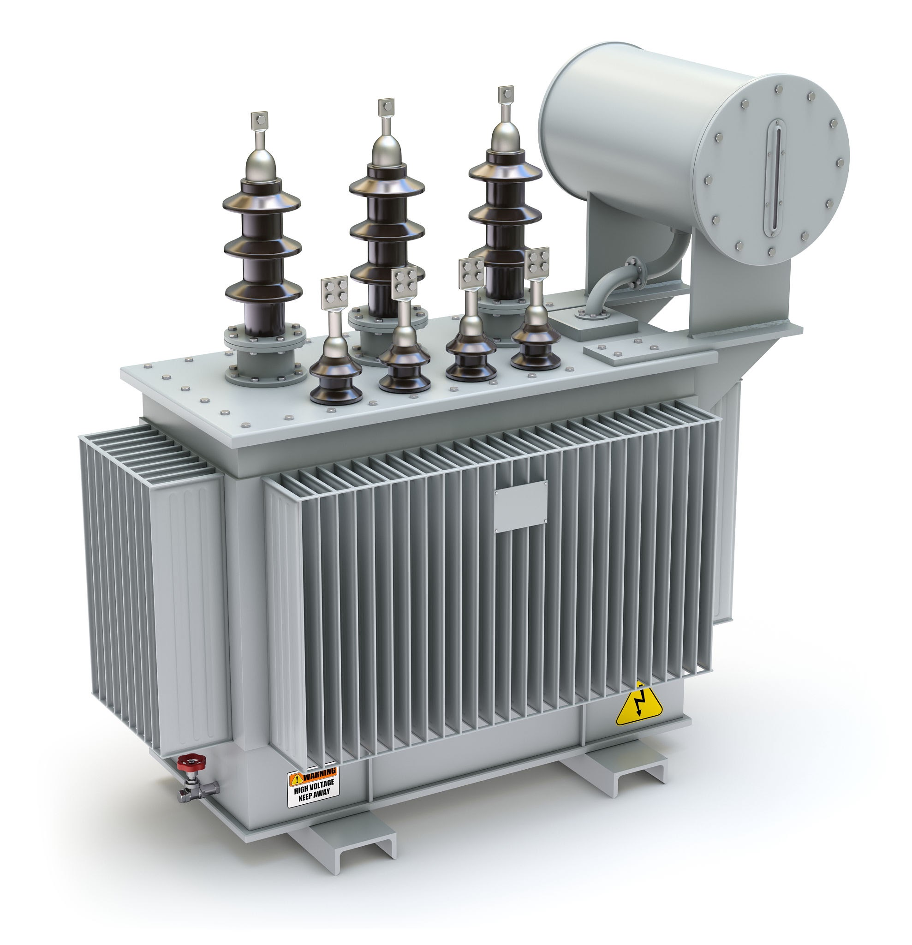
- Borehole Pumps: Borehole pumps (also known as bore pumps, well pumps or bore water pumps) are a type of submersible pumps that are used to control water and liquid supply in various mining, farming; deep wells, rainwater reticulation and petroleum capture applications. They can be used for the benefit of sustainable development to communities.
- Scrubbers: Some of the most commonly used air pollution control devices in manufacturing and processing facilities, industrial air scrubbers employ a physical process—i.e., scrubbing—which removes particulates and gases from industrial emissions, such as smokestack exhaust (in the case of exhaust air scrubbers), before they are released into the atmosphere. There are two main categories of scrubbers—dry scrubbers and wet scrubbers. These help to prevent global warming and air pollution which brings about sustainable development
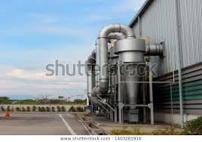

Air Filters: Air filters are devices used to control air pollution which employ a specific type of filtration media—e.g., fabric, sintered metal, ceramic, etc.—to collect and remove dry particulates and contaminants, such as dust, pollen, microbes, chemicals, etc. from air passing through them. These devices are utilized in residential, commercial, and industrial applications to remove pollutants from exhaust air and improve the air quality within the work environment. For industrial applications, there are several types of air filters available, including HEPA filters, fabric filters, and cartridge dust collectors. They can also help to reduce air pollution which reduce global warming and bring benefit to sustainable development.
CHAPTER FIVE
CONCLUSION
As we face significant planetary issues such as global warming, ocean acidification, biodiversity loss and urban migration, it is clear that the engineering profession has a significant part to play in affecting the future of our planet. Australian engineer and incoming president to the World Federation of Engineering Organizations (WFEO) Barry Grear (AO), questions, 'What inspirational role will engineers play in that radically transformed world? … An ever-increasing global population that continues to shift to urban areas will require widespread adoption of sustainability. Demands for energy, drinking water, clean air, safe waste disposal, and transportation will drive environmental protection (alongside) infrastructure development.' 1 Engineers have a critical role to play to help Australia and the world achieve sustainable development. It is clearly no longer possible to be a professional engineer and ignore the challenges and opportunities that arise from needing to achieve sustainable development. There is also a strong business case for engineering firms and university engineering schools to embrace sustainability. Whether you want to attract the best and brightest, or you wish to ensure that your students/employees are equipped with appropriate knowledge and skills to meet client needs, training for sustainability is now recognized as essential.

