Prepared by
OKPALA CHRISTOPHER CHIBUEZE
17/ENG02/068
DEVELOPMENT OF ENVIRONMENTAL HEALTH ENGINEERING FACILITIES, EQUIPMENT, SENSORS AND PUBLIC HEALTH SYSTEMS FOR TACKLING COVID-19 PANDEMIC
SUBMITTED TO
ENGR. OYEBODE
CIVIL ENGINEERING DEPARTMENT,
COLLEGE OF ENGINEERING,
AFE BABALOLA UNIVERSITY, ADO-EKITI,
EKITI STATE, NIGERIA.
IN PARTIAL FULFILMENT OF ENG384: ENGINEERING LAW AND MANAGERIAL ECONOMICS
13TH APRIL 2020

ACKNOWLEDGEMENT
First and foremost, I appreciate God, the giver of life, for enabling me to write this term paper. I would like to acknowledge the efforts of all my lecturers taking this course and then my fellow colleagues.
Many thanks to the Provost College of Engineering: ENGR. PROF. J.O DADA for his
contributions. I am also indebted to all the academic and non-academic staff of College of
Engineering for their immense contribution during this programme. My profound gratitude also
extends to my colleagues for their moral support.

ABSTRACT
Development of environmental engineering health facilities has to do with monitoring natural conditions as well the impact that humans have on these conditions. It also involves accessing possible hazards that may be present, from physical dangers such as the development of food plains and mountain faces, to contaminants that may be in the soil air or water. The demand for environmental healthcare engineering facilities equipment is growing large due to the outbreak of the most recent pandemic COVID-19. Sensors and public health systems for tackling the pandemic should be developed by the environmental health engineer. This could be small facilities such as pocket self-testing kits, movable breathing aids etc. as this will help tackle the basic care for infected patients or patients suspecting attack.
Infrastructure is a basic essential services that should be put in place to enable development to occur. Economic development of Nigeria can be facilitated and accelerated by the presence of infrastructure. If these facilities and services are not in place development will be very difficult and in fact can be likened to a very scarce commodity that can only be secured at a very high price and cost. The provision and development of infrastructures have been the subject of much theoretical analysis and empirical studies. This study in line with has tried to evaluate infrastructural development and economic growth of Nigeria, using simultaneous analysis. In this study, two models are specified, and after applying the substitution method (reduce from equation), the two models are specified and after applying the substitution method.
The study examines the role of infrastructure development in national economic growth. A model was specified for the purpose and secondary quarterly data was collected for the period 2000-2010. The objective of this research was primarily to investigate the level of telecom infrastructure development on the Nigeria economy.

TABLE OF CONTENT
- INTRODUCTION
- CHANLLENGES OF INFRASTRUCTURAL DEVELOPMENT IN NIGERIA
- INTRODUCING MODERN SENSORS AND EQUIPMENTS
- DEVELOPMENT OF PUBLIC HEALTH SYSTEMS FOR THE TACKLING OF COVID-19 PANDEMIC
- Challenges of development of environmental health engineering facilities, equipment, sensors and public health systems for tackling covid-19 pandemic.
- Suggestions development of environmental health engineering facilities, equipment, sensors and public health systems for tackling covid-19 pandemic.
- Conclusion
- Reference

INTRODUCTION

As engineers, it’s our duty to provide a faster and better way in which health facilities can work. When it comes to medical field the primary goal is to improve the health of people. Doctors have the knowledge of human body. They know what is good for a person and what not. But to build anything, you need engineers.
Software Engineers can write software that uses algorithms to analyze massive amount of health information and generate results that help people and doctors in making healthy decisions. Also, making health information readily available using cloud, will make work easier.
One of the main reasons the system lacks stability and infrastructure is that not enough people are aware that health insurance is even possible and affordable for them. Once more people start purchasing quality health insurance, more money will be entering the health care system, and better facilities and hospitals can be built. In the world, today most of the medical facilities depend on the engineering facilities built to carry out various operations. Example using the x-ray machine as a case study. A doctor wont treat a fractured or dislocated bone without having his patient go through series of test using the X-ray machine. Even after the treatment the doctor still follows up the recovery of the patient using the same results gotten off the test carried out by the x-ray machine. We can see that without an x-ray machine set up by an engineer it’s difficult to carry out that operation. It may even lead to errors in the treatment because the doctor can only imagine what is going on without having a proper image of what is going on. we can see that in the society today, especially in Nigeria the medical facilities even as low as the testing kit for the pandemic COVID-19 is not made readily available for all due to the scarcity. This will slow the whole process of combating the virus unlike in developed countries like china where they are readily available to all and is aiding the combating of the pandemic COVID-19.

CHALLENGES OF INFRASTRUCTURAL DEVELOPMENT IN NIGERIA
The challenges of infrastructure development in Nigeria are:
- Dearth of Visionary Leaders: Visionary leaders are the builders of a new dawn, working with imagination, insight, and boldness. They present a challenge that calls forth the best in people and brings them together around a shared sense of purpose. Visionary leaders are change agents. Nigeria contains few change agents and therefore lacks theD needed infrastructure to develop the nation.
- Demand and supply: Due to poor performances of most past leaders in the area of infrastructure provision, the agitation for infrastructure development overwhelms the provision. With a land mass of 9,110,000 square kilometers of land and over 150,000 million people, Nigeria has a total road network of 193,200KM. This comprise of 34,123KM federal roads, 30,500KM state roads and 129,577 KM local government roads. Unfortunately, over 70% of the federal roads are in bad state of repair. In the area of housing, Nigeria requires about 17 million housing units and 60 trillion naira in order to meet its housing needs.
- Pestles analysis: The challenges of infrastructural development in Nigeria can be discussed under PESTLES Analysis. Challenges infrastructural development can be: political, economic, social, technology, legal, environmental and safety. Political environment has to do with the political stability, policy formulation and politics of the project environment both within and without. Economic environment deals with issues like interest rate, inflation, currency exchange rate, price fluctuation etc. Social environment has to do with workforce diversity including cultural difference, age difference etc. Technology environment deals with the machineries which are used for the execution of projects. Physical environmental issues like site topography, geology and climatology is also essential. Safety issues have to do with health and safety and security of resources on site, that is, human, material and financial. While some countries have been able to implement individual projects to alleviate those difficulties, Nigeria does not have common strategic targets for
infrastructure development. Good governance is crucial for ensuring the effective and efficient provision of infrastructure. This is largely because, firstly, good governance means that resource allocations will reflect national developmental priorities and thus respond to societal demands.
- PARETO Analysis: Pareto analysis is a statistical method in decision making that is used for the identification of a specific number of tasks that produce major impact. It uses the Pareto Principle (which is also called the 80/20 rule). It originated the idea that by doing specific 20% of the work, you can generate 80% of the benefits of doing the whole job. In terms of quality improvement, a large majority of defects (80%) are produced by a few key causes (20%). This is also known as the vital few and the trivial many. In project management, 80% of project delays are caused by 20% of tasks etc. It can also mean that 80% of the tasks are done by 20% of the workforce. The people in charge should strive to improve the number of workforce that are genuinely working.
- Development Matrix: The four requirements of any physical infrastructure projects are: design, finance, technology and management. The appropriate designs that will ensure value for money are not adopted. The finance is not adequate, is procured at high interest rates and financial management is lacked by most Nigerian contractors. The technology of construction is scarce and the management of infrastructure is lacking. The maintenance culture of Nigerians is poor thereby allowing most projects to decay.
- Capital Flight, Capital Sink and Capital Stagnancy: Infrastructure development projects in Nigeria suffer from capital flight, capital sink and capital stagnancy. A lot of materials and managerial services are procured outside the country. The contracts are full of loop-holes that allow leakages of funds. In some cases, there are over-design for the designers to earn more professional fees which are percentage of the contract sum. Capital stagnancy due to abandoned projects are also rampant.
- Project Management: Project management approach in project delivery evolved in the late fifties in the United States of America (USA) when it was first used by the American Army for military projects execution. The success recorded through project management approach in the Defense sector led to its establishment as a reliable method of project delivery in other sectors like construction, manufacturing, health Information
Technology (IT), media, pharmaceutical, education and entertainment (Oyedele, 2012). The approach was introduced into United Kingdom (UK) in the early sixties. Countries like Hong Kong, Malaysia, Canada and Ireland have adopted this approach, but it is still unpopular in developing countries, especially in Nigeria. Risk management is necessary for all Nigerian projects.
- Procurement Method: The procurement methods being adopted are prone to criticisms. The Public Finance Initiatives, especially the Concession Method and Public/Private Partnership (PPP) are questionable and seems to mortgage others who are not part of the arrangement to the scheme’s future. The 105-kilometre Lagos-Ibadan Expressway which, under the PPP scheme, the federal government did concession to Bi-Courtney Consortium in 2009 for N89.53 billion for 25 years is not the best arrangement possible and has not change the situation of the road.
INTRODUCING MODERN EQUIPMENTS AND SENSORS
Modern equipment’s should be brought in to test for the coronavirus. People shouldn’t have to wait for a long period before they know if they are positive or negative. New easy and mobile self-testing kits can be developed and released to the public as this will avoid the slow testing rate and stress of the medical workers. For example, they are simple testing kits for diabetic patients which can even be done from home. This has reduced the rate at which people go to the health centers to know the diabetes status. It will also reduce the amount of work for health care workers and allow the, turn focus to other pressing issues. So, if this can also be done for the COVID-19 pandemic it will help a long way in combating it
Below is an image of the ancient way of testing for diabetes and the modern way.

Development of new modern day temperature sensors. Instead of the usual temperature reading equipment where someone has to hold it and point it to your head to see your temperature while others wait in line, sensors should be put in places like airports and big organizations where a large number of people walk in every day. The sensor will be developed and placed in such a way that as you start to approach the entrance door the computer will be reading your temperature while you walk, so by the time you get to the door and your temperature is high when you get there the door won’t open and then you will be isolated and tested immediately. This will reduce the risk of spreading any pandemic such as this one. Imagine having to be a little close to someone to check his/her temperature rather than having an object check it. Below is the current thermometer we have.

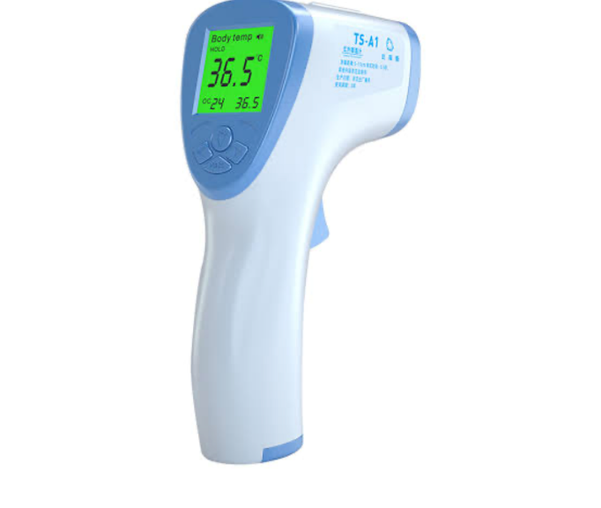

Mobile apps can be built to measure blood, urine etc. using accessories for your phone, mail to labs instantly, get results immediately. Or get alerts when your BP fluctuates or your sugar fluctuates or when your heart behaves erratically.
Build better algorithms for insurance companies so they can provide better insurance for cheaper to a wider population. For example, they are smart watches with this features also smart phones which can also keep all these data and help one monitor all these. Even in some devices today they are emergency trigger buttons to immediately dial emergency units or numbers saved under the emergency lsit in the case of any casualty. Below are some images of a smart watch and a phones health record for a man.

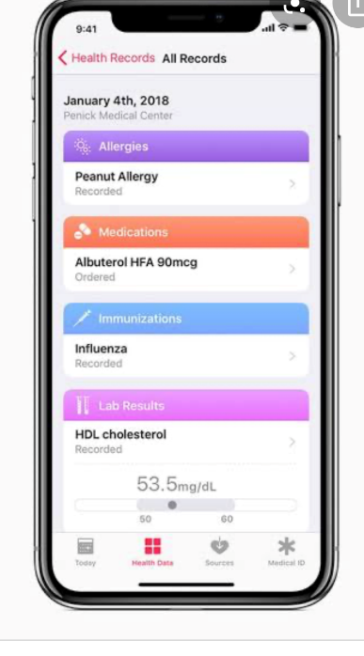
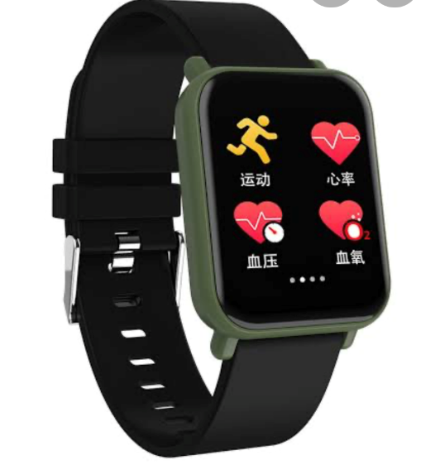

DEVELOPMENT OF PUBLIC HEALTH SYSTEMS FOR THE TACKLING OF COVID-19 PANDEMIC

Healthcare Engineering professionals play key roles in creating and developing hardware and software to innovate, support, improve and optimize the operation processes and systems of patient care, and to improve patient outcomes through engineering approaches.
Protection of frontline staff- the protection and safety of the frontline staff (the doctors, nurses and all medical personnel attending to patients) should be the first move. If the medical personnel are not safe how can they keep their patients safe? So we need to ensure that after everyday treatment and checkup of the patients the medical personnel should also be tested.
Although hospitals are vital to the response, home care and outreach are also important. In an outbreak, you cannot focus only on hospital care; general practitioners and family doctors have a vital role to play as well. You have to take the wider community into account. People should be advised in their various homes on how to stay safe and avoid contacting and spreading the virus. They should also know the symptoms and what to do if the symptoms continue to appear
The people in retirement and nursing homes are at huge risk from covid-19, as the elderly are the most vulnerable and live in close contact in these facilities, so it’s important to reorganize the way they are run. Proper health measures should be taken.

Challenges of development of environmental health engineering facilities, equipment, sensors and public health systems for tackling covid-19 pandemic.
(using Nigeria as a case study)
- Poor research institutes: The country lacks research institutes already before the pandemic COVID-19 hit. This is bad cause now that there’s an outbreak various researches are meant to carried out before any engineering building can take place. An example is an engineer trying to set up a testing kit. He needs to write an algorithm for it and before a device is set up to output a result, the algorithm will give it specifics or conditions to look out for. If researches are carried out properly this will aid the engineer.
- Low funds/capital: A lot of engineers may have the idea of inventions to help combat the virus but not enough funds to actualize their ideas so it dies with them.
- Bad governance: Involvement of bad governance will rather have them travelling out for the better medical care rather staying here and providing the best for them, and the masses.
- Demand and supply: The few engineering facilities put in place are so expensive due to high demand and low supply. Because only a few engineers are providing so the masses can’t even afford it. This goes a long way to discourage other engineers as the feel if majority cant afford it they’ll run at risk of loss.

SOLUTION AND WAY FORWARD

The only way Nigeria can solve its many problems is by giving its youth more opportunities to participate in the government, economy, and society. Young people are the prime beneficiaries of school improvement, and the percentage of youth in higher learning institutions is currently very high. If young people were in charge, the educational system in Nigeria would not be in its current state, and unemployment would be reduced. At the same time, young people shouldn’t wait for good things to come to them; they need to take individual initiative. Youth empowerment and
initiative will improve life for all Nigerians. Nigerian government officials and other elites need to share power with the country’s youth and listen to young peoples’ ideas for how to better the country. The young men and women of Nigeria are tomorrow’s elders and, if included, could transform Nigeria. Without the energy of youth, society will decay and perish. In addition to minimizing corruption in the country, Nigerians should cultivate the habit of being patient. Many indulge in corrupt practices is because they are impatient and want to make quick money. In developed countries of the world like the United States, many Nigerians are locked up in the prisons and some have been killed because of their corrupt practices.
Suggestions for the development of environmental health engineering facilities, equipment, sensors and public health systems for tackling covid-19 pandemic.
(using Nigeria as a case study)
- Improvement of research institutes: Making robust research institutes that can stand the test of time will help enable the easier development of sensors and engineering facilities to tackle pandemics such as COVID-19. Even if it hits the country without preparation it will aid the quick combating.
- Institutions should be set up to receive good ideas of engineers in the society and help them bring it to reality. This will encourage others to even come up with better ideas knowing they’ll be actualized at long last it will aid combating of COVID-19.
- Good governance: It is evident in developed countries where good governance is the other of the way what it is like. Development of the country facilities will enable it better and readily available to any pandemic of sort.
- Government and health organization should try and subsidize all this equipment and facilities to make them easily affordable to the masses and will also encourage developers to involve in them as they know this can be a source of income.

CONCLUSION
The country has a big land mass that makes it possible to spread out. Connecting the people of Nigeria with roads, National Grid and potable water will be tasking. High cost of materials for infrastructure development is also a challenge. The local content of production of goods and services must be increased to reduce production cost. Corruption level in Nigeria is too high and allows incompetent hands to handle contracts. Professionals are not allowed to handle projects due to corruption. The cost of governance

There is no said cure to coronavirus disease, but there are ways as to which the virus can be contained. There are also ways to control the spread of the virus. So as caring humans we are to adhere to these measures.
And we must also note that everyone is important in fighting covid-19.

REFERENCES
- Internet
- NCDC website
- Health care system by M. Griffin harriet B. Nembhard.
- Adebayo, A. (1985).The Implications of Community Leadership for Rural Development Planning in Nigeria. Community Development Journal, Volume 20, No. 1. Agbola T. (1998). The Housing of Nigerians: A review of policy development and Implementation. Research Report No.14. Ajanlekoko, J. S. (2001). Sustainable Housing Development in Nigeria – The Financial and Infrastructural Implication. Available at http://www.fig.net/pub/proceedings/nairobi/ajanlekoko- cmws1-1. pdf. Accessed on March 4, 2012. Akpotor, A.S. (2001). Urban Administration World Outlook. Benin - City: Gigodson International Press. American Heritage Dictionary (2009). Infrastructure, American Heritage Dictionary of the English Language. Available at http://education.yahoo.com/reference/dictionary/entry/infrastructure. Accessed on January 28, 2012). Anyanwu, A. (1998). Governance and Africa Politics, in C. E. Emezi and C. A. Ndoh (eds.). African Politics. Owerri: Achugo Publications Department of Defense Dictionary (2005). Infrastructure. Department of Defense Dictionary of Military and Associated Terms, p. 260, 31 August, 2005). Available at http://www.dtic.mil/cgi- bin/GetTRDoc?AD=ADA439918&Location=U2&doc=GetTRDoc.pdf. Accessed on February
- 12, 2012). Edari, R.S. (1976). Social Change. New York: W.C Brown. Elu, J. (2000). Human Development in Sub-Saharan Africa Analysis and Prospects for the Future. Journal of Third World Studies, Volume XVII: 2. Eregha, E. Z. (2007). Democratic Governance and Development in Africa: Challenges of African Union (AU). Available at http://www.krepublishers.com/02Journals/JSS/JSS-14-0-000-000- 2007-Web/JSS-14-3-000-000-2007-Abst-Text/JSS-14-3-205-2007-180Eregha-E-E/JSS-14-3- 205-2007-180-Eregha-E-E-Tt.pdf. Accessed on February 28, 2012

