NAME: OYEBOADE R. Kiitan
MATRIC NO: 17/ENG08/004
DEPARTMENT: Biomedical Engineering
COURSE CODE: BME 328
COURSE TITLE: Introduction to Clinical Engineering

MICROFLUIDIC POINT-OF-CARE (POC) TECHNOLOGY FOR INFECTIOUS DISEASEES
Microfluidic refers to the behaviour precise control, and manipulation of fluids that are geometrically constrained to small scales at which capillary penetration governs mass transport. Microfluidic is both the science which studies the behaviour of fluid through micro-channels and technology of manufacturing microminiaturization devices containing chambers and tunnels through which fluids flows or confined. Microfluidics deals with very small volumes of fluids down to femtolitre (FL) which is quadrillionth of a litres.
Microfluidics provide efficient tools for multiple research areas, and more specifically for biological analysis:
- Portable devices for point-of-care application
- Low reagent consumptions
- Global cost reduction per analysis
- Whole biological process integrated and simplified for the end-user
- Accurate measurement, microfluidics allowing to increase the measurement resolution given application
History of microfluidics
The technologies developed to miniaturize transistors and manufacture microprocessors have allowed to manufacture microscopic channels and integrate them on chips. According to history:
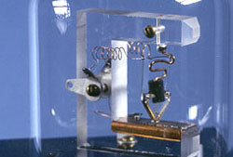
The 50s, the invention and development of the first transistors which, made in blocks of semiconductor which replaced the lamps previously used in the manufacture of electronic devices.
Fig1- the first transistors (replica)
In the 60s, the development of technologies such as photolithography has enable the miniaturization and integration of thousands of transistors on semiconductor wafers, mainly silicon wafers. This research led to the production of the first integrated circuits and then the first microprocessors.
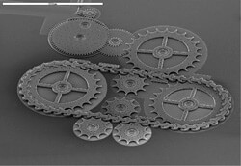
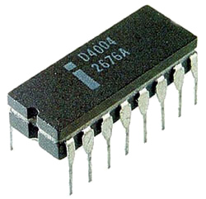
Fig 2- industrial microprocessor Fig 3- example of MEMS

Over the 80s, the use silicon etching procedures, developed for microelectronics industry, allowing the manufacture of the first device containing mechanical micro-elements integrated on silicon wafers. A new type of device called MEMS (Micro Electro Mechanical System) was created which then gave rise to industrial applications, particularly the field of sensors and printer heads
In the 90s, research mainly on the applications of MEMS in biology, chemistry and biomedical fields was carried out. This applications needed to control the movement of liquids in micro-channels and have significantly contributed to the development of microfluidics. At this time, the majority of microfluidic devices were still made a silicon glass, and thus, required the heavy infrastructure of microelectronics industry.
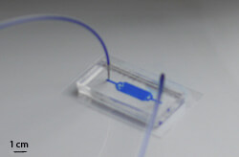
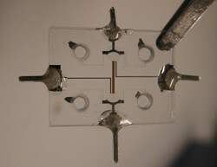
Fig 4- Glass microfluidic chip Fig 5- microfluidic chip made of PDMS/glass

In early 2000s, technologies based on moulding micro-channels in polymers such as PDMS experience a strong growth. The cost reduction and production time decreased of these devices allowed a large number of laboratories to conduct research in microfluidics
Point-Of-Care (POC) Devices
Point-of care (POC) diagnostic devices have provide a boon in healthcare especially in the diagnosis and detection of disease. POC devices have many advantages like a rapid and precise response, portability, low cost, and non- requirement of specialized equipment. The main objective of POC diagnostic research is to develop a chip-base, self-containing miniaturized devices that can be used to examine different analytes in complex sample. The integration of microfluidic with advanced biosensors technologies will result in improved POC diagnostics. The World Health Organization (WHO) suggests the “ASSURED” criteria for selecting the proper POC diagnostic tools for countries with limited resources. According to the ASSURED criteria of WHO the POC diagnostic tools should be:
- Affordable
- Sensitive
- Specific
- User friendly
- Rapid and robust
- Equipment-free
- Deliverable to end-user
Microfluidic pathogen detection chips are an excellent choice in POC device for infectious disease. The chips are highly sensitive and can be designed with the desired level of specificity.
The unique features of microfluidic diagnostics chips such as modularity, portability, low reagent and sample consumption, and high sensitivity make these microchips suitable for point of care applications. Microfluidic technology offers handheld chips that are integrable with magnetic, optical, electrical, and electrochemical modules. Magnetic modules can open/close valves in the chips or help in sample preparation. Electrical and optical sensors are very common as both actuators and readout systems. Electrochemical techniques such as electrochemical impedance spectroscopy (EIS) can easily be employed in the chip for extracting data. These microfluidic point-of-care chips are highly sensitive and are able to process very small amounts of samples. They can be modified or parallelized to analyse larger volumes if need be. Microfluidic chips are excellent choices for the rapid detection of both environmental pollutants such as heavy metals and microorganisms and human pathogens in Point Of Care (POC) applications. They reduce the sample-to-result time significantly and omit the need for fully equipped laboratories at the point of care for real-time monitoring.
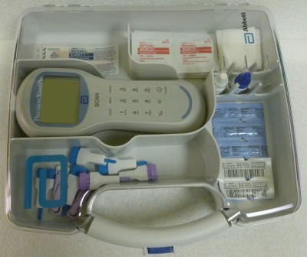
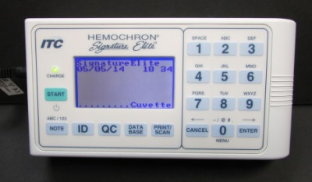
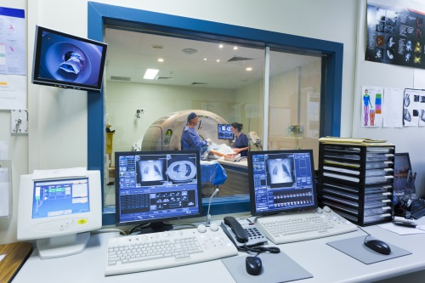
Fig 6- examples of point-of-care (POC) devices

Potentials of POC for infectious Disease
Point-of-care (POC) allows physicians and medical staff to accurately achieve real-time, lab-quality diagnostic results within minutes rather than hours. Through the use of portable blood analysers, testing at the “point of care” streamlines the diagnostic process and helps ensure patients receive the most effective and efficient care when and where it is needed.
POC testing enables staff to make rapid triage and treatment decisions when diagnosing a patient’s condition or monitoring a treatment response. By simplifying the testing process, clinicians can focus on what matters most—providing effective, quality patient care.
With-patient testing offers benefits that extend beyond the bedside. Namely:
- Allows users to improve efficiencies and productivity
- simplify processes and procedures
- comply with regulatory and performance mandates
- Reduce staff burden by bringing the focus back where it belongs: on the patient.
- POC are highly sensitive to capture and detect very low amounts of the target component or pathogen
- POC tools are able to process the sample fully and in real time
- A quick detection POC system enables the patient to benefit from early interventions and increase the survival rate.
- It is easy to integrate with various modalities such as a readout or a communication system

Clinical applications for POC devices
There are several applications of POC devices in the clinical setting which are:
- Musculoskeletal
- Cardiac/critical care
- Emergency medicines (hospital-based and urgent care
- Anaesthesia and pain management
- Medical Laboratory

Strategies of Point-of-care (POC) testing for infectious disease
Infectious diseases are caused by pathogenic microorganisms including fungi, virus and bacteria. Which can be transmitted between individuals and populations thus threatening the general public health and potentially the economy. It is estimated that over half of the world population are at risk for infectious diseases, making them one of the most dangerous threats to humanity.
Viral disease are leading cause of death worldwide. Rapid, accurate, and timely diagnosis of the virus helps prevent wide-spread of the virus like the case of COVID-19. The patients benefits from early- interventions that increase the chances of treatment successfully. Diagnostic tools normally take the advantages of a particular biomarkers of the disease for diagnosis. For example, in case of malaria, the disease causes blood cell to deform. Microfluidic diagnostic tools for detecting malaria can employ microfluidic cell sorting chips that operate based on cell deformability to separate the infected cells and use them for diagnosis. In other cases, cell lysis chips can be integrated with nucleic acid amplification chips to capture the genetic footprint of the disease and detect by on-chip nucleic acid amplification methods. Affinity-based capture of the disease-related proteins hooked up with optical or electric impedance spectroscopy readout systems is common in sexually transmitted viruses such as HIV and syphilis.

Clinical interventions for infectious disease
Clinical intervention can be classified into two broad categories:
- Preventive interventions
- Therapeutic interventions
Preventive interventions:
This prevent disease from occurring and thus reduce the incidence (new cases) of disease. This involves the use of the following:
- Vaccines
- Education and behavioural change
- Nutritional interventions
- Maternal and neonatal interventions
- Environmental alterations
- Vector and intermediate host control
- Drugs for the preventions of disease
- Injury preventions

Therapeutic interventions:
This treat, mitigate, or postpone the effects of disease which reduce the case fatality rate or reduce the disability or morbidity associated with disease.
- Treatment of infectious disease: is the use of drugs to kill or inhibit the replication or spread of pathogen in the host.
- Surgical and radiation treatment: these are usually done in clinical trials
- Diagnostics to guide therapy: these are made on basis of clinical symptoms and signs, but the imprecision of this method for many conditions is increasingly recognized
- Control of chronic diseases: Chronic conditions may have an infectious aetiology (for example, HIV, TB) or may have environmental or other causes (for example, cardiovascular diseases and many cancers). Many chronic diseases, once diagnosed, may not be curable, but they can be controlled by a combination of education/behaviour change interventions, plus regular, often daily, use of pharmaceuticals.

Risk Assessment impact of POC technique during pandemic outbreak
Pandemics are large-scale outbreaks of infectious disease that can greatly increase morbidity and mortality over a wide geographic area and cause significant economic, social, and political disruption. Evidence suggests that the likelihood of pandemics has increased over the past century because of increased global travel and integration, urbanization, changes in land use, and greater exploitation of the natural environment.
Point of Care Risk Assessment (PCRA) is an activity performed by the healthcare workers before every patient interaction, to:
- Evaluate
- from a specific interaction (e.g., Performing/ assisting with aerosol-generating medical procedures, other clinical procedures/ interaction, non-clinical interaction (i.e., admitting, teaching patient/ family), transporting patients, direct face-to-face interaction with patients, etc.),
- with a specific patient (e.g., infants/ young children, patients not capable of self-care/ hand hygiene, have poor-compliance with respiratory hygiene, copious respiratory secretions, frequent cough/ sneeze, early stage of influenza illness, etc.),
- in a specific environment (e.g., single rooms, shared rooms/ washrooms, hallway, influenza assessment areas, emergency departments, public areas, therapeutic departments, diagnostic imaging departments, housekeeping, etc.),
- under available conditions (e.g., air exchanges in a large waiting area or in an airborne infection isolation room, patient waiting areas)
AND
- Choose the appropriate actions/ Personal Productive Equipment needed to minimize the risk of patient, healthcare workers/ other staff, visitor, contractor, etc. exposure to COVID-19

In the case of COVID-19 Pandemic outbreak,
As of 12 April 2020, over 1,800,000 cases of COVID-19 were reported worldwide by more than 100 countries. Since late February, the majority of cases reported are from outside China, with an increasing majority of these reported from EU/EEA countries and the UK but now there are more cases in United States of America.
COVID-19 Pandemic Risk
- The risk of transmission of COVID-19 in health and social institutions with large vulnerable populations is considered high.
- The risk of healthcare system capacity being exceeded in the EU/EEA and the UK in the coming weeks is considered high.

CONCLUSION
The above cases reached pandemic level because the above prevention method was not adhere to. Which causes the rise in the cases.

REFERENCES:
- Websites

