TERM PAPER
ON
ENGINEERING STRATEGIES FOR HANDLING COVID-19 FOR ENVIRONMENTAL HEALTH AND ECONOMIC SUSTAINABILITY
PREPARED BY
IDOWU JOHN AYOKUNLE
LEVEL: 300
COURSE CODE: ENG 384
MATRIC NUMBER: 17/ENG07/013
SUBMITTED TO:
DEPARTMENT OF PETROLEUM ENGINEERING
AFE BABALOLA UNIVERSITY
ADO-EKITI
IN PARTIAL FULFILLMENT OF [ENG384] ENG. LAW AND MANAGERIAL ECONOMICS
BACHELOR OF ENGINEERING (B. ENG.) DEGREE IN PETROLEUM ENGINEERING

Abstract
Coronavirus are a family of viruses that cause disease in animals. Seven, including the new virus, have made the jump to humans, but most just cause cold-like symptoms. Covid-19 is closely related to severe acute respiratory syndrome (Sars) which swept around the world in 2002 to 2003. That virus infected around 8,000 people and killed about 800 but it soon ran itself out, largely because most of those infected were seriously ill so it was easier to control. Furthermore, the report is detailed in the cause, symptoms, and strategies of handling COVID-19 in environmental health and economic stability and how COVID-19 has affected the oil and gas sector.

Literature review
Literature for this review was identified by searching the following online databases: bioRxiv, medRxiv，ChemRxiv, Google scholar, Pubmed, as well as CNKI and Wan Fang (the two primary databases for biomedical research in mainland China). These online databases contain archives of most English and Chinese biomedical journals. In addition, some white papers published online by the National Health Commission of China, National Center of Disease Prevention and Control, and WHO were also searched and included in the analysis. We searched scientific publications from 1 January to 31 January 2020. The search terms were ‘nCoV’, ‘2019 novel coronavirus’. We included all the relevant scientific publications written in English or Chinese in the review. Commentary, reports and news articles were excluded from the analysis.

Table of contents
Title page ………………………………………………………………………………………………………………………………………. 1
Abstract ………………………………………………………………………………………………………………………………………… 2
Literature review …………………………………………………………………………………………………………………………… 3
Table of contents …………………………………………………………………………………………………………………………. 4
CHATPER 1
1.0 Introduction ……………………………………………………………………………………………………………………………………. 5
1.1 What is coronavirus ………………………………………………………………………………………………………………………. 5
1.2 How did the outbreak start? ………………………………………………………………………………………………………… 5
1.3 What are the symptoms of coronavirus? ……………………………………………………………………………………… 5
1.4 How is coronavirus spread COVID-19 and the oil & gas industry? …………………………………………………. 5
CHATPER 2
2.0 Health impacts of covid-19 & oil and gas ……………………………………………………………………………………. 6
2.1 How COVID-19 has affected the oil and gas industry both in environmental health and economic sustainability ………………………………………………………………………………………………………………………………… 7
2.2 IPC strategies associated with health care for suspected COVID-19 ……………………………………………… 9
CHATPER 3
3. 0 Strategies for handling the environmental health and economic sustainability in Africa ……………. 12
3.1 Conclusion ……………………………………………………………………………………………………………………………………. 17
3.2 Recommendation …………………………………………………………………………………………………………………………17
3.3 References …………………………………………………………………………………………………………………………………… 17

CHAPTER 1
INTRODUCTION
What is coronavirus?
Coronavirus are a family of viruses that cause disease in animals. Seven, including the new virus, have made the jump to humans, but most just cause cold-like symptoms. Covid-19 is closely related to severe acute respiratory syndrome (Sars) which swept around the world in 2002 to 2003. That virus infected around 8,000 people and killed about 800 but it soon ran itself out, largely because most of those infected were seriously ill so it was easier to control.
Another coronavirus is Middle East respiratory syndrome (Mers), case of which have been occurring sporadically since it first emerged in 2012 – there have been around 2,500 cases and nearly 900 deaths. Covid-19 is different to these two other coronaviruses in that the spectrum of disease is broad, with around 80 per cent of cases leading to a mild infection. There may also be many people carrying the disease and displaying no symptoms, making it even harder to control.
So far, around 20 per cent of Covid-19 cases have been classified as “severe” and the current death rate varies between 0.7 per cent and 3.4 per cent depending on the location and, crucially, access to good hospital care. Scientist in China believe that Covid-19 has mutated into two strains, one more aggressive than the other, which could make developing a vaccine more complicated.
How did the outbreak start?
The source of the coronavirus is believed to be a “wet market” in Wuhan which sold both dead and live animals including fish and birds. Such markets pose a heightened risk of viruses jumping from animals to humans because hygiene standards are difficult to maintain if live animals are being kept and butchered on site. Typically, they are also densely packed allowing disease to spread from species to species.
The animal source of Covid-19 has not yet been identified, but the original host is thought to be bats. Bats were not sold at the Wuhan market but may have infected live chickens or other animals sold there. Bats are host to a wide range of zoonotic viruses including Ebola, HIV and rabies.
What are the symptoms of coronavirus?
Initial symptoms include fever, dry cough, tiredness and a general feeling of being unwell. Other symptoms are emerging such as a loss of taste and smell and stomach problems etc.
How is coronavirus spread?
Like cold and flu bugs, the virus is spread via droplets when a person coughs or sneezes. The droplets land on surfaces and are picked up on the hands of others and spread further. People catch the virus when they touch their infected hands to their mouth, nose or eyes.

CHAPTER 2
COVID-19 AND THE OIL AND GAS INDUSTRY
COVID-19 and the oil and gas industry are at odds. Air pollution created by oil and gas activities make people more vulnerable to viruses like COVID-19. Simultaneously, the economic impact of the pandemic is posing major challenges to oil and gas companies that were already struggling to meet their bottom line. In responding to these challenges, will our elected leaders agree on a stimulus package that prioritizes people over profits?
Health Impacts of COVID-19 and Oil & Gas
People living in areas with poor air quality may be more vulnerable to COVID-19, a disease that affects the lungs. Poor air quality is linked to higher rates of asthma and chronic obstructive pulmonary disease (COPD), even without a pandemic.
Air pollution from oil and gas development can come from compressor stations, condensate tanks, construction activity, dehydrators, engines, fugitive emissions, pits, vehicles, and venting and flaring. The impact is so severe that for every three job years created by fracking in the Marcellus Shale, one year of life is lost due to increased exposure to pollution.
Yes, air quality has improved in certain areas of China and elsewhere due to decreased traffic during the COVID-19 pandemic. But despite our eagerness for good news, sightings of dolphins in Italian waterways does not mean that mother earth has forgiven us or “hit the reset button.”
Significant environmental health concerns persist, despite some improvements in air quality. During the 2003 SARS outbreak, which was caused by another coronavirus, patients from areas with the high levels of air pollution were twice as likely to die from SARS compared to those who lived in places with little pollution.
On March 8th, Stanford University environmental resource economist Marshall Burke looked at the impacts of air quality improvements under COVID-19, and offered this important caveat:
“It seems clearly incorrect and foolhardy to conclude that pandemics are good for health. Again I emphasize that the effects calculated above are just the health benefits of the air pollution changes, and do not account for the many other short- or long-term negative consequences of social and economic disruption on health or other outcomes; these harms could exceed any health benefits from reduced air pollution. But the calculation is perhaps a useful reminder of the often-hidden health consequences of the status quo, i.e. the substantial costs that our current way of doing things exacts on our health and livelihoods.”
This is an environmental justice issue. Higher levels of air pollution tend to be in communities with more poverty, people of color, and immigrants. Other health impacts related to oil and gas activities, from cancer to negative birth outcomes, compromise people’s health, making them more vulnerable to COVID-19. Plus, marginalized communities experience disproportionate barriers to healthcare as well as a heavier economic toll during city-wide lockdowns.

Financial Instability of the Oil & Gas Industry in the Face of COVID-19
The COVID-19 health crisis is setting off major changes in the oil and gas industry. The situation may thwart plans for additional petrochemical expansion and cause investors to turn away from fracking for good.
Persistent Negative Returns
Oil, gas, and petrochemical producers were facing financial uncertainties even before COVID-19 began to spread internationally. Now, the economics have never been worse.
In 2019, shale-focused oil and gas producers ended the year with net losses of $6.7 billion. This capped off the decade of the “shale revolution,” during which oil and gas companies spent $189 billion more on drilling and other capital expenses than they brought in through sales. This negative cash flow is a huge red flag for investors.
“North America’s shale industry has never succeeded in producing positive free cash flows for any full year since the practice of fracking became widespread.” IEEFA
Corporate welfare vs. public health and safety
Oil and gas industry lobbyists have asked Congress for financial support in response to COVID-19. Two stimulus bills in both the House and Senate are currently competing for aid.
Speaker McConnell’s bill seeks to provide corporate welfare with a $415 billion fund. This would largely benefit industries like oil and gas, airlines, and cruise ships. Friends of the Earth gauged the potential bailout to the fracking industry at $26.287 billion. In another approach, the GOP Senate is seeking to raise oil prices by directly purchasing for the Strategic Petroleum Reserve, the nation’s emergency oil supply.
Speaker Pelosi’s proposed stimulus bill includes $250 billion in emergency funding with stricter conditions on corporate use, but doesn’t contain strong enough language to prevent a massive bailout to oil and gas companies.
Hopefully with public pressure, Democrats will take a firmer stance and push for economic stimulus to be directed to healthcare, paid sick leave, stronger unemployment insurance, free COVID-19 testing, and food security.
How covid-19 has affected the oil industry both in environmental health and economic sustainability
1. Oil price crash
One important impact of the coronavirus outbreak on the downstream oil industry is that the price of crude oil has fallen significantly in a short time, taking billions off the stock prices of major oil and gas companies.
Covid-19 was first identified in China, where it caused an economic slowdown for the world’s largest energy consumer. The decrease in demand led to fears of over-supply for fuel and oil products, and a resulting fall in prices. The Organisation of the Petroleum Exporting Countries (OPEC) met to discuss this on Friday 6 March.
At their summit, OPEC countries agreed to cut another 1.5 million barrels per day from production. They then met with Russian representatives to propose it took 500,000 bpd of the cuts, but Russia did not agree. Talks continued as stock markets closed.
When Russia did not negotiate, OPEC countries decided to increase production until Russia relented. Talks continued while markets closed on Friday. When they reopened on Monday 9 March, most companies lost millions of pounds of value.

On 1 January, a barrel of crude oil sold for $67.05 on New York’s NASDAQ exchange. At the time of writing, it is trading at around $30.00 per barrel. Companies’ oil reserves are worth around half what they were at the start of the year. The value of giants like BP reflects this: Today, BP’s market cap is worth 51% of what it was at the start of January.
2. Demand drops
Oil price wars began with a decrease in supply and demand within China. As the virus spreads, other governments expect similar effects.
Last week, Austrian oil company OMV said Europe’s demand was steady, except for kerosene. As governments advise people to reduce social contact and much international travel is banned, less air travel means less kerosene consumption. This is particularly noticeable in transatlantic flights after the US stopped all travel with Europe.
As demand decreases in Europe and the US, China is hoping to restore production. However, in its monthly report, the International Energy Agency predicted an annual decrease in demand of 90,000 barrels per day, the largest fall in a decade.
3. Rig infections
Last Wednesday, Norwegian oil and gas company Equinor announced an offshore worker had contracted coronavirus. The employee worked on a rig in the Martin Linge field in the North Sea.
On Tuesday, an Equinor spokesperson told Offshore Technology: “The person confirmed with Covid-19 was transported to shore last week and is now in home quarantine in accordance with regulations from Norwegian authorities. No new cases of Covid-19 have been confirmed on the installation following testing of personnel on the rig.
“We are monitoring the situation closely and we have established procedures to handle Covid-19 cases in our operations.”
Work on the rig is proceeding with production as normal, but non-critical tasks are using reduced manpower. Equinor said it has asked downstream staff to work from home and has enforced travel restrictions.
4. Travel restrictions and office closures
Equinor is not the only company enforcing travel restrictions. Royal Dutch Shell was one of the first companies to announce it was suspending travel for its employees, and others then did the same.
US oil company Chevron has asked employees to defer travel, and it was among the first to send downstream employees home. The company sent employees at its London offices home on 26 February after an employee displayed “flu-like symptoms”.
Chevron said it is screening workers and visitors. A spokesperson told Offshore Technology that screening levels were “based on criteria that include local health authority recommendations and regulations, the number of recent travelers at the facility and the capability of health infrastructure in the community.”
“Decisions on working from home and specific travel guidelines will be made locally, based on local circumstances and in consultation with appropriate experts,” the spokesperson said.
IPC strategies associated with health care for suspected COVID-19
IPC strategies to prevent or limit transmission in health care settings include the following:
1. ensuring triage, early recognition, and source control (isolating patients with suspected COVID-19);
2. applying standard precautions for all patients;
3. implementing empiric additional precautions (droplet and contact and, whenever applicable, airborne precautions) for suspected cases of COVID-19;
4. implementing administrative controls;
5. using environmental and engineering controls.
1. Ensuring triage, early recognition, and source control.
Clinical triage includes a system for assessing all patients at admission, allowing for early recognition of possible COVID-19 and immediate isolation of patients with suspected disease in an area separate from other patients (source control). To facilitate the early identification of cases of suspected COVID-19, health care facilities should:
encourage HCWs to have a high level of clinical suspicion;
- establish a well-equipped triage station at the entrance to the facility, supported by trained staff;
- institute the use of screening questionnaires according to the updated case definition. Please refer to the Global Surveillance for human infection with coronavirus disease (COVID-19) for case definitions, and
- post signs in public areas reminding symptomatic patients to alert HCWs. Hand hygiene and respiratory hygiene are essential preventive measures.
2. Applying standard precautions for all patients
Standard precautions include hand and respiratory hygiene, the use of appropriate personal protective equipment (PPE) according to a risk assessment, injection safety practices, safe waste management, proper linens, environmental cleaning, and sterilization of patient-care equipment.
Ensure that the following respiratory hygiene measures are used:
- ensure that all patients cover their nose and mouth with a tissue or elbow when coughing or sneezing;
- offer a medical mask to patients with suspected COVID-19 while they are in waiting/public areas or in cohorting rooms;
- perform hand hygiene after contact with respiratory secretions. HCWs should apply WHO’s My 5 Moments for Hand Hygiene approach before touching a patient, before any clean or aseptic procedure is performed, after exposure to body fluid, after touching a patient, and after touching a patient’s surroundings.
- hand hygiene includes either cleansing hands with an alcohol-based hand rub or with soap and water;
- alcohol-based hand rubs are preferred if hands are not visibly soiled;
- Wash hands with soap and water when they are visibly soiled.
The rational, correct, and consistent use of PPE also helps reduce the spread of pathogens. PPE effectiveness depends strongly on adequate and regular supplies, adequate staff training, appropriate hand hygiene, and appropriate human behavior.
It is important to ensure that environmental cleaning and disinfection procedures are followed consistently and correctly. Thoroughly cleaning environmental surfaces with water and detergent and applying commonly used hospital level disinfectants (such as sodium hypochlorite) are effective and sufficient procedures.8 Medical devices and equipment, laundry, food service utensils, and medical waste should be managed in accordance with safe routine procedures.
3. Implementing empiric additional precautions
3.1 Contact and droplet precautions
- In addition to using standard precautions, all individuals, including family members, visitors and HCWs, should use contact and droplet precautions before entering the room of suspected or confirmed COVID-19 patients;
- Patients should be placed in adequately ventilated single rooms. For general ward rooms with natural ventilation, adequate ventilation is considered to be 60 L/s per patient;
- When single rooms are not available, patients suspected of having COVID-19 should be grouped together;
- All patients’ beds should be placed at least 1 meters apart regardless of whether they are suspected to have COVID-19;
- Where possible, a team of HCWs should be designated to care exclusively for suspected or confirmed cases to reduce the risk of transmission;
- HCWs should use a medical mask (for specifications, see reference 2);
- HCWs should wear eye protection (goggles) or facial protection (face shield) to avoid contamination of mucous membranes;
- HCWs should wear a clean, non-sterile, long-sleeved gown;
- HCWs should also use gloves;
- the use of boots, coverall, and apron is not required during routine care;
- After patient care, appropriate doffing and disposal of all PPE and hand hygiene should be carried out. A new set of PPE is needed when care is given to a different patient;

3.2 Airborne precautions for aerosol-generating procedures.
Some aerosol-generating procedures, such as tracheal intubation, non-invasive ventilation, tracheotomy, cardiopulmonary resuscitation, manual ventilation before intubation, and bronchoscopy, have been associated with an increased risk of transmission of coronaviruses.
Ensure that HCWs performing aerosol-generating procedures:
- Perform procedures in an adequately ventilated room – that is, natural ventilation with air flow of at least 160 L/s per patient or in negative- pressure rooms with at least 12 air changes per hour and controlled direction of air flow when using mechanical ventilation;
- Use a particulate respirator at least as protective as a US National Institute for Occupational Safety and Health (NIOSH)-certified N95, European Union (EU) standard FFP2, or equivalent. When HCWs put on a disposable particulate respirator, they must always perform the seal check. Note that facial hair (e.g. a beard) may prevent a proper respirator fit;
- Use eye protection (i.e. goggles or a face shield);
- Wear a clean, non-sterile, long-sleeved gown and gloves. If gowns are not fluid-resistant, HCWs should use a waterproof apron for procedures expected to create high volumes of fluid that might penetrate the gown;
- limit the number of persons present in the room to the absolute minimum required for the patient’s care and support.
4. Implementing administrative controls
Administrative controls and policies for the prevention and control of transmission of COVID-19 within the health care setting include, but may not be limited to: establishing sustainable IPC infrastructures and activities; educating patients’ caregivers; developing policies on the early recognition of acute respiratory infection potentially caused by COVID-19 virus; ensuring access to prompt laboratory testing for identification of the etiologic agent; preventing overcrowding, especially in emergency departments; providing dedicated waiting areas for symptomatic patients; appropriately isolating hospitalized patients; ensuring adequate supplies of PPE; and ensuring adherence to IPC policies and procedures for all aspects of health care.
4.1 Administrative measures related to health care workers.
- Provision of adequate training for HCWs;
- Ensuring an adequate patient-to-staff ratio;
- Establishing a surveillance process for acute respiratory infections potentially caused by COVID-19 virus among HCWs;
- Ensuring that HCWs and the public understand the importance of promptly seeking medical care;
- Monitoring HCW compliance with standard precautions and providing mechanisms for improvement as needed.
5. Using environmental and engineering controls
These controls address the basic infrastructure of the health care facility and aim to ensure adequate ventilation in all areas in the health care facility, as well as adequate environmental cleaning. Additionally, separation of at least 1 meter should be maintained between all patients. Both spatial separation and adequate ventilation can help reduce the spread of many pathogens in the health care setting. Ensure that cleaning and disinfection procedures are followed consistently and correctly. Cleaning environmental surfaces with water and detergent and applying commonly used hospital disinfectants (such as sodium hypochlorite) is effective and sufficient. Manage laundry, food service utensils and medical waste in accordance with safe routine procedures

CHATPER 3
STRATEGIES FOR HANDLING WITH THE ENVIRONMENTAL HEALTH AND ECONOMIC SUSTAINABILITY OF THE COVID-19 PANDEMIC IN AFRICA
The World Health Organization (WHO)’s March 11 recognition of COVID-19 as a global pandemic has removed any doubt about the threat that the virus poses to every country in the world. The virus has now been detected in 152 countries, with more than 180,000 infected and more than 7,000 killed. Though Africa remains one of the regions with the fewest cases, the number of countries affected has increased over the past week. As of this writing, nearly 450 cases have been reported in 30 countries, concentrated in northern Africa and South Africa, with 10 deaths reported.
While the relatively low number of cases on the continent so far is good news, African policymakers should not be complacent. They should instead use this window of opportunity to take decisive steps to protect their citizens and economies from the pandemic.
To achieve these goals, we recommend a three-step approach: (1) contain the spread of the virus; (2) swiftly treat identified cases; and (3) cushion the economy from the effects of the pandemic. If these measures are implemented, the human casualties will be limited, and Africa’s economic growth will decline by around 1 percentage point or possibly less. If, on the other hand, the measures to contain the pandemic are not swift, the number of deaths will soar, and economic growth could drop by 2.1 percentage points or more.
CONTAIN THE SPREAD OF THE VIRUS
Because many African countries have relatively weak health care systems, proactive measures to prevent the spread of the virus will be critical. Countries should step up campaigns to educate the public on best practices, including promoting good hygiene and social distancing, discouraging large public gatherings, and encouraging employers to protect the jobs of employees who require quarantine or treatment. Campaigns should elicit the help of religious and civil society leaders for maximum effect. Rwanda, which has set up portable sinks throughout public areas to encourage handwashing in its capital, Kigali, provides a good example of how some of these measures can be undertaken.
In addition, governments should suspend all international travel to or from the most-affected countries, and quarantine citizens who have traveled to or through those areas for at least two weeks. Several countries, including Ghana, Kenya, Morocco, Senegal, and South Africa, have already taken these measures. Others should emulate them.
ENSURE HEALTH SYSTEMS ARE PREPARED TO TREAT THOSE AFFECTED
The 2014 Ebola crisis—which lasted two and a half years and resulted in more than 28,600 cases and 11,325 deaths—exposed the inadequacy of health care systems in Africa. Although important lessons were learned from past outbreaks, and health systems have been strengthened since then, there are still critical gaps in preparedness. Governments and health specialists must work in collaboration with the WHO and other partners to ensure that hospitals and clinics have adequately trained personnel and enough capacity for testing and treating the virus. Both Germany and South Korea have developed fast, extensive, and free testing mechanisms that are good examples of what efficient testing looks like.
PREPARE TO CUSHION THE ECONOMIC EFFECT OF THE PANDEMIC
Africa started 2020 with a positive economic outlook, as outlined in AGI’s annual Foresight Africa report. However, the COVID-19 pandemic will have significant effects on economies in several countries as trade, tourism, remittances, financial markets, and consumer and business sentiment are all disrupted.
Commodity prices and trade
The late 2014 drop in oil prices contributed to a significant decline in GDP growth for sub-Saharan Africa from 5.1 percent in 2014 to 1.4 percent in 2016. During that episode, crude oil prices fell by 56 percent over seven months. The current decline in oil prices has been far more rapid, with some analysts projecting even more severe price declines than in 2014. Already, crude oil prices have fallen by 54 percent in the three months since the start of the year, with current prices falling below $30 per barrel. Non-oil commodity prices have also declined since January, with natural gas and metal prices dropping 30 percent and 4 percent, respectively.
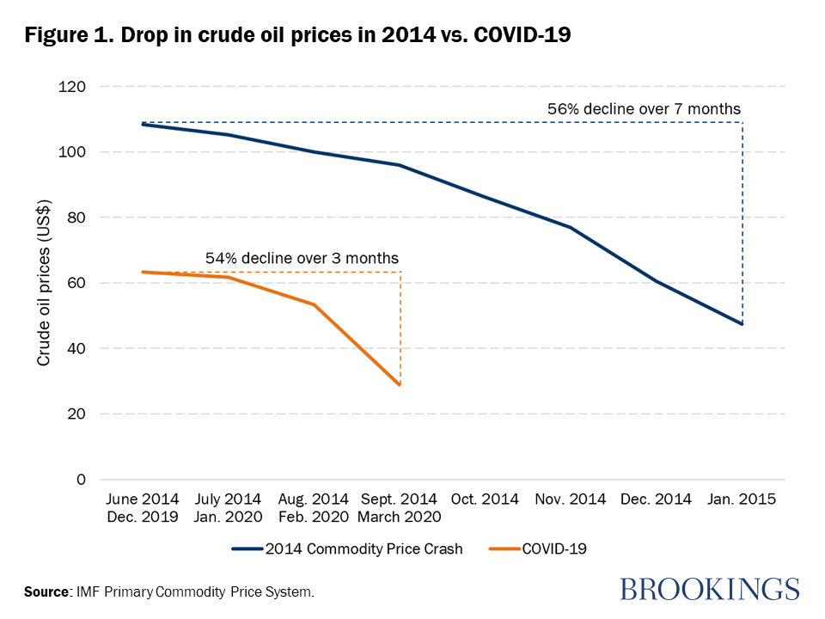
Because of these price drops, the largest disruption to trade will be for commodity-sensitive economies, with Algeria, Angola, Cameroon, Chad, Equatorial Guinea, Gabon, Ghana, Nigeria, and the Republic of the Congo among the most affected. Oil exports range from 3 percent of GDP in South Africa to as high as 40 percent in Equatorial Guinea and are a key source of foreign exchange earnings. Furthermore, the shock comes at a particularly bad time for three of the largest economies—Angola, Nigeria, and South Africa—which already had weak growth outlooks, with South Africa already in recession. Nigeria is now facing U.S. dollar shortages due to the oil price crash and is expected to devalue its currency by 10 percent by the end of June. We expect similar stresses to surface in some other countries.

Tourism and remittances
Tourism, an important sector of economic activity for many countries, will be heavily affected by COVID-19 as countries begin to place restrictions on travel and encourage social distancing. The sector contributes over 10 percent of GDP in the Seychelles, Cape Verde, and São Tomé and Príncipe, and over 5 percent in The Gambia, Morocco, Mauritius, Tunisia, Lesotho, Madagascar, Egypt, and Rwanda. Tourism employs more than a million people in each of Nigeria, Ethiopia, South Africa, Kenya, and Tanzania, and tourism employment comprises more than 20 percent of total employment in Seychelles, Cape Verde, São Tomé and Príncipe, and Mauritius. In past crises, including the 2008 financial crisis and the 2014 commodity price shock, African tourism experienced losses of up to $7.2 billion.
Similarly, with economic activity in the doldrums in many advanced and emerging market countries, remittances to Africa could experience significant declines. Remittances as a share of GDP exceed 5 percent in 13 African countries, and range as high as 23 percent in Lesotho and more than 12 percent in Comoros, The Gambia, and Liberia.
Tighter financial conditions
The COVID-19 pandemic has severely disrupted financial markets, with equity indices in major economies dropping significantly. Equity markets plunged by over 20 percent in the U.S. and experienced the largest single-day drop of the Dow since “Black Monday” in 1987. African equity markets have not been immune, with S&P All Africa index returns dropping by 30 percent since the beginning of the year, and large drops in Egypt, South Africa, Kenya, Mauritius, and Nigeria.
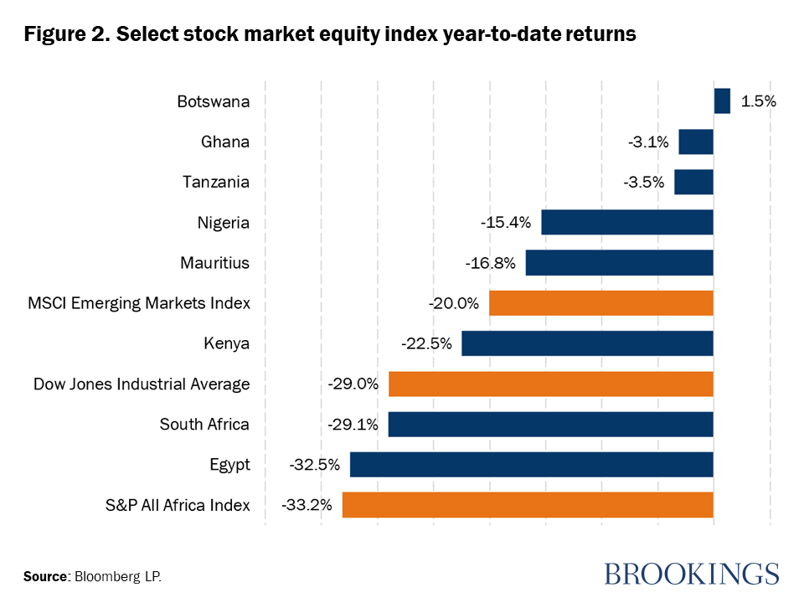
The pullback from African markets as well as a projected decline in export revenues has led to depreciations of local currencies. These exchange rate depreciations will push up local inflation and trigger monetary policy and financial tightening. In addition, exchange rate depreciations inflate local currency values of foreign currency debt and make debt management and servicing more challenging, a particular threat in Africa, where an estimated one-third of countries are either in or at high risk of debt distress.
Additionally, the risk-off sentiment in global markets will push up the cost of external financing for African countries. According to Euro money, the yield on Nigeria’s 2031 eurobond nearly doubled from 6.8 percent on February 21 to 12.1 percent on March 13. Similarly, the yield on Ghana’s 2029 eurobond shot up by 400 basis points to 11 percent, and that for Angola doubled to 14.2 percent. Furthermore, investor pull will cause delays in planned eurobond issuance by several countries. Already, Nigeria has announced a delay in the issuance of $3.3 billion eurobond, and Côte d’Ivoire, Benin, and South Africa are all expected to postpone issuances until markets stabilize. These delays will pose challenges for public finances in several countries.
Deteriorated consumer and business sentiment
The other channel through which COVID-19 will affect economic activity is through consumer and business sentiment. According to a survey by KASI Insights, in seven African countries, consumer sentiment for February dropped over COVID-19 concerns, a signal of reductions in consumer spending. Faced with lower and uncertain demand, business confidence will decrease and cause declines in investment.
Effect on economic growth
We estimate that the COVID-19 related disruptions outlined above will lower sub-Saharan Africa’s GDP growth in 2020 to between 1.5 percent and 2.5 percent, down from the projected 3.6 percent pre-COVID-19 projections. Under a scenario where African governments quickly take the appropriate steps to contain the spread of the virus and global conditions stabilize, the regional GDP growth will decline by around 1 percentage point, to 2.5 percent. In a scenario where the responses are not swift, the pandemic lasts longer, and global conditions take more time to normalize, the disruption will be more severe, resulting in a 2.1 percentage point reduction in growth, to 1.5 percent.
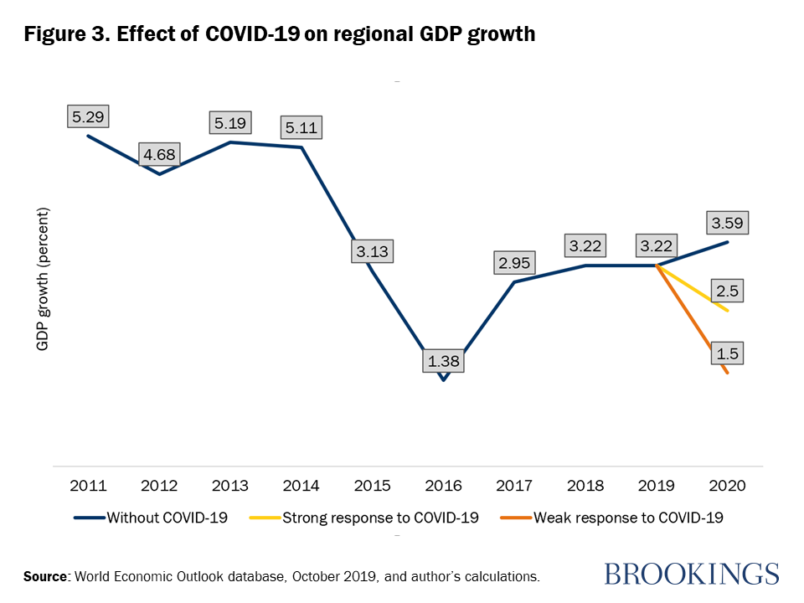

While the health of those affected by the virus is clearly of paramount concern, business owners, consumers, and governments must also prepare for the pandemic’s economic effects to ensure that their countries emerge from the crisis stronger than before. Strong measures taken in several—but not all—countries are positive steps which will help reduce the human and economic impact of the virus in Africa.
The global community must come together to collaborate, coordinate, share lessons learned, and assist each other to combat the pandemic. Until every country is safe, no country will be safe. The outbreak should serve to highlight the extent to which countries are interconnected and interdependent and should be a call to strengthen global institutions and the global governance system.

Conclusion
In conclusion, COVID-19 has done more harm than good to the world especially in terms of environmental health and economic sustainability, which has caused a lot of panic in the world as more problem arises the more the difficult it is to counter it. Because of this outbreak most business has lost a lot of profit, people losing their jobs etc. Unfortunately, there is no cure yet, but there are necessary steps taken or ways of handling COVID-19 in order for the disease not to spread further and to control the increase of people getting infected by it which has been explained in this report.
Recommendation
Due to the current pandemic situation, I strongly recommend:
- People should strictly adhere to advice of any medical personnel to prevent people from having the disease or being in the contact with an infected person.
- People should follow and obey the country’s instructions for the betterment of their own health.
- The government should be responsible for the country’s feeding and health care.
- People should respect the rule about social distancing in order to avoid the spread of the disease
- Ensuring people should always keep good hygiene every time.
References
https://www.google.com/amp/s/www.brookings.edu/blog/africa-in-focus/2020/03/18/strategies-for-coping-with-the-health-and-economic-effects-of-the-covid-19-pandemic-in-africa/amp/
https://www.offshore-technology.com/features/coronavirus-impact-offshore/
https://www.google.com/amp/s/www.telegraph.co.uk/news/2020/04/03/what-is-covid-19-coronavirus-pandemic/amp/
http://www.fractracker.org/2020/03/covid-19-and-the-oil-and-gas-industry/

