A TECHNICAL REPORT ON
DEVELOPMENT OF ENVIRONMENTAL HEALTH ENGINEERING FACILITIES, EQUIPMENT, SENSORS AND PUBLIC HEALTH SYSTEMS FOR TACKLING COVID – 19 PANDEMIC
NAME: NDIBE ARIZE CHUKWUEMEKA
MATRIC NO: 17/ENG06/056
DEPARTMENT: MECHANICAL ENGINEERING
SUBMITTED TO
Engr. O. J. OYEBODE
Lecturer in the Civil Engineering Department,
COLLEGE OF ENGINEERING,
AFE BABALOLA UNIVERSITY, ADO-EKITI, NIGERIA.
IN PARIAL FULFILMENT OF REQUIREMENTS FOR THE AWARD OF BACHELOR OF ENGINEERING (B. ENG) DEGREE IN MECHANICAL ENGINEERING.
MARCH 2020.

CERTIFICATION
This is to certify that this work was undertaken by MOHAMMED SALIM OTHMAN with Matriculation Number 17/ENG06/055, prepared and presented to the Department of Mechanical Engineering, Afe Babalola University, Ado-Ekiti.

ABSTRACT
Engineering activities are those which make the resources of nature available in a form that will benefit man and it also involves the provision of systems which perform economically and optimally. The study is mainly focused on the input of mechanical engineers in tackling the deadly COVID-19. Various reviews concerning the problems facing the continuous spread of the deadly virus as well as the solutions to tackle this problems.
Engineers build various infrastructures such as hospitals, clinics, laboratories in combating diseases (i.e COVID-19) and treating the ailing for the benefits of mankind and which will also aid in the rapid development of any country and shorten the death rate of any country. If there are no qualified numbers of engineers in any country, the country will suffer some major setbacks in its quest for development of medical infrastructures because these set of professionals will implement the developmental plans of such country and its technological advancement. All the engineering sectors are therefore required and expected to contribute their own quotas to the medical infrastructural development of such nation since they all work hand in hand such as Mechanical engineering, Electrical engineering and Civil engineering. It is necessary that the federal government engage the use of indigenous engineers in medical facilities and infrastructural development to be able to tackle the ravaging and deadly novel coronavirus as soon as possible and also to have a better, a secured, a safe and a sound nation.

TABLE OF CONTENTS
- INTRODUCTION
- What is engineering? …………………………................................5
- What is Mechanical Engineering………………………………………5

- LITERATURE REVIEW
- A brief Overview of COVID- 19………………………………………...6
- What is COVID- 19……………………………………………………6
- Symptoms of COVID- 19……………………………………………6
- How does the COVID- 19 spread……………………………......6
- Precautionary Measures for everyone against COVID- 19….8
- Role of Mechanical Engineering in tackling COVID-19………….10
- Role of Engineering as a whole………………………………………14
- How can we prevent future pandemic………………………………15

- METHODOLOGY…………………………………………………………….16

- ANALYSIS OF RESULT…………………………………………………….17

- CONCLUSION ……………………………………………………………….18

- RECOMMENDATION………………………………………………………..19

- REFERENCES…………………………………………………………………20

CHAPTER 1:
INTRODUCTION
What is ENGINEERING?
Engineering is the use of scientific principles to design and build machines, structures and other items including bridges, tunnels, roads, vehicles and buildings. The discipline of engineering encompasses a broad range of more specialized fields of engineering, each with a more specific emphasis on particular areas of applied mathematics, applied science, and types of application.
It can also be defined as the creative application of scientific principles to design or develop structures, machines, apparatus, or manufacturing processes, or works utilizing them singly or in combination; or to construct or operate the same with full cognizance of their design; or to forecast their behaviour under specific operating conditions; all as respects an intended function, economics of operational and safety to life and property.

What is MECHANICAL ENGINEERING?
Mechanical Engineering is the design and manufacture of physical or mechanical systems, such as power and energy systems, aerospace aircraft products, weapon systems, transportation products, engines, compressors, powertrains, kinematic chains, vacuum technology, vibration isolation equipment, manufacturing, robotics, turbines, audio equipment and mechatronics.
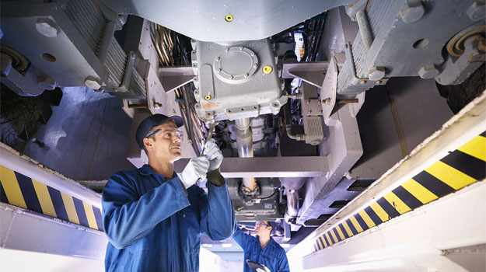

CHAPTER 2:
LITERATURE REVIEW
A Brief Overview of COVID- 19
- What is COVID- 19?
COVID-19 is the infectious disease caused by the most recently discovered coronavirus. This new virus and disease were unknown before the outbreak began in Wuhan, China, in December 2019.
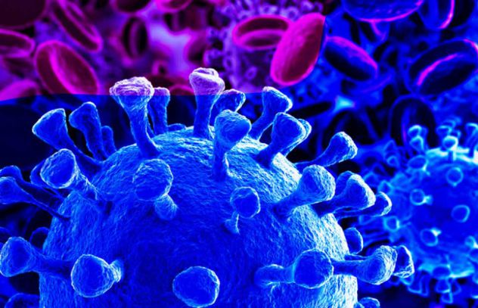
. Fig: COVID-19
- Symptoms of COVID- 19?
The most common symptoms of COVID-19 are fever, tiredness, and dry cough. Some patients may have aches and pains, nasal congestion, runny nose, sore throat or diarrhoea. These symptoms are usually mild and begin gradually. Some people become infected but don’t develop any symptoms and don't feel unwell. Most people (about 80%) recover from the disease without needing special treatment. Around 1 out of every 6 people who gets COVID-19 becomes seriously ill and develops difficulty breathing. Older people, and those with underlying medical problems like high blood pressure, heart problems or diabetes, are more likely to develop serious illness. People with fever, cough and difficulty breathing should seek medical attention.
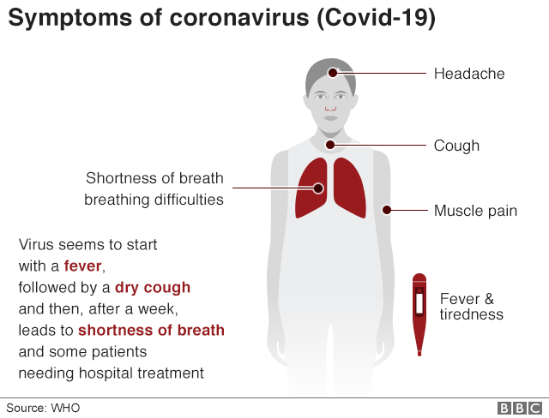
- How does the COVID- 19 spread?
People can contact COVID-19 from others who have the virus. The disease can spread from person to person through small droplets from the nose or mouth which are spread when a person with COVID-19 coughs or exhales. These droplets land on objects and surfaces around the person. Other people then catch COVID-19 by touching these objects or surfaces, then touching their eyes, nose or mouth. People can also catch COVID-19 if they breathe in droplets from a person with COVID-19 who coughs out or exhales droplets. This is why it is important to stay more than 1 meter (3 feet) away from a person who is sick. WHO is assessing ongoing research on the ways COVID-19 is spread and will continue to share updated findings.

Can the virus that causes COVID-19 be transmitted through the air?
Studies to date suggest that the virus that causes COVID-19 is mainly transmitted through contact with respiratory droplets rather than through the air. See previous answer on “How does COVID-19 spread?”

Can CoVID-19 be caught from a person who has no symptoms?
The main way the disease spreads is through respiratory droplets expelled by someone who is coughing. The risk of catching COVID-19 from someone with no symptoms at all is very low. However, many people with COVID-19 experience only mild symptoms. This is particularly true at the early stages of the disease. It is therefore possible to catch COVID-19 from someone who has, for example, just a mild cough and does not feel ill. WHO is assessing ongoing research on the period of transmission of COVID-19 and will continue to share updated findings.

Can I catch COVID-19 from the faeces of someone with the disease?
The risk of catching COVID-19 from the faeces of an infected person appears to be low. While initial investigations suggest the virus may be present in faeces in some cases, spread through this route is not a main feature of the outbreak. WHO is assessing ongoing research on the ways COVID-19 is spread and will continue to share new findings. Because this is a risk, however, it is another reason to clean hands regularly, after using the bathroom and before eating.

Precautionary Measures for everyone against COVID- 19
Stay aware of the latest information on the COVID-19 outbreak, available on the WHO website and through your national and local public health authority. Many countries around the world have seen cases of COVID-19 and several have seen outbreaks. Authorities in China and some other countries have succeeded in slowing or stopping their outbreaks. However, the situation is unpredictable so check regularly for the latest news.
You can reduce your chances of being infected or spreading COVID-19 by taking some simple precautions:
- Regularly and thoroughly clean your hands with an alcohol-based hand rub or wash them with soap and water.
Why? Washing your hands with soap and water or using alcohol-based hand rub kills viruses that may be on your hands.
- Maintain at least 1 metre (3 feet) distance between yourself and anyone who is coughing or sneezing.
Why? When someone coughs or sneezes they spray small liquid droplets from their nose or mouth which may contain virus. If you are too close, you can breathe in the droplets, including the COVID-19 virus if the person coughing has the disease.
- Avoid touching eyes, nose and mouth.
Why? Hands touch many surfaces and can pick up viruses. Once contaminated, hands can transfer the virus to your eyes, nose or mouth. From there, the virus can enter your body and can make you sick.
- Make sure you, and the people around you, follow good respiratory hygiene. This means covering your mouth and nose with your bent elbow or tissue when you cough or sneeze. Then dispose of the used tissue immediately.
Why? Droplets spread virus. By following good respiratory hygiene you protect the people around you from viruses such as cold, flu and COVID-19.
- Stay home if you feel unwell. If you have a fever, cough and difficulty breathing, seek medical attention and call in advance. Follow the directions of your local health authority.
Why? National and local authorities will have the most up to date information on the situation in your area. Calling in advance will allow your health care provider to quickly direct you to the right health facility. This will also protect you and help prevent spread of viruses and other infections.
- Keep up to date on the latest COVID-19 hotspots (cities or local areas where COVID-19 is spreading widely). If possible, avoid traveling to places especially if you are an older person or have diabetes, heart or lung disease.
Why? You have a higher chance of catching COVID-19 in one of these areas.
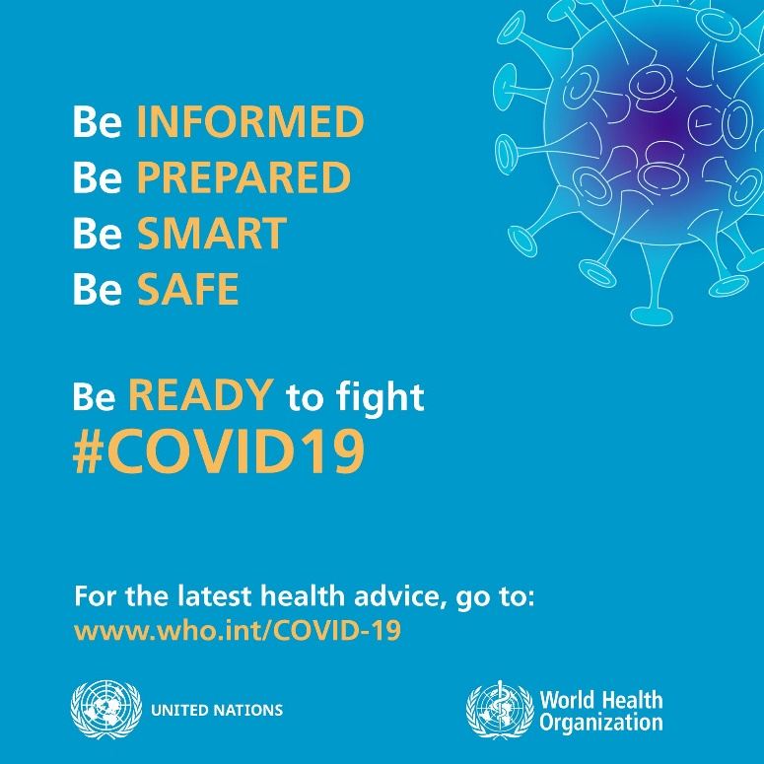

Protection measures for persons who are in or have recently visited (past 14 days) areas where COVID-19 is spreading
- Follow the guidance outlined above (Protection measures for everyone)
- Self-isolate by staying at home if you begin to feel unwell, even with mild symptoms such as headache, low grade fever (37.3 C or above) and slight runny nose, until you recover. If it is essential for you to have someone bring you supplies or to go out, e.g. to buy food, then wear a mask to avoid infecting other people.
Why? Avoiding contact with others and visits to medical facilities will allow these facilities to operate more effectively and help protect you and others from possible COVID-19 and other viruses.
- If you develop fever, cough and difficulty breathing, seek medical advice promptly as this may be due to a respiratory infection or other serious condition. Call in advance and tell your provider of any recent travel or contact with travellers.
Why? Calling in advance will allow your health care provider to quickly direct you to the right health facility. This will also help to prevent possible spread of COVID-19 and other viruses.

ROLES OF MECHANICAL ENGINEERS IN TACKLING COVID- 19
Mechanical engineers create solution and solve problems, playing a central role in the design and implementation of moving parts in a range of industries. Mechanical engineers provide efficient solution to the development of processes and products, ranging from small component designs to extremely large plant, machinery or vehicle.
A mechanical engineer that has any kind of knowledge in medical science can also be referred to as a “medical engineer”. Medical engineers apply engineering principles to research and development of medical applications, treatments or diagnostic technologies related to acute or chronic medical conditions. Medical engineers are employed by research organizations, manufacturers, government agencies or major medical centres.
Some contributions mechanical engineers can make to be able to tackle the COVID- 19 are as follows:
  - Construction of Robotic Drones: Mechanical engineers can create robotic drones (A.I) that will be able to spray disinfectants all over the city while being controlled from a particular control room. The government are trying their best to curtail the spread of the virus but their eyes cannot be on about 200 million people, so in other to assist the government, the drones can be used to disinfect places or objects that might have already being infected by one means or the other.

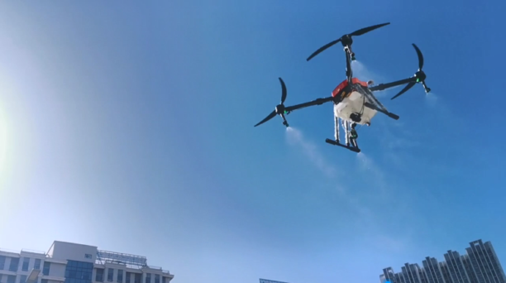

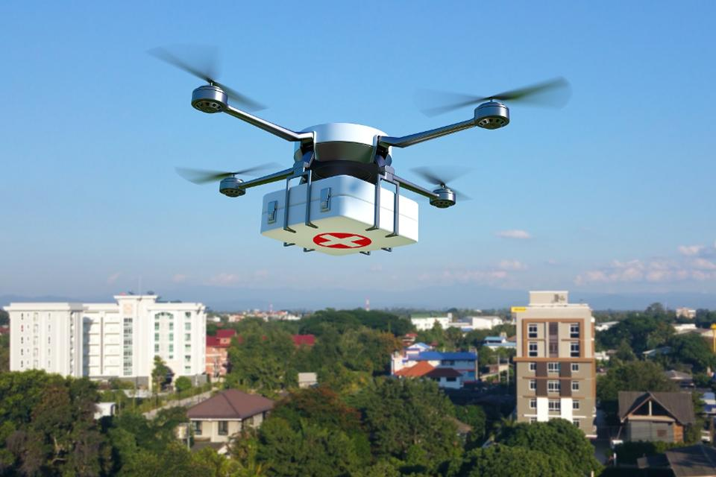
  - Construction of millions of oxygen tanks: As we read earlier, the COVID- 19 is a type of virus that attacks the lungs and makes the patient short of breath. Mechanical engineers will be doing the society a greater good if they make and supply millions of oxygen tanks all over the world so that the death rate of the infected patients will be curtailed. This Oxygen tank will be able to supply the right amount of oxygen to those patients that constantly gasp for breath until they are fully recovered.

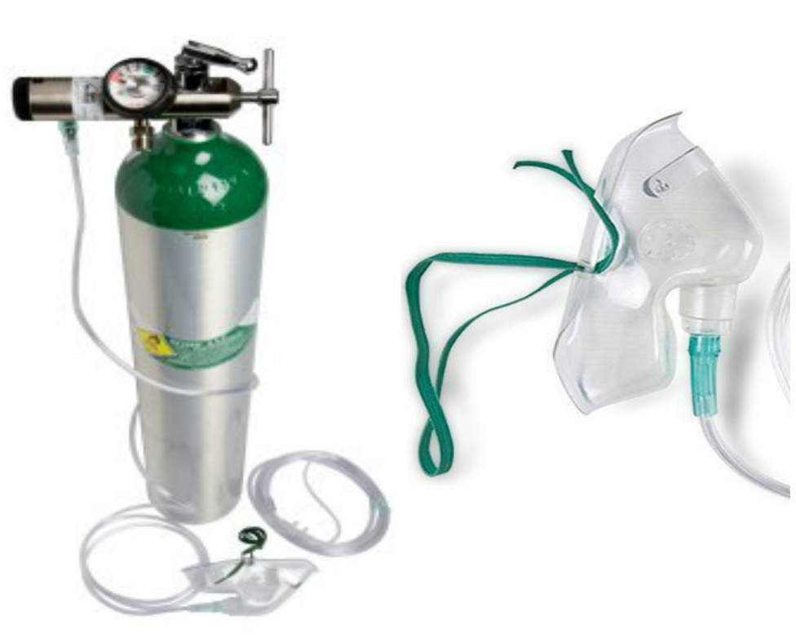

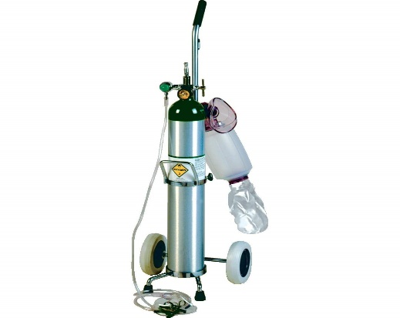
  - Construction of high standard laboratory equipment: If Mechanical engineers are to construct high standard laboratory equipment that can help lab technicians in performing COVID- 19 test easier and faster than the normal 3- 4 days it usually takes before the result is ready. This will now help the lab technicians to be able to conduct large number of tests in fewer days. High standard lab equipment will also be of great use to lab scientists who are working day and night to find a cure or vaccine for the COVID- 19. It will be a boost to their work and might enable them, find a cure sooner than later.
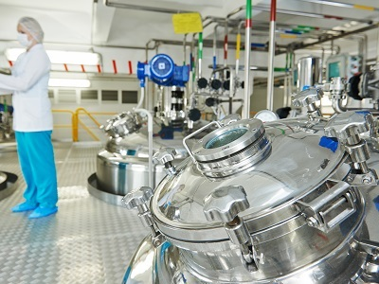
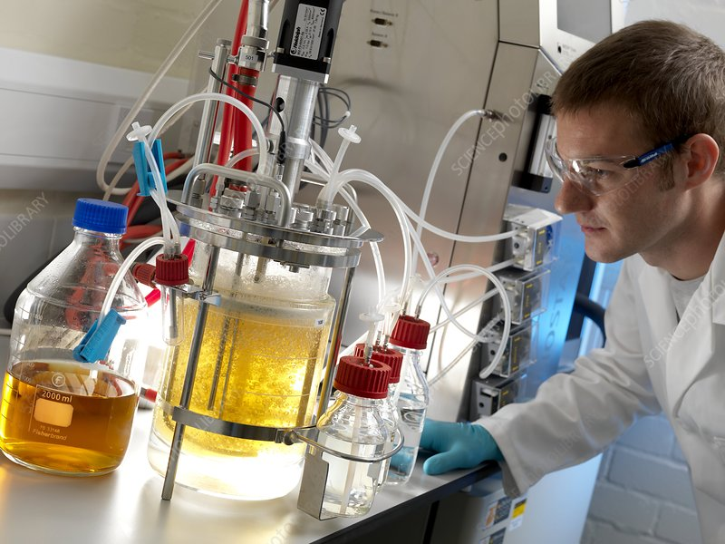

ROLE OF ENGINEERING AS A WHOLE
When it comes to medical field the primary goal is to improve the health of people. Doctors have the knowledge of human body. They know what is good for a person and what not. But to build anything, you need engineers.
Companies from across the engineering spectrum have offered their assistance, and work is under way to build 30,000 devices. But what else can engineers do to help during this national and global crisis?
For some expert suggestions, we asked a group of Professional Engineering readers: “Apart from making ventilators, how could engineers help the fight against coronavirus?”.

The answers are hugely encouraging, with many good ideas and willing helpers. They will hopefully provide inspiration for potential volunteers, who could use this engineering expertise to help minimise the worst of the virus’ impact. Of course, everyone should follow social distancing and other temporary rules. But with potentially months of restrictions ahead and the possibility of the outbreak stretching on, here are few ways that engineers could help.
Electronic engineers can develop and build new gadgets like Heart rate monitors that can help people improve their health. Heart rate monitors can be used to monitor the heart beat and rate of the sick people infected with COVID- 19. It can serve as an upgrade to the doctor’s stethoscope and assist doctors better in checking the current condition of a patient’s heart.
Civil engineers can design and construct hospitals, clinics and health centres that can be used as isolation centres and can be used in treating those infected with COVID- 19. More hospital spaces are needed for patients as the NCDC comes under increasing strain. The Onikan Stadium is being co-opted as a field hospital and isolation centre and could reportedly hold up to 1,000 patients. Following similar measures in China, readers suggested engineers could help build new hospitals, including by designing and manufacturing buildings using offsite construction.
Software Engineers can write software that uses algorithms to analyse massive amount of health information and generate results that help people and doctors in making healthy decisions. Plus making health information readily available using cloud, is something that is being done these days. In India especially.
Chemical engineers can assist in the tackling of COVID- 19 by constantly testing new drugs and medicines in order to find a cure for the deadly virus. Same also applies to genetic engineers.
HOW CAN WE PREVENT FUTURE OUTBREAKS
While Nigeria and other countries around the world struggle with the current outbreak, it is also advised that we look ahead and plan for similar or even worse situations. We need to use our ingenuity to prevent the problem becoming worse, and avoiding future outbreaks like this one.
Engineers should carry out a full assessment of medical equipment that might be required in similar situations, to ensure that designs can be open-sourced and shared with manufacturers when needed.
Industry itself should have a frank appraisal of its international activity to help prevent a repeat of this pandemic. Companies and employees might need to act differently in future. Hopefully this will be a wake-up call in many ways. This is an aggressive virus, but it could be that in future another one will show itself much more slowly, infecting many more people and with much more serious effects. Many of us engage far too much in international travel, with little regard for global warming. The virus is here in Nigeria solely because of this travel.

CHAPTER 3:
METHODOLOGY
The topic that was researched on in this context was “Input of Mechanical Engineering In tackling the deadly COVID- 19”. In order for me to collate the data that would be used in my report writing, I conducted a survey to know peoples various ideas on the role mechanical engineering can play in tackling the COVID- 19 and I also made use of some existing data on the internet of some other professional engineers ideas that were useful in my research.
I chose to use these two methods to collate my data because they are the two most efficient ways of collating information during a research. Carrying out a survey can assist a writer in knowing what the audience think about the topic and also what they intend to gain from the research.
The basic strategies in the control of an outbreak are containment and mitigation. Containment may be undertaken in the early stages of the outbreak, including contact tracing and isolating infected individuals to stop the disease from spreading to the rest of the population, other public health interventions on infection control, and therapeutic countermeasures such as vaccinations which may be effective if available. When it becomes apparent that it is no longer possible to contain the spread of the disease, management will then move on to the mitigation stage, in which measures are taken to slow the spread of the disease and mitigate its effects on society and the healthcare system. In reality, containment and mitigation measures may be undertaken simultaneously.
Another strategy, suppression, requires more extreme long-term non-pharmaceutical interventions so as to reverse the pandemic by reducing the basic reproduction number to less than 1. The suppression strategy, which includes stringent population-wide social distancing, home isolation of cases, and household quarantine, was undertaken by China during the 2019–20 coronavirus pandemic where entire cities were placed under lockdown, but such strategy carries with it considerable social and economic costs.
Some of the engineering strategies employed in this current situation are:
• Epidemiology is the study and analysis of the distribution (who, when, and where), patterns and determinants of health and disease conditions in defined populations. Major areas of epidemiological study include disease causation, transmission, outbreak investigation, disease surveillance, environmental epidemiology, forensic epidemiology, occupational epidemiology, screening, bio monitoring, and comparisons of treatment effects such as in clinical trials. Epidemiologists rely on other scientific disciplines like biology to better understand disease processes, statistics to make efficient use of the data and draw appropriate conclusions, social sciences to better understand proximate and distal causes, and engineering for exposure assessment.
• MANUFACTURING:
Due to capacity limitations in the standard supply chains, some digital manufacturers are printing healthcare material such as nasal swabs and ventilator parts.

• EXPERIMENTAL TESTING:
No medications are approved to treat the disease by the WHO although some are recommended by individual national medical authorities. Research into potential treatments started in January 2020, and several antiviral drugs are in clinical trials. Although new medications may take until 2021 to develop, several of the medications being tested are already approved for other uses or are already in advanced testing.
• INFORMATION TECHNOLOGY:
In February 2020, China launched a mobile app to deal with the disease outbreak. Users are asked to enter their name and ID number. The app is able to detect 'close contact' using surveillance data and therefore a potential risk of infection. Every user can also check the status of three other users. If a potential risk is detected, the app not only recommends self-quarantine, it also alerts local health officials. Big data analytics on cell phone data, facial recognition technology, mobile phone tracking and artificial intelligence are used to track infected people and people whom they contacted in South Korea, Taiwan and Singapore. In March 2020, the Israeli government enabled security agencies to track mobile phone data of people supposed to have coronavirus. The measure was taken to enforce quarantine and protect those who may come into contact with infected citizens.
Also in March 2020, Deutsche Telekom shared aggregated phone location data with the German federal government agency, Robert Koch Institute, in order to research and prevent the spread of the virus.
Russia deployed facial recognition technology to detect quarantine breakers. Italian regional health commissioner Giulio Gallera said he has been informed by mobile phone operators that "40% of people are continuing to move around anyway".
German government conducted a 48 hours weekend hackathon with more than 42.000 participants. Also the president of Estonia, Kersti Kaljulaid, made a global call for creative solutions against the spread of coronavirus.

CHAPTER 4:
ANALYSIS OF RESULTS
According to recent statistics on the number of cases, number of recovered patients and number of deaths, it is 95% possible that COVID- 19 will be tackled before the next one month. The COVID- 19 will become a thing of the past sooner than later if engineers play their huge role in tackling the virus.

CHAPTER 5:
CONCLUSION
For decades, engineers have played a key role in enhancing Nigeria. and international public health by focusing on NCDC goals concerning healthy communities, workplaces, homes, and schools. CDC engineers are meeting public health challenges by conducting laboratory and field studies, overseeing research and development that result in solutions-based products, conducting disaster relief and emergency response, and engaging in public health program management. Engineers are an integral part of the public health team that helps define what is possible, identify existing limitations, and shape workable solutions. Their efforts have contributed immensely to reducing disease spread (i.e COVID-19) in Nigeria and around the world.

CHAPTER 6:
RECOMMENDATION
Places of knowledge acquisition and learning should consequently develop new perspectives in teaching engineers the required knowledge in achieving medical science intelligence so that in whatever environment the students is positioned in future he/she must be contingent upon the ability to adapt to threats to health and engaged oneself within the progression of the world. A debateable and project familiarize with teaching and a good learning foundation or core should be marked in outline, which present the prospective essentials and important proficiency for inexperienced and blooming engineers.

CHAPTER 7:
REFERENCES
https://en.wikipedia.org/wiki/Engineering
https://www.who.int/news-room/q-a-detail/q-a-coronaviruses#:~:text=symptoms
https://crimsonpublishers.com/downloadPdf.php?folder=rmes&file=RMES.000547

