NAME: IJIGA OBEKPA
MATRIC NO: 17/ENG04/030
DEPARTMENT: ELECTRICAL ELECTRONICS
COLLEGE: ENGINEERING
INSTITUTION: AFE BABALOLA UNIVERSITY
DATE: 12/04/20

ASSIGNMENT
TOPIC:
DEVELOPMENT OF ENVIRONMENTAL HEALTH ENGINEERING FACILITIES, EQUIPMENT, SENSORS AND PUBLIC HEALTH SYSTEMS FOR TACKLING COVID-19 PANDEMIC

ACKNOWLEDGEMENT
I acknowledge Almighty God for giving me the grace and the strength to carry out this program. I also want to thank my school Afe Babalola University Ado-Ekiti (ABUAD) for giving me the opportunity to take part in this project.
I also acknowledge my parents (Mr. and Mrs. Ijiga) for their support (financially, physically and emotionally) during this period. I hope that as engineers we can fight and curb this pandemic.

TABLE OF CONTENT
- WHAT IS CORONA VIRUS.
- DEVELOPMENT OF ENVIRONMENTAL ENGINEERING HEALTH FACILITIES, MODERN EQUIPMENTS AND SENSORS.
- DEVELOPMENT OF PUBLIC HEALTH SYSTEMS FOR THE TACKLING OF COVID-19 PANDEMIC.
- CONCLUSION.

WHAT IS CORONA VIRUS
Coronavirus disease (COVID-19) is an infectious disease caused by a new virus. The disease originated from china in a city called WUHAN. The abbreviation COVID-19 simply means CHINESE ORIGINATED VIRUS IN DECEMBER 2019. The disease causes respiratory illness (like the flu) with symptoms such as a cough, fever, and in more severe cases, difficulty breathing. Severe symptoms that can be seen are pneumonia, cardiac arrest, kidney failure and death.
You can protect yourself by washing your hands frequently, avoiding touching your face, and avoiding close contact (1 meter or 3 feet) with people who are unwell. It is also advised that we all cover our mouth when sneezing or coughing. You should also try as much as possible to always keeping yourself hydrated drinking of water at intervals is very necessary. Also in some countries you are advised to wear face mask and hand glove to protect yourself from getting infected.
HOW IT SPREADS
Coronavirus disease spreads primarily through contact with an infected person when they cough or sneeze. It also spreads when a person touches a surface or object that has the virus on it, then touches their eyes, nose, or mouth. This is why we are told to wash our hands for about 20seconds under running water with soap or alcoholic solution.

DEVELOPMENT OF ENVIRONMENTAL ENGINEERING HEALTH FACILITIES
As engineers it’s our duty to provide a faster and better way in which health facilities can work. When it comes to medical field the primary goal is to improve the health of people. Doctors have the knowledge of human body. They know what is good for a person and what not. But to build anything, you need engineers.
Software Engineers can write software that uses algorithms to analyze massive amount of health information and generate results that help people and doctors in making healthy decisions. Also, making health information readily available using cloud, will make work easier.
In response to cases of COVID-19 rising worldwide, the World Health Organization has recently warned that the pandemic is accelerating. Thankfully, it does say the trajectory can still be changed. That’s why the global scientific community is pulling together in order to develop viable treatments and vaccines to combat the spread of the infectious disease.
Much in the same vein, the world is in desperate need of ingenious solutions to widespread issues such as supply shortages of medical equipment. Here are 11 ways the engineering community has stepped up to the challenge.

This is how engineers can help in tackling the COVID-19 pandemic:
Production of respiratory ventilators:
Ventilators are used to aid breathing in COVID-19 patients. As at now the number of ventilators are running out due to the massive numbers of patients admitted into the hospitals. This virus as seen over 1.5 million patients been affected. This calls for more ventilators to be well designed, tested and produced.
Engineers are the front runners to be called up for this project. So far so good Italy has made a reversed engineered 3D-printed ventilators. After the outbreak came to an uncontrollable level in Italy this month, health specialist had a scarcity in ventilators which has become a major necessity this period.
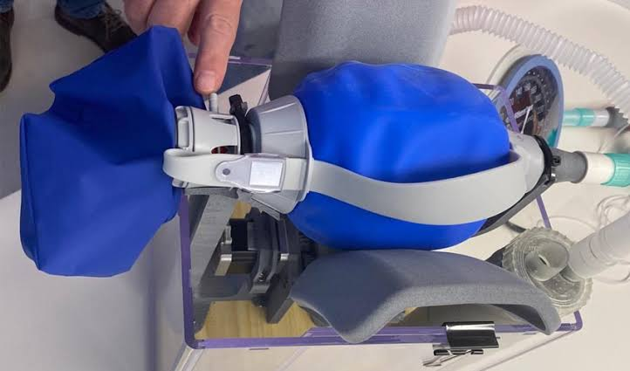 A 3D VENTILATOR.
A group of engineers in Italy decided to help out by making 3D versions of solely needed ventilators. Despite thr possibility of being sued by the medical technology companies that manufacture a specific ventilator, the engineers reversed enginnered the piece that was required and were able to manufacture it in a matter of hours to help save lives.

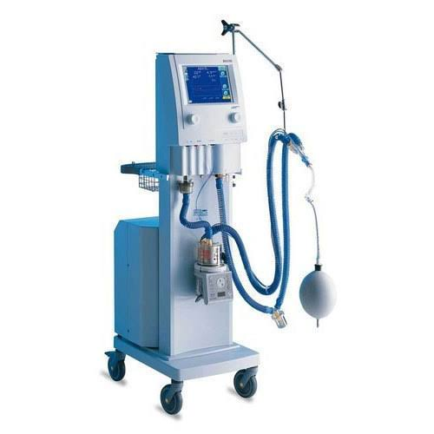 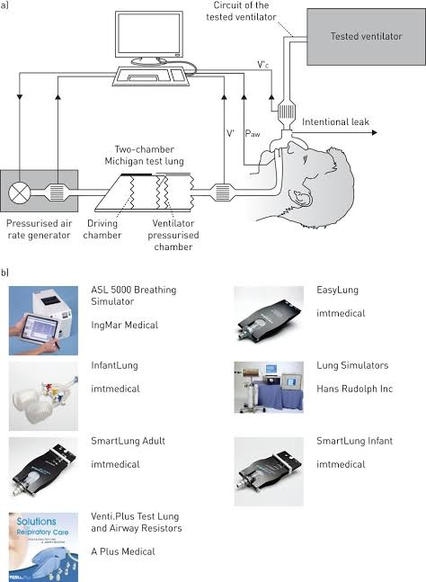This picture shows how/what a typical ventilator looks like. Due to that the fact that patients cannot breathe well with their lungs this has helped patients to recover.
UV LIGHT EMMITING DISINFECTION ROBOTS
UV light disinfectant robots weren’t specifically developed for the COVID-19 pandemic and they haven’t been definitively proven to be infective at eradicating the virus from surfaces and yet, demand has skyrocketed to the point that companies are sending truckloads of the machines to different countries worldwide.
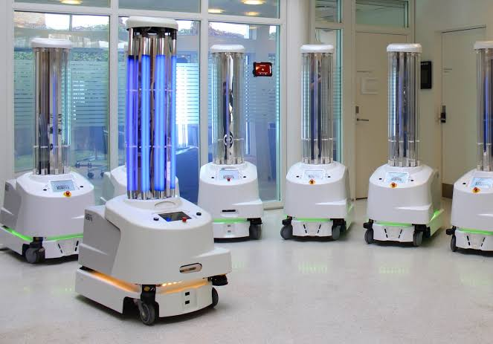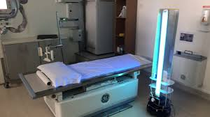
UV LIGHT EMMITING DISINFECTION ROBOTS
Hospitals worldwide seem to be trusting that this is true, as demand is sky high for the robots which use light bulbs to emit concentrated UV-C ultraviolet light over hospital surfaces. This type of light has been shown to destroy viruses, bacteria and other harmful microbes by damaging their DNA and RNA so that they can no longer multiply.
UV DIGITAL THERMOMETER
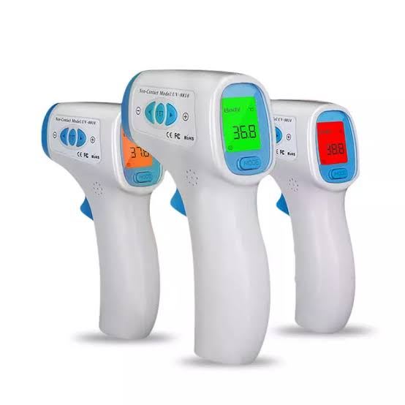
This device is a prototype of engineering development. This is used to check the body temperature of patients. It has helped in hospitals, offices, schools, airports, prisons e.t.c in other to check and arrest the corona virus pandemic. It is clean, quick and easy to use due to its ultra violet feature that can record patient temperature a fast as possible. This is like a sensor that gives a feedback to the screen display.
ARTIFICIAL INTELLIDENCE USED TO ANALYZE SELF ISOLATION HABITS
Some countries have taken longer than others to announce police enforced lockdowns. In the United Kingdom, for example, in UK the decision to lockdown was enforced, according to research by vivacity labs, a startup that makes camera based traffic sensors, the enforcement was severely needed.
This cameras monitor the movement of people and check how citizens a following the self-isolation rule placed by the government. This is an area where computer engineers play their parts in helping the world fight corona virus.
DEVELOPMENT OF PUBLIC HEALTH SYSTEMS FOR THE TACKLING OF COVID-19 PANDEMIC
- Healthcare Engineering professionals play key roles in creating and developing hardware and software to innovate, support, improve and optimize the operation processes and systems of patient care, and to improve patient outcomes through engineering approaches.
- Protection of frontline staff- the protection and safety of the frontline staff (the doctors, nurses and all medical personnel attending to patients) should be the first move. If the medical personnel's are not safe how can they keep their patients safe? So we need to ensure that after everyday treatment and checkup of the patients the medical personnel's should also be tested.
- Although hospitals are vital to the response, home care and outreach are also really important. In an outbreak, you cannot focus only on hospital care; general practitioners and family doctors have a vital role to play as well. You have to take the wider community into account. People should be advised in their various homes on how to stay safe and avoid contacting and spreading the virus. They should also know the symptoms and what to do if the symptoms continue to appear
- The people in retirement and nursing homes are at huge risk from covid-19, as the elderly are the most vulnerable and live in close contact in these facilities, so it’s important to reorganize the way they are run. Proper health measures should be taken.

Conclusion
In conclusion, the COVID-19 PANDEMIC cannot be eradicated by the health works alone. We the engineers are also big game changers when it comes to outscoring this pandemic. With this I want to say that no profession is greater and bigger than the other. In rough and bad times we all need each other to win any battle. If you check the records engineers are solely needed in curbing the covid-19 virus mostly in the supply of respiratory VENTILATORS.

