AFE BABALOLA UNIVERSITY, ADO-EKITI, EKITI STATE, NIGERIA.

TERM PAPER ON;
ENGINEERING STRATEGIES FOR HANDLING COVID-19 FOR ENVIRONMENTAL HEALTH AND ECONOMIC SUSTAINABILITY

PREPARED BY;
AKWIDO OGHENEYOLE PRESLEY.
17/ENG02/010

CERTIFICATION
This is to certify that this work was undertaken by AKWIDO OGHENEYOLE with Matriculation Number 17/ENG02/010, prepared and presented to the Department of Mechanical Engineering, Afe Babalola University, Ado-Ekiti.

ABSTRACT
This term paper describes the details of covid-19 and the strategies for handling the pandemic and managing environmental and economic sustainability as the disease endangers the lives and the economic conditions of a country and the control of the virus will come with an enormous economic and social price.

TABLE OF CONTENTS
CERTIFICATION i
ABSTRACT ii
ACKNOWLEDGEMENTS iii
LIST OF FIGURES v
INTRODUCTION 6
1.1 WHAT IS CORONA VIRUS (COVID-19)? 6
1.1.1 SIGNS AND SYMPTOMS 7
1.1.2 CAUSES AND TRANSMISSION 7
1.1.3 PREVENTION 7
2 LITERATURE REVIEW 9
2.1 ENVIRONMENTAL HEALTH 9
2.1.1 DISCIPLINES 9
2.1.2 CONCERNS 12
2.2 ECONOMIC SUSTAINABILITY 14
3 METHODOLOGY 16
3.1 ENGINEERING STRATEGIES 16
4 RESULTS 19
CONCLUSION 21
5 CONCLUSION AND RECOMMENDATION 21
5.1 RECOMMENDATION 21
6 REFERENCE 1

LIST OF FIGURES
Figure 1: corona virus 6
Figure 2: preventions 8
Figure 3:Air pollution is an example of an exposure that has been linked with negative health outcomes. 9
Figure 4: toxicology 10
Figure 5: Exposure science 10
Figure 6: Environmental engineering 11
Figure 7: Engineering law 12
Figure 8: environmental health 14
Figure 9:EPIDEMOLOGY 17
Figure 10: Mechanical ventilation 20

INTRODUCTION

WHAT IS CORONA VIRUS (COVID-19)?
Corona virus disease (COVID-19) is an infectious disease caused by a newly discovered corona virus. Most people infected with the COVID-19 virus will experience mild to moderate respiratory illness and recover without requiring special treatment. Older people, and those with underlying medical problems like cardiovascular disease, diabetes, chronic respiratory disease, and cancer are more likely to develop serious illness. The best way to prevent and slow down transmission is be well informed about the COVID-19 virus, the disease it causes and how it spreads. Protect yourself and others from infection by washing your hands or using an alcohol based rub frequently and not touching your face. The COVID-19 virus spreads primarily through droplets of saliva or discharge from the nose when an infected person coughs or sneezes, so it’s important that you also practice respiratory etiquette (for example, by coughing into a flexed elbow).At this time, there are no specific vaccines or treatments for COVID-19. However, there are many ongoing clinical trials evaluating potential treatments.
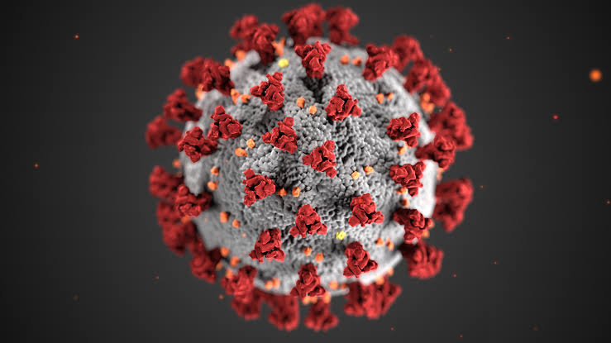
Figure 1: corona virus

SIGNS AND SYMPTOMS
The viruses can make people sick, usually with a mild to moderate upper respiratory tract illness, similar to a common cold. Coronavirus symptoms include a runny nose, cough, sore throat, possibly a headache and maybe a fever, which can last for a couple of days. For those with a weakened immune system, the elderly and the very young, there's a chance the virus could cause a lower, and much more serious, respiratory tract illness like a pneumonia or bronchitis. Those infected with the virus may be asymptomatic or develop flu-like symptoms, including fever, cough, fatigue and shortness of breath. Emergency symptoms include difficulty breathing, persistent chest pain or pressure, confusion, difficulty waking and bluish face or lips; immediate medical attention is advised if these symptoms are present. Less commonly, upper respiratory symptoms, such as sneezing, runny nose or sore throat may be seen. Symptoms such as nausea, vomiting and diarrhoea have been observed in varying percentages.
As is common with infections, there is a delay between the moment when a person is infected with the virus and the time when they develop symptoms. This is called the incubation period. The incubation period for COVID-19 is typically five to six days but may range from two to 14 days. 97.5% of people who develop symptoms will do so within 11.5 days of infection.

CAUSES AND TRANSMISSION
Human-to-human transmission has been confirmed during the 2019–20 coronavirus pandemic. Transmission occurs primarily via respiratory droplets from coughs and sneezes within a range of about 1.8 metres (6 ft.).
Indirect contact via contaminated surfaces is another possible cause of infection. Preliminary research indicates that the virus may remain viable on plastic and steel for up to three days, but does not survive on cardboard for more than one day or on copper for more than four hours; the virus is inactivated by soap, which destabilises its lipid bilayer. Viral RNA has also been found in stool samples from infected people.

PREVENTION
Preventive measures include:
- Wash your hands regularly for 20 seconds, with soap and water or alcohol-based hand rub.
- Cover your nose and mouth with a disposable tissue or flexed elbow when you cough or sneeze.
- Avoid close contact (1 meter or 3 feet) with people who are unwell.
- Stay home and self-isolate from others in the household if you feel unwell.
- Don't touch your eyes, nose, or mouth if your hands are not clean.
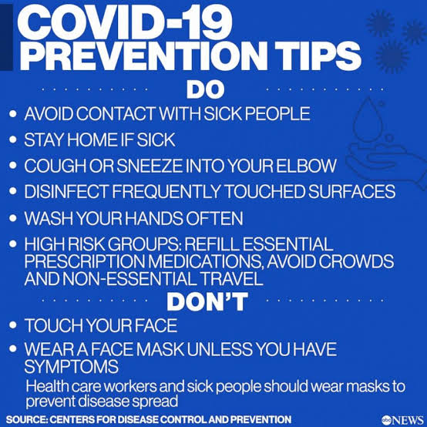
Figure 2: preventions

LITERATURE REVIEW

ENVIRONMENTAL HEALTH
Environmental health is the branch of public health concerned with all aspects of the natural and built environment affecting human health. Environmental health is focused on the natural and built environments for the benefit of human health. The major sub disciplines of environmental health are: environmental science; environmental and occupational medicine, toxicology and epidemiology.

DISCIPLINES
Five basic disciplines generally contribute to the field of environmental health: environmental epidemiology, toxicology, exposure science, environmental engineering, and environmental law. Each of these disciplines contributes different information to describe problems and solutions in environmental health, but there is some overlap among them.
- Environmental epidemiology is a branch of epidemiology concerned with determining how environmental exposures impact human health.^{[2]} This field seeks to understand how various external risk factors may predispose to or protect against disease, illness, injury, developmental abnormalities, or death. These factors may be naturally occurring or may be introduced into environments where people live, work, and play.

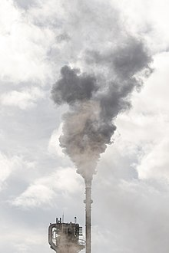
Figure 3:Air pollution is an example of an exposure that has been linked with negative health outcomes.
- Toxicology studies how environmental exposures lead to specific health outcomes, generally in animals, as a means to understand possible health outcomes in humans. Toxicology has the advantage of being able to conduct randomized controlled trials and other experimental studies because they can use animal subjects.

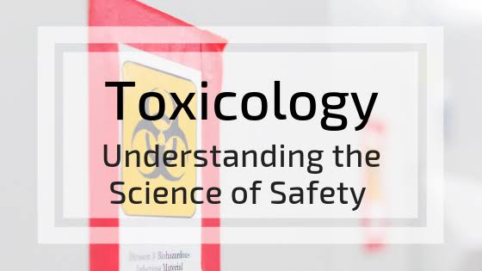
Figure 4: toxicology

- Exposure science studies human exposure to environmental contaminants by both identifying and quantifying exposures. Exposure science can be used to support environmental epidemiology by better describing environmental exposures that may lead to a particular health outcome, identify common exposures whose health outcomes may be better understood through a toxicology study.

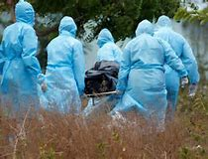
Figure 5: Exposure science

- Environmental engineering applies scientific and engineering principles for protection of human populations from the effects of adverse environmental factors; protection of environments from potentially deleterious effects of natural and human activities; and general improvement of environmental quality.
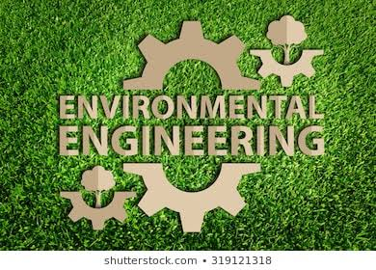
Figure 6: Environmental engineering

- Engineering law includes the network of treaties, statutes, regulations, common and customary laws addressing the effects of human activity on the natural environment.

Figure 7: Engineering law

CONCERNS
Environmental health addresses all human-health-related aspects of the natural environment and the built environment. Environmental health concerns include:
- Air quality, including both ambient outdoor air and indoor air quality, which also comprises concerns about environmental tobacco smoke.
- Biosafety
- Disaster preparedness and response.
- Climate change and its effects on health.
- Environmental racism, wherein certain groups of people can be put at higher risk for environmental hazards, such as air, soil, and water pollution. This often happens due to marginalization, economic and political processes, and ultimately, racism. Environmental racism disproportionately affects different groups globally, however generally the most marginalized groups of any given region/nation.
- Food safety, including in agriculture, transportation, food processing, wholesale and retail distribution and sale.
- Hazardous materials management, including hazardous waste management, contaminated site remediation, the prevention of leaks from underground storage tanks and the prevention of hazardous materials releases to the environment and responses to emergency situations resulting from such releases.
- Housing, including substandard housing abatement and the inspection of jails and prisons.
- Childhood lead poisoning prevention.
- Land use planning, including smart growth.
- Liquid waste disposal, including city waste water treatment plants and on-site waste water disposal systems, such as septic tank systems and chemical toilets.
- Medical waste management and disposal.
- Noise pollution control.
- Occupational health and industrial hygiene.
- Radiological health, including exposure to ionizing radiation from X-rays or radioactive isotopes.
- Recreational water illness prevention, including from swimming pools, spas and ocean and freshwater bathing places.
- Safe drinking water.
- Solid waste management, including landfills, recycling facilities, composting and solid waste transfer stations.
- Toxic chemical exposure whether in consumer products, housing, workplaces, air, water or soil.
- Vector control, including the control of mosquitoes, rodents, flies, cockroaches and other animals that may transmit pathogens.
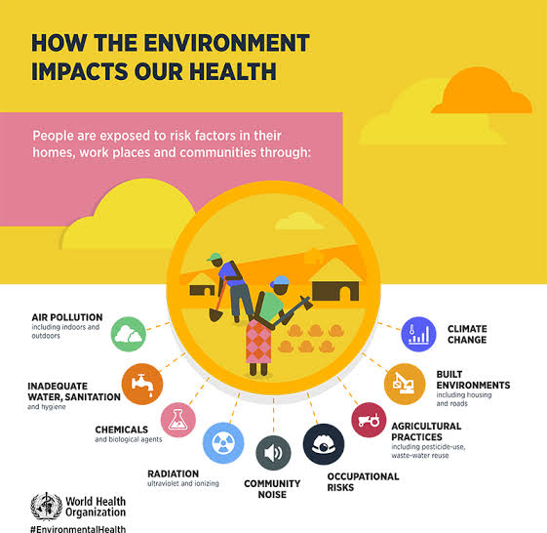
Figure 8: environmental health

ECONOMIC SUSTAINABILITY
Economic sustainability refers to practices that support long-term economic growth without negatively impacting social, environmental, and cultural aspects of the community.
Economic sustainability is the term used to identify various strategies that make it possible to use available resources to their best advantage. The idea is to promote the use of those resources in a way that is both efficient and responsible, and likely to provide long-term benefits. In the case of a business operation, it calls for using resources so that the business continues to function over a number of years, while consistently returning a profit.
On one account, sustainability "concerns the specification of a set of actions to be taken by present persons that will not diminish the prospects of future persons to enjoy levels of consumption, wealth, utility, or welfare comparable to those enjoyed by present persons". Sustainability interfaces with economics through the social and ecological consequences of economic activity. Sustainability economics represents: "... a broad interpretation of ecological economics where environmental and ecological variables and issues are basic but part of a multidimensional perspective. Social, cultural, health-related and monetary/financial aspects have to be integrated into the analysis."^{[198]} However, the concept of sustainability is much broader than the concepts of sustained yield of welfare, resources, or profit margins. At present, the average per capita consumption of people in the developing world is sustainable but population numbers are increasing and individuals are aspiring to high-consumption Western lifestyles. The developed world population is only increasing slightly but consumption levels are unsustainable. The challenge for sustainability is to curb and manage Western consumption while raising the standard of living of the developing world without increasing its resource use and environmental impact. This must be done by using strategies and technology that break the link between, on the one hand, economic growth and on the other, environmental damage and resource depletion

METHODOLOGY

ENGINEERING STRATEGIES

The basic strategies in the control of an outbreak are containment and mitigation. Containment may be undertaken in the early stages of the outbreak, including contact tracing and isolating infected individuals to stop the disease from spreading to the rest of the population, other public health interventions on infection control, and therapeutic countermeasures such as vaccinations which may be effective if available. When it becomes apparent that it is no longer possible to contain the spread of the disease, management will then move on to the mitigation stage, in which measures are taken to slow the spread of the disease and mitigate its effects on society and the healthcare system. In reality, containment and mitigation measures may be undertaken simultaneously.
Another strategy, suppression, requires more extreme long-term non-pharmaceutical interventions so as to reverse the pandemic by reducing the basic reproduction number to less than 1. The suppression strategy, which includes stringent population-wide social distancing, home isolation of cases, and household quarantine, was undertaken by China during the 2019–20 coronavirus pandemic where entire cities were placed under lockdown, but such strategy carries with it considerable social and economic costs.
Some of the engineering strategies employed in this current situation are:
- Epidemiology is the study and analysis of the distribution (who, when, and where), patterns and determinants of health and disease conditions in defined populations. Major areas of epidemiological study include disease causation, transmission, outbreak investigation, disease surveillance, environmental epidemiology, forensic epidemiology, occupational epidemiology, screening, biomonitoring, and comparisons of treatment effects such as in clinical trials. Epidemiologists rely on other scientific disciplines like biology to better understand disease processes, statistics to make efficient use of the data and draw appropriate conclusions, social sciences to better understand proximate and distal causes, and engineering for exposure assessment.
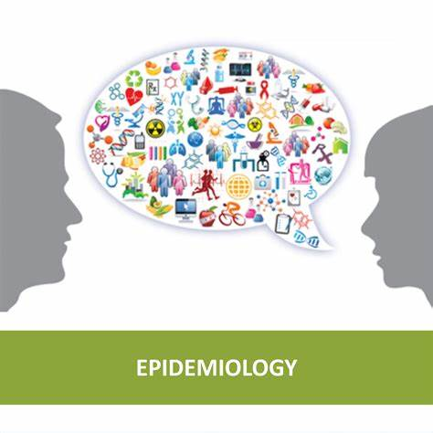
Figure 9:EPIDEMOLOGY
.

- MANUFACTURING:
Due to capacity limitations in the standard supply chains, some digital manufacturers are printing healthcare material such as nasal swabs and ventilator parts.

- EXPERIMENTAL TESTING:
No medications are approved to treat the disease by the WHO although some are recommended by individual national medical authorities. Research into potential treatments started in January 2020, and several antiviral drugs are in clinical trials. Although new medications may take until 2021 to develop, several of the medications being tested are already approved for other uses or are already in advanced testing.
- INFORMATION TECHNOLOGY:
In February 2020, China launched a mobile app to deal with the disease outbreak. Users are asked to enter their name and ID number. The app is able to detect 'close contact' using surveillance data and therefore a potential risk of infection. Every user can also check the status of three other users. If a potential risk is detected, the app not only recommends self-quarantine, it also alerts local health officials. Big data analytics on cell phone data, facial recognition technology, mobile phone tracking and artificial intelligence are used to track infected people and people whom they contacted in South Korea, Taiwan and Singapore. In March 2020, the Israeli government enabled security agencies to track mobile phone data of people supposed to have coronavirus. The measure was taken to enforce quarantine and protect those who may come into contact with infected citizens.
Also in March 2020, Deutsche Telekom shared aggregated phone location data with the German federal government agency, Robert Koch Institute, in order to research and prevent the spread of the virus.
Russia deployed facial recognition technology to detect quarantine breakers. Italian regional health commissioner Giulio Gallera said he has been informed by mobile phone operators that "40% of people are continuing to move around anyway".
German government conducted a 48 hours weekend hackathon with more than 42.000 participants. Also the president of Estonia, Kersti Kaljulaid, made a global call for creative solutions against the spread of coronavirus.

CHAPTER FOUR

RESULTS
- GOOGLE, APPLE NEW CORONA VIRUS TRACKING SYSTEM:
Apple and Google have announced they are developing a new system to track the spread of the novel coronavirus, which will help users share data via Bluetooth Low Energy (BLE) transmissions, and other apps approved by health organizations.
The new tracking system will use short-range communications via Bluetooth to establish voluntary networks that trace recent contacts and archive extensive data on phones that have been in close proximity to one another, reports The Verge. Apps put out by public health authorities will also have full access to the data, and users who download the apps may report if they have been diagnosed with the COVID-19 illness. The new tracking system will also alert those who downloaded them to check if they've been in close contact with an infected person.

- INNOVATIVE FACE MASK FOR THE HEARING IMPAIRED:
The masks have a transparent section over the mouth for the hearing impaired to read lips. The masks also allow people to see the wearer's facial expressions, which is crucial when using Sign Language.
- MECHANICAL VENTILATION:
Most cases of COVID-19 are not severe enough to require mechanical ventilation (artificial assistance to support breathing), but a percentage of cases do. It has been recommended for the use of invasive mechanical ventilation because this technique limits the spread of aerosolised transmission vectors.
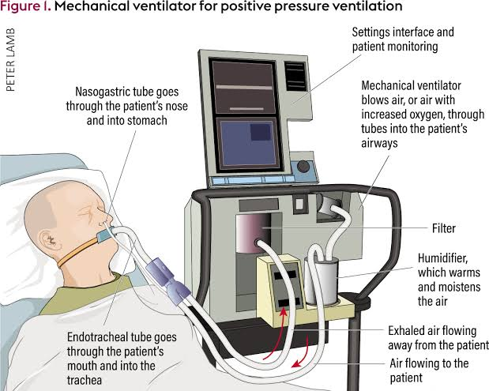
Figure 10: mechanical ventilation

CONCLUSION

CONCLUSION AND RECOMMENDATION
I strongly believe that the above mentioned strategies of engineering in handling the pandemic situation are effectively been carried out to help the victims as well as the rest of the world in taking preventive measures.
I also believe that the above mentioned results have also taking great effect in both sides of the world (victims and non-victims).

RECOMMENDATION
With respect to the current situation, I recommend the following:
- People should strictly adhere to the WHO instructions and guidance.
- People should follow and obey the country’s order and protocols.
- Governments in the country should take responsibility and provide for her citizens, especially those with little or no means of provision.
- People should use this medium to be creative and engage in one form of activity (legal) or the other from their various homes.
- Lastly, every person should engage in prayers and worships and to call upon their LORD fr help.

