A TERM PAPER ON THE DEVELOPMENT OF ENVIRONMENTAL HEALTH ENGINEERING FACILITIES, EQUIPMENTS , SENSORS AND PUBLIC HEALTH SYSTEM FOR TACKLING COVID-19 PANDEMIC
PREPARED BY
OGUNLEYE ADEDAPO ALMARTEEN
FROM
AFE BABALOLA UNIVERSITY, ADO EKITI(ABUAD)
IN THE DEPARTMENT OF
CIVIL ENGINEERING
WITH MATRIC NUMBER
17/ENG03/038

LIST OF FIGURES
- Figure 1-symptoms of COVID-19
- Figure 2-Cases, deaths and recoveries of COVID-19
- Figure 3-Infected patients in mild and critical conditions
- Figure 4-Graph of ACTIVE cases of COVID-19
- Figure 5- Graph of CLOSED cases of COVID-19
- Figure 6-Logarithmic graph of the total cases of COVID-19
- Figure 7-Linear graph of the total cases of COVID-19
- Figure 8- Logarithmic graph of the total deaths of COVID-19
- Figure 9- Linear graph of the total deaths of COVID-19

INTRODUCTION
What is COVID-19?
Coronavirus disease 2019 (COVID-19) is an infectious disease caused by severe acute respiratory syndrome coronavirus 2 (SARS-Cov-2). The virus was first identified in WUHAN, the capital of China’s HUBEI province, and has since spread globally, resulting in the ongoing 2019-20 corona virus pandemic. Common symptoms include fever, cough and shortness of breath. Other symptoms may include fatigue, muscle pain, diarrhea, sore throat, loss of smell and abdominal pain. The time from exposure to onset of symptoms is typically around five days.
Other names for COVID-19
- Corona virus
- COVID
- 2019-nCoV acute respiratory disease
- Novel corona virus pneumonia
- Wuhan pneumonia.
The virus is mainly spread between people in close contact, often via small droplets produced during coughing, sneezing, or even talking. While these droplets are produced when breathing out, they usually fall to the ground or surfaces rather than being infectious over large distances. People may also become infected by touching a contaminated surface and then their face. The virus can survive for up to 72 hours and is most contagious during the first three days after onset of symptoms, although spread may be possible before symptoms, although spread may be possible before symptoms appear and in later stages of the diseases.

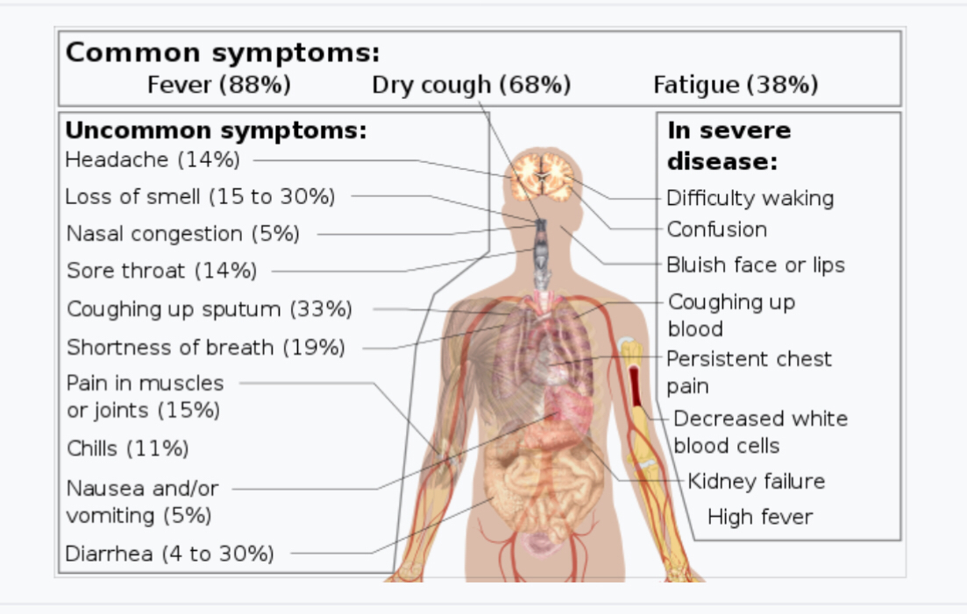
Figure 1-symptoms of COVID-19
“The best defense against any outbreak is a strong health system,” stressed WHO Director-General Tedros Adhanom Ghebreyesus. “COVID-19 is revealing how fragile many of the world’s health systems and services are, forcing countries to make difficult choices on how to best meet the needs of their people.”
To help countries navigate through these challenges, the World Health Organization (WHO) has updated operational planning guidelines in balancing the demands of responding directly to COVID-19 while maintaining essential health service delivery, and mitigating the risk of system collapse. This includes a set of targeted immediate actions that countries should consider at national, regional, and local level to reorganize and maintain access to high-quality essential health services for all.
Countries should identify essential services that will be prioritized in their efforts to maintain continuity of service delivery and make strategic shifts to ensure that increasingly limited resources provide maximum benefit for the population. They also need to comply with the highest standard in precautions, especially in hygiene practices, and the provision of adequate supplies including personal protective equipment This requires robust planning and coordinated actions between governments and health facilities and their managers.
Some examples of essential services include: routine vaccination; reproductive health services including care during pregnancy and childbirth; care of young infants and older adults; management of mental health conditions as well as noncommunicable diseases and infectious diseases like HIV, malaria and TB; critical inpatient therapies; management of emergency health conditions; auxiliary services like basic diagnostic imaging, laboratory services, and blood bank services, among others.
Well-organized and prepared health systems can continue to provide equitable access to essential service delivery throughout an emergency, limiting direct mortality and avoiding increased indirect mortality.
The guidelines stress the importance of keeping up-to-date information. This requires frequent transparent communications with the public, and strong community engagements so the public can maintain trust in the system to safely meet their essential needs and to control infection risk in health facilities. This will help ensure that people continue to seek care when appropriate, and adhere to public health advice.

Country | Total cases | New cases | Total deaths | New deaths | Total recovered | Active cases | Serious/Critical | Total cases/1M pop | Death cases/1M pop | Total tests | Tests/1M pop
World | 1,854,214 | 1,957 | 114,293 | 99 | 428,082 | 1,311,839 | 50,852 | 238 | 14.7
USA | 560,433 | 133 | 22,115 | 10 | 32,634 | 505,684 | 11,766 | 1,693 | 67 | 2,833,112 | 8,559
Spain | 166,831 |  | 17,209 |  | 62,391 | 87,231 | 7,371 | 3,568 | 368 | 600,000 | 12,833
Italy | 156,363 |  | 19,899 |  | 34,211 | 102,253 | 3,343 | 2,586 | 329 | 1,010,193 | 16,708
France | 132,591 |  | 14,393 |  | 27,186 | 91,012 | 6,845 | 2,031 | 221 | 333,807 | 5,114
Germany | 127,854 |  | 3,022 |  | 64,300 | 60,532 | 4,895 | 1,526 | 36 | 1,317,887 | 15,730
UK | 84,279 |  | 10,612 |  | N/A | 73,323 | 1,559 | 1,241 | 156 | 352,974 | 5,200
China | 82,160 | 108 | 3,341 | 2 | 77,663 | 1,156 | 121 | 57 | 2
Iran | 71,686 |  | 4,474 |  | 43,894 | 23,318 | 3,930 | 853 | 53 | 263,388 | 3,136
Turkey | 56,956 |  | 1,198 |  | 3,446 | 52,312 | 1,665 | 675 | 14 | 376,100 | 4,459
Belgium | 29,647 |  | 3,600 |  | 6,463 | 19,584 | 1,223 | 2,558 | 311 | 102,151 | 8,814
Netherlands | 25,587 |  | 2,737 |  | 250 | 22,600 | 1,384 | 1,493 | 160 | 101,534 | 5,926
Switzerland | 25,415 |  | 1,106 |  | 12,700 | 11,609 | 386 | 2,937 | 128 | 193,800 | 22,393
Canada | 24,383 |  | 717 |  | 7,172 | 16,494 | 557 | 646 | 19 | 422,200 | 11,186
Brazil | 22,318 | 126 | 1,230 | 7 | 173 | 20,915 | 296 | 105 | 6 | 62,985 | 296
Portugal | 16,585 |  | 504 |  | 277 | 15,804 | 228 | 1,627 | 49 | 163,616 | 16,046
Russia | 15,770 |  | 130 |  | 1,291 | 14,349 | 8 | 108 | 0.9 | 1,200,000 | 8,223
Austria | 13,945 |  | 350 |  | 6,987 | 6,608 | 243 | 1,548 | 39 | 144,877 | 16,086
Israel | 11,235 | 90 | 110 | 7 | 1,689 | 9,436 | 181 | 1,298 | 13 | 117,339 | 13,557
S. Korea | 10,537 | 25 | 217 | 3 | 7,447 | 2,873 | 55 | 206 | 4 | 514,621 | 10,038
Sweden | 10,483 |  | 899 |  | 381 | 9,203 | 839 | 1,038 | 89 | 54,700 | 5,416
Ireland | 9,655 |  | 334 |  | 25 | 9,296 | 194 | 1,955 | 68 | 53,000 | 10,734
India | 9,240 | 35 | 331 |  | 1,096 | 7,813 |  | 7 | 0.2 | 189,111 | 137
Peru | 7,519 |  | 193 |  | 1,798 | 5,528 | 134 | 228 | 6 | 76,506 | 2,320
Ecuador | 7,466 |  | 333 |  | 501 | 6,632 | 184 | 423 | 19 | 23,635 | 1,340
Japan | 7,370 |  | 123 |  | 784 | 6,463 | 129 | 58 | 1 | 77,381 | 612
Chile | 7,213 |  | 80 |  | 2,059 | 5,074 | 387 | 377 | 4 | 82,271 | 4,304
Poland | 6,674 |  | 232 |  | 439 | 6,003 | 160 | 176 | 6 | 138,007 | 3,646
Norway | 6,525 |  | 128 |  | 32 | 6,365 | 59 | 1,204 | 24 | 126,486 | 23,332
Australia | 6,359 | 46 | 61 | 2 | 3,494 | 2,804 | 79 | 249 | 2 | 362,136 | 14,201
Romania | 6,300 |  | 316 |  | 852 | 5,132 | 204 | 327 | 16 | 62,328 | 3,240
Denmark | 6,174 |  | 273 |  | 2,123 | 3,778 | 104 | 1,066 | 47 | 70,125 | 12,107
Czechia | 5,991 |  | 139 | 1 | 467 | 5,385 | 87 | 559 | 13 | 128,359 | 11,986
Pakistan | 5,374 | 144 | 93 | 2 | 1,095 | 4,186 | 44 | 24 | 0.4 | 65,114 | 295
Malaysia | 4,683 |  | 76 |  | 2,108 | 2,499 | 66 | 145 | 2 | 77,491 | 2,394
Mexico | 4,661 | 442 | 296 | 23 | 1,843 | 2,522 | 185 | 36 | 2 | 36,594 | 284
Philippines | 4,648 |  | 297 |  | 197 | 4,154 | 1 | 42 | 3 | 33,814 | 309
Saudi Arabia | 4,462 |  | 59 |  | 761 | 3,642 | 67 | 128 | 2 | 115,585 | 3,320
Indonesia | 4,241 |  | 373 |  | 359 | 3,509 |  | 16 | 1 | 27,075 | 99
UAE | 4,123 |  | 22 |  | 680 | 3,421 | 1 | 417 | 2 | 648,195 | 65,538
Serbia | 3,630 |  | 80 |  | 400 | 3,150 | 146 | 415 | 9 | 18,312 | 2,096
Panama | 3,400 |  | 87 |  | 29 | 3,284 | 106 | 788 | 20 | 15,147 | 3,511
Luxembourg | 3,281 |  | 66 |  | 500 | 2,715 | 30 | 5,241 | 105 | 29,165 | 46,591
Ukraine | 3,102 | 325 | 93 | 10 | 97 | 2,912 | 45 | 71 | 2 | 30,314 | 693
Qatar | 2,979 |  | 7 |  | 275 | 2,697 | 37 | 1,034 | 2 | 49,102 | 17,043
Finland | 2,974 |  | 56 |  | 300 | 2,618 | 80 | 537 | 10 | 45,019 | 8,125
Dominican Republic | 2,967 |  | 173 |  | 131 | 2,663 | 147 | 274 | 16 | 9,275 | 855
Colombia | 2,776 |  | 109 |  | 270 | 2,397 | 92 | 55 | 2 | 41,765 | 821
Thailand | 2,579 | 28 | 40 | 2 | 1,288 | 1,251 | 61 | 37 | 0.6 | 71,860 | 1,030
Belarus | 2,578 |  | 26 |  | 203 | 2,349 | 50 | 273 | 3 | 64,000 | 6,773
Singapore | 2,532 |  | 8 |  | 560 | 1,964 | 31 | 433 | 1 | 72,680 | 12,423
Argentina | 2,208 | 66 | 95 | 5 | 468 | 1,645 | 83 | 49 | 2 | 19,758 | 437
South Africa | 2,173 |  | 25 |  | 410 | 1,738 | 7 | 37 | 0.4 | 80,085 | 1,350
Greece | 2,114 |  | 98 |  | 269 | 1,747 | 76 | 203 | 9 | 42,261 | 4,055
Egypt | 2,065 |  | 159 |  | 589 | 1,317 |  | 20 | 2 | 25,000 | 244
Algeria | 1,914 |  | 293 |  | 591 | 1,030 | 60 | 44 | 7 | 3,359 | 77
Iceland | 1,701 |  | 8 |  | 889 | 804 | 10 | 4,985 | 23 | 35,253 | 103,308
Moldova | 1,662 |  | 33 | 2 | 107 | 1,522 | 80 | 412 | 8 | 6,271 | 1,555
Morocco | 1,661 |  | 118 |  | 177 | 1,366 | 1 | 45 | 3 | 8,473 | 230
Croatia | 1,600 |  | 23 |  | 373 | 1,204 | 34 | 390 | 6 | 16,381 | 3,990
Hungary | 1,458 | 48 | 109 | 10 | 120 | 1,229 | 58 | 151 | 11 | 34,819 | 3,604
Iraq | 1,352 |  | 76 |  | 640 | 636 |  | 34 | 2 | 35,415 | 880
New Zealand | 1,349 | 19 | 5 | 1 | 546 | 798 | 4 | 280 | 1 | 62,827 | 13,029
Estonia | 1,332 | 23 | 27 | 2 | 102 | 1,203 | 9 | 1,004 | 20 | 30,764 | 23,191
Kuwait | 1,234 |  | 1 |  | 142 | 1,091 | 29 | 289 | 0.2
Slovenia | 1,205 |  | 53 |  | 150 | 1,002 | 35 | 580 | 25 | 34,851 | 16,764
Bahrain | 1,136 |  | 6 |  | 558 | 572 | 4 | 668 | 4 | 63,973 | 37,596
Azerbaijan | 1,098 |  | 11 |  | 250 | 837 | 27 | 108 | 1 | 66,677 | 6,576
Lithuania | 1,062 | 9 | 24 | 1 | 101 | 937 | 14 | 390 | 9 | 41,503 | 15,246
Bosnia and Herzegovina | 1,018 | 9 | 39 |  | 206 | 773 | 4 | 310 | 12 | 10,975 | 3,345
Armenia | 1,013 |  | 13 |  | 197 | 803 | 30 | 342 | 4 | 7,164 | 2,418
Hong Kong | 1,005 |  | 4 |  | 360 | 641 | 13 | 134 | 0.5 | 96,709 | 12,900
Kazakhstan | 973 | 22 | 11 | 1 | 99 | 863 | 21 | 52 | 0.6 | 69,304 | 3,691
Uzbekistan | 896 | 31 | 4 |  | 66 | 826 | 8 | 27 | 0.1 | 70,000 | 2,091
North Macedonia | 828 |  | 34 |  | 41 | 753 | 15 | 397 | 16 | 8,057 | 3,867
Cameroon | 820 |  | 12 |  | 98 | 710 |  | 31 | 0.5
Slovakia | 742 |  | 2 |  | 23 | 717 | 5 | 136 | 0.4 | 27,426 | 5,023
Oman | 727 | 128 | 4 |  | 124 | 599 | 3 | 142 | 0.8
Diamond Princess | 712 |  | 11 |  | 619 | 82 | 10
Tunisia | 707 |  | 31 |  | 43 | 633 | 85 | 60 | 3 | 11,238 | 951
Bulgaria | 676 | 1 | 31 | 2 | 71 | 574 | 36 | 97 | 4 | 18,502 | 2,663
Cuba | 669 |  | 18 |  | 92 | 559 | 11 | 59 | 2 | 15,057 | 1,329
Latvia | 653 | 2 | 5 |  | 16 | 632 | 2 | 346 | 3 | 28,776 | 15,256
Andorra | 638 |  | 29 |  | 128 | 481 | 17 | 8,257 | 375 | 1,673 | 21,653
Cyprus | 633 |  | 11 |  | 65 | 557 | 8 | 524 | 9 | 17,923 | 14,845
Lebanon | 630 |  | 20 |  | 80 | 530 | 34 | 92 | 3 | 15,152 | 2,220
Bangladesh | 621 |  | 34 |  | 39 | 548 | 1 | 4 | 0.2 | 9,653 | 59
Afghanistan | 607 |  | 19 | 1 | 32 | 556 |  | 16 | 0.5
Costa Rica | 595 |  | 3 |  | 56 | 536 | 14 | 117 | 0.6 | 6,762 | 1,327
Ivory Coast | 574 |  | 5 |  | 85 | 484 |  | 22 | 0.2
Ghana | 566 |  | 8 |  | 4 | 554 | 2 | 18 | 0.3 | 37,954 | 1,221
Niger | 529 |  | 12 |  | 75 | 442 |  | 22 | 0.5 | 4,353 | 180
Burkina Faso | 497 |  | 27 |  | 161 | 309 |  | 24 | 1
Uruguay | 480 |  | 8 | 1 | 231 | 241 | 15 | 138 | 2 | 8,774 | 2,526
Albania | 446 |  | 23 |  | 217 | 206 | 7 | 155 | 8 | 3,877 | 1,347
Channel Islands | 431 |  | 9 |  | 48 | 374 |  | 2,479 | 52 | 3,320 | 19,095
Kyrgyzstan | 419 | 42 | 5 |  | 67 | 347 | 5 | 64 | 0.8 | 9,618 | 1,474
Honduras | 397 | 4 | 25 |  | 7 | 365 | 10 | 40 | 3 | 1,600 | 162
Taiwan | 393 | 5 | 6 |  | 114 | 273 |  | 17 | 0.3 | 47,215 | 1,982
Jordan | 389 |  | 7 |  | 201 | 181 | 5 | 38 | 0.7 | 20,500 | 2,009
Réunion | 389 |  |  |  | 40 | 349 | 3 | 434
Malta | 378 |  | 3 |  | 44 | 331 | 4 | 856 | 7 | 17,058 | 38,633
San Marino | 356 |  | 35 |  | 53 | 268 | 14 | 10,492 | 1,032 | 846 | 24,933
Bolivia | 330 | 30 | 27 | 3 | 2 | 301 | 3 | 28 | 2 | 2,185 | 187
Mauritius | 324 |  | 9 |  | 42 | 273 | 3 | 255 | 7 | 7,077 | 5,565
Nigeria | 323 |  | 10 |  | 85 | 228 | 2 | 2 | 0.05 | 5,000 | 24
Palestine | 290 |  | 2 |  | 58 | 230 |  | 57 | 0.4 | 17,329 | 3,397
Senegal | 280 |  | 2 |  | 171 | 107 | 1 | 17 | 0.1
Montenegro | 273 | 1 | 3 |  | 5 | 265 | 7 | 435 | 5 | 2,869 | 4,568
Georgia | 266 | 9 | 3 |  | 67 | 196 | 6 | 67 | 0.8 | 3,271 | 820
Vietnam | 262 |  |  |  | 144 | 118 | 8 | 3 |  | 121,821 | 1,252
Guinea | 250 |  |  |  | 17 | 233 |  | 19
DRC | 234 |  | 20 |  | 16 | 198 |  | 3 | 0.2
Isle of Man | 228 |  | 2 |  | 112 | 114 | 11 | 2,681 | 24 | 1,934 | 22,744
Djibouti | 214 |  | 2 |  | 36 | 176 |  | 217 | 2 | 4,451 | 4,505
Sri Lanka | 210 |  | 7 |  | 56 | 147 | 1 | 10 | 0.3 | 4,525 | 211
Kenya | 197 |  | 8 |  | 25 | 164 | 2 | 4 | 0.1 | 7,449 | 139
Mayotte | 196 |  | 3 |  | 59 | 134 | 3 | 718 | 11 | 1,350 | 4,948
Faeroe Islands | 184 |  |  |  | 157 | 27 |  | 3,766 |  | 5,509 | 112,744
Venezuela | 181 |  | 9 |  | 93 | 79 | 6 | 6 | 0.3 | 181,335 | 6,377
Martinique | 155 |  | 6 |  | 50 | 99 | 19 | 413 | 16
Guatemala | 155 |  | 5 |  | 19 | 131 | 3 | 9 | 0.3 | 1,134 | 63
Paraguay | 147 | 13 | 6 |  | 22 | 119 | 1 | 21 | 0.8 | 2,262 | 317
Guadeloupe | 143 |  | 8 |  | 67 | 68 | 13 | 357 | 20
El Salvador | 137 | 12 | 6 |  | 22 | 109 | 2 | 21 | 0.9 | 6,729 | 1,037
Brunei | 136 |  | 1 |  | 106 | 29 | 2 | 311 | 2 | 9,884 | 22,593
Gibraltar | 129 |  |  |  | 84 | 45 | 1 | 3,829 |  | 1,558 | 46,244
Rwanda | 126 |  |  |  | 25 | 101 |  | 10 |  | 1,966 | 152
Cambodia | 122 |  |  |  | 77 | 45 | 1 | 7 |  | 5,768 | 345
Trinidad and Tobago | 113 |  | 8 |  | 16 | 89 |  | 81 | 6 | 1,126 | 805
Madagascar | 106 |  |  |  | 20 | 86 | 1 | 4
Mali | 105 |  | 9 |  | 22 | 74 |  | 5 | 0.4
Monaco | 93 |  | 1 |  | 6 | 86 | 5 | 2,370 | 25
Aruba | 92 |  |  |  | 32 | 60 | 1 | 862 |  | 1,145 | 10,724
French Guiana | 86 |  |  |  | 51 | 35 | 1 | 288
Liechtenstein | 79 |  | 1 |  | 55 | 23 |  | 2,072 | 26 | 900 | 23,605
Togo | 76 |  | 3 |  | 29 | 44 |  | 9 | 0.4 | 2,532 | 306
Jamaica | 72 |  | 4 |  | 16 | 52 |  | 24 | 1 | 907 | 306
Barbados | 71 |  | 4 |  | 11 | 56 | 4 | 247 | 14 | 805 | 2,801
Ethiopia | 71 |  | 3 |  | 10 | 58 |  | 0.6 | 0.03 | 3,863 | 34
Congo | 60 |  | 5 |  | 5 | 50 |  | 11 | 0.9
Bermuda | 57 |  | 4 |  | 29 | 24 | 2 | 915 | 64 | 416 | 6,680
Gabon | 57 | 8 | 1 |  | 1 | 55 |  | 26 | 0.4
Uganda | 54 |  |  |  | 4 | 50 |  | 1 |  | 5,025 | 110
Cayman Islands | 53 |  | 1 |  | 6 | 46 | 3 | 806 | 15 | 536 | 8,156
French Polynesia | 53 |  |  |  |  | 53 | 1 | 189 |  | 889 | 3,165
Sint Maarten | 50 |  | 9 |  | 5 | 36 | 2 | 1,166 | 210 | 134 | 3,125
Liberia | 50 |  | 5 |  | 3 | 42 |  | 10 | 1
Bahamas | 47 | 1 | 8 |  | 6 | 33 | 1 | 120 | 20
Guyana | 45 |  | 6 |  | 8 | 31 | 3 | 57 | 8 | 193 | 245
Macao | 45 |  |  |  | 10 | 35 | 1 | 69
Zambia | 43 |  | 2 |  | 30 | 11 | 1 | 2 | 0.1 | 1,239 | 67
Myanmar | 41 |  | 4 |  | 2 | 35 |  | 0.8 | 0.07 | 1,406 | 26
Guinea-Bissau | 38 |  |  |  |  | 38 |  | 19 |  | 1,500 | 762
Benin | 35 |  | 1 |  | 5 | 29 |  | 3 | 0.08
Eritrea | 34 |  |  |  |  | 34 |  | 10
Haiti | 33 |  | 3 |  |  | 30 |  | 3 | 0.3 | 365 | 32
Tanzania | 32 |  | 3 |  | 5 | 24 |  | 0.5 | 0.05
Saint Martin | 32 |  | 2 |  | 11 | 19 | 5 | 828 | 52
Somalia | 25 |  | 2 | 1 | 2 | 21 | 2 | 2 | 0.1
Syria | 25 |  | 2 |  | 5 | 18 |  | 1 | 0.1
Libya | 25 |  | 1 |  | 9 | 15 |  | 4 | 0.1 | 535 | 78
Antigua and Barbuda | 21 |  | 2 |  |  | 19 | 1 | 214 | 20 | 40 | 408
Equatorial Guinea | 21 |  |  |  | 3 | 18 |  | 15 |  | 854 | 609
Mozambique | 21 |  |  |  | 2 | 19 |  | 0.7 |  | 679 | 22
Maldives | 20 |  |  |  | 14 | 6 |  | 37
Angola | 19 |  | 2 |  | 4 | 13 |  | 0.6 | 0.06
Sudan | 19 |  | 2 |  | 2 | 15 |  | 0.4 | 0.05
Laos | 19 |  |  |  |  | 19 |  | 3 |  | 1,140 | 157
Chad | 18 |  |  |  | 2 | 16 |  | 1
New Caledonia | 18 |  |  |  | 1 | 17 |  | 63 |  | 2,608 | 9,135
Mongolia | 17 | 1 |  |  | 4 | 13 |  | 5
Dominica | 16 |  |  |  | 8 | 8 |  | 222 |  | 345 | 4,793
Fiji | 16 |  |  |  |  | 16 |  | 18
Namibia | 16 |  |  |  | 3 | 13 |  | 6 |  | 362 | 142
Saint Lucia | 15 |  |  |  | 4 | 11 |  | 82
Zimbabwe | 14 |  | 3 |  |  | 11 |  | 0.9 | 0.2 | 563 | 38
Belize | 14 |  | 2 |  |  | 12 | 1 | 35 | 5 | 364 | 915
Curaçao | 14 |  | 1 |  | 8 | 5 |  | 85 | 6
Grenada | 14 |  |  |  |  | 14 | 2 | 124 |  | 92 | 818
Eswatini | 14 |  |  |  | 7 | 7 |  | 12
Malawi | 13 |  | 2 |  |  | 11 | 1 | 0.7 | 0.1 | 287 | 15
Botswana | 13 |  | 1 |  |  | 12 |  | 6 | 0.4 | 3,115 | 1,325
Nepal | 13 | 1 |  |  | 1 | 12 |  | 0.4 |  | 5,184 | 178
Saint Kitts and Nevis | 12 |  |  |  |  | 12 |  | 226 |  | 205 | 3,853
St. Vincent Grenadines | 12 |  |  |  | 1 | 11 |  | 108 |  | 56 | 505
Greenland | 11 |  |  |  | 11 | 0 |  | 194 |  | 912 | 16,065
Montserrat | 11 | 2 |  |  | 1 | 10 | 1 | 2,204 |  | 36 | 7,212
Seychelles | 11 |  |  |  |  | 11 |  | 112
Suriname | 10 |  | 1 |  | 4 | 5 |  | 17 | 2
Sierra Leone | 10 |  |  |  |  | 10 |  | 1
MS Zaandam | 9 |  | 2 |  |  | 7
Gambia | 9 |  | 1 |  | 2 | 6 |  | 4 | 0.4 | 281 | 116
Nicaragua | 9 |  | 1 |  | 4 | 4 |  | 1 | 0.2
Turks and Caicos | 9 |  | 1 |  |  | 8 |  | 232 | 26 | 62 | 1,601
Cabo Verde | 8 |  | 1 |  | 1 | 6 |  | 14 | 2
CAR | 8 |  |  |  |  | 8 |  | 2
Vatican City | 8 |  |  |  | 2 | 6 |  | 9,988
Mauritania | 7 |  | 1 |  | 2 | 4 |  | 2 | 0.2 | 496 | 107
St. Barth | 6 |  |  |  | 4 | 2 |  | 607
Western Sahara | 6 |  |  |  |  | 6 |  | 10
Bhutan | 5 |  |  |  | 2 | 3 |  | 6 |  | 1,166 | 1,511
Burundi | 5 |  |  |  |  | 5 |  | 0.4
Falkland Islands | 5 |  |  |  | 1 | 4 |  | 1,437 |  | 137 | 39,368
Sao Tome and Principe | 4 |  |  |  |  | 4 |  | 18 |  | 19 | 87
South Sudan | 4 |  |  |  |  | 4 |  | 0.4
Anguilla | 3 |  |  |  | 1 | 2 |  | 200
British Virgin Islands | 3 |  |  |  | 2 | 1 |  | 99
Caribbean Netherlands | 3 |  |  |  |  | 3 |  | 114 |  | 10 | 381
Papua New Guinea | 2 |  |  |  |  | 2 |  | 0.2 |  | 72 | 8
Timor-Leste | 2 |  |  |  | 1 | 1 |  | 2
Saint Pierre Miquelon | 1 |  |  |  |  | 1 |  | 173
Yemen | 1 |  |  |  |  | 1 |  | 0.03
Total: | 1,854,214 | 1,957 | 114,293 | 99 | 428,082 | 1,311,839 | 50,852 | 237.9 | 14.7

Table 1- Analysis of the cases of COVID-19

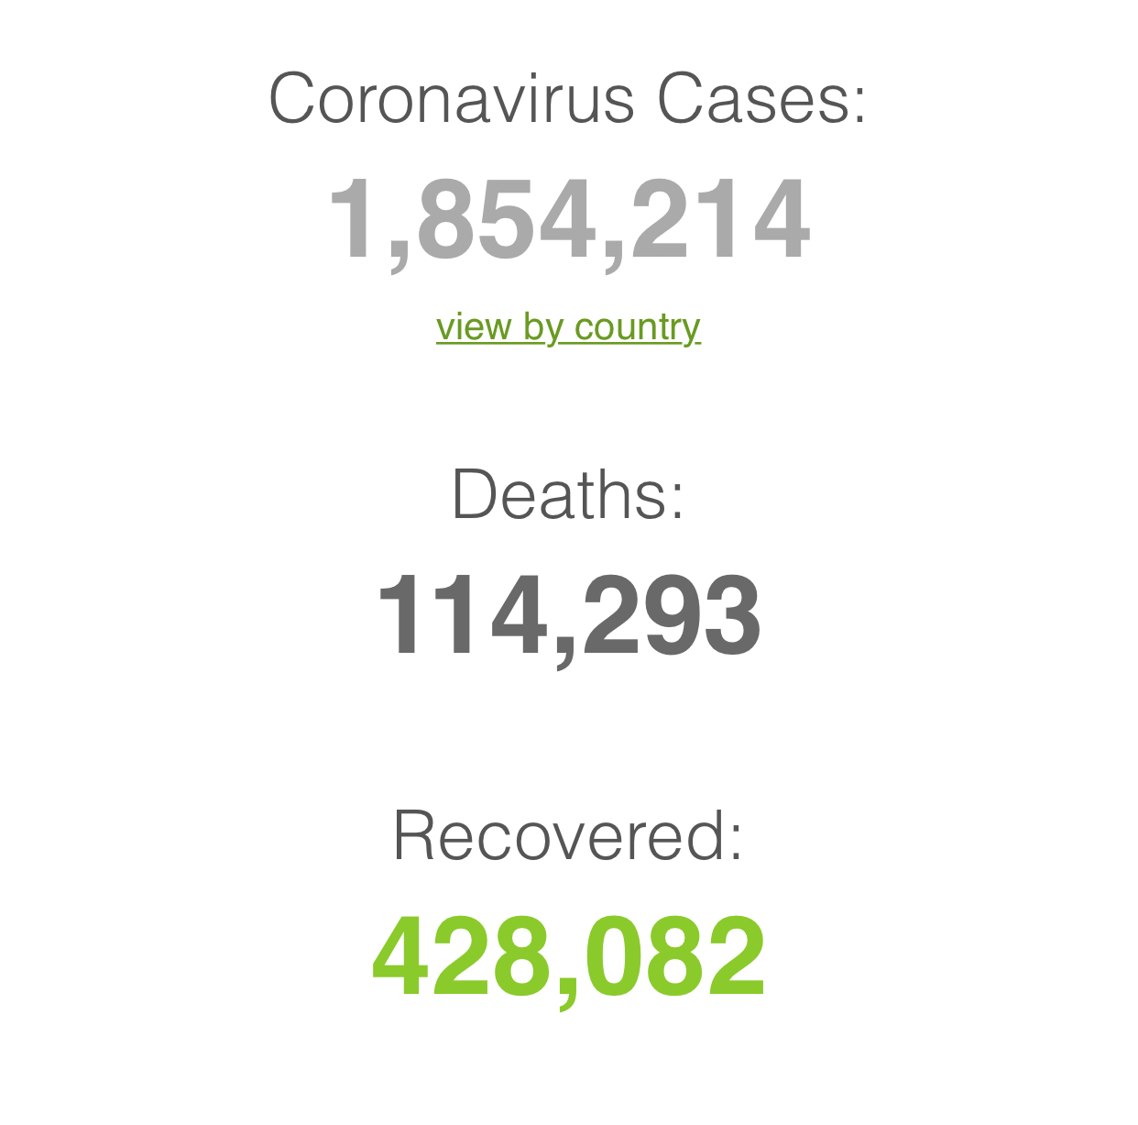
Figure 2-Cases, deaths and recoveries of COVID-19

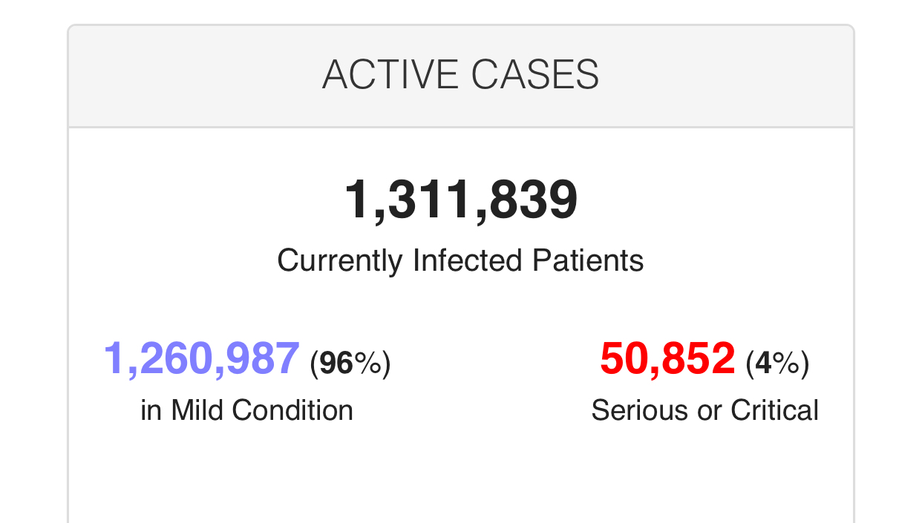
Figure 3-Infected patients in mild and critical conditions
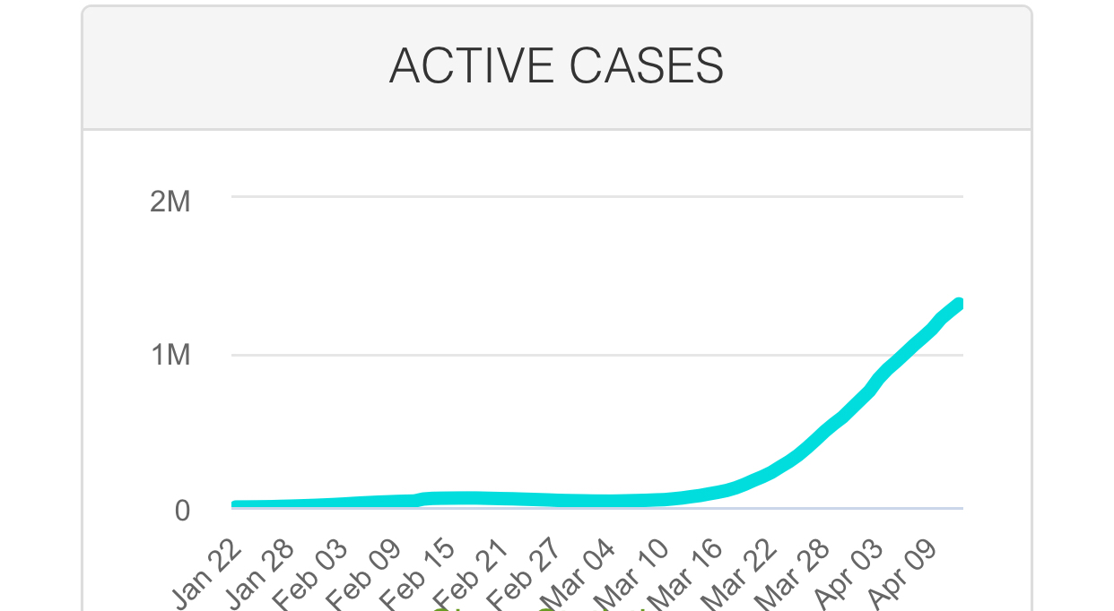
Figure 4-Graph of ACTIVE cases of COVID-19

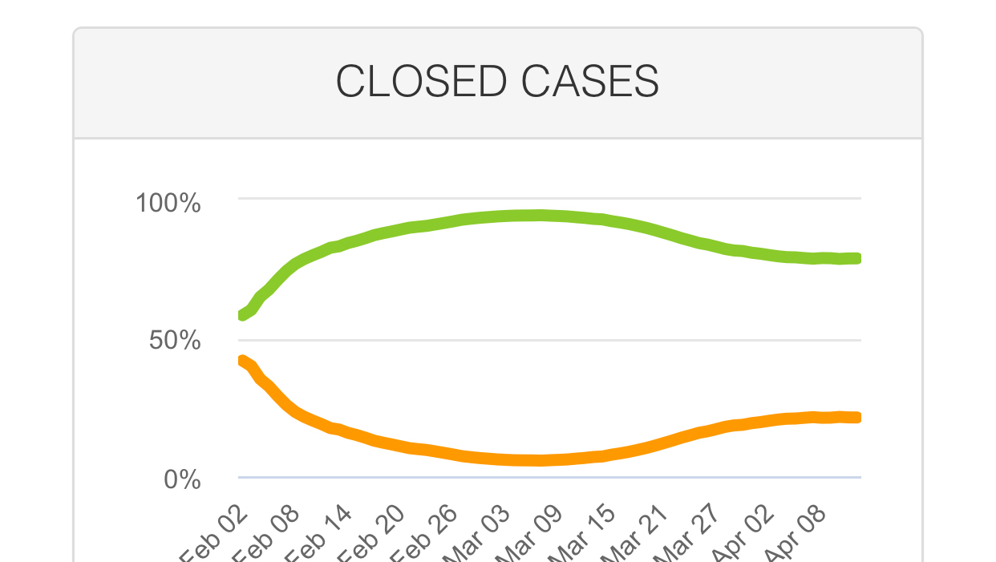
Figure 5- Graph of CLOSED cases of COVID-19
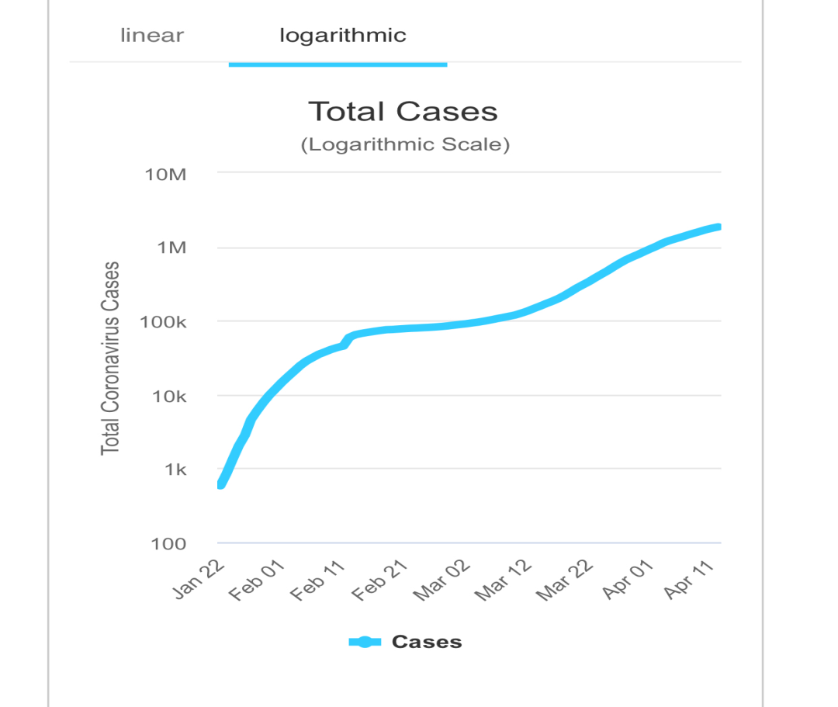

Figure 6-Logarithmic graph of the total cases of COVID-19
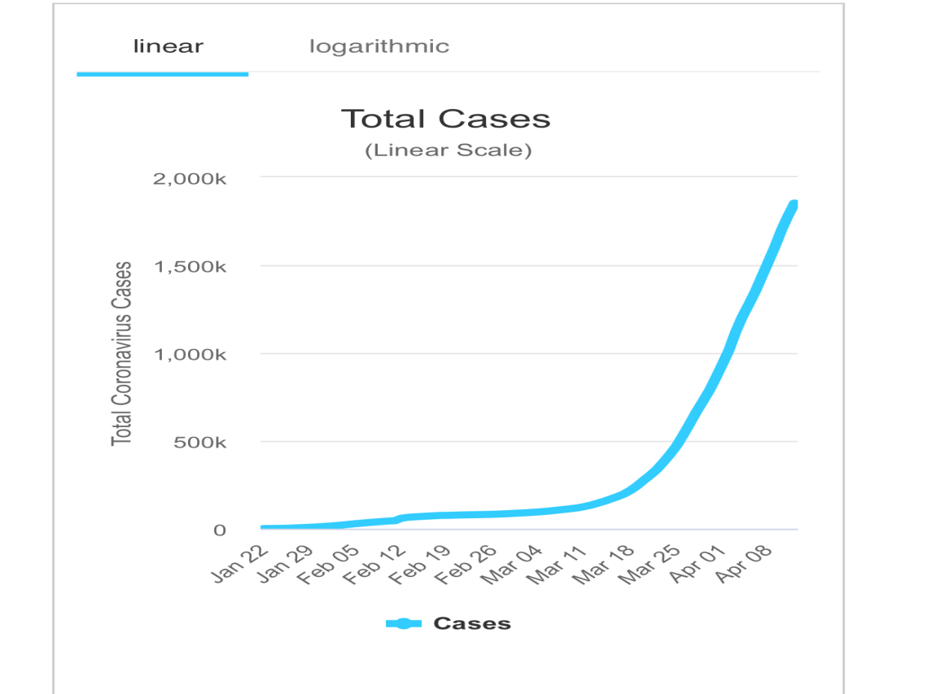
Figure 7-Linear graph of the total cases of COVID-19
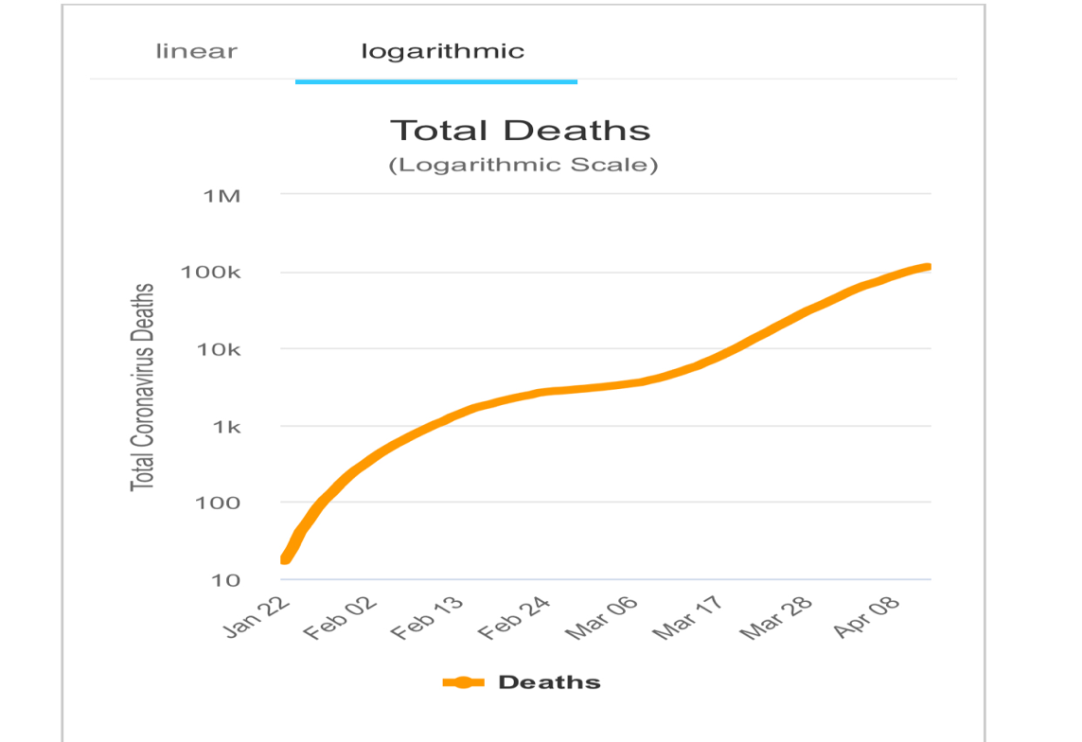

Figure 8- Logarithmic graph of the total deaths of COVID-19
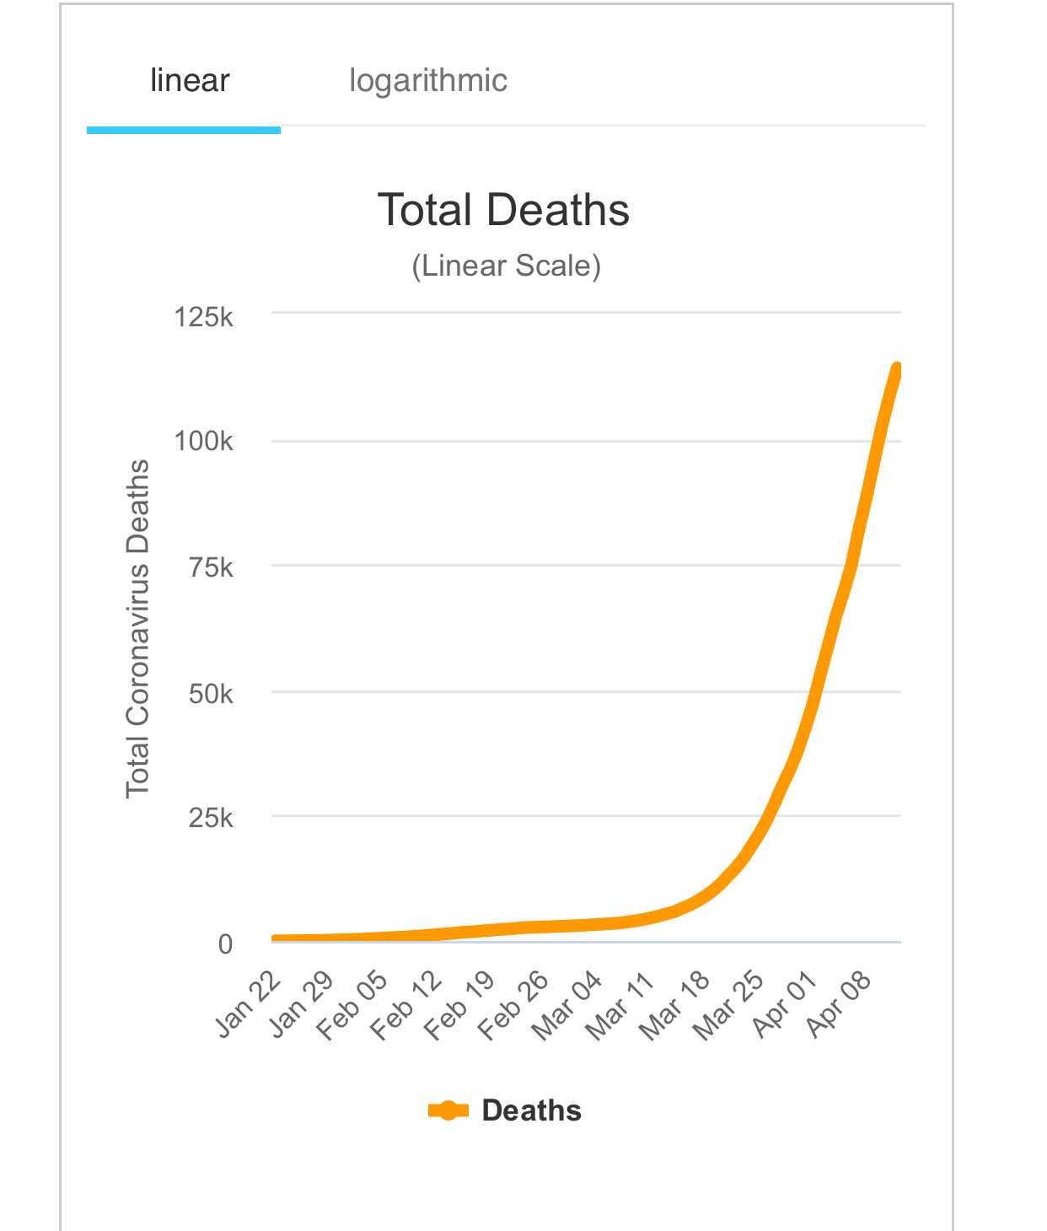
Figure 9- Linear graph of the total deaths of COVID-19

All over the world right now, the COVID-19 pandemic has given every nook and cranny of each country a big blow in the face and that’s to say the very least! The COVID-19 pandemic is straining the health systems worldwide, and the rapidly increasing demand on health facilities, health care workers threatening to leave some health systems is a gunshot to the wound already sustained by the world at large and this in turn would not enhance effective workability of supposedly envisaged development of health system management.
Previous outbreaks have demonstrated that when health systems are overwhelmed, mortality from vaccine-preventable and other treatable conditions can also increase dramatically. During the 2014-2015 Ebola outbreak, the increased number of deaths caused by measles, malaria, HIV/AIDS and tuberculosis attributable to health system failures exceeded deaths from Ebola.
The following are methods and ways that can be used to tackle the virus during its attack, before and after its attack;
- Routine vaccination
Routine vaccines are those recommended for everyone depending on age and vaccine and history. Most people think of these as childhood vaccines that you get before starting school, but CDC also recommends routine vaccines for adults like Flu vaccine, polio vaccine, tetanus booster shots. There should be time-to—time vaccinations ready for tackling corona virus so as to stay ready to fight the virus if there’s any chance that it will resurface.
- Care during pregnancy and childbirth
It is a widely known information that any virus of any sort attacks pregnant women faster because their immune system is already weak and affected thereby giving the virus easy entrance to the body system of these victims so it is very important that pregnant women are looked into and given enough care and protection against the virus.
- Care of young infants and older adults
Young infants and older adults are also very liable to get affected faster than other people because their immune system is not as strong as it is meant to be, and in that case, the virus attacks these lots faster than normal and when it does, their body is not strong enough to resist so they die faster so these people too should also be taken a good look at whilst caring and protecting pregnant women from this virus.
- Management of mental health conditions as well as non-communicable diseases and infectious diseases like HIIV, malaria and tuberculosis
Researches have shown that when viruses attack the body system, other smaller sicknesses like malaria, tuberculosis, HIV attack faster because the virus has paved a way for these sicknesses to penetrate the body system and in order to prevent this, all these casualties are managed beforehand.
- Critical inpatient therapies
An inpatient is someone under treatment that lives in the hospital and they should be given critical therapies that helps them live better after being diagnosed with these virus.
- Management of emergency health conditions
Management of emergencies is an integral part of primary care. Medical emergencies like chest pain accompanied by sweating, vomiting, nausea, shortness of breath and other symptoms that this virus comes with, it’s best to know how to manage these situations with adequate and efficient facilities.
- Auxiliary services (i.e basic diagnostic imaging, laboratory services and blood-bank services etc)
Other services like basic diagnostic imaging, laboratory services and blood-bank services should not be found wanting in this point in time because it is crucial and important that tests are being run every single time a patient is being admitted and it should be done as quick and swift as it can get.
In conclusion, after adhering to these above discussed views and ideas, the pandemic can therefore be brought close too silence if not silenced afterall.

