A TERM PAPER

ON

CRITICAL ASSESSMENT OF LEGAL IMPLICATIONS AND ECONOMIC IMPACT OF LOCK DOWN OF ACTIVITIES IN NIGERIA

PREPARED BY

NWODO CHUBIKE WILLIAM

17/ENG05/023

SUBMITTED TO THE DEPARTMENT OF MECHATRONICS ENGINEERING IN PARTIAL FULLFILLMENT OF ENG 384: ENGINEERING LAW AND MANAGERIAL ECONOMICS

DATE TO BE SUBMITTED: THURSDAY 13TH APRIL, 2020

Abstract
The Coronavirus (COVID-19 pandemic) which has spread like wildfire due to social interactions, and free-living of the citizens, has caused government all over the world to invoke the Stay at Home rule, therefore, leading to Lockdown of shops, malls, restaurants and various social gathering spots and activities.
In this term paper, we are focusing on how the Lockdown of activities in Nigeria caused by the Coronavirus can affect the legal proceedings of Nigeria and also how it can affect us Economically.

LIST OF TABLES
Table 1.0 8

LIST OF FIGURES

Figure 1. 1: COVID-19 Cells Model 7
Figure 3.1: How COVID-19 affects Aggregate Demand………………………………………………………..16

TABLE OF CONTENTS

Chapter 1-Introduction 6
Definition of Lockdown 6
Importance of Social Interaction 6
Chapter 2- Literature Review 7-10
Origin of COVID-19 Pandemic 7-8
Statistics 8
Nigeria’s effort to curb the spread 8-10
Chapter 3- Methology 11-17
Impact of COVID-19 on Nigeria Legally 11-15
Impact of COVID-19 on Nigeria Economcally 15-17
Chapter 4- Conclusion and Recommendation 18
Conclusion 18
Recommendation 18
References 19

Chapter 1
Introduction
  - DEFINITION OF LOCKDOWN
A lockdown is an emergency protocol that usually prevents people or information from leaving an area. The protocol can usually only be initiated by someone in a position of authority. Lockdowns can also be used to protect people inside a facility or, for example, a computing system, from a threat or other external event.
  - IMPORTANCE OF SOCIAL INTERACTION

Humans interact with each other and with their environment to constitute a regular way of life. Social interaction is any relationship between two or more individuals. Social relations derived from individual agency form the basis of social structure and the basic object for analysis by social scientists.
Here are some benefits of Social Interaction;
- Increased physical health. Engaging in relationships helps humans to be more active, improving their physical health through their social activities.
- Boosted immune system. Studies show socially active people have increased immune systems, allowing them to fight of colds, flus and other ailments, more easily.
- More positive outlook on life. Staying connected with others makes us feel more connected to the world and increases our sense of belonging.
- Improved mental sharpness. Keeping our brains active and engaged can sharpen our minds and reduce the risk of cognitive decline.
- Longer, happier lives. By keeping an active social life, humans can increase their lifespan and longevity.
This is just to show that social Interaction is an essential part of human life.
The pandemic induced Lockdown will not only affect the normal life of people by stopping them from freely interacting physically, but also affect the country legally, economically and in other aspects.
This term paper will be giving assessment on the legal implications and economical impact caused by the COVID 19 Lockdown.

Chapter 2
Literature Review
2.1 ORIGIN OF THE COVID-19 PANDEMIC
The disease appears to have originated from a Wuhan seafood market where wild animals, including marmots, birds, rabbits, bats and snakes, are traded illegally. Coronaviruses are known to jump from animals to humans, so it’s thought that the first people infected with the disease a group primarily made up of stallholders from the seafood market contracted it from contact with animals.

The hunt for the animal source of Covid-19 is still unknown, although there are some strong contenders. A team of virologists at the Wuhan Institute for Virology released a detailed paper showing that the new coronaviruses' genetic makeup is 96 per cent identical to that of a coronavirus found in bats, while a study published on March 26 argues that genetic sequences of coronavirus in pangolins are between 88.5 and 92.4 per cent similar to the human virus. Some early cases of Covid-19, however, appear to have inflicted people with no link to the Wuhan market at all, suggesting that the initial route of human infection may pre-date the market cases.

The Wuhan market was shut down for inspection and cleaning on January 1, but by then it appears that Covid-19 was already starting to spread beyond the market itself. On January 21, the WHO Western Pacific office said the disease was also being transmitted between humans’ evidence of which is apparent after medical staff became infected with the virus.
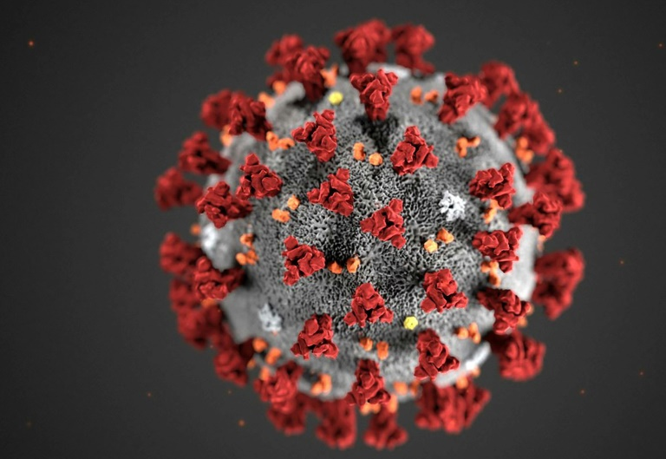
Figure 1. 1: COVID-19 Cell Model
The new coronavirus, which has been provisionally named 2019-nCoV, appears to be a young virus that may have emerged sometime in early December, according to attempts to trace its origins. Based on analysis of its genetic code, 2019-nCOV was initially thought to have jumped to humans from bats. The human virus has been found to share many genetic similarities to two coronaviruses in bats, but others have suggested it may have come from snakes, although this idea has been widely dismissed by virologists.
Most recently, endangered pangolins, whose scales are heavily used in Chinese traditional medicine, are being proposed as a likely conduit for the virus. Some researchers have proposed that a bat coronavirus may have combined with another coronavirus in pangolins to produce the strain now infecting humans.

2.2 STATISTICS

As of recent, Africa has been the lowest in terms of virus spread reach. These are the Statistics of the major countries:

COVID-19 CASES STAISTICS AS OF 12TH APRIL 2020
COUNTRY | CONFIRMED | RECOVERED | DEATHS
NIGERIA | 323 | 85 | 10
UNITED STATES | 559,409 | 33,115 | 22,071
SPAIN | 116,831 | 62,391 | 17,209
ITALY | 156,363 | 34,211 | 19,899
GERMANY | 127,854 | 52,889 | 3,022
FRANCE | 95,403 | 27,186 | 14,393
UNITED KINGDOM | 84,279 | - | 10,612
CHINA | 82,160 | 77,663 | 3,341

TABLE 1.0
The Death toll percentage in Nigeria is 3.10% which is relatively low compared to other Nations around the world.

2.3 NIGERIA’S EFFORT TO CURB THE SPREAD

LOCKDOWN
As part of attempts to limit the spread of Covid-19, governments have instituted lock-down measures and banned public gatherings. Lagos, Africa’s largest city with 21 million people, is attempting to do the same. With 11 confirmed cases, by far the most in Nigeria, the state government has asked schools to shut down and banned public gatherings of more than 50 people, particularly religious congregations.
In the event of more cases, tougher measures will likely follow. Given Lagos’ standing as Nigeria’s economic nerve center, the threat of a highly contagious viral outbreak in a state where 20 million people are squeezed into land mass that’s about the size of Indianapolis (population: 870,000), is grim.
But shutting down Lagos on any scale will likely be an uphill task for the government.

The city is defined by non-stop activity and a hustle and bustle spirit that perennially draws thousands of Nigerians from other states in search of better economic opportunities. It’s a city of ingenuity and chutzpah which most people need to be able to survive in an overwhelmed urban system. This means Lagos is often defined by lawlessness as people seek solutions for their daily life.

For example, it’s not an uncommon to see Lagosians drive on the wrong side of the road to beat the city’s notorious traffic jams. Neither is having roads blocked by tents for parties with hundreds of partygoers. Rather than being seen as breaking the law, in Lagos, these are thought of as being smart.

One long-standing government policy illustrates this point. For more than two decades, Thursday mornings have been set aside for “environmental” clean-ups. But for the last five years at least, the policy has existed only on paper and is now being enforced sparingly by rent-seeking government officials who punish shop owners for opening for businesses before the prescribed 10 am mark.

Beyond cultural and behavioral nuances, the government will also be up against the might of religion—Nigeria’s Christian population is the largest in Africa and is projected to double by 2060. Lagos itself is home to some of the countries most well-attended mega-churches with hundreds of branches that welcome millions in congregation every Sunday.

As such, attempting to enforce a ban on religious gatherings likely puts the state government at odds with powerful religious leaders whose co-operation is fundamental given their influence. Yet, there are already signs of potential conflict between the government and influential clergymen: the Christian Association of Nigeria (CAN) says a ban on religious gatherings is not necessary. “We believe we will never get to the point of having to ban all services and churches will be grounded,” CAN’s Lagos chairman has said.

These issues will also apply to Lagos’ vast Muslim population (Nigeria has the fifth largest Muslim population globally) when it comes to attending large mosques for customary prayer services on Friday.

One way governments across the globe have ensured that lockdowns are effective has been to assuage the effects of lost income on citizens with social benefits like suspending particular taxes and bills as well as offering cash payments. But even those measures are unlikely to work in Lagos.

Inefficient data capturing methods and agencies mean the Lagos government does not really know how many people live in its sprawling city as its suburbs keep growing out into neighboring states.

And there’s also the practical matter of being able to afford such palliative measures for 21 million people as recent events suggest otherwise: after a tragic gas explosion in the Lagos suburb of Abule Ado last week, the state government launched a relief fund asking citizens to donate to pay off medical bills and relocation costs of those affected.

FINANCIAL
Nigeria is also requesting $6.9bn from multilateral lenders to combat the impact of the coronavirus pandemic on Africa's biggest economy, the finance minister said.

Already, the Central Bank of Nigeria (CBN) has arranged a fiscal stimulus package, including a 50-billion-naira credit facility to households and small and medium enterprises most affected by the pandemic, a 100-billion-naira loan to the health sector, and a 1 trillion naira to the manufacturing sector. In addition, the interest rates on all CBN interventions have been revised downwards from 9 to 5 percent, and a one-year moratorium on CBN intervention facilities has been introduced, which was effective as of March 1.

Chapter 3
Methodology

3.1 CASE STUDY: IMPACT OF THE COVID-19 ON NIGERIA LEGALLY
We consider below some of the relevant contractual provisions and risk management strategies which may be invoked in the wake of the crisis. Whilst the analysis below focuses on the position under “English law”, similar considerations are applicable in other jurisdictions.

Businesses worldwide have been forced to “Lockdown” due to the challenges of the spread of COVID-19 pandemic, including interruptions to supply chains and challenges in meeting contractual obligations.

With no foreseeable end to the pandemic, this makes it important for businesses to consider their options to reducing possible risk exposure.

As it stands, many businesses will be caught in a dilemma of a bid to fulfill their contractual obligations within the stipulated time per the contract agreement and the current order of the government on shut down of basic Federal and State infrastructures, and other attendant necessities.

The problem will further be escalated for contractors when the contract does not include a clause which allows for emergency situations as this, thereby placing the burden of delivery without excuse on the contractor.

How about situations where the contractor is to be paid but due to various shut downs, he cannot be paid and money and resources are been wasted due to the inability to pay the contractor and the contract did not envisage this?

This virus shows the importance of three legal doctrines and their relevance in cases of emergency such as this:

(1) Frustration

(2) Force majeure and

(3) Impossibility or impracticability of performance

1. Doctrine of Frustration

Under English law, if a contract becomes impossible to perform as a consequence of the pandemic, it may be open for a party to argue that it has been frustrated.

Performance under a contract can be excused for Frustration. Frustration as a defense in law is asserted where a change in circumstances or situation, outside of the parties making, makes one party’s performance virtually worthless or unachievable to the other party in relation to the agreement.

In order to prove the Doctrine of Frustration, the following must be applicable:

- The contract must be in the process of being performed;

- The frustrated party’s purpose in making the contract must have been known to both parties when the contract was made;

- The purpose must have been fundamentally frustrated by an event not reasonably foreseeable at the time the contract was made, not due to the fault of the frustrated party.

2. Force majeure

Force majeure events are; acts of God, acts of a government or the public enemy; natural disasters; fire; flood; epidemics; quarantine restrictions; strikes; freight embargoes; war or acts of terrorism.

broadly speaking, unexpected circumstances outside of a contracting party’s reasonable control that, having arisen, prevent it from performing its contractual obligations.

A party can also be relieved of a contract based on a force majeure clause. A force majeure clause relieves a party from penalties for breach of contract when circumstances beyond the party’s control render performance untenable or impossible.

The purpose and intent of force majeure provision is to protect the parties from events that are agreed to be outside normal business risk. Force majeure clauses excuse the performance of contractual obligations if specified events outside the parties’ control have prevented such performance.

If successfully invoked, the clause would excuse a party’s performance of its obligations under the contract, thereby avoiding a breach.

Force majeure clauses are typically narrowly construed. Such a clause will generally only excuse a party’s nonperformance if the event that caused the party’s nonperformance is specifically identified.

A force majeure clause applies to objective events that directly affect a party’s ability to perform the contract in question, not the ability to make a profit.

3. Performance Impossibility or Impracticality

The doctrine of impossibility or impracticability may also allow a party to avoid performance of its obligation. There are two types of impossibility:

a.) Original impossibility and

b.) Supervening impossibility.

The former is impossibility of performance existing when the contract was entered into, so that the contract was to do something which from the outset was impossible; in contrast, supervening impossibility develops sometime after the contract is formed.

Under either type, contract performance may be excused when at the making of the contract, or thereafter, performance became impracticable due to some extreme or unreasonable difficulty, expense, injury, or loss involved, rather than that it is scientifically or actually impossible.

The important question for the doctrine to apply is whether an unanticipated circumstance has made performance of the promise vitally different from what should reasonably have been within the contemplation of both parties when they entered into the contract. Although absolute impossibility is not required, there must be a showing of impracticability because of extreme and unreasonable difficulty, expense, injury or loss involved.

Note: Where your business is caught in this situation it is legal wisdom to contact your lawyer to:

1. Send out a letter informing the other party of the present situation.

2. To devise a means to reduce or mitigate risk or loss

Employer/employee legal responsibility:

An employer is required to protect the health and safety of workers at the workplace in accordance with the provisions of Factories Act and Labor Laws. It is obligatory for the employer, under employment contract to provide safe system and place of work and to take measures to ensure the safety of the worker during work related matters.

The rights of employees in Nigeria are heavily guarded by various laws such labor Act, Employee Compensation Act, Factory Act, etc.

Practical steps
The practical steps that should be taken in the future to avoid risk.
Risk management measures which corporates should consider include:
- Inserting express infection disease/epidemic wording into new contracts (and amending existing contracts if possible).
- Checking the terms of existing contracts for protection, including force majeure clauses.
- Check insurance arrangements – especially where cargo is delivered to an interim port or to some other port.
- Conducting risk assessments, considering factors specific to suppliers and working conditions.
- Keeping up-to-date with details of the affected areas through WHO’s Disease Outbreak News.
- Ensuring proper training and providing information and education on the virus for the workforce including how the virus spreads, how to prevent the virus in order to prepare workers and how to dispel myths, fears and misconceptions.
- Auditing suppliers and reviewing their respective work health and safety systems and policies, especially relating to virus and disease control, ensuring they are up to date and appropriate, or requiring compliance with applicable company policies on the subject.
- Engaging with safety managers and ensuring there is continual and ongoing communication with workers, providing updates on the outbreak and training refreshers and drills as and when required.

QUESTIONS ASKED CONCERNING LEGAL IMPLICATIONS DURING COVID-19 LOCKDOWN

- Can my employer terminate my employment during this COVID-19 lockdown?

By law, subject to agreement between parties, the employer can terminate the employees’ employment at any time so far, he follows the LA by giving you the required notice or payment in lie I of the notice.

- Can I get a paid sick leave?

Every worker is entitled to sick leave by Law according to section 16 & 18 of Labor Act. Apart from the provision of the Mano Act, an employee is entitled to protect the employees.

- Can my boss force me to take medical test?

Medical test may be a company policy but you cannot be forced to take a medical test. It is against your Constitutional right to Privacy according to Section 37 of the 1999 Constitution.

Taxation during COVID-19 crisis

Many tax returns will become due during this period of pandemic widespread. Government has issued a lockdown of facilities and service. How then will companies’ effect and file their returns?

For instance, the return date for Value Added Tax (VAT) and Withholding Tax will be due this March. There are many companies whose income tax, tertiary education tax, national information technology development fund levy and capital gains tax are due in March 2020.

It is only sensible that the tax authorities make social plans on this and grant a tax extension period. So, your inability to file tax returns where the government has issued a lockdown order cannot affect or contribute to your liability.

Human right in period of pandemics

Fundamental human rights, as we know, is provided by the Constitution. But as important as they are, they are not totally supreme. They can be breached in times of National Security or cases of National Emergency. In the light of coronavirus, certain restrictions can be made on individual freedoms under the Law such as right to movement, movement of people can be restricted etc.

3.2 IMPACT OF THE COVID-19 ON NIGERIA ECONOMICALLY

With 1.86 million coronavirus cases and 113,191 deaths globally, the world continues to battle the COVID-19 pandemic. Even before the outbreak, the outlook for the world economy and especially countries like Nigeria was fragile, as global GDP growth was estimated to be only 2.5 percent in 2020. While many developing countries have recorded relatively fewer cases Nigeria currently has 323 confirmed cases and 10 deaths as of this writing the weak capacity of health care systems in these countries is likely to exacerbate the pandemic and its impact on their economies.
Before the pandemic, the Nigerian government had been grappling with weak recovery from the 2014 oil price shock, with GDP growth tapering around 2.3 percent in 2019. In February, the IMF revised the 2020 GDP growth rate from 2.5 percent to 2 percent, as a result of relatively low oil prices and limited fiscal space. Relatedly, the country’s debt profile has been a source of concern for policymakers and development practitioners as the most recent estimate puts the debt service-to-revenue ratio at 60 percent, which is likely to worsen amid the steep decline in revenue associated with falling oil prices. These constraining factors will aggravate the economic impact of the COVID-19 outbreak and make it more difficult for the government to weather the crisis.

AGGREGATE DEMAND WILL FALL, BUT GOVERNMENT EXPENDITURE WILL RISE
In Nigeria, efforts were already being made to bolster aggregate demand through increased government spending and tax cuts for businesses. The public budget increased from 8.83 trillion naira ($24.53 billion) in 2019 to 10.59 trillion naira ($29.42 billion) in 2020, representing 11 percent of the national GDP, while small businesses have been exempted from company income tax, and the tax rate for medium-sized businesses has been revised downwards from 30 to 20 percent. Unfortunately, the COVID-19 crisis is causing all components of aggregate demand, except for government purchases, to fall
As shown in Fig 3.1
FIG3.1

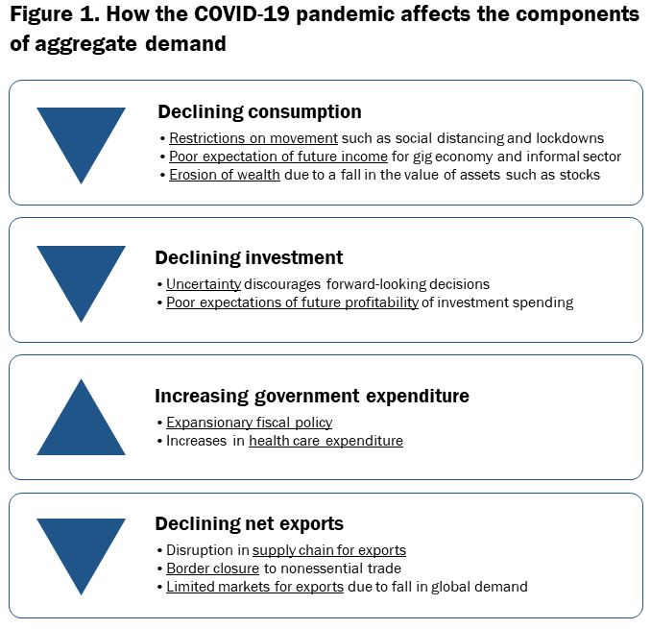

The fall in household consumption in Nigeria will stem from
1) partial (or full) restrictions on movement, thus causing consumers to spend primarily on essential goods and services;
2) low expectations of future income, particularly by workers in the gig economy that are engaged on a short-term/contract basis, as well as the working poor in the informal economy; and
3) the erosion of wealth and expected wealth as a result of the decline in assets such as stocks and home equity. The federal government has imposed a lockdown in Lagos and Ogun states as well as Abuja (which have the highest number of coronavirus cases combined). Subnational governments have quickly followed suit by imposing lockdowns in their states. Nigeria has a burgeoning gig economy as well as a large informal sector, which contributes 65 percent of its economic output. Movement restrictions have not only reduced the consumption of nonessential commodities in general, but have affected the income-generating capacity of these groups, thus reducing their consumption expenditure.
Investments by firms will be impeded largely due to the uncertainties that come with the pandemic-limited knowledge about the duration of the outbreak, the effectiveness of policy measures, and the reaction of economic agents to these measures—as well as negative investor sentiments, which are causing turbulence in capital markets around the world. Indeed, the crisis has led to a massive decline in stock prices, as the Nigerian Stock Exchange records its worst performance since the 2008 financial crisis, which has eroded the wealth of investors. Taking into consideration the uncertainty that is associated with the pandemic and the negative profit outlook on possible investment projects, firms are likely to hold off on long-term investment decisions.
On the other hand, government purchases will increase as governments, which typically can afford to run budget deficits, utilize fiscal stimulus measures to counteract the fall in consumer spending. However, for governments that are commodity dependent, the fall in the global demand for commodities stemming from the pandemic will significantly increase their fiscal deficits. In Nigeria’s case, the price of Brent crude was just over $26 a barrel on April 2, whereas Nigeria’s budget assumes a price of $57 per barrel and would still have run on a 2.18 trillion-naira ($6.05 billion) deficit. Similarly, with oil accounting for 90 percent of Nigeria’s exports, the decline in the demand for oil and oil prices will adversely affect the volume and value of net exports. Indeed, the steep decline in oil prices associated with the pandemic has necessitated that the Nigerian government cut planned expenditure. In fact, on March 18, the minister of finance announced a 1.5 trillion naira ($4.17 billion) cut in nonessential capital spending.
The restrictions on movement of people and border closures foreshadow a decline in exports. Already, countries around the world have closed their borders to nonessential traffic, and global supply chains for exports have been disrupted. Although the exports of countries that devalue their currency due to the fall in the price of commodities (like Nigeria), will become more affordable, the limited markets for nonessential goods and services nullifies the envisaged positive effect on net exports.
Chapter 4
Conclusion and Recommendation
4.1 CONCLUSION
The COVID-19 pandemic has arrived like a storm we did not expect and has come with a lot of complications. In my opinion, the Lockdown is the only solution that will suffice for now, that is till the cure surfaces, but it will lead to few problems which we have spoken about already; Legal and Economical.
In conclusion to the;
Legal aspect, companies must understand the legal implications attached to the recent widespread of the pandemic as it relates to their various legal obligations to their staff, costumers, clients and to themselves. This will help in their decision-making ability.
Economical aspect, The COVID-19 pandemic is a wake-up call to policymakers as the unusual and unprecedented nature of the crisis has made it impossible for citizens to rely on foreign health care services and more difficult to solicit for international support given the competing demand for medical supplies and equipment. A more integrated response spanning several sectors—including the health, finance, and trade sectors—is required to address structural issues that make the country less resilient to shocks and limit its range of policy responses. In the long term, tougher decisions need to be made, including but not limited to diversifying the country’s revenue base away from oil exports and improving investments in the health care sector in ensuring that the economy is able to recover quickly from difficult conditions in the future.

REFERENCES
1. https://www.brookings.edu
2. https://www.nortonrosefulbright
3. https://thenationonlineng
4. https://www.wired.co.uk
5. https://i1.wp.com
6. https://static.bangkokpost.com/media/content/20200205/c1_3514704.jpg

