TERM PAPER
ON
ENGINEERING STRATEGIES FOR HANDLING COVID-19 FOR ENVIROMENTAL HEALTH AND ECONOMIC SUSTAINABILITY
PREPARED BY
AREMU FAWAZ BABAJIDE
17/ENG05/008
MECHATRONICS ENGINEERING
SUBMITTED TO THE
DEPARTMENT OF MECHANICAL AND MECHATRONICS ENGINEERING
IN PARTIAL FUFILMENT OF ENG384 (ENGINEERING LAW AND MANAGERIAL ECONOMICS)
ON THE
13TH APRIL, 2020

TABLE OF CONTENTS

TITLE PAGE …………………………………………………………………..…1
TABLE OF CONTENTS ………………………………………………….……...2
ABSTRACT………………………………………………………………………3
CHAPTER ONE: INTRODUCTION……………………….……………………4
CHAPTER TWO; LITERATURE REVIEW……………..………………………5
2.1 BRIEF HISTORY OF COVID 19……………………………………..5
2.2 OUTBREAK OF COVID 19 TO THE WORLD………….…………..7
2.3EFFECT OF COVID 19 ON ENVIROMENTAL HEALTH AND ECONOMIC SUSTAINABILITY................................................................…...7
2.4ROLES OF CITIZENS/GOVERMENT/MEDICAL PERSONEL/RESEARCHERS/ENGINEERS/ IN MANAGING COVID 19….8
2.5ENGINEERING STRATEGIES FOR HANDLING COVID 19 FOR HANDLING COVID 19 FOR ENVIROMENTAL HEALTH AND ECONOMIC SUSTAINABILITY…………….………………………………….………….…..9
CHAPTER THREE: METHODOLOGY…………………………………………11
CHAPTER FOUR: ANALYSIS OF RESULTS…………………………………13
CONCLUSIONS, RECCOMENDATION AND FUTURE PROSPECT……….15
REFERENCES ………………………………….…..........................................15

ABSTRACT
Human corona viruses, first characterized in the 1960s, are responsible for a substantial proportion of upper respiratory tract infections in children. Since 2003, at least 5 new human corona viruses have been identified, including the severe acute respiratory syndrome corona virus, which caused significant morbidity and mortality. NL63, representing a group of newly identified group I corona viruses that includes NL and the New Haven corona virus, has been identified worldwide. These viruses are associated with both upper and lower respiratory tract disease and are likely common human pathogens. The global distribution of a newly identified group II corona virus, HKU1, has not yet been established. Corona virology has advanced significantly in the past few years. The SARS epidemic put the animal corona viruses in the spotlight. The background and history relative to this important and expanding research area are reviewed here.

CHAPTER ONE:
INTRODUCTION
COVID 19 which is the code name given to the pandemic as a result of the corona virus outbreak affecting the whole world today. The term COVID 19 stands for CORONA VIRUS DISCOVERED IN THE YEAR 2019, however this virus was discovered in 2019 but it has long existed since early 1960s of which then 5 new cases were discovered in 2003. Corona viruses, a family of viruses within the Nidovirus super family, were divided into three groups (1, 2, 3), originally based on antigenic reactivity, later confirmed by genome sequencing. Recently, a new taxonomic nomenclature was adapted by the International Committee on Taxonomy of Viruses (2009). As such, corona viruses are divided into three genera (alpha, beta and gammacoronaviruses), corresponding to groups 1, 2, 3, within the subfamily coronavirinae, within the family of coronaviridae, and within the order or super family of nidovirales. Corona viruses cause diseases in a variety of domestic and wild animals as well as in humans. Probably the most well-studied corona virus is the betacoronavirus, murine corona virus (MuCoV), mouse hepatitis virus (commonly referred to as MHV) that has long provided model systems for the study of central nervous system (CNS) diseases such as encephalitis and multiple sclerosis (MS) and acute hepatitis. While most corona virus infections cause the common cold in humans, the emergence of the agent for severe acute respiratory syndrome (SARS), the SARS-associated corona virus (SARS-CoV), also a betacoronavirus, demonstrated the potential for further significant human diseases to result from corona virus infections. Indeed, shortly after the identification of the SARS-associated human corona virus (HCoV), new corona virus were identified in association with more severe infections in humans, NL63 an alphacoronavirus, believed to cause bronchiolitis in children, and HKU1, a betacoronavirus, associated with chronic respiratory disease in the elderly (). This review will concentrate on the model MuCoV and the human SARS-CoV.

CHAPTER TWO:
LITERATURE REVIEW
2.1 BRIEF HISTORY OF COVID-19
The history of human corona viruses began in 1965 when Tyrrell and Bynoe¹ found that they could passage a virus named B814. It was found in human embryonic tracheal organ cultures obtained from the respiratory tract of an adult with a common cold. The presence of an infectious agent was demonstrated by inoculating the medium from these cultures intranasal in human volunteers; colds were produced in a significant proportion of subjects, but Tyrrell and Bynoe were unable to grow the agent in tissue culture at that time. At about the same time, Hamre and Procknow² were able to grow a virus with unusual properties in tissue culture from samples obtained from medical students with colds. Both B814 and Hamre's virus, which she called 229E, were ether-sensitive and therefore presumably required a lipid-containing coat for infectivity, but these 2 viruses were not related to any known myxo- or paramyxoviruses. While working in the laboratory of Robert Chanock at the National Institutes of Health, McIntosh et al³ reported the recovery of multiple strains of ether-sensitive agents from the human respiratory tract by using a technique similar to that of Tyrrell and Bynoe. These viruses were termed “OC” to designate that they were grown in organ cultures.
Within the same time frame, Almeida and Tyrrell⁴ performed electron microscopy on fluids from organ cultures infected with B814 and found particles that resembled the infectious bronchitis virus of chickens. The particles were medium sized (80–150 nm), pleomorphic, membrane-coated, and covered with widely spaced club-shaped surface projections. The 229E agent identified by Hamre and Procknow² and the previous OC viruses identified by McIntosh et al³ had a similar morphology (Fig. 1).
In the late 1960s, Tyrrell was leading a group of virologists working with the human strains and a number of animal viruses. These included infectious bronchitis virus, mouse hepatitis virus and transmissible gastroenteritis virus of swine, all of which had been demonstrated to be morphologically the same as seen through electron microscopy.^{5,6} This new group of viruses was named corona virus (corona denoting the crown-like appearance of the surface projections) and was later officially accepted as a new genus of viruses.⁷
Ongoing research using serologic techniques has resulted in a considerable amount of information regarding the epidemiology of the human respiratory corona viruses. It was found that in temperate climates, respiratory corona virus infections occur more often in the winter and spring than in the summer and fall. Data revealed that corona virus infections contribute as much as 35% of the total respiratory viral activity during epidemics. Overall, he proportion of adult colds produced by corona viruses was estimated at 15%.⁸
In the 3 decades after discovery, human strains OC43 and 229E were studied exclusively, largely because they were the easiest ones to work with. OC43, adapted to growth in suckling mouse brain and subsequently to tissue culture, was found to be closely related to mouse hepatitis virus. Strain 229E was grown in tissue culture directly from clinical samples. The 2 viruses demonstrated periodicity, with large epidemics occurring at 2- to 3-year intervals.⁹ Strain 229E tended to be epidemic throughout the United States, whereas strain OC43 was more predisposed to localized outbreaks. As with many other respiratory viruses, reinjection was common.¹⁰ Infection could occur at any age, but it was most common in children.
Despite the extensive focus placed exclusively on strains 229E and OC43, it was clear that there were other corona virus strains as well. As shown by Bradburne,¹¹ corona virus strain B814 was not serologically identical with either OC43 or 229E. Contributing to the various strain differences in the family of corona viruses, McIntosh et al¹² found that 3 of the 6 strains previously identified were only distantly related to OC43 or 229E.
Epidemiologic and volunteer inoculation studies found that respiratory corona viruses were associated with a variety of respiratory illnesses; however, their pathogen city was considered to be low.^{2,8,13,14} The predominant illness associated with infections was an upper respiratory infection with occasional cases of pneumonia in infants and young adults.^{15,16} These viruses were also shown to be able to produce asthma exacerbations in children as well as chronic bronchitis in adults and the elderly.^{17–19}
While research was proceeding to explore the pathogen city and epidemiology of the human corona viruses, the number and importance of animal corona viruses were growing rapidly. Coronaviruses were described that caused disease in multiple animal species, including rats, mice, chickens, turkeys, calves, dogs, cats, rabbits and pigs. Animal studies included, but were not limited to, research that focused on respiratory disorders. Study focus included disorders such as gastroenteritis, hepatitis and encephalitis in mice; pneumonitis and sialodacryoadenitis in rats; and infectious peritonitis in cats. Interest peaked particularly regarding areas of encephalitis produced by mouse hepatitis virus and peritonitis produced by infectious peritonitis virus in cats. Pathogenesis of these disease states was various and complex, demonstrating that the genus as a whole was capable of a wide variety of disease mechanisms.²⁰ Human and animal corona viruses were segregated into 3 broad groups based on their antigenic and genetic makeup. Group I contained virus 229E and other viruses, group II contained virus OC43 and group III was made up of avian infectious bronchitis virus and a number of related avian viruses.²¹
The figure below shows the diagram of the virus
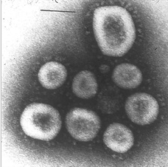

2.2 OUTBREAK OF COVID-19 TO THE WORLD
The origin story of corona virus seems well fixed: in late 2019 someone at the now world-famous Huanan seafood market in Wuhan was infected with a virus from an animal.
The rest is part of an awful history still in the making, with Covid-19 spreading from that first cluster in the capital of China’s Hubei province to a pandemic that has killed about 80,000 people so far.
Stock footage of pangolins – a scaly mammal that looks like an anteater – have made it on to news bulletins, suggesting this animal was the staging post for the virus before it spread to humans.
But there is uncertainty about several aspects of the Covid-19 origin story that scientists are trying hard to unravel, including which species passed it to a human. They’re trying hard because knowing how a pandemic starts is a key to stopping the next one.

2.3 EFFECT OF COVID 19 ON ENVIROMENTAL HEALTH AND ECONOMIC SUSTAINABILITY
To begin, the pandemic has led to the abandonment of many environmental sustainability programs - in the United States, smaller municipalities have halted recycling programs due to the risks associated with the spread of the virus.
Likewise, Italy has banned infected residents from sorting their waste at all. Additionally, many corporations have overturned disposable bag bans and begun relying once again on single-use plastics, and many restaurants are no longer accepting reusable containers - in early March, Starbucks announced a temporary ban on using reusable cups.
Furthermore, with more and more consumers isolated at home, there has been an increasing number of online purchases and meal deliveries made. This has not only caused the disposal of more single-use plastic packaging, but has further required more fossil fuels to be burned for the individual transportation and distribution of goods.
There has also been an increase in medical waste - much of the personal protective equipment that healthcare professionals are using can only be worn once before being disposed of. Hospitals in Wuhan, for example, produced over 200 tons of waste per day during the peak of their outbreak, compared to an average of less than 50 tons prior.
Even if mass isolation were aiding in the reduction of climate change, it would not be a sustainable way of cleaning up the environment.
ECONOMIC CONSEQUENCE
The effects of economic downturn and quarantine have hit the poor the hardest - those that do not have access to unemployment insurance, those who live pay check to pay check, and those who do not have social safety nets bear the economic brunt of the crisis.
Unemployment is reaching record highs and trillions have been pledged by governments to help Accepting the deaths of the vulnerable and extreme restrictions on everyday life is not a realistic or reliable way to fight climate change.
Furthermore, many have predicted that following mandatory lockdowns, countries will be focused on restarting their economies by funding industrial activities, while individuals will want to travel.
These actions could reverse what beneficial environmental effects have arisen from the pandemic response. A similar case can be seen with the 2008 financial crash - although there was a temporary decrease in emissions of 1.3%, as the economy recovered in 2010, emissions were at an all-time high.

2.4 ROLES OF CITIZENS/GOVERMENT/MEDICAL PERSONEL/RESEARCHERS/ENGINEERS/ IN MANAGING COVID 19
As many of our countries are facing unprecedented challenges from COVID-19 the strain on our governments is extreme, and the impact on people all over the world continues to grow. At OGP our first steps have been to take proactive measures to protect our own team, and to adjust the timelines and expectations around OGP participation – such as postponing Open Gov Week events to later in the year and replacing the activities planned for May 3-10 with a series of online community events (more details coming soon). We will continue to assess whether we need to take further action as this crisis evolves.
With the current pandemic affecting the world slowing down global economic activities, individuals,citizens,government,researchers and engineers have different roles to put up to help reduce the spread. These include in summary:
• Citizen-led community responses, including neighbourhood volunteer groups and neighbourhood associations, clergy, teachers or others helping to inform the public on the risks and needed steps.
• Participatory disaster response strategies, including working with civil society and citizens.
• Building trust between government and citizens, including through strong communications and focusing on reaching vulnerable communities with the information they need.
• Transparency over forecasting models and data that are influencing government’s strategies.
• Digital platforms or apps to keep citizens informed, enable public participation and/or offer open data; Digital tools to enable public participation.
• Digital and/or crowd sourced provision of public and government services.
• Protecting data rights and privacy as corporations help lead the response in many countries.
• Tackling misinformation and disinformation online.
• Publishing proactive information for affected communities, including economic and social support.

2.5 ENGINEERING STRATEGIES FOR HANDLING COVID 19 FOR HANDLING COVID 19 FOR ENVIROMENTAL HEALTH AND ECONOMIC SUSTAINABILITY
Engineering as a profession which is diverse in nature, has several applications which has helped improve many other fields such as medicine pharmacy e.t.c. The diversity of this profession has aided several necessary strategies and precautions during this period of the global pandemic due to the corona virus. Some of which include the production of safety protective equipment for personnels and also citizens in managing this global pandemic.
Taking china for instance where the ongoing COVID-19 pandemic has hit the business world in an unprecedented scale and speed. It has caused the closures of business, the stoppage of factory outputs, and the disruption to global manufacturing industries and their supply networks.
Major industries including automotive, electronics, pharmaceuticals, medical equipment and supplies, consumer goods and more have been significantly affected. This is a result of China having become a world production centre over the past two to three decades.
China provides the bulk of the components, raw or processed materials, as well as major subsystems to manufacturers globally. Not only have China’s original equipment manufacturers (OEMs) faced the challenges of resuming their production capacity but also global manufacturers have felt the impact of part shortages in their supply networks.
Companies inside China are slow to resume their normal productions due to various factors. These include the shortage of parts from lower-tier suppliers; the shortage of labor workers who might still be trapped due to the shutdown of their villages and other infected regions; the stringent requirements for companies to establish adequate protective measures and provide an adequate supply of protective gears for employees; and the slow recovery of transportation network capacity due to road closures and other emergency regulations and priorities.
Many global manufacturing OEMs have been scrambling to find alternative solutions, including quickly shifting orders to secondary or tertiary suppliers to make up the missed delivery from their primary suppliers and moving some core business priorities back to their own factories.
Some OEMs have even ventured to re-tool their production systems to make totally different products. For instance, when automotive business was down by more than 90% in China in February, automobile manufacturer Shanghai-GM-Wuling (SGMW) quickly retooled its production system to produce medical face masks, which positively contributed to mitigating the COVID-19 spread and at the same time generated rewarding revenues and positive reputation for the company.
To meet the production needs, Chinese firms have also become creative and resourceful to recruit workforce. Some firms negotiated with local governments for permission to send in charted buses and even airplanes to bring back workforce from remote regions. Others have started to adopt automations to make up for labor shortages. Some are also applying technologies to do crash training for newly recruited manual labor workforce. In some firms, salaried workers are temporarily taking on the work of hourly labor workforce in certain critical production areas.
As the COVID-19 crisis has intensified the competition for valuable supply sources, in certain industrial sectors, including electric vehicle (EV) production, the bargaining power has shifted from OEMs to suppliers. For instance, Tesla and CATL recently announced their strategic partnership for CATL to supply EV batteries to Tesla’s Model-3 production in China, shifting away from the sole supply by Panasonic alone. Toyota and Panasonic also announced their agreement to launch a joint venture to produce EV batteries. And BMW signed a major agreement to purchase EV batteries from CATL worth of 7.3 billion Euros.
Moving forward, there will be an increased need for infrastructures and technical means to create the transparency within global supply chains. There must also be a call for the development of predictive models for proactive scheduling and dynamic planning of supply demands with the consideration of uncertainties and risk factors. These predictive models will help corporate decision-makers do what-if analysis of various scenarios.

CHAPTER THREE:
RESEARCH METHODOLOY
With the incidence of new COVID-19 cases growing by the day, healthcare stakeholders are continuing to search for tools and medications to help stem the tide. We have seen the digital health community release a slew of new tools aiming to monitor the spread of the disease and facilitate better treatment.
Engineering as a profession is not left out in the struggle, that being said a lot of process has been put in place to control the spread especially since it affects all activities and sustainable development across the world today.

China as an example has taken so many steps in engineering in improving the covid 19 situation especially in conjunction with information and communication technology. The orientation of Tech's role in tracking, testing, treating COVID-19 aids the motive of engineering in improving the covid 19 situation.

Countries like china has employed great engineering and i.t combination in employing the strict tracking role, as the recently launched COVID-19 tracking program that relies on GPS-tracking electronic bracelets and a corona virus contact tracing app. The system alerts a government monitoring station when an infected individual leaves isolation or if the bracelet loses its connection. In addition, Ministry of Health officials may randomly send picture requests to which self-isolating individuals must respond with a photo that clearly shows their face and bracelet.
With the improvement in Speedy testing, companies such Everlywell with the engineering of producing well designed testing kit announced that it is working to develop a take-home corona virus test that will be available soon. The company said it plans to offer the test at cost, with no profit to the company. The test will allow users to collect samples at home and then ship their sample to a lab.
The test results will then be available within 3 to 5 days online. The home test kit will include an overnight delivery label, a telemedicine consultation for those with positive results and the disease-sample collecting kit. Hence speeding up the process by which individuals can get proper treatment and thus reduce the spread.
Chinese government also employed using of drones to ensure that its citizens are following public health safety guidelines. The drones, which come with loudspeaker capabilities, will zero in on individuals who aren’t following the recommendations, and an operator will give them instructions, such as, “go inside” or “put on a mask.”
IT medical teams have also tapped the development robots to care for the first person diagnosed with the virus as this method was employed first in the US. The robot was used to take vitals and communicate with the medical team outside of the isolation area. The robot was used as a means of preventing the virus from being transmitted to the medical staff.
The battle against this spread has employed several automation companies such as Shanghai-GM-Wuling (SGMW) which quickly retooled its production system to produce medical face masks, which positively contributed to mitigating the COVID-19 spread and at the same time generated rewarding revenues and positive reputation for the company.
So far in the world today as a result of the outbreak, a lot of measures has been put in place to make the world a much safer place of which engineering as a profession has contributed immensely to the fight against the covid 19 pandemic in conjunction with the medical and pharmaceutical profession as they work hand in hand to speed up this process.

CHAPTER FOUR:
ANALYSIS OF RESULT
Scientiﬁc research institutions especially with their increase research on epidemics and issue early warnings and predictions of epidemics by analyzing various data at the same time, although the development of vaccines is extremely complex, involving various safety and health issues, it is still necessary to strengthen the development of new vaccines.

A clear strategy was developed, and goals were well articulated and communicated across the entire response architecture. This strategy was rapidly adapted and adjusted to the outbreak, both in terms of the epidemiological situation over time and in different parts of the country. The epidemiological situation has been used to define location into four areas: • In areas without cases, the strategy in these areas is to "strictly prevent introduction". This includes quarantine arrangements in transportation hubs, monitoring for temperature changes, strengthening of triage arrangements, use of fever clinics, and ensuring normal economic and social operations. • In areas with sporadic cases, the strategy is focused on "reducing importation, stopping transmission and providing appropriate treatment". • In areas with community clusters, the strategy is focussed on "stopping transmission, preventing exportation, and strengthening treatment". • In areas with community transmission, the strictest prevention and control strategies are being implemented, the entry and exit of people from these areas has been stopped and public health and medical treatment measures are comprehensively strengthened.
The main control measures implemented in China are as follows and are illustrated in the figure below, representing the national level response and examples of the response at the Provincial and municipal levels: Monitoring and reporting: COVID-19 was included in the statutory reporting of infectious diseases on 20 January and plans were formulated to strengthen diagnosis, monitoring, and reporting. Strengthening ports of entry and quarantine: The Customs Department launched the emergency plan for public health emergencies at ports across the country and restarted the health declaration card system for entry and exit into cities as well as strict monitoring of the temperature of entry and exit passengers. Treatment: For severe or critical patients, the principle of "Four Concentrations" was implemented: i.e. concentrating patients, medical experts, resources and treatment into special centres. All cities and districts transformed relevant hospitals, increased the number of designated hospitals, dispatched medical staff, and set up expert groups for consultation, so as to minimise mortality of severe patients. Medical resources from all over China have been mobilized to support the medical treatment of patients in Wuhan. Epidemiological investigation and close contact management: Strong epidemiological investigations are being carried out for cases, clusters, and contacts to identify the source of infection and implement targeted control measures, such as contact tracing. Social distancing: At the national level, the State Council extended the Spring Festival holiday in 2020, all parts of the country actively cancelled or suspended activities like sport events, cinema, theatre, and schools and colleges in all parts of the country postponed reopening after the holiday. Enterprises and institutions have staggered their return to work. Transportation Departments setup thousands of health and quarantine stations in national service areas, and in entrances and exits for passengers at stations. Hubei Province adopted the most stringent traffic control measures, such as suspension of urban public transport, including subway, ferry and long-distance passenger transport. Every citizen has to wear a mask in public. Home support mechanisms were established. As a consequence of all of these measures, public life is very reduced. Funding and material support: Payment of health insurance was taken over by the state, as well as the work to improve accessibility and affordability of medical materials, provide personal protection materials, and ensure basic living materials for affected people. Emergency material support: The government restored production and expanded production capacity, organized key enterprises that have already started to exceed current production capacity, supported local enterprises to expand imports, and used cross-border e-commerce platforms and enterprises to help import medical materials and improve the ability to guarantee supplies.

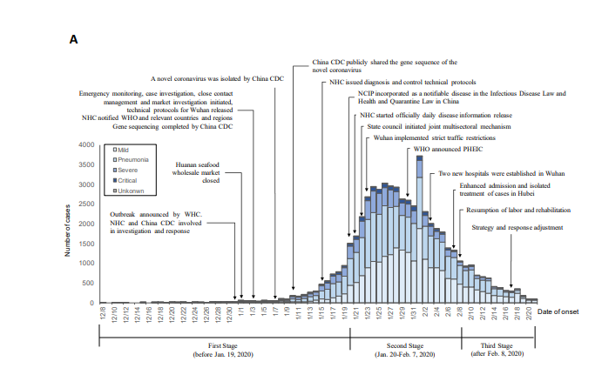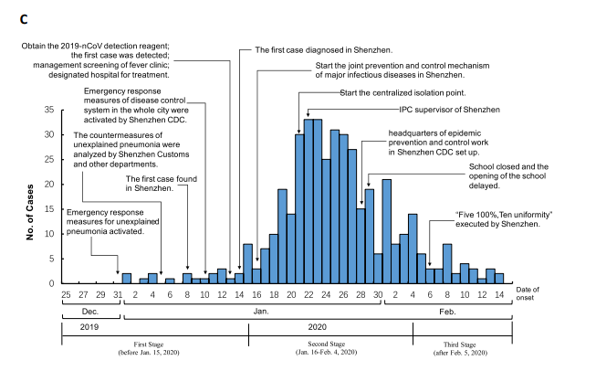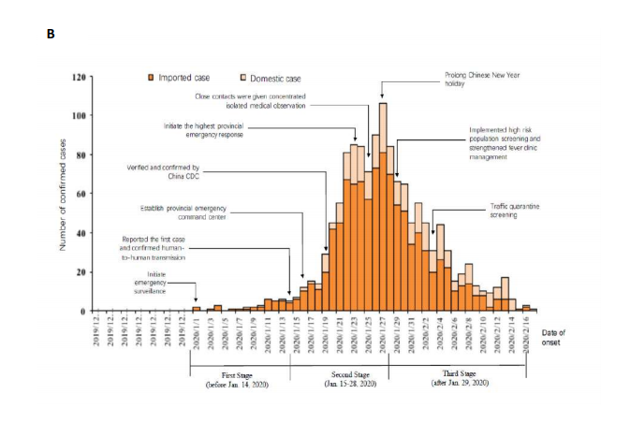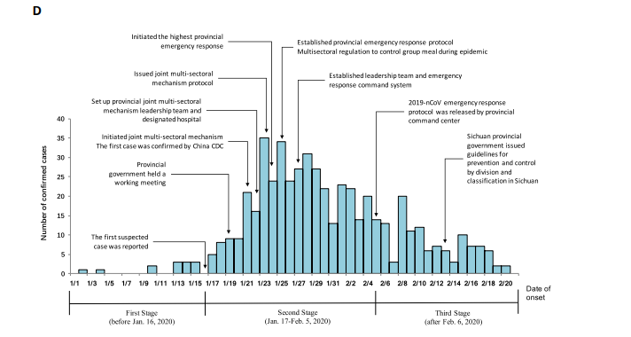

CHAPTER FIVE:
CONCLUSION RECOMMENDATION AND FUTURE PROSPECTS
The ﬁrst and most critical step is to restore the conﬁdence of the people, as many people will be
Psychologically aﬀected with the burden of this disease. Focusing on the basic situation in Wuhan City,
we analyzed the latest data, made a comparison with SARS, and identiﬁed key issues. Through our
analysis, we found that the risk of 2019-nCoV is much less than SARS (a virus that scares the Chinese).
Despite the rapid spread, the CFR (%) of 2019-nCoV is low. Our model also shows that the 2019-nCoV
is expected to be under control around February 19, 2020. We will publish the data analysis in the
next paper.
It is also expected that the economic and social development of Wuhan will be greatly aﬀected after
this novel pneumonia outbreak. It is predicted that it will not only have a major impact on industrial
and agricultural production, but it might have a serious impact on transportation, catering, sales,
Tourism, entertainment, and other industries. Therefore, we propose the following recommendations:
(1) Optimise the industrial structure and develop high-tech and high-value-added industries,
such as artiﬁcial intelligence, life and health, and ﬁnancial technology.
(2) Encourage large enterprises and groups to invest in Wuhan and provide the most preferential
Policies in China.
(3) The VAT and income tax on all existing industries in Wuhan should be reduced, with subsidies
being provided to the units and employees.
(4) Explore various methods of remote work to ensure that various institutions can continue to
Operate smoothly when similar situations occur in the future

RFERENCES
Changjiang Daily. 2020. Wuhan City, new coronavirus infected pneumonia prevention and control headquartersnotice (no. 1). Available online: http://www.wuhan.gov.cn/2019_web/whyw/202001/t20200123_304072.html(accessed on 26 January 2020).China sanitation and health network. 2020. New pneumococcal virus identiﬁed as a new type of coronavirusin Wuhan. Available online: http://health.people.com.cn/n1/2020/0110/c14739-31542882.html (accessed on26 January 2020).Liu, Shan-Lu, and Linda Saif. 2020. Emerging viruses without borders: The Wuhan coronavirus. Viruses 12: 130.[CrossRef] [PubMed]
Nishiura, Hiroshi, Sung-mok Jung, Natalie M. Linton, Ryo Kinoshita, Yichi Yang, Katsuma Hayashi, Tetsuro Kobayashi, Baoyin Yuan, and Andrei R. Akhmetzhanov. 2020. The extent of transmission of novel coronavirus in Wuhan, China. J. Clin. Med 9: 330. [Google Scholar] [CrossRef] [PubMed]
Wuhan Municipal Health Commission. 2019. Wuhan Municipal Health Commission’s briefing on the current pneumonia epidemic situation in our city. Available online: http://wjw.wuhan.gov.cn/front/web/showDetail/2019123108989 (accessed on 26 January 2020). (http://talk.ictvonline.org/media/g/vertebrate-2008/default.aspx
Pyrc et al., 2007

