AFE BABALOLA UNIVERSITY ADO EKITI
ENG384 ASSIGNMENT
ENGINEERING STRATEGIES FOR HANDELING COVID-19 FOR THE ENVIRONMENTAL HEALTH AND ECONOMIC SUSTAINABILITY
BY
ADAMOH YUSUF
17/ENG02/003
COMPUTER ENGINEERING

CONTENTS
- INTRODUCTION/DEFINITION
- CORONAVIRUS(COVID-19)
- ENGINEERING STRATEGIES
- RESULTS
- CONCLUSION AND RECOMMENDATION

INTRODUCTION

- Coronavirus disease (COVID-19) is an infectious disease caused by a new virus.
- The disease causes respiratory illness (like the flu) with symptoms such as a cough, fever, and in more severe cases, difficulty breathing. You can protect yourself by washing your hands frequently, avoiding touching your face, and avoiding close contact (1 meter or 3 feet) with people who are unwell.

HOW IT SPREADS
- Coronavirus disease spreads primarily through contact with an infected person when they cough or sneeze. It also spreads when a person touches a surface or objects that has the virus on it, and then touches their eyes, nose, or mouth.
- Environmental health is the branch of public health concerned with all aspects of the natural and built environment affecting human health. Environmental health is focused on the natural and built environments for the benefit of human health. The major subdisciplines of environmental health are: environmental science; environmental and occupational medicine, toxicology and epidemiology.
- The general definition of economic sustainability is the ability of an economy to support a defined level of economic production indefinitely.

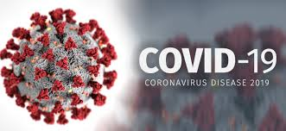
Coronavirus
Coronavirus disease (COVID-19) is an infectious disease caused by a newly discovered coronavirus.
Most people infected with the COVID-19 virus will experience mild to moderate respiratory illness and recover without requiring special treatment. Older people and those with underlying medical problems like cardiovascular disease, diabetes, chronic respiratory disease, and cancer are more likely to develop serious illness.
The best way to prevent and slow down transmission is be well informed about the COVID-19 virus, the disease it causes and how it spreads. Protect yourself and others from infection by washing your hands or using an alcohol based rub frequently and not touching your face.
The COVID-19 virus spreads primarily through droplets of saliva or discharge from the nose when an infected person coughs or sneezes, so it’s important that you also practice respiratory etiquette (for example, by coughing into a flexed elbow).
At this time, there are no specific vaccines or treatments for COVID-19. However, there are many ongoing clinical trials evaluating potential treatments. WHO will continue to provide updated information as soon as clinical findings become available.
If you are healthy, you only need to wear a mask if you are taking care of a person with suspected 2019-nCoV infection, Wear a mask if you are coughing or sneezing, masks are effective only when used in combination with frequent hand-cleaning with alcohol-based hand rub or soap and water, If you wear a mask, then you must know how to use it and dispose of it properly.
SYMPTOMS OF COVID-19
People may be sick with the virus for 1 to 14 days before developing symptoms. The most common symptoms of coronavirus disease (COVID-19) are fever, tiredness, and dry cough. Most people (about 80%) recover from the disease without needing special treatment.
More rarely, the disease can be serious and even fatal. Older people, and people with other medical conditions (such as asthma, diabetes, or heart disease), may be more vulnerable to becoming severely ill.

People may experience:
Cough
Fever
Tiredness
Difficulty breathing (severe cases)
PREVENTIVE MEASURES TO TAKE
There’s currently no vaccine to prevent coronavirus disease (COVID-19).

You can protect yourself and help prevent spreading the virus to others if you:
- Wash your hands regularly for 20 seconds, with soap and water or alcohol-based hand rub
- Cover your nose and mouth with a disposable tissue or flexed elbow when you cough or sneeze
- Stay home and self-isolate from others in the household if you feel unwell
- Don’t touch your eyes, nose, or mouth if your hands are not clean

HOW TO WEAR A FACE MASK
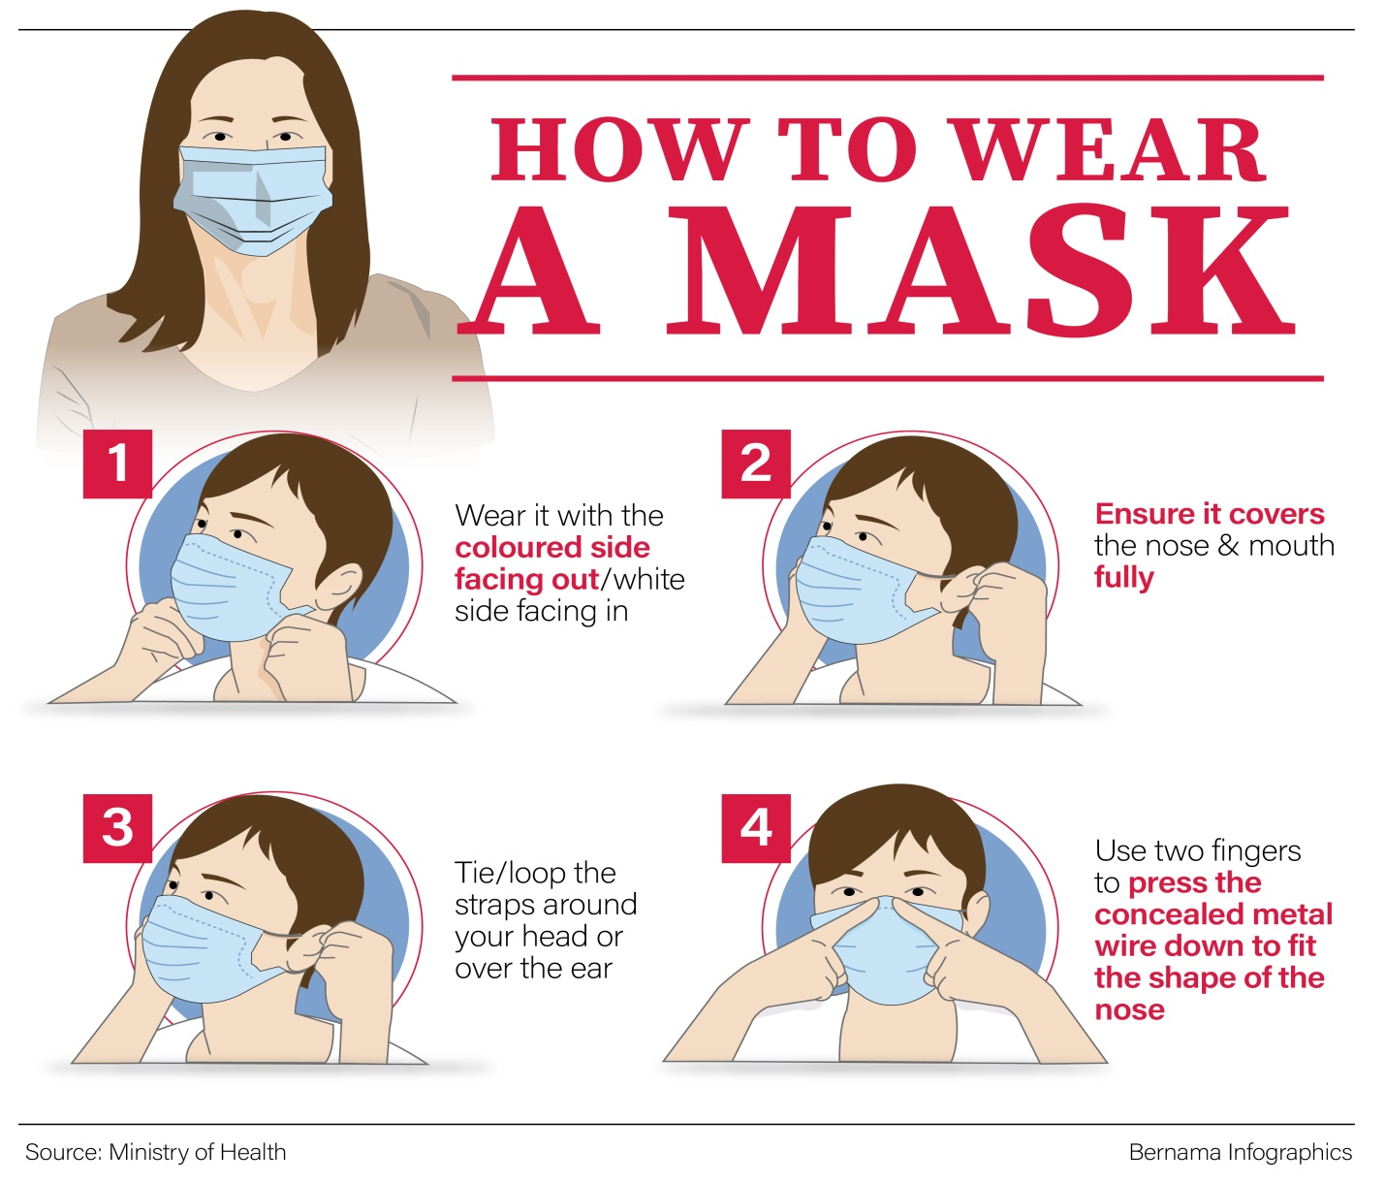
- Before putting on a mask, clean hands with alcohol-based hand rub or soap and water.
- Cover mouth and nose with mask and make sure there are no gaps between your face and the mask.
- Avoid touching the mask while using it; if you do, clean your hands with alcohol-based hand rub or soap and water.
- Replace the mask with a new one as soon as it is damp and do not re-use single-use masks.
- To remove the mask: remove it from behind (do not touch the front of mask); discard immediately in a closed bin; clean hands with alcohol-based hand rub or soap and water.
ENGINEERING STRATEGIES
EPIDEMOLOGY
Epidemiology is the study and analysis of the distribution, patterns and determinants of health and disease conditions in defined populations. It is a cornerstone of public health, and shapes policy decisions and evidence-based practice by identifying risk factors for disease and targets for preventive healthcare. It studies the relationship between environmental exposures (including exposure to chemicals, radiation, microbiological agents, etc.) and human health.
Several measures are commonly used to qualify morality. These numbers vary by region and over time and are influenced by the volume of testing, healthcare system quality, treatment options, time since initial outbreak and population characteristics such as age, sex and overall health.
It is a cornerstone of public health, and shapes policy decisions and evidence based practice by identifying risk factor for disease and targets for preventive healthcare. Epidemiologists help with study design, collection, and statistical analysis of data, amend interpretation and dissemination of results (including peer review and occasional systematic review). Epidemiology has helped develop methodology used in clinical research, public health studies, and, to a lesser extent, basic research in the biological sciences.
Major areas of epidemiological study include disease causation, transmission, outbreak investigation, disease surveillance environmental epidemiology, forensic epidemiology, occupational epidemiology, screening, biomonitoring, and comparisons of treatment effects such as in clinical trials. Epidemiologists rely on other scientific disciplines like biology to better understand disease processes, statistics to make efficient use of the data and draw appropriate conclusions, social science to better understand proximate and distal causes, and engineering for exposure assessment.

MANUFACTURING
Several measures are commonly used to quantify morality. These numbers vary by region and over time and are influenced by the volume of testing, healthcare system quality, treatment options, time since initial outbreak and population characteristics such as age, sex and overall health.

EXPERIMENTAL TESTING
Scientists are urgently pursuing vaccines that could protect large numbers of people against the deadly coronavirus. To do this as quickly as possible, one company is skipping early testing steps and fast-tracking a type of vaccine technology that isn’t yet proven effective in people.
While several companies and academic groups are just beginning to develop their vaccines, Moderna, a biotech firm based in Cambridge, Massachusetts, is already injecting healthy participants with an experimental vaccine.
“In trying times, we sometimes do things that perhaps we wouldn’t do if we had an unlimited amount of time,” Michael Diamond, a viral immunologist at the Washington University School of Medicine in St. Louis, Missouri, tells OneZero. “Desperate times warrant desperate measures.” And as infections and deaths from the virus surge around the world, the situation is becoming increasingly dire.
A vaccine represents the best long-term defense against the virus, known as SARS-Cov-2, and could help thwart future outbreaks. But even if one is found to be safe and successful at preventing infection, public health experts say it will take at least a year to become widely available. While that seems like a long time, it’s actually extremely fast for vaccine development.
Just weeks after China shared the genetic sequence of the coronavirus in January; Moderna announced that it would ship its experimental vaccine to the U.S. government for testing. Last week, a handful of volunteers in Seattle became the first to receive that vaccine. The Seattle suburbs have been among the hardest hit areas in the country after the state of Washington confirmed the first U.S. case of coronavirus on January 21.
A total of 45 healthy adults ages 18 to 55 years are expected to receive the investigational vaccine over the next six weeks. Known as a Phase I trial, this initial human study will test the safety of the vaccine as well as its ability to produce an immune response at three different doses. An effective vaccine must be able to create an immune response in the body that imitates an infection but doesn’t make a person sick.
Moderna manufactured the vaccine quickly, skipping lab experiments to determine how well it prevents infection in animals. Typically, scientists must test vaccines on animals before moving to human subjects, but the U.S. Food and Drug Administration has given Moderna permission to instead conduct animal tests in parallel with the human safety trial.
Dr. Nathan Erdmann, an infectious disease physician at the University of Alabama at Birmingham, says the decision is warranted amid a public health crisis. “Fortunately, we had a head start on this,” he tells One Zero. “Because of our experience with SARS and MERS, there’s been work toward developing ways of having an immune response to a coronavirus vaccine for some time.”
“In trying times, we sometimes do things that perhaps we wouldn’t do if we had an unlimited amount of time.”
The viruses that cause SARS, or severe acute respiratory syndrome, and MERS, or Middle East respiratory syndrome, are also coronaviruses. Previous outbreaks of these diseases provided scientists with a starting point for making a coronavirus vaccine so quickly. Moderna was already working with researchers at the National Institute of Allergy and Infectious Diseases on an experimental MERS vaccine.
Coronaviruses are sphere-shaped, with protein spikes protruding from their surface. These spikes lock onto human cells, allowing the virus to get inside and infect them. The vaccine that Moderna is developing consists of a short segment of genetic material, called messenger RNA, that provides instructions for a human cell to make a harmless version of the spike protein. The RNA is packaged into nanoparticles to be delivered as a vaccine. (Unlike some other vaccines, this one does not contain part of the actual pathogen.)
Once in the body, the vaccine is meant to spur cells into producing some of the harmless spike proteins. If it succeeds, the immune system will recognize the spikes as foreign and unleash antibodies to attack them. These antibodies will continue to live in the body and would prevent infection if a person is exposed to the virus in the future.
At least, that’s the hope. There is no vaccine on the market today that uses this approach. So far, this type of vaccine — known as an RNA vaccine — has only been tested on people in small safety trials. Scientists don’t actually know how effective it is in people. In previous experiments on animals, RNA vaccines produced antibody levels “in the same ballpark” as other types of vaccines, says Diamond.
RNA vaccines have some advantages compared to current vaccines. “They can be developed and deployed very rapidly,” says Diamond, who’s on Moderna’s scientific advisory board and has worked with the company on an RNA vaccine for Zika virus. The process is much faster than other methods of making vaccines. Moderna was able to manufacture and ship the vaccine to the NIH for testing in a matter of weeks.
“Even generating the flu vaccine takes months and months, and we know exactly what we’re working with year to year,” says Erdmann.
This type of vaccine could also be fairly inexpensive to manufacture because RNA is cheap to produce in the lab. Plus, some scientists think the risk for serious side effects is low because the body makes the protein itself. But because these vaccines haven’t been tested widely in people, their side effects aren’t well understood.
Karen Maschke, a research scholar at the Hastings Center, a bioethics research institute in Garrison, New York, says that since a vaccine will be given to healthy people, the safety bar has to be very high. “The people who are usually in these first-in-human trials go into it with a very altruistic mindset, but they also need to understand the risk they’re taking.”
Participants in the Moderna trial will receive two injections of the vaccine in the upper arm about a month apart and will be followed for any negative side effects. If the vaccine appears safe, it will then be tested in a trial of hundreds of people to make sure it’s effective at stopping the spread of the disease. And that will take several months.
The FDA will ultimately decide whether the vaccine is safe and effective and whether it should be approved. Dr. Anthony Fauci, the director of the National Institute of Allergy and Infectious Diseases, said during a March 12 congressional hearing that a vaccine that’s ready for widespread use won’t be ready for at least 12 to 18 months.
“That’s very fast,” says Dr. Drew Weissman, an expert on RNA vaccines whose University of Pennsylvania lab originally developed the technology Moderna is using. “It typically takes about five years for a new vaccine to be approved.”
But Weissman says the difficult part of making a vaccine is showing that it works. “You have to immunize a whole bunch of people and follow them to see if they’re protected from the disease. That’s something that’s hard to speed up.”
Maschke says it will be important for scientists and regulators to decide what’s sufficient for the vaccine to “work.” For instance, one dose of the measles vaccine is 93% effective at preventing the disease. By contrast, the current flu vaccine is 45% effective against preventing the 2019–2020 flu strain. Would that be good enough for a coronavirus vaccine? Scientists don’t yet know. “You could be giving people false hope if you say something works and it turns out it’s not that effective,” Maschke says.
Given how contagious coronavirus is, it’s likely that a large portion of the population would need to be vaccinated to prevent future outbreaks. This idea is known as herd immunity. For the measles virus, around 90% to 95% of a population typically must be vaccinated to achieve herd immunity and prevent outbreaks. It’s unknown, however, what the threshold would be for coronavirus.
“Without question, if we had a vaccine that could not only establish protection for individuals but also increase the potential of herd immunity to stop the ability of the coronavirus to find productive infections, that’s tremendously helpful,” Erdmann says.
Meanwhile, German company CureVac is also working on an RNA vaccine. The Trump administration reportedly tried to convince the company to move its work to the United States, according to the New York Times. Another German firm, BioNTech, has partnered with pharma giant Pfizer to develop an RNA vaccine. A handful of other companies and academic labs are working on different vaccine approaches.
Even if scientists manage to develop an effective vaccine against this coronavirus in a record amount of time, there might be another major obstacle.
Coronaviruses are RNA viruses, which means their genetic material is made up of RNA instead of DNA, a related molecule. RNA viruses are known to mutate with higher frequency than DNA viruses, like those that cause chicken pox, herpes, and smallpox. It’s possible that the coronavirus could mutate into different strains and continue to circulate in a seasonal manner, like the flu. If this happens, scientists would have to come up with a new formulation of the coronavirus vaccine every year, like we currently do with flu vaccines.
“If we develop an effective vaccine to the original strain, how effective will that vaccine be to future modifications of that strain?” says Erdmann. “I don’t know the answer to that.”
But if an RNA vaccine works and can be manufactured rapidly and cheaply, it could be easily adapted to make vaccines against different strains of coronavirus, as well as new pathogens that might emerge. All it would take is swapping out the piece of genetic material to match the new pathogen. Of course, there would need to be enough of the vaccine to go around. Some say government funding could help boost manufacturing efforts for a coronavirus vaccine — and vaccines needed in the event of future outbreaks.
“We’re always going to have new infections entering into the human population,” Erdmann says. “Investing in this in a meaningful way would allow us to be much better prepared for when it eventually happens again.”

INFORMATION TECHNOLOGY
Big data analysis on cellphone data, facial recognition technology, mobile phone tracking and artificial intelligence are used to track infected people and people whom they contacted in South Korea, Taiwan and Singapore.
In February 2020, china launched a mobile application to deal with the disease outbreak. Users are asked to enter their name and ID number requested by the application. The application is able to detect close contact using surveillance data and therefore a potential risk of infection. Every user can also check the status of three other users.
RESULTS
GOOGLE, APPLE NEW CORONAVIRUS TRACKING SYSTEM:
Apple and Google announced a system for tracking the spread of the new coronavirus, allowing users to share data through Bluetooth Low Energy (BLE) transmissions and approved apps from health organizations.
The new system, which is laid out in a series of documents and white papers, would use short-range Bluetooth communications to establish a voluntary contact-tracing network, keeping extensive data on phones that have been in close proximity with each other. Official apps from public health authorities will get access to this data, and users who download them can report if they’ve been diagnosed with COVID-19. The system will also alert people who download them to whether they were in close contact with an infected person.
Apple and Google will introduce a pair of iOS and Android APIs in mid-May and make sure these health authorities’ apps can implement them. During this phase, users will still have to download an app to participate in contact-tracing, which could limit adoption. But in the months after the API is complete, the companies will work on building tracing functionality into the underlying operating system, as an option immediately available to everyone with an iOS or Android phone.
MECHNICAL VENTILATION:
Mechanical ventilation is a form of life support. A mechanical ventilator is a machine that takes over the work of breathing when a person is not able to breathe enough on their own. The mechanical ventilator is also called a ventilator, respirator, or breathing machine. There are many reasons why a patient may need a ventilator, but low oxygen levels or severe shortness of breath from an infection such as pneumonia are the most common reason.
CONCLUSION
- I believe that the above mentioned strategies of engineering in handling the pandemic situation are effectively been carried out to help the victims as well as the rest of the world in taking preventive measures.
- I also believe that the above mentioned results have also taken great effect in both sides of the world (affected and non-affected people).

