TERM PAPER
ON
ENGINEERING STRATEGIES FOR HANDLING COVID-19 FOR
ENVIRONMENTAL HEALTH AND ECONOMIC SUSTAINABILITY
PREPARED BY
OPARA EBUBECHUKWU UZOMA
17/ENG06/069

SUBMITTED TO

THE DEPARTMENT OF MECHANICAL ENGINNEERING

COLLEGE OF ENGINEERING,

AFE BABALOLA UNIVERSITY, ADO-EKITI, EKITI STATE, NIGER

ABSTRACT
This term paper describes the details of covid-19 and the strategies for handling the pandemic and Focusing on pandemic influenza, this chapter approaches the planning for and response to such a major worldwide health event as a complex engineering systems problem. Action-oriented analysis of pandemics requires a broad inclusion of academic disciplines since no one domain can cover a significant fraction of the problem. Numerous research papers and action plans have treated pandemics as purely medical happenings, focusing on hospitals, health care professionals, creation and distribution of vaccines and anti-viral, etc. But human behavior regarding hygiene and social distancing constitutes a first-order partial brake or control of the spread and intensity of infection.

ACKNOWLEDGEMENTS
First and foremost, I appreciate God, the giver of life, for enabling me to write this term paper.All glory and praise be to the Almighty God for his favour and grace upon my life and for the wisdom, knowledge and understanding . Also I would love to acknowledge my parents and family for their support and sacrifices they continually provide.

TABLE OF CONTENTS
CERTIFICATION
ABSTRACT
ACKNOWLEDGEMENTS
LIST OF FIGURES
INTRODUCTION
WHAT IS CORONA VIRUS (COVID-19)?
SIGNS AND SYMPTOMS
CAUSES AND TRANSMISSION
PREVENTION
LITERATURE REVIEW
ENVIRONMENTAL HEALTH
DISCIPLINES
CONCERNS
ECONOMIC SUSTAINABILITY
METHODOLOGY
ENGINEERING STRATEGIES
RESULTS
CONCLUSION
CONCLUSION AND RECOMMENDATION
RECOMMENDATION
REFERENCE 16

LIST OF FIGURES
Figure 1: corona virus
Figure 2: preventions
Figure 3:Air pollution .
Figure 4: toxicology
Figure 5: Exposure science
Figure 6: Environmental engineering
Figure 7: Engineering law
Figure 8: environmental health
Figure 9:INNOVATIVE FACE MASK
Figure 10: mechanical ventilation

INTRODUCTION

WHAT IS CORONA VIRUS (COVID-19)?
A healthy population is essential for economic development. The poorest people on the planet tend to suffer most from the health effects from exposures to environmental hazards like air pollution and impure water. In turn, disease and disability related to polluted environments slows and blocks economic development. In addition to its toll on human suffering, illness carries a significant financial burden in the form of healthcare expenditures and lost productivity. For example, unhealthy children often cannot attend or perform well in school, and unhealthy adults cannot work or care for their families.
Coronavirus disease (COVID-19) is an infectious disease caused by a newly discovered coronavirus. Most people infected with the COVID-19 virus will experience mild to moderate respiratory illness and recover without requiring special treatment. Older people, and those with underlying medical problems like cardiovascular disease, diabetes, chronic respiratory disease, and cancer are more likely to develop serious illness. The best way to prevent and slow down transmission is be well informed about the COVID-19 virus, the disease it causes and how it spreads. Protect yourself and others from infection by washing your hands or using an alcohol based rub frequently and not touching your face. The COVID-19 virus spreads primarily through droplets of saliva or discharge from the nose when an infected person coughs or sneezes, so it’s important that you also practice respiratory etiquette (for example, by coughing into a flexed elbow).At this time, there are no specific vaccines or treatments for COVID-19.
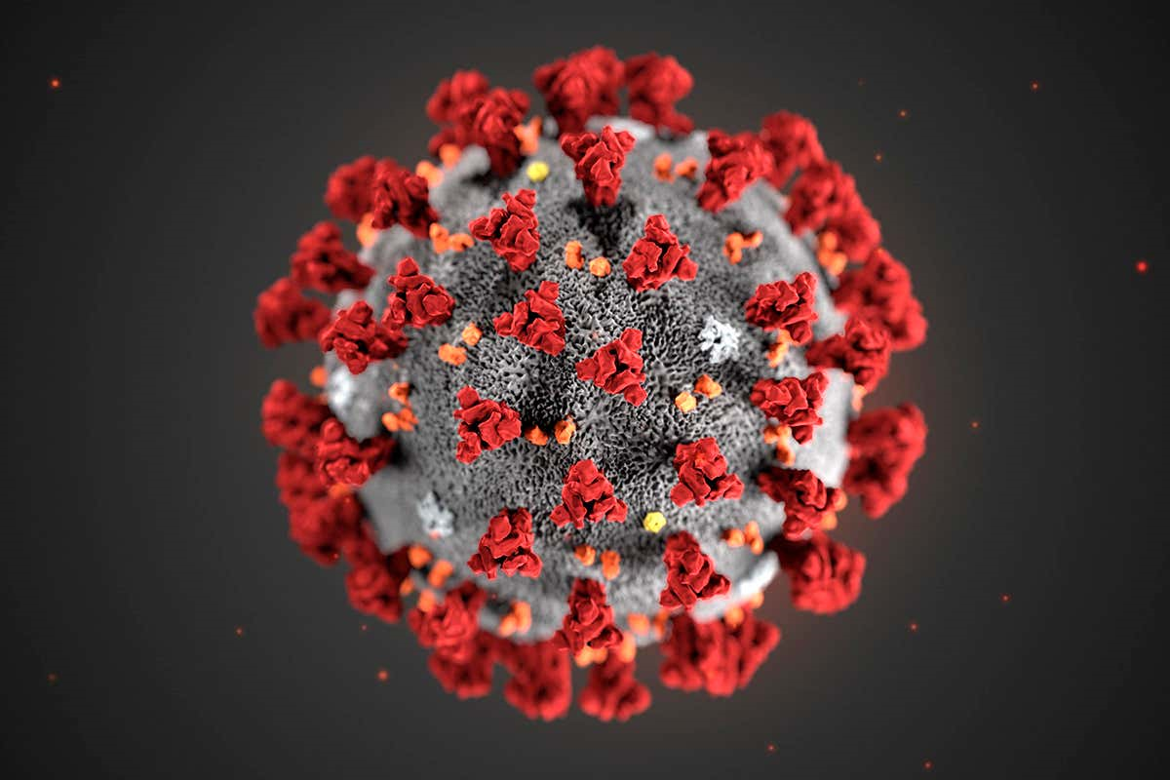
Figure 1: corona virus

SIGNS AND SYMPTOMS
The viruses can make people sick, usually with a mild to moderate upper respiratory tract illness, similar to a common cold. Coronavirus symptoms include a runny nose, cough, sore throat, possibly a headache and maybe a fever, which can last for a couple of days. For those with a weakened immune system, the elderly and the very young, there's a chance the virus could cause a lower, and much more serious, respiratory tract illness like a pneumonia or bronchitis. Those infected with the virus may be asymptomatic or develop flu-like symptoms, including fever, cough, fatigue and shortness of breath. Emergency symptoms include difficulty breathing, persistent chest pain or pressure, confusion, difficulty waking and bluish face or lips; immediate medical attention is advised if these symptoms are present. Less commonly, upper respiratory symptoms, such as sneezing, runny nose or sore throat may be seen.
As is common with infections, there is a delay between the moment when a person is infected with the virus and the time when they develop symptoms. This is called the incubation period. The incubation period for COVID-19 is typically five to six days but may range from two to 14 days. 97.5% of people who develop symptoms will do so within 11.5 days of infection.

CAUSES AND TRANSMISSION
- Human-to-human transmission has been confirmed during the 2019–20 coronavirus pandemic. Transmission occurs primarily via respiratory droplets from coughs and sneezes within a range of about 1.8 metres (6 ft.).
- Indirect contact via contaminated surfaces is another possible cause of infection. Preliminary research indicates that the virus may remain viable on plastic and steel for up to three days, but does not survive on cardboard for more than one day or on copper for more than four hours; the virus is inactivated by soap, which destabilises its lipid bilayer. Viral RNA has also been found in stool samples from infected people.

PREVENTION
- Avoid close contact (1 meter or 3 feet) with people who are unwell.
- Stay home and self-isolate from others in the household if you feel unwell.
- Don't touch your eyes, nose, or mouth if your hands are not clean.
- Frequently wash your hands with soap and water for at least 20 seconds. When soap and running water are unavailable, use an alcohol-based hand rub with at least 60% alcohol. Always wash hands that are visibly soiled.
- Practice good respiratory etiquette, including covering coughs and sneezes.
- Recognize personal risk factors. certain people, including older adults and those with underlying conditions such as heart or lung disease or diabetes, are at higher risk for developing more serious complications from COVID-19.
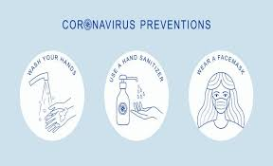
Figure 2: preventions

ENVIRONMENTAL HEALTH
Environmental health is the branch of public health concerned with all aspects of the natural and built environment affecting human health. Environmental health is focused on the natural and built environments for the benefit of human health. The major sub disciplines of environmental health are: environmental science; environmental and occupational medicine, toxicology and epidemiology.
- Environmental epidemiology is a branch of epidemiology concerned with determining how environmental exposures impact human health.^{[2]} This field seeks to understand how various external risk factors may predispose to or protect against disease, illness, injury, developmental abnormalities, or death. These factors may be naturally occurring or may be introduced into environments where people live, work, and play.

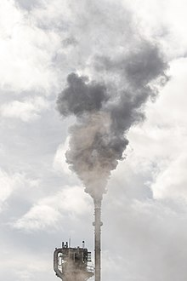
Figure 3:Air pollution is an example of an exposure that has been linked with negative health outcomes.
- Toxicology studies how environmental exposures lead to specific health outcomes, generally in animals, as a means to understand possible health outcomes in humans. Toxicology has the advantage of being able to conduct randomized controlled trials and other experimental studies because they can use animal subjects.
Figure 4: toxicology

- Exposure science studies human exposure to environmental contaminants by both identifying and quantifying exposures. Exposure science can be used to support environmental epidemiology by better describing environmental exposures that may lead to a particular health outcome, identify common exposures whose health outcomes may be better understood through a toxicology study.

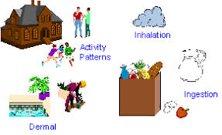
Figure 5: Exposure science

- Environmental engineering applies scientific and engineering principles for protection of human populations from the effects of adverse environmental factors; protection of environments from potentially deleterious effects of natural and human activities; and general improvement of environmental quality.
Figure 6: Environmental engineering

- Engineering law includes the network of treaties, statutes, regulations, common and customary laws addressing the effects of human activity on the natural environment.

Figure 7: Engineering law

CONCERNS
Environmental health addresses all human-health-related aspects of the natural environment and the built environment. Environmental health concerns include:
- Biosafety
- Disaster preparedness and response.
- Climate change and its effects on health.
- Food safety, including in agriculture, transportation, food processing, wholesale and retail distribution and sale.
- Housing, including substandard housing abatement and the inspection of jails and prisons.
- Childhood lead poisoning prevention.
- Land use planning, including smart growth.
- Liquid waste disposal, including city waste water treatment plants and on-site waste water disposal systems, such as septic tank systems and chemical toilets.
- Medical waste management and disposal.
- Noise pollution control.
- Occupational health and industrial hygiene.
- Radiological health, including exposure to ionizing radiation from X-rays or radioactive isotopes.
- Recreational water illness prevention, including from swimming pools, spas and ocean and freshwater bathing places.
- Safe drinking water.
- Solid waste management, including landfills, recycling facilities, composting and solid waste transfer stations.
- Toxic chemical exposure whether in consumer products, housing, workplaces, air, water or soil.

ECONOMIC SUSTAINABILITY
Economic sustainability is the term used to identify various strategies that make it possible to use available resources to their best advantage. The idea is to promote the use of those resources in a way that is both efficient and responsible, and likely to provide long-term benefits. In the case of a business operation, it calls for using resources so that the business continues to function over a number of years, while consistently returning a profit.
On one account, sustainability "concerns the specification of a set of actions to be taken by present persons that will not diminish the prospects of future persons to enjoy levels of consumption, wealth, utility, or welfare comparable to those enjoyed by present persons". Sustainability interfaces with economics through the social and ecological consequences of economic activity. Sustainability economics represents: "... a broad interpretation of ecological economics where environmental and ecological variables and issues are basic but part of a multidimensional perspective. However, the concept of sustainability is much broader than the concepts of sustained yield of welfare, resources, or profit margins. At present, the average per capita consumption of people in the developing world is sustainable but population numbers are increasing and individuals are aspiring to high-consumption Western lifestyles. The developed world population is only increasing slightly but consumption levels are unsustainable.

METHODOLOGY

ENGINEERING STRATEGIES

The basic strategies in the control of an outbreak are containment and mitigation. Containment may be undertaken in the early stages of the outbreak, including contact tracing and isolating infected individuals to stop the disease from spreading to the rest of the population, other public health interventions on infection control, and therapeutic countermeasures such as vaccinations which may be effective if available. When it becomes apparent that it is no longer possible to contain the spread of the disease, management will then move on to the mitigation stage, in which measures are taken to slow the spread of the disease and mitigate its effects on society and the healthcare system. In reality, containment and mitigation measures may be undertaken simultaneously.
Some of the engineering strategies employed in this current situation are:
- Epidemiology is the study and analysis of the distribution (who, when, and where), patterns and determinants of health and disease conditions in defined populations. Major areas of epidemiological study include disease causation, transmission, outbreak investigation, disease surveillance, environmental epidemiology, forensic epidemiology, occupational epidemiology, screening, biomonitoring, and comparisons of treatment effects such as in clinical trials. Epidemiologists rely on other scientific disciplines like biology to better understand disease processes, statistics to make efficient use of the data and draw appropriate conclusions, social sciences to better understand proximate and distal causes, and engineering for exposure assessment.
.

- MANUFACTURING:
Due to capacity limitations in the standard supply chains, some digital manufacturers are printing healthcare material such as nasal swabs and ventilator parts.

- EXPERIMENTAL TESTING:
No medications are approved to treat the disease by the WHO although some are recommended by individual national medical authorities. Research into potential treatments started in January 2020, and several antiviral drugs are in clinical trials. Although new medications may take until 2021 to develop, several of the medications being tested are already approved for other uses or are already in advanced testing.
- INFORMATION TECHNOLOGY:
In February 2020, China launched a mobile app to deal with the disease outbreak. Users are asked to enter their name and ID number. The app is able to detect 'close contact' using surveillance data and therefore a potential risk of infection. Every user can also check the status of three other users. If a potential risk is detected, the app not only recommends self-quarantine, it also alerts local health officials. Big data analytics on cell phone data, facial recognition technology, mobile phone tracking and artificial intelligence are used to track infected people and people whom they contacted in South Korea, Taiwan and Singapore. In March 2020, the Israeli government enabled security agencies to track mobile phone data of people supposed to have coronavirus. The measure was taken to enforce quarantine and protect those who may come into contact with infected citizens.

CHAPTER FOUR

RESULTS
- INNOVATIVE FACE MASK FOR THE HEARING IMPAIRED:
The masks have a transparent section over the mouth for the hearing impaired to read lips. The masks also allow people to see the wearer's facial expressions, which is crucial when using Sign Language.
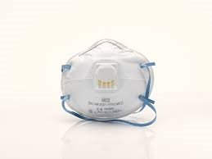
figure 9
- MECHANICAL VENTILATION:
Most cases of COVID-19 are not severe enough to require mechanical ventilation (artificial assistance to support breathing), but a percentage of cases do. It has been recommended for the use of invasive mechanical ventilation because this technique limits the spread of aerosolised transmission vectors.
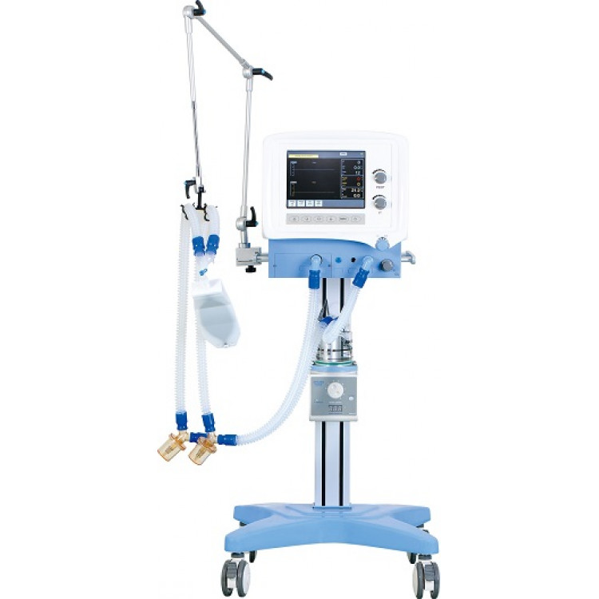
Figure 10: mechanical ventilation

CONCLUSION

CONCLUSION
The study shows the positive impact of quarantine in decreasing the number of confirmed cases, which was effective after about 14 days, alongside the impact of environmental factors in confirmed cases of COVID-19 and the role of regression analysis and binary classification by using artificial intelligence in the investigations. we strongly believe that the above mentioned strategies of engineering in handling the pandemic situation are effectively been carried out to help the victims as well as the rest of the world in taking preventive measures.

RECOMMENDATION
With respect to the current situation, I recommend the following:
- People should strictly adhere to the WHO instructions and guidance.
- People should follow and obey the country’s order and protocols.
- Governments in the country should take responsibility and provide for her citizens, especially those with little or no means of provision.
- People should use this medium to be creative and engage in one form of activity (legal) or the other from their various homes.
- Provide isolation rooms that are well ventilated (wide open windows that open to the outside, away from other wards with doors closed and preferably with an ante-room. Rooms should provide air flow of at least 160 L/s per patient with at least 12 air exchanges per hour and controlled direction of air flow

