A
TERM PAPER
ON
OPERATION, MAINTENANCE AND MANAGEMENT OF ENGINEERING EQUIPMENT FOR SUSTAINABLE DEVELOPMENT IN NIGERIA
BY
ADEPOJU NUMAN
17/ENG05/002
SUBMITTED TO
ENGR. O.J. OYEBODE
DEPARTMENT OF CIVIL AND ENVIRONMENTAL ENGINEERING
AFE BABALOLA UNIVERSITY, ADO-EKITI
(ABUAD)
13TH APRIL 2020

TABLE OF CONTENTS
CHAPTER 1: Introduction
Sustainable Environment And Why?
CHAPTER 2: Challenges and prospects for sustainable development
CHAPTER 3: Principles to Guide Engineers.
CHAPTER 4: Conclusion.

CHAPTER 1
INTRODUCTION
Who is an Engineer?
An engineer is a person who uses scientific knowledge to design, construct, and maintain engines and machines or structures such as roads, railways, and bridges. An engineer is a person who repairs mechanical or electrical devices. They send a service engineer to fix the disk drive.nes and machines or structures such as roads, railways, and bridges. An engineer is a person who repairs mechanical or electrical devices. They send a service engineer to fix the disk drive.
WHAT IS SUSTAINABLE DEVELOPMENT?
The term “sustainable development” was first proposed by the World Commission on Environment and Development (WCED) in its 1987 report Our Common Future (also known as the Brundtland Commission report). WCED, which included 23 members from 22 countries, was formed by the United Nations in 1984, and for three years studied the conflicts between growing global environmental problems and the needs of less-developed nations. WCED’s widely used definition of sustainable development is: “Meeting the needs of the present without compromising the ability of future generations to meet their own needs.” Since 1987, there have been many efforts to explain and amplify what is meant by sustainable development. To an engineer, a sustainable system is one that is either in equilibrium, or one that changes slowly at a tolerable rate. This concept of sus-tainability is best illustrated by natural ecosystems, which consist of nearly closed loops that change slowly. For example, in the food cycle of plants and animals, plants grow in the presence of sunlight, moisture and nutrients and are then consumed by insects and herbivores which, in turn, are eaten by successively larger animals. The resulting natural waste products replenish the nutrients, which allows plants to grow and the cycle to begin again. If humans are to achieve sustainable development, we will have to adopt patterns that reflect these natural processes. The roles of engineers in sustainable development can be illustrated by a closed-loop human ecosystem that mimics natural systems. This model of a closed-loop ecosystem was first proposed in 1990.
WHY IS ENGINEERING IMPORTANT IN A SUSTAINABLE ENVIRONMENT? Professional engineers have a significant role to play in sustainability. ... The goal of sustainable development is to enable all people throughout the world to satisfy their basic needs i.e food,clothing and shelter) and enjoy a better quality of life, without compromising quality of life for future generations. It is important for our environment and surrounding to be sustainable for a better and conducive place to reside.
Engineers contribute to all the steps in this systems model;
• By developing, processing and transporting natural resources in closed-loop systems, we can reduce waste and increase the efficient use of resources.
• Harvesting renewable resources such as water, fish and trees within the limits allowed by nature will ensure a continuing supply of resources for humans and natural ecosystems. Minimizing our use of non-renewable resources, such as petroleum and scarce minerals, and replacing them with environmentally friendly substitutes will also help extend the supply of natural resources.
• Processing natural resources efficiently and with little or no waste helps to preserve the earth’s finite natural resources. We can further preserve resources by designing products and packaging for reuse and recycling, and we can protect resources through industrial processes and facilities that have minimal adverse environmental impacts throughout their full life-cycles.
• Transporting goods contributes heavily to pollution; to minimize these effects, we can transport resources and manufactured goods efficiently to consumers by pipelines, rivers, railways, roads, ships and airplanes using technologies that have minimal impacts on the surrounding land use and serve the needs of consumers with little waste
Most Importantly,
• we develop, process and transport resources can improve living standards in many ways. These include providing clean water, energy, housing and commercial buildings and streets and other forms of infrastructure; efficiently storing and distributing food; and meeting acceptable health standards, including high-quality waste management and treatment.
• Engineers allow natural and built environments to be clean and unpolluted, we can reduce waste throughout this ecosystem cycle by continually recycling and recovering residual byproducts of resource development, industrial processing and meeting consumer needs. Some waste in the system is inevitable but should be in forms that have minimal long-term impacts on the natural environment. The impacts from residual waste can be offset by continuing programs to clean up and reuse old waste sites, along with other forms of environmental restoration.
• The effects of developing energy sources on the atmosphere, earth and water can be reduced by more efficient use of power and by production from non-fossil sources

CHAPTER 2.
CHALLENGES AND PROSPECTS FOR SUSTAINABLE DEVELOPMENT
Often, mechanical, electronic and software engineers in many companies are in different locations of the company. Better still, in some cases, they may be in the same building or the same office but the chances are they live in different worlds, speaking different languages and therefore cannot effectively communicate with each other when it comes to product design or problem solving. Simply because they come from different backgrounds knowing remarkably little about other related disciplines. For instance, when the Mechanical engineers design a system they pass it over to the Electrical/Electronic engineers to design and fit the control systems and they, in turn, pass it over to the Software engineers to write the control program. This serial and disjointed engineering practice result in producing an un-optimized product or solution.
To overcome these difficulties, Mechatronics evolves as a trans-disciplinary approach to solving engineering problem based on open communication systems and concurrent practices, with the overall benefit of designing and providing better engineering products and services.
WHY DO WE NEEED EQUIPMENTS?
As engineers who advance every day, we must have specific tools to ensure better work and efficiency of our work so as to produce a good job. Does one see a farmer without a hoe or A Teacher without books? The same as for an engineer, tools and equipment are very key to get a job done easier and faster. No tools means no work for engineers. And no job for engineers means no sustainable and efficient development in the environment or in this case country. So as to get this government can also be of help because they hold a higher percent of the world’s financial services.

CHAPTER 3

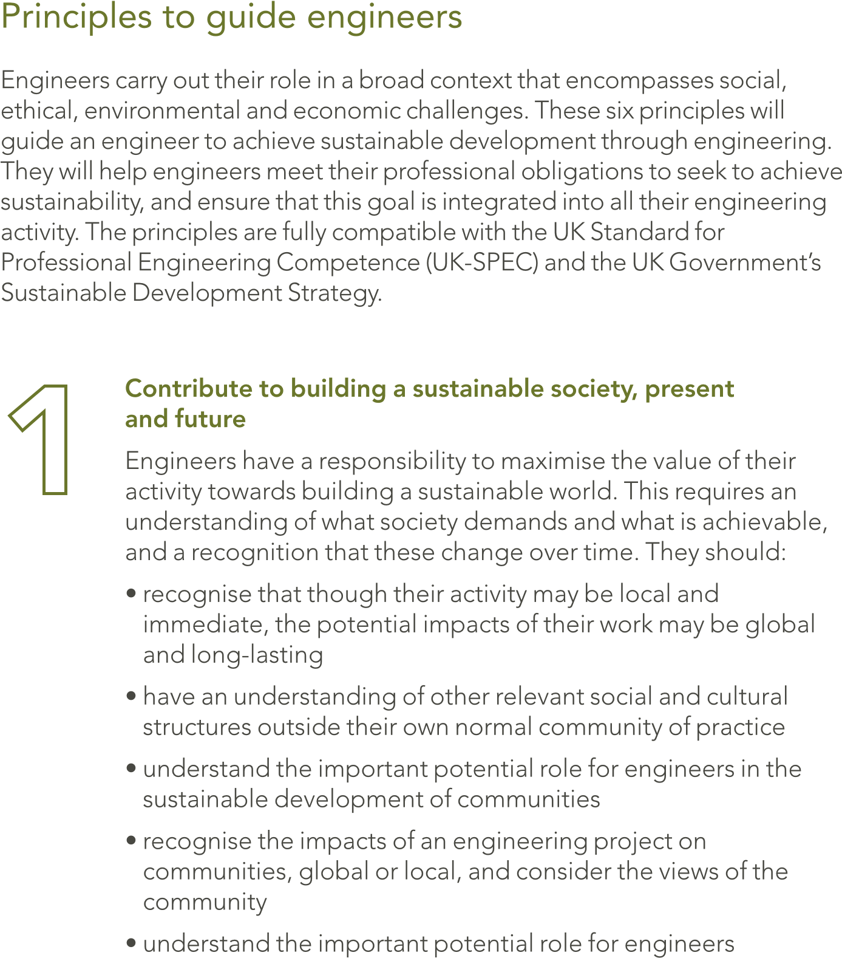

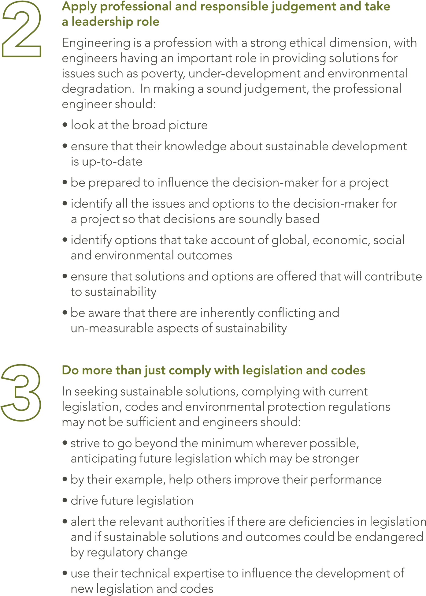

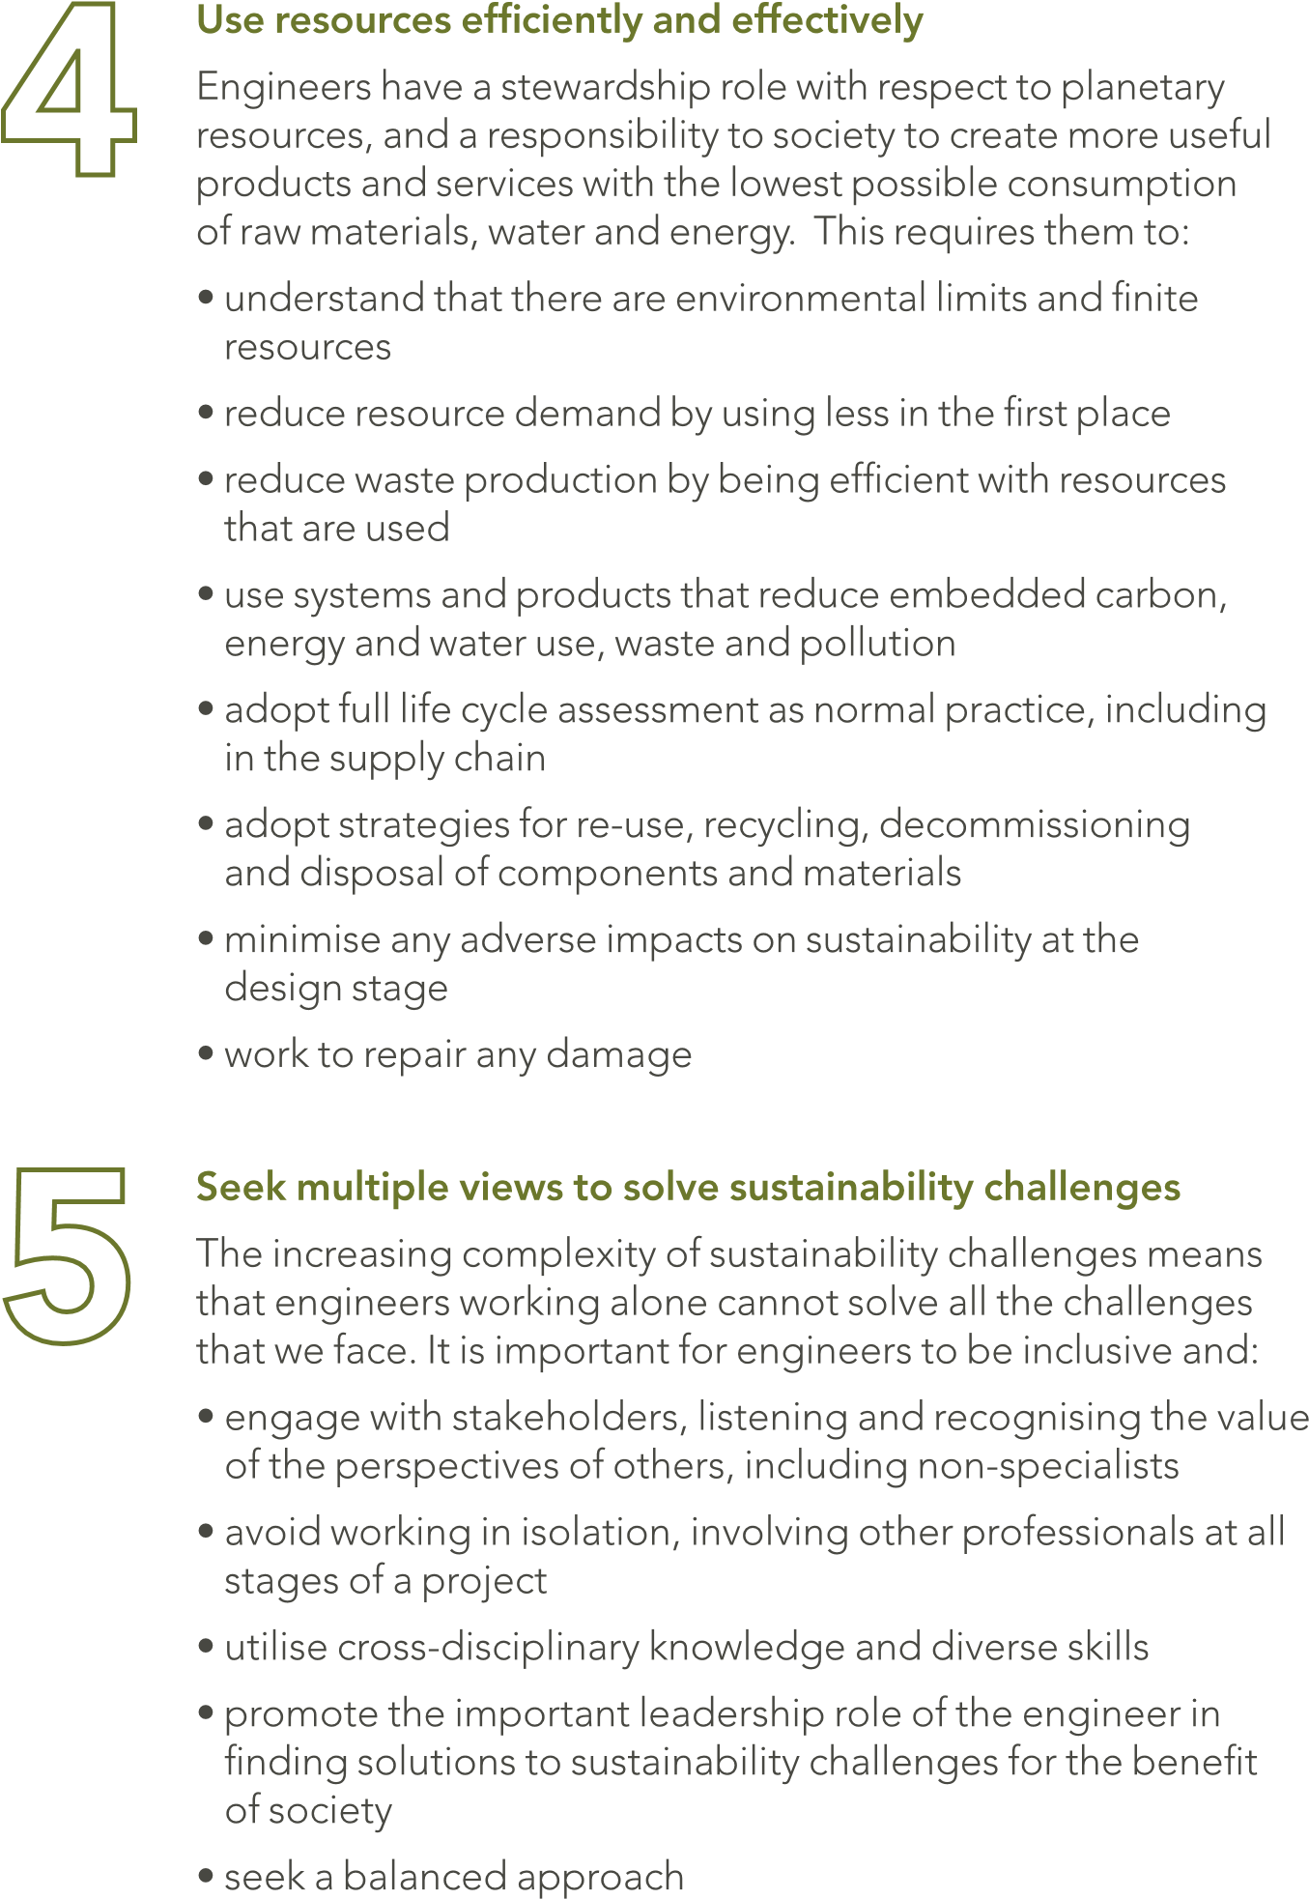.

CHAPTER 4
CONCLUSION
Technology has remained one of the most essential ingredients to attaining national development and self-sufficiency. Nowadays, the trend in manufacturing and services has shifted to the use of automated and intelligent production plants, which is mechatronics. This has been recognized early enough by many countries (such as China, India, Thailand, Singapore, Malaysia, among others) that were classified as developing countries some few years back, but most of which are today providing Hi-Tec products and services to the so called industrialized nations of yester years. For the simple reason that they embraced technological transformation at the appropriate time act swiftly. It is still not late for Nigeria to take dressing from these countries. The benefits of establishing mechatronics education in Nigeria are numerous. Sustainability is referred to both explicitly and implicitly in several Engineering Council documents, including the UK Standard for Professional Engineering Competence (UK-SPEC), The Accreditation of Higher Education Programmes and Guidelines for Institution Codes of Conduct, which can be found in UK-SPEC. Many Professional Engineering Institutions produce materials related to sustainability, some of which were referred to in the preparation of this guidance.

