ENG 384
ENGINEERING LAW REPORT
FOR
ENGINEERING STRATEGIES FOR HANDLING COVID-19 FOR ENVIRONMENTAL HEALTH AND ECONOMIC SUSTAINABILITY
PREPARED BY
AROH ARINZECHUKWU
ANTHONY
17/ENG02/012
A TERM PAPER SUBMITTED TO THE DEPARTMENT OF COMPUTER ENGINEERING
AFE BABALOLA UNIVERSITY, ADO-EKITI
IN
IN PARTIAL FULFILMENT OF THE REQUIREMENTS FOR THE AWARD OF THE DEGREE OF BACHELOR OF ENGINEERING (B. ENG) IN MECHATRONICS ENGINEERING
FOR THE SESSION 2019/2020.
9TH APRIL 2020

Table of Contents

ABSTRACT 3
INTRODUCTION 4
LITERATURE REVIEW 6
METHODOLOGY 7
RECOMMENDATIONS 9
CONCLUSION 10
REFERENCES 11

ABSTRACT
The coronavirus disease 19 (COVID-19) is a highly transmittable and pathogenic viral infection caused by severe acute respiratory syndrome coronavirus 2 (SARS-CoV-2), which emerged in Wuhan, China and spread around the world. Genomic analysis revealed that SARS-CoV-2 is phylogenetically related to severe acute respiratory syndrome-like (SARS-like) bat viruses, therefore bats could be the possible primary reservoir. The intermediate source of origin and transfer to humans is not known, however, the rapid human to human transfer has been confirmed widely. There is no clinically approved antiviral drug or vaccine available to be used against COVID-19. However, few broad-spectrum antiviral drugs have been evaluated against COVID-19 in clinical trials, resulted in clinical recovery. In the current review, we summarize and comparatively analyze the emergence and pathogenicity of COVID-19 infection and previous human coronaviruses severe acute respiratory syndrome coronavirus and middle east respiratory syndrome coronavirus. We also discuss the approaches for developing effective vaccines and therapeutic combinations to cope with this viral outbreak.
All coronaviruses contain specific genes in ORF1 downstream regions that encode proteins for viral replication, nucleocapsid and spikes formation. The glycoprotein spikes on the outer surface of coronaviruses are responsible for the attachment and entry of the virus to host cells. The receptor-binding domain (RBD) is loosely attached among virus, therefore, the virus may infect multiple hosts

INTRODUCTION
Coronaviruses belong to the Coronaviridae family in the Nidovirales order. Corona represents crown-like spikes on the outer surface of the virus; thus, it was named as a coronavirus. Coronaviruses are minute in size (65–125 nm in diameter) and contain a single-stranded RNA as a nucleic material, size ranging from 26 to 32kbs in length. The subgroups of coronaviruses family are alpha, beta, gamma and delta coronavirus. The severe acute respiratory syndrome coronavirus, H5N1 influenza A, H1N1 2009 and Middle East respiratory syndrome coronavirus cause acute lung injury and acute respiratory distress syndrome which leads to pulmonary failure and result in fatality. These viruses were thought to infect only animals until the world witnessed a severe acute respiratory syndrome outbreak caused by SARS-CoV, 2002 in Guangdong, China. Only a decade later, another pathogenic coronavirus, known as Middle East respiratory syndrome coronavirus an endemic in Middle Eastern countries.
Coronaviruses are viruses that circulate among animals with some of them also known to infect humans.
Bats are considered natural hosts of these viruses yet several other species of animals are also known to act as sources. For instance, Middle East Respiratory Syndrome Coronavirus is transmitted to humans from camels, and Severe Acute Respiratory Syndrome Coronavirus-1 (SARS-CoV-1) is transmitted to humans from civet cats. More information on coronaviruses can be found in the ECDC factsheet.

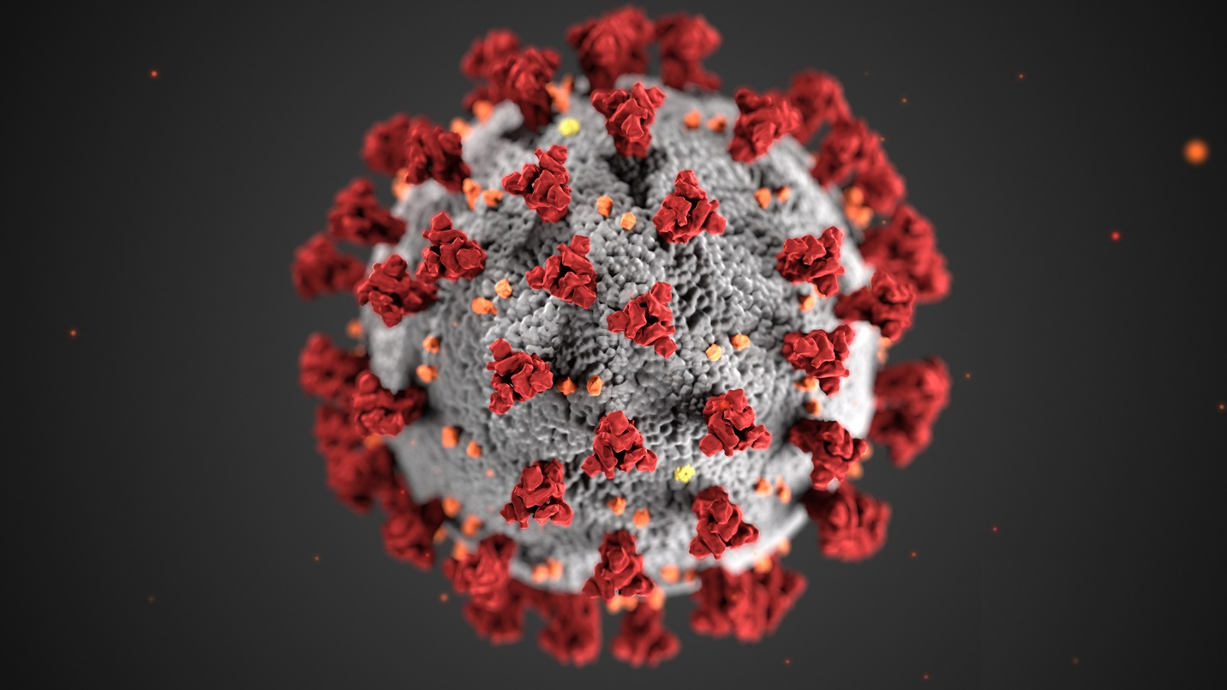

LITERATURE REVIEW
Coronavirus disease 2019 (COVID-19) is an infectious disease caused by severe acute respiratory syndrome coronavirus 2. The disease was first identified in December 2019 in Wuhan, the capital of China's Hubei province, and has since spread globally, resulting in the ongoing 2019–20 coronavirus pandemic
There is no available vaccine against COVID-19, Recombinant protein from the strain of SARS-CoV was administered to mice and hamsters, resulted in the production of neutralizing antibodies and protection against SARS-CoV. The DNA fragment, inactivated whole virus or live-vectored strain of SARS-CoV, significantly reduced the viral infection in various animal models.
While animals are believed to be the original source, the virus spread is now from person to person (human-to-human transmission). There is not enough epidemiological information at this time to determine how easily this virus spreads between people, but it is currently estimated that, on average, one infected person will infect between two and three other people. The virus seems to be transmitted mainly via small respiratory droplets through sneezing, coughing, or when people interact with each other for some time in close proximity (usually less than one meter). These droplets can then be inhaled, or they can land on surfaces that others may come into contact with, who can then get infected when they touch their nose, mouth or eyes. The virus can survive on different surfaces from several hours (copper, cardboard) up to a few days (plastic and stainless steel). However, the amount of viable virus declines over time and may not always be present in sufficient numbers to cause infection.
Preliminary data from the EU/EEA (from the countries with available data) show that around 20-30% of diagnosed COVID-19 cases are hospitalized and 4% have severe illness. Hospitalization rates are higher for those aged 60 years and above, and for those with other underlying health conditions.

METHODOLOGY
The presence of Covid-19 has caused extreme strain at the moment worldwide. The field Engineering can play a great role in helping stop the spread of the virus. With the help of professional engineers, the covid-19 curve can be flattened and significantly decrease the number of cases we are seeing.
It is not certain as to how long the virus that causes COVID-19 survives on surfaces, but it seems to behave like other coronaviruses. Studies suggest that coronaviruses (including preliminary information on the COVID-19 virus) may persist on surfaces for a few hours or up to several days.
The most common symptoms are fever, cough, shortness of breath, and breathing difficulties. In more severe cases infection can cause pneumonia, severe acute respiratory syndrome, and even death. The period within which the symptoms would appear is 2-14 days.
Engineers can play a great role by employing these strategies for handling covid-19 for environmental health and economic sustainability:
- The creation of awareness

With the use of printing press machines, companies have dedicated and contributed to the spread of awareness of the covid-19 to the general public by printing flyers with information containing the symptoms and expected protection methods to be carried out. Also, network communication companies have also assisted in the awareness of thus virus by sending broadcast text messages to citizens containing the symptoms and preventive measures against the virus. Information goes a long way. It is Key as ignorance is never an excuse.

- The Design and manufacture of respiratory equipment
The very first symptoms of the virus are respiratory related such as coughing. This has created a unique and urgent demand for many crucial pieces of healthcare equipment. For one, the need for respiratory ventilators is rapidly increasing as more and more hospitals find themselves without the resources to cope with a huge number of COVID-19 cases.
In fact, these lifesaving pieces of equipment are so essential right now that the government has issued a plea for companies who can supply ventilators or ventilator components to offer their services.

Build temporary hospitals or donate materials
Since the spread of the virus, patients who have already contacted the disease are required to be self-isolated to avoid further spread of the disease. Civil engineers have contributed in the construction of temporary isolation centers where patients can be contained for the 14 days where proper treatments can be given to them to help flatten the curve of the spread of the covid-19.
Recently, camp kits, empty shipping containers have been used to develop and construct temporary isolation centers to the healthcare system. Notwithstanding there are still many more temporary intensive care units (ICUs) for patients in life-threatening states to be treated. Along with this, being able to offer any other helpful materials and manpower to help make these will be appreciated. Appropriate accommodations been provided will go a long way in curbing the spread of the virus.
- Automatic sanitizer dispensing machine
Hand hygiene is an important part of the response to the prevention pf COVID-19. Washing hands often with soap and water for at least 20 seconds is essential, especially after going to the bathroom; before eating; and after coughing, sneezing, or blowing one’s nose. If soap and water are not readily available, recommendations have been made for consumers to use an alcohol-based hand sanitizer that contains at least 60 percent alcohol (also referred to as ethanol or ethyl alcohol).

*

RECOMMENDATIONS
As proper measures and preventive methods have been spread across the nation, it is a great role in curbing the spread of the disease but certainly not all that needs to be done. If all these Engineering methods mentioned above are applied appropriately and maintained effectively, then the country shouldn’t be a long way from handling covid-19 efficiently for environmental health and economic sustainability.

CONCLUSION
The issue of COVID-19 is a worldwide problem and have been declared a pandemic by the World Health Organization (WHO). Most countries of the world are currently facing the influence of this virus from the very complicated and high-class ones to the very minimal ones. All the problems no matter the level of seriousness hence, can’t be solved with just mere words but with action as well, both from the part of the citizens(as they adhere to the various preventive measures being given by the government) and also the government(doing their job by maintaining the safety and wellbeing of the citizens). Everyone and all hands need to be involved for the country to experience environmental health and economic sustainability.

REFERENCES
- https://www.google.com/search?q=Everything+you+need+to+know+about+covid-19&oq=Everything+you+need+to+know+about+covid-19&aqs=chrome..69i57.14801j0j4&sourceid=chrome&ie=UTF-8
- https://www.ecdc.europa.eu/en/novel-coronavirus/facts
- https://www.ecdc.europa.eu/en/covid-19/questions-answers
- https://edition.cnn.com/2020/03/24/health/soap-warm-water-hand-sanitizer-coronavirus-wellness-scn/index.html
- https://www.ncdc.com

