TERM PAPER
ON

OPERATION, MAINTANANCE AND MANAGEMENT OF ENGINEERING EQUIPMENT FOR SUBSTAINABLE DEVELOPMENT IN NIGERIA

PREPARED BY
OYEBOADE R. KIITAN
17/ENG08/004

SUBMITTED TO

THE DEPARTMENT OF BIOMEDICAL ENGINEERING
AFE BABALOLA UNIVERSITY ADO EKITI (ABUAD)

IN PARTIAL FULFILMENT OF ENG 384- ENGINERING LAW AND MANAGERIAL SKILLS

ACKNOWLEDGEMENT

I wish to record my deep sense of gratitude and profound thanks to my father Engr. Yemi Oyeboade for his interest, inspiring guidance with my work to bring this paper to fruition.

ABSTRACT

Sustainability is a critically important goal for human activity and development. Sustainability in the area of engineering is of great importance to:
- Economic development and living standards, and
- Significant impacts that engineering processes and systems have had, and continue to have, on the environment.
There are many factors that need to be considered and appropriately addressed if we are to achieve good operation, maintenance and management of engineering equipment for sustainable development in Nigeria.
Biomedical equipment management is a significant concern for safety and worth in the current hospital operations environment. The practice of an efficient information system will effectually stimulate the management performance and affords for the safe and steadfast operation of medical equipment used in the treatment of patients,

LIST OF FIGURES

Fig 1------------------------------------------------The element of sustainable maintenance practice
Fig 2----------------------------------------------------------------------------------------N95 Respirator
Fig 3----------------------------------------------------------------------------------------------Facemask
Fig 4------------------------------------------------------------------------------------------Eye Protector
Fig 5------------------------------------------------------- Nurse wearing facemask and Eye Protector
Fig 6----------------------------------------------------------------------------------------------Ventilator
Fig 7--------------------------------------------------------------------------------------Disinfectant bots
Fig 8-------------------------------------------------------------------------------------------Isolation Pod

TABLE OF CONTENTS

Title page 1
Acknowledgement 2
Abstract 3
List of figures 4
INTRODUCTION 6
- Operation
- Management
- Sustainability
LITERATURE REVIEW 8
- Sustainability and Sustainable Development
- Engineering and Sustainability
- Key Requirement for Engineering sustainability
- Operation, Maintenance and Management of Engineering equipment for sustainable development in Nigeria
- Types of maintenance
- Challenges of Maintenance and Management Plan in Nigeria
- Consideration when making management and maintenance plan
BIOMEDICAL EQUIPMENT FOR SUSTAINABLE DEVELOPMENT IN NIGERIA 12
METHODOLOGY 16
RECOMMENDATION 17
CONCLUSION 18
References 19

INTRODUCTION

Engineering is that branch of human training, endeavor or learning which majors in the design, construction, manufacture, repair or maintenance of mechanical, electrical/electronic appliances, facilities for use by man in the course of his daily life.
Put in another way, Engineering is a scientific field or job that involves taking our scientific understanding or knowledge of the natural world and using it to invent, design and build things to solve problems and achieve practical goals.
Or
The action of working artfully to bring about something.

Engineer is from the word ENGINE which comes from the Latin word INGENIUM which means “innate ability particularly of mental power"

Many technical advances are brought about through engineering. Engineering activities are significant contributors to economic development, standard of living and well-being of a society and this impact its cultural development and environment. Engineering is evolving continually as a profession and engineering education is correspondingly continually changing.

OPERATION
Operational sustainability is a method of evaluating whether a Process/business can maintain existing practices without placing future potential resources at risk.
It can also be defined as operations that meet the present needs without compromising on the ability to meet future needs.

MANAGEMENT
Sustainable management means ensuring that it is preserved in a way for future use. Sustainability management is needed because it is an important part of ability to successfully maintain the quality of life on our planet. Which can be applied to all aspect of life including the healthcare.

SUSTAINABILITY
Sustainable development is increasingly becoming a goal to which numerous countries throughout the world aspire. Overall sustainability has been defined in many ways, and is often considered to have three distinct components:
- environmental sustainability,
- economic sustainability and
- Social sustainability.
These three factors when considered separately usually pull society in different directions (e.g., economic sustainability may be achieved at the expense of environmental and social sustainability). Overall sustainable development in general requires the simultaneous achievement of environmental, economic and social sustainability.

Although engineering is not directly one of the three components of sustainability mentioned above, it is indirectly linked to each. That is, engineering uses resources to drive much if not most of the world’s economic activity, virtually all economic sectors, e.g., industry, transportation, residential, commercial, health/medical etc. Also, resources used in engineering, whether fuels, minerals or water, are obtained from the environment, and wastes from engineering processes (production, transport, storage, utilization) are typically released to the environment. Finally, the services provided by engineering allow for good living standards, and often support social stability as well as cultural and social development. Given the intimate ties between engineering and the key components of sustainable development, it is evident that the attainment of sustainability in engineering is a critical aspect of achieving sustainable development, in individual countries and world at large.

Engineering sustainability is taken here to be a comprehensive concept. That is, engineering sustainability is taken to involve the sustainable application of engineering in systems. Such systems include processes and technologies for harvesting resources, converting them to useful forms, transporting, storing, and the utilization of engineering products and processes to provide useful services such as operating computers, providing healthcare or sheltering people.

The objective of this Term Paper is to identify, examine, and understand the operation, maintenance and management of engineering equipment for sustainable development in Nigeria.

LITERATURE REVIEW

Sustainability and Sustainable Development
To understand the concepts of engineering sustainability, it is important to consider the concept and definitions of sustainability and sustainable development. Sustainable development was defined by the 1987 Brundtland Report of the World Commission on Environment and Development as “development that meets the needs of the present without compromising the ability of future generations to meet their own needs.” This definition implies that actions of present societies should not threaten cultures or living standards for societies. The degree to which sustainable development can be achieved by countries varies, since countries differ according to such characteristics as size, wealth, living standards, culture, and political and administrative systems. The basic motivations and desires of societies, countries, cultures and people to advance appear not to have changed, and these aspirations usually require increasing use of engineering and consumption of resources.

Other definition of sustainability is the capacity to endure. The word sustainability is derived from the latin word “sustinere” which can be broken down to “sus” and “tenere” which means up and hold respectively. This definition will be more applicable to this topic and main object of this Term Paper. It is the potential for long term operation, maintenance and management.

Engineering and Sustainability
The concept of engineering sustainability is simply the application of the general definitions of sustainability to engineering. In other words, engineering sustainability involves the provision of engineering services in a sustainable manner, which in turn necessitates that engineering services be provided for all people in ways that, now and in the future, are sufficient to provide basic necessities, affordable, accessible, not detrimental to the environment, and acceptable to communities and people.

Key Requirements for Engineering Sustainability
There are several distinct components to the manner in which engineering can be practised sustainably in society, each of which is a requirement for engineering sustainability:
- Sustainable resources
- Sustainable processes
- Increased efficiency
- Reduced environmental impact
- Fulfilment of other aspects of sustainability

Sustainable Resources
Most engineering activities utilize resources that are derived from nature. Such resources include water (fresh and salinated), materials (virgin and recycled) and energy. The degree to which resources are sustainable depends on many factors, including their scarcity and importance to ecosystems. Sometimes engineering resources are sustainable, in that they can be replenished at a rate equal to or greater than the usage rate. Wood and biomass resources when used in a controlled manner provide examples. More often, the resources used in engineering activities are available in finite quantities and not sustainable in the longer term (e.g., metal ores, fossil fuels).

Sustainable Processes
Resources are used in engineering processes and operations to yield products and/or services. An important requirement of sustainable engineering is the use of sustainable processes. This implies that the engineering processes utilized must exhibit sustainable characteristics in terms of the operations and steps they involve, and the energy and materials they utilize. As many engineering processes are energy intensive, the concept of sustainable processes suggests that the energy carriers utilized should be sustainable. Energy carriers include secondary chemical fuels, ranging from such conventional ones as petroleum products (e.g., gasoline, diesel fuel, naphtha), coal products (e.g., coke) and synthetic gaseous fuels (e.g., outputs of coal gasification), to non-conventional chemical fuels like hydrogen, methanol and ammonia. Many energy carriers do not exist naturally, including such energy forms as work, electricity and non-ambient thermal energy.

Increased Efficiency
High efficiency allows the greatest benefits, in terms of products or services, to be attained from resources, and thus aid efforts to achieve engineering sustainability.

Reduced environmental impact
Numerous environmental impacts associated with engineering processes are of concern and must be addressed in efforts to attain engineering sustainability. These include impacts to the atmosphere, the lithosphere and the hydrosphere, and can be exhibited in many forms (e.g., damage to the ecosystems, health, and aesthetics).

OPERATION, MAINTANANCE AND MANAGEMENT OF ENGINEERING EQUIPMENT FOR SUSTAINABLE DEVELOPMENT

Due to high costs associated with replacement of parts or equipment failing due to lack of preventive maintenance, equipment owners are increasingly emphasizing the need to maintain and calibrate equipment as well as replace parts in an organized manner. Due to rapid changes in technology and engineering, scientific equipment has been evolving at the same pace.
Companies in the developed countries have the potential to keep pace with these rapid changes. Unfortunately, recipients of such equipment in the developing world have evidently lagged behind owing to lack of financial capacity, resulting in the continued reliance on expertise from the developed countries.
In general, the goal of maintenance is to eliminate or avoid unnecessary or unplanned downtime due to failure. Good maintenance practice can cut production costs immensely, whereas poor maintenance procedures can cost a company millions of cash/fund to effect repairs and correct poor quality and production loss. In the bid to correct and reduce this menace, a good sustainable maintenance strategy and practice needs to be adopted.

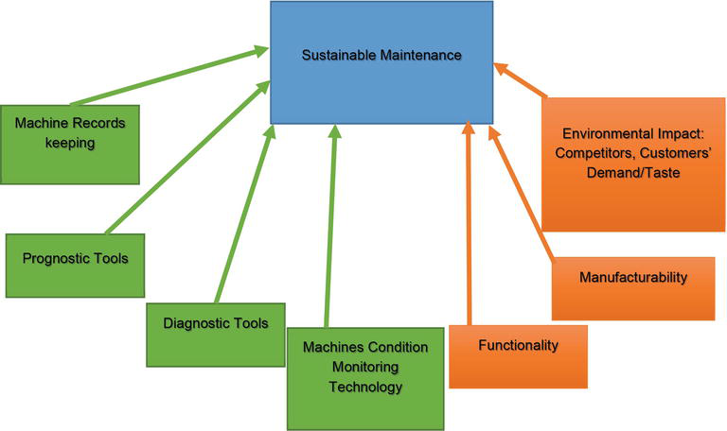
Fig 1. The element of sustainable maintenance practice
Maintenance engineering is the discipline and profession of applying engineering concepts for the optimization of equipment, procedures, and departmental budgets to achieve better maintainability, reliability and availability of equipment.
Maintenance is increasingly important due to rising cost of equipment, systems, machineries and infrastructures.

Types of maintenance
There are five (5) types of maintenance which are distinguished and differentiated by the nature of the tasks they include.
- Corrective Maintenance: these are set of tasks to correct the defects communicated to the maintenance department by user of the equipment found in the equipment.
- Preventive Maintenance: its mission is to maintain a level of certain service on equipment, programming the interventions on their vulnerabilities in the most opportune time. It is used to be a systematic character, that is, the equipment is inspected even if it has not given any symptoms of having a problem.
- Predictive Maintenance: it constantly know and report the status and operational capacity of the installations by knowing the values of certain variables, which represent such state and operational ability. To apply this maintenance, it is necessary to identify physical variables (temperatures, vibrations, power consumptions, etc.,). Which variations is indicative of problems that may be appearing on the equipment. This maintenance it is most technical, since it requires advanced technical resources, and at times of strong mathematical, physical, and/or technical knowledge.
- Zero Hours Maintenance (Overhaul): this maintenance goal is to review the equipment at scheduled intervals before appearing any failure, either when the reliability of the equipment has decreased considerably so it’s risky to make forecasts production capacity. This review is based on leaving the equipment to zero hours of operation, that is, as if the equipment were new. These review is replace or repair all items subjected to wear. The aim is to ensure a good working time fixed in advance.
- Periodic Maintenance (Time Based Maintenance TBM): the basic maintenance of equipment made by the user of it. It consists of a series of elementary task (data collections, visual inspections, cleaning, lubrications, retightening screws…) for which no extensive training is necessary, but only brief training is required. This type of maintenance is based on TPM (Total Production Maintenance).

Challenges of Maintenance and Management Plan in Nigeria
- Shortage of spares
- Local maintenance expertise
- Outdated technology
- Lack of adequate funding to support maintenance
- Lack of proper training

Consideration when making management and maintenance plan
When designing, the Maintenance Plan should take into account two important considerations affecting some equipment in particular. Firstly, some equipment are subjected to legal rules that regulate their maintenance, forcing them to perform certain activities within an established frequency.
Secondly, some of the maintenance activities can not be performed with the regular maintenance equipment because it requires knowledge and / or specific resources that are only up to the manufacturer, distributor or a specialist team.

BIOMEDICAL EQUIPMENT FOR SUSTAINABLE DEVELOPMENT IN NIGERIA

As regards to the subject of this paper the followings will be required to have a sustainable development in Nigeria in operation, maintenance and management of engineering equipment in our hospital/medical health facility
- Efficient equipment management for biomedical engineering department which will comprise the followings:
      - Maintenance labels
      - Standard Operation Procedure (SOP)
      - Equipment inventory management
      - Maintenance program
      - Regular Audit/Review of inventory
      - Replacement and disposal policy
      - Support spare parts inventory
      - Adequate training (user/staff/support)
      - Tools

Maintenance labels: this indicate the due date for service of an equipment. It helps to track and record regular inspections and maintenance work with periodic inspections labels to keep equipment safe and compliant. They are used in variety of operating procedures such as installation, servicing, testing, overhauls and repairs, as well as assets/inventory marking.
Standard Operation Procedure (SOP): it is a step by step instructions compiled by an organization to help workers carry out complex routine operations. SOPs provide employees with references to common practice, activities or tasks. New employees use the SOP to answer questions without having to interrupt supervisors to ask how an operation is performed.
Equipment inventory management: Managing medical equipment’s properly and efficiently, ultimately ensures that health care services are adequate and up and running at all time. It is important to create an inventory for managing medical equipment’s. Inventory is basically a working document that is inspected and updated at regular time intervals in order to provide precise information about the said medical asset. Inventory of medical equipment’s evaluates the equipment’s that are present in a hospital, provides details such as model and quantity etc. of medical equipment’s, acts as a base for efficient equipment management since it is also proving the preventive maintenance timetables and keeps records of service calls and recall notices etc., Inventory show finance related data that allow for budget evaluations to be done objectively and beneficially.
Maintenance program: this is a document containing the maintenance requirements/tasks that needs to be carried out on medical equipment in other to ensure it’s in good condition
Regular Audit/Review of inventory: Inventory is checked and evaluated by engineering department or any other responsible person annually. The reason to do so is to keep an audit check on the items and to have an update on the available quantity and their operational status.
Replacement and disposal policy: All medical equipment has a particular lifetime after which they need replacement or disposal. History of service of medical equipment should be available in inventory if equipment goes beyond repair, out of service or missing etc., and if the inventory is properly taken.
Support spare parts inventory: Medical equipment inventory can favour to identify the spare parts and accessories that are required to be ordered. Inventory notifies the biomedical engineers if spare parts and accessories quantity is exhausted due to which services can stop, so that engineers can request to purchase more at the right time.
Adequate training (user/staff/support): engineers face issues like failures, misuse or mishandling of equipment, this happens because of lack of training. So, it is important to provide trainings for biomedical engineers and end-users, both, technical and operational trainings.
Tools: It is essential to keep a biomedical workshop well equipped with test tools and other required tools to provide effective services for medical equipment. Equipment inventory management system will also provide with the list of test tools and other important tools available in the workshop, required for performing proper services and maintenance of equipment.

Using the case of COVID-19 pandemic as an example in Nigeria, it is totally clear that Nigeria has no proper/accurate inventory records and plans which led to
- Lack of appropriate planning
- Lack of equipment
- Lack of isolation centres
- Lack of inventory records for the medical equipment
- Lack of preparedness
Also as an example is the Abbot M2000 PCR equipment in USA. The equipment is required to carry out the test that is necessary to identify the COVID19 carrier whether symptomatic or asymptomatic patient but was discovered that 80% of the equipment in stock was not functioning at the time of need during the COVID-19 in March 2020 according to CNN news.

Equipment Used During the COVID-19 Pandemic
To prevent Infectious disease transmission, elimination (physically removing the hazard) and substitution (replacing the hazard) are not typically option for healthcare setting.
- N95 Respirators: this is a respiratory protective device designed to achieve a very close facial fit and very efficient filtration of airborne particles. It helps wearer from breathing in some hazardous substances.
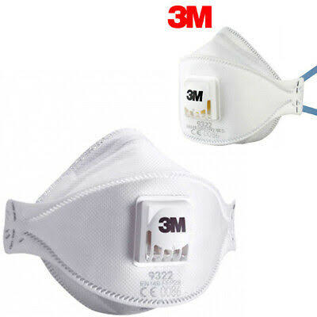
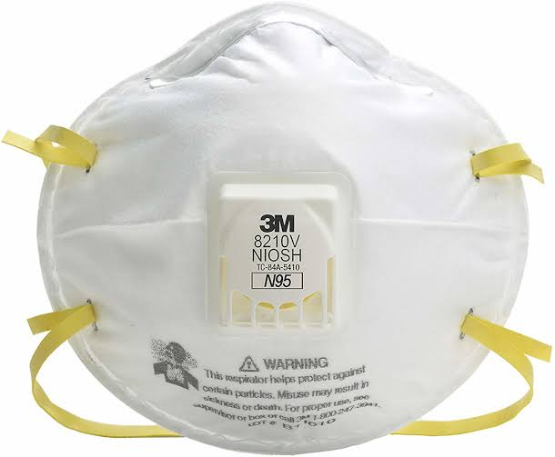
Fig 2- N95 Respirator
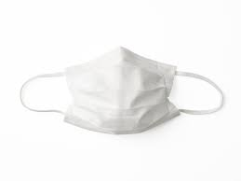
- Facemasks: this used to prevent the spread of disease. It helps limit the spread of germs. In case of the COVID-19 When someone talks, coughs or sneezes they may release tiny drops into the air that can infect others. If someone is ill a face masks can reduce the number of germs that the wearer releases and can protect other people from becoming sick.
Fig 3- Facemask

- Eye Protection: It prevent the virus to enter the body through the eyes when positive COVID-19 patient coughs, sneezes, or talks.
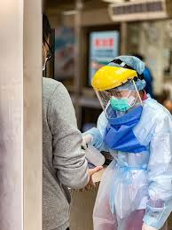
Fig 4- Eye Protector Fig 5- Nurse wearing facemask and Eye Protector

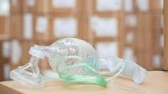
- Ventilators: is a machine that provides mechanical ventilation by moving breathable air into and out of the lungs, to deliver breaths to a patient who is physically unable to breathe, or breathing insufficiently.
Fig 6- ventilator
- Disinfectant Robot: All over the world, hundreds of engineers, scientists and software developers are at work building a robotic army with a bold mission: to help prevent the spread of coronavirus.
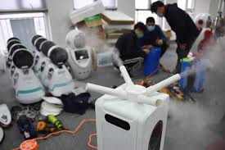
Fig7 – Disinfectant bots
- Isolation Pod: This are used to transport infected people without have to have contact with them.
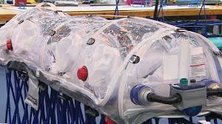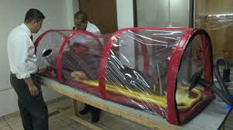
Fig 8- Isolation pod

These equipment prevent the transmission of the COVID-19 to some extent.
Technology of healthcare is considered a crucial part of the healthcare industry because it plays a major role in diagnostic, treatment, monitoring and giving therapy to patients.
Managing medical equipment properly and efficiently, ultimately ensures that up-to-date, ready and fit for services are presented at any time of emergency in the future like the case of the COVID-19 pandemic situation.
The goal of biomedical equipment management is to provide electrically safe, calibrated and well-functioning equipment with the purpose of delivering best healthcare for patients and to present the best cost effective manner of maintaining equipment in hospitals.
In the healthcare centres in Nigeria, a framework of medical equipment management system should be used for in-house clinical engineering department.

METHODOLOGY

This study adopted a conceptual approach in an attempt to view the various strategies for maintaining and management of engineering equipment for sustainable development in Nigeria. The justification for this approach is because the study is exploratory in nature anchored on discovery of ideas and insights.
Materials were gathered via internet, textbook, course handouts and other documents relevant to this study.

RECOMMENDATION

With the challenges facing Nigeria and lack of maintenance planning in Nigeria I will recommend the following:
- A maintenance policy must be put in place to address the procurement of equipment
- Procurement should the prepared by the appropriate professional individual
- Proper training should be provided for the right personnel so that it can ensure the maximum utilization of the equipment.
- Budget to facilitate the movement and exchange of staff and training
- Adequate funding for the management and maintenance of medical equipment must be provided
- The federal, state, local government and private concerns must ensure that funds allotted to the cause are properly disbursed to the management/maintenance plans. This commitment will ensure adequate provision for failed equipment and developed a sustainable equipment for future use.
- Our leaders are encouraged to pay adequate attention to human development as well as the plight of masses under their jurisdiction.

CONCLUSION

It is necessary that several key factors need to be considered and appropriately addressed to achieve engineering sustainability, which itself is a crucial component of overall sustainability for human activity and development. The key factors include appropriate planning, maintenance, management of medical equipment for sustainability criteria, the use of sustainable processes, enhancement of the efficiency of resource utilization and engineering processes, environmental stewardship in engineering activities so as to mitigate environmental impacts, and fulfilment of other aspects of sustainability, such as economics and equity.

REFERENCES

- Marc A. Rosen, 2012, ‘Engineering Sustainability: A Technical Approach to Sustainability’, sustainability, ISSN 2071-1050, pp. 2270-2292
- Aruna1,M, Uma, G, Saadia, N, (2018), ‘Efficient Equipment Management for Biomedical Engineering Department in the Hospital’, International Review of Management and Marketing, vol.8, ISSN: 2146-4405, pp. 69-74
- Wilson,R.N, Able,M & Charles, M, (2017),’Equipment Maintenance Challenges and Solutions for Capacity Building and Sustainability in the Training of Engineering: the Case for the University of Zimbabwe’, Sustainable Materials Processing and Manufacturing, vol. 7, pp. 303-308
- Wikipedia
- Mdpi journal
- Science direct journal
- Petrochemical Maintenance website
- Bio-technology Research international

