Name: agunoweh preye helen
Matrix no:18/sms04/003
Course:CMS 204

Social media and proliferation of fake news, dodgy health advice and fake ‘cures.of Covid 19

Most research on fake news has emerged from developed countries. This work concentrated on the Nigerian setting. Despite the Anti-fake news campaign launched in Nigeria, the spread of fake news remains alarming. Sharing news among Nigerians is seen as contributing to social cohesion. Users doing so are motivated by the emotional impact the news is seen to have, the relevance it might have for the receiver, and the sender’s intention to ‘provide advice or warning.’ Most Nigerians tend to trust information shared by family members and friends more than strangers. They are more likely to share misinformation about entertainment, political news, job adverts, kidnapping and those that have elements of patriotism and emotions. Moreover, religion or ethnic organization or someone they hold in high esteem and share the same faith with also motivates such sharing. This work suggests the need to increase fake news awareness through media and information literacy because, in Nigeria, fake news awareness campaigns have not been fully actualized. There is a need to increase the media literacy of the public, particularly young people to critically access and respond to media messages. Furthermore, social media users should be constantly informed about the consequences of fake news, how to spot it, and why it is important to be self-aware before forwarding any message There should also be adequate adverts, workshops, conferences, and other forms of sensitization across all media to enable individuals to differentiate between factual and made-up news.

Watch out for fake coronavirus medicines and dodgy health advice

Unscrupulous sellers tout fake or unproven products claiming to prevent or cure COVID-19

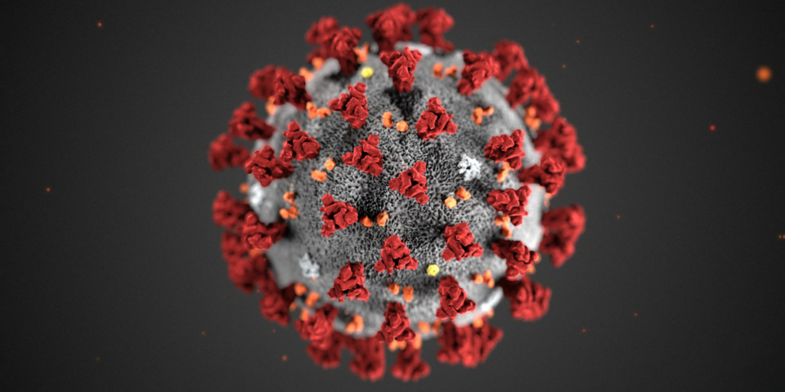
Unscrupulous sellers are trying to exploit the coronavirus pandemic by touting dodgy coronavirus medicines and tests online. Fake news about ways to prevent or cure COVID-19 is also rife, causing confusion about how to best protect yourself against the virus. The Medicines and Healthcare products Regulatory Agency (MHRA) has reported that it has uncovered 14 new cases of fake or unlicensed COVID-19 medication being sold online. It has also disabled nine domain names and social media accounts selling fake or unauthorised coronavirus products to people in the UK. Among the products seized were unauthorised anti-viral medication, self-testing kits and ‘anti-viral misting sprays.’ Publicity around drugs, such as the anti-malarial Chloroquine, currently being tested as potential treatments for coronavirus, has added fuel to the fire, as people try to get hold of these as-yet unproven ‘cures.’ The MHRA has also expressed concerns that confusion around the availability and legitimacy of testing kits could provide scammers
The crackdown on fake coronavirus medicines is part of a continuing effort by MHRA to stamp out unproven and counterfeit COVID-19 products, in conjunction with other authorities. Last month, a global effort coordinated by Interpol known as ‘Operation Pangea’ found 2,000 online advertisements related to fake COVID-19 medicines. It also intercepted more than 34,000 fake coronavirus-related products. In one example, a Brighton man was charged with fraud for shipping ‘coronavirus treatment kits’ to the US, which consisted of the chemicals potassium thiocyanate and hydrogen peroxide which users were instructed to rinse their mouths with – which can be very dangerous. A spokesperson for the MHRA said: ‘Patient safety is our highest priority and we are working with other law enforcement agencies and with partners across government to combat this type of criminal activity. We are also actively investigating a number of reports of the sale of counterfeit or unlicensed products relating COVID-19.’ If you see anywhere claiming to have a cure or treatment for coronavirus, don’t be tempted. There is currently no proven treatment or cure for COVID-19.

Don’t fall for fake news about coronavirus Hold your breath, drink lots of water and sunbathe? Some questionable advice on how to prevent COVID-19 has been doing the rounds recently. Messages with dodgy advice have been spreading rapidly via email and messaging platforms, often supposedly from ‘[medical staff or researchers] at [hospital, country or academic institution]’, in the form of a note or voice memo. Some we’ve seen include variants of the same ‘advice’ from, variously: ‘a doctor at St George’s Hospital’, ‘a doctor at Stanford’ and ‘a doctor treating COVID-19 patients in Japan’. Fake health messages causing confusion 45% of Which? members we surveyed in April 2020 said they had heard health advice they thought was incorrect or misleading. It can be hard to separate fact from fiction as the unfounded or simply outlandish claims are mixed in with official and sensible advice such as washing your hands. Some of the claims floating around include: Drinking water will ‘flush out’ the virus (FALSE) Text from one of the letters going around tells you that drinking water will flush the virus from your throat into the stomach where gastric acids can destroy it. While drinking plenty of water and staying hydrated is always important, the idea that you can remove a virus this way is unscientific. The virus can find its way into the cells of the respiratory system, as well as transmitting through the nostrils or eyes. Gargling with salt water or disinfectant will kill the virus (FALSE) Advice that was incorrectly attributed to a London hospital says that gargling with disinfectant ‘removes the virus before it goes down to the trachea and then to the lungs.’ This is a fundamental misunderstanding of the virus, which affects the entire respiratory system and doesn’t just lurk in the throat. If you can hold your breath for 10 seconds, you don’t have COVID-19 (FALSE) This claim says that if you can hold your breath for 10 seconds without coughing, you’re in the clear. It also suggests you do this daily and that by the time you have the officially recognised symptoms it’s ‘too late’. This is nonsense. While shortness of breath and coughing are (sometimes) symptoms of COVID-19, the ability to hold your breath for 10 seconds will vary from person to person, for a myriad of reasons. It isn’t an indicator that you do or don’t have the virus. The virus is killed by the sun (FALSE) Claims that the new Coronavirus ‘hates the sun’ and that therefore sunbathing can prevent you catching it are unfounded. Given the global spread of the virus so far in both hot and cold climates, there is no evidence for this. We don’t yet know if COVID-19 is a seasonal flu. Drinking hot water and avoiding ice or cold drinks will help (FALSE) Working on the same flawed logic of the myth above, some advice recommends constantly drinking hot drinks and avoiding ice or cold drinks. But drinking hot drinks will not change your body temperature. You cannot kill the virus once it’s in the body – your immune system just needs to fight it off.

Coronavirus: The fake health advice you should ignore

Coronavirus is emerging in more countries around the world and there's currently no known cure. Unfortunately that hasn't stopped a slew of health advice, ranging from useless but relatively harmless, to downright dangerous.

We've been looking at some of the most widespread claims being shared online, and what the science really says.

1. Garlic

Lots of posts that recommend eating garlic to prevent infection are being shared on Facebook.

The WHO (World Health Organization) says that while it is "a healthy food that may have some antimicrobial properties", there's no evidence that eating garlic can protect people from the new coronavirus.

In lots of cases, these kinds of remedies aren't harmful in themselves, as long as they aren't preventing you from following evidence-based medical advice. But they have the potential to be.

The South China Morning Post reported a story of a woman who had to receive hospital treatment for a severely inflamed throat after consuming 1.5kg of raw garlic.

We know, in general, that eating fruit and vegetables and drinking water can be good for staying healthy. However, there is no evidence specific foods will help fight this particular virus.

2. Miracle minerals'

YouTuber Jordan Sather, who has many thousands of followers across different platforms, has been claiming that a "miracle mineral supplement", called MMS, can "wipe out" coronavirus.

It contains chlorine dioxide - a bleaching agent.

Sather and others promoted the substance even before the coronavirus outbreak, and in January he tweeted that, "not only is chlorine dioxide (aka MMS) an effective cancer cell killer, it can wipe out coronavirus too".

3. Home-made hand sanitiser

There have been many reports of shortages of hand sanitiser gel, as washing your hands is one key way to prevent spread of the virus .

As reports of the shortages emerged in Italy, so did recipes for home-made gel on social media.

But these recipes, alleged dupes for one of the country's most popular brands, were for a disinfectant better suited for cleaning surfaces and, as scientists pointed out, not suitable for use on skin.

Alcohol-based hand gels usually also contain emollients, which make them gentler on skin, on top of their 60-70% alcohol content.

Professor Sally Bloomfield, at the London School of Hygiene and Tropical Medicine, says she does not believe you could make an effective product for sanitising hands at home - even vodka only contains 40% alcohol .

For cleaning surfaces, the US Centers for Disease Control and Prevention (CDC) says most common household disinfectants should be effective.

4. Drinkable silver

The use of colloidal silver was promoted on US televangelist Jim Bakker's show. Colloidal silver is tiny particles of the metal suspended in liquid. A guest on the show claimed the solution kills some strains of coronavirus within 12 hours (while admitting it hadn't yet been tested on Covid-19).

The idea that it could be an effective treatment for coronavirus has been widely shared on Facebook, particularly by "medical freedom" groups which are deeply suspicious of mainstream medical advice.

Proponents of colloidal silver claim it can treat all kinds of health conditions, act as an antiseptic, and state it helps the immune system. There are some occasional uses of silver in healthcare, for example in bandages applied to wounds, but that doesn't mean it's effective to consume.

There's clear advice from the US health authorities that there's no evidence this type of silver solution is effective for any health condition. More importantly, it could cause serious side effects including kidney damage, seizures and argyria - a condition that makes your skin turn blue.

They say that, unlike iron or zinc, silver is not a metal that has any function in the human body.

Some of those promoting the substance for general health on social media have found their posts now generate a pop-up warning from Facebook's fact-checking service.

5. Drinking water every 15 minutes

One post, copied and pasted by multiple Facebook accounts, quotes a "Japanese doctor" who recommends drinking water every 15 minutes to flush out any virus that might have entered the mouth. A version in Arabic has been shared more than 250,000 times.

Professor Trudie Lang at the University of Oxford says there is "no biological mechanism" that would support the idea that you can just wash a respiratory virus down into your stomach and kill it.

Infections like coronaviruses enter the body via the respiratory tract when you breathe in. Some of them might go into your mouth, but even constantly drinking water isn't going to prevent you from catching the virus.

Nonetheless, drinking water and staying hydrated is generally good medical advice.

6. Heat and avoiding ice cream

There are lots of variations of the advice suggesting heat kills the virus, from recommending drinking hot water to taking hot baths, or using hairdryers.

One post, copied and pasted by dozens of social media users in different countries - and falsely attributed to Unicef - claims that drinking hot water and exposure to the sun will kill the virus, and says ice cream is to be avoided.

