NAME: OKEKE OTITOCHI MMARYANN
MATRIC NO:16/SCI01/030
- The Caesar cipher is one of the earliest known and simplest ciphers. It is a type of substitution cipher in which each letter in the plaintext is 'shifted' a certain number of places down the alphabet. For example, with a shift of 1, A would be replaced by B, B would become C, and so on. The method is named after Julius Caesar, who apparently used it to communicate with his generals.
Example
To pass an encrypted message from one person to another, it is first necessary that both parties have the 'key' for the cipher, so that the sender may encrypt it and the receiver may decrypt it. For the Caesar cipher, the key is the number of characters to shift the cipher alphabet. Here is a quick example of the encryption and decryption steps involved with the Caesar cipher. The text we will encrypt is 'defend the east wall of the castle', with a shift (key) of
plaintext: defend the east wall of the castle
cipher text: efgfoe uif fbtu xbmm pg uif dbtumf
It is easy to see how each character in the plaintext is shifted up the alphabet. Decryption is just as easy, by using an offset of -1.
plain: abcdefghijklmnopqrstuvwxyz
cipher: bcdefghijklmnopqrstuvwxyza
Obviously, if a different key is used, the cipher alphabet will be shifted a different amount.

- MonoAlphabetic Cipher - MonoAlphabetic cipher is a substitution cipher in which for a given key, the cipher alphabet for each plain alphabet is fixed throughout the encryption process. They work by replacing each letter of the plaintext (and sometimes punctuation marks and spaces) with another letter (or possibly even a random symbol). A MonoAlphabetic substitution cipher, also known as a simple substitution cipher, relies on a fixed replacement structure. That is, the substitution is fixed for each letter of the alphabet.
EXAMPLE: if ‘A’ is encrypted as ‘D’, for any number of occurrences in that plaintext, ‘A’ will always get encrypted to ‘D’.
- Playfair Cipher - The Play fair cipher was the first practical digraph substitution cipher. The scheme was invented in 1854 by Charles Wheatstone but was named after Lord Playfair who promoted the use of the cipher. In Play fair cipher unlike traditional cipher we encrypt a pair of
alphabets(digraphs) instead of a single alphabet. It was used for tactical purposes by British forces in the Second Boer War and in World War I and for the same purpose by the Australians during World War II. This was because Play fair is reasonably fast to use and requires no special equipment.
EXAMPLE
The key is “monarchy”
Thus the initial entries are ‘m’, ’o’, ’n’, ’a’, ’r’, ’c’, ’h’, ’y’ followed by remaining characters of
a-z (except ‘j’) in that order.
- Vigenere Cipher - Vigenere Cipher is a method of encrypting alphabetic text. It uses a simple form of polyalphabetic substitution. A polyalphabetic cipher is any cipher based on substitution, using multiple substitution alphabets.
EXAMPLE:
Input: Plaintext: GEEKSFORGEEKS
Keyword: AYUSH
Output: Cipher text: GCYCZFMLYLEIM
For generating key, the given keyword is repeated in a circular manner until it matches the length of the plain text. The keyword “AYUSH” generates the key” AYUSHAYUSHAYU”
Encryption- The first letter of the plaintext, G is paired with A, the first letter of the key. So use row G and column A of the Vigenère square, namely G. Similarly, for the second letter of the plaintext, the second letter of the key is used, the letter at row E and column Y is C. The rest of the plaintext is enciphered in a similar fashion.
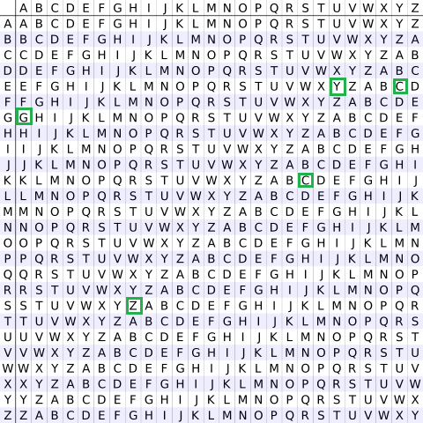
Table to encrypt
Decryption - is performed by going to the row in the table corresponding to the key, finding the
position of the ciphertext letter in this row, and then using the column’s label as the plaintext. For
example, in row A (from AYUSH), the ciphertext G appears in column G, which is the first
plaintext letter. Next we go to row Y (from AYUSH), locate the ciphertext C which is found in
column E, thus E is the second plaintext letter.
- Polyalphabetic Cipher - A polyalphabetic cipher is any cipher based on substitution, using multiple substitution alphabets. The Vigenère cipher is probably the best-known example of a polyalphabetic cipher, though it is a simplified special case.
Input: Plaintext: GEEKSFORGEEKS
Keyword: AYUSH
Output: Cipher text: GCYCZFMLYLEIM
For generating key, the given keyword is repeated in a circular manner until it matches the length of the plain text.
The keyword "AYUSH" generates the key "AYUSHAYUSHAYU"
The plain text is then encrypted using the process explained below.

- One Time Cipher - The One-Time Pad, or OTP is an encryption technique in which each character of the plaintext is combined with a character from a random key stream. Originally described in 1882 by banker Frank Miller (USA), it was re-invented in 1917 by Gilbert Vernam and Joseph Mauborgne. When applied correctly, the OTP provides a truly unbreakable cipher. It is named after the sheets of paper (pads) on which the key stream was usually printed. It is said that the one-time pad is the best cipher anywhere. It is uncrack able as long as you keep the messages short, use shorthand and abbreviations, remove unnecessary letters, never reuse a pad, and have a good enough random source for data.
EXAMPLE:

