TECHNICAL REPORT
ON

DESIGN OF INNOVATIVE AND AUTOMATED RESPIRATORY BUILDINGS FOR PATIENTS AND HEALTH WORKERS AGAINST CORONAVIRUS DISEASE OUTBREAK

PREPARED BY

ORILADE EMMANUEL OLUWATOMISIN
17/ENG05/037
SUBMITTED TO

THE COLLEGE OF ENGINEERING
AFE BABALOLA UNIVERSITY, ADO-EKITI, EKITI STATE, NIGERIA.
IN PARTIAL FULFILMENT OF REQUIREMENTS FOR THE AWARD OF BACHELOR OF ENGINEERING (B.ENG) DEGREE IN MECHATRONICS ENGINEERING.

APRIL, 2019.

TABLE OF CONTENTS

CHAPTER 1 2
INTRODUCTION 2
WHAT IS RESPIRATION AND HOW DOES IT WORK? 2
CHAPTER 2 5
LITERATURE REVIEW 5
DESIGN OF THE AUTOMATED RESPIRATORY BUILDINGS 5
CHAPTER 3 8
CONSTRUCTION OF THE SYSTEM 8
THE CONSTRUCTION 9
What are the new features of this design that makes it special? 9
CHAPTER 4 11
CONCLUSION 11
Some of these possible challenges that might be encountered include; 11
Some recommended solutions to help curb these challenges include; 11
REFERENCES 12

CHAPTER 1

INTRODUCTION
There are a lot of diseases, illnesses and other conditions that can lead to severe respiratory complications. Some of these include; Asthma, Chronic Bronchitis, Emphysema, Drowning, Obstruction in the trachea, Weakness of breathing muscles, Damage to the bones and tissues of the chest, Lung cancer, Pleural Effusion, and the resent global viral outbreak Coronavirus (Covid-19).
As a result of these respiratory complications, patients would have difficulty breathing and as such, they are hooked up to mechanical/electromechanical devices known as ventilators, which are to aid their respiration.
In order to proceed with the design of these respiratory buildings, we need to know how the process of respiration takes place and to do this, we need to firstly understand the concept of respiration.

WHAT IS RESPIRATION AND HOW DOES IT WORK?
When we hear the word 'respire', we probably think of breathing. When you breathe, you are taking in oxygen with each inhale and releasing carbon dioxide with each exhale. This gas exchange is important for respiration, but while breathing is a physical process, respiration can be thought of as more of a chemical process. Respiration refers to the utilization of oxygen and removal of carbon dioxide by the body as a whole, or by individual cells in cellular respiration.
Lack or shortage of oxygen, can result in damage of vital organs including the heart and brain.
In general, respiration entails two basic processes, namely; Inhalation and Exhalation.

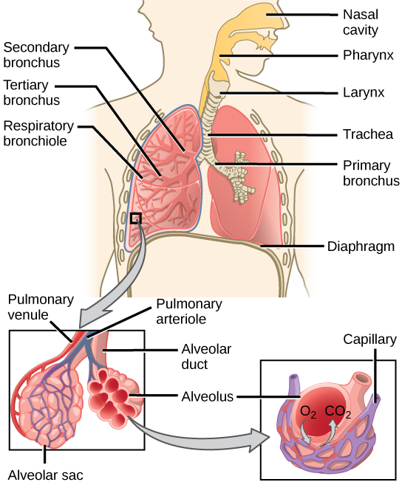

Fig 1.1: Diagram of the human Respiratory System

- INHALATION: During the inhalation process, Oxygen is taken into the body through the nose or mouth and into the pharynx or throat. It then goes into your trachea, or windpipe. Your trachea divides to become the left and right main bronchi, which enters your lungs. Inside your lungs, the main bronchi divides repeatedly and eventually becomes small tubes called bronchioles. At the end of the bronchioles ae tiny air sacs called alveoli. Oxygen in your alveoli is absorbed into nearby blood vessels called capillaries. where it mixes. During this process, air moves into the lung when a muscle called the diaphragm, along with other muscles nearby, contract and causes the chest cavity to expand.

- EXHALATION: During exhalation, carbon dioxide which must be removed, passes into the alveoli and back through the airways. During this process, air is exhaled when these muscles relax, and the lung tissue passively returns to its original size.
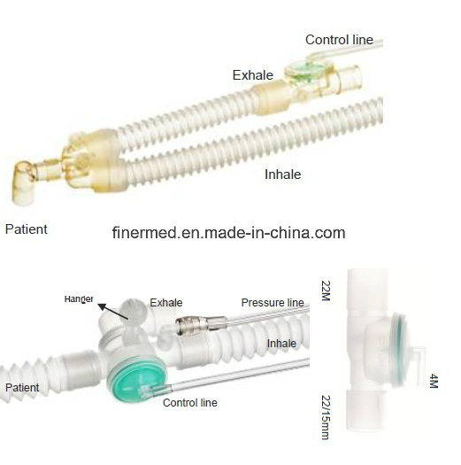
Fig 1.2: Picture of an Inhale/Exhale Valve

NOTE: The expansion and contraction that occurs during the process of respiration is visible, by looking at the chest region.

After the brief study of respiration, how it works, and processes behind it, we will go into discussing how to develop respiratory buildings for patients and health workers.

CHAPTER 2

LITERATURE REVIEW

DESIGN OF THE AUTOMATED RESPIRATORY BUILDINGS

Before, discussing on the designing of the respiratory buildings, we are to understand firstly the purpose of these systems.
The main aim of the respiratory building, is to aid the breathing in people who have illnesses or other conditions, which affect their respiration. These systems must have the ability to pump in oxygen, and remove carbon dioxide, and this process must be done with great precision and everything in the right proportion.
Also, in the design of these systems, the method of insertion (how the systems are to be connected to the body), has to be determined.
The two-basic type of insertion methods are;

- Non-invasive method (Use of mask): In this method, a mask is placed over the face of the patient, and then the respiratory system is turned on. This method is used mainly for patients whose complications are not so serious. It is also regarded as the safest method as it reduces the risk of infections.

- Invasive method (Endotracheal tube): In the process, a respiratory therapist after sterilizing inserts a laryngoscope into the patients mouth & guide the endotracheal tube into the wind pipe. This process is used for severe complications.
Now, let’s look at the equipment’s required for the development of these automated respiratory systems.

Essential parts which every automated respiratory system must have include;

- Inhale Valve: This is the valve responsible for the transportation of oxygen into the respiratory system.
- Exhale Valve: This is the valve responsible for the removal of carbon dioxide from the body.
- Endotracheal Tube: An endotracheal tube is a flexible plastic tube that is placed through the mouth into the trachea (windpipe) to help a patient breathe. The endotracheal tube is then connected to a ventilator, which delivers oxygen to the lungs. The process of inserting the tube is called endotracheal intubation.

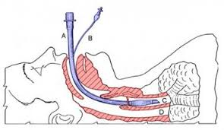
Fig 2.1: Diagram of an Endotracheal Tube inserted in the respiratory system

- Laryngoscope: This is a device that used by doctors, to get a close-up view of your larynx and throat. It comprises of a handle, light, and a dull blade. It is used to raise the epiglottis (flap of tissue protecting the larynx).
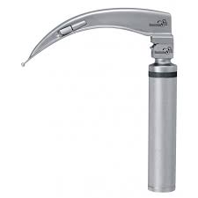
Fig 2.1: Diagram of a Laryngoscope

- Breathing Rate Monitor: This device is similar to an oscilloscope. The respiratory rate is the rate at which breathing occurs. This is usually measured in breaths per minute and is set, and controlled by the respiratory centre. Similar to the ECG and heart rate data, the breathing monitor measures and stores a breathing waveform from which an accurate mobile breathing rate is provided. This allows analysis of breathing trends in active individuals which has until now been very difficult to achieve. This device can be controlled by the doctor to regulate the patients breathing.

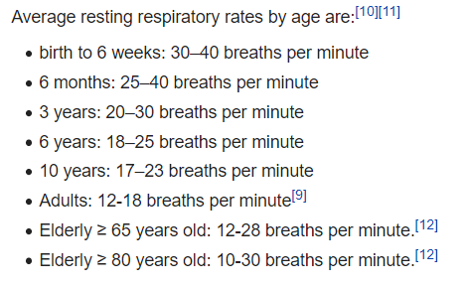
Fig 2.2: A chart of the average respiratory rates by age

CHAPTER 3

CONSTRUCTION OF THE SYSTEM

Now, let us go into the construction of this system. Let us note that this system is a prototype, and we would be improvising materials, which are not available.

Remote Control and/or Voltage Regulator: The Respiratory system/ventilator will be controlled manually by a remote and a voltage controller switch. This remote will be used to control the rate at which the inhale and exhale valve transport oxygen and remove carbon dioxide from the body. It will also be used to control the displays on the breathing rate monitor. In an event where this remote has any fault, a manual voltage regulator, will be used to perform those functions.

LED indicators: These LED’s will be used to indicate the power state of the system. It will also be used to indicate the present conditions of the patient (either stable or unstable).

Microcontroller: A microcontroller will be required to program the systems sensors and actuators.

An Oscilloscope: This will be connected to the ECG sensors, to monitor the heartrate. It will serve as the breathing rate monitor.

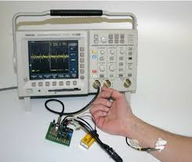
Fig 2.3: An Oscilloscope connected to and ECG sensor

THE CONSTRUCTION

An oxygen tank/cylinder, will be connected to a circuitry, which will be responsible for the regulation of oxygen flow. That circuitry, will be further connected to an inbuilt humidifier in the ventilatory system, which would warm and moisten the air. From here, the warm moist air will be connected to the the inhale valve, for the transportation of O₂ and an exhale valve will be attached for the removal of CO₂. The oscilloscope will then be connected to the ECG sensors on the patients’ body which will monitor the patients’ heart and breathing rate.
For the inhale valve, a fluid hose can used.

What are the new features of this design that makes it special?

Unlike other designs, this new design will be integrated into the structure of the hospital buildings. It will be done in such a way that the ventilators hose will be at several outlets of the Intensive Care Units (ICU’S) walls, and it can be connected to the patient in need. This will eradicate the need for many ventilators because the design will be like a very big ventilator, serving multiple patients.

Below is a list of Components needed for this project, the quantity, the unit price and the total price.
S/N | Components | Quantity | Unit Price | Total Price
1. | Arduino Uno | 2 | N5,000 | N10,000
2. | Raspberry Pie 4 | 1 | N30,000 | N30,000
3. | 500m length Hose | 1 | N10,000 | N10,000
4. | 5-Channel Solid State Relay | 1 | N5,1000 | N5,000
5. | Vero Boards (line) | 5 | N300 | N1,500
6. | Male to Female Headers | 10 | N200 | N2,000
7. | LED’s | 15 | N50 | N750
8. | Remote Control Power Module | 1 | N2,000 | N2,000
9. | Voltage Regulator | 2 | N1,000 | N2,000
10. | Soldering Iron | 1 | N3,000 | N3,000
11. | Soldering LED | 2 | N500 | N1000
12. | Power Extension Cord | 2 | N500 | N1000
13. | Soldering Lead | 2 | N1,000 | N2,000
14. | Oxygen Tank/Cylinder | 1 | N50,000 | N50,000
15. | Oscilloscope | 1 | N200,000 | N200,000
16. | ECG Sensors kit | 1 | N50,000 | N50,000
17. | Equipment’s for the humidifier | - | N50,000 | N50,000
18. | Uninterrupted Power Supply | 2 | N35,000 | N35,000
19. | Servo Motors | 5 | N2,500 | N12,500
20. | Miscellaneous | - | N200,000 | N200,000
21. | Shipping | - | N50,000 | N50,000
 | TOTAL |  |  | N706,050

CHAPTER 4

CONCLUSION
In concluding this report, I will like to discuss possible challenges that might be encountered in the process of carrying out this project.

Some of these possible challenges that might be encountered include;
- Lack of funds
- Unavailability of resources
- Shortage of manpower to carry out this project
- Unconducive working environment
- Faulty working equipments

Some recommended solutions to help curb these challenges include;
- Sponsorship and support from the school and the government
- Encouraging students to signup and participate in projects like this
- Provision of conducive working environments
- Assistance / contribution from staff

In this closing remark, I would love to thank the management and staff of this college for their relentless effort in ensuring that we are the best amongst our peers. I also want to appeal to the college authorities to make group projects like this compulsory for every department at the end of every academic session. It will boost our academic performance in both theory and practical aspects. It will also equip us with a lot of skills and as such, we would be able to give a lot back to our community, society, the country and the world at large.

THANK YOU!!!

REFERENCES

- https://www.khanacademy.org/science/high-school-biology/hs-human-body-systems/hs-the-circulatory-and-respiratory-systems/a/hs-the-respiratory-system-review
- https://www.usatoday.com/in-depth/news/2020/04/10/coronavirus-ventilator-how-works-why-covid-19-patients-need/2942996001/
- https://www.youtube.com/watch?v=V8VIw0fk4X0
- https://www.verywellhealth.com/endotracheal-tube-information-2249093
- https://www.rtmagazine.com/disorders-diseases/critical-care/ards/building-craftsmanship-in-respiratory-care/
- https://study.com/academy/lesson/what-is-respiration-definition-process-equation.html

