**Onitiri Oluwaseun**

**Mechanical engineering**

**17/ENG06/066**

**QUESTION 1a ANSWERS**

1. The three conditions for a coutte flow are:
2. Pressure gradient is constant
3. The flow is uniform
4. The flow is steady
5. Four (4) conditions that can be used to determine the nature of flow are given by Reynolds experiment as:
6. The diameter of the pipe(m)
7. The density of the fluid passing through the pipe(kg/m3)
8. The viscousity of the fluid(Ns/m2)
9. The velocity of the flow(m/s)
10. The differences between aerofoil and hydrofoils are enlisted below:

|  |  |
| --- | --- |
| AEROFOIL | HYDROFOIL |
| 1. The aerofoil is a lifting device mainly used in gaseous fluids(air in particular) | The hydrofoil is a lifting device mainly utilized in liquid fluids( water) |
| 1. The aerofoil is mainly used for lifting of airplanes and jets. | The hydrofoil is mainly used to overcome drag and make machines move with a higher velocity in water. |

**QUESTION 1b SOLUTION**

Given: µ= 0.9 centipoise= 0.9 x 10-2 poise = 0.9 x 10-3 Ns/m2

U= 1m/s

b= 10mm=0.01m

dp= 60KN/m2

dx= 60m

therefore the pressure difference gradient is = = = -1 x 103 N/m3

1. Velocity distribution= u = $\frac{U_{y}}{b}-\frac{1}{2μ}\left(\frac{∂p}{∂x}\right)\left(by-y^{2}\right)$

u =100y + 5555.56y – 555555.56y2

u = (5.65556 x 103 )y – (5.556x 105 ) y2

1. Discharge per unit width = q= $\frac{Ub}{2}-\frac{b^{3}}{12μ}\left(\frac{∂p}{∂x}\right)$

q = 0.005 + 0.09259 = 0.09759 m3/s/m

1. Shear stress at upper plate is @y=b,

τ = $\frac{μU}{b}-\frac{1}{2}\left(\frac{∂p}{∂x}\right)\left(b-2y\right)$

= τ = $\frac{μU}{b}-\frac{1}{2}\left(\frac{∂p}{∂x}\right)\left(-b\right)$

τ = 0.09-5 = - 4.91 N/m2

**QUESTION 2 SOLUTION**

Given: µ= 0.9Ns/m2 b= 10mm=0.01m

ρ= 1260kg/m3 P1= 250KN/m2

U= -1.5m/s P2= 80KN/m2

=

But P.1= P1 + ρgz (piezometric)

= 250000 + (1260) *(9.81) *(1)

= 262.36KN/m2

And P.2= P2 + ρgz (piezometric)

= 80000 + (1260)*(9.81)*(0)

= 80KN/m2

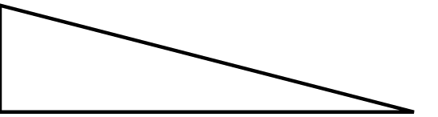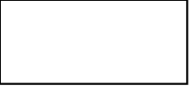

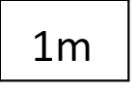

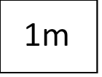

Because the two plates are aligned at an angle of 45 degrees, the above diagram can be used to calculate the change in x

By Pythagoras theorem,

$Δx$ = $\sqrt{1^{2}+1^{2}}$ = $\sqrt{2}$ m

Therefore,

$\frac{∂p}{∂x}$ = $\frac{-(P.1-P.2)}{Δx}$ = $\frac{-\left(262⋅36-80\right)}{\sqrt{2}}$ = -128.948KN/m3

1. Velocity distribution= u = $\frac{U_{y}}{b}-\frac{1}{2μ}\left(\frac{∂p}{∂x}\right)\left(by-y^{2}\right)$

u = -150y + 716.38y – 71637.8 $y^{2}$

u = -(7.16378 x 104 ) + 565.62y

1. Shear distribution= τ = $\frac{μU}{b}-\frac{1}{2}\left(\frac{∂p}{∂x}\right)\left(b-2y\right)$

τ = -135 + 644.74 – 128948y

τ = 509.74 – (1.289 x 105 )y

1. Maximum flow velocity

At maximum flow velocity, $\frac{∂u}{∂y}=0$

0= -(1.4328 x 105 )y + 565.62

y= 3.9476 x 10-3 m

umax= -(7.16378 x 104 ) + 565.62(3.9476 x 10-3)

umax= 1.12 m/s

1. Shear stress at upper plate is @y=b

Therefore, τ = 509.74 – (1.289 x 105 )y

τ = 509.74 – (1.289 x 105 )( 0.01)

τ = -779.26 N/m2