18/MHS02/120
1. Vasculture is the arrangement of blood vessels in the body or in an organ or body part.
Think of it as the body’s personal army working from the cellular to macro level. Each cell, molecule, tissue and organ in this army plays a vital role in warding off invading pathogens.
The system has two types of response: innate and adaptive

The body’s natural barriers against disease-causing intruders – for example, our skin, the mucous and hairs in our nose, and the acid in our stomachs – are part of our innate immune systems.

Adaptive immunity develops over a lifetime of contact with pathogens and vaccines, preparations which help our immune systems to distinguish friend from foe.

The specific immune responses that are effective against viruses are
1. cell-mediated immunity involving T lymphocytes and cytotoxic effector T lymphocytes
2.antibody, with and without its interaction with complement and antibody-dependent cell-mediated cytotoxicity (ADCC)
3. natural killer cells and macrophages,
4. lymphokines and monokines

Cytokines are proteins used by the immune system as alarm beacons—they recruit immune cells to the site of infection. The immune cells then kill off the infected tissue in a bid to save the rest of the body.

Humans rely on our immune systems to keep their cool when facing a threat. But during a runaway coronavirus infection, when the immune system dumps cytokines into the lungs without any regulation.
The implications extend outside the lungs. Cytokine storms create inflammation that weakens blood vessels in the lungs and causes fluid to seep through to the air sacs. “Basically you’re bleeding out of your blood vessels,” Rasmussen says. The storm spills into your circulatory system and creates systemic issues across multiple organs.

In some of the most severe COVID-19 cases, the cytokine response—combined with a diminished capacity to pump oxygen to the rest of the body—can result in multi-organ failure.
2. The adductor canal (subsartorial or Hunter’s canal) is an aponeurotic tunnel in the middle third of the thigh, extending from the apex of the femoral triangle to the opening in the adductor magnus, the adductor hiatus.

The adductor canal serves as a passageway for structures moving between the anterior thigh and posterior leg. It transmits the femoral artery, femoral vein (posterior to the artery), nerve to the vastus medialis and the saphenous nerve – the largest cutaneous branch of the femoral nerve.

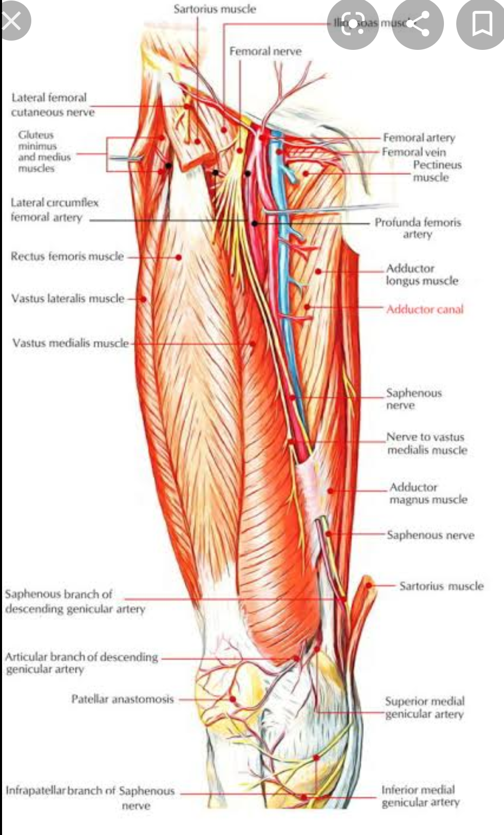
3. The extraocular muscles are the six muscles that control movement of the eye and one muscle that controls eyelid elevation (levator palpebrae). The actions of the six muscles responsible for eye movement depend on the position of the eye at the time of muscle contraction.

Four of the extraocular muscles have their origin in the back of the orbit in a fibrous ring called the annulus of Zinn: the four rectus muscles. The four rectus muscles attach directly to the front half of the eye (anterior to the eye's equator), and are named after their straight paths.

Medial indicates near the midline, and lateral describes a position away from the midline. Thus, the medial rectus is the muscle closest to the nose. The superior and inferior recti do not pull straight back on the eye, because both muscles also pull slightly medially. This posterior medial angle causes the eye to roll with contraction of either the superior rectus or inferior rectus muscles. The extent of rolling in the recti is less than the oblique, and opposite from it.

The superior oblique muscle originates at the back of the orbit (a little closer to the medial rectus, though medial to it), getting rounder as it courses forward to a rigid, cartilaginous pulley, called the trochlea, on the upper, nasal wall of the orbit. The muscle becomes tendinous about 10mm before it passes through the pulley, turning sharply across the orbit, and inserts on the lateral, posterior part of the globe. Thus, the superior oblique travels posteriorly for the last part of its path, going over the top of the eye. Due to its unique path, the superior oblique, when activated, pulls the eye downward and laterally.

The last muscle is the inferior oblique, which originates at the lower front of the nasal orbital wall, and passes under the LR to insert on the lateral, posterior part of the globe. Thus, the inferior oblique pulls the eye upward and laterally.

The movements of the extraocular muscles take place under the influence of a system of extraocular muscle pulleys, soft tissue pulleys in the orbit. The extraocular muscle pulley system is fundamental to the movement of the eye muscles, in particular also to ensure conformity to Listing's law. Certain diseases of the pulleys (heterotopy, instability, and hindrance of the pulleys) cause particular patterns of incomitant strabismus. Defective pulley functions can be improved by surgical intervention.

THE NERVE SUPPLY
The nuclei or bodies of these nerves are found in the brain stem. The nuclei of the abducens and oculomotor nerves are connected. This is important in coordinating the motion of the lateral rectus in one eye and the medial action on the other. In one eye, in two antagonistic muscles, like the lateral and medial recti, contraction of one leads to inhibition of the other. Muscles show small degrees of activity even when resting, keeping the muscles taut. This "tonic" activity is brought on by discharges of the motor nerve to the muscle.

b. INTRAOCULAR MUSCLE
The intraocular muscles include the ciliary muscle, the sphincter pupillae, and the dilator pupillae. The ciliary muscle is a smooth muscle ring that controls accommodation by altering the shape of the lens, as well as controlling the flow of aqueous humor into Schlemm's canal.

THE NERVE SUPPLY
Nerves. The extraocular muscles are innervated by nerves that enter the orbit through the superior orbital fissure. The oculomotor nerve (CN III) divides into superior and inferior branches and innervates the superior, medial, and inferior recti, the levator palpebrae superioris, and the inferior oblique.

