ENGINEERING strategies for handling covid-19 for environmental health and economic sustainability

PRESENTED
BY

ZIBIRI MIRACLE
17/ENG03/059
DEPARTMENT OF CIVIL ENGINEERING
AFE BABALOLA UNIVERSITY, ADO-EKITI,
EKITI STATE, NIGERIA.

IN PARTIAL FULFILMENT OF THE REQUIREMENTS FOR THE AWARD OF THE BACHELOR OF ENGINEERING (B.ENG) DEGREE IN CIVIL ENGINEERING.

CONTENTS
- Abstract
- INTRODUCTION/DEFINITION
- CORONAVIRUS (COVID-19)
- ENGINEERING STRATEGIES
- RESULTS
- CONCLUSION AND RECOMMENDATION
- References

ABSTRACT
Engineers are faced with a lot of challenges and the Nigerian engineers are no exception. This paper draws light on engineers on how they can tackle COVID-19 for environmental health and economic sustainability in Nigeria. Firstly, this paper discusses engineering strategies that could come in use and its importance. Secondly, this paper identifies and discusses key topics or major scopes of economic sustainability. Lastly, it also highlights challenges faced in Nigeria and task ahead for improvement. Overall, I concluded that proper management and strictly adhering to law is crucial to success of projects.

INTRODUCTION
Coronaviruses possess a distinctive morphology, the name
being derived from the outer fringe, or “corona” of embedded
envelope protein. Members of the family Corona viridae cause
a broad spectrum of animal and human diseases. Uniquely,
replication of the RNA genome proceeds through the
generation of a nested set of viral mRNA molecules. Until
2003, coronaviruses attracted little interest beyond causing
mild upper respiratory tract infections. This changed
dramatically in 2003 with the zoonotic SARS-CoV and the more
recent emergence of MERS-CoV has confirmed the
coronaviruses as significant causes of severe respiratory
disease.
Coronavirus disease 2019 (COVID-19) is an infectious disease caused by severe acute respiratory syndrome coronavirus 2.
The disease was discovered during December 2019 in Wuhan,
the capital of China's Hubei province, and has since spread
globally, resulting in the ongoing 2019–20 coronavirus
pandemic.
Common symptoms include fever, cough and shortness of
breath. Other symptoms may include fatigue, muscle pain,
diarrhea, sore throat, loss of smell and abdominal pain.
Further more, The virus is mainly spread during close contact
and by small droplets produced when those infected cough,
sneeze or talk. These droplets may also be produced during
breathing; however, they rapidly fall to the ground or surfaces
and are not generally spread through the air over large
distances. People may also become infected by touching a
contaminated surface and then their face. The virus can survive
on surfaces for up to 72 hours.
Recommended safety measures to adhere to in order to
prevent contamination include frequent washing of hands,
social distancing ( i.e avoid social gathering of any such)
especially from those with symptoms), use of inner elbow when
sneezing or coughing and keeping unwashed hands away from
the face. The use of masks is recommended for those who
suspect they have the virus and their caregivers.

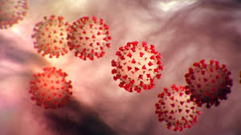

ENGINEERING STRATEGIES

Studies the relationship between environmental exposures
(including exposure to chemicals, radiation,
microbiological agents and so much more) and human health.
Several measures are commonly used to quantify mortality.
These numbers vary by region and over time and are influenced
by the volume of testing, healthcare system quality, treatment
options, time since initial outbreak and population
characteristics such as age, sex and overall health.
MANUFACTURING:
Several measures are commonly used to quantify mortality.
These numbers vary by region and over time and are influenced
by the volume of testing, healthcare system quality, treatment
options, time since initial outbreak and population
characteristics such as age, sex and overall health.

EXPERIMENTAL TESTING:
Research into potential treatments started in January 2020, and
several antiviral drugs are in clinical trials. Although new
medications may take until 2021 to develop, several of the
medications being tested are already approved for other uses
or are already in advanced testing.
INFORMATION TECHNOLOGY:
Big data analytics on cellphone data, facial recognition
technology, mobile phone tracking and artificial intelligence
are used to track infected people and people whom they
contacted in South Korea, Taiwan and Singapore.
In February 2020, China launched a mobile app to deal with the
disease outbreak. Users are asked to enter their name and ID
number. The app is able to detect 'close contact' using
surveillance data and therefore a potential risk of infection.
Every user can also check the status of three other users.

INNOVATIVE FACE MASK FOR THE HEARING IMPAIRED:
The masks have a transparent section over the mouth for the
hearing impaired to read lips. The masks also allow people to
see the wearer's facial expressions, which is crucial when using
Sign Language.
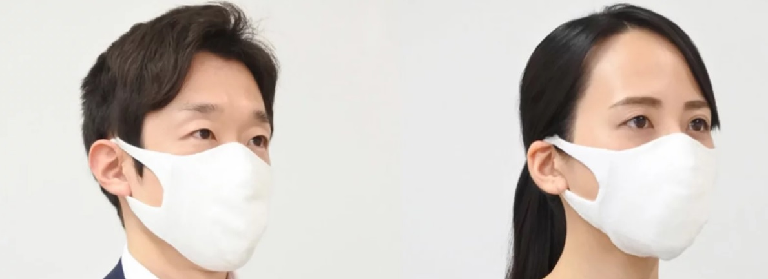

MECHANICAL VENTILATION:
Most cases of COVID-19 are not severe enough to require
mechanical ventilation (artificial assistance to support
breathing), but a percentage of cases do. It has been
recommended for the use of invasive mechanical ventilation
because this technique limits the spread of aerosolised
transmission vectors.

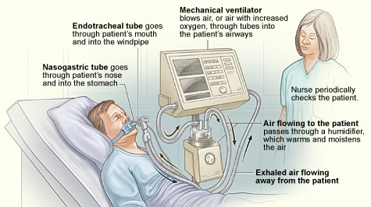

CONCLUSION
I strongly believe that the above mentioned strategies of engineering in handling the pandemic situation are effectively been carried out to help the victims as well as the rest of the world in taking preventive measures.
I also believe that the above mentioned results have also taking great effect in both sides of the world (victims and non-victims).

RECOMMENDATION
With respect to the current situation, I recommend the following:
- People should strictly adhere to the WHO instructions and guidance.
- People should follow and obey the country’s order and protocols.
- Governments in the country should take responsibility and provide for her citizens, especially those with little or no means of provision.
- People should use this medium to be creative and engage in one form of activity (legal) or the other from their various homes.
- Lastly, every person should engage in prayers and worships and to call upon their LORD(S) for help.

