17/SCI01/043
CSC 314
- A queue stands for a number of customers waiting to be serviced. For example, the number of people in line for medical advice from a doctor(service) in the hospital is a queue, the number of machines that are broken down and waiting for the attention of the maintenance crew for repair(service). I consider the study of waiting in line as an important aspect since it can help with creating an efficient and cost-effective work flow, allowing the user to improve traffic flow.
- Poisson arrival pattern is a pattern where the average time between arrivals is known but the exact timing of arrivals is random. For example, arrivals of customers at grocery shops, arrival of customers at ticket window.
Exponential service pattern describes the time between arrivals and specifies that these time intervals are completely random. For example, a service station operator waiting until a minimum desired customers arrives before he starts the service.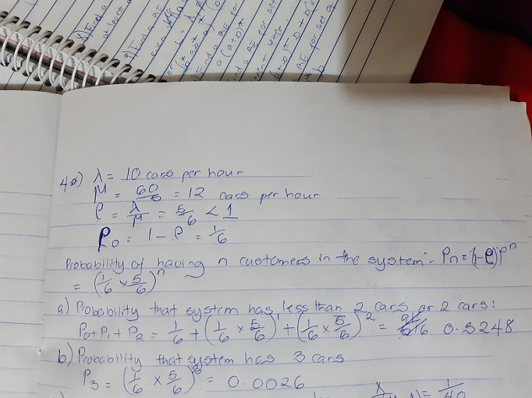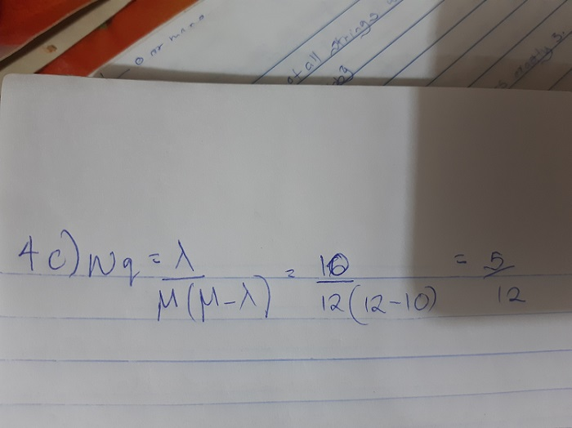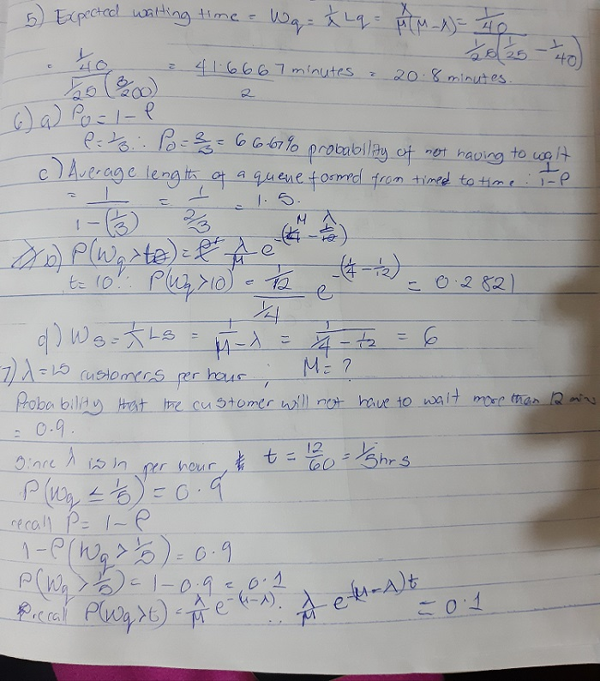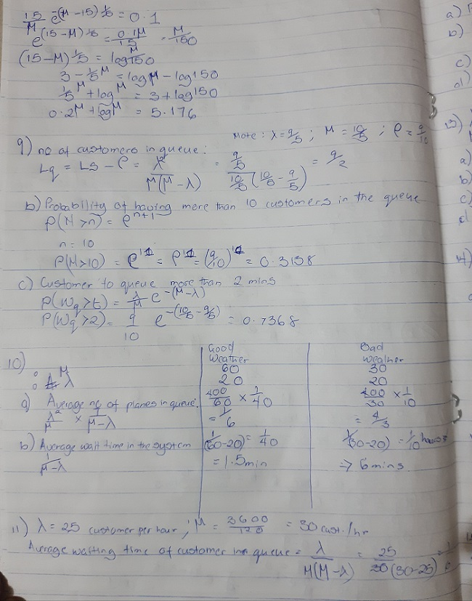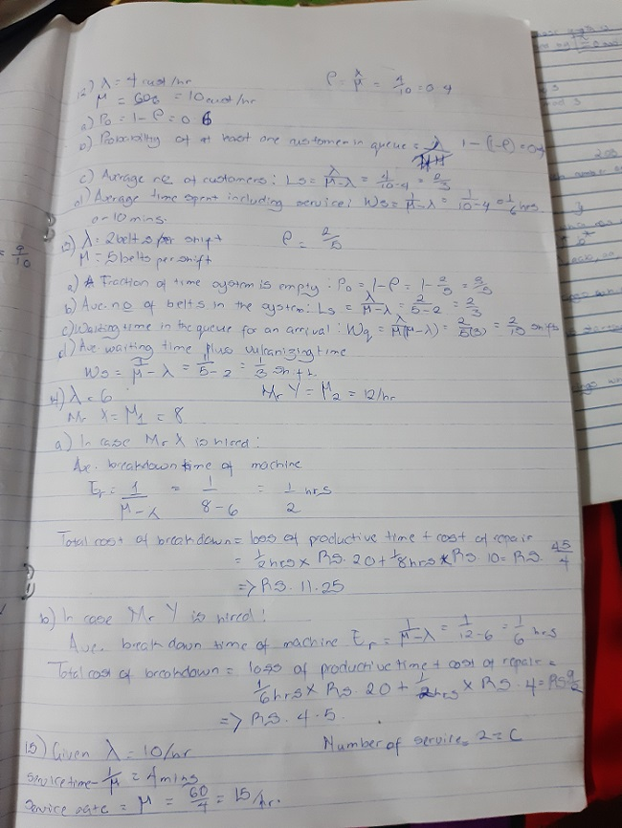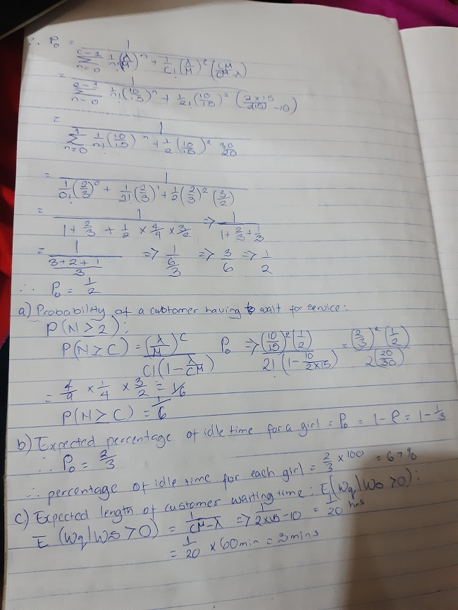

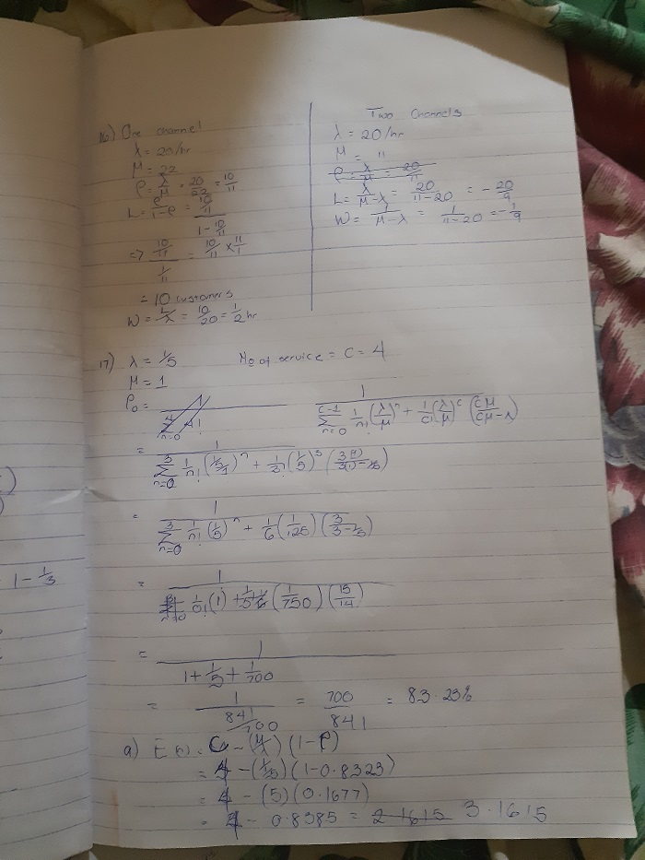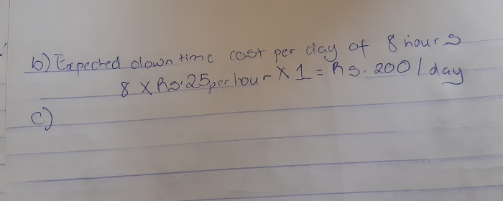
MULTIPLE CHOICE QUESTIONS
- C
- D
- D
- A
- A
- C
- A
- A
- D
- C
- B
- C
- D
- A
- C
- D
- C
- C
- D
- C
- A
- C
- B
- C
- A
- C
- B
- C
- A
- D

