NAME: NDIFE NZUBECHUKWU KINGSLEY
MATRIC NUMBER: 15/ENG05/014
COURSE: POWER ELECTRONICS
COURSE CODE: MCT 510
ASSIGNMENT 2
DATE: 13-04-2020
- Differentiate between a controlled and an uncontrolled rectifier
Controlled Rectifier | Uncontrolled Rectifier
In a controlled rectifier, the conduction can start at any angle in positive half cycle from 0° to 180 °. Once, the conduction starts, it can only be turned off in the negative half cycle.  Here the firing angle can also be adjusted with a gate pulse. | In an uncontrolled rectifier, it usually consists of a simple diode which conducts for half cycle or 180 ° of sine wave and remains off for the remaining 180°. Here, only one half of the input wave reaches the output and it is very incompetent for power.

- Differentiate between single phase half wave rectifier and single phase full wave rectifier

Single phase half wave rectifier | Single phase full wave rectifier
Here, either the negative or positive half wave of the Ac flows while the other half is blocked. During the positive half cycle, the diode is under forwarding bias condition and it conducts current to RL (Load resistance). A voltage is developed across the load, which is the same as the input AC signal of the positive half cycle. Alternatively, during the negative half cycle, the diode is under reverse bias condition and there is no current flow through the diode. Only the AC input voltage appears across the load and it is the net result which is possible during the positive half cycle. The output voltage pulsates the DC voltage. | Here, both half cycle of the input are utilized with the help of two or four diodes working alternatively. Using two diodes in a full wave rectifier circuit, one for each half of the wave. A multiple winding transformer is used whose secondary winding is split equally into two halves with a common center tapped connection. Configuration results in each diode conducting in turn when its anode terminal is positive with respect to the transformer center point produces an output during both half-cycles. Full rectifier advantages are flexible compared to that of half wave rectifier.

- Explain the operational characteristics of a DIAC
A DIAC is a bi-directional semiconductor switch which consists of four layers and two terminals and can be switched on in both polarities. The full form of the name DIAC is Diode alternating current. DIAC is connected back to back using two zener diodes. The main application of this DIAC is, it is widely used to help even activating of a TRIAC when used in AC switches, dimmer applications and starter circuits for florescent lamps
Structure of A DIAC
Operation principle of a DIAC

DIAC circuits use the fact that a DIAC only conducts current only after a certain breakdown voltage has been exceeded. The actual breakdown voltage will depend upon the specification for the particular component type. When the DIAC breakdown voltage occurs, the resistance of the component decreases abruptly and this leads to a sharp decrease in the voltage drop across the DIAC, and a corresponding increase in current. The DIAC will remain in its conducing state until the current flow through it drops below a particular value known as the holding current. When the current falls below the holding current, the DIAC switches back to its high resistance, or non-conducting state. The break over voltage of DIAC is around 30 V (typically 20–40 V).
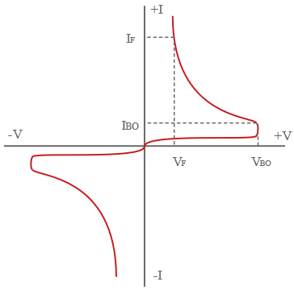
Voltage- current (V-I) characteristics of a DIAC
4. Explain the operational characteristics of A TRIAC
TRIAC is the three terminal semiconductor device used for controlling the current. They are able to switch high voltages and high levels of current, and over both parts of an AC waveform. The term TRIAC stands for triode for alternating current.
It consist of four layers like PNPN is in the positive direction and the negative direction consists of NPNP as we can see in the figure below. The three-terminal bidirectional device blocks the current in the OFF state and it will act as an open circuit switch.
Structure of a TRIAC

Operation of TRIAC
The Triode for Alternating Current (TRIAC) consists of two SCRs which are connected in parallel and they are in opposite directions. It has ON and OFF state characteristics which are similar to the SCR. In the first quadrant the MT2 is positive with respect to the MT1 and in the fourth quadrant, it is in the negative.
The gate trigger may occur in any four quadrant modes of operation. If the device is in ON state the conduction permits a huge amount of current to flow through it. Large amount of current is controlled by the resistance, otherwise, the device may be damaged. With the device, the gate is a control terminal and the proper signal is applied to the gate, therefore the firing angle of the device is controlled.
The circuit used in the gate for triggering the device is called the gate triggering circuit. For the TRIAC the gate triggering circuits are similar to the SCRs. Generally, the triggering circuits will generate the triggering pulses for firing the devices. The triggering pulses will have sufficient magnitude and duration, hence the firing of the device is assured. To sustain the firing of the device duration of 35 us is required.
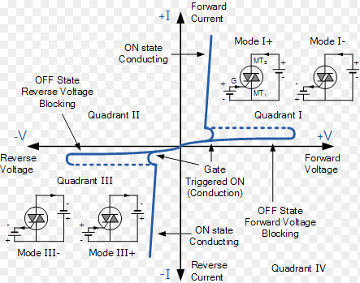
Voltage –current (V-I) characteristics of a TRAIC

REFERENCES

https://electricalacademia.com/electronics/diac-triac-basics-characteristics-curve/

https://www.electronics-notes.com/articles/electronic_components/scr/what-is-a-diac.php

https://www.efxkits.us/triac-circuit-working-principle-construction-application/

https://www.electricaltechnology.org/2019/01/what-is-rectifier-types-of-rectifiers-their-operation.html

