MICROFLUID POINT-ON-CARE(POC) TECHNOLOGY FOR INFECTIOUS DISEASES

BY
NAME: AMAINO SAMUEL OTONBARA
MATRIC NO: 18/ENG08/026
DEPARTMENT: DEPARTMENT OF AERONAUTIC, BIOMEDICAL AND AEROSPACE ENGINEERING
PROGRAM: BIOMEDICAL ENGINEERING
Table of Contents
CHAPTER 1 1
WHAT IS POC DEVICES? I
MICROFLUIDICS II
CHAPTER 2 2
POINT-OF-CARE DEVICES ON MICROFLUIDIC PLATFORM I
CHAPTER 3 3
CLINICAL INTERVENTIONS FOR INFECTIOUS DISEASE I
CHAPTER 4 4

ABSTRACT
Microfluidics will play a vital role in the revolution in point of care diagnostics that is set to take place over the next decade. By providing a platform for miniaturizing, integrating, and automating fluid flow, microfluidic tools are likely to become the standard disposable elements that will accompany many near-patient diagnostic tests. This chapter outlines recent microfluidic advances in point of care tests with a focus on key developments and review papers on the subject. It is organized by diagnostic test category highlighting some key developments in the area. We also describe some of the important developments such as smartphone integrated tests and the challenges in taking microfluidic technologies to market

INTRODUCTION
POC DEVICES
Point of care (POC) diagnostic devices are used to obtain diagnostic results while with the patient or close to the patient. Used in doctors’ offices, hospitals, and in patients' homes, POC diagnostic devices give quick feedback on many sorts of medical tests.
POC diagnostic devices are used to test glucose and cholesterol levels, do electrolyte and enzyme analysis, test for drugs of abuse and for infectious diseases, and for pregnancy testing. Blood gases, cardiac markers, and fecal occult blood tests can also be done with POC diagnostic devices. There are several advantages to doing the tests at the point of care, including quick results and faster implementation of therapy, if needed.

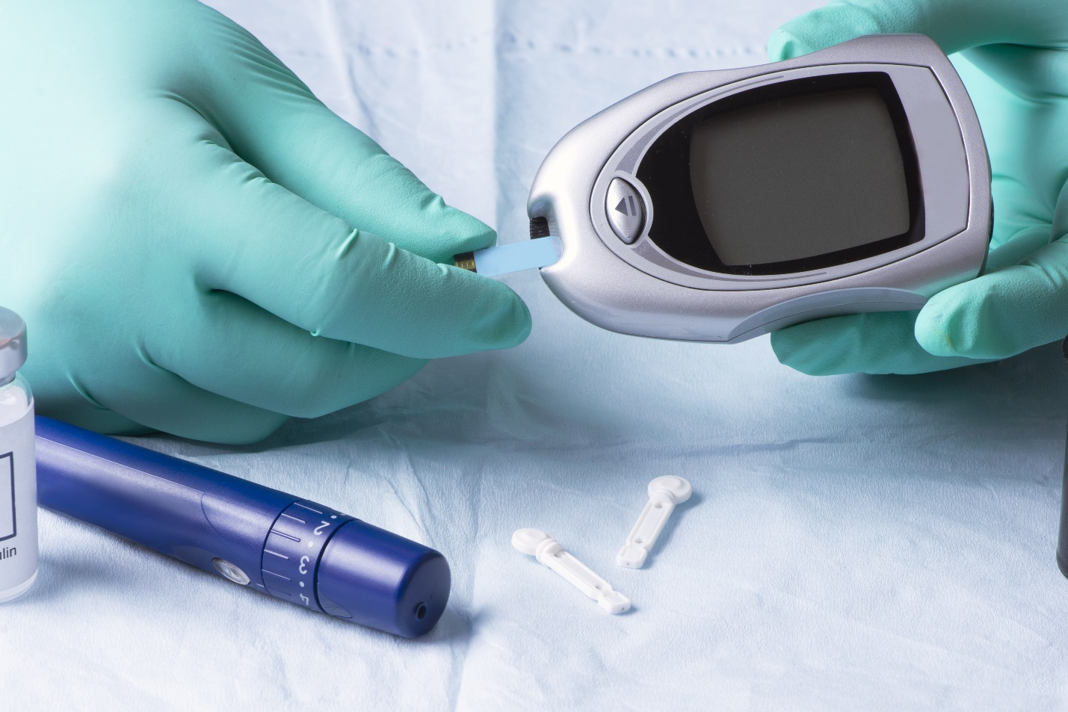

MICRO-FLUIDICS
Microfluidics is the science of manipulating and controlling fluids, usually in the range of microliters (10⁻⁶) to picoliters (10⁻¹²), in networks of channels with dimensions from tens to hundreds of micrometers. This discipline takes its origins in the early 1990’s and has grown exponentially. It is viewed as an essential tool for life science research or in a larger way in biotechnologies.
Microfluidics is both the science which studies the behavior of fluids through micro-channels, and the technology of manufacturing microminiaturized devices containing chambers and tunnels through which fluids flow or are confined.
Microfluidics deal with very small volumes of fluids, down to femtoliters (fL) which is a quadrillionth of a liter. Fluids behave very differently on the micrometric scale than they do in everyday life: these unique features are the key for new scientific experiments and innovations.
Digital microfluidic devices, also referred to as “lab-on-a-chip” devices, have been used in biomedical testing applications for the purposes of finding biomarkers and completing biological protocols such as ELISA (Enzyme-Linked Immunosorbent Assay) and EIA (Enzyme Immunoassay). Microfluidic devices can enable more effective and faster medical diagnostics where access to normally large testing machines is limited or nonexistent, such as remote areas, battlefields, and doctor’s offices. It is expected to contribute to the portability and speedof medical diagnostic devices while reducing the costs associated with production and testing. Objectives for this include: making a small, application specific control system with feedback, reducing fabrication costs, and having the system be in a user-friendly, portable package.

Microfluidic chips
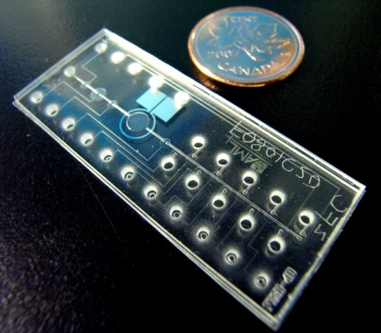
A microfluidic chip is a pattern of microchannels, molded or engraved. This network of microchannels incorporated into the microfluidic chip is linked to the macro-environment by several holes of different dimensions hollowed out through the chip. It is through these pathways that fluids are injected into and evacuated from the microfluidic chip. Fluids are directed, mixed, separated or manipulated to attain multiplexing, automation, and high-throughput systems. The microchannels network design must be precisely elaborated to achieve the desired features (lab-on-a-chip, detection of pathogens, electrophoresis, DNA analysis etc.).
To accurately manage fluids inside the microchannels, specific systems are required. These elements can either be found embedded inside the microfluidic chip, such as Quake valves, or outside of it, like in the case of pressure controllers.
POINT OF CARE DEVICES ON MICROFLUIDIC PLATFORM
Through microfluidics technology, samples and reagents can be transported, mixed, and reacted in specific micro chambers in a precisely controlled manner. It is naturally an ideal platform for POC test development with many desired features such as automation, integration, and miniaturization.

CLINICAL INTERVENTIONS FOR INFECTIOUS DISEASES
An intervention carried out to improve, maintain or assess the health of a person, in a clinical situation, the keyword intervention describes an objective of improving human health by preventing disease, by curing or reducing the severity or duration of an existing disease, or by restoring function lost through disease or injury.
Infectious diseases are caused by pathogenic organisms such as bacteria, virus, parasites, fungi etc. now “Without diagnostics, medicine is blind.” Adequate and prompt treatment to illnesses cannot be made properly without diagnosis in the first place. Sensitive, specific and rapid diagnostic testing not only paves the way toward effective treatment but also plays a critical role in preventing the transmission of infectious diseases. While central clinical laboratories offer sensitive and specific assays, such as blood culture, high-throughput immunoassays, polymerase chain reaction (PCR) and mass spectrometry (MS) tests, they are often time and labor intensive, costly, and dependent on sophisticated instruments and well trained operators. On the other hand, point-of-care (POC) tests provide rapid ‘on-site’ results at the site of care delivery, and in resource-limited settings, supporting timely and proper treatment. According to the World Health Organization (WHO), POC tests that address infectious disease control needs, especially for the developing countries, should follow “ASSURED” criteria:
(1) affordable,
(2) sensitive,
(3) specific,
(4) user-friendly,
(5) rapid and robust,
(6) equipment-free and (7) deliverable to end-users .
Here in, we review literature published in the past decade and indexed in Pubmed, on the development of POC tests for infectious diseases. Based on the number of published studies in this field, we have chosen to focus on several major infectious disease-causing microorganisms, including malaria parasites, human immunodeficiency virus (HIV), human papillomavirus (HPV), dengue, Ebola and Zika viruses, and Mycobacterium tuberculosis (TB) bacteria. We first review the pathological processes, impact on public health, and POC needs for the detection of these microorganisms, then focus on several key biomarkers used in developed POC tests, including pathogen nucleic acids and proteins, circulating microRNAs and antibodies, comparing their roles during the entire process of disease management. Finally, we review advancements in microfluidics and plasmonics, two technologies that we have seen significant innovations in the past decade in developing POC tests for infectious diseases. These technologies, together with others in the “POCT Toolbox” act as personal radar in the fight against infectious diseases, toward the goal of patient-centralized diagnosis and treatment, as shown below.
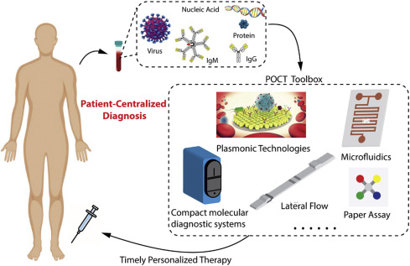

POC TECHNIQUES AND IT'S APPLICATIONS IN CLINICAL SETTINGS

1. Type 1 – Qualitative strip-based POCT methods
These qualitative tests discriminate plus and minus results and are mostly strip-based. The signaling is often performed by simple visualization or by optical detection using a simple readout device. The detection principles span from chemical-indicator reactions to immunological reactions [e.g., immunochromatography (performed as lateral flow assays)]. The strips are made of a porous matrix mixed with dried reagents onto a carrier element. The sample (e.g., urine, blood, stool or swab material) is deposited onto the matrix and starts the reaction while penetrating and soaking the stick layer.
Applications are urinary pregnancy testing, detection of blood in stool, urine dipstick analyses, detection of infectious agents in swab material and others.
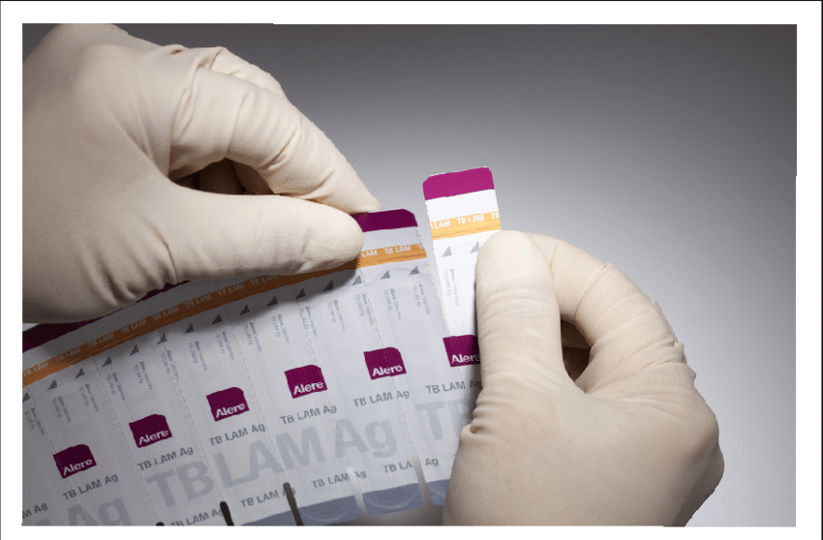
Strip based POCT method

2. Type 2 – Unit-use analyzers
Here is the simplest form of quantitative POCT device, with most of the analysis taking place on the respective test strips. The reader is used only to read the result from the strips where the reaction has already taken place. These test strips are one-use articles.
Applications include glucometers for home and the hospital POCT stations.
Blood-sugar analysis is, both historically and financially, the most commonly used POCT technique. This is valid for in-patient and out-patient care, and for home testing by patients.
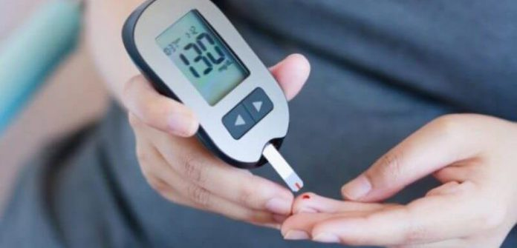
Glucometer as an example of unit use analyser

3. Type 3 – Bench-top POCT analyzers
These instruments are generally more complex than unit-use machines and use different analytical principles:
- Spectrophotometric substrate and enzyme-activity measurement;
- Hematological particle counting;
- Immunoassay; and,
- Sensor-based blood-gas analysis
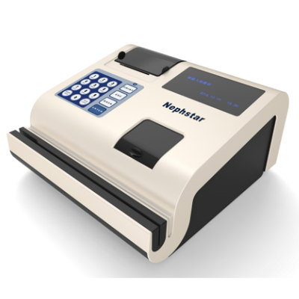
Bench-top nephelometer

4. Type 4 – Hemostaseological coagulation analyzers
These POCT compatible machines show a high degree of complexity. Although they are valid for use in POCT, only qualified personnel should operate them (e.g., a laboratory physician or a trained technical assistant). The combined analysis of plasma clotting, thrombocyte function and fibrinolysis is termed viscoelastic coagulation testing. Examples include the ROTEM (TEM International, Munich, Germany) or the Sonoclot from Sienco Inc (Arvada, CO, USA). It is also possible to analyze platelet function in terms of in vitro bleeding time or via optical aggregometry
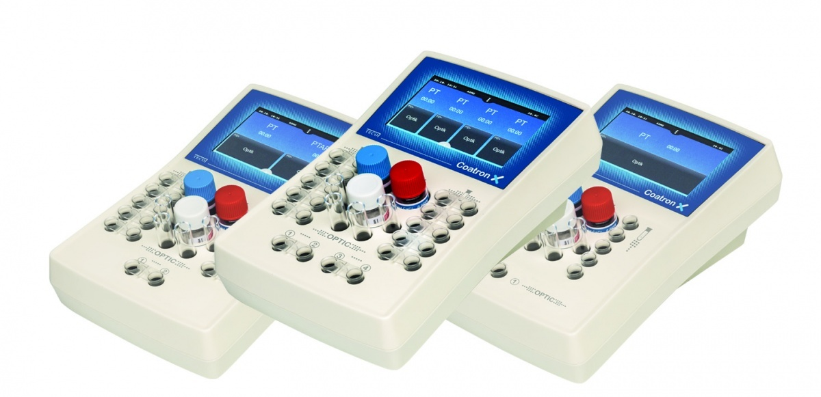
Coagulation analyzers

5. Type 5 – Continuous measurement with POCT systems
The most common example is continuous glucose monitoring . Such analyzing and application systems are already available commercially. They are likely to replace the invasive, intravenous electrode by the minimally invasive location of a microdialysis catheter in subcutaneous tissue. Conversely, other non-invasive methods (e.g., microporation or optical techniques in direct transcutaneous measurement of metabolic parameters) are at least unlikely to prevail. This is mainly due to the broad range of human-skin characteristics concerning thickness, pigmentation and hairiness as well as physiological phenomena (e.g., humidity and salt content).
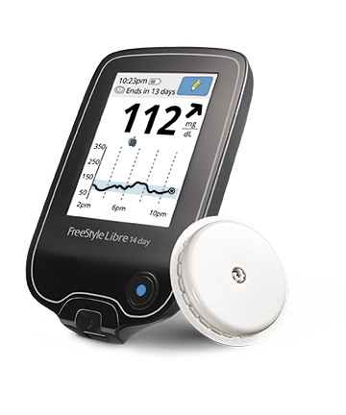
Continuous glucose monitoring system

6. Type 6 – Molecular biology-based POCT devices to detect infectious agents
At present on the market, there are many qualitative test strips to detect infectious pathogens. The basic principle in most systems is immunochromatography of a specific microbial antigen (or, more rarely, antibody) in the patient sample (urine, swab, or whole blood). There have also been some attempts to use molecular biological methods [mostly the polymerase chain reaction, (qRT)-PCR] for POCT, although these are technically demanding (with a DNA/RNA-extraction step required), so that they are no rapid tests in the strict sense (yet). Due to the complexity of the test procedures and the challenging interpretation of results, future rapid nucleic-acid testing (NAT) is more likely to be located in the central laboratory rather than at the bed-side. Nevertheless, rapid quantification of DNA/RNA from various infectious agents will be beneficial for clinical diagnostics.

STRATEGIES OF POINT OF CARE TESTING FOR INFECTIOUS DISEASES

As a result of the increasing mandate for POC testing, there is a need for laboratories to implement strategies that accommodate quick turnover in large volumes; labs must not only ensure that there are enough tests available at all times, but also ensure that newly developed tests are suitable for procedural operations at POC locations and meet the end goal of prompt and quality patient care.

MEDICAL ANALYSIS OF POINT OF CARE TESTING SCHEMES

Due to increasing healthcare pressures for faster turnaround of laboratory results and the development of a broader menu of testing devices, POCT is growing in popularity. Devices today are more portable, require less blood, and have computerized information management.

Despite its popularity, point-of-care-testing does not necessarily yield laboratory-comparable results. Delivery of laboratory testing outside the laboratory exposes a device to a variety of environmental, technique and patient factors that can adversely affect the analysis. Quality assurance of POCT requires an appreciation of the technical and operational factors that can influence the testing process.

RISK ASSESSMENT IMPACT OF POINT OF CARE TECHNIQUES DURING PANDEMIC OUTBREAKS

Synthesis of geospatial and POC concepts can facilitate emergency care, crisis response, and control of highly infectious diseases, such as Ebola virus disease (“Ebola”). Integration of both concepts improves population access to healthcare. For efficiency and cost-effectiveness, POCT must fulfill healthcare needs on a daily basis, improve diagnostic skills, and enable public health, emergency medicine, and other personnel with fast decision making.

Citation:
- TrAC Trends in Analytical Chemistry,Volume 30, Issue 6June 2011, Pages 887-898.
- Diagnostics (Basel). 2017 Sep; 7(3): 39.
Published online 2017 Jul 4.
- Front. Public Health, 26 November 2019
- December 1999, Management of point-of-care testing by James H. Nichols

