NLEMADIM CHIAZOR
MECHATRONICS ENGINEERING
15/ENG05/015

- DIFFERENCES BETWEEN CONTROLLED AND UNCONTROLLED RECTIFIER
The rectifier circuit using diodes only are called uncontrolled rectifier circuit. When SCRs (thyristor) are used to convert AC to DC, they have a controlled output voltage so it is called a Controlled rectifier output. Unlike diodes, SCR does not become conducting immediately after its voltage has become positive.
- DIFFERENCE BETWEEN SINGLE PHASE HALF WAVE RECTIFIER AND SINGLE PHASE FULL-WAVE RECTIFIER
The Half Wave and Full Wave Rectifier have significant differences. A rectifier converts AC voltage into Pulsating DC voltage. A Half-Wave rectifier is an electronic circuit which converts only one-half of the AC cycle into pulsating DC. It utilizes only half of AC cycle for the conversion process. On the other hand, Full wave rectifier is an electronic circuit which converts entire cycle of AC into Pulsating DC.

The Half-Wave Rectifier is unidirectional; it means it will allow the conduction in one direction only. That’s why either it can convert positive half only or negative half only into DC voltage. This is the reason that it is called Half Wave Rectifier. While Full-wave Rectifier, is bi-directional, it conducts for positive half as well as negative half of the cycle. Thus, it is termed as full wave rectifier.

- EXPLAIN THE OPERATIONAL CHARACTERISTICS OF DIAC
When the DIAC breakdown voltage occurs, the resistance of the component decreases abruptly and this leads to a sharp decrease in the voltage drop across the DIAC, and a corresponding increase in current. The DIAC will remain in its conducing state until the current flow through it drops below a particular value known as the holding current. When the current falls below the holding current, the DIAC switches back to its high resistance, or non-conducting state.

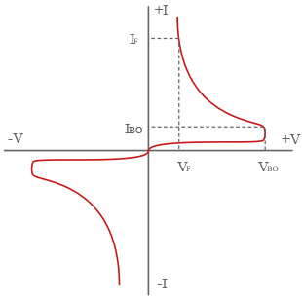
- EXPLAIN THE OPERATIONAL CHARACTERISTICS OF TRIAC
Triac is a three terminal AC switch which is different from the other silicon controlled rectifiers in the sense that it can conduct in both the directions that is whether the applied gate signal is positive or negative, it will conduct. Thus, this device can be used for AC systems as a switch.
The triac can be turned on by applying the gate voltage higher than break over voltage. However, without making the voltage high, it can be turned on by applying the gate pulse of 35 micro seconds to turn it on. When the voltage applied is less than the break over voltage, we use gate triggering method to turn it on.
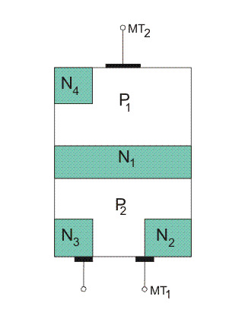
There are four different modes of operations, they are-
- When MT₂ and Gate being Positive with Respect to MT₁
When this happens, current flows through the path P₁-N₁-P₂-N₂. Here, P₁-N₁ and P₂-N₂ are forward biased but N₁-P₂ is reverse biased. The triac is said to be operated in positively biased region. Positive gate with respect to MT₁ forward biases P₂-N₂ and breakdown occurs.
- When MT₂ is Positive but Gate is Negative with Respect to MT_{1.}
The current flows through the path P₁-N₁-P₂-N₂. But P₂-N₃ is forward biased and current carriers injected into P₂ on the triac.
- When MT₂ and Gate are Negative with Respect to MT₁
Current flows through the path P₂-N₁-P₁-N₄. Two junctions P₂-N₁ and P₁-N₄ are forward biased but the junction N1-P1 is reverse biased. The triac is said to be in the negatively biased region.
- When MT₂ is Negative but Gate is Positive with Respect to MT₁
P₂-N₂ is forward biased at that condition. Current carriers are injected so the triac turns on. This mode of operation has a disadvantage that it should not be used for high (di/dt) circuits. Sensitivity of triggering in mode 2 and 3 is high and if marginal triggering capability is required, negative gate pulses should be used. Triggering in mode 1 is more sensitive than mode 2 and mode 3.

