NWABINELI DAISY CHINWOKE
18/mhs07/055
PHA 312 assignment

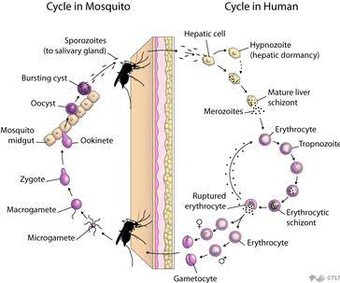
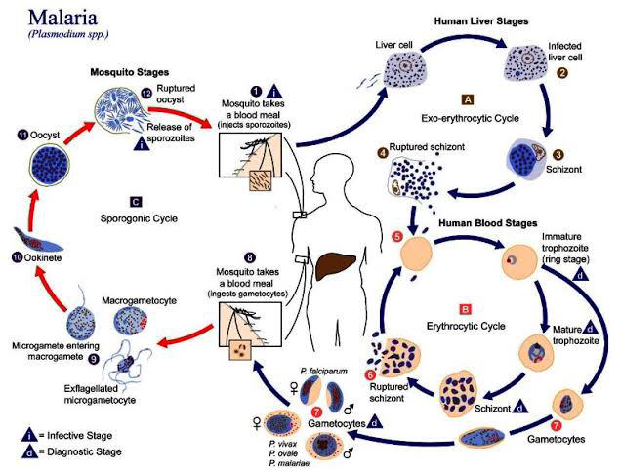

LIFE CYCLE OF MALARIA PARASITE

Tissue amoebicides
Luminal amoebicides
Tissue amoebicides
For intestinal and extra intestinal amoebiasis
Nitroimidazoles: Metronidazole, tinidazoke, secnidazole, ornidazole,
Alkaloids: Emetine, dehydroemetine
For external intestinal amoebiasis only: chloroquine
Luminal amoebicides
Amide: Diloxanide furoate, nitazoxanide
8-hydroxyquinolines: quiniodochlor (iodochlorohydroxyquin, clioquinol)
Antibiotics: tetracycline, paromomycin
Mechanism of action of metronidazole
Metronidazole is a prodrug. It requires reductive activation of the nitro group but a susceptible organism, it’s nitro group is reduced by certain redox proteins operative only in anaerobic microorganisms to a highly reactive neuroradical which exerts cytotoxicity. It does not affect aerobic bacteria, it is selectively toxic to anaerobic and microaerophilic microorganisms. It enters the cell by diffusion. It contains electron transport components e,g, ferridoxin and small Fe-S proteins

